Open-book and open-resource except consult no one else. Return your answers to me in the course dropbox (Catalyst link on webpage) by this Friday (March 9) at midnight (= Saturday 12:00!) Earlier would be great! As usual, at the top of your answer sheet put the following:
The answers to these questions are mine alone; I consulted no one else in writing my answers.
____________________________ (type your name)

- It has been hypothesized that the animals are capable of the following complex behaviors and mental capacities. For each one, (a) give an operational definition, (b) provide an example from the course (from one of the papers we read), (c) say whether it has been hypothesized as limited to just some animals, and (d) provide a contrarian or ‘killjoy’ viewpoint of the ability.

Example: Self-awareness. In animals, said to be demonstrated when the animal recognizes itself in the mirror, i.e., touches a spot on its head that can be seen only when looking in a mirror. Thought to be limited to humans and the great apes and perhaps a few other brainy animals (e.g., dolphins, elephants, some corvids). Contrarian viewpoint: Epstein & Skinner have shown in simulation experiments that the lowly pigeon will show ‘mirror self-recognition’ if it is first trained to use a mirror to locate objects or marks not on its body.

Insight learning
Observational learning (contrast with Local enhancement)
Cultural transmission
Episodic memory
Positive emotion
Theory of mind
Prosociality

- Most introductory courses in animal behavior have no section on animal mind (or animaI cognition). For example, many of you had Alcock’s animal behavior text in 200 or 300; you may remember he had nothing on animal mind. What is the justification that would be given for this omission?

- What does the Herrmann et al group think is different between the learning abilities of humans, chimps and bonobos? (You will need to refer to the group’s earlier study as well as the more recent one we read.)

- I hang an opaque food container in the tree in my yard. The container has several latches that must be worked for the food to become accessible. One crow works on it for a long time, and finally gets it open. The latches are set to close when a bird leaves. The original crow leaves. Subsequently other crows, then other birds come and feed from the container. (a) Can we say that the first crow showed insight in figuring this out? Provide an alternative explanation. (b) Can we say that subsequent crows and birds learned how to get the food through observational learning? Provide an alternative explanation. And suggest an experiment that might distinguish between the two explanations.

- Suppose you think dogs are capable of the emotion of jealousy and that you want to convince a skeptic that you are right. Describe the demonstrations and/or experiments that you think would make a strong case. (If you prefer, you can turn this question around, and suppose you think dogs are not capable of jealousy, and that you want convince a skeptic that you are right about this.)

- (a) What is anthropomorphism? (b) Why do humans do it? (c) Do you think animals do the same thing when thinking about us? Explain your reasoning.

- Most (probably all) songbirds learn their songs. In the study of song learning, the older birds from whom the young birds learn their songs are referred to as “tutors”. The word is used just for convenience, but what would we need to show that older birds do in fact teach younger birds their songs? Describe this in the natural context rather than in a lab context.
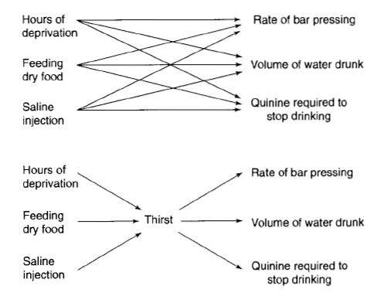
- The diagram at the right shows why intervening variables can be parsimonious. Explain why mental concepts in general and theory of mind in particular can be useful as intervening variables in the explaining behavior.

