Disturbance and Succession

- One of the major realizations in ecology has been that ecological systems are rarely found in equilibrium conditions. Populations, communities, and ecosystems are nearly always in perpetual change. A large assortment of different disturbances prevent ecological systems from remaining static over most relevant time periods. Although mathematical models often assume that ecological systems are at equilibrium (for matter of analytical convenience), it is important to realize that these conditions are more the exception than the norm out there in the real world.

- Examples of common disturbances to ecosystems
  - fire (forest, prairies)
  - flooding
  - volcanoes
  - glacial activity
  - avalanches
  - drought
  - windfall
  - seasonal changes in weather
  - grazing/browsing
  - bioturbation
  - a huge variety of human activities
  - others?

- Following a disturbance, there is often a predictable series of species arrangements that ecological systems progress through as they ‘recover’ to a climax community. In other communities, reassembly of the species composition is often more random, and the key processes regulating recovery in these types of systems are not as well understood.

- Succession is the term describing the sequence of changes that communities progress through following a disturbance. The endpoint of succession is usually assumed to be a stable state associated with the climax community. (At least it is stable until the next disturbance shows up!)

- Primary succession refers to community development in newly formed habitats the previously lacked plants or other organisms. Thus, primary succession often follows exceptionally catastrophic disturbances such as volcanic activity and receding glaciers. Secondary succession generally refers to community development following disturbances that move communities away from their climax state.

- The first species to colonize new habitat created by disturbance are referred to as pioneer species which often have very characteristic life history strategies.

Characteristics of plants that reinvaded Krakatau following the massive volcanic eruption in 1883.

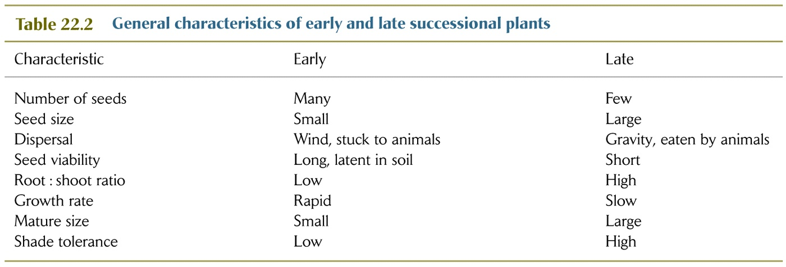
- Pioneer species usually change the abiotic conditions of the habitat that then facilitates the recolonization and success of later successional species.

Examples of facilitation: shade, soil development, nutrient enhancement – especially by N fixers, others?

- Inhibition refers to the fact that many late successional species compete strongly (or eat) early successional species and therefore exclude the pioneers from the late successional or climax community. Examples? Shade tolerance, others?

In some situations, the species that arrives in a new habitat before its competitors takes over and prevents their colonization. In these cases, precedence, the order that species arrive, ultimately determines composition of the climax community.

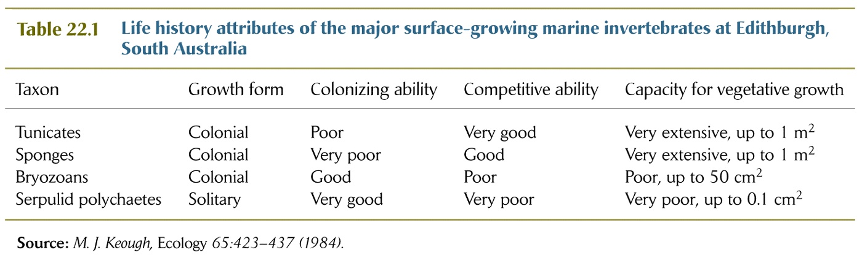

- Tolerance refers to the situations where certain species can invade and become established in a community, independent of the composition of the rest of the community. Its success is determined by its dispersal abilities and the environmental conditions of the new habitat.

- Climax communities represent a continuum of vegetation types of community compositions determined by the underlying environmental conditions and any stochastic processes affecting the successional sequence in any situation.

K) Examples of some of the more dramatic instances where succession/disturbance have overwhelming effects on community structure and ecosystem processes.

- Prairie fires
- Forest fires
- Beaver dams
- Sand dunes
- Alder trees a pioneers in deglaciated and riparian habitats
- Seasonal changes in plankton communities

Seasonal succession of phytoplankton and zooplankton in Lake Washington.

- Succession on carcasses by scavengers often follows a predictable process

- Periodic or cyclical disturbances often prevent communities from attaining the climax condition. Therefore, these disturbances are often the key structuring forces of certain ecosystems and communities. Human ‘control’ of these natural disturbances often allows these communities to progress towards the climax condition which would rarely be attained in the absence of humans.

Examples:

Prairie fires

River flooding

- Multiple disturbances may compound each other and drive communities to certain states that are very stable but novel for a certain environment.

