## Food Processing and Agricultural Supply Chains

|  |
| --- |
| This is a diverse set of industries and includes several NAICS codes, [11](http://www.census.gov/cgi-bin/sssd/naics/naicsrch?code=11&search=2002%20NAICS%20Search)XXX for Beer, Wine, and Distilled Alcoholic Beverage Merchant Wholesalers. Agriculture, Forestry, Fishing and Hunting, [311](http://www.census.gov/cgi-bin/sssd/naics/naicsrch?code=311&search=2002%20NAICS%20Search)XX for Food Manufacturing, [312](http://www.census.gov/cgi-bin/sssd/naics/naicsrch?code=312&search=2002%20NAICS%20Search)XX for Beverage and Tobacco Product Manufacturing, [4244](http://www.census.gov/cgi-bin/sssd/naics/naicsrch?code=4244&search=2002%20NAICS%20Search)XX for Grocery and Related Product Merchant Wholesalers, [4245](http://www.census.gov/cgi-bin/sssd/naics/naicsrch?code=4245&search=2002%20NAICS%20Search)XX for Farm Product Raw Material Merchant Wholesalers, and [4248](http://www.census.gov/cgi-bin/sssd/naics/naicsrch?code=4248&search=2002%20NAICS%20Search)XX for Beer, Wine, and Distilled Alcoholic Beverage Merchant Wholesalers. In addition, there are the carriers who serve the industry. |

### Description of Supply Chain

The agricultural and food processing industries are diverse, with many players, operational characteristics, and product types. However, all supply chains are designed to convert and move raw agricultural products from farms into food products for end consumers. The figure below provides an example from the potato industry.

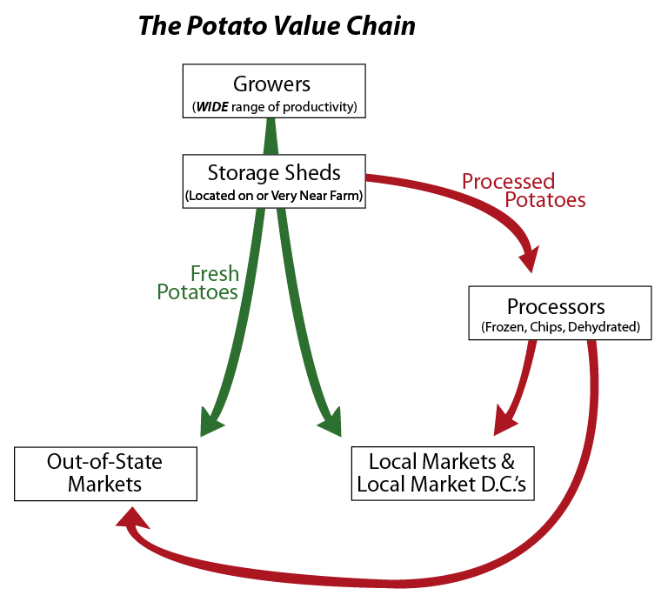

The next figure provides an example from Breakfast cereals.

Another example is provided for cherries.

### Modes and Nodes – including stick diagram. Maps as sidebars, where available.

As described in the figure below, the supply chain begins with a grower who harvests or sells the product they have grown. In most cases this is transported to a processing plant where the raw agricultural product is converted into a food product designed for longer-term storage in appropriately sized packages. These products then enter the food distribution chain, moving between warehouses and/or distribution centers to supermarkets. The specifics of this portion of the chain are determined by economics and inventory management, and the business model of the retailer and distributor.

Finished goods such as frozen french fries, begin at food processing plants. From here they may be transported directly to vendors, or may be transported through distribution centers for inventory management or short-term storage. Domestically, the majority of this transport occurs by truck, but longer distances and larger shipments may move by rail carload and truckload. Distribution to stores may occur by smaller peddle vans.

While some of the transportation may occur via rail if distances are longer than approximately 400 miles, much of this distribution is performed via truck. Particularly for time sensitive andhighlyperishable products. For international trade both air and water modes are used depending on the economics of the industries. Examples of products moved by air include cherries, while frozen potato products move via marine vessels.

A variety of methods are used for performing or contracting transportation. For example, some supermarkets operate their own truck fleet, delivering goods from distribution centers to stores. Private carriers are also used to move products from processing facilities to distribution centers and in some cases on to stores. Supermarkets are large corporations with multi-state or national reach that operate large regional distribution centers. Of course, much smaller stores also sell food products but tend to be served by wholesalers and distributors who operate their own distribution centers. A recent survey of large grocery stores, found that even within this category, truck activity varied by almost 100%, with some stores receiving 15 truck trips per day, while others received twice that.

### Key Players

The actors in the food processing supply chain includes growers, processors, traders, wholesalers and distributors, transportation providers (carriers, owner-operators, 3PLs, etc.), retailers, and agricultural inspectors or regulators. Most growers and processors are product specific, whereas traders, wholesalers, distributors, and retailers tend to serve a range of products.

### Trends or Other Issues

Production of many products is seasonal, with shipments from the farms to storage facilities only occurring during harvest time, however, storage facilities are used to moderate supply to better match demand throughout the year. In the case of apples, product is stored near farms for up to provide constant supply year-round.

### Components of Supply Chain Covered in National Databases

Given the diversity of the food production industry and the use of intermediate terminals, it is poorly captured in the CFS data. The US Department of Agriculture provides a broad range of statistics regarding agricultural products. There are also several private companies such as AC Neilsen that provide regionally specific data for purchase. However, these commodities are difficult to track when these are converted into food products and enter the food delivery system.

### Supplemental Data to Fill in the Holes

The diversity of business strategies, supply chain structures, and operational practices makes it difficult to capture activities within the food distribution supply chain with aggregate statistics. However, many specific commodities are well organized and these industry organizations are potential sources of data. For example, when mapping the potato value chain which is used as an example below, data on production, processing, and consumption of potatoes and potato products was available from the Washington Potato Commission. Data on grocery store locations is generally available from regional planning organizations. However, truck or rail volumes are difficult to identify. In some cases these shipments are seasonal, with demand for products varying throughout the year. The most sophisticated of these supply chains operate in a demand responsive way, so that shipments are not pre-planned, but products are moved from distribution centers to stores as per consumption.