5.2 Potato Case Study
By potato movements, we refer to estimates of daily vehicle level trips, for example, daily truck trips of fresh potatoes in the state. To identify the consequences of a disruption to potato movements, an understanding of existing potato movements is first required. This also includes capturing the variety of potato products, as well as the origins and destinations within the state.
A report completed for WSDOT and the Washington Potato Commission (Creamer, Selmin and Jessup 2008) proved very useful in providing the information required to estimate truck trips within Washington state.

5.2.1 Potato Production
Through previous work by Creamer et al., and as shown in Figure 5.7, it is clear that potatoes are produced in three regions of the state: the Skagit Valley, the Lower Basin, and the Upper Basin.
These three regions are considered origins of fresh potatoes. Centroids of the region are identified as the origins of truck trips. Potato production volumes are estimated from U.S. Department of Agriculture (USDA) field production data (Table 5.1).

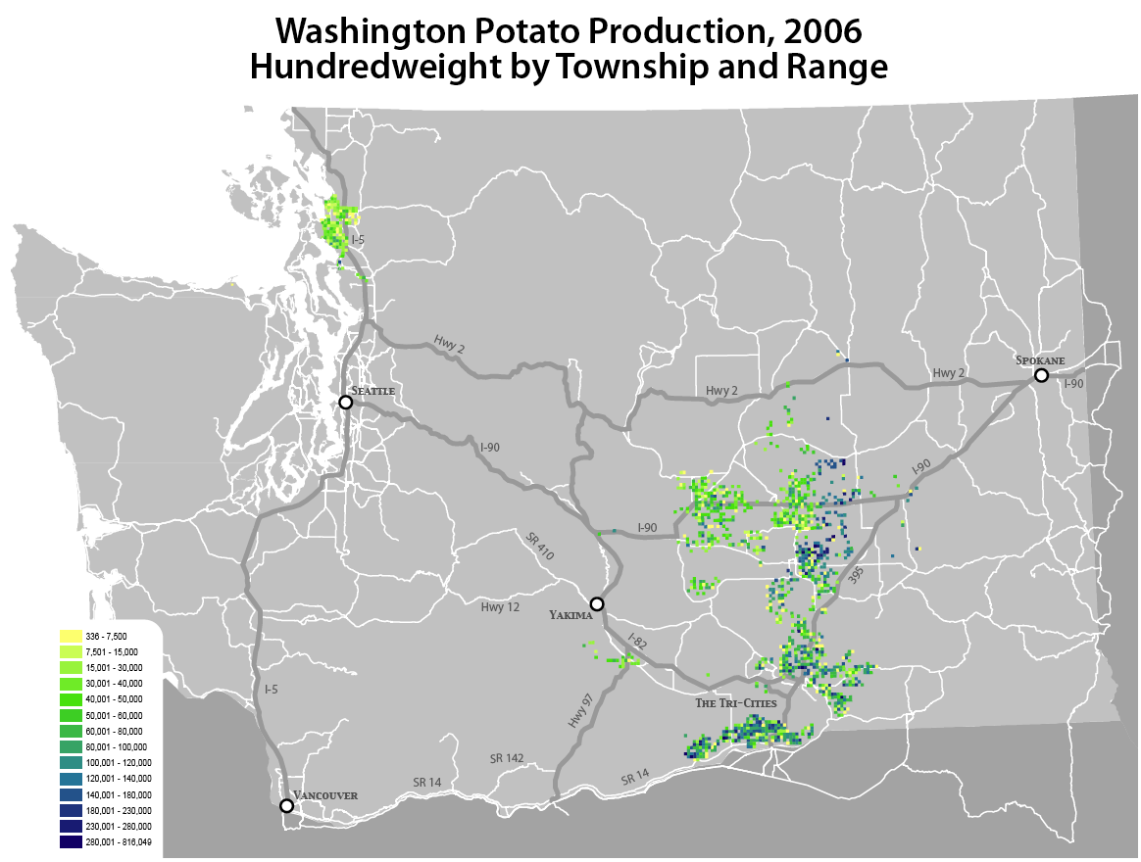
Figure 5.7 Washington potato production, 2006 from USDA field production data
(Creamer, Selmin and Jessup 2008)

Table 5.1 Production volumes per region less recovery rate (USDA, Potato Commission)
 | Total Production
 | Skagit Valley | Upper Basin | Lower Basin
Production (Short Tons) | 162,742 | 1,972,626 | 2,197,012
Recovery Rate | 0.94 | 0.94 | 0.94
Total Purchased | 152,977 | 1,854,268 | 2,065,191

On the basis of conversations with the Washington State Potato Commission, a capture rate of 94 percent was assumed in all regions. For each production region, percentages of potatoes sold fresh or processed were estimated on the basis of an “end of year comparison” from the Washington State Potato Commission (Table 5.2).
Table 5.2 Potato utilization by product for three production regions (Potato Commission)
 | Potato Utilization
 | Skagit Valley | Upper Basin | Lower Basin
Fresh | 100% | 14% | 14%
Frozen | 0 | 73% | 73%
Dehy | 0 | 11% | 11%
Chips | 0 | 2% | 2%

5.2.2 Potato Processing
Potatoes are processed at 16 facilities within Washington state, as shown in Figure 5.8.

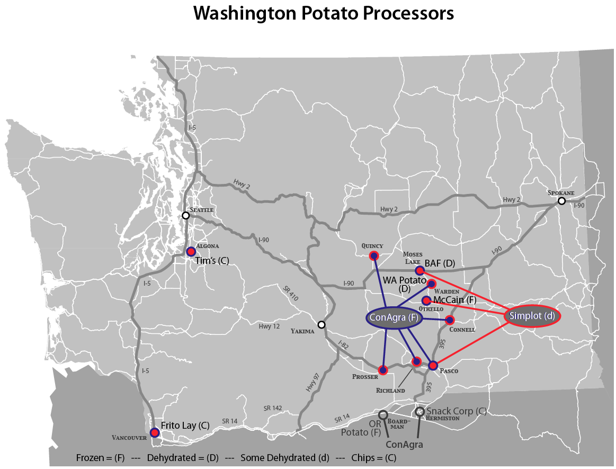
Figure 5.8 Potato processors in Washington state (Potato Commission)

Ratios of truckloads of fresh potatoes to truckloads of processed potatoes were estimated by the Washington State Potato Commission. The ratio for fresh potatoes is of course 1:1, and it is 2:1 for frozen potatoes, 4:1 for chips, and 6:1 for dehydrated potatoes. For example, for every truckload of dehydrated potatoes leaving a processing facility, six truckloads of fresh potatoes are required. Note, however, that a truckload of fresh potatoes is assumed to be equivalent to 22.22 tons, and a truckload of frozen potatoes is assumed to be equivalent to 20 tons.
No information was available regarding the location of dehydration for potatoes grown in the Skagit Valley. Dehydration could take place at processing facilities in either the Upper or Lower basins. On the basis of the expert knowledge of the Potato Commission, we estimated that 25 percent of these potatoes would be dehydrated in the Upper Basin, and 75 percent would be dehydrated in the Lower Basin. Potatoes grown in the Upper Basin were assumed to be processed in the Upper Basin, and potatoes grown in the Lower Basin were assumed to be processed in the Lower Basin.

5.2.3 Mode
We assumed that 25 percent of frozen potatoes processed in the state leave the state via rail. This was based on conversations with one of the state’s largest frozen potato producers, ConAgra. We also assumed that 11 percent of fresh, dehydrated, and chipped potatoes are shipped out of the state on rail, given unpublished data from the Washington Potato Commission. Typically these potatoes are destined for regions east of the Mississippi.

5.2.4 Potato Consumption and Export
Potatoes grown and processed in the state are either consumed in the state or exported. The distribution of potatoes by destination given by the 2007 Potato Commission Survey is shown in Table 5.3.

Table 5.3 Percentage of shipments to major destinations by region (Potato Commission Survey)
Major destinations | Lower Basin | Skagit Valley | Upper Basin
Eastern Washington | 12.48% | 2.03% | 6.22%
Western Washington | 14.29% | 6.81% | 6.40%
Oregon | 2.31% | 4.35% | 1.25%
California | 14.58% | 40.72% | 11.85%
Idaho | 0.00% | 0.00% | 34.33%
States west of Mississippi | 22.01% | 13.30% | 12.76%
States east of Mississippi | 24.26% | 23.58% | 11.99%
Canada | 8.85% | 7.04% | 2.91%
Mexico | 0.14% | 1.96% | 0.25%
Other international | 1.09% | 0.20% | 12.03%

Potatoes destined to other international locations are exported via the Port of Seattle. According to the 2007 Potato Commission Survey, these shipments use the routes shown in Table 5.4. These truck trips are shown graphically in figures 5.9 through 5.11.
Table 5.4 Major routes used by region (Potato Commission)
Major Destinations | Lower Basin | Skagit Valley | Upper Basin
Eastern Washington | I-90, I-82, | I-5, I-90, | I-90, I-82,
Eastern Washington | Hwy 12, 14 | Hwy 2, 405 | Hwy 17
Western Washington | I-90, I-82, I-5, | I-5, | I-90,
Western Washington | 240, 395 | 405, 167 | Hwy 17
Oregon | I-90, I-82, I-84, | I-5 | I-90, I-82, I-84
Oregon | Hwy 97, | I-5 | I-90, I-82, I-84
Oregon | 395, 597 | I-5 | I-90, I-82, I-84
California | I-90, I-82, I-5, | I-5 | I-90, I-82, I-5,
California | Hwy 97, 395 | I-5 | Hwy 17, 395
Idaho |  |  | I-90, I-82, I-84,
Idaho |  |  | SR 17, 395
States west of Mississippi | I-90, I-82, | I-90, I-80, I-5, I-84, 405 | I-90, I-82, I-5, I-84,
States west of Mississippi | 395 | I-90, I-80, I-5, I-84, 405 | SR 17, 395
States east of Mississippi | I-90, I-82, | I-90, I-80, I-5, | I-90, I-82, I-5, I-84,
States east of Mississippi | 395 | 405 | SR 17, 395
Canada | I-90, I-82, I-5 | I-5, I-90 | I-5, I-90
Mexico | I-82, I-5, Hwy 97 | I-5

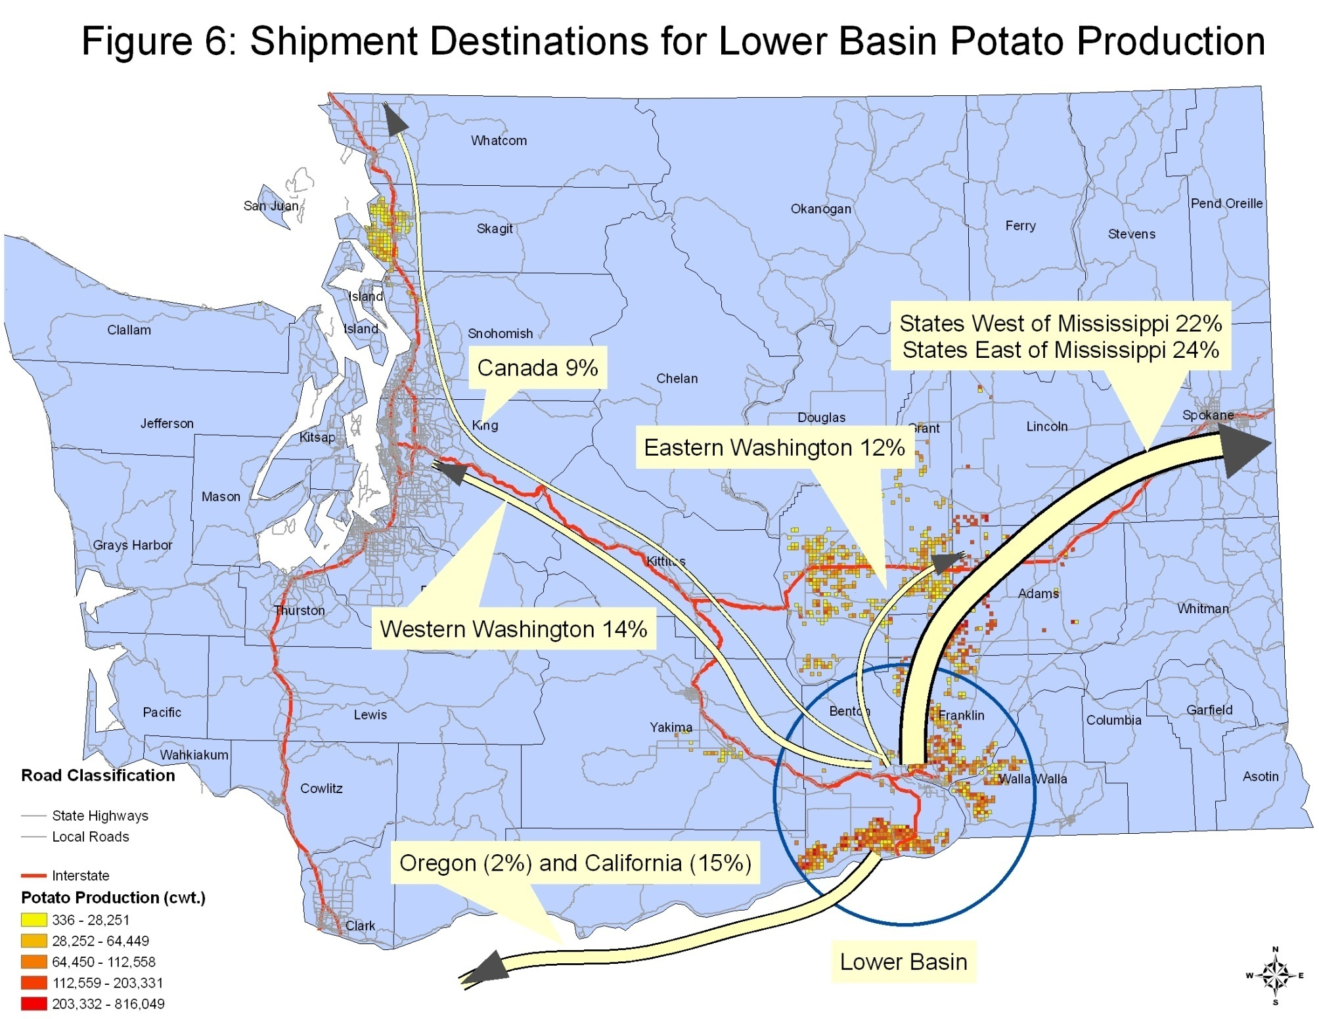
Figure 5.9 Shipment destinations for Lower Basin potato production
(Creamer, Selmin and Jessup 2008)
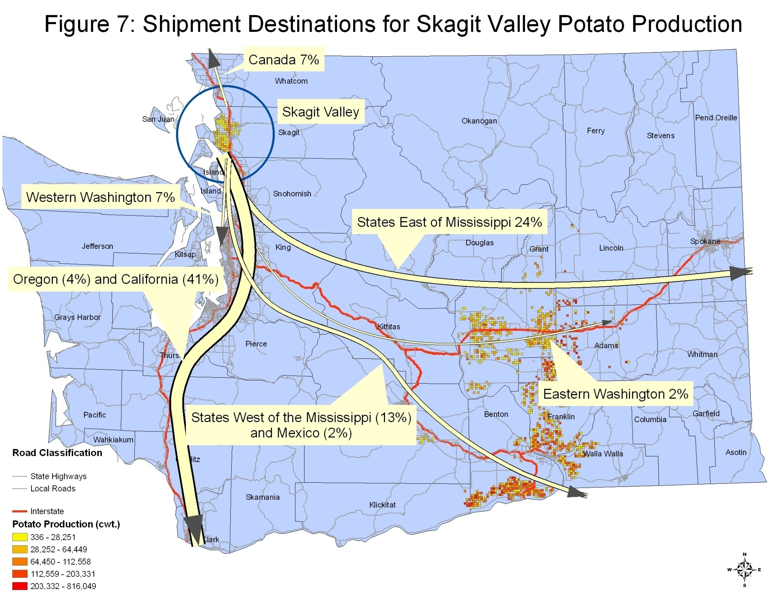
Figure 5.10 Shipment destinations for Skagit Valley potato production
(Creamer, Selmin and Jessup 2008)
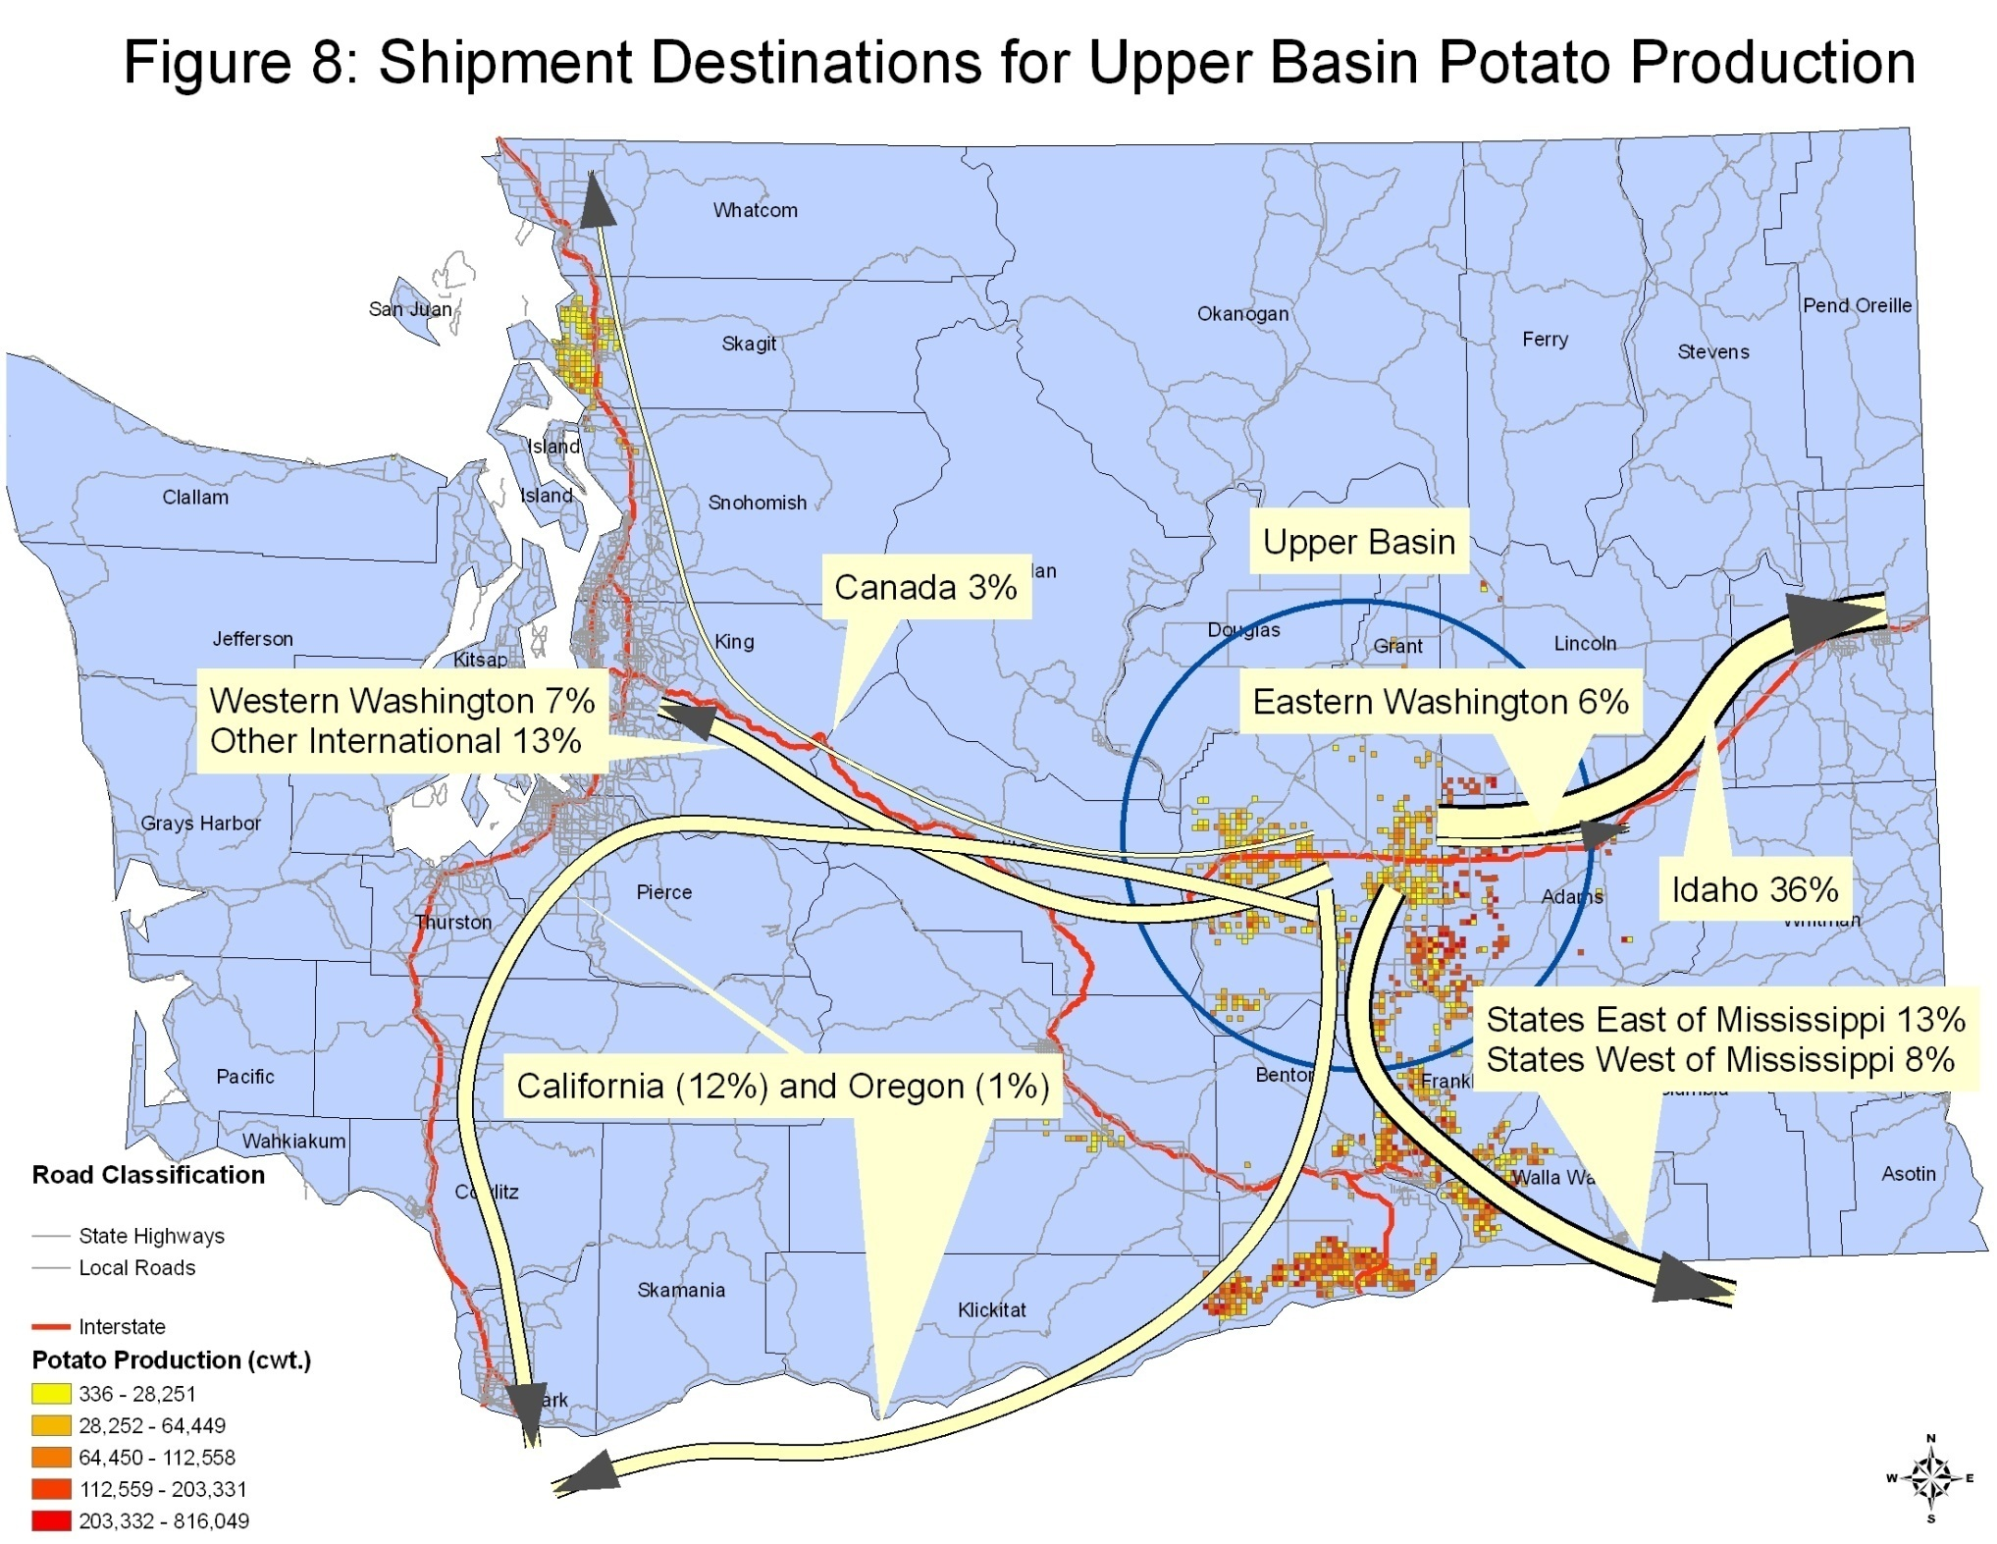
Figure 5.11 Shipment destinations for Upper Basin potato production
(Creamer, Selmin and Jessup 2008)

Destinations in Eastern Washington are distributed to Moses Lake, Spokane, Kennewick, Warden, Yakima, and Grandview. Destinations in Western Washington are distributed to Seattle, Tacoma, Stanwood, and Auburn. Destinations in Oregon and California are served via I-5, I-205, I-82, and Highway 97. Destinations in Idaho are served via I-90, Highway 2, Highway 12, I-82, and I-84. Other destinations in the U.S. are served via I-90 and I-82. Destinations in Canada are served via I-5 or Highway 9. Destinations in Mexico are served via I-5, I-205, I-82, or Highway 97.

5.2.5 Truck Trips
To convert short tons to truckloads of potatoes, we assumed that fresh and dehydrated potatoes weigh out at 22,000 pounds. For frozen potatoes we assumed that a truckload can carry 20,000 pounds because of the refrigeration unit necessary. For potato chips, a truckload can carry only 5,000 pounds.

Table 5.5 Truck trips per day
Destinations |  | Total Production |  |  | Fresh |  |  | Frozen |  |  | Dehy |  |  | Chips
 |  | Skagit Valley | Upper Basin | Lower Basin | Skagit Valley | Upper Basin | Lower Basin | Skagit Valley | Upper Basin | Lower Basin | Skagit Valley | Upper Basin | Lower Basin | Skagit Valley | Upper Basin | Lower Basin
E. WA |  | 0.17 | 0.06 | 0.12 | 2.90 | 1.71 | 3.96 | 0.00 | 4.17 | 9.67 | 0.00 | 0.24 | 0.53 | 0.00 | 0.27 | 0.63
Moses Lake | 0.04 | 0.01 | 0.00 | 0.01 | 0.13 | 0.07 | 0.17 | 0.00 | 0.18 | 0.42 | 0.00 | 0.01 | 0.02 | 0.00 | 0.01 | 0.03
Spokane | 0.48 | 0.08 | 0.03 | 0.06 | 1.40 | 0.83 | 1.92 | 0.00 | 2.02 | 4.68 | 0.00 | 0.12 | 0.26 | 0.00 | 0.13 | 0.30
Kennewick | 0.17 | 0.03 | 0.01 | 0.02 | 0.50 | 0.30 | 0.69 | 0.00 | 0.72 | 1.68 | 0.00 | 0.04 | 0.09 | 0.00 | 0.05 | 0.11
Warden | 0.04 | 0.01 | 0.00 | 0.01 | 0.13 | 0.07 | 0.17 | 0.00 | 0.18 | 0.42 | 0.00 | 0.01 | 0.02 | 0.00 | 0.01 | 0.03
Yakima | 0.13 | 0.02 | 0.01 | 0.02 | 0.37 | 0.22 | 0.50 | 0.00 | 0.53 | 1.23 | 0.00 | 0.03 | 0.07 | 0.00 | 0.03 | 0.08
Grandview | 0.13 | 0.02 | 0.01 | 0.02 | 0.37 | 0.22 | 0.50 | 0.00 | 0.53 | 1.23 | 0.00 | 0.03 | 0.07 | 0.00 | 0.03 | 0.08
W. WA |  | 0.06 | 0.07 | 0.14 | 0.99 | 1.99 | 4.53 | 0.00 | 6.49 | 14.76 | 0.00 | 0.28 | 0.61 | 0.00 | 0.32 | 0.72
Seattle | 0.28 | 0.02 | 0.02 | 0.04 | 0.28 | 0.56 | 1.28 | 0.00 | 1.83 | 4.15 | 0.00 | 0.08 | 0.17 | 0.00 | 0.09 | 0.20
Tacoma | 0.23 | 0.01 | 0.02 | 0.03 | 0.23 | 0.47 | 1.06 | 0.00 | 1.52 | 3.46 | 0.00 | 0.07 | 0.14 | 0.00 | 0.07 | 0.17
Stanwood | 0.20 | 0.01 | 0.01 | 0.03 | 0.20 | 0.40 | 0.92 | 0.00 | 1.32 | 2.99 | 0.00 | 0.06 | 0.12 | 0.00 | 0.06 | 0.15
Auburn | 0.28 | 0.02 | 0.02 | 0.04 | 0.28 | 0.56 | 1.28 | 0.00 | 1.83 | 4.15 | 0.00 | 0.08 | 0.17 | 0.00 | 0.09 | 0.20
OR |  | 0.03 | 0.01 | 0.02 | 0.57 | 0.28 | 0.73 | 0.00 | 0.70 | 1.79 | 0.00 | 0.04 | 0.10 | 0.00 | 0.05 | 0.12
via I-5 | 0.25 | 0.01 | 0.00 | 0.01 | 0.14 | 0.07 | 0.18 | 0.00 | 0.17 | 0.45 | 0.00 | 0.01 | 0.02 | 0.00 | 0.01 | 0.03
via I-205 | 0.25 | 0.01 | 0.00 | 0.01 | 0.14 | 0.07 | 0.18 | 0.00 | 0.17 | 0.45 | 0.00 | 0.01 | 0.02 | 0.00 | 0.01 | 0.03
via I-82 | 0.25 | 0.01 | 0.00 | 0.01 | 0.14 | 0.07 | 0.18 | 0.00 | 0.17 | 0.45 | 0.00 | 0.01 | 0.02 | 0.00 | 0.01 | 0.03
via Hwy 97 | 0.25 | 0.01 | 0.00 | 0.01 | 0.14 | 0.07 | 0.18 | 0.00 | 0.17 | 0.45 | 0.00 | 0.01 | 0.02 | 0.00 | 0.01 | 0.03
CA |  | 0.35 | 0.12 | 0.15 | 5.81 | 3.42 | 4.63 | 0.00 | 8.34 | 11.29 | 0.00 | 0.48 | 0.62 | 0.00 | 0.54 | 0.73
via I-5 | 0.25 | 0.09 | 0.03 | 0.04 | 1.45 | 0.85 | 1.16 | 0.00 | 2.09 | 2.82 | 0.00 | 0.12 | 0.16 | 0.00 | 0.14 | 0.18
via I-205 | 0.25 | 0.09 | 0.03 | 0.04 | 1.45 | 0.85 | 1.16 | 0.00 | 2.09 | 2.82 | 0.00 | 0.12 | 0.16 | 0.00 | 0.14 | 0.18
via I-82 | 0.25 | 0.09 | 0.03 | 0.04 | 1.45 | 0.85 | 1.16 | 0.00 | 2.09 | 2.82 | 0.00 | 0.12 | 0.16 | 0.00 | 0.14 | 0.18
via Hwy 97 | 0.25 | 0.09 | 0.03 | 0.04 | 1.45 | 0.85 | 1.16 | 0.00 | 2.09 | 2.82 | 0.00 | 0.12 | 0.16 | 0.00 | 0.14 | 0.18
ID |  | 0.00 | 0.36 | 0.00 | 0.00 | 10.26 | 0.00 | 0.00 | 25.03 | 0.00 | 0.00 | 1.45 | 0.00 | 0.00 | 1.63 | 0.00
via I-90 | 0.20 | 0.00 | 0.07 | 0.00 | 0.00 | 2.05 | 0.00 | 0.00 | 5.01 | 0.00 | 0.00 | 0.29 | 0.00 | 0.00 | 0.33 | 0.00
via Hwy 2 | 0.20 | 0.00 | 0.07 | 0.00 | 0.00 | 2.05 | 0.00 | 0.00 | 5.01 | 0.00 | 0.00 | 0.29 | 0.00 | 0.00 | 0.33 | 0.00
via Hwy 12 | 0.20 | 0.00 | 0.07 | 0.00 | 0.00 | 2.05 | 0.00 | 0.00 | 5.01 | 0.00 | 0.00 | 0.29 | 0.00 | 0.00 | 0.33 | 0.00
via I-82 | 0.20 | 0.00 | 0.07 | 0.00 | 0.00 | 2.05 | 0.00 | 0.00 | 5.01 | 0.00 | 0.00 | 0.29 | 0.00 | 0.00 | 0.33 | 0.00
via I-84 | 0.20 | 0.00 | 0.07 | 0.00 | 0.00 | 2.05 | 0.00 | 0.00 | 5.01 | 0.00 | 0.00 | 0.29 | 0.00 | 0.00 | 0.33 | 0.00
West of MS |  | 0.11 | 0.08 | 0.22 | 1.84 | 2.28 | 6.98 | 0.00 | 5.56 | 17.05 | 0.00 | 0.32 | 0.94 | 0.00 | 0.36 | 1.11
via I-90 | 0.50 | 0.05 | 0.04 | 0.11 | 0.92 | 1.14 | 3.49 | 0.00 | 2.78 | 8.52 | 0.00 | 0.16 | 0.47 | 0.00 | 0.18 | 0.55
via I-82 | 0.50 | 0.05 | 0.04 | 0.11 | 0.92 | 1.14 | 3.49 | 0.00 | 2.78 | 8.52 | 0.00 | 0.16 | 0.47 | 0.00 | 0.18 | 0.55
East of MS |  | 0.20 | 0.13 | 0.24 | 3.40 | 3.70 | 7.70 | 0.00 | 9.04 | 18.79 | 0.00 | 0.52 | 1.03 | 0.00 | 0.59 | 1.22
via I-90 | 0.50 | 0.10 | 0.07 | 0.12 | 1.70 | 1.85 | 3.85 | 0.00 | 4.52 | 9.39 | 0.00 | 0.26 | 0.52 | 0.00 | 0.29 | 0.61
via I-82 | 0.50 | 0.10 | 0.07 | 0.12 | 1.70 | 1.85 | 3.85 | 0.00 | 4.52 | 9.39 | 0.00 | 0.26 | 0.52 | 0.00 | 0.29 | 0.61
Canada |  | 0.06 | 0.03 | 0.09 | 0.99 | 0.85 | 2.81 | 0.00 | 2.09 | 6.85 | 0.00 | 0.12 | 0.38 | 0.00 | 0.14 | 0.45
via I-5 | 0.50 | 0.03 | 0.02 | 0.04 | 0.50 | 0.43 | 1.40 | 0.00 | 1.04 | 3.43 | 0.00 | 0.06 | 0.19 | 0.00 | 0.07 | 0.22
via Sumas (Hwy 9?) | 0.50 | 0.03 | 0.02 | 0.04 | 0.50 | 0.43 | 1.40 | 0.00 | 1.04 | 3.43 | 0.00 | 0.06 | 0.19 | 0.00 | 0.07 | 0.22
Mexico |  | 0.02 | 0.00 | 0.00 | 0.28 | 0.00 | 0.04 | 0.00 | 0.00 | 0.11 | 0.00 | 0.00 | 0.01 | 0.00 | 0.00 | 0.01
via I-5 | 0.25 | 0.00 | 0.00 | 0.00 | 0.07 | 0.00 | 0.01 | 0.00 | 0.00 | 0.03 | 0.00 | 0.00 | 0.00 | 0.00 | 0.00 | 0.00
via I-205 | 0.25 | 0.00 | 0.00 | 0.00 | 0.07 | 0.00 | 0.01 | 0.00 | 0.00 | 0.03 | 0.00 | 0.00 | 0.00 | 0.00 | 0.00 | 0.00
via I-82 | 0.25 | 0.00 | 0.00 | 0.00 | 0.07 | 0.00 | 0.01 | 0.00 | 0.00 | 0.03 | 0.00 | 0.00 | 0.00 | 0.00 | 0.00 | 0.00
via Hwy 97 | 0.25 | 0.00 | 0.00 | 0.00 | 0.07 | 0.00 | 0.01 | 0.00 | 0.00 | 0.03 | 0.00 | 0.00 | 0.00 | 0.00 | 0.00 | 0.00
Other Int'l |  | 0.00 | 0.13 | 0.01 | 0.00 | 3.70 | 0.35 | 0.00 | 9.04 | 0.84 | 0.00 | 0.52 | 0.05 | 0.00 | 0.59 | 0.05
Port of Seattle | 1.00 | 0.00 | 0.00 | 0.00 | 0.00 | 3.70 | 0.35 | 0.00 | 9.04 | 0.84 | 0.00 | 0.52 | 0.05 | 0.00 | 0.59 | 0.05
 | TOTAL TRUCK TRIPS per DAY |  |  |  | 16.79 | 28.20 | 31.73 | 0.00 | 70.46 | 81.14 | 0.00 | 3.98 | 4.25 | 0.00 | 4.48 | 5.04

Table 5.5 shows the number of truck trips per day between each origin and each destination for each product type. In all cases except for Eastern and Western Washington, we assumed that trips were equally distributed across minor destinations because of a lack of more detailed information. In Eastern and Western Washington, truck trips were distributed according to the populations of the cities identified as destinations. The minor destinations were identified in the Creamer et al. 2007 potato survey.

5.2.6 Disruption
The pattern of movements within the state clearly includes some movements of potatoes and potato products from Western Washington to Eastern Washington and vice versa. According to our estimates of truck trips, of the almost 250 truck trips generated each day in the state serving potato movements, about 50 trucks, or about 20.47 percent of all truck trips, travel over the mountain passes.
During the last ten years, heavy snow and avalanche danger have frequently caused WSDOT to close I-90 at Snoqualmie Pass. In fact, during the 2007-2008 winter season, Snoqualmie Pass was closed for roughly 370 hours (WSDOT GrayNotebook 2008a). The closures were distributed approximately equally between eastbound and westbound lanes, but eastbound traffic was slightly more affected. In the same season, Steven’s Pass received 562 inches of snow. The closures of I-90 due to inclement weather also affected the other mountain routes of Highway 2 and 12. Highway 410 and Highway 20 are closed seasonally every winter, leaving SR 14, the southern-most east-west route as the only available cross-state route.
Given our decision to model this disruption to east-west routes, only a subset of the trucks needed to be re-routed (those that would normally travel the east-west routes). Truck trips that would not cross the Cascades would not be directly affected by the closure, and therefore it was not necessary to re-route them. For example, we know that shipments of fresh potatoes from Skagit County to the Port of Seattle do not utilize a mountain pass. Table 5.6 shows the routes for origins and destinations that cross the Cascades and would therefore be disrupted by a mountain pass closure. It also shows the estimated number of daily truck trips on these routes and the products they carry. Notice that I-90 carries the majority (67 percent) of the trips, followed by 410 West. Notice that the eastbound movements originate in Skagit county, which is quite far north in the state, and so eastbound movements favor the more northerly crossings, whereas the westbound movements originate farther south in the Upper and Lower basins, and so favor the more southerly routes such as 410, which only serves westbound movements.
Also notice that all of the potatoes heading east are fresh potatoes. These are potatoes grown in the Skagit Valley and transported to processing facilities on the east side of the state. However, the westbound traffic is composed of all product varieties, of which 69 percent are frozen.

Table 5.6 Truck trips per day under normal conditions on cross-Cascades routes
Normal Conditions
 | Truck Trips | Fresh | Frozen | Dehy | Chips
Hwy 2 East | 4.3
Skagit to Moses Lake |  | 0.13
Skagit to Spokane |  | 1.40
Skagit to Warden |  | 0.13
Skagit to other U.S. states (excluding Oregon or California) |  | 2.62
Hwy 2 West | 1.8
Upper Basin to Stanwood |  | 0.40 | 1.32 | 0.06 | 0.06
I-90 East | 1.2
Skagit to Kennewick |  | 0.50
Skagit to Yakima |  | 0.37
Skagit to Grandview |  | 0.37
I-90 West | 32.4
Upper Basin to Seattle |  | 0.56 | 1.83 | 0.08 | 0.09
Upper Basin to Tacoma |  | 0.47 | 1.52 | 0.07 | 0.07
Upper Basin to Auburn |  | 0.56 | 1.83 | 0.08 | 0.09
Upper Basin to Port of Seattle |  | 3.70 | 9.04 | 0.52 | 0.59
Lower Basin to Seattle |  | 1.28 | 4.15 | 0.17 | 0.20
Lower Basin to Stanwood |  | 0.92 | 2.99 | 0.12 | 0.15
Lower Basin to Port of Seattle |  | 0.35 | 0.84 | 0.05 | 0.05
410 West | 10.6
Lower Basin to Tacoma |  | 1.06 | 3.46 | 0.14 | 0.17
Lower Basin to Auburn |  | 1.28 | 4.15 | 0.17 | 0.20

The truck trips shown in Table 5.6 are represented in green on the map of Washington in Figure 5.12. Using the GIS tool, we disabled network links on I-90, Highway 2, and Highway 12 to replicate the impacts of a severe winter storm and re-routed the potato trucks to the next shortest path between their origin and destination.

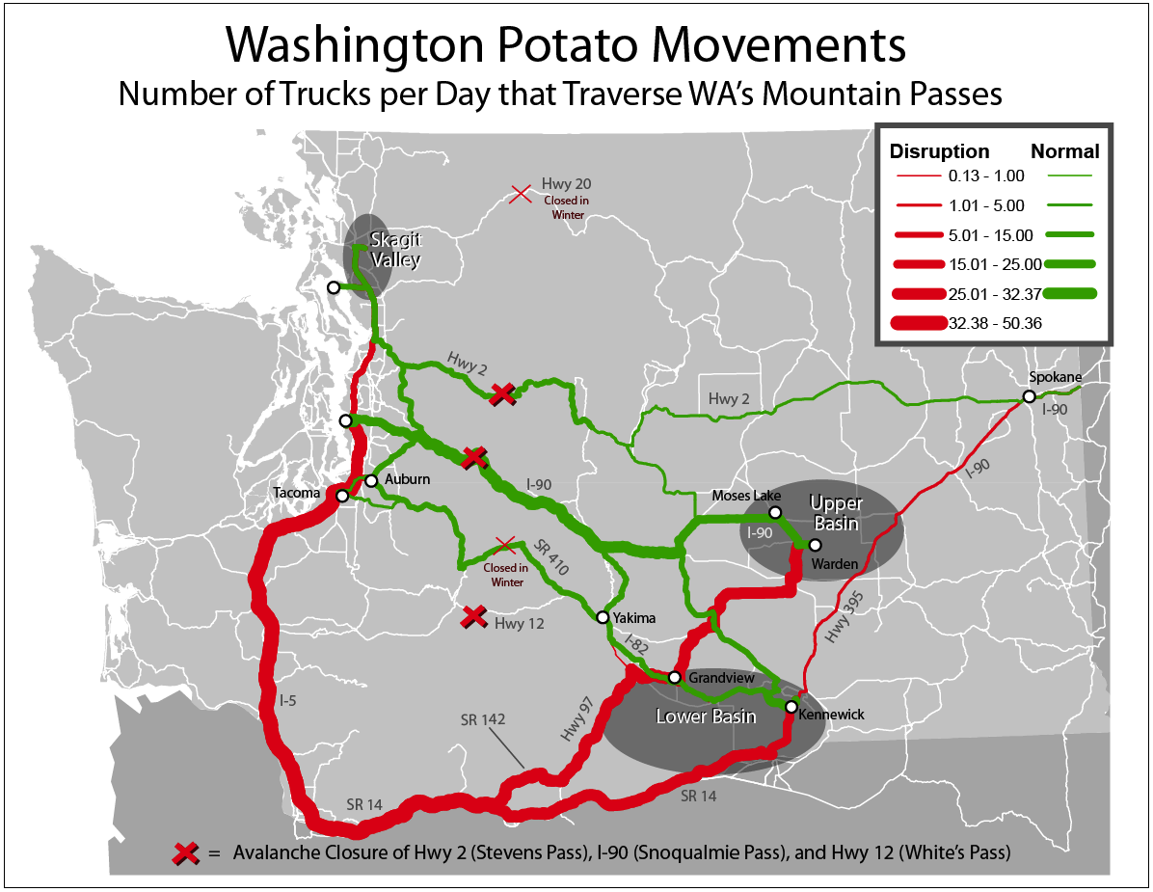
Figure 5.12 Truck trips per day on cross-Cascades routes under disruption scenario

The new routes are shown on the map in red and are further detailed in Table 5.7. We observed the rerouting to the only remaining east-west freight route, SR 14, then utilized I-5 for the north/south portion of the trip. In the base case, no trucks would use this route to cross the Cascades. The result is an increase of truck trips on these roads of about 50 trucks per day.

Table 5.7 Truck trips per day under disruption scenario on cross-Cascades routes
Disruption
 | Truck Trips | Fresh | Frozen | Dehy | Chips
I 84 East | 5.5
Skagit to Moses Lake |  | 0.13
Skagit to Spokane |  | 1.40
Skagit to Warden |  | 0.13
Skagit to other U.S. states (excluding Oregon or California) |  | 2.62
Skagit to Kennewick |  | 0.50
Skagit to Yakima |  | 0.37
Skagit to Grandview |  | 0.37
I 84 West | 44.8
Upper Basin to Stanwood |  | 0.40 | 1.32 | 0.06 | 0.06
Upper Basin to Seattle |  | 0.56 | 1.83 | 0.08 | 0.09
Upper Basin to Tacoma |  | 0.47 | 1.52 | 0.07 | 0.07
Upper Basin to Auburn |  | 0.56 | 1.83 | 0.08 | 0.09
Upper Basin to Port of Seattle |  | 3.70 | 9.04 | 0.52 | 0.59
Lower Basin to Seattle |  | 1.28 | 4.15 | 0.17 | 0.20
Lower Basin to Stanwood |  | 0.92 | 2.99 | 0.12 | 0.15
Lower Basin to Port of Seattle |  | 0.35 | 0.84 | 0.05 | 0.05
Lower Basin to Tacoma |  | 1.06 | 3.46 | 0.14 | 0.17
Lower Basin to Auburn |  | 1.28 | 4.15 | 0.17 | 0.20

The rerouting would affect about 50 truck trips per day, five in the eastbound direction and about 45 in the westbound direction, or about 20 percent of total truck trips moving potatoes in the State of Washington. Under normal conditions, trucks travel an estimated 11,000 miles each day. Under the disrupted conditions, if all trucks re-routed, truck miles would increase to almost 21,000 miles, an increase of almost 80 percent. The additional truck miles by product are shown in Table 5.8. In terms of truck miles, the greatest impact would be to frozen potatoes moving from the Upper and Lower basins to the markets on the west side of the state (including export facilities at the Port of Seattle). Fresh potatoes would also be significantly affected.

Table 5.8 Additional truck miles by product under disruption scenario
 | Skagit Valley | Upper Basin | Lower Basin
Fresh | 1327 | 1191 | 679
Frozen | 0 | 3233 | 2170
Dehydrated | 0 | 168 | 91
Chips | 0 | 189 | 108

5.2.7 Economic Impacts
The economic impacts from the highway closure of I-90 described above would include a variety of both direct and indirect costs that would adversely affect the Washington state potato industry. Some of these impacts are easily identified but more difficult to measure accurately, given the dynamic nature of markets and market participants and how they respond/change in different circumstances. A discussion of these impacts, based upon the model assumptions provided above and the transportation characteristics of the potato industry collected from earlier studies, is provided below, in addition to the direct/indirect nature of how they affect the state’s potato industry.

5.2.7.1 Direct Costs
The direct costs of the I-90 closure at Snoqualmie described earlier would include those additional costs associated with trucks required to travel an additional 9,148 miles (in aggregate), including added fuel consumption, truck driver wages, and vehicle operating costs. Earlier studies have estimated these costs for different commodities/general freight, which are influenced by the current price of fuel and labor market conditions, in addition to other factors that include commodity weight/density and backhaul opportunities in the geographic market served. Table 5.9 provides a list of cost coefficients from recent studies, with the truck cost per mile ranging from $1.50 to $3.50 per mile. If we apply these coefficients to the additional miles encountered from the I-90 Snoqualmie disruption, we could expect an additional $13,722 to $32,018 per day cost impact, or approximately $275 to $640 dollars per truck. This direct cost estimate range was based upon several assumptions, including the following:
- Re-routing of truck traffic as a result of an I-90 closure would occur from the shipment origin and would not account for time caught in traffic, backtracking of the route to the shipment alternative, or the cost of driver hours of service (i.e., drivers who exceeded their hours of service limits as a result of being stuck in disruption traffic would have to be replaced in order to move the shipment).
- Potato products would follow average daily historical shipping patterns, as provided by the industry, and seasonal fluctuations were ignored.
- Potato shippers would continue to ship the product when a disruption occurred, instead of delaying shipments for a period to avoid the disruption.

Table 5.9 Truck transportation cost per mile of operation for various agricultural commodities
Commodity | Cost Estimates Per Mile
Wheat, Corn and Soybeans | 2.17 – 3.46
Switchgrass | 1.67 – 1.87
Barley | 2.30 – 3.46

5.2.7.2 Indirect Costs
The indirect costs of such a disruption would include lost market opportunities from fresh or processed potato shippers. This could be in the form of lost customers/markets as a result of shipments that failed to reach the ports of Seattle or Tacoma to meet ocean vessel shipping deadlines, thus resulting in unsatisfied customers or clients, which would adversely affect future potato sales. This would also apply to domestic retail markets in the Puget Sound area for truck shipments west of the Cascade Mountains, although for this market shippers would likely delay shipment to avoid the closure disruption. For the portion of potato shipments leaving the Skagit Valley production area and heading east to processors in the Columbia basin or markets east, the I-90 closure would also have some adverse impacts as a result of delayed delivery and/or missed market opportunities. Given the relatively small volume of shipments in this movement, the indirect impacts would likely be minor. Other indirect costs might include product spoilage/damage from shipments that were drastically delayed or diminished quality as a result of additional handling because of load transfer/reload. Inventory costs might also increase as a result of delayed product movement, although the marginal daily cost increase is would be minor.

5.2.7.3 Discussion of Economic Implications
Figure 5.13 shows that the price of fresh potatoes is quite variable. The figure shows the average value received by the potato grower for each month over the last six years. Notice that even within one year, prices can change substantially from one month to the next.

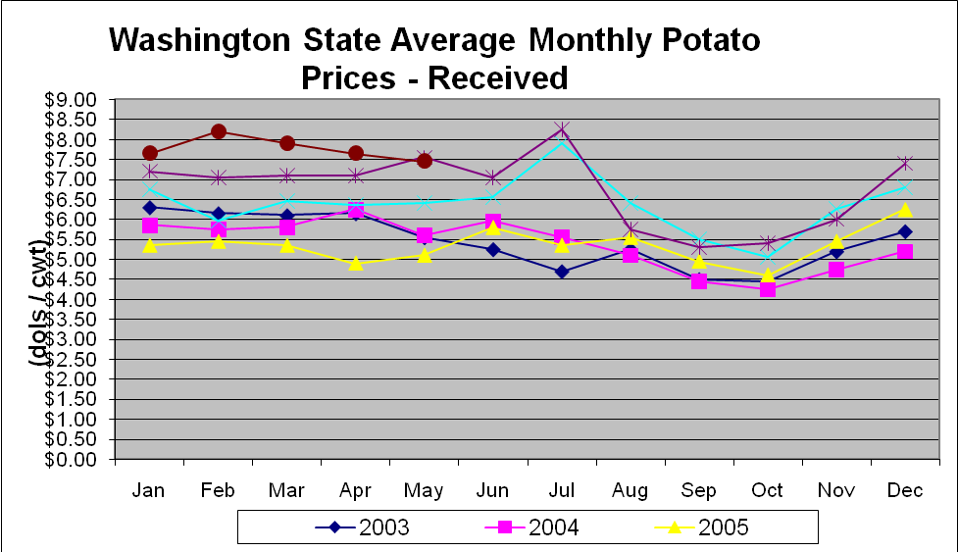
Figure 5.13 Price of fresh potatoes (source: Washington Potato Commission)

Retailers paid on average $7.83 for 50 lbs or about $15.00 per cwt, almost doubling the value from the farmer. Retailers in the Lower Yakima Valley and Columbia Basin paid almost $16.00. Potatoes from NW Washington achieved the highest price paid by the retailer, about $18.00 per 50 lbs, or $36.00 per cwt (Washington Potato Commission).
The range of prices for fresh potatoes in the store range from $.33/pound to $2/pound for organically grown, low-yield fresh potatoes. According to AC Nielsen, the average price paid for fresh potatoes in the Seattle region in 2008-2009 was $.50/pound. Frozen French fries can be purchased for about $2/pound, dehydrated potatoes for about $2.70/pound, and potato chips range from $4.50 to $8/pound.
Given this, the value of a truckload of fresh potatoes could be as little as $1,000 with respect to the grower’s revenue; however, the value of a truckload of potatoes to the grocery store is an order of magnitude larger, or about $10,000 (Table 5.10). A truckload of processed potatoes is worth substantially more, closer to $50,000 for frozen French fries, dehydrated potatoes, and about $25,000 for potato chips. These estimates are all based on the sale price of the products at the grocery store, since prices at the processing facility are not known. However, these would over-estimate the value of a truckload of potatoes.

Table 5.10 Approximate truckload value along the supply chain for each potato product
 | Grower | Retailer | Consumer
Fresh | $1,000 - $5,000 | $2,000 - $8,000 | $7,000 - $50,000
Frozen |  |  | $40,000
Dehydrated |  |  | $60,000
Chip |  |  | $20,000-$40,000

Consider a truckload of fresh potatoes worth about $3,000. Even if a 10 percent profit could be made on this load, it would be completely offset by the cost of re-routing a truck to avoid a winter road closure. Given this, it is not surprising that many truckloads would choose to wait out the closure, rather than reroute, particularly if the length of the closure was unknown. While there are certainly quality concerns about fresh potato products, none of the experts we talked to had any concern about the effects of several days’ delay on product quality.
If carriers knew at the time of the closure that the delay to the trucks would be limited to 24 hours, we can assume that a majority of potato trucks would choose not to re-route but to incur the additional cost of waiting (driver wages) for the pass to re-open. Some trucks, including those with frozen potatoes destined for the ports, might re-route if there was concern that an outbound ship would be missed. If the length of the closure were uncertain, we would see a larger volume of trucks taking the re-route. The indirect impacts, therefore, of a 24-hour closure to the potato industry in Washington state, would be minimal, although there would be significant disruption to traffic. The economic impact would be primarily the direct cost of delay to the carrier, including extra fuel, driver wages, and driver accommodations.

REFERENCES

Abraham, J. E., and J. D. Hunt (1998). "Calibrating the MEPLAN model of Sacramento." Presented at the 77th Annual Meeting of the Transportation Research Board, Washington D.C., January 1998, Paper No. 980649.
Britton, N., and G. Clark (2000) From Response to Resilience: Emergency Management Reform in New Zealand, Natural Hazards Rev. 1:3(145)
Benson, Abby Sophia. “The Role of Organizational Culture in Creating Secure and Resilient Supply Chains.” Masters Thesis, Massachusetts Institute of Technology, 2005.
Berdica, Katja (2002), “An Introduction to Road Vulnerability: What Has Been Done, Is Done and Should Be Done,” Transport Policy, Vol. 9. No. 2 (www.elsevier.com/locate/tranpol), April 2002, pp. 117-127.
Bröcker, J. (1998) Operational spatial computable general equilibrium models, Annals of Regional
Bröcker, J., Kancs, A., Schürmann, C.,Wegener, M. (2001). Methodology for the Assessment of Spatial Economic Impacts of Transport Projects and Policies. IASON Deliverable 2. Kiel/Dortmund: Christian-Albrechts-Universität Kiel/Institut für Raumplanung, Universität Dortmund.
Brockner, Joel, and Erika Hayes James. 2008. Toward an Understanding of When Executives See Crisis as Opportunity. Journal of Applied Behavioral Science 44 (1):94-115.
Brown, David L., Steven Baigel, David L. Brown Productions, Professional Engineers in California Government. Amazing the Rebuilding of the MacArthur Maze DVD. Professional Engineers in California Government, California, 2007.
Bruneau, M., S. E. Chang, R. T. Eguchi, G. C. Lee, T. D. O Rourke, A. M. Reinhorn, M. Shinozuka, K. Tierney, W. A. Wallace, and D. von Winterfeldt. 2003. A Framework to Quantitatively Assess and Enhance the Seismic Resilience of Communities. Earthquake Spectra,Vol. 19, 2003, pp. 733-752, pp. 735.
Chang, Stephanie E., and Nobuoto Nojima. Measuring Post-Disaster Transportation System Performance: the 1995 Kobe Earthquake in Comparative Perspective. In Transportation Research Part A: Policy and Practice, Vol. 35, No. 6, 2001, pp. 475.
Chang, Stephanie E., Diana Ericson and Laurie Pearce. 2003. Airport Closures in Natural and Human-Induced Disasters: Business Vulnerability and Planning, edited by Office of Critical Infrastructure Protection and Emergency Preparedness, Ontario, Canada: Her Majesty the Queen in Right of Canada, 2003. http://dsp-psd.pwgsc.gc.ca/Collection/PS4-8-2004E.pdf. Accessed February 20, 2008.
Chase, Robert, Eric Jessup and Ken Casavant. “2003 Washington Statewide Transportation Input-Output Study.” http://www.sfta.wsu.edu/research/reports/pdf/SFTA%20Research%20Report%2019_Chase%20All%20Wash%20I%20O.pdf
Cho, S., P. Gordon, J. E. Moore, H. W. Richardson, M. Shinozuka, and S. Chang. 2004. Integrating Transportation Network and Regional Economic Models to Estimate the Costs of a Large Urban Earthquake'. INTERNATIONAL LIBRARY OF CRITICAL WRITINGS IN ECONOMICS 178 (1):262-288.
CREATE Homeland Security Center, Economics, http://www.usc.edu/dept/create/research/economics.htm, Accessed June 22, 2009).
Chow, Garland. 2004. Regional Freight Modeling: Potential Directions for the Vancouver Lower Mainland. Vancouver, B.C.: The University of British Columbia, Center for Transportation Studies.
Christopher, Martin and Helen Peck. "Building the Resilient Supply Chain." The International Journal of Logistics Management, vol. 15, issue 2 (2004).
Coates, John. 2006. Anticipating Disaster, or Putting the Fear of God into Top Management. Research Technology Management, January - February 2006, 3.
Creamer, Selmin and Eric Jessup. “Washington State Industry Outlook: Potato Industry.” Final Report to the Washington State Department of Transportation, August, 2008.
CREATE Homeland Security Center, Economics, http://www.usc.edu/dept/create
/research/economics.htm, Accessed June 22, 2009 (p. 46)
Cutter, Susan L., Douglas Richardson, and Thomas J. Wilbanks. 2003. The geographical dimensions of terrorism. New York: Routledge.
de la Barra, T. (1998). The mathematical and algorithmic structure of TRANUS. Unpublished paper available at http://www.modelistica.com.
Drabek, T.E. (1990) Emergency Management: Strategies for Maintaining Organizational Integrity. Springer-Verlag, New York.
Drake, John W. 1973. The administration of transportation modeling projects, Lexington books. Lexington, Mass. [usw.]: Heath.
Endsley, Mica R. 1995. Toward a Theory of Situation Awareness in Dynamic Systems. Human factors : the journal of the Human Factors Society. 37 (1):32.
Endsley, Mica R., Betty Bolté, and Debra G. Jones. 2003. Designing for situation awareness : an approach to user-centered design. London; New York: Taylor & Francis.
Energy Information Administration. (2008). Refinery Capacity Report. Available from Energy Information Administration Web site: http://www.eia.doe.gov/oil_gas/petroleum/data_publications/refinery_capacity_data/refcapacity.html
Energy Information Administration. (n.d.). Washington State Energy Profile. Retrieved May 14, 2009 from http://tonto.eia.doe.gov/state/state_energy_profiles.cfm?sid=WA
ESRI website, http://www.gis.com/whatisgis/index.html, accessed June 20, 2009
Jack Faucett Associates (1999). Research and Development of Destination, Mode, and Routing Choice Models for Freight.
Fischer, Michael J., Myong Han, Program National Cooperative Highway Research, Highway American Association of State, Officials Transportation, Administration United States. Federal Highway, and Board National Research Council . Transportation Research. 2001. Truck trip generation data, Synthesis of highway practice, 298. Washington, D.C.: National Academy Press.
Fleming, R. S. 1998. "Assessing Organizational Vulnerability to Acts of Terrorism". SAM ADVANCED MANAGEMENT JOURNAL. 63 (4): 27-32.
Foster, Harold D. (1993), “Resilience Theory and System Evaluation,” in J.A. Wise, V.D. Hopkin V D and P. Stager (editors), Verification and Validation of Complex Systems: Human Factor Issues, NATO Advanced Science Institutes, Series F: Computer and Systems Sciences, Vol.110, Springer Verlag (New York), pp.35-60.
Godschalk, D. R. 2003. Urban Hazard Mitigation: Creating Resilient Cities. Natural Hazards Review, Vol. 4, No. 3, pp. 136-143.
Haddow, George D. and Jane Bullock. 2004. Introduction to Emergency Management. Stoneham, Massachusettes: Butterworth-Heinemann.
Hood, J. N., T. Olivas, C. B. Slocter, B. Howard, and D. P. Albright. Vulnerability Assessment Through Integrated Transportation Analysis. In Transportation Research Record: Journal of the Transportation Research Board, No. 1822. TRB National Research Council, Washington, D.C. 2003, 18-23.
Hopp, Wallace J. and Zigeng Yin. “Protecting Supply Chain Networks Against Catastrophic Failures.” (not yet published). 2006.
Horowitz, A. 1999. Guidebook on statewide travel forecasting, July 1999.
Hunt, J.D. and D.C. Simmonds (1993). Theory and application of an integrated land-use and transport modelling framework. Environment and Planning, 20B, 221-244.
Husdal, Jan (2005), The Vulnerability Of Road Networks In A Cost-Benefit Perspective, TRB 84th Annual Meeting (www.husdal.com/gis/trb2005_final.pdf).
ICF International. (2007). Review of pipeline utility corridor capacity and distribution for petroleum fuels, natural gas and biofuels in southwest Washington (Prepared for the State of Washington Energy Facility Site Evaluation Council). Retrieved from http://www.efsec.wa.gov/Studies_pipeline%20capacity.shtml
Ivanov, Barbara, George Xu, Tonia Buell, Danna Moore, Bruce Austin and Yi-Jen Wang. “Storm-Related Closures of I-5 and I-90: Freight Transportation Economic Impact Assessment Report, Winter 2007-2008.” 2009
Ivanova O. (2007), On the development of the new version of the RAEM model for the Netherlands (RAEM 3.0), paper presented on the ERSA 2007 Conference.
Ivanova, O., A. Vold and V. Jean-Hansen (2002). PINGO a Model for Prediction of Regional and Interregional freight transport. TØI report 578/2002. Institute of Transport Economics, Oslo.
Jenelius, Erik, Petersen, Tom and Lars-Goran Mattsson (2006), “Importance and Exposure in Road Network Vulnerability Analysis,” Transportation Research A, Vol. 40, Issue 7 (www.elsevier.com/locate/tra), Aug. 2006, pp. 537-560.
Jessup, Eric L., Kenneth L. Casavant, Catherine T. Lawson, Unit Oregon. Dept. of Transportation. Research, Agricultural Washington State University. Dept. of, Resources Economic, Geography State University of New York at Albany. Dept. of, and Planning. 2004. Truck trip data collection methods. Salem, OR; Springfield, Va.: Oregon Dept. of Transportation, Research Unit ; Available from the National Technical Information Service.
Kleindorfer, Paul R. and Germaine H. Saad. “Managing Disruption Risks in Supply Chains.” Production and Operations Management, vol. 14, issue 1 (2005): 53-68.
Kuzmyak, J. Richard, Board National Research Council . Transportation Research, Program National Cooperative Highway Research, Highway American Association of State, Officials Transportation, and Administration United States. Federal Highway. 2008. Forecasting metropolitan commercial and freight travel. Washington, D.C.: Transportation Research Board.
Lakshmanan, T.R. andW.P. Anderson (2002). Transportation Infrastructure, Freight Services Sector and Economic Growth. A White Paper prepared for The U.S. Department of Transportation Federal Highway Administration. Center for Transportation Studies, Boston University. http://www.ncgia.ucsb.edu/stella/meetings/20020115/Lakshmanan.pdf
Latora, Vito and Massimo Marchiori. “Vulnerability and Protection of Infrastructure Networks.” Physical Review - Series E, vol. 71, issue 1 (2005): 015103.
Litman, Todd. (2008). Evaluating Transportation Resilience: Evaluating the Transportation System's Ability to Accommodate Diverse, Variable and Unexpected Demands with Minimal Risk. 2007. Online TDM Encycolpedia, www.vtpi.org/tdm/tdm88.htm. Accessed January 27, 2008.
Mallak, L. (1998). Putting Organizational Resilience to Work, Industrial Management, November/December, pp 8-13
McManus, S., E. Seville, J. Vargo, and D. Brunsdon. 2008. Facilitated process for improving organizational resilience. Nat. Hazards Rev. Natural Hazards Review 9 (2):81-90.
Miles, Scott B. and Stephanie E. Chang. (2006). Modeling Community Recovery from Earthquakes. Earthquake Spectra, Vol. 22, No. 2, pp.439-458.
MIT Center for Transportation and Logistics. Development of a Statewide Freight System Resiliency Plan. Massachusetts Institute of Technology, Cambridge, MA, 2008.
Morlok, E. K., and D. J. Chang. Measuring Capacity Flexibility of a Transportation System. Transportation research. Part A, Policy and practice, Vol. 38, No. 6, 2004, pp. 405-420.
Murray-Tuite, P. M. and H. S. Mahmassani. Methodology for Determining Vulnerable Links in a Transportation Network. In Transportation Research Record: Journal of the Transportation Research Board, No. 1882. TRB National Research Council, Washington, D.C. 2004, pp. 88-96.
Murray-Tuite, Pamela M. A Comparison of Transportation Network Resilience Under Simulated System Optimum and User Equilibrium Conditions. In 2006 Winter Simulation Conference, IEEE, 2006, pp. 1398-1405.
Oakland Tribune. Here's Hoping for Rapid Reconstruction of Maze. May 2, 2007. FindArticles.com. http://findarticles.com/p/articles/mi_qn4176/is_20070502/ai_n19047338. Accessed July 28, 2008.
Oomes, A.H.J. 2004. ORGANIZATION AWARENESS IN CRISIS MANAGEMENT: Dynamic organigrams for more effective disaster response. Delft: Delft Cooperation on Intelligent Systems (DECIS).
Peck, Helen. 2005. "Drivers of supply chain vulnerability: an integrated framework". International Journal of Physical Distribution & Logistics Management. 35 (4): 210-232.
Pickett, Christopher B. “Strategies for Maximizing Supply Chain Resilience: Learning from the Past to Prepare for the Future.” Masters Thesis, Massachusetts Institute of Technology, 2003.
Pitera, K. Interpreting Resiliency: An Examination of the Use of Resiliency Strategies within the Supply Chain and Consequences for the Freight Transportation System, Master’s Thesis, 2009. University of Washington, Seattle, WA.

Rice, J. B. and F. Caniato. Supply Chain Response to Terrorism: Creating Resilient and Secure Supply Chains. Interim Report of Progress and Learnings, Supply Chain Response to Terrorism Project. 2003.
Rowshan, S., M. C. Smith, et al. Highway Vulnerability Assessment: A Guide for State Departments of Transportation. In Transportation Research Record: Journal of the Transportation Research Board, No. 1827. TRB National Research Council, Washington, D.C. 2004, pp. 55-62.
Sarathy, Ravi. “Security and the Global Supply Chain.” Transportation Journal, vol. 45, issue 4 (2006): 28-51.
Sato, Tetsuji and Seiichi Hino. (2005). “A Spatial CGE Analysis of Road Pricing in the Tokyo Metropolitan Area.” Journal of the Eastern Asia Society for Transportation Studies, Vol. 6, pp. 608 - 623, 2005
Sheffi, Yosef. 2005. The resilient enterprise overcoming vulnerability for competitive advantage. Cambridge, Mass.: MIT Press.
Simmonds, D.C. (1996). DELTA Model Design. David Simmonds Consultancy, Cambridge, UK.
Snyder, Lawrence V. and Zuo-Jun Max Shen. “Managing Disruptions to Supply Chains.” Bridge: National Academy of Engineering, vol. 36, issue 4 (2006): 39-45.
Snyder, Lawrence V., Maria P. Scaparra, et. al. “Planning for Disruptions in Supply Chain Networks.” Tutorials in Operations Research, (2006): 234-257.
Somers, Scott. 2009. Measuring Resilience Potential: An Adaptive Strategy for Organizational Crisis Planning. Journal of Contingencies and Crisis Management 17 (1):12-23.
Tierney, Kathleen, and Michel Bruneau. All-Hazards Preparedness, Response, and Recovery - Conceptualizing and Measuring Resilience: a Key to Disaster Loss Reduction. TR news. 2006. Vol. 250, No. 14, 2007, pp. 15.
Tomlin, Brian. “On the Value of Mitigation and Contingency Strategies for Managing Supply Chain Disruption Risks.” Management Science, vol. 52, issue 5 (2006): 639-657.
Turnquist, Mark A. 2006. Characteristics of Effective Freight Models. In Transportation Research Board Annual Meeting. Washington, D.C.
U.S. Department of Transportation, Federal Highway Administration, Freight Management and Operations. (n.d.). Freight analysis framework (FAF2). Retrieved May 14, 2009 from http://ops.fhwa.dot.gov/freight/freight_analysis/faf/faf2_tech_document.htm

United States. 2003. Transportation security research coordination needed in selecting and implementing infrastructure vulnerability assessments. [Washington, D.C.]: U.S. General Accounting Office. http://purl.access.gpo.gov/GPO/LPS37003.
United States. Bureau of Transportation, Statistics. Special Issue on the Northridge Earthquake. Journal of Transportation and Statistics. Washington, DC: Bureau of Transportation Statistics, U.S. Dept. of Transportation, 1998.
Waddell, P. (2000) Simulating Land capacity at the Parcel Level, In Monitoring Land Supply with Geographic Information System, (Eds, Moudon, A. V. and Hubner, M.), New York: John Wiley & Sons, 201-214
Waddell, Paul and Gudmundur F. Ulfarsson, Introduction to Urban Simulation: Design and Development of Operational Models. In Handbook in Transport, Volume 5: Transport Geography and Spatial Systems, Stopher, Button, Kingsley, Hensher eds. Pergamon Press, 2004, pages 203-236.
Washington Research Council. (2007). The economic contribution of Washington state’s petroleum refining industry in 2005. Retrieved from http://www.wspa.org/wa-economic-impact-report.aspx
Washington State Department of Transportation. (2008a). Storm-related closures of I-5 and I-90: freight transportation impact assessment report (WA-RD 708.1). Retrieved from http://www.wsdot.wa.gov/Freight/publications/FreightMobility.htm
Washington State Department of Transportation. (2008b). Washington state freight and goods transportation system (FGTS) 2007 update. Retrieved from http://www.wsdot.wa.gov/Freight/FGTS/2007Report.htm
Washington State Department of Transportation. (2008c). Washington transportation plan update freight movement. Retrieved from http://www.wsdot.wa.gov/Freight/publications/FreightMobility.htm
Waterborne Commerce Statistics Center (2008). Destination and origin of waterborne commerce of the United States, 2007 (Commodity Movements from the Public Domain Database). Retrieved from http://www.ndc.iwr.usace.army.mil/wcsc/wcsc.htm
Weick, K. E., K. M. Sutcliffe, and D. Obstfeld. 1999. Organizing for High Reliability: Processes of Collective Mindfulness. RESEARCH IN ORGANIZATIONAL BEHAVIOR 21:81-124.
Weick and Sutcliffe 2001, Managing the Unexpected: Assuring High Performance in an Age of Complexity, Jossey-Bass
Werner et al., 2006. REDARS2 Methodology and Software for Seismic Risk Analysis of Highway Systems. Produced by MCEER for the Federal Highway Administration.

