Truck Trip Generation by Grocery Stores

by

|  |  |
| --- | --- |
| Edward McCormack University of Washington | Chilan Ta University of Washington |
| Alon Bassok Puget Sound Regional Council, | Emily Fishkin University of Washington |

**Transportation Northwest (TransNow)**Nancy Nihan, Director  
University of Washington129 More Hall, Box 352700  
Seattle, Washington 98195-2700

|  |
| --- |
|  |

Acknowledgments

We would like to thank the following for providing technical support, guidance, and match to support this effort: Bob Shull (PTV America), Maren Outwater (previously with the Puget Sound Regional Council and now with Resources Systems Group), and Dale Tabat and George Xu (both with the Washington State Department of Transportation).

Table of Contents

EXECUTIVE SUMMARY v

INTRODUCTION 5

LITERATURE REVIEW 5

ITE Trip Generation Manual and Truck Trip Generation 5

NCHRP Synthesis Report 384 and Truck Trip Generation 5

Data Collection Methods for Truck Trip Generation 5

Grocery Store Classifications 5

Grocery Stores and Trucks 5

DATA COLLECTION 5

Grocery Store Selection and Characteristics 5

Telephone Interviews 5

Manual Truck Counts 5

Adjustments to the Observation Form 5

FINDINGS 5

Telephone Interviews 5

Size, Operations, and Employees 5

Truck Types 5

Empty Trucks 5

Where Trucks Travel 5

Manual Truck Counts 5

Truck Arrivals 5

Truck Types and Delivery Locations 5

Trip Rates and Store Characteristics 5

CONCLUSIONS 5

REFERENCES 5

APPENDIX A—Distribution Center A-5

Interview Process A-5

General Trends A-5

Size, Operations, and Employees A-5

Truck Types A-5

Empty Trucks A-5

Where Trucks Travel A-5

Truck Movement Information A-5

Questions for Regional Warehouses or Distribution Centers A-5

APPENDIX B—Interview Form for Individual Grocery Stores B-5

APPENDIX C—Supplemental Automobile Counts C-5

APPENDIX D—FHWA 13-Bin Vehicle Classification D-5

APPENDIX E—Manual Counts Observation Form E-5

**List of Figures**

1. Freight Supply Chain 6

2. Geographic Extent of the Interview Process 11

A-1. Geographic Extent A-2

C-1. Average Peak-Hour Passenger Vehicle Trip Rates Determined from 2-hour  
Peak-Hour Windows C-2

List of Tables

1. Store Characteristics and Phone Interview Results 13

2. Manual Count Results 16

3. Averaged Aggregate Truck Trip Rates and Delivery Times 17

4. Regression Analysis Results 18

A-1. Distribution Centers Interview Results Summary A-4

C-1. Average Peak-Hour Passenger Car Trip Rates Determined from 2-hour  
Peak-Hour Windows C-2

# EXECUTIVE SUMMARY

Quantifying the relationship between the number and types of truck trips generated by different land uses provides information useful for traffic demand analyses, forecasting models, and a general understanding of the factors that affect truck mobility. This project evaluated data collection methodologies for determining truck trip generation rates by studying a specific kind of establishment. This effort focused on grocery stores and collected both interview and manual count data from eight supermarkets in the Puget Sound region.

We selected grocery stores for this project because they constitute a common land use that is present in almost every type of neighborhood in the metropolitan region. Grocery stores generate truck trips that have the potential to affect all levels of the transportation roadway network, from local roads in neighborhoods to highways. The eight stores in the Puget Sound region identified for this study were diverse and included both national and local chains. The stores ranged in size from 23,000 to 53,500 square feet and included a variety of urban and suburban locations.

Methodologies for gathering trip generation information were identified in the literature. Telephone interviews and manual counts, which are frequently used data collection methodologies, were explored in this project. The project started with telephone interviews of four distribution centers. This step helped to refine the interview approach and helped to determined that data from larger warehouses could not be easily used to develop information on the number of trips traveling to individual stores. A second round of interviews, lasting between 10 and 15 minutes, was then conducted with the managers or receivers of the nine grocery stores. In addition to the number of truck trips that the store generated, the interviews explored a range of topics related to the busiest days and their delivery windows. This information was used to set up manual, on-site truck counts at each of the grocery stores.

We concluded that a combination of telephone interviews and manual counts is a reasonable way to collect accurate truck trip generation rates. Telephone interviews were an important first step. They established contact with grocery stores, which then provided permission for on-site manual counts. Information elicited from store interviews also included the days and times when the truck deliveries occurred so that the manual counts could be scheduled to reflect optimal times. In addition, the interview conversations provided sometimes unanticipated but valuable information that was relevant to understanding truck trip-generation rates. Because it is cost prohibitive and inefficient to send manual counting teams to observe facilities for long shifts, information from store managers regarding their delivery windows and hours made the counts more feasible.

The Puget Sound grocery stores in the study (all of which were conventional supermarkets) generated an average of 18 truck trips per day on typical weekdays. These daily counts were probably low, as some of the stores accepted a few late deliveries outside of the receiving windows. Most of these truck arrivals occurred before noon, and the average delivery time was 27 minutes. Although peak days of the week varied across the sample set, all reported higher volumes during holidays.

The manual counts (15 site observations) provided more accurate truck trip generation rates than did telephone interviews. The interview responses indicated approximately ten to twelve trucks per day in comparison to the average of 18 trucks per day counted at each store by observers. The telephone interviewees at the grocery stores clearly underestimated the number of trucks and provided only minimal information on truck characteristics. Manual counts also provided more detailed information regarding truck type, delivery location (loading docks or front door), average delivery time, and product mix.

Few grocery store characteristics that could be directly related to truck trip generation rates were identified. The project team reviewed literature discussing both trip generation data collection and grocery store management and could not identify any specific characteristic that could be used to quantify the number of truck trips generated by different stores. While size or employment is often related to truck trips in the ITE *Trip Generation Manual*, this effort did not find any direct relationship with these variables, with a possible exception related to a store’s size. This finding, that smaller stores generated more trucks trips, suggests that one promising area to explore is the linkage between the level at which stores are served by regional warehouses or direct service delivery (DSD) and the number and type of truck trips. The manual counts indicated variability in the nature and size of the delivery trucks, which in turn related to whether the deliveries were at the front door (often small trucks and DSD) or loading dock (larger trucks from warehouses with consolidated loads). Smaller stores often use more DSD, which may result in more truck trips generated. It is also possible that smaller stores had smaller stock rooms, requiring more frequent deliveries. Other census-related variables such median household income, residential density and jobs-housing balance, were evaluated, but no significant relationships to truck trip rates were found.

# INTRODUCTION

Commercial vehicle (truck) trips result from a complex web of supply chain and logistics decisions and are motivated by the need to transport goods to market, natural resources from extraction sites, and garbage to landfills. Trucks dominate freight transportation in the United States, carrying the majority of freight by weight and value (USDOT 2010). Being a gateway state with a large manufacturing base and notable agricultural production, Washington state is highly dependent on freight and truck movements (WSDOT 2008).

The recognition that freight mobility, and truck activity in particular, is critical to economic viability has increased the call by planners and engineers for truck-oriented tools and data. One important tool is trip generation information, which quantifies the numbers of vehicle trips that are produced by specific types of land uses or business establishments. Accurate truck trip generation rates are necessary to make informed decisions about not only efficient freight movements but also passenger transportation, land use, and environmental issues. In comparison to passenger trip generation tools, which are used in many municipalities and jurisdictions across the U.S., truck trip generation has traditionally received far less attention. A National Cooperative Highway Research Program (NCHRP) Synthesis Report on trip generation summarized truck generation data in the U.S., concluding that “the current state of the practice in truck trip generation data falls short of the needs of today’s transportation engineers and transportation planners” .

Transportation engineers use trip generation data, often from the Institute of Transportation Engineers (ITE) *Trip Generation Manual*, for a range of activities (2008), including traffic impact fee assessments, traffic operations studies, site impact analysis, street design, and the design and provision of loading facilities and parking. However, the available data—which are based on relatively few surveys and counts, especially for trucks—fall short of providing the necessary micro-level accuracy, transferability, applicability across land-use types, and clear and consistent truck trip generation estimation and presentation procedures. For transportation planners, the use of truck trip generation information is limited by the needs for data at varying levels of geographic detail and varying levels of precision, transferability, and the comparability of truck trip generation rates and socioeconomic or land-use data . For example, aggregate truck trip-generation data by traffic analysis zone is necessary for travel demand modeling. Therefore, there is a need to develop usable truck trip generation data.

This report explores the collection of disaggregated truck generation data at a specific land-use/industry level. First, a summary of the results of a literature review related to truck trip generation and land uses is presented. Then we review our methodology for determining truck trip generation rates for medium-sized grocery stores and present the findings from our study. The methodology used here for grocery stores is meant to be replicated for other land-use functions. The results can populate truck trip rate tables and be applied as inputs to existing travel demand and transportation models for use in local and regional planning and development decision making.

We selected grocery stores for a variety of reasons. One is that these stores are a ubiquitous feature of our urban and suburban landscape. Their prevalence, combined with their ongoing requirement for frequent truck deliveries because of a relatively high turnover of goods and their need to replace perishable products, indicates that they have a widespread impact on our transportation network. Trucks making grocery store deliveries are also representative of the local distribution network. Distribution of goods makes up 80 percent of all truck movements in Washington state Grocery stores are a notable subset of this group. The Washington State Transportation Plan (2008) estimated in 2005 that there were 2,093 food stores in Washington. In addition, the project team had grocery store location data and experience with the grocery industry in the Puget Sound region.

# LITERATURE REVIEW

Meaningful literature addressing the nexus of land use and truck trip generation consists primarily of freight modeling literature that discusses the limitations of freight models. Truck trip generation rates tend to come from studies on land uses obviously dominated by freight transportation: warehouses, distributions centers, industrial lands, commercial, and retail. Few studies have disaggregated land use to a finer detail. For example, Tolliver 's truck trip rate study provided information about truck trip rates around large grain elevators (2006).

Other trip generation studies have looked at “retail” land use. “Retail” can encompass grocery stores, but the breadth of the category eliminates any unique characteristics related to grocery stores that could improve the accuracy of truck trip generation rates . Brogan surveyed eleven cities that had implemented “land-area trip rate” by truck trip generation and found that the highest truck trip generation rates were for “commercial use,” with “industrial-type use” having the second highest . Brogan’s study highlighted the high level of aggregation of rates and the lack of standardized land-use classifications, reminding studies to use caution when transferring truck trip generation rates across localities. It is important to identify and consider the unique characteristics of the land uses under study and to clearly identify both the unique and common characteristics of the land use to aid in transferability across localities.

Despite such findings, most current forecasting of truck trip generation rates by land-use type depends upon using a set of truck trip generation rate tables from sources such as the ITE *Trip Generation Manual* or a local jurisdiction or metropolitan planning organization. Much of the weakness in the ITE tables stems from the small number of studies on which the tables were based. Balbach and Tadi (1994) revealed that only two studies on truck terminals and industrial parks underpin the published truck trip generation rates in the Fifth Edition of the ITE *Trip Generation Manual*. Despite being in their eighth edition, the ITE *Trip Generation Manual’s* truck trip rate tables remain inadequate.

Another issue is the limited understanding of truck trip generation factors in general. For example, Shin and Kawamura tested the link between employment data and truck trip generation in their study of furniture stores. They found that the number of employees and size of the store did not explain truck trip generation . Therefore, if the aim is to produce meaningful forecasts of truck trips and freight demands by land use, then accurate methods for creating useful truck trip generation tables that link truck trips with unique land-use characteristics must be explored.

## ITE Trip Generation Manual and Truck Trip Generation

The Institute of Transportation Engineer’s (ITE) *Trip Generation* *Manual* contains standard trip generation rates, for passenger vehicles and trucks, delineated by land uses based on employment rates. Transportation planners and traffic engineers use the ITE *Trip Generation* *Manual* to provide input for uses ranging from models to developer mitigation efforts. For example, Brehmer, Butorac, and Marc (2003) used ITE’s land-use codes 850, 854, and 820 to determine the number of trips associated with supermarkets, discount supermarkets, and shopping centers, respectively. However, although they used ITE’s standard land-use codes to identify grocery store-related land uses, their work examined grocery store trip generation rates for non-commercial vehicle trip generation .

The overall lack of data on truck trip rates is not surprising. Only recently has interest in truck trip generation and identification of predictive variables based on land use arisen within the transportation planning and modeling world. See, for example, the following works, which explore the quantification of freight flows: Golias and Boile (2007); Guiliano et al. (2010); Iding (2009); Shin and Kawamura (2005); Shin and Kawamura (2005b).

## NCHRP Synthesis Report 384 and Truck Trip Generation

NCHRP Synthesis Report 384 summarized the many challenges to forecasting and modeling freight transportation (Kuzmyak 2008). Some important difficulties in providing truck trip generation rates relate to the fact that truck movements “are influenced by multiple decision making ‘agents.” Kuzmyak noted differences in truck types; in addition, distribution typologies and the direct, inextricable link to economic activities create varying demands for the movement of different commodities. Furthermore, given the many factors related to truck trip movements that are different than those of passenger vehicle movements, methods for determining truck trip generation rates cannot merely replicate passenger vehicle trip generation methods. Freight necessarily involves data such as "vehicle type, origin and destination, and nature of stops” . Transportation planners’ understanding of freight movements, the transportation system, and the intricacies and nuances that influence freight movements remains limited. A lack of funding for collecting freight data continues to limit the available number of meaningful and useable freight data for truck trip generation.

## Data Collection Methods for Truck Trip Generation

Several methods exist for collecting truck trip data. There are also distinct land-use foci for truck trip generation. A number of studies have addressed truck trip generation at sea ports and terminals for container movements . More directly applicable to methods for truck trip generation at retail establishments, Fischer and Han (2001) focused on surveys and outlined three approaches—vehicle classification counts, roadside intercept surveys, and travel diaries—each of which requires specific data collection techniques. Manual vehicle classification counts were noted to be flexible in terms of setting truck categories and are frequently used. Roadside intercept surveys typically involve sampling and can also collect trip data that can be used for other purposes. Travel diaries require a good sampling framework, and undercounting is a problem.

In “Truck Trip Data Collection Methods (SPR 343),” Jessup, Casavant and Lawson (2004) profiled four travel diary survey implementation techniques. They analyzed early urban truck travel studies in seven cities: Chicago, Illinois; Phoenix, Arizona; New York and New Jersey; El Paso, Houston, and Galveston, Texas; Ontario, Canada; and Alameda County-San Francisco, California. Jessup et al. also identified the related data applications, costs, advantages and disadvantages of four survey methods: the telephone interview, mailout-mailback survey, combined telephone and mailout-mailback survey, and roadside intercept/personal interview. Their work found that the most common data collection method has been mail surveys to shippers and trucker owners. Mail surveys are easy to implement, do not disrupt traffic flow on roadways, are low-cost, and require minimal staff to implement. On the downside, mail surveys tend to have low response rates, low coverage area, and an inability to clarify questions respondents may have. In comparison, telephone surveys can achieve slightly higher response rates, but they pose the challenge of identifying and reaching the most relevant respondents. The combined telephone and mailout survey method also produces higher response rates than mail-only surveys. However, this method is also limited because many vehicles come from outside the geographical region in which records are available. The work of both Fischer and Han (2001) and Jessup et al. (2004) suggests the importance of using multiple data collection methods to enhance the data’s validity. In addition, the advantages and disadvantages of the unique implementation requirements of each survey approach should be balanced against the desired use of the data.

Kawamura et al. (2005) examined truck trip generation rates at the level of a business type, specifically, furniture and shoe stores. They identified store type and location (limited to “mall” or “off-mall”) to be the major influences on replenishment frequency, the rate at which trucks service the businesses. The resulting conceptual framework situates truck trip generation within a supply chain decision matrix, reproduced in Figure 1. Truck trip generation can be considered a result of the strategic, tactical, and operational decisions within a firm. This highlights some of the complexities behind truck trip generation decisions.

Ortúzar and Willumsen (1994) identified three additional variables that influence truck trip generation: turnover, floor area and location/site area occupied by the firm, and the number of employees . However, Kawamura et al. (2005) found the number

   
  
**Figure 1. Freight Supply Chain (from Kawamura et al. 2005, 9).**

of employees and floor area to be poor predictors of truck trip generation for the furniture and shoe stores they analyzed. They explained that the number of employees is a poor indicator because facilities differ not only by type but also by function. These two studies indicate the complexity involved in isolating the factors related to truck trip generation for widespread application. Major land-use factors that influence truck trip generation appear to be industry specific.

Iding, Meester and Tavasszy also explored the challenges of using what they termed “firm-level survey data,” assuming that “the number and type of freight trips can be regarded as the outcome of a series of decisions about products, markets, production locations, delivery times and frequencies, transport modes, types of vehicles and routes … [that] result in transport and traffic flows”. After examining 18 different industries, they suggested that the patterns of truck transport produced by firms from various sectors of industry exhibit large variations.

Given the results of these three studies, there appears to be a need to approach truck trip generation modeling at a level of greater detail than current reliance on land-use classifications, which obscure important details for truck trip generation. Moreover, the variability in definitions of land uses across levels of government creates limitations in the transferability of truck trip generation studies across industries. Therefore, given the lack of understanding of truck trip generation, the dearth of truck trip generation data, and weaknesses in the transferability of studies across industries, this study sought to find methods of accurate truck trip generation data collection specifically related to the retail grocery industry. It focused on comparing two truck trip generation rate data collection methods, with the intent of finding an approach that would be potentially transferable across industry type and land-use classification.

## Grocery Store Classifications

According the U.S. Department of Labor, the grocery industry is made up of two major sectors: supermarkets and convenience stores (2009). Businesses that specialize in selling specific types of foods, such as butcher shops or fruit and vegetable markets, are not considered part of the grocery industry (U.S. Department of Labor 2009). Within the supermarket classification are several subsets of grocery stores, but this study focused on what the Food Management Institute labels “conventional supermarkets” (2010). Conventional supermarkets (of which there are 35,000 in the United States) are classified as full-line, self-service stores when they have more than $2 million in annual sales. This classification eliminates less ubiquitous stores, such as wholesale clubs and warehouse stores, that sell a mixture of food products and more general merchandise. (We also thought that these larger warehouse-type stores may get more trips, but not ones trips related to food.) This classification was used rather than Standard Industrial Classification (SIC) codes because Kawamura et al. (2008) found that SIC codes provided insufficient categories for stratifying industries in relation to distribution types.

This effort also explored whether the grocery industry classifies or recognizes grocery stores in a manner that also might be linked to different levels of truck trip generation. However, we found that grocery-related trade journals such as the Progressive Grocer, Grocery Headquarters, and Today’s Grocery Magazine are not informative on the subject of trip generation related to different grocery store classes. Similarly, grocery associations, such as the Northwest Grocery Association, Grocery Manufacturer’s Association, and the Northwest Co-operative Grocers Association, do not provide such information. Contacts with urban food system and freight transportation researchers from the University of Washington confirmed the lack of findings from the journals, magazines, and associations.

While the grocery store industry often classifies stores by annual gross revenue, this variable was not seen as directly meaningful or accessible to our investigation of land use and truck trip generation. Annual revenue is difficult to find at an individual store level because of business and privacy concerns. Square footage, which is one of the easiest to obtain of the grocery characteristics, is explored later in the paper. Other variables, such median household income, residential density and jobs-housing balance, that are more closely linked to the surrounding land use and are not directly tied to the grocery store itself, are also evaluated later in the paper.

## Grocery Stores and Trucks

Grocery stores are replenished by several types of truck-based systems. Many stores, especially larger, national chains, use their own chain’s regional distribution centers. However, all stores also depend on direct store deliveries (DSD) in which retailers provide their products directly to grocery stores (Kuai 2007, Grocery Manufacturers Association 2005). Although both methods generate truck trips, the DSD trips tend to be in smaller trucks (often with bread, snack foods, beer) that operate through a store’s front door (and frequently place the products directly on the store’s shelves), whereas trucks from distribution centers tend to be larger and use side or back door loading docks. A Grocery Manufacturers Association national survey of grocery stores found that 66 percent of volume arrived by DSD and 34 percent from regional warehouses (2005, 9). The number of DSDs is expected to increase, suggesting that future grocery deliveries will involve smaller trucks (Everitt 2008).

Few studies exploring truck trip generation at grocery stores were found. However, several studies not directly oriented toward truck trip generation suggested that grocery stores generate a considerable number of trucks. The Grocery Manufacturers Association surveyed a number of grocery stores with more than $2 million in annual revenue (fewer than 35 stores across the country, but the exact number was not specified) and concluded these stores received 11,700 DSD trips each year (Grocery Manufacturers Association 2005, 16), which suggests an average of 32 deliveries per day—and this number did account for non-DSD deliveries. A case study of one specialty grocery store in a dense urbanized area of Seattle determined that this store required 375 truck deliveries per week (Heffron 2001), which averages to 57 deliveries per day.

# DATA COLLECTION

This project’s plan included data collected by two methods: telephone interviews and manual counts/observations. The literature on truck trip data generation methods suggested that phone interviews would best suit the initial needs of our study. To develop a methodology for determining truck trip generation rates linked to land-use classifications requires having information about the attributes of the land use—in this case grocery stores. Certain attribute information required interview questions or site visits to identify characteristics such as the number of loading docks. The NCHRP Synthesis Report 298 on trip generation (Fisher and Han 2001) guided the interview design process for this effort. To get data that would be useful for regional, sub-regional, and statewide applications, the interviews were segmented into the following categories: facility information, hours of operation, truck type, trip productions and attractions, and the origin-destination of external truck trips.

Managers from four large distribution centers (between 450,000 and 5,000,000 square feet) were also interviewed to determine whether truck information from warehouses might be used to calculate the number of trucks sent to individual stores. These interviews are discussed in Appendix A. The grocery store distribution centers generated from 15 to 150 inbound trips and from 25 to 82 outbound trips. Given the variability in the number of truck trips generated by these distribution centers, business privacy concerns, and the difficulty in obtaining the distribution center’s truck routing data, the conclusion was that these data could not be directly linked to individual stores.

## Grocery Store Selection and Characteristics

The eight grocery stores selected for this effort were spread across the Puget Sound metropolitan area (Figure 2). The stores were all adjacent to major arterials and ranged in size from 23,000 to 53,500 square feet. Five of the surveyed stores were Quality Food Centers (QFC), which is one store banner of the Kroger Corporation. This is one of the nation’s largest grocery retailers, operating 2,468 stores in 31 states under nearly two dozen banners. One store was a Safeway, which is another national chain that operates under eight store banners. Another store was an Albertsons, which is also part of a national chain that recently became part of the SUPERVALU family as one of 18 banners. The one PCC was part of a nine-store chain owned by approximately 45,000 members living within the Puget Sound region. It is the largest consumer-owned natural, food retail co-operative in the United States. All of the stores except PCC have company trucks and operate through regional distribution centers.

## Telephone Interviews

The phone interview questions were chosen to be as efficient as possible. They focused on the most pertinent information, including the following:

* typical hours of deliveries
* any noise restrictions affecting delivery schedules
* average number of truck deliveries per day
* whether there were specific days for specific products.

The questions on the initial interview form were revised on the basis of input from external reviewers from the Institute of Traffic Engineers (ITE). The final interview form can be found in Appendix B.

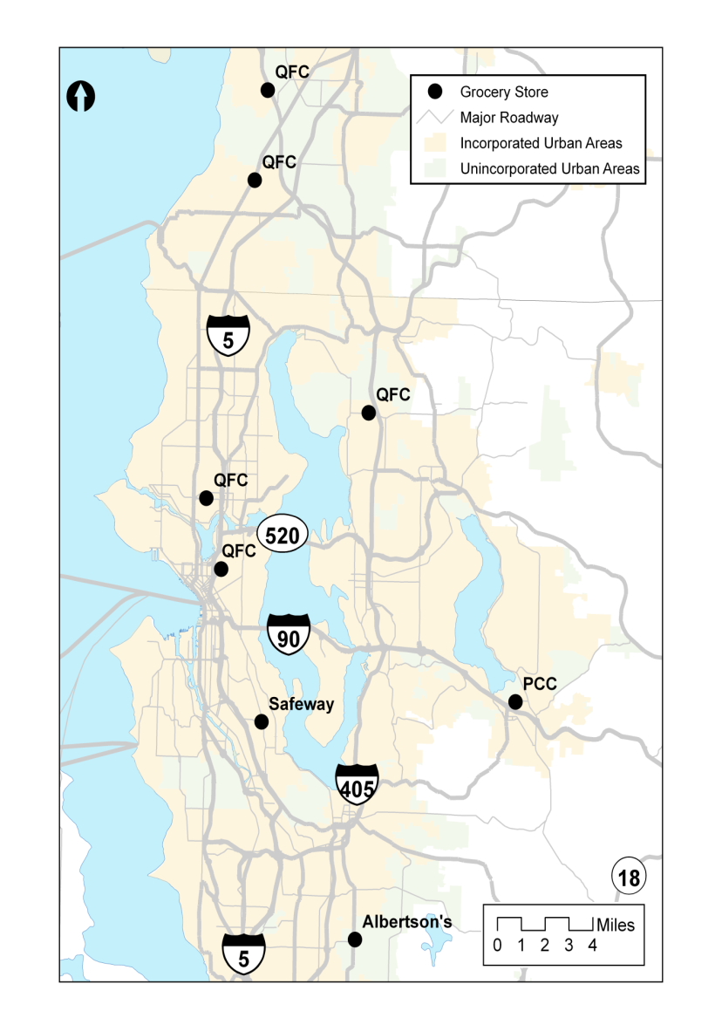

Figure 2. Geographic Extent of the Grocery Stores.

The grocery store phone interviews were generally conducted between 9:30 and 11:00 AM, after the morning rush of deliveries. An effort was made to identify and interview the individual who had most immediate contact with and knowledge of deliveries to the store. Store managers were interviewed for all the stores with the exception of the QFC on Broadway Avenue in Seattle and the Albertsons in Kent. At these two stores, loading dock employees known as receivers were interviewed. The interviewing process quickly revealed that grocery store employees were reluctant to accept interviews any longer than five or ten minutes; they were often busy handling multiple issues in the store.

## Manual Truck Counts

After the individual grocery store managers had been interviewed, the next step was to conduct manual, on-site truck counts. Data from manual counts would validate the accuracy of the estimates of daily truck deliveries provided by grocery store telephone interview respondents.

Manual counts were conducted by experienced vehicle counters who received a short training session about counts specific to grocery stores. The best counting locations for capturing all truck arrivals for each grocery store site were initially determined by using Google Earth and Google Street, but as the observers gained more experience they were allowed to select the best location. In each case, the grocery store contact from the initial telephone interviews was called and informed that observers would be outside their stores. Technically, this was not required, but this step was considered important to avoid any possible problems.

Sets of two to four counters deployed to each site, depending on the layout of the store, the parking lot, and the loading docks. For example, two counters typically covered a grocery store site with one loading dock because deliveries are often made at both the loading dock and through the front door. This arrangement also allowed for counting coverage across rest periods. The count times were selected on the basis of the time window when store operators had indicated that their store accepted deliveries. The hours of observation varied, but most covered the range between 6:00 AM and 12:00 PM (noon). Some manual counts started at 5:00 AM, and others ended at 2:30 PM. During this time the observers noted the arrival and departure times of each truck, the size of truck, and when applicable, the company associated with the truck, and documented whether the truck unloaded anything.

In addition to observing truck deliveries, the observers also tallied the cars visiting the store. This additional information was collected because it was relatively easy to collect and would be relevant for other land-use studies. (Appendix C includes details about the car count.)

With the exception of the QFC in Lynnwood, two sets of observation data were collected for each store. The assignments took into account the busiest day of the week to supplement the information gained through the interviews.

### Adjustments to the Observation Form

Several changes were made to the observation form after the initial results had been reviewed. For example, inconsistencies in the descriptions of the sizes of the trucks became obvious. Some trucks were categorized as “2-axle,” but it was not clear whether that meant a single unit or a tractor trailer. As a result, the form was amended. The revisions on the form incorporated use of the FHWA’s 13-Bin Classification scheme. The FHWA 13-Bin Classification scheme is a standardized method for classifying truck types on the basis of the number of trailers and axle configurations. The results from the first observation form were re-classified in accordance with the FHWA 13-Bin Classification scheme. The revised observation form is included in Appendix D, along with a copy of the FHWA 13-Bin Classification scheme in Appendix E.

# FINDINGS

## Telephone Interviews

A summary of the telephone interview results is shown in Table 1.

**Table 1 Store Characteristics and Phone Interview Results.**

|  |  |  |  |  |  |  |  |
| --- | --- | --- | --- | --- | --- | --- | --- |
| **Store and Location** | **Square Footage** | **Employees** | **Delivery Hours** | **Delivery Days** | **Peak Periods** | **Estimated Daily Number of Trucks** | **Loading Docks** |
| **QFC Wallingford** | 23,000 | 80 | 7 AM to 12 PM | Mon to Sat | No Peak | 10 | 1 |
| **QFC Kirkland** | 28,000 | 70 | 5 AM to 11 AM | Mon to Sat | Holidays, Mon, Fri | 8 to 10 | 1 |
| **QFC Mukilteo** | 37,000 | 70 | 5 AM to 11 AM | Mon to Sat | Holidays, Mon, Wed, Fri | 10 | 3 |
| **QFC Capitol Hill** | 46,984 | 100 | 5 AM to 11 AM | Mon to Sat | Holidays, Tue, Fri | 8 to 10 | 1 |
| **QFC Lynnwood** | 53,500 | 72 | 5 AM to 10 PM | Mon to Sat | Holidays, Mon, Wed, Fri | 15 to 20 | 1 |
| **Safeway Othello** | 26,092 | * | * | Mon to Sat | * | * | 1 |
| **Albertsons Kent** | 46,000 | 60 | 5:30 AM to 10:30 AM | Mon to Sat | Holidays | 15 | 2 |
| **PCC Issaquah** | 23,000 | 90-95 | 6 AM to 2 PM | All days | Holidays, Tue, Fri | 10 to 15 | 1 |

* These data were not collected.

### Size, Operations, and Employees

The grocery store facilities ranged from 23,000 square feet to 53,000 square feet and were staffed by 70 to 100 employees. The largest store, by square footage, was the QFC in Lynnwood. The QFC on Broadway in Seattle, with 100 employees, had the most employees out of the sample.

All the stores interviewed had at least one loading dock, but all also accepted deliveries through the front door. The QFC in Mukilteo had three loading docks, and the Albertsons in Kent had two loading docks. The Kirkland and Lynnwood QFCs each had one loading dock. The number of loading docks was relevant to consider because the more loading docks at a facility, the higher the number of deliveries a store can handle at any one time.

All but one of the grocery stores accepted deliveries six days of the week, with limited delivery hours on Saturday and no deliveries on Sundays. PCC was the only store to accept deliveries seven days a week. The hours of delivery generally lasted from early morning to the afternoon, roughly 5:00 AM to noon. Holidays typically produce peak days and hours, but the higher volumes were reported to be delivered by the same number of trucks, which indicates that typical deliveries are less than a truckload. This suggests that stores must receive a minimum number of truck trips, regardless of size or employment levels. Fridays were also reported to receive higher volumes than other days of the week for all interviewed stores. Some stores, like the QFC in Wallingford, reported consistent deliveries across days of the week, whereas the other QFCs around the Puget Sound reported higher volumes on Mondays and Wednesdays, except for the QFC on Broadway in Seattle, which reported higher volumes on Tuesdays and Fridays. PCC also reported higher volumes on Tuesdays and Fridays. This variation in higher volumes across days of the week was significant because it meant that a clear pattern of deliveries could not be assumed, even within one grocery chain.

### Truck Types

A variety of truck types serviced the stores. The trucks identified by the interviewees ranged from “18-wheelers” to “small-” and “medium-”sized vans, as well as “large refrigerated tractor trailers.” All stores reported receiving deliveries from 18-wheelers, small vans, and medium-sized vans. All QFC, Safeway, and Albertsons stores used company trucks from distribution warehouses. The only store that did not use company trucks was PCC. The number of company trucks out of all trucks to make deliveries varied in the responses. For example, at the QFC in Wallingford, 25 percent of the trucks were reported to be company trucks, while 20 percent were company trucks at the QFC in Kirkland, and only a few percent were company trucks at the QFC in Mukilteo. Stores did not report keeping any logs of truck trips; however, we suspect that there are records of deliveries from which the number of trucks that service a store could be calculated. Records of truck types that serviced the store also appeared to be nonexistent. However, truck types could be deduced from manual counts and observations of truck delivery patterns.

### Empty Trucks

The only reports of empty trucks arriving at the stores were of garbage and service trucks, such as cardboard recycling trucks, that came to remove refuse. Otherwise, interviewees mentioned that no empty trucks serviced the stores. This suggests that many trucks that service grocery stores are less-than-truck load (LTL) carriers as opposed to full-truck-load (FTL) carriers who would leave empty. The respondent from PCC provided the most detailed information regarding “empty trucks,” informing us that sometimes a delivery truck would take wooden pallet boards for reuse or disposal.

### Where Trucks Travel

Respondents told us that they could not summarize the origins of the variety of delivery trucks, had no clear idea of this information, or believed that most of the trucks were from within the Puget Sound region. Some QFC respondents were aware of the origin of the QFC company trucks, that is, the regional distribution center (according to the QFC in Kirkland) or other stores in the Seattle/Puget Sound region (according to the QFC in Wallingford).

## Manual Truck Counts

A summary of the manuals count results is shown in Table 2.

### Truck Arrivals

The data from the 17 sets of manual counts at eight stores showed that during the stores’ delivery windows, between 11 and 30 trucks arrived, with an average of 18 trucks arriving per store. The arrival rate was approximately three trucks/hour. The delivery times varied greatly. The mean

**Table 2 Manual Count Results.**

|  |  |  |  |  |  |  |  |  |  |
| --- | --- | --- | --- | --- | --- | --- | --- | --- | --- |
|  | **Manual Count One** | | | | | Manual Count Two | | | |
| **Total Trucks** | **Front Door/ Loading Dock** | **Heavy Trucks** | **Count Time/Dates** | **Total Trucks** | | **Front Door/ Loading Dock** | **Heavy Trucks** | **Count Time/Dates** |
| QFC Wallingford | 25 | 8/17 | 3 | 7 AM to 2 PM Mon, Aug. 15th | 22 | | 16/8 | 3 | 7 AM to 2 PM Fri, Oct. 16 |
| QFC Kirkland | 15 | 0/15 | 2 | 5 to 11 AM  Thurs, Nov. 12 | 19 | | 1/18 | 4 | 5 to 11 AM Weds, Dec. 2 |
| QFC Mukilteo | 18 | 8/10 | 6 | 5 to 11 AM Thurs, October 7 | 17 | | 16/1 | 0 | 5  to 11 AM Weds, October 7 |
| QFC Capitol Hill | 14 | 14/0 | 6 | 5 to 11 AM  Fri. Oct 23rd | 18 | | 18/0 | 3 | 5  to 11 AM Weds, Nov. 25 |
| QFC Lynnwood | 13 | 7/9 | 2 | 6 AM to 12:00 PM Thurs, Nov. 19 | * | | * | * |  |
| Safeway Othello | 15 | 5/10 | 2 | 6 to 11 AM  Weds, Nov. 4 | 15 | | 8/9 | 4 | 6  to 11 AM Thurs, Dec 3 |
| Albertsons Kent | 11 | 7/4 | 1 | 6 to 11 AM  Thurs, Dec. 10 | 15 | | 0/15 | 6 | 6  to 11 AM  Fri, Nov. 6 |
| PCC Issaquah | 23 | 16/7 | 3 | 6 AM to 2:30 PM Mon, Aug 31 | 30 | | 18/12 | 4 | 6 AM to 2 PM Thurs., Nov. 5 |

* These data were not collected

delivery time was roughly 27 minutes for each truck, with a minimum of 6 minutes and maximum of 73 minutes for all observed deliveries.

### Truck Types and Delivery Locations

Deliveries were observed at the loading docks and through the grocery store’s front door. Front door deliveries were generally made by the smaller “Class 5” trucks, whereas both “Class 5” and “Class 8 and 9” trucks delivered to loading docks. For only front door deliveries, delivery times averaged 25 minutes, with a minimum of 6 minutes and a maximum of 54 minutes. For front door deliveries only, the average hourly truck trip generation rate was one truck/hour and ten trucks/day (assuming a 6-hour delivery period). For only loading dock deliveries, the average delivery time was 24 minutes, with a minimum of 10 minutes and a maximum of 64 minutes. Truck trip rates at loading docks were two trucks/hour and eight trucks/day (assuming a 6-hour delivery period). These results from the manual count data suggest that deliveries made at loading docks tended to take longer than deliveries at the front door. Table 3 includes the average truck rate and delivery times.

## Trip Rates and Store Characteristics

Store characteristics were compared to truck generation rates in an attempt to develop quantitative tools that practitioners can use to conduct trip generation studies for grocery stores.

Two easily obtained factors that are directly related to a grocery store were evaluated: square footage and employment. Other data related to the land use surrounding each store were explored. These included household income, residential density, and jobs-housing balance. These data were collected for the U.S. Census block groups where each of the stores were located. Each of these pieces of data was meant to serve as a proxy for other information that was not readily available. For example, we theorized that a high median household income would indicate a propensity to consume higher-end grocery items or perhaps a need to have a larger number of stock-keeping units available per store, which might result in more specialized truck trips. Residential density was our attempt to capture the urban nature of the location of each of the stores. We hypothesized that at higher densities, more truck trips would be necessary because the demand for goods at that store would be higher (a proxy for sales), and store warehousing would be more limited because rent constraints would force the retailer to rely more heavily on just-in-time delivery practices and, therefore, require more truck trips. Finally, jobs-housing balance—the number of jobs divided by the number of housing units—for each block group attempted to capture the mixed-use nature of the existing land uses surrounding the grocery stores. The results of a regression analysis are shown in Table 4.

Table 3 Averaged Aggregate Truck Trip Rates and Delivery Times.

|  |  |  |  |  |  |
| --- | --- | --- | --- | --- | --- |
| **Average Truck Trips (trucks/day)** | | | **Delivery Times (minutes)** | | |
| Total | Loading Dock | Front Door | Total | Loading Dock | Front Door |
| 18 | 7 | 13 | 27 | 24 | 25 |

Table 4 Regression Analysis Results.

|  |  |  |  |
| --- | --- | --- | --- |
| **Variable** | **β** | **t** | |
| **(Intercept)** | **12.2600** | **2.925** | |
| Employment | 0.1852 | 2.334 | |
| **Square Footage** | **-0.0002** | **-3.634** | |
| Median household income | 0.0000 | 0.707 | |
| Residential Density | -0.1328 | -1.319 | |
| Jobs-Housing balance | -0.6936 | -0.573 | |
|  | N = 8 | | |
|  | R2 = .8798 | | |
| **Bold indicates p < .1** |  | |

The only statistically significant variable was square footage, which was negatively correlated with truck trips. This suggested that an increase of 5,000 square feet for an average store would reduce the total number of truck trips by one. The fact that smaller stores generated more truck trips suggested that these stores were served by smaller vehicles or smaller loads on vehicles. This could be related to the store’s distribution system. The manual observers noted variation between stores of the same company in the use of company trucks originating from the regional distribution center. This highlights one of the complexities in predicting truck routing as it relates to truck trip generation. The role of distribution centers in a grocery chain’s truck delivery structure may notably affect the number of trucks trips. A regional distribution center may lead to lower truck trip rates for larger stores because the distribution center consolidates freight volumes for a particular store into fewer trucks. Therefore, smaller stores that are not served or as well-served by a regional distribution center trucks may actually have higher truck trip rates than larger stores.

In addition, stores with more DSD deliveries (and proportionately fewer distribution warehouse deliveries) may also generate more trucks trip because DSD trucks tend to smaller and involve food categories with higher volumes (soda, bread, milk) (Grocery Manufacturers Association 2008). In fact, one study noted that a DSD-based supply system resulted in 10 to 30 times more frequent deliveries than a retailer warehouse system (Grocery Manufacturers Association 2005, 9).

The remaining variables were not statistically significant (Table 4). However, employment had a predictably positive relationship to truck trips. Surprisingly, income did not seem to have any relationship to truck trips, suggesting that it is either a poor indicator for stock-keeping units or that, regardless of price, grocery stores generate the same number of trips. Contrary to the initial hypothesis, both density and jobs-housing balance appeared to be negatively correlated with truck trips. This relationship merits further examination in future research.

# CONCLUSIONS

Truck trip generation rates are relevant for traffic demand analyses and mitigation efforts, understanding land-use impacts, and for planning-level decision making. Accurate trip generation information can also improve the modeling of truck trips and their impacts on the transportation system and contribute to an understanding of the factors that affect freight movements. This effort explored the development of establishment-level truck trip generation rates by using grocery stores as a case study. Grocery stores were selected because they are a common land use present in most metropolitan neighborhoods. Because grocery stores require frequent re-supply, they generate a number of daily truck trips that affect all parts of the transportation roadway network, including local roads, arterial connectors, and highways.

Aggregating data from a particular industry such as grocery stores to higher level industry classifications might obscure the details discovered by this study, and further investigation is needed to better understand how truck trip generation rates change as larger industry sector classifications are used. Given that trip generation is largely determined by using zones with land-use concentrations or larger industry sectors, the results of this study suggest that collecting truck trip rates may require disaggregation of traditional land-use concentrations and industry sectors, starting from the level of the vehicle (as opposed to deducing vehicle trips and numbers of vehicles from volume and tonnage data).

A number of specific conclusions can be drawn from the project’s findings.

1. **Phone interviews combined with manual counts provide a reasonable trip generation data collection approach.** Both the telephone interviews and the manual counts had value, especially when completed together.

Phone interviews, while sometimes difficult to arrange, were relatively low cost and allowed direct communication with receiving managers or general managers. In this project, these interviews were used as the first step in data collection. In addition to providing each store’s time window for deliveries, the interviews provided background information about each store’s size, number of employees, and general information about deliveries. Information from interview respondents guided the manual on-site counts and provided a baseline measurement of counts. The days of the week selected for manual observations were also based on information garnered from interviews. Interview results provided little or no mention of the number of truck trips during peak delivery times, so the manual counts provided the most accurate record of truck trip generation.

An important discovery was that interview conversations provided sometimes unanticipated but valuable information that was relevant to understanding grocery store operation and truck trip-generation rates. For example, questions about loading locations and truck sizes indicated that grocery stores are replenished by two types of truck-based systems, which directly affect generation rates—direct store delivery (DSD) and regional distribution centers.

In comparison to the manual counts conducted through field observation, the telephone interviews of store managers and receivers consistently under-reported truck trips by approximately five to ten trips per day. This difference in the number of truck trips reported by the store employees and number observed might be explained because the interviewees would tend to not count or consider the direct service deliveries. These deliveries have a lower visibility because the truck drivers often directly stock the shelves, and the truck’s arrival does not require much involvement by store staff. However, although the interviews under-counted truck trips, the information gathered through the interviews did improve our knowledge of context and general activities across all days of the week without intensive investment in person-hours of observation. Conducting telephone interviews first also established contact and eased acceptance of the placement of manual counters on-site.

The manual counts offered specific information about delivery duration, which can be useful for improving the accuracy of the temporal component of traffic generation as it relates to truck trips. The information from manual counts not only provided usable quantitative data but also descriptive information about truck types, the different companies servicing the stores, and the characteristics and patterns of delivery as they related to truck type. In comparison to the telephone interviews, the manual counts required greater personnel time, including people available to travel to the study sites and time involved in training counters, and therefore were more expensive. However, the manual counts provided detailed data that would be useful for understanding, documenting, and analyzing the number of trucks on the road for trip generation and traffic impacts. Although data generated by manual counts are subject to human error during collection, this can be reduced through adequate training.

1. **The grocery stores in our study generated an average of 18 trucks trip per day on a typical peak weekday.** This number is based on multiple manual counts at eight grocery stores. The counts were during the peak morning delivery windows identified by the store managers during telephone interviews. These daily counts are probably low, as some of the stores accepted late deliveries outside of the receiving windows.
2. **With the possible exception of the store’s distribution network and store size, few grocery store characteristics that could be directly related to truck trip generation were identified**. The project reviewed literature discussing both trip generation data collection and grocery store management and did not identify any specific characteristic that could be used to quantify the number of truck trips generated by different stores. While employment is often related in the ITE *Trip Generation Manual* to truck trips, this effort did not find any direct relationship to these variables. Other variables linked the land use around the store—household income, residential density, and jobs-housing balance—were also not significantly related to trip rates. We suspect that other factors that we did not evaluate, such as a store’s product mix, might be relevant to truck deliveries and worthy of additional research.

One area to explore that might be particularly promising is the linkage between the percentage at which a store is serviced by regional warehouses as opposed to direct service delivery (DSD) and the number and type of truck trips. The manual counts indicated variability in the nature and size of the trucks servicing the stores and that this was related to whether the delivery was at the front door (often small DSD trucks) or the loading dock (larger trucks from warehouses). The use of both warehouses deliveries and DSD suggests a range of interesting trip generation complexities. For instance, the use of distribution centers in a grocery chain’s truck delivery structure could lead to fewer truck trips for stores because the distribution center consolidates freight volumes into fewer trucks. Therefore, smaller stores that are independent or belong to regional chains that do not use large distribution center trucks could actually have higher truck trip rates than larger stores do.

# REFERENCES

Al-Deek, H., G. Johnson, A. Mohamed, and A. El-Maghraby. (2000) Truck Trip Generation Models for Seaports with Container and Trailer Operation. *Transportation Research Record:* 1719, no. 1 (January) pp. 1-9.

Balbach, P., and R. Tadi. (1994) Truck Trip Generation Characteristics of Nonresidential Land Uses. *ITE Journal*, Vol. 64, pp. 43–47.

Brehmer, C., L. Butorac and A. Marc. (2003) Trip Generation Characteristics of Discount Supermarkets. *ITE Journal*, Vol. 73, no. 11, pp. 38-42.

Brogan, J.D. (1979) Development of Truck-Trip Generation Rates by Generalized-Land Use Categories. *Transportation Research Record* 1719, pp. 38-43.

Everitt, L. (2008) Can DSD Change the Retail World?, BNET, September 26th, Accessed on April 8, 2010 from http://industry.bnet.com/retail/1000217/can-dsd-change-the-retail-world/.

Fischer, M. J., and M. Han. (2001) *NCHRP Synthesis of Highway Practice 298: Truck Trip Generation Data*. Transportation Research Board, National Research Council, Washington, D.C.

Food Market Institute (2008) *Supermarket Facts, Industry Overview.* Accessed on April 6, 2010 from <http://www.fmi.org/facts_figs/?fuseaction=superfact>.

Grocery Manufacturers Association (2005) *Unleash the Power of DSD, Driving DSD Supply Chain Efficiency and Profitability* September, Accessed on April 8, 2010 from http://www.gmabrands.com/publications/docs/2006/2005dsd.pdf.

Grocery Manufacturers Association (2008) *Powering Growth Through Direct Store Delivery* September, Version 1.1 Accessed on April 28th 2010 from http://www.gmabrands.com/publications/DSD_Final_111108.pdf.

Golias, M. and M. Boile. (2007) Truck Trip Estimation by Facilities Using Arc-Info. In *Conference Proceedings for the 2007 ESRI International Users Conference*, June 18-22 San Diego CA.

Guiliano, G., P. Gordon, Q. Pan, J. Park, and L. Wang. (2010) Estimating Freight Flows for Metropolitan Area Highway Networks Using Secondary Data Sources. *Network and Spatial* Economics Vol. 10, No 1, pp. 73-91.

Heffron Transportation, Inc. (2001) Howe Street Mixed-Use Project Traffic and Parking Impact Analysis: November .Case study: Metropolitan Market on Seattle’s Queen Anne Hill.

Holguín-Veras, J. (2002) Truck-trip Generation at Container Terminals: Results from a Nationwide Survey. *Transportation Research Record 1790*, Freight Transportation 2002.pp. 89-96.

Iding M., W. Meester and L. Tavasszy, (2002) Freight Trip Generation by Firms, *ERSA Conference Papers,* 42nd European Congress of the Regional Science Association (April).

Institute of Transportation Engineers, (2008) *Trip Generation*, 8th Edition, December, Washington D.C.

Jessup, E., K. Casavant, C. T. Lawson. (2004) *Truck Trip Data Collection Methods*, Oregon Department of Transportation SPR 343, February. Accessed on April 8, 2010 from http://www.oregon.gov/ODOT/TD/TP_RES/docs/Reports/TruckTripData.pdf.

Jessup, E. and M. Clark. (2004) *Strategic Freight Transportation Analysis (SFTA)*. Washington State University, November. Accessed on April 24, 2010 from www.sfta.wsu.edu/presentation/pdf/7_Steering_Origin_Destination.pdf.

Kawamura, K., H. Shin, S. McNeil and L. Ogard. (2005) *Business and Site Specific Trip Generation Methodology for Truck Trips*. Project 05-03, Midwest Regional University Transportation Center, University of Wisconsin-Madison, September. Accessed on April 24, 2010 from http://www.minds.wisconsin.edu/handle/1793/6958.

Kuai, J. (2007) *Who Stocks a Shelf? An Analysis of Retail Replenishment Strategies*, Thesis, Master of Engineering in Logistics, Massachusetts Institute of Technology, June.

Kuzmyak, J. (2008) *Forecasting Metropolitan Commercial and Freight Travel,* National Highway Cooperative Research Program, Synthesis *384*. Washington, D.C.: Transportation Research Board.

Moore, L., and A. Diez Roux. (2006) Neighborhood Characteristics & Location and Type of Food Stores: Discussion. *American Journal of Public Health.* Vol. 96 No. 2 pp. 325-331.

Ortúzar, J., and L. Willumsen. (1994) *Modeling Transport*. Chichester, U.K.: John Wiley.

Shin, H., and K. Kawamura. 2005. *Data Need for Truck Trip Generation Analysis: Qualitative Analysis of the Survey of Retail Stores*. Transport Chicago 2005. Illinois Institute of Technology, June 3. Accessed on April 288, 2010 from http://www.mrutc.org/research/0503/Kazuja_paper_final.pdf.

Shin, H., and K. Kawamura. (2005b). Framework for a Disaggregate Truck Trip Generation Model Based on a Survey of Retail Businesses, Issue Paper, Accessed on April 28, 2010 from http://www.mrutc.org/research/0503/Kazuja_paper_final.pdf.

Tolliver, D. (2006) Trip Generation Rates for Large Elevators. *Transportation Research Record 1966*, pp. 88-95.

WSDOT Washington State Department of Transportation (2008) *Washington Transportation Plan Update Freight Movement* , September, Access on April 15, 2010 from http://www.wsdot.wa.gov/NR/rdonlyres/67530525-3531-4552-A198-BA4255AADAA7/0/WTPSeptember_2008web.pdf.

USDOT, United States Department of Transportation (2004) Federal Highway Administration, Office of Freight Management and Operations. *Freight Analysis Framework - State Freight Profile*. November. Accessed on April 24, 2010 from www.ops.fhwa.dot.gov/freight/freight_analysis/state_info/washington/profile_wa.htm.

United States Department of Labor, Bureau of Labor Statistics,(2009) Career Guide to Industries, 2010-11 Edition, Grocery Stores, Accessed on April 6, 2010 from <http://www.bls.gov/oco/cg/cgs024.htm>.

USDOT, United States Department of Transportation (2002), Bureau of Transportation Statistics, Freight Data and Statistics, Truck, Accessed on April 10, 2010 from http://www.bts.gov/programs/freight_transportation/html/trucking.html.

# APPENDIX A—Distribution Center

## Interview Process

Several large regional distribution centers were initially contacted to refine the interview process and to determine whether the trips from these centers could be used as a tool for determining an upper to limit to the number of trips to individual stores.

A list of distribution centers was compiled from our industry contacts. Managers from four distribution centers were contacted for interviews. Three involved food distribution to grocery stores. REI, an outdoor gear distribution center, was included because the project team had a contact at its warehouse and wanted to explore whether there were any major differences between this distribution center and grocery store distribution warehouses. The four distribution centers were

* SYSCO
* Safeway
* Charlie’s Produce
* REI.

The points of contact for interviews with distribution centers were the senior logistics manager or an equivalent position. Often after multiple contacts, interviews were scheduled in advance with the interviewee. These generally lasted about 20 minutes and included a general discussion about truck operations at the facility and specific issues such as strategies for timing deliveries and shipments. The interviewer used a standard interview form to guide the questioning. Questions touched on four main areas: facility information, hours of operation and number of trucks, types of trucks, and origin-destination information. Information was also collected to establish a relationship for possible future contact. The complete distribution center interview script is at the end of this appendix.

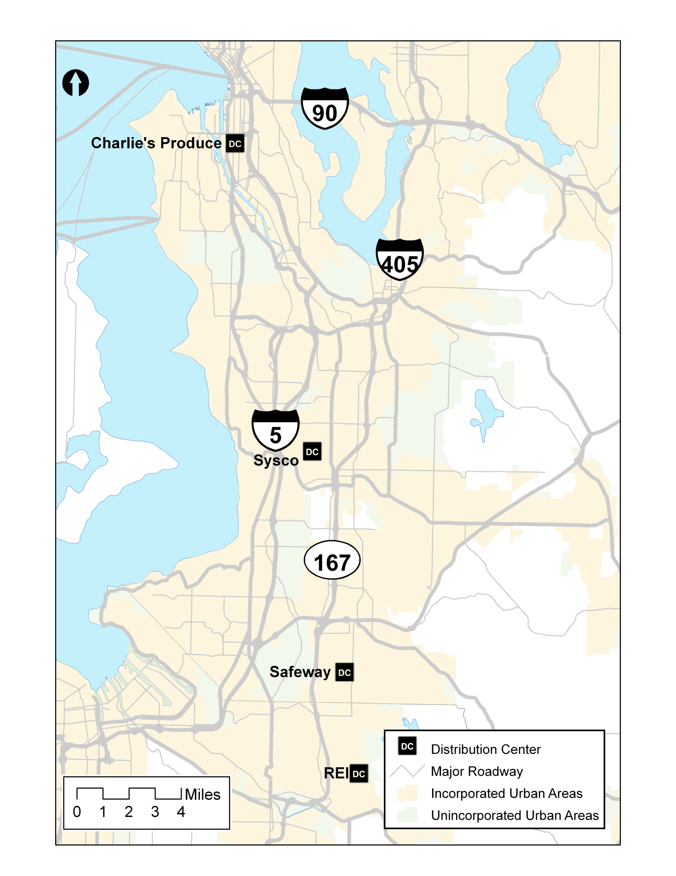

Figure A-1. Geographic Extent.

## General Trends

### Size, Operations, and Employees

Three of the four facilities have approximately 500 employees, with REI being larger. They range in size from 150,000 to 5,009,400 square feet.

Sysco Food Systems, Safeway, and Charlie’s Produce reported 24-hour operations. REI reported operations from 6:00 AM to 5:00 PM. All reported using electronic routing software to determine daily delivery schedules and to keep track of where their trucks are on the road.

### Truck Types

Across all of the four distribution centers, truck types that serve the distribution center vary. For example, SYSCO uses 22- to 48-foot trucks for outbound trips, while inbound trucks are typically 53-foot trailers. Similarly, REI uses 28-foot trailers for outbound trips but relies mostly on 53-foot trailers for inbound trips. By contrast, Charlie’s Produce uses 53-foot trailers for both inbound and outbound trips. About 40 percent of outbound trips from Charlie’s Produce are made with 53-foot trailers. Although it may not be significant to differentiate between 28-foot trailers and 53-foot trailers for truck trip generation purposes, for questions of truck trip generation as it relates to planning, the size of the truck will affect roadway design and influence discussions of appropriate adjacent land uses.

### Empty Trucks

Strategies for allowing empty trucks vary depending on the cost effectiveness to the distribution center. SYSCO, Charlie’s Produce, and REI found that it is not cost effective for them to search for goods to backhaul, so almost all of their trucks return empty. In contrast, Safeway found it more efficient for trucks to pick up items to bring back to the warehouse while they are making a delivery, such as produce from Yakima or palette boards from a store.

### Where Trucks Travel

All of the distribution centers reported that more loaded trucks arrive at the distribution center than depart from the distribution center. This suggests that trucks arrive at the distribution center carrying truckloads of specific products. Then the products are bundled into consolidated shipments that are sent to grocery stores in larger trucks.

The distribution centers tend to be regional facilities, with territories stretching across Washington state from Yakima to the Olympic coast. Often they have smaller “satellite” facilities in the outlying areas that handle further distribution to individual stores.

Origin and destination information for the trucks that service the distribution centers varied. For the most part, the majority of outbound and inbound trips occur in the Puget Sound region. For instance, Safeway reported that outbound shipments extending to Portland (to service its distribution center there) and Alaska (via the Port of Seattle) make up approximately only 20 percent of its outbound trips. Similarly, Charlie’s Produce reported that 80 percent of its outbound trips remain in the Puget Sound (servicing areas between Bellingham, Chehalis, Yakima, and the Olympic coast, approximating an area of 170 miles by 250 miles). In comparison, REI reported that only 25 percent to 35percent of its outbound shipments stay in the Puget Sound; the remainder travel to other parts of Washington, Oregon, California, Idaho, and Arizona. This makes sense because groceries generally satisfy local consumption, whereas REI has larger distribution areas.

### Truck Movement Information

All of the four distribution centers use some type of program to track and monitor inbound and outbound trucks to and from their facilities. Safeway and SYSCO have routing software that provides them with origin and destination information. REI contracts with a carrier, so it does not have regular access to that information. To access origin-destination information from distribution centers that operate like REI will require contacting the contracted LPL carrier. Lastly, Charlie’s Produce has origin and destination information for inbound trucks because it is required to report that type of information as part of the United States Food and Drug Administration’s Hazard Analysis and Critical Control Point (HCCAP) program, which is designed to prevent food-borne illnesses.

The distribution center interview results are summarized in Table A-1.

In relation to responses from the three grocery distribution center interviews, REI appeared to have a similar peak-hour delivery period, which was the early morning. The REI distribution center is much larger than that of Charlie’s Produce and almost double the size of that of SYSCO. However, all three are substantially smaller than the Safeway distribution center.

Table A-1. Distribution Centers Interview Results Summary.

|  |  |  |  |  |  |  |
| --- | --- | --- | --- | --- | --- | --- |
| **Distribution Center** | **Square footage** | **Employees** | **Hours** | **Inbound Truck Daily** | **Outbound Trucks Daily** | **Peak Periods** |
| **Charlie’s Produce** | 140,000 | 500 | 24 hours | 15 to 20 | 62 | 5 am to noon |
| **Safeway** | 5,009,400 | 500 to 600 | 24 hours | 100-150 | 25-50 | No peak |
| **SYSCO** | 340,000 | 550 | 24 hours | 75 to 150 | 68 to 82 | 1 am and 4 am |
| **REI** | 650,000 | 600 to 900 | 5am to 6pm | 60 | 35 | Mondays and Tuesdays; 5am to 9am |

## Questions for Regional Warehouses or Distribution Centers

**[Interviewer Introduction]**

(Record interview details: date, interviewee’s title)

**[Obtain information about the facility]**

* Our records indicate your facility is x square feet. Is that about right?
* How many employees work at the facility?

**[Hours of operation and number of trucks]**

* What are your typical hours for either receiving or delivering goods, and what are the constraints for your hours of operation?
* Do you keep a log of truck arrivals and departures for your facility?
* How many truck trips do you see on a typical day? Can you break that down by arrivals and departures?
* When are your peak periods of activity (hours during the day)? Do you have peak periods within the week, for example, a day of the week with the most deliveries?

**[Type of trucks that use the facility]**

* Do you keep a record of the types of trucks that service your facility?
* What percentage of the trucks that service your facility are your company’s trucks?
* Would you describe the types of truck types that service your facility?

For example are they:

* Single unit trucks with 2 axles?
* Single unit trucks with 2 axles, 6 tires (dual rear tires)?
* A tractor pulling one or two trailers with 3 or more axles?

What percentage of empty trucks service your facility?

**[Origin-Destination Information]**

* Do you have records that would indicate origins or destinations of your truck trips?
* [If answer to records is ‘Yes,’ then ask:]
* Could we have access to these records to identify origins and destinations of the trucks that service your facility?
* [If answer to records is ‘No,’ then ask:]
* What percent of trucks arrive at you facility from outside the Puget Sound region?

What percent of trucks that service your facility leave to destinations outside the Puget Sound region?

**[Ask about future contacts]**

* Are we able to contact you in the future if further questions arise?
* Are there other people in your company that might be good resources to contact in the future regarding patterns of truck receptions/deliveries?
* (Thank the interviewee for their time.)

# APPENDIX B—Interview Form for Individual Grocery Stores

**[Interviewer Introduction]**

(Record interview details: date, interviewee’s title)

**[Obtain information about the store]**

* Our records indicate your store is x square feet. Is that about right?
* How many employees work at the store? Are they generally full-time, or does that include part-time as well?
* What are your employee shifts? Which shift has the most employees, if any?
* Where do you accept deliveries - front door / loading dock / off the street?
* How many loading bays do you have?
* About how long does it take to unload a truck of goods?

**[What hours do you accept deliveries]**

* When are you able to receive deliveries at the store?
* What are the constraints for when you can accept deliveries, if any? *(could give an example of a neighborhood noise ordinance)*
* Does that change between weekdays and weekend?

**[Truck flow patterns]**

* On average, how many truck deliveries do you see on a typical day?
* When are your peak periods of activity (hours during the day)?
* For a typical week:
* Which day of the week do you see your maximum number of deliveries?
* Are there certain days that specific goods are delivered?
* Do delivery quantities vary by season? Are there increases or decreases in deliveries on major holidays? E.g. Christmas items, Easter, Thanksgiving, Super Bowl?

[Type of trucks that use the facility]

* Can you estimate what percentage of the trucks arriving at your store are your company’s trucks?
* Can you describe the types of truck that service your facility?

For example are they:

* Single unit trucks with 2 axles?
* Single unit trucks with 2 axles, 6 tires (dual rear tires)?
* A tractor pulling one or two trailers with 3 or more axles?
* What is the percentage of empty trucks that service your facility?

**[Ask about future contacts]**

* Are we able to contact you in the future if further questions arise?
* If you do not feel you were the best contact person, would you direct us to someone you think is a good contact?
* (Thank the interviewee for their time.)

# APPENDIX C—Supplemental Automobile Counts

Counting automobiles was not the major focus of this project. However, given the ease of tallying automobiles, the counters were asked to do so. The results should be used with some caution because the parking lots in which the grocery stores were located often served multiple establishment, making it difficult to state with a high degree of confidence that the vehicle trips generated were associated with the specific land use in question, grocery stores. That is, the vehicle trips would become aggregated for all the retail and service uses that shared the one parking lot. Therefore, the car counts were only a rough estimate of the traffic generated by the grocery store.

In this sense, the truck counts associated with the grocery store land use were more accurate and therefore more meaningful.

In counting the passenger vehicles, 15 sets of manual count data were collected by teams of trained vehicle counters. Passenger vehicle trips associated with each site were summarized by average 2-hour peak-hour periods. The *ITE Trip Generation Handbook* suggests 2-hour peak-hour periods of 7:00 AM to 9:00 AM.

The passenger vehicle trip generation rates associated with the grocery stores in this study are summarized in Figure C-1. Two-hour peak-hour periods were used to determine the average peak-hour rate for each grocery store site. Three average peak-hour rates are presented. One is the average peak-hour rate when the entire observation period (which varied for each site) is accounted for. The other is average peak-hour rates determined by using ITE’s standard 2-hour peak-hour suggestion. Finally, the average peak-hour rate is also calculated from a 2-hour peak-hour period drawn from the observed data. On some instances, the observed 2-hour peak-hour period corresponded to ITE’s standard 7:00 AM to 9:00 AM period, but not in all instances.

The passenger vehicle counts are also presented in tabular format in Table C-1.

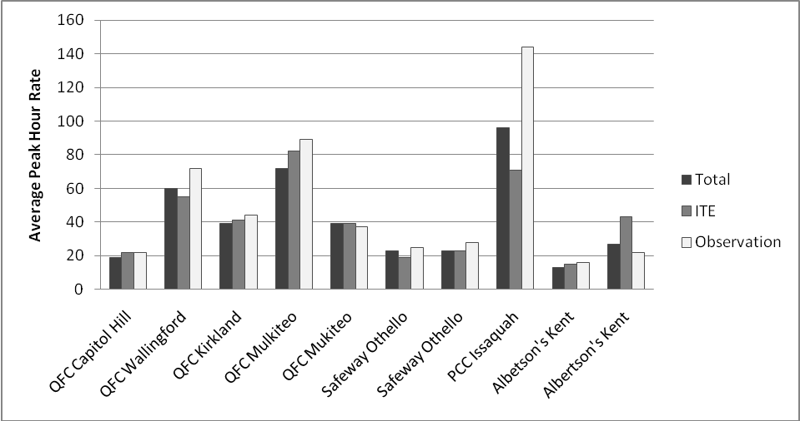

Figure C-1. Average Peak-Hour Passenger Vehicle Trip Rates Determined from 2-hour Peak-Hour Windows.

Table C-1. Average Peak-Hour Passenger Car Trip Rates Determined from 2-hour Peak-Hour Windows.



# APPENDIX D—FHWA 13-Bin Vehicle Classification

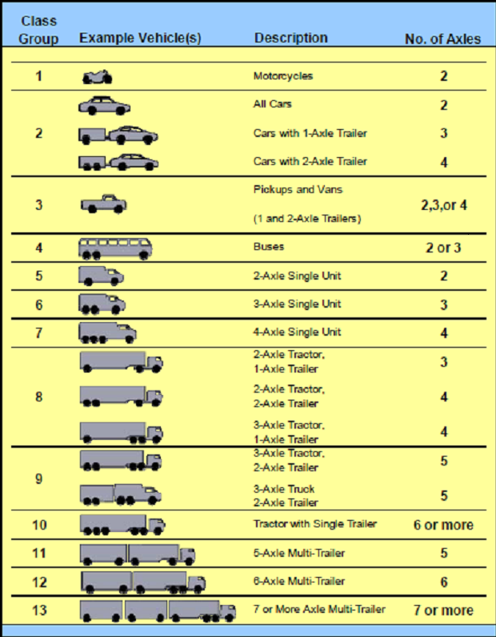

# APPENDIX E—Manual Counts Observation Form

Observer Name:

Name of Store:

Date:

Shift Duration:

Observation location (near loading dock, at front of store, etc.):

|  |  |  |  |  |  |
| --- | --- | --- | --- | --- | --- |
| **Time Arrive:** | **Time Depart:** | **Type of truck:** | **Company or Product:** | **Unload? (Y/N)** | **Comments:** |
|  |  |  |  |  |  |
|  |  |  |  |  |  |
|  |  |  |  |  |  |
|  |  |  |  |  |  |
|  |  |  |  |  |  |
|  |  |  |  |  |  |
|  |  |  |  |  |  |
|  |  |  |  |  |  |
|  |  |  |  |  |  |