Washington State Industry Outlook and Freight Transportation Forecast:

Wheat Industry

Prepared for the
Washington State Department of Transportation
Freight Systems Division

By

Selmin Creamer
Research Assistant

Dr. Eric Jessup
Assistant Professor

School of Economic Sciences
Washington State University
Pullman, WA 99164-6210

September 2008

TABLE OF CONTENTS

Study Goal ii

Industry Information 1

Economic Outlook 2

Washington State Outlook 5

Statewide Transportation and Logistics 8

Statewide Freight Projections 8

Conclusions 12

References 13

TABLES

Table 1: Export Value and Percentage Share of Wheat, Washington State 6

Table 2: Base Year and Forecasted Wheat Production 8

Table 3: Highway Impact for years 2007, 2012, 2017 and 2027(Production) 11

Table 4: Highway Impact for years 2007, 2012, 2017 and 2027 (Truck Trips) 12

FIGURES

Figure 1 World Wheat Production and Use 3

Figure 2 US All Wheat - Exports 4

Figure 3 Top Ten Customers for US Wheat 4

Figure 4 Washington State Outlook 5

Figure 5 U.S & Washington Average Price Received by Farmers for All Wheat 6

Figure 6 Intensity of Washington State Wheat Production, 2006 7

Figure 7 Historical and Projected Statewide Wheat Production 9

Figure 8 Highway Wheat Flows – Eastern Washington 10

STUDY GOAL

The goal of this report is to offer state and regional transportation planners’ necessary information regarding future freight flows specific to the wheat industry. This is accomplished by providing general industry information regarding the prospects for increased trade and production growth and also estimation of a prediction model for statewide wheat production over the next twenty years. This prediction model is estimated using historical production information at the Township, Section, and Range level and is then allocated to truck shipments and highways using information and data collected from a recent survey of the wheat industry regarding transportation characteristics of the industry.
INDUSTRY INFORMATION

Wheat was the third most valuable farm product in Washington State, after apples and milk, generating $625.8 million in 2007. Washington produced 128.7 million bushels of wheat in 2007, and ranks sixth in the nation. In 2007, 75 percent of wheat acres planted was Common Soft White, and the other 25 percent was Hard Red. Hard White wheat is the newest wheat type grown in the US and Washington State and was planted on 19,500 acres in 2007. Soft white wheat was accounted for 70 percent of the wheat production in Washington. Washington provides more than 40 percent of all US white wheat production [1].

Most of the state’s wheat production takes place in 15 central and eastern Washington counties. In the year 2006 Whitman, Adams, Walla Walla, Lincoln, and Grant produced 71 percent of the wheat in the state. Whitman County has been the number 1 wheat producing county in the nation since 1978. Washington is one of the leading wheat exporting states, with 85 to 90 percent exported each year [2].

The average value per harvested acre of wheat in Washington was $235 for 2005/06. Washington produces approximately one-half the amount (volume) of wheat that Kansas produces, which ranks number 1 in the nation [2]. In 2007 wheat became the number 1 agricultural export for Washington with the value of $ 1.3 billion [3].

Washington wheat combined with the production of Oregon and Idaho is marketed to the world as Pacific Northwest (PNW) wheat. Approximately 85 percent of Washington and PNW wheat is exported and 15 percent is sold into the domestic market. Washington is the biggest contributor in the Pacific Northwest All Wheat Production. In 2006 Washington, Idaho and Oregon produced 274.7 million bushels together [2].

In year 2005, the total number of jobs created by the wheat industry was approximately 11,709 and total economic impact on the state’s economy was $760.9 million, including direct, indirect, and induced impacts [4].

ECONOMIC OUTLOOK
New Market Potential
Central America and South America are potential wheat markets for the US due to the proximity and growing demand. The primary competitors in those markets are Argentina and Canada offering lower-priced wheat. Black Sea Exports are also entering into these markets slowly [5].
Wheat from PNW is known for its cleanliness and consistency. The high grain quality of the wheat has also brought higher market prices over the past couple years given increases in world demand [5].

The Free Trade Agreement (FTA) negotiations between Columbia and the US is important to US wheat farmers, since this would improve access to tariff free wheat from US. Argentina and Black Sea exporters are the main competitors for the Columbian market. Central America’s increasing demand for wheat also makes that region a potential market for US wheat producers. Mexico, with the increase of in-store bakeries, convenience stores and a growing fast food society, is considered a potential candidate for US wheat [5].
Domestic vs. International
The Northern Hemisphere provides most of the world’s winter wheat, while Canada, Kazakhstan, Russia, and the United States provide spring wheat, which is planted much later. In the Southern Hemisphere, Australia and Argentina plant crops after the planting of spring wheat in the Northern Hemisphere. Thus, the diversity of exporting countries brings stability to the world wheat market and prices [6].
World wheat production decreased five percent in 2006/07 and consumption exceeded production [Figure 1]. In the US and Australia, drought reduced crop yields, while the European Union and Black Sea Regions also experienced drops in their production levels. Canada performed the best with good spring wheat production and quality among major wheat exporters [7].

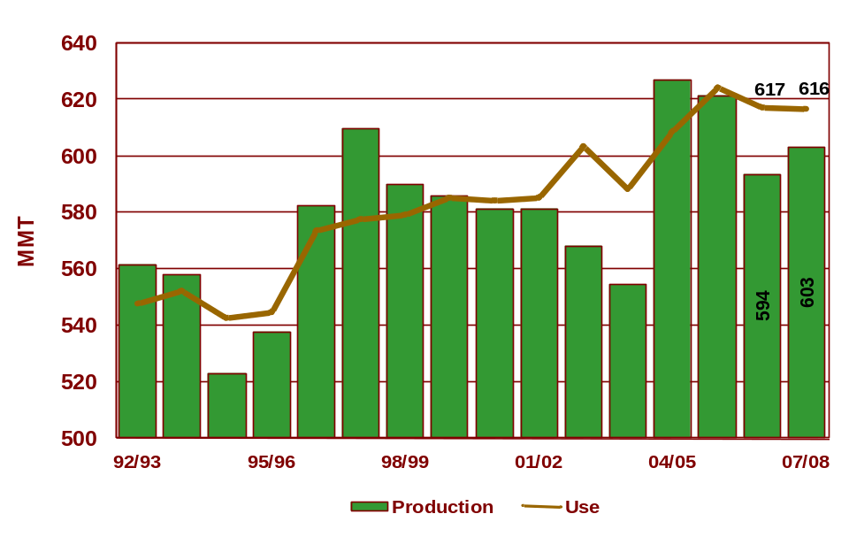
Figure 1: World Wheat Production and Use

Source: World Wheat Demand and Supply Situation, US Wheat Associates, January 2008
Some of the factors affecting the world wheat market, based on a report from US Wheat associates, are declining world stocks, drought, high ocean freight transportation rates, high corn/wheat price spread, possible restrictions on export, and declining wheat plantings [8].
Overall, approximately 50 percent of US wheat is exported; wheat is considered one of the largest agricultural exports in the US [2]. US exports fell about 10 percent in 2006/07, while the US wheat had a 23 percent market share in the world market [Figure 2]. The world wheat trading dropped nearly 7 percent to 107 million metric tons (3,946 million bushels). While Canada’s market share increased, Australia’s market share decreased. The ending world wheat stocks decreased more than 16 percent to 125 million metric tons (4,589 million bushels).

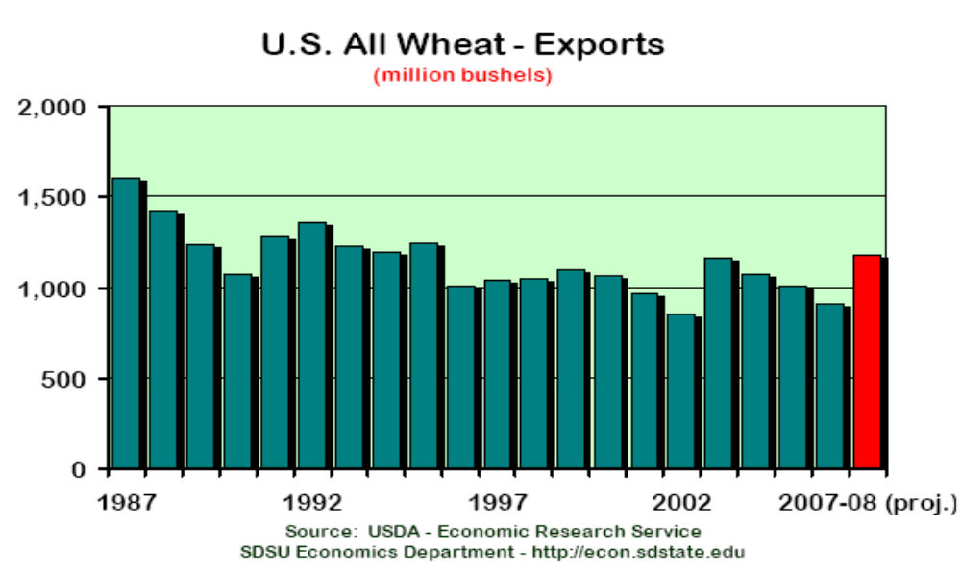
Figure 2: US All Wheat – Exports

The top ten customers for US wheat are Egypt, Japan, Mexico, Nigeria, Iraq, EU-27, Philippines, S. Korea, Algeria, and Taiwan [Figure 3]. In 2006/07, the US was the fourth largest wheat producing country in the World after European Union, China and India.
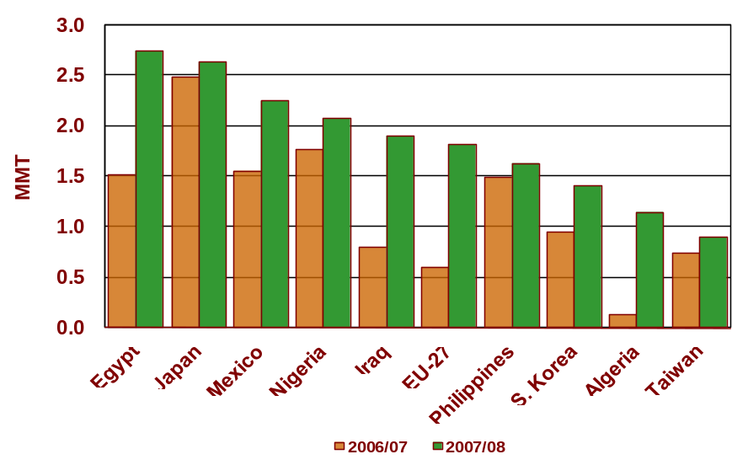
Figure 3: Top Ten Customers for US Wheat

Source: World Wheat Demand and Supply Situation, US Wheat Associates, January 2008
Washington State Outlook
In 2002, the economic impact of the wheat industry in Eastern Washington was $1.02 billion, while it was $1.18 billion for the whole state [9]. Wheat production generated $824.3 million and government payments added an additional $83.8 million to the state’s economy. Transportation, handling and storing of wheat and wheat processing created $112.5 million in economic value for the wheat industry [10].
The quantity of wheat stored in Washington State as of September 1, 2007 was at its lowest level since 1973. Total quantity stored decreased 19 percent to a total of 116.3 million bushels in 2007 [11]. In 2007 the total wheat production in Washington State decreased from 140.1 million bushels to 128.7 million [Figure 4].
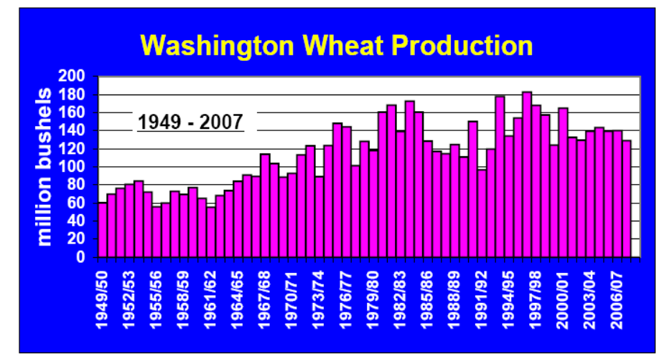
Figure 4: Washington Wheat Production

Source: Washington Wheat Commission
In 2007, average price for wheat received by farmers went up significantly, in parallel with the US average price. Average price of wheat in Washington State was below the average price of wheat in the nation [Figure 5].

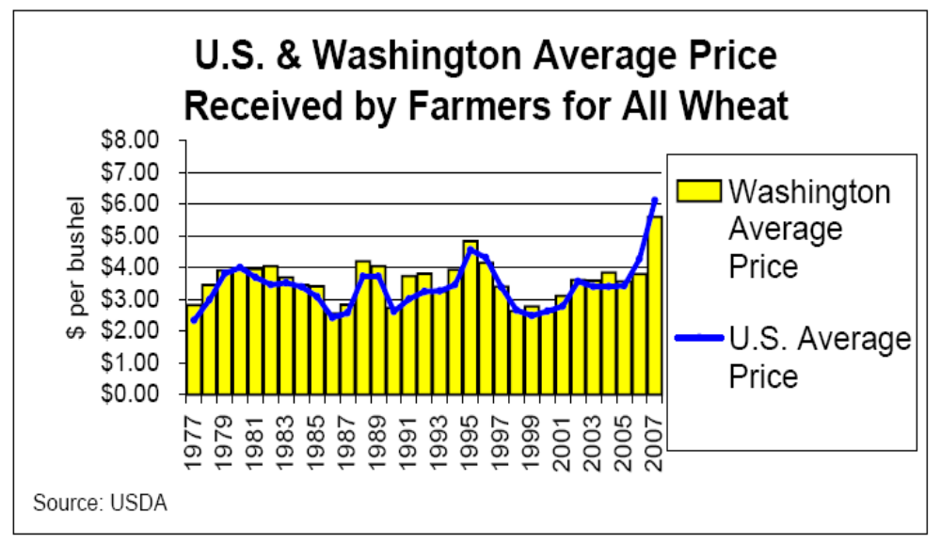
Figure 5: U.S & Washington Average Price Received by Farmers for All Wheat

Total value of the Washington State Wheat and Meslin exports has increased from $483 million in 2003 to $895 million in 2006, while the percentage share of the wheat exports increased from 1.4 percent to 1.7 percent (Table 1).

Table 1: Export Value and Percentage Share of Wheat and Meslin in Washington State
 | Year
 | 2003 | 2004 | 2005 | 2006
Value of Washington Wheat and Meslin Exports  ($ million) | 483 | 830 | 584 | 895
Proportion of Total State Exports | 1.4 | 2.5 | 1.5 | 1.7
Source: Total US Exports (Origin of Movement) via Washington State, Foreign Trade Statistics

In 2007, total wheat production in Washington State was 128,722,000 bushels. Whitman (32,081,400 bushels), Lincoln (19,875,900 bushels), Walla Walla (16,193,600 bushels), Adams (14,895,900 bushels), and Spokane (7,754,200 bushels) were the top five county producers in the state. Figure 6 demonstrates the 2007 Washington State wheat production intensity at the county level.
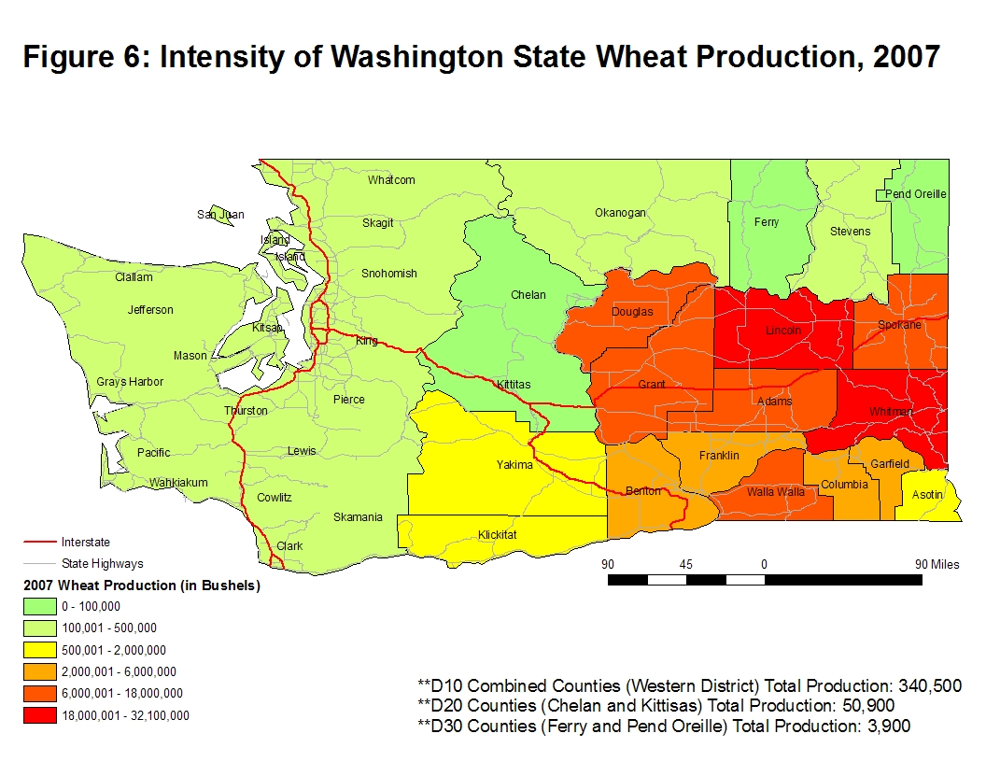
STATEWIDE TRANSPORTATION AND LOGISTICS
The wheat industry in Eastern Washington relies heavily on truck-barge shipments, utilizing river ports along the Snake/Columbia River to move grain to ocean terminals. Harvested wheat is taken to storage or grain elevators by farmers and is then transported by truck to regional rail or barge loading facilities after it is sold. More than 60 percent of the exports travel by barge from ports along the Snake-Columbia river system to Portland. Approximately 36 percent of the wheat is transported by rail to coastal grain terminals. From the seaport terminals, wheat is exported to the other countries. Fifty-five percent of the Washington wheat is transported by truck/barge, 5 percent is transported by rail/barge, 22 percent is transported by rail, 1 percent is transported to the final markets by truck, and 15 percent is transported to the other elevators by truck [2].
STATEWIDE FREIGHT PROJECTIONS
Wheat production in Washington State has shown variations between 1980 and 2007. The highest production year was in 1996 with 182,670,000 bushels, while the lowest production year was in 1991 with 98,600,000 bushels. The annual average growth rate between 1980 and 2007 was estimated at 1.0 percent.
During the calculations of the future projections on wheat production, the estimated historical growth rate of 1.0 percent was used as the future growth rate. Projections were calculated on the county level and forecasted statewide for the years 2008 through 2027 (provided in Table 2), along with the growth rates for each time period. Historical and projected statewide production is also demonstrated in Figure 7. The blue bars indicate the historical production volumes and the red represents forecasted figures.

Table 2: Base Year and Forecasted Wheat Production
Year | Annual Growth Rate | Year | Production (Bushels)
2007-2008 | 0.01 | 2007 | 128,722,000
2008-2012 | 0.05 | 2012 | 135,288,116
2008-2017 | 0.10 | 2017 | 142,189,169
2008-2027 | 0.21 | 2027 | 157,065,302

Figure 7: Historical and Projected Statewide Wheat Production
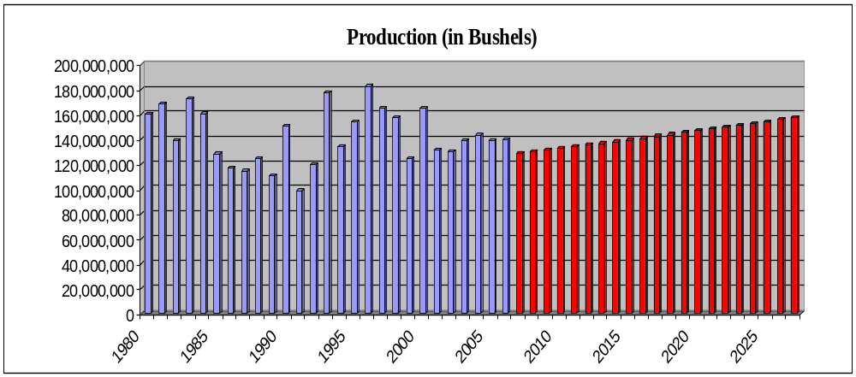

The allocation of wheat flows onto specific highways (Figure 8) was created based on the results of the transportation optimization model developed as part of the Eastern Washington Intermodal Transportation Study in 1998 which model wheat shipments in the region [12]. Figure 8 illustrates the optimized wheat shipments with all modes available to the shippers and represents a close approximation of how wheat flows from production areas to final markets based on the cost minimization decision rule. Highway wheat flows are segregated by the number of standard deviations the flow on each highway segment is from the mean. Based on the figure it can be easily observed that many of Eastern Washington’s roads and highways are utilized for wheat shipments but heavy concentrations of truck traffic occur for those highways accessing river ports [12].

In Figure 8 the highways with positive wheat flows can be easily identified with the heavier traffic progressing from colors purple, red, and yellow indicate highways with heaviest wheat traffic, while highways represented by green color receive slightly lighter traffic compared to the other colors [12].

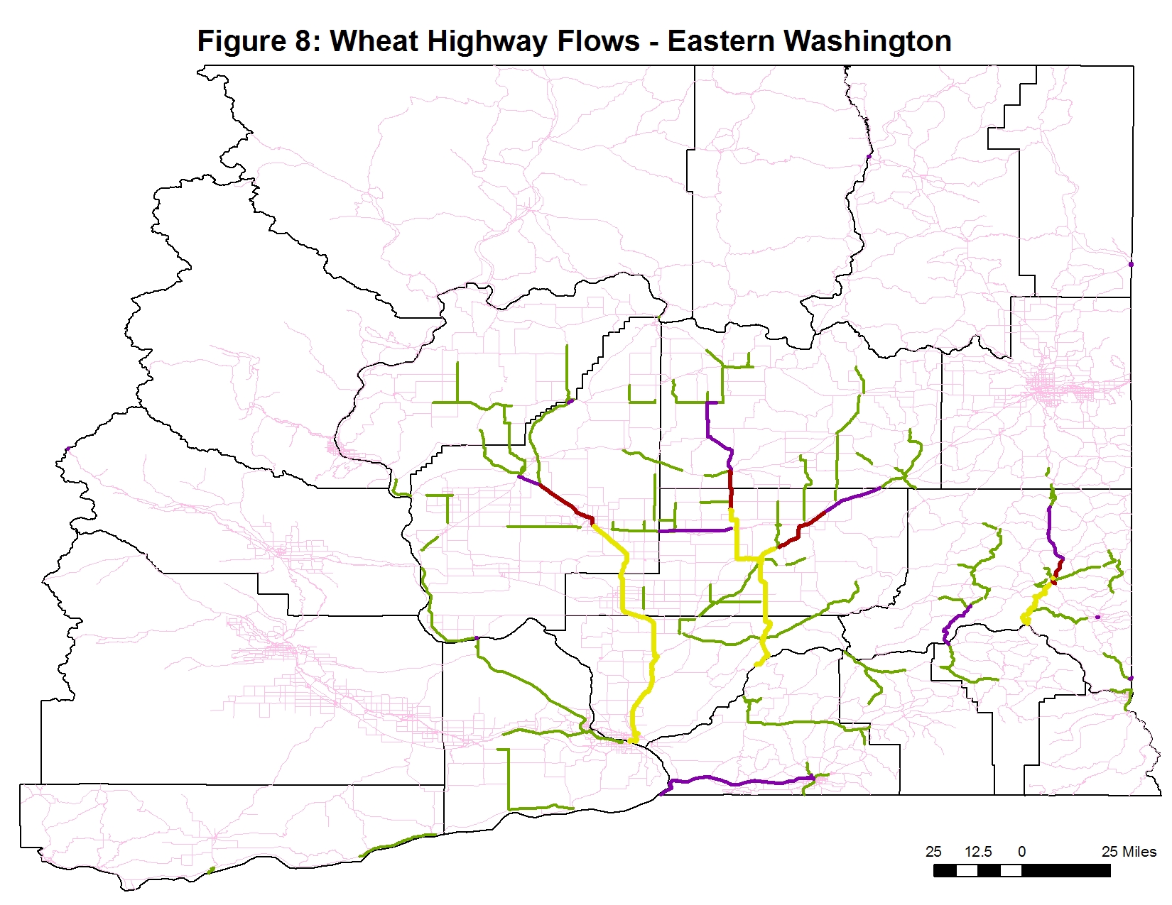
Table 3 below represents the production and the colors associated with the production for the years 2007, 2012, 2017, and 2027. Highways with wheat shipments larger than three standard deviations to the right represent the heaviest wheat truck traffic flows [12].

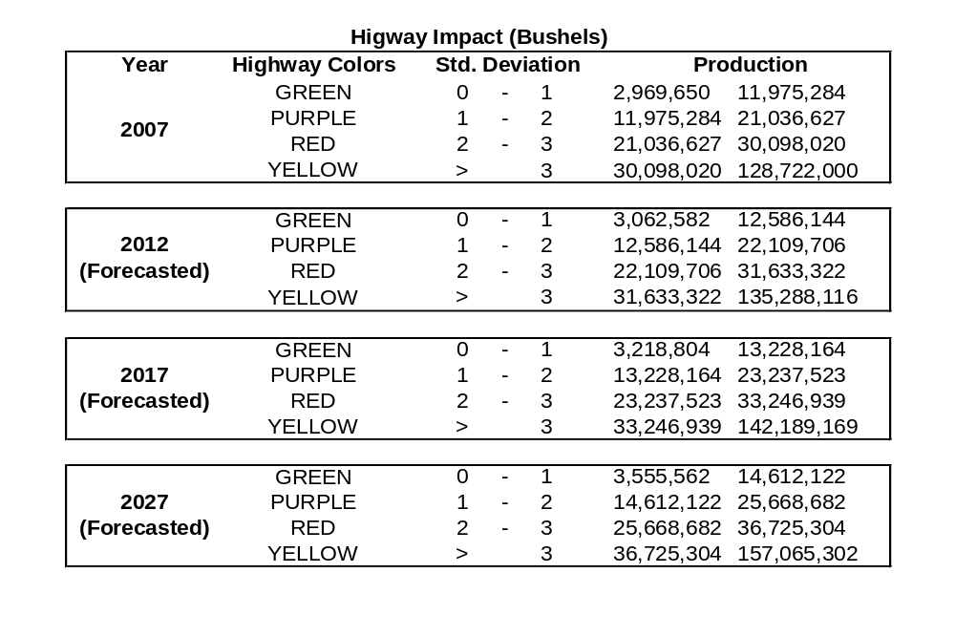
Table 3: Highway Impact for years 2007, 2012, 2017 and 2027 (Production)

River ports and the highways providing the infrastructure backbone to these ports draw the largest wheat volume [12]. State route192 and SR195 support heavy truck traffic to access the port at Almota while SR127 experiences heavy truck volumes approaching Central Ferry [12]. State route 21 and SR 263 are the critical highways for the shipments to Windust, while SR395 is the main highway serving the Tri-Cities’ ports. The largest volumes in the Tri-Cities are received at Almota and Windust [12]. The greater part of the truck-barge wheat is shipped to the river ports above Tri-Cities [12].

Table 4 represents the truck trips and colors associated with those figures for the years 2007, 2012, 2017 and 2027. Average payload capacity was assumed at 20 tons per truck, and a one bushel equivalent was assumed to be 0.027216 tons.

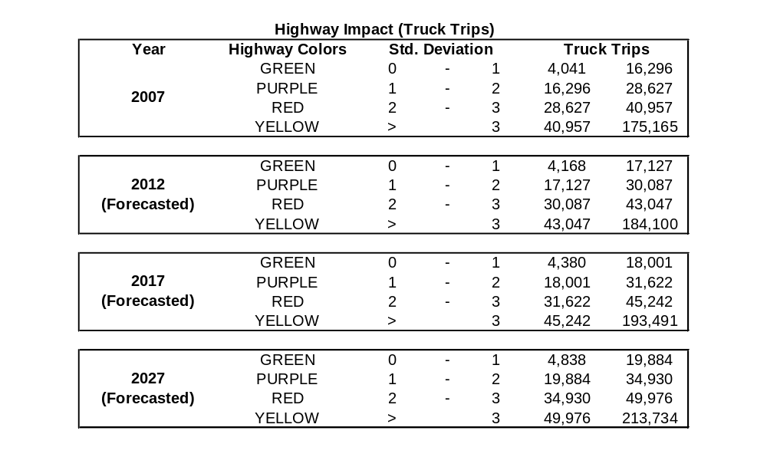
Table 4: Highway Impact for years 2007, 2012, 2017 and 2027 (Truck Trips)

CONCLUSION
The large majority of wheat produced in Eastern Washington accesses final markets via truck-barge, utilizing the Snake/Columbia River to transport wheat to Portland, OR to be loaded onto ocean vessels. The remaining utilizes a truck-rail combination. State highways incur the largest amount of mileage from truck shipments; however county roads generate the largest infrastructure investment due to lower highway design. Many Eastern Washington roads and highways are utilized for wheat shipments, with heavy concentrations occurring at grain elevators/terminals and river port facilities. State route 192, SR195, SR 127, SR21, SR263 and SR395 are the heavily utilized state roads in Eastern Washington.

REFERENCES
[1] 2007 Washington Wheat Facts
[2] Washington Wheat Facts, 2006, Washington Wheat Commission
[3] http://www.wawg.org/
[4] http://wbc.agr.mt/gov/Consumers/General/WheatEconomicImpactByState2005.pdf
[5] http://www.wawg.org/images/E0177801/Latinmarkets_09.07.pdf
[6] USDA, Economic Research Service, Wheat: Trade
[7] US Wheat Associates, Annual Report, 2006/2007
[8] “Top 10 factors affecting the wheat market”, Sep 15, 2007, by Elton Robinson Farm Press Editorial Staff
[9] Agri-Facts, National Agricultural Statistics Service, USDA
[10] Washington Transportation Plan Update Freight Movement (Draft), June 20, 2005, Washington State Department of Transportation
http://www.wsdot.wa.gov/NR/rdonlyres/9B7EB617-3B6F-41AB-B9A4-609EE4FFEF57/0/WTP_FreightUpdate5mb.pdf
[11] http://www.washingtongrainalliance.com/images/E0177801/EconomicImpact.pdf
[12] “Transportation Optimization Marketing for Commodity Flow, Private Shipper Costs, and Highway Infrastructure Impact Analysis”, May 1998, by Eric L. Jessup

