# Washington State Industry Outlook and Freight Transportation Forecast:

# Wine Grape Industry

Prepared for the

**Washington State Department of Transportation**

**Freight Systems Division**

By

**Selmin Creamer**

*Research Assistant*

**Dr. Eric Jessup**

*Assistant Professor*

Transportation Research Group

School of Economic Sciences

Washington State University

Pullman, WA 99164-6210

**September 2008**

# TABLE OF CONTENTS

# Study Goal ii

# Industry Information 1

# Economic Outlook 4

# Washington Outlook 6

# Statewide Transportation and Logistics 6

# Statewide Freight Projections 7

# Highway Assignments 10

# Conclusions 16

# References 17

# TABLES

# Table 1: Base year and forecasted years Production 8

# Table 2: Wine Grapes Production (in Tons) for the State, by Region 9

# Table 3: Bulk wine Truck Loads to Puget Sound Wineries 10

# Table 4: Wine Grape Production and Total Truck Loads for Walla Walla Valley 11

# Table 5: Wine Grape Production and Total Truck Loads for Yakima Valley 12

# Table 6: Wine Grape Production and Total Truck Loads for Columbia Valley 12

# Table 7: Wine Grape Production and Total Truck Loads for Puget Sound 12

# Table 8: Number of Truck Shipments, by Highway for Yakima Valley 13

# Table 9: Number of Truck Shipments, by Highway for Columbia Valley 14

# Table 10: Number of Truck Shipments, by Highway for Walla Walla Valley 15

# Table 11: Number of Truck Shipments, by Highway for Puget Sound 15

# FIGURES

# Figure 1 Location of Washington State Viticulture Areas 3

# Figure 2 US Wine Exports in Million Dollars, 1996-2006 5

# Figure 3 US Wine Imports in Million Dollars, 1989-2002 5

# Figure 4 Historical and Projected Statewide Wine Grape Production 8

# Figure 5 Projected Wine Grape Production, by Region 9

# Figure 6 Projected Wine Grape Production, by Region 10

# Figure 7 Major Marketing Regions for Washington Wine 12

# Figure 8 2006 Yakima Valley Wine Grape Production Intensity 14

# Figure 9 2006 Columbia Basin Wine Grape Production Intensity 16

# Figure 10 2006 Wenatchee Wine Grape Production Intensity 18

**STUDY GOAL**

The goal of this report is to offer state and regional transportation planner’s necessary information regarding future freight flow specific to the wine grapes industry. This is accomplished by providing general industry information regarding the prospects for increased trade and production growth and estimation of a prediction model for statewide wine production over the next twenty years. This prediction model is estimated using historical production information at the Township, Section, and Range level and is then allocated to truck shipments and highways using information and data collected from a recent survey of the wine grape industry regarding transportation characteristics of the industry.

**INDUSTRY INFORMATION**

In 2005, grapes were one of the highest valued fruit crops and sixth highest of all US crops. Juice grapes account for nine percent of the total grape production. Over 615,210 tons of juice grapes produced juice and juice products with a retail value of approximately $2.8 million. In the US approximately 23,000 farms raise grapes, 90 percent of which are grown in field areas of less than 100 acres. The total US grape bearing acreage in 2005 was 934,750 acres with a total value of over $3.5 billion [1].

In 2006, the number of wineries had doubled since 1999, reaching 5,435 wineries nationwide. The total shipping value of wine sales were over $11 billion; $700 million in exports and $1.8 billion in direct winery sales. In 2006 the total retail value of wine was $28 billion. Most of the growth came from smaller, boutique wineries. Though California is the top producer of wine, every state has at least one winery. The evident growth in wineries is observed in states such as Washington and Oregon, and to a lesser extent in Iowa, Virginia, and North Carolina [2]. The wine and grape industries have benefited from increased interest in America’s new “experiential” consumer in agricultural, culinary, and wine tourism. Wineries are now attracting over 27 million visitors annually, stimulating the local and rural economies [1].

Between 2001 and 2005, full-time nationwide winery employment increased from 25,363 to 33,560. In 2005, total employment provided by wine, grapes, grape products, and related sectors reached 1,088,344 jobs nationwide. Total US wine and grape product exports were over $1.785 billion.

As of 2005, California produces approximately 90 percent of the nation’s wine and is home to 847 wineries. In 2005, California produced 6,130,000 tons of grapes; followed by Washington producing 415,000 tons. The 2005 value of utilized production was approximately $2.73 billion and $142 million for California and Washington respectively.

Some of the challenges faced by the US wine industry include the scarcity of skilled labor, climatic risks, increased competitive pressures in the grape juice market, volatility of the wine grape market, shortage of certain wine grapes, competition from imports, and lack of federal support to guarantee the long-term growth of the industry [1].

Some of the opportunities in the US wine industry include the growth of wine tourism, direct-market shipments allowing better access for consumers as well as better market opportunities for wineries, increased collaboration among industry organizations and businesses, changing demographics and consumer values, and retail and restaurant promotions contributing to a growing market for wine [1].

Washington State’s wine industry employs more than 19,000 people and contributes $3 billion to the statewide economy and more than $4.7 billion to the US economy annually. Even though Washington State doesn’t have a history of producing wine, the industry has more than doubled in size during the past ten years and now ranks second in total wine production nationwide. According to the Washington State Wine Commission, Washington State now has over 530 wineries, 350 grape growers and 31,000 vineyard acres. [3].

Many of the profits from wine are kept within the state boundaries as a result of the vertically integrated wine industry. Washington State winery revenues increased 51 percent from $289 million in 1999 to $436 million in 2006. This corresponded with increases in wine related tourism expenditures that also increased between 1999 and 2006 to reach $237.6 million. [3].

While small wine grape acreages are planted in limited areas around the Puget Sound, the primary wine grape growing region is in Eastern Washington including Benton, Yakima, Grant, Franklin, Klickitat, and Walla Walla counties. Overall, 99 percent of Washington State’s wine grapes are produced east of the Cascade Mountains [4].

Grapes produced in Washington are processed into wine and juice. The acreage devoted to red wine grapes surpassed that for white grapes due to the growing demand in red wines. The wine grapes in the state are grown under contracts between growers and a winemaker. The climate of Eastern Washington’s long, hot summer days and cool nights allow production of high quality grapes at a low cost per acre compared to California [4].

**Figure 1: Location of Washington State Viticulture Areas**

**Source:** Washington Vineyard Acreage Report 2006

Washington State’s Viticultural areas are illustrated above in Figure 1. Horse Heaven Hills, Columbia Gorge, Rattlesnake Hills, Wahluke Slope, and Red Mountain are some of the regions where wine grapes are also grown.

**ECONOMIC OUTLOOK**

**Domestic versus International**

Throughout the 1970’s and 80’s, wine consumption in the US increased, while in the 1990’s it decreased slightly. Per capita consumption dropped from 2.3 gallons to 1.7 gallons from 1989 to 1995. In 2000, per capita consumption was 2 gallons [5]. As of 2005, the US ranked third in the world in wine consumption after France and Italy and ranked fourth in the world in wine production after France, Italy, and Spain [6]. According to the Wine Institute, the US and Canada are the only two markets in which the demand for wine priced above $5 per 750ml bottle has been growing [1].

Consumer interest in wine has led to an increase in the number of labels. Most of the imported wine competes at the lower end of the quality spectrum with bottles selling around $10 to $15. However, the average market price for all wine is between $15 and $20 and is increasing [2].

The share of US made wine in the domestic market decreased from 81.6 percent in 1998 to 73 percent in 2005. Imports to the US increased with a focus on the under $10 per bottle market. As of 2005, imports represented more than 27 percent of the wine consumption in the US. Leading importers are Australia, Italy, and France. The countries with the fastest growing exports to the US are New Zealand and South Africa. Aggressive marketing campaigns by the major exporters penetrated the growing US wine market for mid-priced and more expensive wines [1].

In 2006, US wine exports grew by 30 percent in value and four percent in volume compared to 2005. Ninety-five percent of the export volume came from California, totaling $876 million. Exports to Europe increased 48 percent, while wine exports to Canada grew 29 percent by value. Other growing markets include China, up 53 percent, Singapore, up 68 percent, and Hong Kong, up 19 percent in value [7].

**Figure 2: US Wine Exports in Million Dollars, 1996-2006**



**Source:** Source: Wine Institute using data from US Dept. of Commerce, USA Trade Online. Gallons do not convert exactly due to rounding. History revised

Figure 2 illustrates the historical trend in US wine export revenues, and wine production in gallons. US wine export revenues experienced a large increase from 2003 to 2004, but the increase was almost neutralized by a decrease from 2004 to 2005, and 2006 had the highest wine export revenues of the previous ten years.

**Figure 3: US Wine Imports in Million Dollars, 1989-2002**



**Source:** Commodity Profile: Wines and Wine Grapes, Agricultural Issues Center University of California, Updated November 2003

US wine imports experienced a continuous increase between 1989 and 2002, except for the year 1992. US wine imports experienced a sharp increase from 2001 to 2002 (Figure 3).

**Washington Outlook**

More than 75 percent of the wine produced in Washington is shipped out-of-state, valuing at $225 million [3]. The number of Washington wineries in 2006 was 427 with 232 wineries crushing grapes [8]. The number of wineries increased from 160 in 1999 to 534 in 2008. The number of grape farm entities reached 325 in 2006 with 57,000 grape bearing acres. In 2006, the total value of farm gate grapes was $144 million, and the total value of grape juice production was $463 million. The total value of state and local taxes paid by the wine, grape, and grape juice products sectors was $145.1 million. These sectors also paid an additional $268.7 million in federal taxes and $57.5 million in other state taxes [3].

In the established vineyards, approximate production costs are $3,773 per acre. Per acre average revenue is $2,700 in the third year and $4,320 in the fourth year. Losses are incurred during the first three years with an average net return of $811 in the fourth year [4].

In 2006, 120,000 tons of wine grapes were produced on the bearing acreage of 29,500. Yield per acre was 4.07 tons, and average price per ton was $942. One hundred percent of the production was utilized with the value of $113,040,000 [9]. Figure 4 illustrates the 2006 Washington State wine grape production in tons at the Township, Section, and Range level.

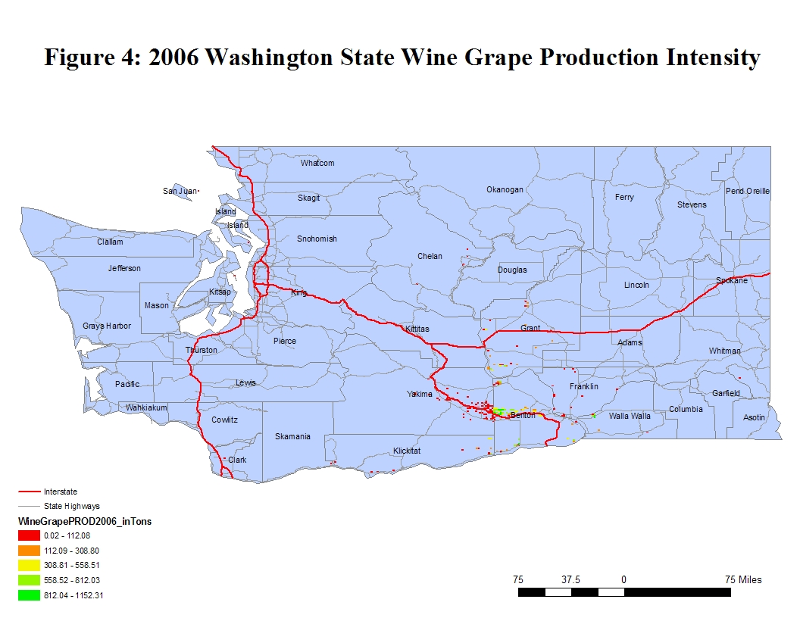

**STATEWIDE TRANSPORTATION AND LOGISTICS**

The transportation of wine can be broken down into three components; wine grape, bulk wine, and bottled wine movements. Wine grape movements typically use van style trailers to transport grapes to processing facilities with an average payload weight of 30,124 lbs. Bulk wine movement typically occurs in tankers from processing facilities to wineries with an average payload weight of 37,200 lbs. Finished bottled wine movements are in van style trailers are used to carry finished products from wineries to their final destinations with an average payload weight of 41,469 lbs. [10].

Wine industry related freight traffic peaks occur between late August and early November, during harvest. During this peak period, a large number of trucks carry grapes from fields to be processed. Even though the majority of bulk juice falls into the same time frame, bulk unfinished wine can be shipped throughout the year. The months of November through January are the peak seasons for the wine consumption, thus the flow of the finished product is continuous during this period [11].

The most critical route for the wine industry is I-82. A large number of wineries are located in the vicinity of I-82. Interstate five and I-90 are also critical routes, due to the fact that shipments of grapes and juice west to wineries rely on these routes. Interstate five and I-90 are the major corridors to large markets for finished wine products [11].

**STATEWIDE FREIGHT PROJECTIONS**

Wine grape production acreage data for the state was received from the Washington State Department of Agriculture. The township-range-section (TRS) level acreage data used in this study is the compilation of the results from a continuum of surveys conducted by the Department of Agriculture between 1999 and 2007. The wine grape production figures on county levels were not available. Thus, the 2002 acreage information for each county was used to calculate the acreage ratios. The calculated ratios were then used to reach the annual production figures for each county. The wine grape production figures for each county were allocated to the TRS level by using yield and acreage information calculated for each county. The TRS level acreage data was used to calculate the acreage ratios of each TRS in each county. The county wine grapes production figures that were calculated prior were multiplied with the TRS acreage ratio information for each county. Eventually 2006 wine grape production data for Washington State were reflected on the township-range-section level.

An average annual growth rate of 1.1 percent was estimated from historical production volumes and used to forecast the production volumes between 2007 and 2027. The production levels for the years 2007, 2012, 2017, and 2027 were projected at the TRS level. The average annual growth rate from historical production information dating back to 1980 was very high at 18.4 percent. However, considering the fast growth of the wine grape production and the high historical growth rates and industry analyses, it was considered unlikely that Washington State will experience that same level of wine grape production growth over the next 20 years. Thus, the forecast utilizes a more modest annual growth rate of 1.1 percent.

The forecasted statewide wine grapes production for the years 2007 through 2027 are provided in Table 1, along with the growth rates for each time period. Historical and projected statewide production is also demonstrated in Figure5. The blue bars indicate the historical production volumes and the red represents forecasted figures.

**Table 1: Base year and forecasted years Production**

|  |  |  |  |
| --- | --- | --- | --- |
| **Year** | **Annual Growth Rate** | **Year** | **Production in Tons** |
| 2006-2007 | 0.012 | 2007 | 121,426 |
| 2006-2012 | 0.071 | 2012 | 128,557 |
| 2006-2017 | 0.131 | 2017 | 135,688 |
| 2006-2027 | 0.250 | 2027 | 149,950 |

**Figure 5: Historical and Projected Statewide Wine Grape Production**

The forecasted wine grape production for each region is provided in Figure 6. The forecasted production volumes for the state and by each region are shown in Table 2. The Walla Walla Valley, Yakima Valley, Columbia Valley, and Puget Sound regions dominate the statewide production.

**Figure 6: Projected Wine Grapes Production, by Region**



**Table 2: Wine Grapes Production (in Tons) for the State, by Region**

|  |  |  |  |  |  |
| --- | --- | --- | --- | --- | --- |
| **Year** | **Washington State** | **Walla Walla Valley** | **Yakima**  **Valley** | **Columbia**  **Valley** | **Puget Sound** |
| 2006 | 120,000 | 7,024 | 44,758 | 67,999 | 219 |
| 2007(Forecast) | 121,426 | 7,107 | 45,290 | 68,807 | 222 |
| 2012 (Forecast) | 128,557 | 7,524 | 47,949 | 72,848 | 235 |
| 2017 (Forecast) | 135,688 | 7,942 | 50,609 | 76,889 | 248 |
| 2027 (Forecast) | 149,950 | 8,777 | 55,929 | 84,971 | 274 |

Walla Walla Valley wine grape production represents the Walla Walla county production. Yakima Valley wine grape production represents the Yakima county production. Columbia Valley wine grape production is the total county productions for Benton, Franklin, Grant, and Klickitat, while Puget Sound wine grape production is the total county productions for Whatcom, Thurston, Skagit, Pierce, Kitsap, King and Island.

**HIGHWAY ASSIGNMENTS**

Each wine grape production region is forecasted separately and converted into truck load equivalents leaving each region for bulk wine and finished wine products. The information of how shipments leave and which highways are traversed to each destination were obtained from the SFTA’s industry survey which was designed to capture information concerning the timing, size, origin, destination, route, and shipping characteristics of Washington grape and wine movements.

**Bulk Wine Movements**

Bulk wine movements from Columbia, Walla Walla, and Yakima Valleys to Puget Sound wineries were analyzed. Based on the 2002 SFTA Survey, Puget Sound wineries were responsible for processing approximately 1,000,000 gallons (3,783 tons) of wine, which was 3.29 percent of Washington States total wine grape production. During the calculation of the truck loads this 3.29 percent was used as a reference to determine the amount of production transported to the wineries in Puget Sound. In order to convert tons of wine grapes production into truck load equivalents, the truck capacity for wine grapes was estimated to be 16.87 tons (37,200 pounds).

**Table 3: Bulk Wine Truck Loads to Puget Sound Wineries**

|  |  |  |  |  |
| --- | --- | --- | --- | --- |
| **Shipment Origin** | **2007 (Forecast)** | **2012**  **(Forecast)** | **2017**  **(Forecast)** | **2027**  **(Forecast)** |
| **Walla Walla Valley** | 13 | 14 | 15 | 16 |
| **Yakima Valley** | 84 | 88 | 93 | 103 |
| **Columbia**  **Valley** | 127 | 134 | 142 | 157 |

During the transportation of bulk wine from Walla Walla Valley to Puget Sound, I-90, I-82, US-12, I-182, I-405, and SR-221 are the most heavily used routes, while Yakima Valley uses all mentioned except US-12 and I-182.

State Route-243, I-90, I-405, I-182, I-82, SR-221 and SR-14 are the most commonly used routes in transportation of bulk wine from Columbia Valley to Puget Sound wineries.

**Finished Wine Movements**

Shipments carrying finished wine products most commonly utilize van type trailers, both with and without temperature control. Finished wine movements from Columbia, Walla Walla, Yakima Valleys and Puget Sound to British Columbia, California, Western Washington and Eastern markets were included as part of this analysis. In order to convert tons of wine grapes production into truck load equivalents, the truck capacity for wine grapes was estimated to be 18.81 tons (34,161 pounds). During the calculations of the finished wine movements, the bulk wine amount sent to Puget Sound from Walla Walla Valley, Columbia Valley, and Yakima Valley was considered.

Tables 4 through 7 present the total volumes of finished wine products leaving each production region and the total number of truck loads required to transport the finished products to their final destinations.

**Table 4: Wine Grape Production and Total Truck Loads for Walla Walla Valley**

|  |  |  |
| --- | --- | --- |
| **Walla Walla Valley** | **Volume**  **(Tons)** | **Unique Truck Loads** |
| **Finished Wine** |
| 2007 (Forecast) | 6,886 | 366 |
| 2012 (Forecast) | 7,290 | 388 |
| 2017 (Forecast) | 7,695 | 409 |
| 2027 (Forecast) | 8,503 | 452 |

**Table 5: Wine Grape Production and Total Truck Loads for Yakima Valley**

|  |  |  |
| --- | --- | --- |
| **Yakima Valley** | **Volume**  **(Tons)** | **Unique Truck Loads** |
| **Finished Wine** |
| 2007 (Forecast) | 43,880 | 2,333 |
| 2012 (Forecast) | 46,457 | 2,470 |
| 2017 (Forecast) | 49,034 | 2,607 |
| 2027 (Forecast) | 54,188 | 2,881 |

**Table 6: Wine Grape Production and Total Truck Loads for Columbia Valley**

|  |  |  |
| --- | --- | --- |
| **Columbia Valley** | **Volume**  **(Tons)** | **Unique Truck Loads** |
| **Finished Wine** |
| 2007 (Forecast) | 66,666 | 3,544 |
| 2012 (Forecast) | 70,581 | 3,752 |
| 2017 (Forecast) | 74,496 | 3,960 |
| 2027 (Forecast) | 82,326 | 4,377 |

**Table 7: Wine Grape Production and Total Truck Loads for Puget Sound**

|  |  |  |  |  |
| --- | --- | --- | --- | --- |
| **Puget Sound** | **Production Volume**  **(Tons)** | **Transported Bulk Volume (Tons)** | **Total Volume (Tons)** | **Unique Truck Loads** |
| **Finished Wine** |
| 2007 (Forecast) | 222 | 3,772 | 3,994 | 212 |
| 2012 (Forecast) | 235 | 3,994 | 4,229 | 225 |
| 2017 (Forecast) | 248 | 4,216 | 4,464 | 237 |
| 2027 (Forecast) | 274 | 4,659 | 4,933 | 262 |

The major marketing regions for Washington’s finished wine products are British Columbia, California and Washington markets. During the calculation of truck loads, it was assumed that all the three regions in the analysis of transport of the finished wine products were based on their weighted production percentages. Based on the SFTA Wine Grapes Survey conducted, key highways used for transportation of finished wine products are I-90, I-5, I-405, I-82, I-182, and SR-221.

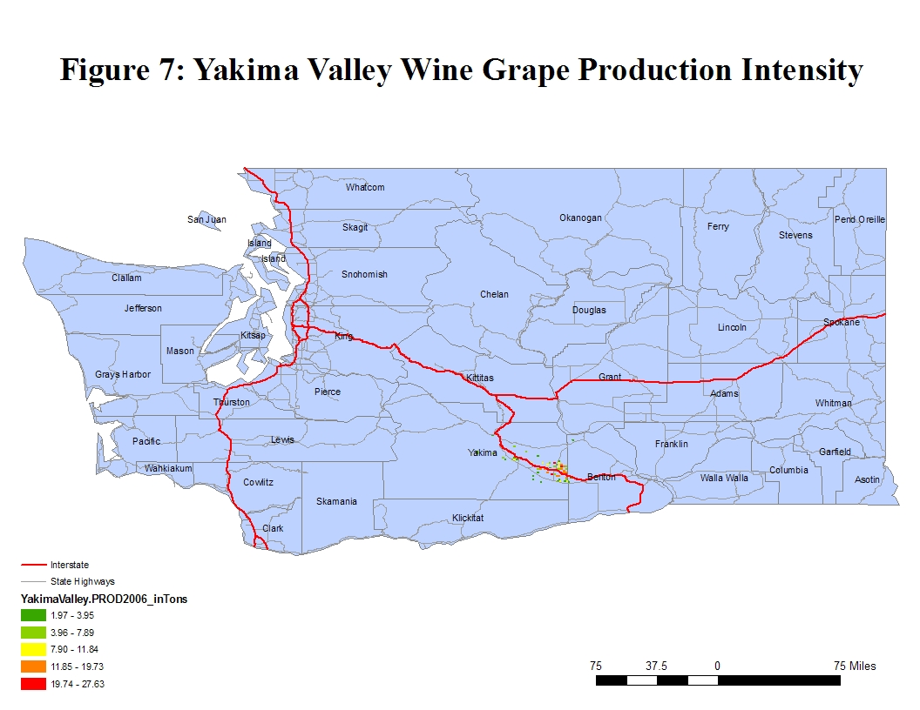

**Table 8: Number of Truck Shipments, by Highway for Yakima Valley**

|  |  |  |  |  |
| --- | --- | --- | --- | --- |
| **Yakima**  **Valley** | **2007** | **2012** | **2017** | **2027** |
|
| **Major Routes** |
| I-182 | 366 | 387 | 409 | 452 |
| I-82 | 2,333 | 2,470 | 2,607 | 2,881 |
| I-405 | 1,601 | 1,695 | 1,789 | 1,977 |
| I-5 | 1,601 | 1,695 | 1,789 | 1,977 |
| I-90 | 1,967 | 2,082 | 2,198 | 2,429 |
| SR22 | 732 | 775 | 818 | 904 |
| SR221 | 1,601 | 1,695 | 1,789 | 1,977 |
| SR14 | 366 | 387 | 409 | 452 |
| **Total** | **2,333** | **2,470** | **2,607** | **2,881** |

Figure 5 illustrates the wine grapes production intensity for Yakima Valley on the TRS level. Most commonly used routes for transportation of finished wine products from Yakima Valley to the final destinations are I-182, I-82, I-405, I-5, I-90, SR22, SR221, and SR14. Table 8 shows the aggregate number of truck loads on each highway during the transportation of Yakima Valley wine to the final destinations.

In Tables 8 through 11, the total value in the bottom row of each table represents the total unique truck trips for each year. Given that many of truck trip routes are common to several different highways, summation of trucks on all highways results in exceeding the total unique truck trips due to the fact that each truck trip is not unique to one and only one highway.

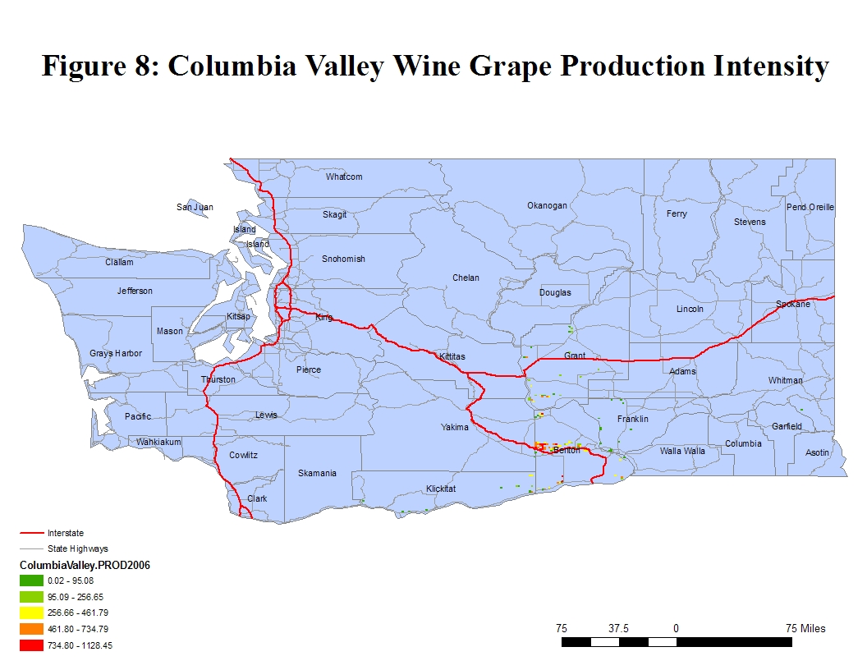

**Table 9: Number of Truck Shipments, by Highway for Columbia Valley**

|  |  |  |  |  |
| --- | --- | --- | --- | --- |
| **Columbia Valley** | **2007** | **2012** | **2017** | **2027** |
|
| **Major Routes** |
| I-182 | 3,544 | 3,752 | 3,960 | 4,377 |
| I-82 | 3,544 | 3,752 | 3,960 | 4,377 |
| I-405 | 2,432 | 2,575 | 2,718 | 3,004 |
| I-5 | 2,432 | 2,575 | 2,718 | 3,004 |
| I-90 | 3,544 | 3,752 | 3,960 | 4,377 |
| SR22 | 2,988 | 3,164 | 3,339 | 3,690 |
| SR221 | 2,988 | 3,164 | 3,339 | 3,690 |
| SR14 | 2,988 | 3,164 | 3,339 | 3,690 |
| **Total** | **3,544** | **3,752** | **3,960** | **4,377** |

Figure 8 illustrates the wine grape production intensity for Columbia Valley on the TRS level. Most commonly used routes for transportation of finished wine products from Columbia Valley to the final destinations are I-182, I-82, I-405, I-5, I-90, SR22, SR221, and SR14. Table 9 shows the aggregate number of truck loads on each highway during the transportation of Yakima Valley wine to the final destinations.

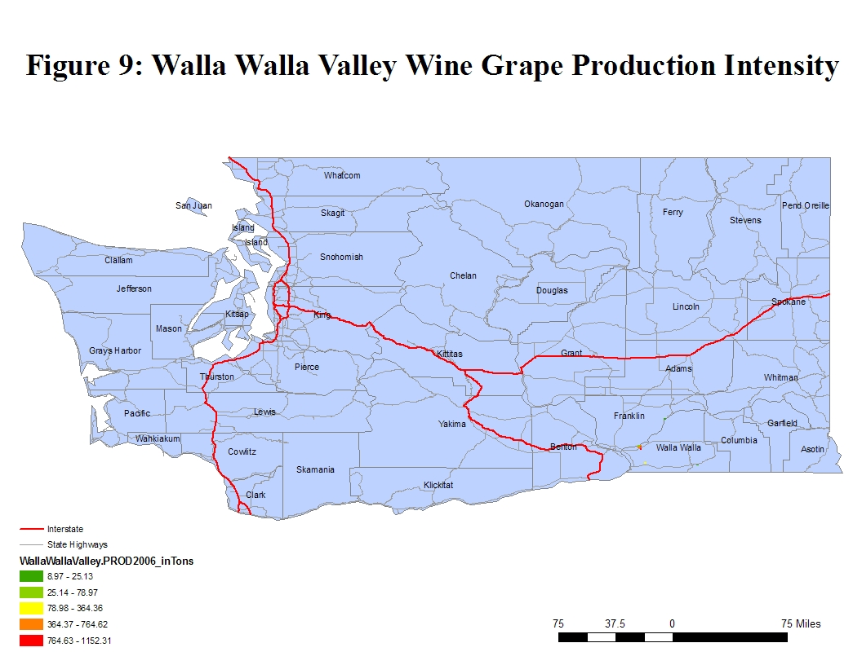

**Table 10: Number of Truck Shipments, by Highway for Walla Walla Valley**

|  |  |  |  |  |
| --- | --- | --- | --- | --- |
| **Walla Walla Valley** | **2007** | **2012** | **2017** | **2027** |
|
| **Major Routes** |
| US 12 | 366 | 388 | 409 | 452 |
| I-182 | 366 | 388 | 409 | 452 |
| I-82 | 366 | 388 | 409 | 452 |
| I-405 | 251 | 266 | 281 | 310 |
| I-5 | 251 | 266 | 281 | 310 |
| I-90 | 309 | 327 | 345 | 381 |
| SR221 | 309 | 327 | 345 | 381 |
| SR14 | 57 | 61 | 64 | 71 |
| Total | 366 | 388 | 409 | 452 |

Figure 9 illustrates the wine grapes production intensity for Walla Walla Valley on the TRS level. Most commonly used routes for transportation of finished wine products from Walla Walla Valley to the final destinations are US12, I-182, I-82, I-405, I-5, I-90, SR22, and SR221. Table 10 shows the aggregate number of truck loads on each highway during the transportation of Walla Walla Valley wine to the final destinations.

**Table 11: Number of Truck Shipments, by Highway for Puget Sound**

|  |  |  |  |  |
| --- | --- | --- | --- | --- |
| **Puget Sound** | **2007** | **2012** | **2017** | **2027** |
|
| **Major Routes** |
| I-405 | 212 | 225 | 237 | 262 |
| I-90 | 212 | 225 | 237 | 262 |
| I-5 | 212 | 225 | 237 | 262 |
| **Total** | **212** | **225** | **237** | **262** |

Most commonly used routes for transportation of finished wine products from the Puget Sound to the final destinations are I-405, I-90, and I-5. Table 11 shows the aggregate number of truck loads on each highway during the transportation of the Puget Sound wine to the final destinations.

**CONCLUSION**

The SFTA wine grapes Survey results and further analysis on future wine grapes production and future total truck trips required to ship the bulk wine to the wineries and finished wine products to their final destinations, allow conclusions to be drawn regarding the transportation characteristics of Washington wine grapes, logistic used and needs of the Washington State wine grapes industry, as follows:

* Truck to final destination is the most commonly used transportation mode in all three wine grapes-growing regions. Bulk wine is shipped in tankers, while the finished wine products are shipped in van type trailers in Washington State.
* Major domestic destinations for finished wine products are Western Washington, British Columbia, California, and Eastern Markets, while most of the bulk wine is shipped to wineries in Puget Sound area from Yakima Valley, Walla Walla Valley, and Columbia Valley.
* The most heavily used routes during the transportation of bulk wine are SR522, I-90, SR221, SR243, I-82 and I-182.
* The most heavily used routes during the transportation of finished wine products are I-5, I-90, I-405, I-82, SR 221 and I-182.

**REFERENCES**

[1] MKF Research: The Impact of Wine, Grapes and Grape Products on the American Economy 2007: Family Businesses Building Value

<http://www.ngwi.org/files/documents/Economic_Impact_on_National_Economy_2007.pdf>

[2] Economics of Wine Industry NN October 2007

<http://www.nabe.com/publib/news/07/10/05.html>

[3] Economic Impact of Washington Wine and Related Industries Produces $3 Billion Annually for State, Februrary7, 2008, Washington Association of Wine Grape Growers <http://www.washingtonwine.org/_assets/managed/files/2917_Updated%20economic%20impact%20study_2%2028%20(2).pdf>

[4] Crop Profile for Wine Grapes in Washington, Washington State University

<http://www.tricity.wsu.edu/~cdaniels/profiles/WineGrapes.pdf>

[5] Commodity Profile: Wines and Wine Grapes, Agricultural Issues Center University of California, Updated November 2003

<http://aic.ucdavis.edu/profiles/wine.pdf>

[6] Trade Data and Analysis

[7] US Wine Exports, 95 Percent from California, Jump 30 Percent to $876 Million in 2006, March 14, 2007, Wine Institute

<http://www.wineinstitute.org/resources/exports/article58>

[8] Preliminary Washington Winery Report 2006

[9] “Transportation Characteristics of the Washington Wine Industry”, SFTA Steering Committee, June 13, 2003, Washington State University

<http://www.sfta.wsu.edu/presentation/pdf/15_TobySFTAPresentation2.pdf>

[10] “Transportation Usage of the Washington Wine Industry”, SFTA Research Report #, December 2002, Washington State University

http://www.sfta.wsu.edu/research/reports/pdf/Rpt_4_Transportation_Needs_Wine_Industry.pdf