Washington State Industry Outlook and Freight Transportation Forecast:

Livestock Industry

Prepared for the
Washington State Department of Transportation
Freight Systems Division

By

Selmin Creamer
Research Assistant

Dr. Eric Jessup
Assistant Professor

Transportation Research Group
School of Economic Sciences
Washington State University
Pullman, WA 99164-6210

September 2008

TABLE OF CONTENTS

Study Goal ii

Industry Information 1

Economic Outlook 2

Washington Outlook 6

Statewide Transportation and Logistics 8

Statewide Freight Projections 8

Highway Assignments 10

Conclusions 11

References 13

TABLES

Table 1: Estimated Job Changes Due to the Canadian Live Cattle Import Ban 4

Table 2: Top Markets for US Beef 5

Table 3: Base Year and Forecasted Cattle Production 9

Table 4: Truck Loads from Producers to Processors 10

Table 5: Truck Loads from Producers to Processors 11

FIGURES

Figure 1 US Cattle Inventory (1990-2005) 2

Figure 2 US Cattle Exports to Canada and Mexico 3

Figure 3 US Cattle Trade-Exports and Imports 4

Figure 4 US Beef Trade-Exports and Imports 5

Figure 5 Top 10 Cattle Producers of Washington State in 2006 6

Figure 6 Washington State Cattle Production Intensity (2006) 7

Figure 7 Historical and Projected Statewide Cattle Production 9

Figure 8 Projected Cattle Production, by Countries 10

STUDY GOAL

The goal of this report is to offer state and regional transportation planners’ necessary information regarding f uture freight flows specific to livestock/cattle. This is accomplished by providing general industry information regarding the prospects for increased trade and production growth and also projecting statewide cattle production over the next twenty years. This projection was conducted at the county level and is then allocated to truck shipments and highways using information and data collected from a recent survey of the livestock industry regarding transportation characteristics of the industry.

INDUSTRY INFORMATION

The United States is the largest producer of high quality, grain-fed beef for domestic, and export use and has the largest cattle-fed industry in the world [1]. The beef industry is also the largest among other livestock and meat production industries. The beef industry is represented by interrelated sectors such as producers, stockers, feeders, packers, processors, distributors, retailers, and exporters [2]. The nature of cattle production is cyclical; this can be observed via the trends in the number of cattle slaughtered.

Eighty percent of the cattle-fed marketed domestically gets slaughtered and processed by four major meat packers. In the late 1980’s and early 1990’s concentration in the beef packing industry increased sharply as a result of mergers, since then it has stabilized [2].

In 2006, the value of US cattle and calf production was $35.7 billion. The retail equivalent value of the US beef industry was $74 billion in 2007 with a total consumption of 28.1 billion pounds [3]. The beef cattle market is well-established in the US, primarily utilizing meat processors and export markets. According to IBIS World estimates, approximately 70 percent of beef cattle are sold to meat processors for slaughter. In 2007 more than 34.3 million beef cows were slaughtered in the US based on the USDA accounts.

For 2007, the top five producing states, based on the percentage of cattle produced in the US are Texas, Kansas, Nebraska, California, and Oklahoma with the percentages of 14.5, 6.8, 6.7, 5.7, and 5.6. Among those states Texas, Nebraska and Kansas had the highest percentage value of beef production with percentages of 16.3, 11.4, and 8.3 [4]. The distribution of US Cattle was heavily concentrated on three major regions in 2007; Plains (30.2 percent), South West (23.8 percent), and South East (16.2 percent) [4].

Based on the USDA data the total number of feed-cattle and calves for slaughter market in US was 11.9 million head as of March 1, 2008. The total cattle inventory was down one percent, from March 1, 2006, but up from March 1, 2007. In 2008, the March inventory was the highest since 1996. The total placements in feedlots during February of 2008 were 4 percent higher than the 2007 figures, with the total of 1.72 million. The numbers of net placements were 1.66 million head [5]. Figure 1 below illustrates the historical figures for the US cattle Inventory between 1990 and 2005.

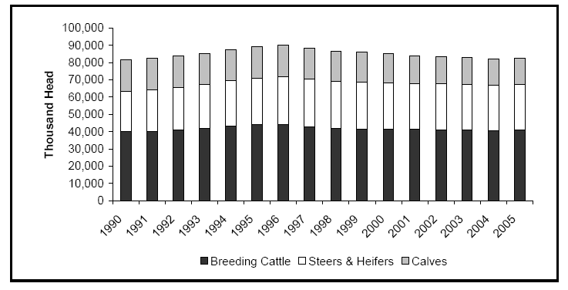
Figure 1: US Cattle Inventory (1990-2005)

Source: GIPSA Livestock and Meat Marketing Study, Volume 3: Fed Cattle and Beef Industries Final Report, January 2007, prepared by RTI International
ECONOMIC OUTLOOK

The US is a net exporter of cattle with Mexico and Canada being the primary markets. Canadian demand for US cattle has decreased due to the weak prices in and large supplies of cattle in Canada. Cattle exports experienced a decrease in 2004, and the export levels stayed low through 2006 [6]. Figure (2) illustrates US cattle exports to Mexico and Canada. Cattle exports to Mexico decreased by 13.2 percent in 2007, while exports to Canada increased by 36.2 percent [7].

Figure 2: US Cattle Exports to Canada and Mexico
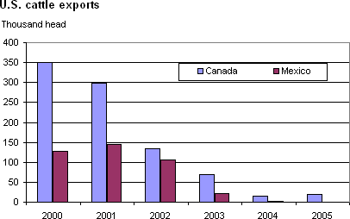

There was a gradual reduction in the US live exports to Canada due to the outbreak of bovine spongiform encephalopathy (BSE) in Canada. US farmers could not re-import their cows as a result of the ban that requires finishing the cows in US feedlots. Between 2003 and 2004 exports Canada decreased significantly (Figure (2)) [4].

The ultimate effects of the 2003 trade ban on all Canadian live cattle imports cost 11,016 jobs and 1.7 billion value-added dollars (0.02 of GDP) in the U.S based on a study conducted by the IMPACT Center at the Washington State University [8]. The ban resulted in increased consumer prices and income losses, which led to an overall decrease in demand in other market sectors. Meat slaughtering, packaging, and retail services were also hurt by the ban, while feed production and agricultural services gained some benefits [8]. Before the outbreak, the US was the primary market for Canadian live cattle, representing 72 percent of all US live cattle imports [8]. Estimated job changes due to the Canadian Live Cattle Import Ban are illustrated in Table 1.

Table 1: Estimated Job Changes Due to the Canadian Live Cattle Import Ban
Other Livestock | -7,775 | Retail Sector | -5,420
Feed | 13,106 | Out of House Food | -2,224
Crop | -825 | Services | -15,746
Meat Packing | -2,668 | Other Job Gain/Losses | -237
Other Food Processing | -563 | Manufacturing | -7,038
Construction | -2,869 | Total Estimated Job Change | -11,016
Source: Wieck/Holland compilation- IMPACT Center at Washington State University

Figure 3 demonstrates the historical U.S cattle import and export movements between 1980 and 2005.

Figure 3: US Cattle Trade- Exports and Imports

Source: USDA
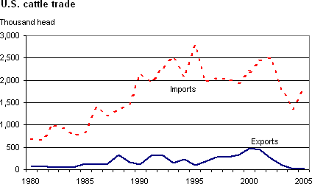
The US is the largest producer of beef in the world. The U.S mostly exports grain-finished, high value cuts, while most of the beef the US imports are lower value, grass-fed beef for processing, primarily as ground beef [7]. In 2005, the production started increasing again as the herd rebuilding began [7]. Beef exports have been growing since the 1980’s. The discovery of BSE in 2003 led to restriction of beef imports from the US. Before the discovery, Japan was the biggest receiver of US beef, followed by Mexico, South Korea, and Canada. Overall these countries represented 90 percent of the total the US beef exports [7]. Table 2 illustrates the export volumes and the associated dollar values for those countries.

Table 2: Top Markets for US Beef
Year | Japan |  | Mexico |  | South Korea |  | Canada
Year | Volume | Value | Volume | Value | Volume | Value | Volume | Value
Year |  | ($million) |  | ($million) |  | ($million) |  | ($million)
2003 | 918 | 1,182 | 586 | 623 | 586 | 754 | 227 | 309
2004 | 12 | 31 | 333 | 393 | 1 | 2 | 56 | 105
2005 | 17 | 50 | 464 | 584 | 1 | 3 | 106 | 194
2006 | 52 | 105 | 660 | 786 | 1 | 4 | 239 | 415
2007 | 159 | 294 | 586 | 732 | 78 | 124 | 339 | 575
Source: USDA

As illustrated in Figure 4, in 2004 beef export patterns showed dramatic changes due to the BSE discovery. Japan, South Korea and some other countries stopped importing US beef. During the second half of 2006, exports to Japan started again, while exports to South Korea have been restricted [7]. Australia, Canada, and New Zealand have been the important suppliers of US beef imports during the recent years. The beef from Australia and New Zealand mostly gets processed as ground beef, while the significant portion of imports from Argentina and Brazil come as cooked [7].

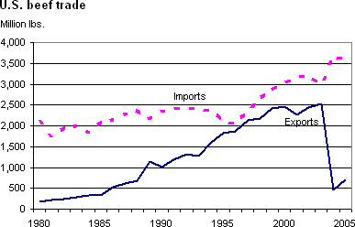
Figure 4: US Beef Trade- Exports and Imports

Source: USDA

WASHINGTON OUTLOOK

In 2006 cattle and calves ranked third among all the agricultural commodities for Washington State with the value of receipts for $649,290,000 accounting for 10.6 percent of state total farm receipts [8]. In 2007, 1,140,000 cattle were produced with the total value of $1,276,800. Per head value was $1,120 [9]. Live animals and meat ranked fifth among the entire agricultural export commodities in 2006, with an overall ranking of 17 among other states, and a value of 66.1 million [10].

Cattle is produced in almost every county in Washington State, however the heaviest concentration of cattle production is located in the Columbia Basin Region. Mild climate, low levels of rainfall, and accessibility of feed contribute to the region’s suitability for cattle production [11]. The second largest area for the cattle production is the Northwestern part of the state, while the lowest concentration takes place in the furthest western counties along the coast and also the eastern counties of Washington [10]. Yakima, Grant, Whatcom, Franklin, and Okanogan were the top cattle producing counties in 2006. Highest concentration cattle take place in two main counties, Yakima and Grant (Figures 5 and 6). Grant was also biggest producer of cattle, while Yakima was the number 4 in 2006.

Figure 5: Top 10 Cattle Producers of Washington State in 2006

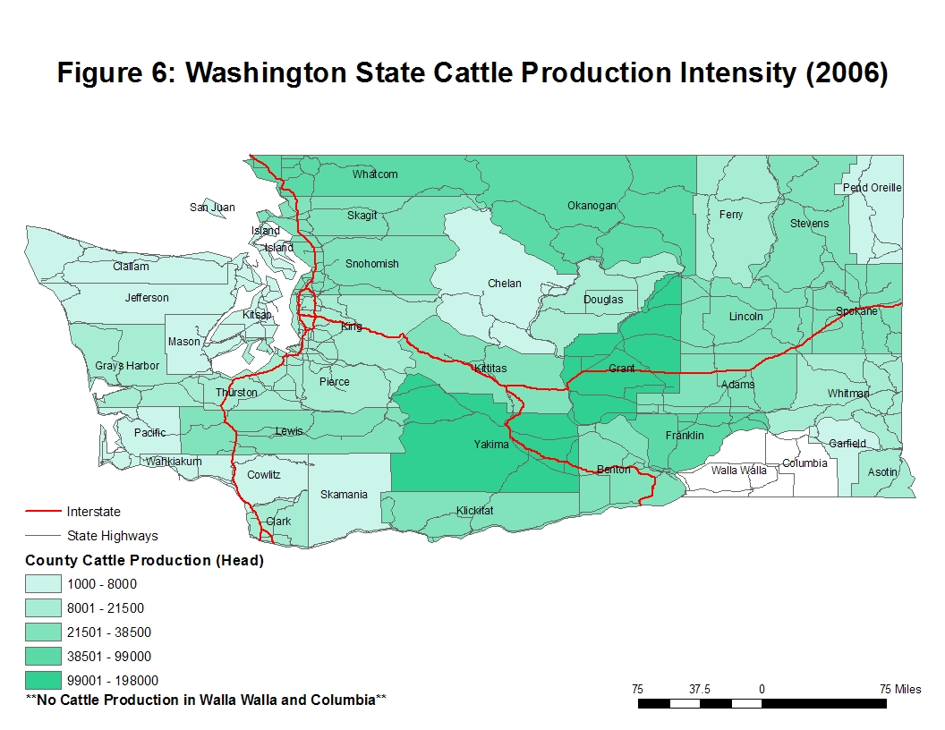
STATEWIDE TRANSPORTATION AND LOGISTICS
A significant proportion of livestock is produced, processed, and transported throughout Washington. Transportation of livestock is an important component of the state’s future growth and prosperity. Major movements of livestock within the state can be categorized as livestock to processing facilities, livestock to feedlots and livestock to/from farms. Even though each category has distinctive traffic flows, heavy overlaps occur on I-5, I-82, and I-90 since many of the farms and processing facilities are located on theses routes. A large majority of the livestock and processed meats are shipped within the Pacific Northwest [11]. This paper focuses on two main movements of livestock; transportation of livestock by producers and processors.

Transportation of Livestock – Producers

The most popular vehicle of the commercial livestock industry is the semi or “Pot” trailer.
Pot trailers are 40 feet long by 8.5 feet wide. The multiple decks make it possible to legally haul up to 45,000 pounds of livestock [11]. State route 12, US97, US395, I-90 and I-82 are the most critical highways for the Central Washington regions supporting the key livestock markets, while I-5, I-90, SR7, and SR18 are the most critical highways for the Western Washington livestock shipments [11].

Transportation of Livestock – Processors

The standard live weight of cattle that are ready to be slaughtered is 1,200 lbs.
After the meat is packaged and boxed it is loaded into refrigerated trucks and shipped to various locations throughout the US. There are 8 to 10 different sizes of boxed meat packages ranging from 20 to 70 lbs. The reported number of trucks leaving processing facilities is from 35 to 85 daily, with a payload capacity of roughly 41,000 lbs of processed meat per vehicle [11].

STATEWIDE FREIGHT PROJECTIONS
Cattle production in Washington State experienced a decline in cattle production (head) between 1986 and 2006. The annual average growth rate was -1.3 percent. However, the cattle production, based on weight, demonstrated ups and downs. The annual average growth rate of cattle production based on weight was 1.1 percent. A 21 year average weight per cattle was calculated as 526.5 pounds. Total weight of cattle produced was divided by the total number of cattle produced for the same year, and the average of those figures from 1986 to 2006 was taken to reach 526.5 pounds.
During the calculations of the future projections on cattle production -1.3 percent was estimated from historical cattle production and applied as the future growth rate. Projections were the allocated on the county level. The forecasted statewide cattle production for the years 2007 through 2027 are provided in Table 3, along with the growth rates for each time period. Historical and projected statewide production is also demonstrated in Figure 7. The blue bars indicate the historical production volumes and the red represents forecasted figures. The forecasted cattle production for the top ten cattle producers is provided in Figure 8.

Table 3: Base year and forecasted Cattle Production
Years | Annual Growth Rate | Years | Production (Head)
2006-2007 | -0.01 | 2007 | 1,085,700
2006-2012 | -0.08 | 2012 | 1,016,941
2006-2017 | -0.13 | 2017 | 952,536
2006-2027 | -0.24 | 2027 | 835,705

Figure 7: Historical and Projected Statewide Cattle Production

Figure 8: Projected Cattle Production, by Counties

HIGHWAY ASSIGNMENTS
A high percentage of the listed processing facilities are located at Western Washington. Approximately 80 percent of those facilities are located on or at close proximity to I-5, 8 percent of them is located around I-395 and I-82, while the rest is equally distributed (4 percent) among I-2 and I-90, I-405, and I-97 [12].
The payload capacity of 45,000 pounds was assumed to calculate the truck loads from producers to the processors, and payload capacity of 41,000 pounds was assumed to determine truck loads from processors to the final destinations. Carcass utilization was assumed as 50 percent.
Table 4: Truck Loads from Producers to Processors
Producers to Processors
 | 2007 | 2012 | 2017 | 2027
Total Cattle Production (Head) | 1,085,700 | 1,016,941 | 952,536 | 835,705
Total Cattle Weight (Pound) | 571,615,129 | 535,413,891 | 501,505,009 | 439,994,125
Truck Loads | 12,703 | 11,898 | 11,145 | 9,778
Tables 4 and 5 illustrate the total truck loads required to ship the cattle from the producers to the processors and the total truck loads required to ship the packed meat to final destinations within Washington State and to foreign markets via Port of Seattle and Port of Tacoma.
Table 5: Truck Loads from Producers to Processors
Processors to Final Destinations
Total Meat | 2007 | 2012 | 2017 | 2027
(Pounds)
Northeastern US | 14,290,378 | 13,385,347 | 12,537,625 | 10,999,853
Southeastern US | 14,290,378 | 13,385,347 | 12,537,625 | 10,999,853
Southwest US | 88,600,345 | 82,989,153 | 77,733,276 | 68,199,089
Pacific Northwest | 167,197,425 | 156,608,563 | 146,690,215 | 128,698,282
Mexico | 1,429,038 | 1,338,535 | 1,253,763 | 1,099,985
Total | 285,807,565 | 267,706,945 | 250,752,505 | 219,997,063
Truck Loads
Northeastern US | 318 | 297 | 279 | 244
Southeastern US | 318 | 297 | 279 | 244
Southwest US | 1,969 | 1,844 | 1,727 | 1,516
Pacific Northwest | 3,715 | 3,480 | 3,260 | 2,860
Mexico | 32 | 30 | 28 | 24
Total | 6,351 | 5,949 | 5,572 | 4,889

CONCLUSION

The SFTA Livestock Industry Survey results and further analysis of future cattle production and future total truck trips required to ship the cattle to the processors, and the meat to the final destinations allow conclusions to be drawn regarding the future transportation characteristics of Washington livestock industry, logistic uses, and needs of the Washington State livestock industry, as follows:

- Nearly 100 percent of livestock is transported via truck with in the United States currently.
- Livestock movements from producers to processors and from processors to the final destinations present distinctive traffic flows, and heavy overlap of routes on I-5, I-82, and I-90.

- Approximately 80 percent of the processing facilities are located on or at close proximity to I-5, 8 percent of them is located around I-395 and I-82, while the rest is equally distributed (4 percent) among I-2 and I-90, I-405, and I-97.
- A large majority of livestock and processed meats are shipped within the Pacific Northwest, while the rest is distributed to Northeastern, Southeastern, and Southwest of US, and to Mexico.

REFERENCES
[1] Home / Briefing Rooms / Cattle/ ERS/USDA Briefing Room
http://www.ers.usda.gov/Briefing/Cattle/
[2] GIPSA Livestock and Meat Marketing Study, Volume 3: Fed Cattle and Beef Industries Final Report, January 2007, RTI International
http://archive.gipsa.usda.gov/psp/issues/livemarketstudy/LMMS_Vol_1.pdf
[3] US Beef and Cattle Industry: Background Statistics and Information
http://www.ers.usda.gov/news/BSECoverage.html
[4] 11211 - Beef Cattle Production in the US - Industry Report
http://www.ibisworld.com/industry/default.aspx?indid=46
[5] Cattle on Feed Rises 2 Percent in U.S
http://www.statpub.com/open/307195.phtml
[6] Cattle: Trade
http://www.ers.usda.gov/Briefing/Cattle/Trade.htm
[7] Livestock and Meat Trade Data
Cattle: Annual and cumulative year-to-date US trade (head)
http://www.ers.usda.gov/data/meattrade/CattleYearly.html
[8] Washington State Department of Agriculture
http://www.nasda.org/cms/7195/8617/8849.aspx
[9] All Cattle and Calves, January 1, Washington Value Total, NASS, Washington Field Office
[10] Data Sets, State Fact Sheets: Washington, USDA
[11] Transportation and Marketing Needs for the Washington State
Livestock Industry, SFTA Research Report # 12, November 2004
[12] http://www.fsis.usda.gov/xls/MPI_Directory_by_Establishment_Name.xls

