Washington State Industry Outlook and Freight Transportation Forecast:

Hay Industry

Prepared for the
Washington State Department of Transportation
Freight Systems Division

By

Selmin Creamer
Research Assistant

Dr. Eric Jessup
Assistant Professor

Transportation Research Group
School of Economic Sciences
Washington State University
Pullman, WA 99164-6210

September 2008

TABLE OF CONTENTS

Study Goal ii

Industry Information 1

Economic Outlook 3

Washington Outlook 4

Statewide Transportation and Logistics 7

Statewide Freight Projections 7

Highway Assignments 9

Conclusions 11

References 12

TABLES

Table 1: Base Year and Forecasted Hay Production 8

Table 2: Truck Loads from Producers to Processors 9

Table 3: Truck Loads from Processors to Final Destinations 10

FIGURES

Figure 1 Distribution of Hay Production in US in year 2007 2

Figure 2 Top 10 Hay Producing Counties in Washington State (2006) 4

Figure 3 2006 Washington State Hay Production Intensity 6

Figure 4 Historical and Projected Statewide Hay Production 8

Figure 5 Projected Hay Production, by Counties 9

STUDY GOAL

The goal of this report is to offer state and regional transportation planners’ necessary information regarding future freight flows specific to the hay industry. This is accomplished by providing general industry information regarding the prospects for increased trade and production growth and also projecting statewide hay production over the next twenty years. This projection was conducted at the Township, Section, and Range level and is then allocated to truck shipments and highways, using information and data collected from a recent survey of the hay industry regarding transportation characteristics of the industry.

INDUSTRY INFORMATION

The US produces over 150 million tons of hay each year. Alfalfa is the primary hay crop grown in the US. Though US hay production caters mostly to domestic consumption, there is a growing export market, especially for timothy, some alfalfa, sudangrass, and bermuda grass hay [1].

The hay industry has generally experienced rising returns due to increases in domestic hay prices over the past 50 years. In 1950, the average price for hay was $21 per ton, while in the early 1990’s, prices hit more than $80 per ton. With the growing production of livestock, the increased demand for livestock feed has caused an increase in hay prices. The hay industry has also benefited from the expansion of export markets to Asia [2]. In 2003, the prices varied from a low of $80.70 per ton in November to a high of $94.60 per ton in May [3].

Approximately 40 percent of the alfalfa hay grown in the US is produced by Arizona, California, Colorado, Idaho, Montana, Nevada, New Mexico, Oregon, Utah, Washington, and Wyoming. These western states also make the largest contribution to the exports of alfalfa hay and seed. Of the above states, Montana has the highest acreage for alfalfa, while California has the highest yield for alfalfa [4].

As of May1, 2007, the total amount of hay stored on US farms was the lowest since 1950, down 30 percent from the previous year to 15 million tons. During the 2006, drought deteriorated the pastures throughout the Southeast and caused a reduction in December 1 stocks [5].

In 2006, the total amount of hay harvested in US was 60,807,000 acres, with an average yield per acre of 2.33 tons. Total production was 141,666,000 tons; the average price paid was $109 per ton with a total production value of $13,506,119,000. Based on the NASS statistics for 2006-2007, Texas, California, Missouri, Kansas, and Nebraska were the top five producers of hay [6].

Figure 1: Distribution of Hay Production in US in year 2007
Source: Hay & Other Crop Farming in the US: 11199, IBIS World Industry Report
March 06, 2008

Hay farming requires abundant supplies of sunshine and rain. Other factors affecting the location of hay farming are proximity to irrigation water, soil nutrition, and flat terrain. Although hay farming takes place in every region, the far west represents the region with the largest hay production followed by the plains (Figure 1).These two regions account for over 48 percent of US hay production [2].

According to the USDA, the production of hay can be classified as alfalfa hay and other hay. Alfalfa accounts for 50.3 percent of production, while other hay accounts for the rest. Alfalfa has higher protein content, and needs more fertilizer and water to grow. In the past, alfalfa production was higher, but due to lower prices and production costs, the production share of other hay has increased in the past five years [2].

In 2007, hay farming had an estimated revenue value of $5.22 billion, an increase of 47.6 percent from the previous year. Within the next five years, the revenue is expected to increase by 2.28 percent on average annually, while in 2008 hay revenue is expected to increase to 5.48 billion. The high prices in 2007 were caused by the drought conditions in many states creating a shortage of feed for livestock producers. Future prices are expected to increase as a result of the high costs of the alternative feeds [2].

ECONOMIC OUTLOOK
Domestic versus International

For the Pacific Northwest forage producer, exports represent an important market. In 2004, the US exported 2.8 million metric tons of forage products to the Pacific Rim (Japan, Korea, Taiwan, and others). A large proportion of the exported forage products go to Japan and Korea respectively. Canada and Australia are the main competitors for US forage exports to Japan. From 1995 to 2004, Canada’s share of forage exports has remained stable, but Australia’s share has increased dramatically [7].

Five countries are responsible for over 98 percent of the US alfalfa hay and other hay product exports: Japan, South Korea, Canada, Mexico, and Taiwan. Japan receives the majority, with 75 percent of the US alfalfa and other hay product exports [4]. In 2007, exports accounted for 11.8 percent of the hay farmers’ revenue. Hay exports reached up to $449.4 million, and the demand for US hay is expected to stay strong. Imports for hay are less than 3 percent of the domestic demand. There are no tariffs available for hay imports to the US. The US government offers non-tariff assistance to the hay farmers, which falls under the Farm Act [2].

US agricultural exports are expected to grow as a result of population growth and stronger global economic performance. Growth in developing transitional markets, changing diets in North Africa, the Middle East and South East Asia are anticipated to increase demand for livestock feed [2].

Washington Outlook
In 2006, hay producers contributed $398 million to the state’s agricultural economy, ahead of the previous high of $380 million set in 2004 [8]. Hay ranks in the top six agriculture commodities produced in the state [4].

In 2006, 770,000 acres of hay were harvested, with a total production of 3,113,000 tons and a yield of 4.04 tons per acre. The total value of production was $395,824,000 with an average price of $127 per ton [9]. Of the total harvested hay acreage, alfalfa hay accounts for 440,000 acres, with a total production of 2,156,000 tons and a yield of 4.9 tons per acre. The total value of alfalfa production was $269,500,000, with an average marketing price of $125 per ton and an average value of $613 per harvested acre [10].

In 2006, the top ten hay producing Counties in Washington State were Grant, Franklin, Kittitas, Yakima, Adams, Stevens, Spokane, Okanogan, Walla Walla and Lincoln Counties. While hay is produced in almost every county in Washington State, Grant County is by far the largest producer. In 2006, Grant County produced over 900,000 tons of hay, approximately 30 percent of the states total, while Franklin County produced 500,000 tons of hay, approximately 16 percent of the states total (Figure 2).

Figure 2: Top 10 Hay Producing Counties in Washington State (2006)

Source: NASS

Washington hay prices generally peak during the months of May, June, and July. The typical trend for hay prices is to be strong and constant through June and then level off for the remainder of the year. Eighty percent of Washington hay is distributed domestically, whereas the remaining 20 percent is exported [3].

As indicated earlier, hay is produced in almost every county of Washington State, but is heavily concentrated in Grant, Franklin, Kittitas, and Yakima County where the major hay brokers are located. The 2006 production is provided at the Township, Section, and Range level in tons in Figure3.
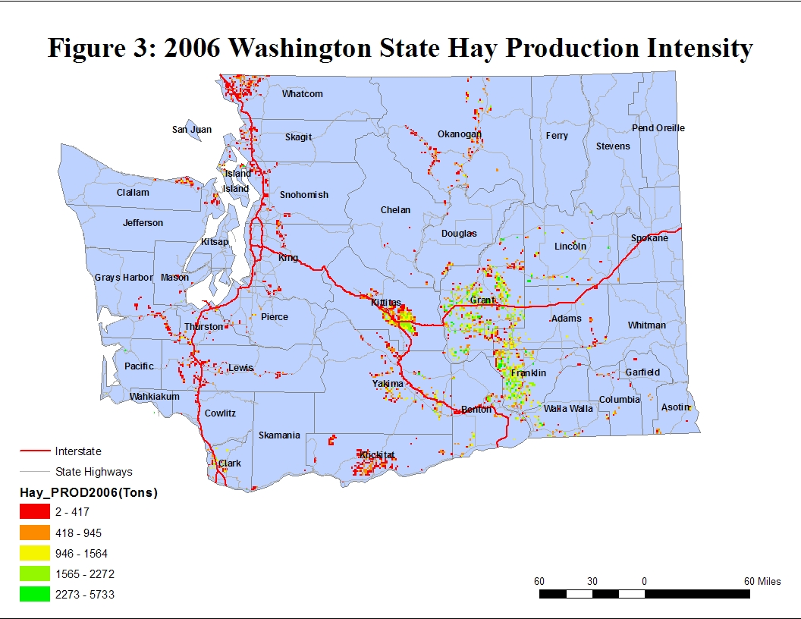

STATEWIDE TRANSPORTATION AND LOGISTICS
The Washington State hay industry generated economic benefits via significant growth experienced over the past few years. This growth was due to access to markets and an efficient multimodal transportation system to bridge production supply sources with destination demand markets. Year-round demand for hay in the state requires an efficient and multimodal transportation infrastructure supporting hay movements. Without an efficient transportation system, the value of hay would have diminished considerably for the state [3].

Trucks are the dominant transportation modes utilized by both hay producers and processors for receiving raw products and shipping out to the final markets. This is especially true for the Central southern part of the state, which heavily relies on truck movements. There are three primary destinations for hay shipments including; processing facilities (brokers), livestock farms and ocean ports. While 80 percent of the hay is distributed domestically, the rest is exported to foreign markets [3].

The seasonality of hay shipments into processing facilities is more varied and less differentiated than shipments from processing facilities illustrating the natural climatic factors influencing hay production and the product transformation occurring at processing facilities to satisfy export demand markets. Highways supporting hay movements from the producer tend to be more local and county based [3].

STATEWIDE FREIGHT PROJECTIONS
Hay acreage and production information for the state was obtained from the Washington State Department of Agriculture in order to forecast future hay production quantities. The township-range-section (TRS) level acreage data used in this study are the compilation of the results from a continuum of surveys conducted by the Department of Agriculture between 1999 and 2007. The hay production figures for each county were allocated to the TRS by using yield and acreage information calculated for each county. The 2006 hay production data for Washington State were reflected on the TRS level.

The average annual growth rate of 1.1 percent was estimated from historical data and used to forecast the production volumes between 2007 and 2027. The production levels for the years 2007, 2012, 2017, and 2027 were also projected at the TRS level. This average annual growth rate used in the forecasting was developed based on the historical growth rates between 1986 and 2006.

The forecasted statewide hay production for the years 2007 through 2027 are provided in Table 1, along with the growth rates for each time period. Historical and projected statewide production is also demonstrated in Figure 4. The blue bars indicate the historical production volumes and the red represents forecasted figures. The forecasted hay production for the top ten hay producers is provided in Figure 5.

Table 1: Base year and forecasted Hay Production
Year | Annual Growth Rate | Year | Production in Thousand Tons
2006-2007 | 0.011 | 2007 | 3,147
2006-2012 | 0.068 | 2012 | 3,324
2006-2017 | 0.128 | 2017 | 3511
2006-2027 | 0.258 | 2027 | 3,917

Figure 4: Historical and Projected Statewide Hay Production

Figure 5: Projected Hay Production, by Counties

HIGHWAY ASSIGNMENTS
In this analysis it is assumed that 100 percent of the hay is transported by trucks to hay brokers/processors which are mainly concentrated in the Moses Lake and Ellensburg regions. During the calculations of the truck loads from producers to processors, 20 metric tons was used as the approximate payload weight. After the hay is shipped to processors, it is then shipped to final destinations within Washington State and to the foreign markets via the Ports of Seattle and Tacoma. Based on the SFTA survey conducted in year 2004, 8.67 percent of the hay leaving brokers is shipped to destinations within Washington State, while 91.33 percent is shipped to foreign markets. Semi-Flatbeds and containers are the transportation mode choice for shipping from processors to final destinations. During the calculations of the truck loads from the processors to final destinations, 28 metric ton was used as the approximate payload weight.
Table 2: Truck Loads from Producers to Processors
Producers to Processors
Total Hay Amount (Tons) | 2006 | 2007 | 2012 | 2017 | 2027
Total Hay Amount (Tons) | 3,113,000 | 3,147,243 | 3,324,192 | 3,511,089 | 3,916,998
Truck Loads | 155,650 | 157,362 | 166,210 | 175,554 | 195,850
Tables 2 and 3 illustrate the total truck loads required to ship hay from producers to the processors and the total truck loads required to ship the hay products to final destinations within Washington State and to foreign markets via Port of Seattle and Port of Tacoma.
Table 3: Truck Loads from Producers to Processors
Processors to Final Destinations
 | Total Tons of Hay
Markets | 2006 | 2007 | 2012 | 2017 | 2027
Washington | 269,897 | 272,866 | 288,207 | 304,411 | 339,604
Foreign Markets | 2,843,103 | 2,874,377 | 3,035,984 | 3,206,678 | 3,577,395
Total Tons | 3,113,000 | 3,147,243 | 3,324,191 | 3,511,089 | 3,916,999
 | Total Truck Loads of Hay
Washington | 9,639 | 9,745 | 10,293 | 10,872 | 12,129
Foreign Markets | 101,539 | 102,656 | 108,428 | 114,524 | 127,764
Total Truck Loads | 111,179 | 112,402 | 118,721 | 125,396 | 139,893

Producer to Processor

The three major routes used during the movement of hay from producers to processors are I-90, I-82, and SR 395. These three major routes run through the two largest hay producing counties (Grant and Franklin) and provide both north-south and east-west access to markets within and beyond the state. A number of major hay processing facilities are located in these two counties making these routes critical to the hay industry. State Route 12, SR-14, SR-24, and SR-97 also generate significant truck traffic that intersects with I-90, I-82, and SR 395 for other shipments. These state roads are located in the central southern part of Washington which houses the largest hay production in the state [3].

Processor to Final Destinations
The key highways that support hay shipments from major hay processing facilities to final destinations include; I-90, I-82, SR 24 and SR 395. I-90 and SR 395 run through the two largest hay producing counties (Grant and Franklin) as mentioned before. Forty-six percent of the total tons of hay produced in Washington are supplied by Grant and Franklin County and travel on these highways. After the hay has been processed, it is transported by truck to the Port of Seattle or the Port of Tacoma for further shipment. I-90 is a major corridor to large markets domestically and also internationally [3].

CONCLUSIONS

The SFTA Hay Survey results and further analysis of future hay production and future total truck trips required to ship the apples to their final destinations allow conclusions to be drawn regarding the future transportation characteristics of Washington hay, logistic uses and needs of the Washington State hay industry, as follows:

- Truck to final destination is the most commonly used transportation mode for the movement of hay.
- The majority of hay produced in the state is utilized domestically. Of that which is sold to hay brokers/processors, the primary shipment destination is foreign markets accessed through the ports of Seattle and Tacoma.
- The most heavily used routes for transportation of hay from producers to processors run through the two major hay producing counties. These routes are I-90, I-82, and SR 395.
- The most heavily used routes for transportation of hay from processors to final destinations are I-90, I-82, SR 24 and SR 395.

REFERENCES
[1] http://www.epa.gov/oecaagct/ag101/cropmajor.htm
[2] Hay & Other Crop Farming in the US: 11199, IBIS World Industry Report, March 06, 2008
[3] Transportation Characteristics and Needs of the Washington Hay Industry: Producers and Processors, SFTA Research Report # 11, November 2004
[4] “High quality hay market may be most impacted by removal of Alfalfa”, Tracy Sayler, April 2007
[5] “Hay Stocks Plunge in United States, Statpub.com”, WASHINGTON - May 11/07 – SNS
[6] NASS, Crops Branch, USDA - NASS Statistical Highlights of US Agriculture 2006 - 2007 (Crop Tables)
[7] 2006 Hay Market and Export Report, William T. W. Woodward
[8] “Washington's 2006 agricultural value breaks record”, Washington Farm Bureau, October 16, 2007 - 7:58pm
[9] Washington State Agriculture Overview – 2006, USDA, NASS
[10] Hay: Acreage, Yield, Production, Value, and Stocks, Washington, 1997-2006, 2007 Washington Agricultural Statistics

