Diesel Distribution
This document describes diesel distribution from refineries through to the “last mile” delivery to the consumer. Data on diesel distribution is available from numerous governmental agencies and private entities, however, each holds the information for its own reasons and the data vary in their levels of spatial and temporal resolution and data quality. Data may be available from:
- Departments of Transportation performing strategic planning, for example the Washington Transportation Plan Update Freight Movement (2008c) provides general information on the locations of refineries, pipelines, and terminals, and outlines the distribution of petroleum products on an aggregated level within Washington state and to other locations. The Washington State Freight and Goods Transportation System (FGTS) 2007 Update (2008b) provides an understanding of the roadway network within the state as it applies to the movement of freight.
- The State of Washington Energy Facility Site Evaluation Council report completed by ICF International (2007) verifies much of the information provided in the WSDOT report while also describing in greater detail the pipeline and barge movement operations along the supply chain.
- State Department of Agriculture (DOA) regulates the accuracy of the quantity and quality of fuel delivered at gas stations in a state.
- The locations that it monitors are based on a list of businesses that have fuel meters registered with the Washington State Department of Licensing (DOL).
- State Department of Ecology (ECY) regulates active underground storage tanks (USTs) in the state and as such has location and volume information for these tanks.
- Environmental Protection Agency (EPA) regulates above-ground storage tanks (ASTs). Location and volume for these tanks is available.
- State Department of Revenue (DOR) is responsible for assessing and collecting fuel taxes at terminal locations. This agency can provide locations of terminals and refineries.
  - Fuel marketers and distribution companies. These companies purchase fuel from refineries or terminals and transport it to distribution points such as gas stations or card-lock facilities. They may be able to provide location and volume information. For example, terminals and cardlock facilities in Washington are shown below.
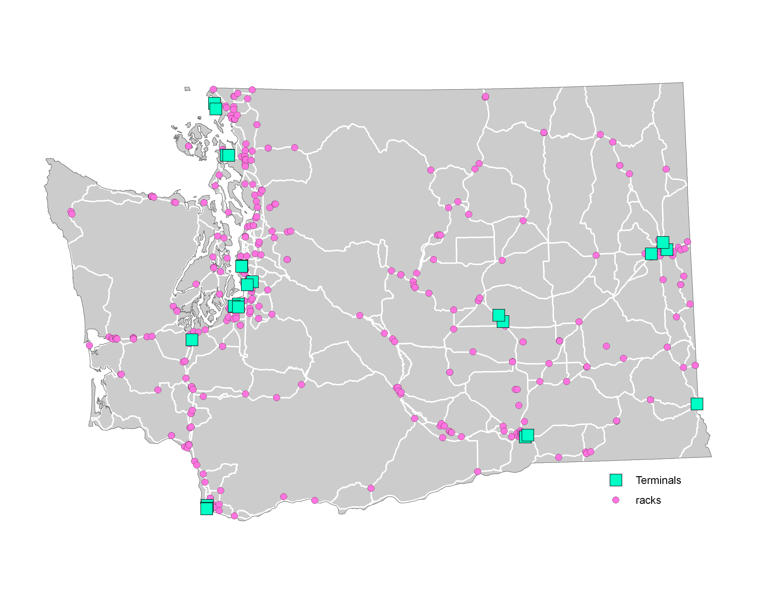
Diesel terminal and cardlock (rack) facilities in Washington state
  - Regional Commodity Flow Surveys such as the Strategic Freight Transportation Analysis (SFTA) conducted in 2003 and 2004. The database is categorized by UN placard number (1202 and 1203 for petroleum products), payload weight, and origin-destination (city, state) for the surveyed truck trips.
  - The Freight Analysis Framework (FAF2) is an origin-destination database published by the Federal Highway Administration (FHWA) based on data collected during the 2002 Commodity Flow Survey. Report Number S6 – Petroleum National Totals (http://ops.fhwa.dot.gov/freight/freight_ analysis/faf/faf2_tech_document.htm) provides national aggregated movement totals for petroleum products by pipeline, water, highway, and rail.

Waterway Movement
- In Washington, the ECY publishes the annual Vessel Entry and Transit for Washington Waters (VEAT) report that identifies vessels in Washington state waters tracked by the ECY.
- The Destination and Origin of Waterborne Commerce of the United States, 2007 report from The Waterborne Commerce Statistics Center of the Army Corps of Engineers Institute for Water Resources (2008) (http://www.ndc.iwr.usace.army.mil/wcsc/wcsc.htm) contains aggregated petroleum and crude waterborne imported and exported data, but they are not disaggregated for diesel product and are only origin-destination specific by state or country.

Pipeline Movement and Refinery Capacity
  - Pipeline operators such as ConocoPhillips Pipeline, Chevron Pipeline Company, and Kinder Morgan may be able to provide information. Form 6-Annual Report of Oil Pipeline Companies is a form that the Office of External Affairs (OEA) of the Federal Energy Regulatory Commission (FERC) requires each pipeline company to annually submit to report financial and operational information. Filed Form 6’s are available at http://www.ferc.gov/docs-filing/eforms.asp#6.
  - The Energy Information Administration (EIA) maintains State Energy Profiles that contain a compilation of various aggregated fuel production and consumption data by state. The EIA also publishes the Refining Capacity Report (2008) which reports the total production capacity at each refinery.
  - Regional Industrial Associations such as The Western States Petroleum Association may be available for contact or have reports available.

Key Supply Chain Players
The actors that participate in the supply chain incorporate a three-tier structure of major oil companies, marketers, and cardlock locations or other consumers.

Major Oil Companies
Marketers
Cardlocks/Consumer
Diesel supply system actors

The major oil companies (BP, Shell, ConocoPhillips, U.S. Oil, and Chevron – defined by ownership of their own crude oil reserves) refine crude oil into diesel and transport their product by way of pipeline, marine vessel, or tanker truck. The pipelines in Washington State are each owned and operated by one of the major oil companies (Olympic Pipeline – BP, Yellowstone Pipeline – ConocoPhillips, and Chevron Pipeline – Chevron), which is common practice. Independent operators in the marine industry contract with the major oil companies to move diesel by barge or tanker ship, and the tanker trucks are operated by independent companies known as marketers. Diesel that is transported by a pipeline or marine vessel is offloaded at a terminal. The terminals owned and operated by a major oil company are known as proprietary terminals, and those owned and operated by an independent terminal operator are known as common terminals. From the terminals, a marketer purchases diesel and makes delivery to a cardlock location, other fueling stations, directly to fleets of vehicles, or as specified by its customers. In addition, the major oil companies can contract directly with the marketers to transport diesel directly from a refinery.

Description of the Diesel Distribution Network
The movement of diesel involves a multi-modal system of pipelines, waterborne vessels (barge and tanker), and tanker trucks that make the “last mile” delivery of diesel product to the consumer. The supply chain begins at the source, whether in northern Alaska where crude oil is pumped to Valdez, Alaska, and loaded onto tanker ships or imported from oil fields in Alberta or British Columbia, Canada, via the Trans Mountain Pipeline, or transported by oil tanker from another foreign source. Refineries receive crude oil and create refined products such a gasoline and diesel fuel. These products are transported to terminals from the refineries through pipelines, trucks, or waterborne vessels. The Figures below summarizes this flow within the Washington state diesel distribution network.
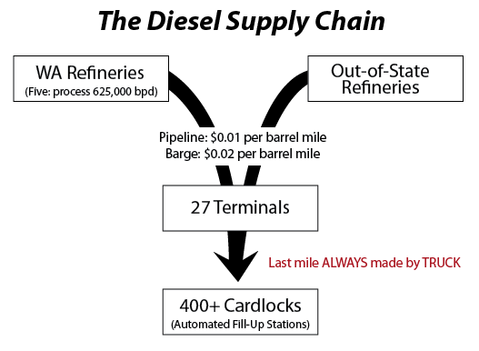
The Diesel Supply Chain for Washington State

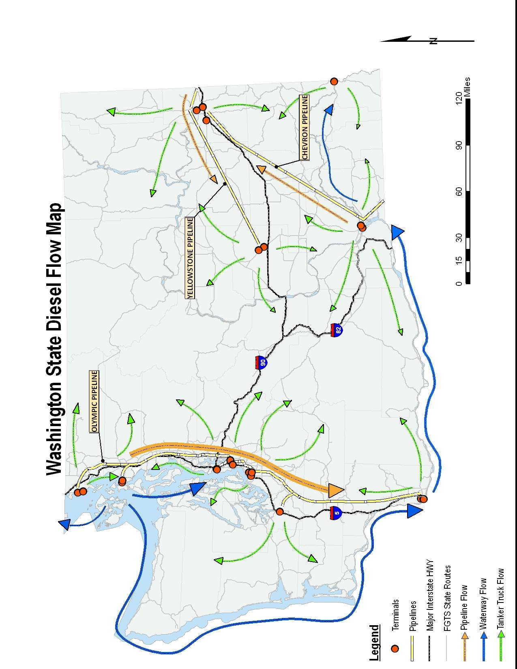
Washington state diesel flow

From the refineries, diesel is further transported along the diesel supply chain by one of three ways: pipeline, waterway, or tanker truck. A Washington Research Council Report (2007) stated that in 2005, 53 percent of diesel product refined in Washington state was shipped by pipeline, 38 percent shipped by waterway, and the remaining 9 percent was transported by other modes (presumably by tanker truck to destinations near the refineries).
Pipeline is the most efficient and economic mode of moving diesel. It provides the lowest shipping rate and is the most reliable origin to destination carrier of the three modes. For instance, the Washington State Plan Update Freight Movement (WSDOT 2008c) reports that one barrel of fuel moved between Ferndale and Tacoma on the Olympic Pipeline costs 1.0 cent in comparison to 1.8-cents by barge.
The operations of a pipeline involve shipping batches of distinct product in sequence to avoid contamination of one product by another. The products are injected into the pipeline one after the other based on the basis of the oil company’s required batch sizes. Diesel is shipped on the basis of a schedule set by the major oil company at the head of the pipeline, but it can also operate in a fungible mode, meaning that diesel product meeting the same grade and specifications of multiple oil companies may be mixed in a single batch and transported to a common terminal, where it is sold from a single inventory. However, when diesel product is transported to a proprietary terminal, the diesel is offloaded from the pipeline to the terminal company that shipped the specific batch.
The second most common and economical mode of transport for long haul shipments of diesel is via waterways (short sea shipping). Although tanker ships can be used, the majority of waterborne diesel movements are by way of barge. Like pipelines, barges take advantage of economies of scale on the basis of the volume that can be shipped during a single movement.
The “last mile” segment of the diesel delivery network is a 24-hour-per-day, seven-day-per-week operation completed by tanker trucks. Transportation of diesel by tanker truck is by far the most expensive mode in comparison to pipeline and marine vessel, but it is essential because of the roadway infrastructure necessary to complete the final leg of the distribution network. Tanker trucks are owned and operated by marketers that purchase diesel from the major oil companies at terminal locations and transport the product to the consumer. This is different from carriers in many other industries, who do not own the product and cannot profit from price differences between the time of pick-up and delivery. Some marketers operate their own cardlock locations, but they also deliver to other independent cardlock locations, other fueling stations, fleets of trucks (termed “fleet fueling”) construction sites (termed “wet hosing”) or other locations as requested by their customers. Within the diesel industry, the major oil companies are trying to decrease direct contact with the end consumer; this forces the marketers to interact directly with the customer. Analogous to other freight industries, marketers operate as a typical carrier, but they also operate as a supplier, as the product becomes their proprietary responsibility once they purchase it from the major oil company until they sell it to the customer. This gives them an incentive to look for the lowest price in their purchase of diesel, not just to minimize transportation costs by picking up from the closest facility. In addition, marketers can contract directly with the major oil companies to transport diesel to a direct customer of the major oil company. In this sense the marketer operates as a carrier only.

Fuel Price Variability
The past 36 months have seen tremendous fluctuation in the selling price of diesel on the market, as well as in the price of diesel at terminal locations. These fluctuations can cause diesel prices to change hourly, with 5- to 15-cent price fluctuations at a single terminal location per day. As a result, the marketers are constantly monitoring the price at each terminal and re-routing origin-destination trips in real time in order to take advantage of the lowest instantaneous terminal price, given their fixed and variable transportation and inventory costs. Often the shortest trip between an origin terminal and a destination location is not utilized because greater costs can be saved by traveling a greater distance to a terminal that has a lower diesel selling price.
Diesel delivery is similar to just-in-time (JIT) delivery. Although some customers might have pre-set delivery dates or an automatic request for delivery technology in place, most customers requiring diesel will place an order with a marketer as demand requires, and the marketer will make the delivery. Some marketers have the capacity to store inventory, but most deliveries require the marketer to pull diesel directly from a terminal and then make the delivery. A tanker truck can load diesel at a terminal at a rate of 600 to 800 gallons per minute. Marketers prefer to maximize each trip by being efficient with their deliveries. If possible, they will try to combine deliveries in order to avoid deadheading and will also make multiple deliveries on a single trip if needed.

Although Chevron does not operate a refinery in Washington state, it imports diesel into the state via the Chevron Pipeline from Utah.

