Homework 3: Traffic & Level of Service (LOS)

Textbook Assignment
Problem | Points | Answer
5.3 | 10 | Capacity = 4006 veh/hr, Speed at capacity = 25.04 mph, Density at ¼ capacity = 21.5 veh/mi or 299 veh/mi
5.4 | 10 | Flow = 1200 veh/mi/ln, Average speed = 34.09 mph, Density = 35.2 veh/mi
6.1 | 10 | V = 3,794 veh/hr
6.6 | 10 | LOS D
6.10 | 10 | Before: D = 29.13 pc/mi/lane, v/c = 0.732, LOS D  After: D = 31.61 pc/mi/lane, v/c = 0.794, LOS D
6.25 | 20 | You figure this one out

Additional Required Work (30 points)
WSDOT recently completed a second Tacoma Narrows Bridge (http://www.wsdot.wa.gov/projects/sr16narrowsbridge). Determine the improvement in Level Of Service (LOS) of State Route (SR) 16 before and after the bridge construction. Use the following information:

Item | Before (2006) | After (2007)
Lane width | 10 ft | 12. ft
Left lateral clearance | 0.5 ft | 6 ft
Right lateral clearance | 1 ft | 6 ft
PHF | 0.95 | 0.95
Design K-factor | 30th highest | 30th highest
Other stuff | Up to you | Up to you

Extra Credit (1 point)
How many lives were lost when the first Tacoma Narrows Bridge collapsed in a windstorm on 7 November 1940?

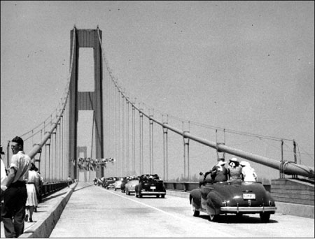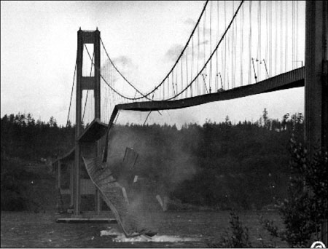
Photos from WSDOT (http://www.wsdot.wa.gov/TNBhistory/3bridges/1940pane.htm)

Hints and Recommendations
- Analyze the before and after TNB’s as freeways.
- Interchange density can be estimated using a map.
- You can find the number of lanes by viewing the satellite pictures using Windows Live Local, Google Maps or Google Earth.
- The traffic and % trucks can be found by using WSDOT’s Annual Traffic Report (http://www.wsdot.wa.gov/mapsdata/tdo/annualtrafficreport.htm). You need to find a vehicle axle classification station near the Tacoma Narrows Bridge. You can find one using the map in the Annual Traffic Report. The traffic report will list truck percentages as “single”, “double”, “triple” and “total”. Use the “total” amount.
- You need to estimate traffic growth between when the traffic data was taken (2006) and after the bridge opening. This can be done in a number of ways such as: (1) taking data from the last 5 years and projecting that growth rate into the future, (2) finding estimates of traffic growth rate and applying those or (3) finding estimates of population growth rates and converting them to traffic growth rates.
- You need to find the design K-factor and directional distribution factor in WSDOT’s Peak Hour Report available at the WSDOT Transportation Data Office (http://www.wsdot.wa.gov/mapsdata/tdo)
- The Tacoma Narrows Bridge is an extended bridge segment. As you may recall, LOS calculation methods do not account for this. Your LOS calculations should briefly discuss this condition and any others that might cause your LOS calculations to differ from reality. The reported LOS should be your best estimate of LOS given all actual conditions.

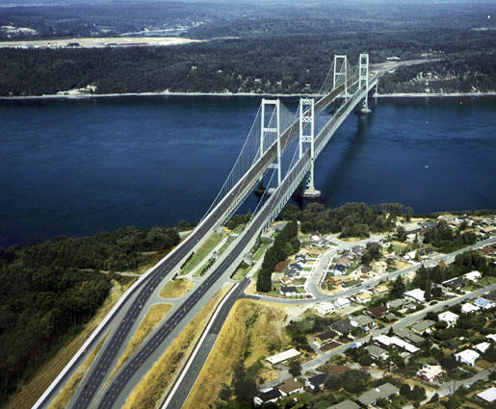
Figure 1: Tacoma Narrows Bridges (from WSDOT).

