Homework 4: Queuing

Textbook Assignment
Problem | Points | Answer
5.22 | 20 | $\bar{Q}$ = 1.6 vehicles, $\bar{t}$ = 36 seconds, $\bar{w}$ = 24 seconds
5.32 | 20 | P[n>5] = 17.8%

Additional Required Work (60 points) – similar to Example 5.13
At 10:00 a.m. on the Evergreen Point Floating Bridge, a vehicle traveling westbound breaks down in the right-hand lane causing that lane to temporarily close. Twenty minutes later the WSDOT tow truck arrives and clears the breakdown to restore both lanes to service (and the bridge to capacity). Assume D/D/1 queuing. Determine the 10:00 a.m. flow from Figure 1 and assume a constant flow from 10:00 a.m. until 2:00 p.m. Capacity is 3600 vph and no adjustments to traffic flow occur due to the accident. Report the following:

- Time of queue dissipation
- Longest queue length
- Total delay
- Average delay per vehicle
- Longest wait of any vehicle (assuming FIFO)
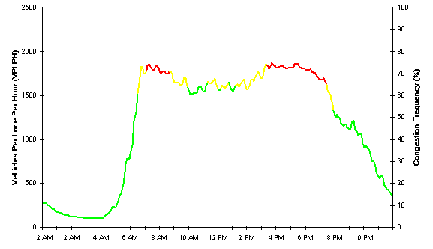Figure 1: Estimated Weekday Volume for SR 520 at 76th Ave. NE,
General purpose lanes, Westbound direction

Hint: The vertical axis in Figure 1 is in terms of vehicles per lane per hour. Since there are two lanes in each direction of the Evergreen Point Floating Bridge, total flow in the westbound direction is twice the number you get from the graph.

