Project 1: Geometric and Pavement Design
The city of Woodinville has received money to plan an upgrade of SR 202 in Woodinville (see map).

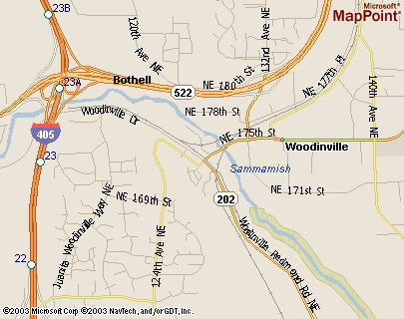
Project Area

The plan is to remove the 90-degree turn SR 202 takes through the intersection with NE Woodinville Dr. and turn it into a nice horizontal curve. The road shall remain one 12-ft. wide lane in each direction. Construction is tentatively planned for 2009. The tie-in with Woodinville Dr. will be designed later. You are producing an exploratory analysis of the SR 202 portion of this proposed solution and must present your findings to the Woodinville City Council. The City Council would like answers to the following questions:

- What is the highest safe speed for which the curve can be designed?
- What is the design for a 25 mph speed limit?
- What design do you recommend and why?
- What is your recommended pavement design for a 40-year design life?

In addressing the Council’s request, you should assemble a short report that addresses the following for each design:

- Horizontal curve
  - Design speed in miles per hour
  - Design superelevation (e)
  - The resulting side friction factor (f) and whether this is acceptable
  - Curve centerline radius (R)
  - Curve tangent length (T)
  - Curve length (L)
  - The angle subtended by the curve (Δ)
  - The stations of the PC, PI and PT

- Vertical curves (your design will necessarily have a crest and sag vertical curve)
  - Design speed in miles per hour
  - Curve lengths
  - Grade of any constant grade section connecting the vertical curves
  - The stations of the PVC, PVI and PVT or both curves

- Pavement design
  - Flexible pavement recommended design
  - Rigid pavement recommended design
  - Your recommended design between the two

You need not spend a lot of time drawing the curves unless you want to. If they are nicely drawn in AutoCAD, I will give extra credit. However, your brief report should at least contain some visual representation of the curves and a listing of all relevant data.

PLAN VIEW (not to scale)

110°
Bridge
Sammamish River
Begin Project
NE Woodinville Dr.
127th Place NE
A
D
C
B
E
F
SR 202
SR 202
North
Proposed Curve

Point | Station | Elevation | Comments
A | 100+00 | 130.00 ft. | The beginning of the proposed project. You cannot alter SR 202 prior to point A.
B | 103+00 | 130.00 ft. | SR 202 is flat between points A and B.
C | unknown | 132.00 ft. | Existing intersection location.
D | 105+50 | unknown | Point of intersection of the two parts of SR 202. The distance from point D to point F is 500 ft. The angle of intersection between AD and DF is 110 degrees.
E | unknown | 100.00 ft. | SR 202 is flat between points E and F.
F | unknown | 100.00 ft. | Beginning of the bridge. You cannot alter SR 202 after this point. Nobody wants to build a new bridge.

Pavement Design Data
You are able to scrape together the following information:

- There is a large industrial area on SR 202 just south of the project that creates substantial truck traffic.
- A traffic count on SR 202 taken at 5 p.m. on a Wednesday rush hour showed 1,632 vehicles (both directions) with 0.5% trucks.
- Two one-hour informal truck counts by you gave the following data:

 | Count 1 | Count 2
Begin time: | Thursday, 10 a.m. | Tuesday, 2 p.m.
FHWA Class 9 count: | 31 in both directions | 24 in both directions
FHWA Class 5 count: | 18 in both directions | 19 in both directions

- The City estimates the general population growth rate for the area is 1.5%.
- The City estimates traffic from the industrial area to increase by 1% per year.
- Assume an average load of 1.20 ESALs for the Class 9 trucks and 0.26 ESALs for the Class 5 trucks.
- WSDOT records show the subgrade M_{R} to be about 5,000 psi in the area.
- As often is the case, nobody has any estimate of the k-value for rigid pavement design. Use a default value of 200 pci.

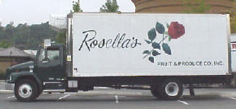
Typical FHWA Class 5 Truck seen on SR 202

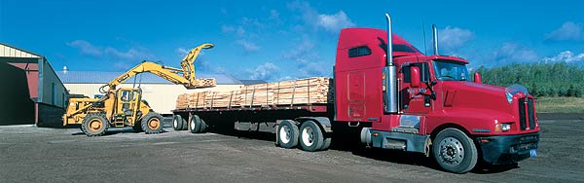
Typical FHWA Class 9 Truck seen on SR 202

Hints and Recommendations
- The NE 175th St. and 131st Ave. NE intersection just across the bridge to the northeast is quite busy so you probably don’t want to make your recommended design speed too high or else motorists will scream around your horizontal curve and then have to slam on the brakes at the intersection.
- Consider your choice of design superelevation carefully. If the NE 175th St. and 131st Ave. NE intersection gets backed up, cars may be idling on your curve.
- Do not design the superelevation runoff and runout.
- The required vertical curve design process is very similar to Examples 3.8 and 3.9 in the text.
- Be careful, the curve centerline radius is not necessarily the R_{v} that you will use in design.
- Two helpful equations for calculating ESALs are:
- $\text{Total}=\frac{P\left({\left(1+i\right)}^{n}−1\right)}{i}$$F=P{\left(1+i\right)}^{n}$Use either the WSDOT tables or the 1993 AASHTO interactive equations in the Pavement Guide Interactive (http://guides.ce.washington.edu/wsdot) to design the pavement.
- You may draw a pavement cross-section as in typical roadway plans or you may just report you recommended pavement materials and depths.
- WSDOT typically uses a reliability of 85% on a road such as SR 202

