Project 2: Traffic and Queuing
The Evergreen Point Bridge (Figure 1) on SR-520 was ranked one of the worst commuter hot spot in the U.S. (AAA, 2005). This floating bridge supports the majority of cross-lake traffic north of downtown Seattle at approximately 110,000 vehicles per day. Being one of the oldest floating bridges in the world, the Evergreen Point Bridge is approaching the end of its life time after over forty years of service. In 2000, the remaining useful life of the floating portion of the Evergreen Point Bridge was estimated to be 20 years, assuming no major storms or earthquakes hit the region (WSDOT, 2005). This indicates that the facility must be replaced before 2020. WSDOT is looking at alternatives to reconstruct the Evergreen Point Floating Bridge (http://www.wsdot.wa.gov/projects/sr520bridge).

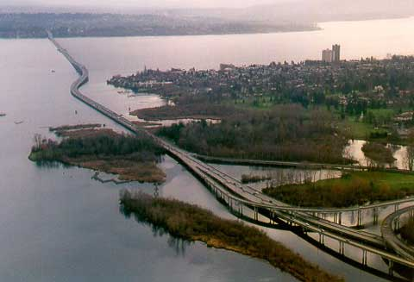
Figure 1: Evergreen Point Floating Bridge (from WSDOT website)

Tolls will provide much of the project's funding. Electronic Toll Collection (ETC) is preferred over the traditional manual tolls because ETC can be automatically done at toll gates without stopping ETC-enabled vehicles. However, since ETC requires a Radio Frequency (RF) tag to be installed in a vehicle in order to work, ETC will likely not work for all vehicles in a traffic stream. A recent study (Slavicek, 2004) found that the typical usage rate for ETC during a facility’s start-up phase is about 10-35% of Average Daily Traffic (ADT). Once the toll facility matures after about three years of usage, ETC use will reach as much as 80% of ADT. To collect tolls from vehicles without RF tags, two methods are available:

- Use license plate recognition technology to identify each vehicle and send a bill to the vehicle owner periodically by mail; and
- Construct Manual Tool Booths (MTBs) for onsite toll collection.

Both methods have been used in recent years. The decision is normally made based on analyses results. In this case, WSDOT has already selected MTBs.

Your team is retained as a consultant to provide WSDOT with key information regarding the proposed new floating bridge as described below.

Part 1: Traffic
WSDOT would like to know traffic flows and vehicle speeds over a typical 24-hour period. WSDOT has provided loop detector data for May 6th, which they consider a typical day. Using this data, provide the following:
- Histogram plot of hourly traffic volume over a typical 24-hour period.
- Histogram plot of average hourly speed over a typical 24-hour period.

Part 2: Level of Service
WSDOT would like to know the current bridge LOS and how it will change when the proposed new bridge is opened to traffic. Provide the following:
- The design LOS (for the 30th highest hourly volume) for the current Evergreen Point Floating Bridge.
- The design LOS (for the 30th highest hourly volume) for the 4-lane and 6-lane alternatives in 2015 when the new bridge is scheduled to open.

Part 3: Tolling
In order to determine the traffic impact of tolling and, ultimately, the best toll booth configuration, WSDOT would like you to provide:
- The time period (from which hour to which hour) for a typical day when vehicles will need to wait in a queue for toll collection.
- The total delay in vehicle-hours per day based on this initial toll booth configuration.
- The average toll collection rate needed to avoid backing up vehicles beyond the 50-vehicle storage space.
- Recommended configuration for the eight gates in 2018 (how many ETC and how many MTB?).
- The total vehicle delay in vehicle-hours per day and the maximum queue length for your recommended configuration in 2018.

Previous studies and WSDOT analyses provide the following information:

- There will be a total of 8 toll gates for the Eastbound direction with 7 of them configured as MTBs when the bridge opens in 2015.
- Each MTB has a storage space of 50 vehicles.
- HOV volume is 30% of average daily traffic and HOV also pay the toll
- 35% of vehicles will have the RF tags installed for the ETC service when the new bridge is planned to open in 2015
- ETC usage rate grows linearly
- 80% of vehicles will use ETC in 2018
- It takes an average of 12 seconds (deterministically) to collect a toll manually
- vehicles arrive at a constant rate each hour (this is a bit of a stretch, but is necessary to make the calculations less tedious)
- A vehicle always chooses the shortest queue to join at the manual toll area

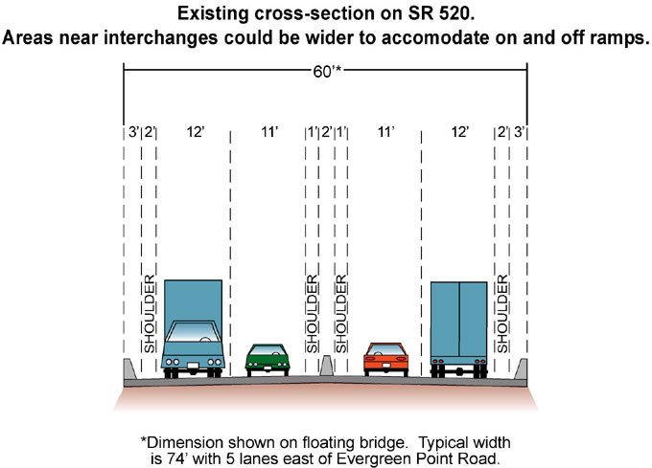

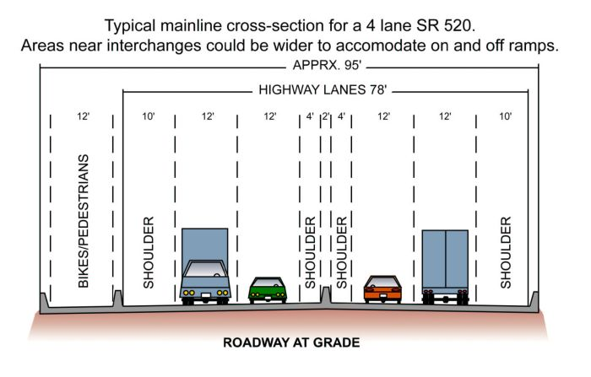
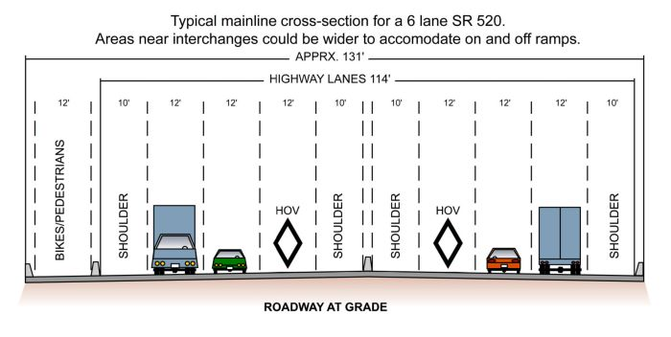
Figure 2: Current, 4-lane and 6-lane Evergreen Point Floating Bridge alternatives (from WSDOT).

Hints and Recommendations
Part 1: Traffic
- Use the speed calculation algorithm introduced in lecture for speed estimates.
- Use the default speed of 60 mph for intervals when no vehicle is detected.

Loop detector data at station ES-506 (located at the beginning of the Evergreen Point Bridge on Eastbound SR-520) for May 6th are provided. The data is available for download at our course Web site (http://courses.washington.edu/cee320ag/Projects/traffic_project_data.xls).

The file contains data for 4320 20-second intervals (4320*20/3600 = 24 hours). The measurements for each interval are shown in one row.

Key to reading the row
- Field 1: It is a time stamp. In this example, the date is May 6, 2005, and the time is 01:08:52.000 (the time when the measurements were taken).
- Field 2: The value is 8. It is the number of vehicles detected for both lanes of the interval. SR 520 has 2 lanes in each direction.
- Field 3: The value is 5.08%. It is the average occupancy per lane..

Part 2: Level of Service
- Calculate FFS directly from loop detector data. Use the average calculated speed for intervals with 20-second volume lower than 8 as the free flow speed of the existing bridge.
- Use the observed 20-second volume data to determine the PHF.
- The following equation can be used for estimating traffic volume after n years with an average yearly growth rate of i: $V_{n}=V{\left(1+i\right)}^{n}$
- SR 520 milepost 3.07 is in the middle of the Evergreen Point Floating Bridge, an extended bridge segment. As you may recall, LOS calculation methods do not account for this. Your LOS calculations should briefly discuss this condition and any others that might cause your LOS calculations to differ from reality. The reported LOS should be your best estimate of LOS given all actual conditions.
- If you find that the LOS does not change between the current and new bridge designs, you should comment on why that is and whether or not the lack of LOS improvement is reason enough not to consider the design.

Part 3: Tolling
- Reduce the 20-second data to hourly data, it’s much easier to work with and will give roughly the same answer.
- You really need to use a spreadsheet or some sort of programming.
- Basically, you are creating a plot like Figure 5.7 in the text only you are concerned with arriving vehicles that will be using the MTB and departing vehicles from the toll booth.
- Once you have a plot of queue length vs. hour of the day, don’t bother to integrate it; just figure out the total vehicle-hour delay for each hourly data point and sum them up.
- Include spreadsheet tables and plots in the appendix so that I know you did the work.

References
America Automobile Association (AAA). (2005). AAA Cites Some Of Nation’s Worst Commuter Hot Spots. News Room. Feb. 14, 2005. Available online at http://www.aaanewsroom.net/Articles.asp?ArticleID=353&CategoryID=7&SectionID=3&.

Slavicek, J. (2004). Tolling Options for the New SR-520 Bridge: Electronic vs. Manual Toll Collection. Master degree paper. University of Washington, Seattle, WA.

WSDOT. (2005). SR 520 Bridge Project - Frequently Asked Questions. Accessed online at http://www.wsdot.wa.gov/Projects/SR520Bridge/Questions.htm.

