Prototype Project Report

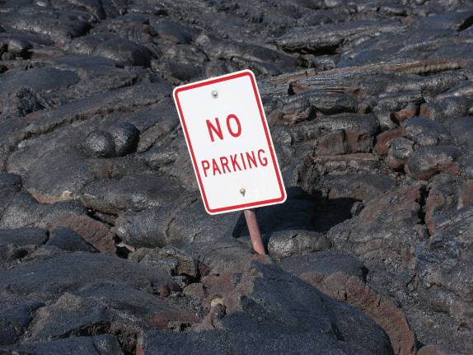

Group X
Anne Goodchild
Other Person 1
Other Person 2
Other Person 3

21 February 2008
CEE 320

(you can do the title page however you like – graphics, pictures, etc. Just be sure it has the title, group letter/name, contributors’ names, date and class)

Executive Summary
You can call this whatever you like, but it functions as a short summary of all your major findings. If someone does not want to read the report and does not care about any of the details of your work, they should be able to read this and understand the following:

- What you were asked to do. This lets the reader know what you were faced with and also lets them know that they are reading the right report.
- What you did. This should be one or two sentences or maybe a brief list. Keep it general; your key findings should make the details more obvious.
- Key findings. You can often communicate this in a table, bulleted list or graph. Writing a bunch of findings up in a long, run-on paragraph forces the reader to wade through your prose for answers they want: this is bad.
- Summary of work. If it is appropriate, summarize your work and recommendations in a sentence or two…or even a short bulleted list.

Try and keep this to one page. If you want to include a cover letter with your report (some people like to), don’t put any vital information in the letter if it is not elsewhere; the cover letter is often detached from the report and may easily get lost or discarded (or simply not read).

Some people (me included) find this section easiest to write if written last. You can then take what you’ve written in detail and distil it down to a summary.

Table of Contents
You can include one if you like, but for a paper that’s only about 10-pages long, it’s not essential. If you submit a 50-page paper (in some other class) then it’s essential.

Introduction
A brief description of the task at hand. Some things to consider describing:

- What have you been asked to do?
- Why is it important?
- What does your design or analysis cover (a brief summary of the major areas)

By reading the introduction, the reader should know what the report is about and what it contains.

Remember, your group’s final write-up should be concise and to-the-point. Key answers and assumptions should be clearly stated and supporting calculations should be included after the write-up and referenced in the write-up.

Analysis (or Design)
You can call this section whatever you want, but this is the area where you present your findings, reasoning and major assumptions. Generally, it’s best to write for someone who will be scanning your document – that means using headers, sub-headers, bulleted or numbered lists, tables and figures; it is easier to get the information you need by scanning these items than by reading paragraphs of prose.

Consider dividing up this section into major themes or tasks. For instance, a geometric design project report might include a section titled, “Existing Conditions” that describes how things are now and what is deficient about them. Or, if you are asked to determine 3 key things, then it might be logical to use a sub-header for each key thing.

Labeling Tables and Figures
For technical writing (that’s what we’re doing here) it is most common to label a Table above the table, and label a Figure below the figure. The table should look nice and be formatted so that it is easy to read. The figure should not be pixilated (blown up significantly beyond 100%) and should be easy to view.

Table 1: Float Test Results
Category | Result | Observations
Very small rocks | Does not float | Originally though these floated
Wood | Floats | Floats, but generally cannot be used to discern a witch.
A duck | Floats | Floats, and can be used to determine witch origins.


Figure 1: View from Scorpion Ridge.

Length of Paper
For CEE 320, your project reports should be somewhere between 5 and 10 pages (not counting appendices, table of contents or title page). You should have tables, pictures, etc. included in these 5 to 10 pages. For a typical report, you might use up 4 or 5 pages with tables and figures leaving you only about 5 or 6 pages at most for writing.

Other Writing Standards
All the usual standards apply such as:
- Written on computer and printed out on 8½ x 11 inch white paper.
- Single or double spaced – either is fine although you may find it difficult to fit everything in 10 double-spaced pages.
- Standard margins, font size, etc. Please do not endlessly mess with these things to make you paper fit the 5 to 10 page rule. If you must go an extra page or two, do so and keep the paper readable. However, if you find your paper is 20 pages long, single spaced, you need to go back and shorten it.

Summary (or Conclusions or whatever)
A brief summary of what you found. Do not regurgitate all your calculations but rather give an overview. If you are asked to recommend a design alternative and calculate its parameters, you would probably just overview your recommendation and major reasons why you chose it. You would not post all your calculations and results tables again.

References
If you look up information that is not contained in a CEE 320 lecture or in the class textbook (Mannering et al., 2005) then you should reference that material and list the reference in this section. Any standard format is acceptable. Note that standard formats include the author, date of publication, title of book/article/website, title of periodical (if applicable), publisher (if it is a book) and web address (if it is a website).

Appendices
Because this is an engineering class, you will likely have calculations, spreadsheets, graphs, etc. that you use to come up with your answers. These are most appropriately contained in an appendix. Do not count on the reader looking in an appendix; if something is really important for the reader to see, put it in the main body of the report.

For the purposes of this class, I am fine with handwritten calculations on engineering paper as an appendix. For example, if you figure out LOS on engineering paper first, include the paper in the appendix. Even though they are in the appendix, items here should still be neat and readable; do not include random bits of scratch paper.

