CEE 424
GIS for Civil Engineers
Homework 8: Spatial Analyst

Introduction
The ArcGIS Spatial Analyst extension provides a rich suite of tools and capabilities for performing comprehensive, raster-based spatial analysis. With this extension, you can employ a wide range of data formats to combine datasets, interpret new data, and perform complex raster operations. Examples of the analysis that you can do with Spatial Analyst include terrain analysis, surface modeling, surface interpolation, suitability modeling, hydrological analysis, statistical analysis, and image classification
The following are brief descriptions of the main components of Spatial Analyst:
- The most common way to access Spatial Analyst functionality is with the geoprocessing tools. This rich environment allows you to quickly and easily organize and execute the tools necessary to complete your analytic tasks, as well as providing a mechanism to automate, document, and share your workflows.
In the geoprocessing framework, you can perform Spatial Analyst operations in these ways:
  - Running individual tool dialogs
  - Combine tools with ModelBuilder to automate workflows and create spatial models
  - Automate workflows and create new tools with Python
- Map Algebra is a powerful algebraic language for performing raster analysis. In ArcGIS 10, Map Algebra is now fully integrated into the Python environment.
There is also a Raster Calculator tool that allows you to easily create Map Algebra expressions in a tool dialog or in ModelBuilder.
- The Spatial Analyst toolbar provides some interactive tools useful for simple exploration of your raster data.
- With the Image Classification toolbar, you can take multiband raster data, such as aerial photos or satellite imagery, and create classified rasters such as land-use or vegetation cover layers that can be used in further analysis or for creating maps. The tools available for creating, evaluating, and editing training samples will help you to get good results from the classification process.
For more information, please visit:

http://help.arcgis.com/en/arcgisdesktop/10.0/help/index.html#//005900000002000000.htm
Part A: Population Densities.

Calculate the population of the Northshore School district.

 | Go to C:\CEE424_GIS\GTKArcGIS\ and copy the HW8 folder to a place where you have write-permission (e.g., the desktop).  Start a New Blank Map in ArcMap, and add the shapefile school_dist.shp and the pop_density raster to your project map.  Note: Ignore the SHAPE_area and SHAPE_length fileds of school_dist. Assume these fields have unknown units.

This lab will make use of Raster files and the Spatial Analyst tools. Remember that a raster is a grid of information. The population density raster file given here has a pixel size of 100m by 100m. To make things confusing, this data set is reporting density in citizens / mile². Fortunately, you are a GIS expert and can deal with these units.

Step 1 | First make sure the Spatial Analyst is on. Go to Customize > Extensions. A dialogue box will appear. Check the box next to Spatial Analyst. Hit Close.
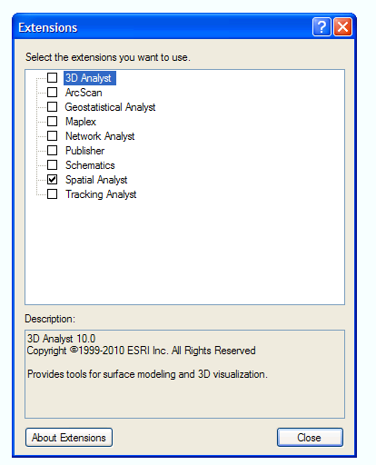

Step 2 | Go to Customize > Toolbars > Spatial Analyst so it shows up on the screen.

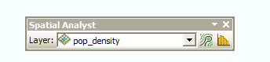

This toolbar will not be used in this exercise, but it is useful in other spatial analyst applications.

Step 3 | If you have not done so yet, add the the shapefile school_dist.shp and the pop_density raster to your project map. Your screen should look like the image below (the shapefile colors will vary).

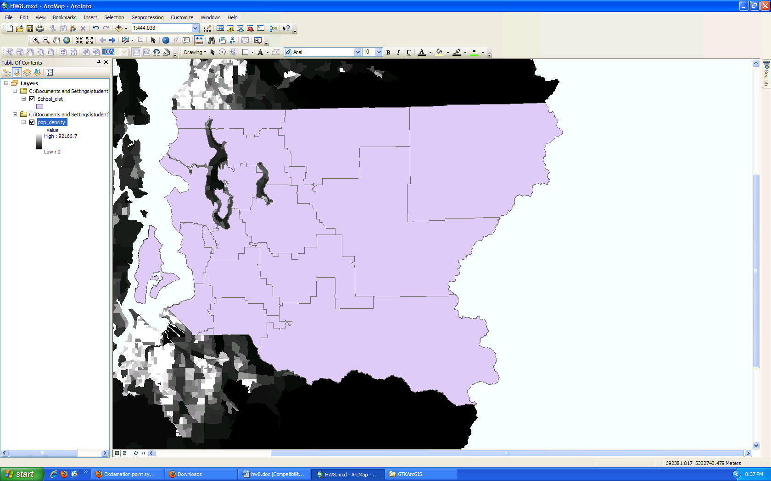

Step 4 | Now you first want to find the population density (not actual population) of each school district based on the pop_density raster. To do so, you will need to use the Zonal Statistics as Table tool (use the Search window to find this).  Your input feature will be School_dist, and the Zone filed is NAME. The input value raster is pop_density. Specify a name for the table and make sure all your settings match the window below. Then hit OK.

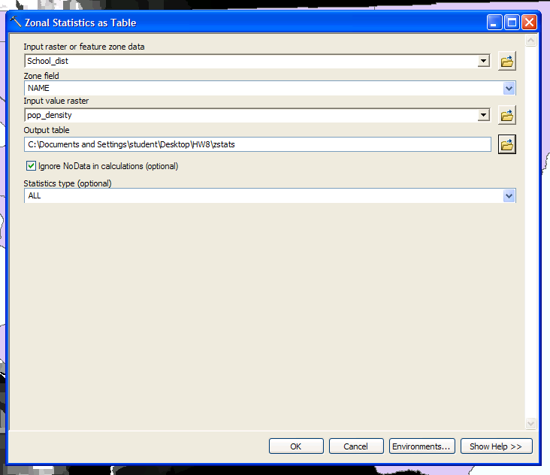

The output will be a table that includes all the basic statistics (min, max, range, mean, standard deviation, and sum) of the pop_density raster in the school districts. Again this is population density (citizens / mile²), not total population.

Open the table and look at the various columns. Your table should look like the one below. For this problem, we are most interested in the MEAN population density of each school district.

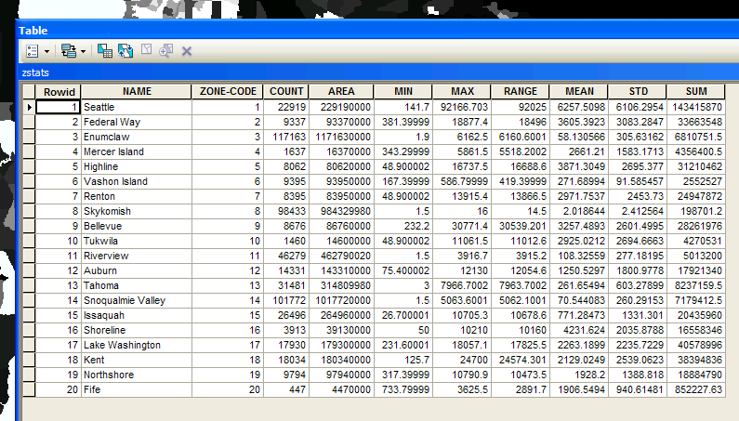

Step 5 | Now to get total population of the school districts, you need to multiply the MEAN population density by the area for each district. You need to calculate the area of each school district in miles² because your population density is in citizens / mile².  Open the attribute table for the School_dist shapefile. Note that area and length fields already exist in the School_dist attribute table. These units are unknown, so do not use these fields.  You will first need to create a new field for the area in miles². Click on Table Options ->Add Field. Then name your new field and use “Float” for type with precision = 6, scale=4.  Now right click on the new field and hit Calculate Geometry. A dialogue will advise you to use an edit session, hit ok to continue anyway.  Change the units to Square Miles US [sq mi] and make sure your dialogue matches the following, then hit OK.
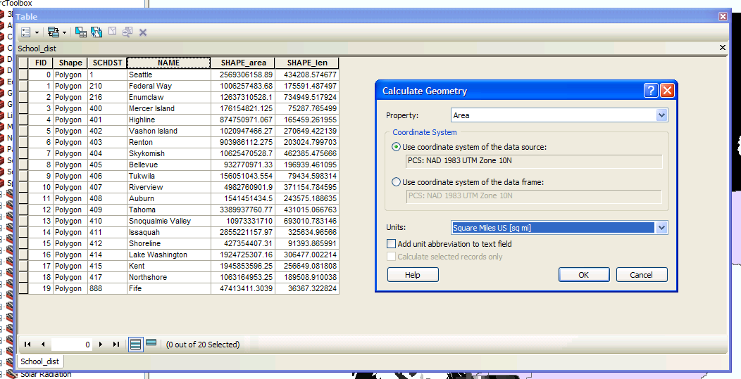

Step 6 | It may be helpful to join the School_dist attribute table (Step 5) to your zonal statistics table (from Step 4).
Step 7 | Now you are ready to calculate the population of each school district.  To do this, you will need to add a new field and use Field Calculator (in the attribute table, under Table Options) to multiply the area field (from Step 5) by the MEAN population density field (from Step 4).  Once again remember units when looking at the statistics. With the stats joined it should be a simple matter of operations within Arc to calculate the population or a matter of calculations with any other number crunching means you have.

Questions/Tasks

- Print a screenshot of your final attribute table that (at a minimum) shows the name, area, mean density, and population of each school district. Be sure to clearly indicate which column is the population of the school districts. Be sure to make it clear that you did the exercise and that you did not just copy and paste the images from this Word document. You will get no credit if it appears that you borrowed the above image from this file. So make your screenshot similar, but NOT THE SAME as the sample screenshot.

- In a 1 sentence statement, state what the population of the Northshore School district is, based on your spatial analyst estimate.

Hint: The population of the Northshore district is between 10,000 and 100,000.

Part B: Trail Elevations.

Which trail systems can we hike that are over 1000 m based on the elevation data that we currently have? What is the total length of the trail(s) above 1000 m?

Go to C:\CEE424_GIS\GTKArcGIS\ and copy the HW8 folder to a place where you have write-permission (e.g., the desktop).

Start a New Blank Map in ArcMap, and add the shapefile Trail.shp and the Elevation raster to your project map
(see step 3 if the Elevation raster appears to be a uniform value)

Note: the vertical units of the Elevation raster are in meters.

Step 1 | First make sure the Spatial Analyst is on. Go to Customize > Extensions. A dialogue box will appear. Check the box next to Spatial Analyst. Hit Close.

Step 2 | Go to Customize > Toolbars > Spatial Analyst so it shows up on the screen.

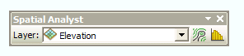

The layer should be set to the Elevation raster.

Step 3 | If you have not done so, add the Trails.shp and Elevation raster to your map project.  Note: If your Elevation raster looks like a uniform colored area (with minimum and maximum values in the 10³⁸ range), then you need to make a quick adjustment to the symbology. This appears to be some sort of weird hiccup with this particular raster file, but it should not impact the analysis, just your visualization of the elevation data.  The workaround: Right click on the Elevation layer, go to Properties, then the Symbology tab. Make sure it is “stretched” symbology. Then scroll down to statistics and choose “From Custom Settings (Below)”. Make your settings match the following and hit OK.  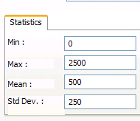  You should now see distinct elevation patterns, with ridges and valleys. For reference, the lower right part is the northwest slope of Mt. Rainier.

Step 4 | In ArcToolBox, go to the Spatial Analyst Tool -> Map Algebra, and then open the Raster Calculator.  The idea of the raster calculator is rather straight forward for simple concepts. The elevation raster has values in each pixel representing elevation and we wish to look at areas with elevations above a certain level. So with the raster calculator we simply double click the raster desired use the greater-than symbol and enter our desired elevation of interest. Input the following equation and designate an output raster, then hit OK.
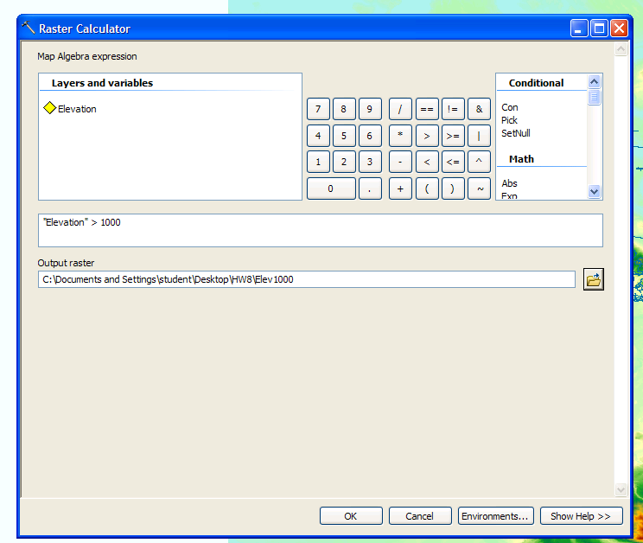

This should provide a new binary raster file made up of two distinct values (e.g., 0=area at or below 1000m, 1=area above 1000m).

Step 5 | We will change the binary raster file from Step 4 such that it will only provide us with data about the areas of elevation above the desired level. To do this we use the spatial analyst tool Reclassify (which is located in Spatial Analyst Tools –> Reclass).  Since our map currently represents the 0 value as values that were below our selected elevation we will want to get rid of this data. Change the 0 value (from the old raster) to “NoData” in the new raster, as indicated below. It does not matter what value you place for the New Value in the second row, as long as it is a real number (e.g., 2). Designate an output raster and make sure your screen matches the follow graphic, then hit OK.

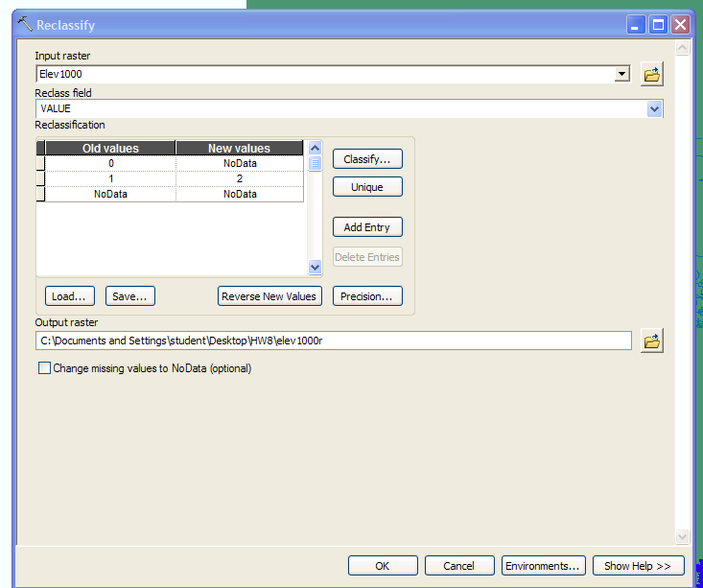

Turn off all layers except Trails and the reclassified raster. Your screen should look like this (colors will vary):

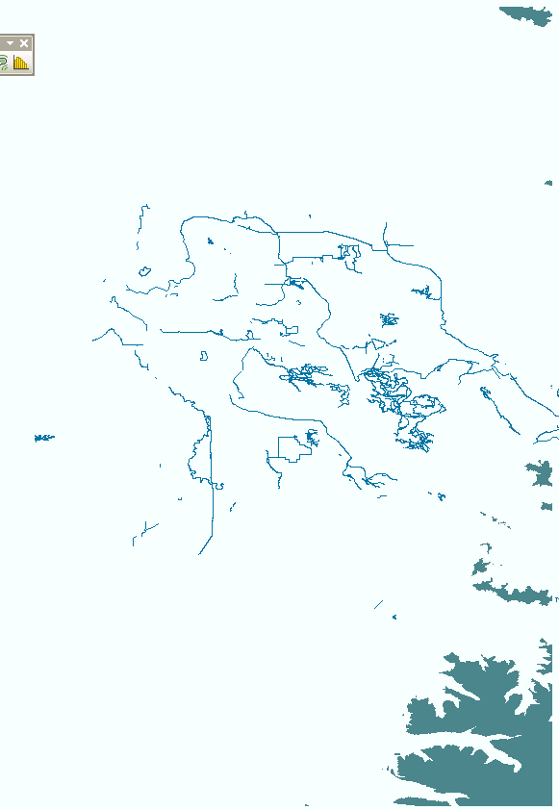

Step 6 | For your analysis, you cannot compare a raster to a line, so you need to convert the reclassified raster to a polygon.  In ArcToolbox, go to Conversion tools > From Raster > Raster to Polygon. Put your reclassified raster into the input and designate an output polygon shapefile. Match the following graphic and hit OK.

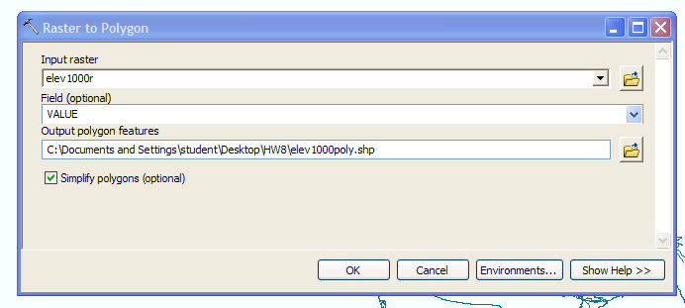

Step 7 | From here you should have the knowledge of what you have previously done in this class to determine which trails we can hike in order to be above our given elevation.  Go to Analysis tool and use the Intersect tool to find the trails higher than 1000m in elevation.
Step 8 | After you have used the intersect tool, you should have a new line that shows the trails above 1000m. Open the attribute table of this new layer, add a new field (name=”length”, type=short integer), then Calculate Geometry in meters.
Step 9 | Label the length of the trail(s).

Your final product should look like this:
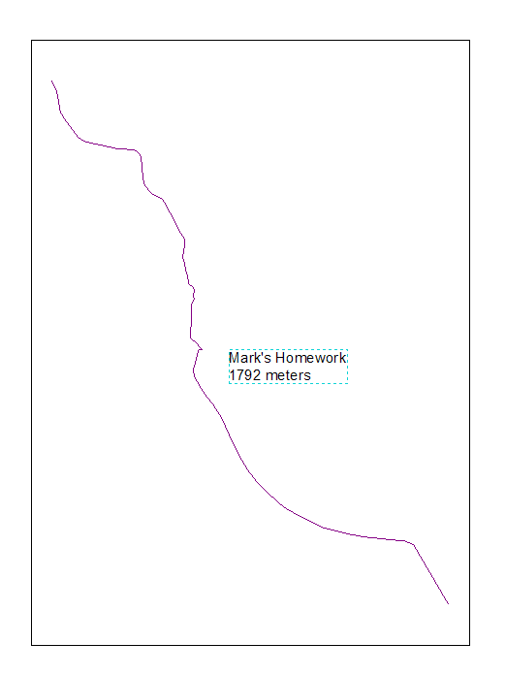

Questions/Tasks

- Turn off all other layers except for the layer that includes your trail(s) above 1000 m (note this is not the same as the original TRAILS layer). Zoom extents to this single layer and print a screenshot of the final trail above 1000 meters with a text label that lists the length of the trail (1792 meters).

You will want to confirm that your layer has the length of 1792 meters. Again be sure to make it clear that you did the exercise and that you did not just copy and paste the images from this Word document. You will get no credit if it appears that you borrowed the above image from this file. So make your screenshot similar, but NOT THE SAME as the sample screenshot.

