Stone Matrix Asphalt

The Washington Experience

by

Nancy M. Myers

A Research Project submitted in partial fulfillment of the requirements of the degree of

Master of Science in Civil Engineering

University of Washington

June, 2007

Abstract

Find a hard durable, quality stone; fracture it into a cubical shape with 100 percent crushed surfaces; reduce the medium sized stone; and then glue the remaining stones together with an asphalt rich mortar, in such a quantity to give stone-on-stone contact among the coarse particles (Brown 1994). The goal of this recipe is to make a durable, rut-resistant pavement called Stone Matrix Asphalt (SMA). For the asphalt mix designer the skill is in getting the recipe right. For the contractor the challenge is to produce and place SMA pavement properly.
SMA pavements have performed very well in Europe and parts of the United States. The pavement was originally developed in Sweden to combat rutting caused by the use of studded tires. With the increased traffic volumes and loadings, states such as Maryland, Virginia, and Georgia use SMA exclusively for all of their high volume pavements. (Brown et al. 1999) found that performance of these pavements has been excellent and rutting has been reduced dramatically.
Washington State Department of Transportation (WSDOT) has constructed four SMA projects. Washington experienced the expected SMA learning curve and revised their specifications after each project. Three are performing well and one was replaced a year later with conventional HMA pavement. Even with the problems of meeting the volumetric specifications on the three remaining projects, the pavements are performing well.
Washington learned that SMA projects are very different from HMA projects. Plant revisions are required for the mineral filler and stabilizer feeding systems. High quality aggregates are required and fortunately Washington State has the high quality aggregate needed for SMA. Quarries produce aggregates with the needed 100 percent crushed surfaces while impact crushers produce the cubical shaped stones. The asphalt binder also needs to be bumped up a couple of grades. This mix is difficult to work with and paving crews need to be trained to place and compact his mix.
The use of pay factors on the volumetric properties was used and questioned on the last Washington project. The contractor could not meet both volumetric property specifications at the same time and paid a penalty. It appeared that there was greater operator error on the volumetric tests than the asphalt content and gradation tests. Since volumetric properties are correlated to the AC and gradations, pavement performance may not be improved by the use of volumetric pay factors with SMA.
SMA is an expensive pavement to build. The last SMA section of pavement in Washington cost 76 percent more than the conventional HMA pavement. The higher cost was due to the higher grade of oil, addition of mineral filler, addition of cellulose fibers, plant revisions, and the added work associated with the mix. Currently the price of the higher grade oil is considerably more than the lower grades used in conventional HMA. Total plant revisions were estimated at approximately $50,000 on the project built in 2001. If more projects are constructed the cost of these plant revisions will be spread over more projects. When SMA costs become approximately 30 to 50 percent more than HMA, instead of 76 percent more than HMA, SMA will be more cost effective. A life cycle cost analysis (LCCA) needs to be conducted to determine where this breaking point is for Washington projects.

GLOSSARY
Aggregate - A collective term for the mineral materials such as sand, gravel and crushed stone that are used with a binding medium (such as water, bitumen, portland cement, lime, etc.) to form compound materials (such as asphalt concrete, portland cement concrete, etc.).
Air Voids (V_{a}) - The total volume of the small pockets of air between the coated aggregate particles throughout a compacted paving mixture, expressed as a percent of the bulk volume of the compacted paving mixture. The amount of air voids in a mixture is extremely important and closely related to stability and durability. For typical dense-graded mixes with 12.5 mm (0.5 inch) nominal maximum aggregate sizes air voids below about 3 percent result in an unstable mixture while air voids above about 8 percent result in a water-permeable mixture.
Asphalt binder - the principal asphaltic binding agent in HMA. "Asphalt binder" includes asphalt cement as well as any material added to modify the original asphalt cement properties.

Asphalt Content (AC) - The percent of asphalt binder by weight in the mix.

Batch plant - A manufacturing facility for producing HMA or PCC that makes the product in batches rather than continuously.

Coarse Aggregates - Aggregates retained on the 4.75 mm (no. 4) sieve.

Dense-graded - Refers to an HMA mix design using an aggregate gradation that is near the FHWA’s 0.45 power curve for maximum density. These are the most common HMA mix designs in the U.S.

Draindown - That portion of the mixture (fines and AC) that separates and flows downward through the mixture.

Drum plant - A manufacturing facility for producing HMA. They manufacture HMA continuously rather than in batches.

Equivalent Single Axle Load (ESAL) - Based on the results from the AASHO Road Test, the most common approach to determining traffic loading is to convert wheel loads of various magnitudes and repetitions to an equivalent number of "standard" or "equivalent" loads. The most commonly used equivalent load in the U.S. is the 80 kN (18,000 lbs.) equivalent single axle load.

Fine Aggregates - Material that passes the 4.75 mm (No 4) sieve and is retained on the 0.075 mm (#200) sieve.

Flushing, fat spots (also called "bleeding") - A film of asphalt binder on the pavement surface caused by the upward migration of asphalt binder in an HMA pavement.

Gap graded - Refers to a gradation that contains only a small percentage of aggregate particles in the mid-size range. The curve is flat in the mid-size range. HMA gap graded mixes can be prone to segregation during placement.

Hot Mix Asphalt (HMA) - A high quality, thoroughly controlled hot mixture of asphalt binder and aggregate that can be compacted into a uniform dense mass.

International Roughness Index (IRI) - IRI is used to define a characteristic of the longitudinal profile of a traveled wheeltrack and constitutes a standardized roughness measurement.

Job-Mix Formula (JMF) - A recommended/specified mixture of aggregate and asphalt binder.

Mineral filler - Defined by the Asphalt Institute as a finely divided mineral product at least 65 percent of which will pass through a No. 200 sieve. Pulverized limestone is the most commonly manufactured mineral filler, although other stone dust, silica, hydrated lime, portland cement and certain natural deposits of finely divided mineral matter are also used (Asphalt Institute, 1962).

Material Transfer Vehicle (MTV) - Used to assist the paver in accepting HMA. Most pavers are equipped to receive HMA directly, however in certain situations it can be necessary or advantageous to use an MTV. Paving using bottom dump trucks and windrows requires a windrow elevator MTV while other MTVs are used to provide additional surge volume allowing the paver to operate continuously without stopping, minimizing truck waiting time at the paving site and possibly minimizing segregation and temperature differentials.
National Asphalt Pavement Association (NAPA) - NAPA supports an active research program designed to improve the quality of HMA pavements and paving techniques used in the construction of roads, streets, highways, parking lots, airports, and environmental and recreational facilities.
National Center for Asphalt Technology (NCAT) - NCAT was established at Auburn University in 1986 with an endowment set up by the NAPA Research and Education Foundation. Its mission is to improve HMA performance through research, education, and information services.
Nominal Maximum Aggregate Size (NMAS) - One size larger than the first sieve that retains more than 10 percent aggregate.
Pay factor - A multiple applied to the contract price of a particular item.
Performance Grade (PG) - Performance grade asphalt binder. Binder is chosen for the environment it will experience. For example PG 64-28. 64° C is the average seven day high temperature. -28° C is the minimum low temperature.
Permeability - A property describing the degree to which a material can be permeated or penetrated, especially by liquids or gases.
Pit - contains loose sand and gravel that is dug directly out of the ground. A Pit can produce some products that consist of round stones.
Quarry - contains bedrock that must be blasted first before it can be processed. All products from a quarry are crushed (ie have sharp edges).
Recycled Asphalt Pavement (RAP) - RAP is typically generated by (1) milling machines in rehabilitation projects or (2) a special crushing plant used to break down large pieces of discarded HMA pavement.
Raveling - In flexible pavements, the progressive disintegration of an HMA layer from the surface downward as a result of the dislodgement of aggregate particles.
Residuals - In petroleum refining, they are the left-overs from the refining process.
Rutting - Surface depressions in the wheelpath of a pavement.
Segregation - Regarding HMA, the broad definition is “a lack of homogeneity in the hot mix asphalt constituents of the in-place mat of such a magnitude that there is a reasonable expectation of accelerated pavement distress(es).” Typically though, “segregation” refers to aggregate segregation, which is “the non-uniform distribution of coarse and fine aggregate components within the asphalt mixture.”
Stability - A term often used to describe an HMA’s ability to resist deformation under loading.
Stripping - In flexible pavements, the loss of bond between aggregates and asphalt binder that typically begins at the bottom of the HMA layer and progresses upward. When stripping begins at the surface and progresses downward it is usually called raveling.
Stone Matrix Asphalt (SMA) - is a tough, stable, rut resistant mixture that relies on stone-to-stone contract for its strength and a rich mortar binder for its durability.
Theoretical maximum density (TMD, also called "Rice density") - The theoretical maximum density of an HMA if it contained zero air voids.
Tensile Strength Ratio (TSR) - Ratio of the average indirect tensile strength of conditioned specimens (wet) to the average indirect tensile strength of conditioned specimens (dry). Also know as the Modified Lottman Test. this test predicts stripping.
Voids in the Mineral Aggregate (VMA) - The volume of intergranular void space between the aggregate particles of a compacted paving mixture that includes the air voids and the effective asphalt content, expressed as a percent of the total volume of the specimen.

List of Abbreviations and Acronyms
AC-Asphalt Content
AASHTO-American Association of State Highway Transportation Officials
AIMS-Aggregate Imaging System
ASTM-American Society of Testing Materials
ESAL-Equivalent Single Axle Load
F/E - Flat to Elongation Ratio
HMA-Hot Mix Asphalt
IRI-International Roughness Index
JMF-Job Mix Formula
NAPA-National Asphalt Pavement Association
NCAT-National Center for Asphalt Technology
NMAS-Nominal Maximum Aggregate Size
RAP-Recycled Asphalt Pavement
SMA-Stone Matrix Asphalt
SHRP-Strategic Highway Research Plan
TMD -Theoretical Maximum Density, also called "Rice Density”
TSR-Tensile Strength Ratio
Va- Air Voids
VCA-Voids in Coarse Aggregate
VFA-Voids Filled with Asphalt
VMA-Voids in the Mineral Aggregate
WSDOT- Washington State Department of Transportation
List of Figures
Figure 1. SMA gap-graded mix and HMA dense- graded mix comparison. 3
Figure 2. Volumetric diagram. 6
Figure 3. SMA gap-graded aggregate - HMA dense-graded aggregate. 8
Figure 4. 0.45 power curve for an SMA and conventional HMA, 12.5 mm mixture. 9
Figure 5. Examples of draindown and fatspots. 15
Figure 6. Washington State SMA project locations. 25
Figure 7. Aggregate Imaging System. 39
Figure 8. Surface texture results from AIMS and core cross section. 40
Figure 9. Coarse aggregate texture results from AIMS (Myers 2004). 41
Figure 10. Volumetrics and gragations for Moses Lake project. 45
Figure 11. Mineral filler feeding systems. 47
Figure 12. Celluslose fibers. 48
Figure 13. Cellulose fiber dispensing system. 48
Figure 14. Cellulose fiber feed. 49
Figure 15. SMA truck loading. 50
Figure 16. SMA sticking to truck. 50
Figure 17. SMA in truck. 51
Figure 18. Placement of SMA. 51
Figure 19. Temperature differentials on mat. 52
Figure 20. Compaction of mat. 52
Figure 21. Infrared camera and nuclear density guage. 53
Figure 22. Pavement bleeding and rutting. 54
Figure 23. Low air voids (Ritzville to Tokio). 55
Figure 24. High air voids (Ritzville to Tokio). 55
Figure 25. Fat spots (Ritzville to Tokio). 56
Figure 26. Skid results for failed project (Ritzville to Tokio). 57
Figure 27. Rutting of SMA and HMA pavements near Ritzville. 58

List of Tables

Table 1. AASHTO MP8-01: Specification for designing SMA 4
Table 2. SMA gradations - Maryland specifications (AI 2002). 10
Table 3. Coarse aggregate quality requirements (AASHTO MP8-01). 11
Table 4. Relationship of L.A. Abrasion to Flatness/Elongation Ratio (GDOT 2002). 11
Table 5. Average rut depth in mm for Georgia projects (Georgia DOT 2002). 23
Table 6. Performance data for Maryland projects (Michael et al. 2002). 23
Table 7. Performance data-Virginia (McGhee et al. 2005). 24
Table 8. General Information for SR-524 project in Lynnwood. 28
Table 9. General Information for I-90 project east of Ritzville. 30
Table 10. General Information for I-90 project west of Ritzville. 32
Table 11. General Information for I-90 project near Moses Lake. 33
Table 12. Aggregate blends for Eastern Washington projects. 35
Table 13. JMF-Field Gradations-Field Standard Deviations for Washington SMA projects. 36
Table 14. LA abrasion- Degradation-SpecificGgravity for selected Washington pit and quarry sites. 38
Table 15. Volumetrics for Washington SMA projects. 44
Table 16. SMA project costs for Washington State. 59

Table of Contents

Abstract…………………………………………………………………………………...ii
Glossary…………………………………………………………………………………..iv
List of Abbreviations and Acronyms……………………………………………………viii
List of Figures…………………………………………………………………………….ix
List of Tables………………………….……………………………………………….....ix
Table of Contents…………………………………………………………………………xi

1 Introduction 1
2 Literature Review 2
2.1 Description and Background 2
2.2 Mix Design 4
2.2.1 Air Voids and Asphalt Content 5
2.2.2 Voids in Mineral Aggregates 5
2.2.3 Voids in Coarse Aggregate . 7
2.3 Asphalt Binder 7
2.4 Aggregates 7
2.4.1 Gradation 8
2.4.2 Hardness, Flat to Elongation Ratio, and Surface Texture 10
2.4.3 Voids in Coarse Aggregate 13
2.5 Modifiers and Fillers 14
2.6 Construction Operations 16
2.6.1 Aggregate Production 16
2.6.2 Asphalt Plant Production 17
2.6.3 Placement 20
2.7 Sampling and Testing Procedures 22
2.8 Pavement Performance 22
3 Analysis of Data for Washington SMA Projects 25
3.1 Introduction 25
3.2 Projects 27
3.3 Aggregate Gradation 35
3.4 Aggregate Characteristics 37
3.5 Volumetrics and Binder 41
3.6 Construction Issues 46
3.6.1 Production 46
3.6.2 Placement 49
3.7 Pavement Performance 53
3.8 Project Costs 59
4 Summary and Conclusions 60
4.1 Literature Review 60
4.2 Washington SMA projects 61
5 Bibliography 65
6 APPENDIX 68

Introduction

SMA is a tough, stable, rut resistant mixture that relies on stone-to-stone contract for its strength and a rich mortar binder for its durability (NAPA 1999). SMA was first developed in Europe to combat rutting caused by the use of studded tires. In the 1980’s federal and state highway officials in the United States recognized the need to design stiffer, more rut resistant pavements. As a result, American professionals participated in the European Asphalt Study Tour in 1990, where SMA pavements were investigated. This was the first concerted effort to figure out how to use SMA in the United States. In 1994 the Federal Highway Administration awarded a contract to the National Center for Asphalt Technology (NCAT) to determine the performance of SMA pavements. Results from this study showed a significant reduction of rutting with SMA pavements (Brown et al. 1997).
A number of states have had experience with SMA pavements, some with more success than others. SMA pavement projects and studies were conducted in Maryland, Virginia, Wisconsin, Georgia, and Washington to name a few. Many states have adopted SMA pavement as their standard mix for their high traffic highways.
Washington State has constructed four projects; one in Western Washington, two in Eastern Washington and one in Central Washington. The first project experienced many of the expected problems associated with a new product. The second project in Eastern Washington failed and had to be replaced with conventional hot mix asphalt (HMA) the following year. The last two projects experienced fewer problems and have performed well to date. This paper will review reports from SMA projects through out the United States and then focus on the problems and successes of the Washington state projects.

Literature Review
This section is organized into eight topic areas which include: (1) description and background, (2) mix design, (3) asphalt binder, (4) aggregates, (5) modifiers and fillers, (6) construction operations, (7) sampling and testing, and (8) pavement performance. Resources included both national and local studies and project reports.

Description and Background
SMA is a tough, stable, rut resistant mixture that relies on stone-to-stone contact for its strength and a rich mortar binder for its durability (NAPA 1999). The expectation is that since aggregates do not deform as much as asphalt binder under load, its stone-on-stone contact will greatly reduce rutting. The pavement strength is achieved through the interlocking of a high quality gap-graded aggregate. As seen in Figure 1, the gradation contains only a small percentage of aggregate particles in the mid-size range which leaves more room for the mortar of fine aggregate and polymer modified binder.
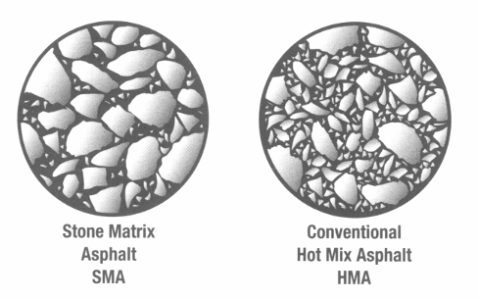
Figure 1. SMA gap-graded mix and HMA dense- graded mix comparison.

SMA was developed in Germany and Sweden in the 1960’s to achieve a pavement more resistant to studded tire wear. Asphalt content ranged between 6.5 to 7.5 percent by weight of mixture (Mahoney 2000). There was a problem of the liquid asphalt (binder) separating and flowing downward through the mixture. To prevent this binder draindown, cellulose or mineral fibers were used in the mixes. Carbon black and polymers were also allowed however fibers were preferred over polymers due to lower cost, higher possible mixing temperatures, increased time for compaction and reduced mixing segregation. The job mix formula (JMF) was based on the 50 blow compaction Marshall with a 3 percent air void (Va) target. Aggregate size mostly ranged between 5 mm to 22 mm, Sweden using the larger sizes, usually 12mm or 16mm. Lab studies showed a 40 percent reduction in studded tire wear (Mahoney 2000).
The first concerted efforts to use SMA in the United States began in the 1990s. American professionals first participated in the European Asphalt Study Tour in 1990, where SMA pavements were investigated. In 1997 NCAT determined SMA pavements were effective against rutting. As a result a few states began to try SMA pavements on their high volume roads. For example, Georgia developed two research projects to study the performance of SMA as a wearing course for heavy truck loads and as an overlay for Portland cement pavements (GDOT 2002). As a result of this study it was determined SMA was effective against rutting, had a longer service life, had a greater fatigue life, and had a lower annualized cost (GDOT 2002). Maryland and Virginia were also early in experimenting with SMA.

Mix Design

SMA mix design is similar to that for traditional dense-graded HMA with target air voids of 3.5 to 4 percent and a minimum asphalt content (AC) of 6 percent. Voids in Mineral Aggregate (VMA) are higher than conventional HMA mixes with a minimum of 17 percent. Early mix designs were performed with the Marshall Compactor but most designs now use the Gyratory Compactor. Table 1 below shows a summary of the AASHTO MP8-01: Specification for Designing SMA.
Table 1. AASHTO MP8-01: Specification for designing SMA
Property | Requirements
Asphalt Content, % | 6 minimum
Air Voids, % | 4
VMA, % | 17
VCA, % | < VCA_{DRC}
TSR, % | 70 minimum
Draindown, % | 0.3 max

Air Voids and Asphalt Content

Air Voids (Va) is the total volume of the small pockets of air between the coated aggregate particles, expressed as a percent of the bulk volume of the paving mixture. Asphalt Content (AC) is defined as the percent of asphalt binder in the mix by weight. See Figure 2 for the Volumetric Diagram.
SMA mixes are now designed at 4 percent Va. This represents a good compromise between preventing permanent deformation and fat spots and ensuring the SMA lift is impermeable. AC should be at least 6 percent to increase pavement durability. Low Va and too much AC will push the coarse aggregate particles apart with a reduction in pavement shear deformation resistance. High Va with too little matrix reduces the pavement durability caused by aging and moisture damage (Pierce 2000). Mahoney (2000) found that SMA mixtures should be compacted to 5-7 percent Va during construction. This is done because compaction continues during the use of the roadway.
There is also a relationship between in-place Va and pavement permeability. To ensure that permeability is not a problem in-place Va should be between 6 and 7 percent or lower (Brown et al. 2004). Other factors influencing the permeability are gradation, Nominal Maximum Aggregate Size (NMAS), lift thickness and design compactive effort.

Voids in Mineral Aggregates

Voids in the Mineral Aggregate (VMA) is the volume of intergranular void space between the coarse aggregate particles of a compacted paving mixture that includes the Va and the effective AC and fines, expressed as a percent of the total volume of the specimen (see Figure 2).
SMA mixes require higher VMA values than dense graded asphalts because of the gap-graded nature of these pavements, (Schmiedlin and Bischoff 2002). The higher VMA is necessary so a higher AC can be used, which improves the pavement durability. (Brown and Mallick 1994) found that VMA values for most projects studied ranged between 15-20 percent and the recommended minimum VMA should be at least 17 percent. There are several factors that can affect VMA. First, when the percentage passing the 4.75 mm (No. 4) sieve increases, the VMA decreases significantly. Brown and Mallick (1994) found that the material passing the 4.75 mm (No. 4) sieve had to be less than 30 percent to meet the VMA requirements. Harder aggregates, which do not break down during laboratory compaction, result in a higher VMA. The higher the abrasion loss, the lower the VMA. (Brown et al.1997) found if there is a reduction in AC to increase air voids, VMA values decrease.
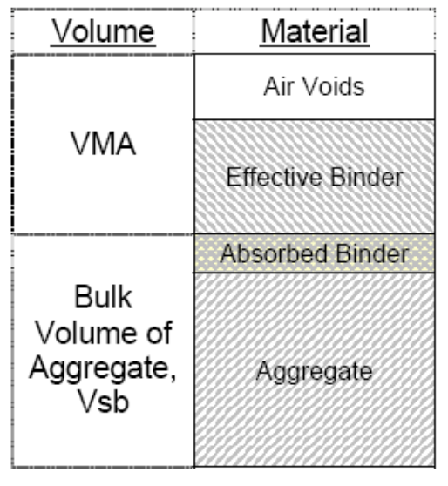
Figure 2. Volumetric diagram.

Voids in Coarse Aggregate SMA mixtures require that the voids in coarse aggregate (VCA_{MIX}) should be less than the voids in coarse aggregate in the dry rodded condition (VCA_{DRC}) to ensure that stone-to-stone contact does exist within the pavement (Brown et al. 1997). This is not a requirement for traditional dense-graded mixtures and a more detailed description is included in the following Aggregate section of this paper.

Asphalt Binder

Asphalt binder includes the AC and any other modifiers added to it. AC for SMA mixtures is higher than standard mixes. AC should be at least 6 percent by weight (Brown et al.1997) and typically ranges from 6 to 6.7 percent. Too much asphalt will push the coarse aggregate particles apart with a drastic reduction in pavement shear deformation. Too little matrix will result in high air voids which reduces pavement durability caused by accelerated aging and moisture damage (Pierce 2000). Both AC grade and Performance Grade (PG) grade binders have been used for SMA pavements. It is best to increase the asphalt grade by one or two grades above that recommended by climate (Brown and Cooley 1999).
Brown and Cooley (1999) recommend that design AC is selected to achieve 4 percent Va. This however results in a rich mixture so bleeding and draindown can be a problem. The greater amount of asphalt binder requires the use of a combination of more fines (mineral filler) and a stabilizing agent to reduce the draindown.

Aggregates

SMA pavement is composed of gap-graded aggregates which result in the stone-to-stone contact as shown in Figure 3 below. SMA pavements lack the medium sized aggregates and have a lot of fines. The interlocking of the large aggregates gives the pavement its strength. The gaps between the large aggregates create the spaces for the
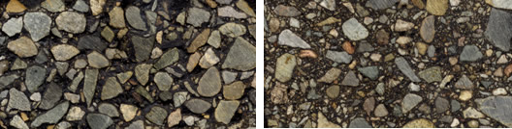
Figure 3. SMA gap-graded aggregate - HMA dense-graded aggregate.
mastic which includes the liquid asphalt and the fines. Aggregates should be selected with adequate hardness, surface texture, shape and durability. SMA projects are best designed using all crushed aggregates with a cubical shape. Projects have been constructed with different NMAS. SMA mixes have also been used for thin overlays.

Gradation

Figure 4 is an example of the 0.45 power curve for both SMA and conventional HMA pavements. SMA mixtures generally contain about 10 percent material passing the 0.075 mm (No. 200) sieve (commonly referred to as dust), with a 1.5 dust to binder ratio. Mid-sized aggregates are lacking in SMA mixtures.
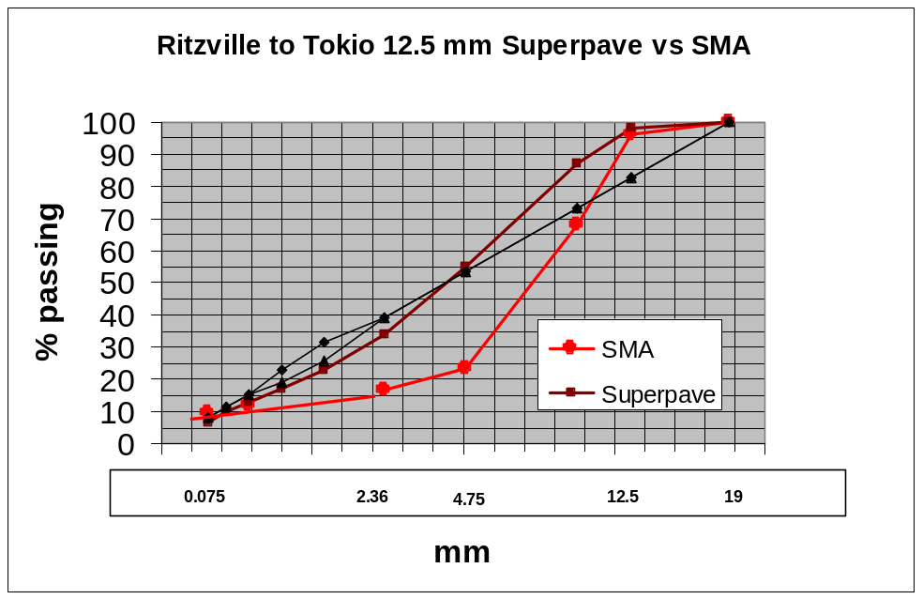
Figure 4. 0.45 power curve for an SMA and conventional HMA, 12.5 mm mixture.

Brown et al. (1997) showed that SMA mixtures are sensitive to the percentage of material passing the 4.75 mm (No. 4) sieve. 90 percent of the projects, studied in this 1997 NCAT report had 25-35 percent material passing the 4.75 mm (No. 4) sieve. When the material passing the 4.75 mm (No. 4) sieve increased, the VMA decreased significantly, hence low air voids and fat spots. So, the fines have decreased in SMA mixtures over the years. The percent passing the 4.75 mm (No. 4) sieve decreased from approximately 32 percent in 1991 to 26 percent in 1996.
Fines, passing the 0.075 mm (N0. 200) sieve usually range from 8 to 11 percent (Brown et al. 1997). These fines, with their large surface areas, bind with the asphalt, to make the mastic (glue) that binds the large aggregates together.
Most SMA mixes are either 12.5 mm (1/2 in) or 19.0 mm (3/4 in) NMAS, which conforms to European SMA mixtures. For example, Table 2 below summarizes the specifications for Maryland’s SMA gradation (AI 2002). Maryland usually uses the 19 mm and 12.5 mm NMAS aggregate sizes.
Table 2. SMA gradations - Maryland specifications (AI 2002).
Sieve, mm | 19mm NMAS |  | 12.5mm NMAS |  | 9.5mm NMAS
 | Lower | Upper | Lower | Upper | Lower | Upper
37.5
25.0 | 100 | 100
19.0 | 100 | 100 | 100 | 100
12.5 | 82 | 88 | 90 | 99 | 100 | 100
9.5 |  | 60 | 70 | 85 | 70 | 90
4.75 | 20 | 28 | 30 | 50 | 30 | 50
2.36 | 14 | 20 | 20 | 33 | 20 | 30
1.18 | - | - | - | - | - | -
0.6 | - | - | - | - | - | -
0.3 | - | - | - | - | - | -
0.15 | - | - | - | - | - | -
0.075 | 9 | 11 | 8 | 11 | 8 | 13

The use of 4.75 mm NMAS SMA pavements (thin overlays), have become more attractive to engineers because these mixes can be placed in thin lifts thus can be used within a preventative maintenance program. Cooley (2003) found these fine mixes could be designed to obtain stone-to-stone contact as well, and these pavements were rut- resistant. Permeability testing showed these mixes were less permeable than conventional SMA mixes at similar Va levels, and thus should be more durable.

Hardness, Flat to Elongation Ratio, and Surface Texture
Aggregates should be selected with adequate hardness, surface texture, shape and durability. Table 3 below is a summary of the Coarse Aggregate Quality Requirements (AASHTO MP8-01).
Table 3. Coarse aggregate quality requirements (AASHTO MP8-01).
Test | Method  (AASHTO) | Specification  Minimum | Specification  Maximum
L.A. Abrasion, % Loss | T96 |  | 30
Flat & Elongated, %
3:1 | D4791 |  | 20
5:1 | D4791 |  | 5
Absorption, % | T85 |  | 2.0
Crushed Content, %
1-Face |  | 100
2-Face |  | 90

Hardness properties of the aggregate are important to resist the abrasion from studded tires. Hardness also helps resist fracture under heavy loads and polishing. A 1997 NCAT report stated, “Approximately 85 percent of the projects used an aggregate meeting the recommended L.A. abrasion factor below 30” (Brown et al.1997). Research conducted at Georgia Tech showed that there was a complex relationship between the degree of rutting and two parameters: the 3:1 flatness/elongation ratio and the L.A. abrasion value. Specifically it stated “Under favorable conditions for the flatness/elongation (F/E) ratio, the abrasion value can be as high as 45, and under favorable conditions for the abrasion value, the F/E ratio can be as high as 45, see Table 4 below (GDOT 2002).
Table 4. Relationship of L.A. Abrasion to Flatness/Elongation Ratio (GDOT 2002).
L.A. Abrasion Value | F/E Ratio  (3:1) %
< 45 | < 20
< 40 | 21-25
< 35 | 26-35
< 30 | 36-40
< 25 | 41-45

Based on this research Georgia implemented the use of aggregates which have no more than 45 percent abrasion loss and which have no more that 20% flat and elongated particles when measured at the 3:1 ratio. Aggregates also need to have a high cubic shape and rough texture to resist rutting and movement (GDOT 2002). Maryland requires coarse and fine aggregates must have 100 percent crushed faces (AI 2002).
Currently the L.A. abrasion test is specified in AASHTO design of SMA mixes to measure aggregate degradation. A study at Texas A&M questioned whether the L.A. abrasion test represented aggregate abrasion during construction compaction and subsequent traffic loading (Gatchalian 2006). The study suggested that aggregates such as granite and gneiss, which performs well in service may exhibit high levels of loss in the L.A. abrasion test due to their coarse grained crystalline structure. Also, soft aggregate may absorb the impact of the high loads in the test. The study recommended the use of the Micro-Deval abrasion test to evaluate the resistance of aggregate particles to degradation in SMA mixes (Gatchalian 2006).
The Micro-Deval abrasion test examines a coarse aggregate’s ability to resist abrasion and weathering. This test induces abrasion on the coarse aggregate using the Micro-Deval machine to roll a steel jar containing the aggregate (soaked in water prior to the test), steel spheres and water. Cooley and James (2003) suggested that the L.A. abrasion test measures impact and abrasion while the Micro-Deval measures only for abrasion.
Aggregates should also have a rough (crushed) surface texture and a cubical shape. The Texas A&M study also recommended the use of the Aggregate Imaging System (AIMS) method to capture the characteristics of the aggregates using digital imaging techniques (Gatchalian 2006). This system provides a means for characterizing aggregates as opposed to the Superpave tests for measuring coarse aggregate shape properties, but the equipment is expensive. It consists of top and back lighting apparatus, an auto-focus microscope, and associated software. The analysis determines angularity, texture and shape of the aggregate.

Voids in Coarse Aggregate

Stone-to-stone contact of the aggregate in SMA pavement is considered necessary to resist plastic deformation. In the past, evaluation has been very subjective and only done by visual inspection from cored samples. Brown and Mallick (1994), at the National Center for Asphalt Technology (NCAT), developed a test to determine optimum stone-to-stone contact. They measured the Voids in Coarse Aggregate (VCA), with no fines, by placing the coarse aggregate in a container and using dry rod compaction to achieve maximum density in accordance with ASTM C29, “Standard Test Method for Bulk Density (Unit Weight) and Voids in Aggregate.” Because there are no fines in the container the voids in this dry rodded condition represent the void condition at which stone-on-stone contact exists for the coarse aggregate. The NCAT report stated, “The point at which the Voids in the Coarse Aggregate of the mixture (VCA_{MIX}) is equal to the Voids in the Coarse Aggregate in the dry rodded condition (VCA_{DRC}) is the point at which it is assumed that the stone-to-stone contact occurs” (Brown and Mallick 1994). The VCA_{MIX} should never exceed VCA_{DRC} because it indicates there are too many intermediate size aggregates.
Hongbin et al. (2003) conducted a study on using 4.75 NMAS SMA for thin overlays. These mixes had the potential for use within preventative maintenance programs. The VCA criteria, was also developed in this study for these 4.75 mm mixtures. For 4.75 mm NMAS SMA, the definition of coarse aggregate was different than with other traditional mixtures. The coarse aggregate was defined as aggregates larger than the 1.18 mm sieve instead of the material retained on the 4.75 mm (No. 4) sieve.

Modifiers and Fillers
One of the biggest problems with SMA has been draindown and the resultant fat spots due to the higher AC and VMA. Draindown occurs when the liquid asphalt (binder) separates and flows downward through the mixture as seen in the left photo in Figure 5. Most of the draindown occurs in the first hour. Draindown increases significantly when AC is increased. Brown and Mallick (1994) found that an increase of the asphalt content from 6 to 7 percent increases draindown by a factor of 5. It appears that for a given
mixture there is a threshold asphalt content at which there is very little draindown. Once the threshold is exceeded, draindown occurs.
Fat spots are pools of asphalt binder on the pavement surface caused by the upward migration of asphalt binder or by mastic dripping or plopping off machinery onto the mat. The right photo in Figure 5 also shows some extreme fat spots. Fat spots can lead to deformation or deterioration in specific areas. Fat spots can be caused by a high asphalt content.
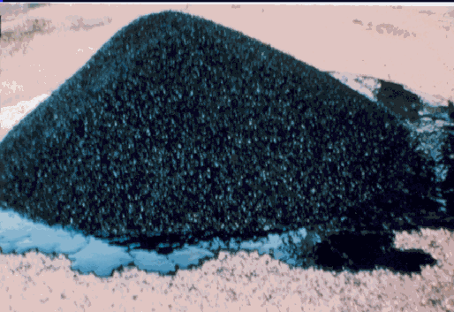 | 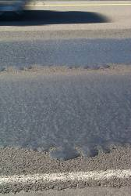
Draindown (Moses Lake Project) | Fat Spots (Ritzville to Tokio Project)
Figure 5. Examples of draindown and fatspots.

Stabilizing additives have been introduced into SMA mixes to alleviate these draindown and bleeding problems (fat spots). Because of compaction issues, storage and placement, temperatures cannot be lowered. Additives such as, fibers, mineral filler, rubbers, and polymers have been added to stiffen the mastic at high temperatures. Fibers do the best job of preventing draindown, where polymers improve the asphalt cement properties at low and high temperatures. Brown and Mallick (1994), in a 1994 NCAT study, found that a combination of 0.3 percent mineral fiber or 0.3 percent European cellulose fiber, produced the least draindown. They also found mixtures with no additives (mineral fiber or European cellulose) and 0.3 percent vestoplast polymer produced the highest draindown. Brown and Cooley (1999) also concluded in NCHRP Report 425 that fibers do a better job than polymers to reduce draindown
The type of fines can also affect draindown. Brown and Mallick (1994) determined that baghouse fines had much less draindown than mixtures containing marble dust. This is because the smaller particles provide more surface area for a given weight and thus tend to stiffen the binder more than coarse fines. This clearly shows the importance of the size of the particles passing the 0.075 mm (No. 200) sieve.
Brown and Mallick (1994) also discovered that the amount of material passing the 4.75 mm (No. 4) sieve also affects draindown. The mixtures with 20 percent passing the No. 4 sieve had significantly more draindown than the mixes with 50 percent passing the No. 4 sieve. With coarser mixes the internal voids of the uncompacted mix are larger, resulting in more draindown.

Construction Operations
The production, placement and compaction of SMA mixtures are different from conventional SMA mixtures. Plant revisions are required, the mix is difficult to work with and compaction must occur quickly. The following discussions will cover aggregate production, asphalt plant production, and asphalt placement.

Aggregate Production
Brown (1999) found that gradation control for SMA mixtures is directly related to pavement performance. The mix is very sensitive to the percent passing the 4.75 mm (No. 4) and the 0.075 mm (No. 200). Pierce (2000) also found that several different aggregate stockpiles of differing sizes are usually necessary to meet the gradation requirements for SMA. It is very important that aggregates are handled carefully and don’t segregate or spill over into other piles.
Brown (1999) concluded that cubical shaped stones with crushed surfaces are required for successful SMA pavements. (NSSGA 2001) reported that materials crushed by impact crushers produce a more cubical shaped stone, materials produced from quarries produce aggregates with 100% crushed surfaces and materials crushed from pits exhibit more rounded faces.

Asphalt Plant Production
Either drum or batch plants can be used to produce this mix. Plant production of SMA is critical to the success of the pavement. Close control of plant temperatures, plant stockpiles and cold feed are necessary. Plant modifications are necessary for the feeding of fibers and mineral fillers into the mix.

Materials
Materials needed for the production of SMA mixes include a high grade of asphalt binder, high quality aggregates, mineral filler, a stabilizer and at times modifiers. These materials are handled, produced and placed differently than conventional HMA mixes.
The handling and storage of liquid asphalt for SMA is similar to any HMA mixture. Storage temperatures for modified asphalts may be higher.
It is typical to blend at least three coarse aggregate piles to meet gradation specifications. SMA consists of a high percentage of coarse aggregate so the blending can be a challenge. It is very important that the aggregates be carefully handled and stockpiled. Each coarse aggregate stockpile may need to be fed through more than one cold feeder to meet gradation requirements. Using more than one cold feeder will also minimize variability in the gradation of the coarse aggregate stockpiles.
Mineral fillers are necessary for SMA pavements because baghouse fines account for only 5 percent of the fines. SMA gradation specifications usually require approximately 10 percent passing the 0.075 mm (No. 200) sieve. These fines, along with the liquid asphalt and fiber, make the mastic which holds the mix together. SMA mixtures are very sensitive to the amount of 0.075 mm (No. 200) in the mix. Handling, storing and the introduction of the mineral filler is therefore an important concern. A mineral filler silo is necessary at the plant. These silos are closed systems in which filler is stored and then the material is metered at the proper amounts into the mix. Brown and Cooley (1999) found that the mineral filler should be captured by the asphalt binder or coarser aggregate as soon as it is added to the mixture. Mineral filler should not be added to conveyor belts from the cold feeder or from the rap feeder.
Stabilizing additives are necessary to prevent draindown. Both fibers and polymers have been used, the fibers being the most effective. Fibers are usually added by a machine that is supplied by the fiber manufacturer. The fiber is fluffed and then metered into the pugmill for batch plants, or the drum for drum plants. In the drum plant the fiber line is placed next to the asphalt binder line. This allows the fibers to be captured by the asphalt binder before being exposed to the high velocity gases of the drum. Pelletized fibers can be used as well. The pellets are placed in a hopper and can be metered and conveyed into the drum or the pugmill. Pellets do contain some asphalt binder so this has to be taken into account in the mix design. A less common way of stabilizing the mix is with asphalt binder modifiers. The asphalt binder can be modified at the refinery or added at the hot mix plant. The modifier is either blended into the asphalt binder before it is injected into the mixture or it is added directly to the dry aggregates during production.

Mixing
The mixing process for SMA is different than conventional HMA mixtures as this is a very sensitive mix. Additional feed systems for mineral filler and the stabilizer need to be carefully calibrated. Mixing temperatures need to be controlled and maintained. Mixing times should be monitored to ensure the stabilizer is thoroughly distributed into the mix. Storage of SMA should be limited due to the possibility of draindown.
It is very important that all feed systems be carefully calibrated prior to the production of SMA. Calibration of aggregate cold feed bins should be performed with care to ensure proper gradation. Stabilizing additive manufacturers will usually assist the hot mix producer in setting up, calibrating and monitoring the stabilizing additive delivery system. The mineral filler feed system and the dust collector/return system should be interrelated because this determines the total fines in the mix. Brown and Cooley (1999) discovered that for most SMA projects the ability to add mineral filler into the mixture governs mix production rates.
SMA mixing temperatures vary according to aggregate moisture content, weather conditions, grade of asphalt binder, and type of stabilizing additive used. Normal HMA production temperatures, or a little higher, are typical. The SMA mixture should never be heated above 176° C (350° F) since this may damage the asphalt binder, increase plant emissions and increase the chance of draindown. The damage is due to oxidation which occurs when the actual molecules are thermally broken apart, which makes the asphalt less ductile and more susceptible to cracking (WSDOT 2002).
When adding fibers to the SMA mixture, mixing time should be increased slightly over conventional HMA. In batch plants both dry and wet cycles should be increased from 5 to 15 seconds each. In the drum plant the fiber line is placed next to the asphalt binder line so the fibers are captured by the asphalt binder to improve mixing. The proper mixing times can be estimated by visual inspection. If clumps of fibers or pellets still exist in the mixture at the discharge chute or if aggregate particles and not sufficiently coasted, the mixing times should be increased.
Brown and Cooley (1999) found that SMA mixtures should not be stored more than 12 hours due to the draindown issues.

Placement
The placement and compaction of SMA pavement requires special attention due to potential draindown problems and the difficult handling of this harsh sticky mix. Plant production, mixture delivery, placement, and compaction should be carefully coordinated. Brown (1999) recommended a target density of 95 percent maximum density with a 94 percent minimum of maximum theoretical density which is higher than the 91-93 percent normally used for normal dense-graded HMA. SMA pavements compact readily at proper mix temperatures but are very difficult to compact once they begin to cool. Below are some recommendations for the construction of SMA pavements.
Hauling
- Haul times should be as short as possible
- Do not increase hauling temperature to facilitate longer hauling times. The increased hauling times coupled with truck vibrations can induce draindown.
- Deliver the mix between 140°-150° C (280°-300° F). Higher temperatures may be needed if polymers are added.
- Use approved releasing agents and prohibit the use of fuel oils.
Placement
- Use Material Transfer Vehicles (MTV’s)
- Paving speed should be dictated by the speed of the rolling operation.
- Keep the rollers close behind the pavers
- Pavers should not start and stop as bumps may be left in the pavement.
- SMA mixture delivery and paver speed should be calibrated so augers can be kept tuning 85-90 percent of the time. This results in the slowest auger speed. High auger speed can shear the mortar from the coarse aggregate and cause fat spots.
- Do not run conveyor of MTV empty because it may cause draindown.
- Keep raking and hand work to a minimum.
Compaction
- Keep rollers immediately behind the paver and compact quickly.
- 5 rollers work well for compaction, 2 breakdown, 2 intermediate and one finish roller.
- Laydown temperatures below 290° F tend to stick to the trucks and above 305° tend to bleed (Schmiedlin and Bischoff 2002).
- Vibratory rollers should be used sparingly.
- Pneumatic tired rollers should not be used.
In summary SMA mixtures can be placed and compacted successfully with careful planning and calibration of the entire paving process from production to compaction.

Sampling and Testing Procedures
Pierce (2000) discovered that the handling of SMA samples needs special care. Use greased metal buckets rather than cardboard boxes for storing mix sample so the asphalt binder is not absorbed into the container. This is a very sticky mix so test equipment must be thoroughly cleaned after each use.
Tests are performed for mix design as well as acceptance. A number of tests are performed on the aggregate. Gradations are performed to ensure the aggregate is within the allowable limits. Key physical attributes are checked by the following tests; Coarse Aggregate Angularity, Fine Aggregate Angularity, and Flat and Elongated Particles. Bulk specific gravity of the mixture is determined by using AASHTO T166 and ASTM D2726. Other source properties may be checked such as L.A. abrasion and degregation.
During construction densities of the in place mix are taken using a nuclear density guage. Asphalt content is determined by burning off the asphalt binder in an ignition furnace using AASHTO T-308. Gradations are checked on the remaining aggregate using AASHTO T-27/T11.

Pavement Performance
This section will quickly summarize some SMA performance studies in the United States. Performance characteristics such as rutting depth, roughness and/or friction were measured on the projects. Clearly the SMA pavements have performed well.
In 1994 the Federal Highway Administration funded a project for the National Center of Asphalt Technology to evaluate the performance of SMA pavements in the United States. Pavement performance was evaluated by measuring rutting depth. Brown et al. (1997) found that over 90 percent of the projects experienced rutting measurements less than 4 mm and 25 percent of the projects had no measurable rutting. There were six projects that had more than 6 mm of rutting but this was not attributed to the SMA mixture. This study confirmed that rutting is significantly reduced with SMA pavements if they are properly designed and constructed.
Georgia monitored rutting on an I-85 test section for several years and compared it to a standard hot mix. The SMA mixture certainly experienced less rutting. SMA and HMA projects comparisons are shown in Table 5.

Table 5. Average rut depth in mm for Georgia projects (Georgia DOT 2002).
Year | SMA (mm) | HMA (mm)
1993 | 0 | 3
1994 | 2.3 | 5.3
1995 | 2.5 | 6.8

In 2002 Marlyand reported on the performance 85 SMA projects as shown in Table 6. Note these are cumulative rut depths.
Table 6. Performance data for Maryland projects (Michael et al. 2002).
 | Rut Depth  Cumulative  inches (mm) | IRI Roughness  in/mile | Friction
12.5 mm | 0.14 (3.5) | 75.7 | 49.1
19 mm | 0.13(3.3) | 97.1 | 46.5

McGhee et al. (2005) documented pavement performance for Virgina DOT projects constructed in 2003 and 2004, to baseline information for the development of future projects, (see Table 7). The International Roughness Index (IRI), and friction were recorded on these projects. IRI is used to define a characteristic of the longitudinal profile of a traveled wheel track and constitutes a standardized roughness measurement; it measures ride quality.
Table 7. Performance data-Virginia (McGhee et al. 2005).
Year | IRI Average  in/mile all mixes | Friction  12.5mm
2003 | 66 | 44.1
2004 | 62 | 49.5

Pay factors were applied to International Roughness Index (IRI) values in 2004. Note the improved smoothness for SMA improved from 2003 to 2004, as seen in Table 7.
Overall the performance of SMA pavements in the United States has been very good as seen from the above studies and projects due to the low rutting depths and no early failures.

Analysis of Data for Washington SMA Projects
This section will discuss and compare the four SMA projects constructed by WSDOT. It is organized by the following topics: (1) introduction, (2) individual projects, (3) aggregate gradation, (4) aggregate characteristics (5) volumetrics and binder, (6) construction issues, (7) pavement performance, and (8) project costs.

Introduction
The Washington State Department of Transportation (WSDOT) has constructed four SMA projects between 1999 and 2004, totaling approximately 48,000 tons. The projects are listed below. See map in Figure 6 for project locations.
- SR 524 64th Avenue West to I-5 in Lynnwood 1999
- I-90 Ritzville to Tokio (east of Ritzville) 2000
- I-90 SR 21 to Ritzville (west of Ritzville) 2001
- I-90 Dodson Road to Moses Lake 2004
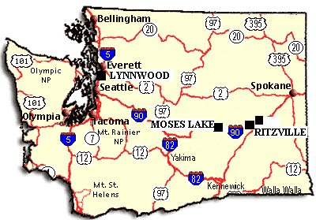
WASHINGTON STATE SMA PROJECTS
Figure 6. Washington State SMA project locations.

Research data for the Washington projects was obtained from the following resources. Advice and recommended practices that are given come from interviews and conversation from the following individuals as well as project reports and data provided and referenced.
- Linda Pierce, WSDOT Pavement Engineer, provided project data, correspondence, photos, and project reports for all of the projects.
- Tim Moomaw, WSDOT Trainer, by interview and emails, provided information about the Moses Lake project which included the project reports, SMA PowerPoint presentations and some insight on volumetric testing of HMA.
- Ken Olsen, WSDOT Project Engineer for the I-90 Ritzville to Tokio project, by phone interview and emails, contributed a PowerPoint presentation summarizing both Ritzville projects, change order information as well as discussion about the failed pavement.
- Gordon Olsen, WSDOT Project Engineer for the I-90 SR 21 to Ritzville project, by interview provided a lot of insight about the production and placement of SMA.
- Pamp Maiers, Jr. of Central Washington Asphalt, by interview, provided the contractor’s perspective on producing, placement and payment of SMA. He disagreed with using both VMA and Va as pay factors. He also felt the 18 percent minimum for VMA was too high.
- T. J. Morgan, Quality Control Officer for Inland Asphalt, by phone interview and emails, had the opportunity to work on two SMA projects. He provided contractor insight on the production and placement of SMA contributed information on the cost of the plant revisions.

WSDOT consulted industry experts in SMA construction from the states of Maryland, Georgia and Oregon prior and during some of the projects. Valuable feedback was obtained form these experts for planning and designing future projects. Both contractors and the WSDOT personnel have learned many lessons about successfully constructing SMA pavements.
All four projects used 12.5mm (1/2 in) NMAS SMA mixes with different grades of asphalt binders. Three of the projects have performed reasonably well to date. The Ritzville to Tokio project however, experienced severe flushing and raveling, and had to be replaced with a conventional HMA pavement within a year. Detailed discussions follow for each project.

Projects
Below is a summary of each SMA project including some general information, project discussion, project assessment, and suggested revisions to the specifications for future projects. Each project assessment includes the project’s mix design, asphalt production, asphalt placement, final pavement quality and pavement performance. Project areas were assessed as either, good, acceptable, or poor.
SR-524, 64th Avenue to I-5

The first trial project was constructed in 1999, on SR 524, in Lynwood WA, on the west side of the state. Outside experts were invited to share their advice in advance of the project. Don Watson, Georgia DOT and Pace Jordon, a paving foreman for C. W. Mathews were asked because of they have had a lot of experience with SMA. This project experienced a number of expected and unexpected construction issues. Table 8 below displays some general project information.
Table 8. General Information for SR-524 project in Lynnwood.
SR-524, 64th Avenue to I-5
Contractor | CRS
Date | Aug 1999
NMAS | 12.5 mm
Asphalt Grade | PG 64-22
Tonnage | 5800
SMA Price/Ton | $72.50

Mix design was difficult to achieve because the contractor did not submit trial blends. JMF gradations were within SMA limits but the asphalt binder grade was not increased.
There were significant production problems with this project. The contractor introduced the fiber manually which did not uniformly distribute the fiber into the mix. Mineral filler was blended with the 4.75 mm (No. 4) to dust material. There was not a separate silo for the mineral filler which caused some gradation problems initially. Sampling containers were changed from cardboard boxes to steel containers to eliminate the absorption of liquid asphalt and possibly some fines.
Draindown of the asphalt and lack of compaction were the main problems during construction. Low compaction was caused by low mix temperatures and the lack of an aggressive compaction train close to the paver. Vibratory rollers were allowed on this project.
The contractor and WSDOT both experienced the SMA learning curve on this project and made the adjustments needed to resolve the problems. Overall project assessment; mix design was acceptable, production poor, and construction poor. Even with the overall problems, this pavement turned out to be acceptable and in most areas has performed reasonably well to date.
Experience from the first project in Lynnwood resulted in the following changes to the SMA mix specifications:
- Minimum degradation requirement of 30 (WSDOT Test Method 103)
- Require a VMA 17.5 ± 0.5
- Require an air voids of 3.5 ± 0.5
- Require an asphalt content of a minimum of 6.0 percent
- Include requirements for voids in the course aggregate (VCA)
- Once the SMA test section has been constructed there will be no paving the following day to allow for analysis of test section results.
- Prohibit the addition of mineral filler into an aggregate stockpile
- Prohibited the use of a conveyor belt system for adding the mineral filler
- The mixture delivery should not have cold spots, that are more than 25°F less than the recommended compaction temperature as specified in the mix design.
  - Only approved releasing agents should be allowed and a location should be designated where these agents can be used on the project.
  - Acceptance testing for compliance of asphalt content will be based on the results from AASHTO Test Method T308, Determining the Asphalt Binder Content of Hot-Mix Asphalt (HMA) by the Ignition Method.
  - The compliance of gradation should be in accordance with AASHTO Test Method T30 Standard Test Method for Mechanical Size Analysis of Extracted Aggregate.
I-90, Ritzville to Tokio
The second trial project, I-90, Ritzville to Tokio, was constructed in 2000 just east of Ritzville. This project experienced severe flushing and raveling. The pavement had to be removed and replaced with conventional Hot Mix Asphalt (HMA) the following year. Table 9 below displays some general project information.
Table 9. General Information for I-90 project east of Ritzville.
I-90, Ritzville to Tokio
Contractor | Inland Asphalt
Date | Aug 2000
NMAS | 12.5 mm
Asphalt Grade | PG 64-34
Tonnage | 17,000
SMA Price/Ton | $41.65

The mix design for this project was acceptable. Gradations and volumetrics were within limits however the binder grade again was not increased.
Production improved for this project. The stabilizer and mineral filler were added through two separate hoses into the back of the drum where the asphalt is introduced. A separate fiber dispensing system was provided for the stabilizer. The stabilizer was interlocked with the aggregates and liquid asphalt so the stabilizer was always proportioned correctly. The mineral filler (fly ash) was metered to the plant by a vein feeder but it was not interlocked with the other mix components, so there was not a good control of the 0.075 mm (No. 200) screen. A quarry was used as an aggregate source. Both cone and impact crushers were used. During production the gradation and AC tolerance limits were achieved on this project. This project experienced production Va between 0.4 percent 6.1 percent. Production AC ranged between 5.9 percent and 6.5 percent.
Cores were extracted a year later. Va for the cores had a much greater variation from 0.7 to as high as 13.3 percent. Some cores with the high Va also had low AC. The areas that appeared to be flushing had low air voids and areas that experienced the raveling had the highest air voids. The extraction results from the cores of the raveled areas showed a significant reduction in asphalt content from both mix design and production. Clearly the production test results were inconsistent with the in place, core test results. The gradation data from the cores showed that the mix was coarser than the original mix design. It was also determined from the roadway core asphalt residue findings that the asphalt on this project was not aging.
In summary this mix design was acceptable for this project. Production appeared to be acceptable during construction but that does not explain the low AC and high Va on some of the cores from the raveled areas. Daily average densities were all above 94 percent. Placement and compaction procedures appeared to be acceptable based on the data available. Final quality was very poor, pavement was replaced with conventional HMA the following year.
Volumetrics were only required for mix design and then again for the test section but not used as pay factors. Suggested specification revisions were suggested for future projects.
- Use volumetric pay factors
- Increase grade of binder
- Use three piles of aggregate
- Add inter-tie between dust feed and plant
- Use different binder
- Prohibit the use of vibratory rollers
I-90, SR 21 to Ritzville
The third SMA project, SR 21 to Ritzville, was constructed the following year on I-90 just west of Ritzville. This was the second SMA project for this contractor. Table 10 below displays some general project information.
Table 10. General Information for I-90 project west of Ritzville.
I-90, SR 21 to Ritzville
Contractor | Inland Asphalt
Date | Oct 2001
NMAS | 12.5 mm
Asphalt Grade | PG 76-28
Tonnage | 3195
SMA Price/Ton | $39.47

The mix design was good for this project. Gradation, AC, and volumetrics were within tolerances. The asphalt binder was increased two grades to PG 76-28. Asphalt production was good on this project. The contractor used a quarry as an aggregate source. Both cone and impact crushers were used. The contractor discovered the mix was sensitive to the percent passing the 2.36 mm (No. 8) sieve as well. The gradations were within tolerances with low variances. The VMA and air void averages were a bit low and asphalt content was a bit high but variances were low. Construction operations were good on this project. Final pavement quality was good and this section of pavement has performed very well to date.
I-90, Dodson Road to Moses Lake
In 2003 WSDOT North Central Region requested to use SMA on I-90 just west of Moses Lake, to replace a micro-surfacing section which experienced severe raveling in some areas. The micro-surfacing was placed the year before to mitigate the major rutted areas. The Federal Highway Administration’s Mobile Asphalt Laboratory Trailer was asked to participate on this project to evaluate plant site materials for the SMA. The Aggregate Imaging System (AIMS) was used on this project to classify the individual aggregate particles by angularity, texture and shape. Table 11 below displays some general project information.
Table 11. General Information for I-90 project near Moses Lake.
I-90, Dodson Road to Moses Lake
Contractor | Central Wash. Construction
Date | June 2004
NMAS | 12.5 mm
Asphalt Grade | PG 76-34
Tonnage | 21,617
SMA Price/Ton | $41.50

Asphalt production went reasonably well for this project. Both the mineral filler and stabilizer feeding systems were designed properly. Although the fracture requirements were met per the specifications, a large percent of the coarse aggregate exhibited rounded edges as seen in images of the aggregates. The contractor chose to use his own gravel pit source instead of the state provided quarry source. Cone crushers were used on this project. Excessive draindown occurred during test section construction. Adjustments were made to the aggregate gradations and the amount and type of fiber to correct the draindown issue. There were problems meeting the specifications for both VMA and Va. As the contractor met the required minimum VMA of 18 percent the Va would then be too high. There were pay factors for both VMA and Va, so the contractor could not met specifications on both criteria and paid a penalty on both. The contractor also noted that other states required only a 17 percent minimum VMA.
Construction operations went well. The contractor worked very hard to place and compact this mix properly.
In summary mix design was good, production was good, construction was good, final product quality was good, and the pavement has performed very well to date.
Suggested specification revisions were for future projects were as follows:
- Eliminate pay factors on volumetric properties and/or reduce VMA minimum of 18 percent
- Limit aggregate source to quarry site
- Require aggregate with 100 percent crushed surfaces
- Consider using Recycled Asphalt Pavement RAP-some states allow 10 percent-15 percent RAP

The following sections of this report will discuss aggregate gradation, aggregate quality characteristics, volumetrics and binder, construction issues, pavement performance, and project costs for these Washington projects in more detail. Some additional information is included about the overall quality of aggregates throughout the state. Data was acquired from project reports and test results from WSDOT, interviews from contractor and agency personnel, HMA view data base, and WSDOT web-sites.

Aggregate Gradation
Gradation control is important to the success of an SMA project to ensure its stone-to-stone contact. Contractors learned how to blend the SMA aggregates by trial and error. The contractors on the last two project learned that three piles of aggregate worked best to meet the specifications. The blends for the eastern Washington projects are shown in Table 12 below.

Table 12. Aggregate blends for Eastern Washington projects.
Ritzville to Tokio SR 21 to Ritzville Moses Lake
Piles | % Passing | Piles | % Passing | Piles | % Passing
5/8 - 3/8 | 71 | 5/8 - 3/8 | 15 | 3/4 - No. 4 | 44
3/8 - 0 | 20 | 3/8- No. 4 | 42 | 3/8 - 0 | 17
Blend sand | 1 | 3/8 - 0 | 35 | 1/2 - No. 4 | 32.5
Mineral filler | 8 | Mineral filler | 8 | Mineral filler | 6.5

Table 13 is a summary of the project job mix formula gradations, average project gradations, and standard deviations. For the most part aggregate gradations were not a problem for these projects. The SR 21 to Ritzville project had the lowest variation. This project used three blend piles and it was the second SMA project for this contractor. The production gradations on the Moses Lake and Lynnwood project had the highest variation. The Moses Lake project did use three blend piles. The Moses Lake project also included pay factors on VMA and air voids. Increased variation on this project may have been due to the contractor trying to adjust the mix to meet both VMA and air void specifications, which was difficult. The percents passing the 4.75 mm (No. 4) and 2.36 mm (No. 8) screens were adjusted. The contractor could only get one of the volumetric values within specification at a time. The Ritzville to Tokio project only used two piles.
Table 13. JMF-Field Gradations-Field Standard Deviations for Washington SMA projects.

Cont. No. | 5626 | 5626 |  | 5882 | 5882 |  | 6151 | 6151 |  | 6687 | 6687
Project Name | SR 525 LYNN JMF¹ | SR 525 LYNN FIELD¹ |  | I-90 RITZVILLE TO TOKIO JMF² | I-90 RITZVILLE TO TOKIO FIELD² |  | I-90 SR 21 TO RITZ JMF³ | I-90 SR 21 TO RITZ FIELD³ |  | I-90 MOSES LAKE JMF³ | I-90 MOSES LAKE FIELD³
SCREENS | % PASS | % PASS | Std. Dev. | % PASS | % PASS | Std. Dev. | % PASS | % PASS | Std. Dev. | % PASS | % PASS | Std. Dev.
3/4 | 100 | 100 | 0.00 | 100 | 100.0 | 0.00 | 100 | 100.0 | 0.00 | 100 | 100.0 | 0.00
1/2 | 96 | 90.8 | 3.22 | 96 | 95.4 | 1.90 | 97 | 97.5 | 1.29 | 91 | 91.0 | 1.59
3/8 | 68 | 67.5 | 5.26 | 70 | 69.4 | 4.69 | 83 | 84.8 | 1.71 | 70 | 67.5 | 3.77
No. 4 | 25 | 25.9 | 2.30 | 27 | 26.8 | 2.56 | 30 | 32.0 | 1.41 | 30 | 30.5 | 5.59
No.8 | 20 | 17.5 | 1.92 | 20 | 19.0 | 1.97 | 21 | 21.5 | 1.29 | 20 | 20.8 | 3.96
No. 16
No. 30
No. 50 | 14 | 12.2 | 1.66 | 14 | 12.3 | 1.23 | 12 | 12.0 | 0.00 | 10 | 12.3 | 1.92
No.200 | 9.7 | 9.2 | 1.24 | 11.1 | 9.5 | 0.92 | 10.6 | 8.9 | 0.13 | 9 | 9.3 | 1.43
¹ data from Lynnwood project report
² data from Ritzville to Tokio project report
³ data from HMA view
WSDOT SMA SPECIFICATIONS
SCREENS | % PASS
1 1/4
3/4 | 100
1/2 | 90-98
3/8 | 50-80
No. 4 | 20-35
No.8 | 16-24
No. 16
No. 30
No. 50
No.200 | 8-11

Aggregate Characteristics
The quality characteristics of the aggregates are very important for SMA mixes. The strength of this pavement is obtained through the strength and durability of the stone. Washington SMA specifications require Los Angeles (LA) abrasion less than 30, which is a test used to characterize toughness and abrasion resistance. Washington uses its own degradation test, which measures the aggregates durability and resistance to breakdown and disintegration from weathering, such as wetting/drying and freezing/thawing (WSDOT 2002). For SMA degradation values are required to be greater than 30.
Washington fortunately has a good source of quality aggregate. For example, L.A. abrasions can run as low as 11 for the glacial alluvial material in portions of the Puget Sound and Washington Degradation values as high as 94 (Glacier 2003). Sources of Clark County aggregates include alluvial deposites, volcanic rocks and quartz with L.A. abrasions running between 18-27 and degradation from 45 to 64 (Johnson et al. 2005). Yakima aggregate sources include alluvial gravels, Columbia River basalts, and Ellensburg Formation gravel with L.A. abrasions running between 15 to 22 and Washington Degradation from 56 to 76 (Palmer et al. 2005) The basalts in Moses Lake L.A. abrasion values are typically 17 and Washington Degradation of 80 (WSDOT). Spokane aggregates include Missoula flood gravel deposites with L.A. abrasion values of 19 and Washington Degradation at 70 (WSDOT). See Table14 below for a list of some selected pits and quarries in the state. A complete list can be found from the WSDOT Aggregate Source Approval link, which can be found below the table. Click on the blue ASA icon, choose the desired county and a list of approved pits and quarries will appear.
Table 14. LA abrasion- Degradation-SpecificGgravity for selected Washington pit and quarry sites.
County Site Name | Site No. | L.A. Abrasion | Degradation | Specific Gravity
Adams
Klein Pit | QS-AD-23 | 17 | 82 | 2.929
Becker Quarry | QS-AD-137 | 16 | 70 | 2.862
Benton
Kiona Pit | PS-R-140 | 26 | 76 | 2.7
Kiona Quarry | QS-R-46 | 25 | 47 | 2.74
Clark
Lewisville | PS-G-85 | 21 | 70 | 2.751
WSDOT | QS-G-78 | 25 | 87 | 2.751
Franklin
Central Pre-Mix | PS-FN-50 | 18 | 70 | 2.684
Caclus Quarry | QS-FN-113 | 17 | 94 | 2.868
Grant
WSDOT | PS-GT-18 | 17 | 87 | 2.82
WSDOT | QS-GT-256 | 20 | 77 | 2.932
King
Auburn Pit | PS-A-464 | 15 | 73 | 2.706
Mt. Si Quarry | QS-A232 | 13 | 82 | 2.877
Lewis
Alderbrook | QS-L-291 | 16 | 87 | 2.807
Barkly Pit | PS-L-238 | 17 | 64 | 2.663
Pierce
Sunset Lake | QS-B-342 | 18 | 43 | 2.678
Dupont Pit | B-335 | 16 | 74 | 2.704
Snohomish
Everett Pit | PS-D-47 | 14 | 84 | 2.69
Iron Rock Quarry | QS-D-334 | 16 | 80 | 2.748
Spokane
Sullivan | PS-C-173 | 19 | 71 | 2.665
Latah Quarry | QS-C-67 | 19.2 | 78 | 2.84
Thurston
Nisqually Pit | PS-J-9 | 19 | 76 | 2.702
Johnson Creek | QS-J-209 | 16 | 66 | 2.7
Yakima
McCay | PS-E-61 | 13.9 | 85 | 2.7
Selah Pit | PS-E-141 | 17 | 75 | 2.78

Information gathered from WSDOT website: http://www.wsdot.wa.gov/biz/mats/asa/

SMA requires an aggregate with a cubical shape and 100 percent crushed surfaces. Aggregate concensus properties such as texture and shape have a direct relationship to air voids (Va) and voids in mineral aggregate (VMA). Cubical shaped aggregates, with a rough texture gives greater aggregate interlock, internal friction and requires more binder to fill the voids. Aggregate crushed by impact crushers produce a more cubical shaped stone (NSSGA 2001). The impact crushers tend to produce more fines which can be problematic for the contractor to dispose of. Quarries tend to produce aggregate with more crushed surfaces as well (NSSGA 2001).
The Federal Highway Administration’s Mobile Asphalt Laboratory Trailer was asked to participate on the Moses Lake project to evaluate plant site materials for the SMA. The Aggregate Imaging System (AIMS) was used on this project to classify the individual aggregate particles by angularity, texture and shape as seen in Figure 7.

 | 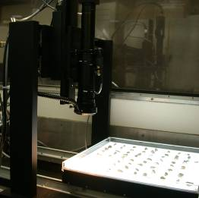
AIMS computer and operator  (Moses Lake Project) | AIMS auto-focus microscope (Moses Lake Project)
Figure 7. Aggregate Imaging System.

The contractor in Moses Lake was provided a quarry site and did own a vertical shaft crusher but elected to use their own gravel pit and cone crusher. This decision was partially due to the location of the quarry (Moomaw).
The coarse aggregate was scanned through the AIMS system. Aggregate that did not have any fractured faces were labeled as rounded. Those aggregates with at least one fractured face, was labeled as crushed as seen in Figure 8. The round surfaces can be seen in the core cross-section in Figure 8 (Myers 2004). Although the fracture requirements were met per the specifications a large percent of the coarse aggregate exhibited rounded edges as seen in images of the aggregates.
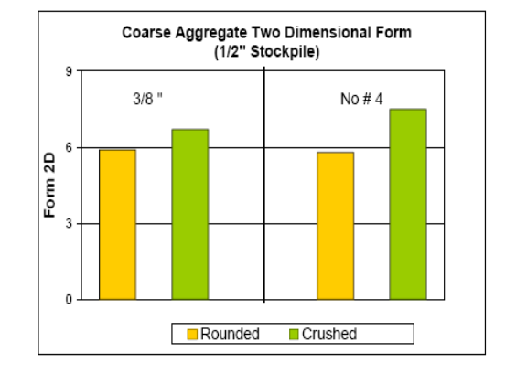 | 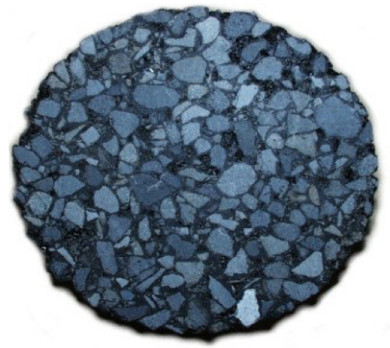
Crushed vs. Rounded Surfaces  from AIMS (Myers 2004) | Cross Section of SMA Sample  (Myers 2004)
Figure 8. Surface texture results from AIMS and core cross section.

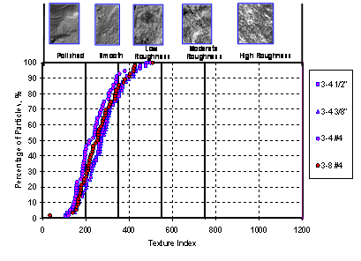
Figure 9. Coarse aggregate texture results from AIMS (Myers 2004).

The surface texture of the different aggregate piles, are shown in Figure 9 (Myers 2004). Clearly there is a large percentage of polished and smooth textured rock on this project which likely caused the low VMA.

Volumetrics and Binder
Table 15 lists the average asphalt content (AC), Voids in Mineral Aggregate (VMA), air voids (Va) and corresponding standard deviations for the Washington projects. Bulk Specific Gravity (G_{mb}) and Maximum Specific Gravity (G_{mm}) values are listed as well. Average VMA for all of the projects were below the current 18 percent mix design requirement.
The highest variation of air voids occurred on the Ritzville to Tokio project, where the extreme flushing and raveling occurred. This is the section of pavement that was replaced with conventional HMA a year later. Pavement cores were taken throughout this project. The areas that appeared to be flushing had the lowest Va and areas that were lean had the highest Va at 13.3 percent, which likely caused the raveling. The cause for the high Va content most likely was the low asphalt content. The gradation data from all but one core showed that mix was coarser than the original mix design. The extraction results from the cores from the raveled areas showed a significant reduction in asphalt content from mix design and production. VMA variation was high as well.
The least variation volumetric properties occurred on the SR 21 to Ritzville project. This was the second project for this contractor. This shows that there is a learning curve for each contractor for this complicated mix. Average VMA was still lower than the job mix formula however the variation was low. The Va average was low and experienced a higher than desirable variance.
Volumetric variation was the highest on the Moses Lake project. VMA and Va were used as a basis for pay adjustments, as well as asphalt content, gradation, and compaction. There were problems meeting the specifications for both VMA and Va. As the contractor met the required minimum VMA of 18 percent, the Va would then be too high. Figure 10 shows the volumetrics graphically for this project. When the 18 percent VMA was achieved flushing occurred. To solve this problem the percent passing the No. 4 and No. 8 was increased by 2 percent, which tightened up the aggregate structure and eliminated the flushing. Since both VMA and Va criteria could not be met the contractor paid a penalty. The contractor also noted that other states required only a 17 percent minimum VMA.
It was determined in (Willoby and Mahoney 2007) that volumetric field testing is more complicated than previously thought and subject to greater operator error than binder content and gradation testing. This may explain volumetric values and variances on these projects. Also pay factors should not be based on multiple factors that are correlated. Va and VMA are correlated to AC, gradations and density.

Table 15. Volumetrics for Washington SMA projects.
 | SR 525 LYNN¹ FIELD | STAND. DEV. |  | I-90 RITZ TO TOKIO JMF² | I-90 RITZ TO TOKIO FIELD² | STAND. DEV. |  | I-90 SR 21 TO RITZ DESIGN³ | I-90 SR 21 TO RITZ FIELD³ | STAND. DEV. |  | I-90 MOSES LAKE DESIGN³ | I-90 MOSES LAKE FIELD³ | STAND. DEV. |  | SMA SPECS
% ASPH. | 6.1 | 0.371 |  | 6.4 | 6.2 | 0.17 |  | 6.3 | 6.6 | 0.187 |  | 6.3 | 5.96 | 0.147 |  | 6 min
VMA | 17.5 |  |  | 17.8 | 16.4 | 1.1 |  | 16.7 | 15.95 | 0.517 |  | 18.8 | 16.41 | 1.261 |  | 18
VA |  |  |  | 4.3 | 3.1 | 1.8 |  | 4.5 | 2.65 | 0.96 |  | 4 | 4.74 | 1.355 |  | 2.5-5.5
VFA |  |  |  |  |  |  |  |  | 83.5 | 5.723
Dust/Asph |  |  |  |  |  |  |  |  | 1.58 | 0.043
G_{mb} |  |  |  | 2.484 | 2.484 | 0.08 |  |  | 2.436 | 0.013 |  | 2.347 | 2.42 | 0.433
G_{mm} |  |  |  | 2.594 | 2.614 | 0.004 |  | 2.52 | 2.502 | 0.011 |  | 2.561 | 2.55 | 0.456
¹ data from Lynnwood project report
² data from Ritzville to Tokio project report
³ data from HMA view

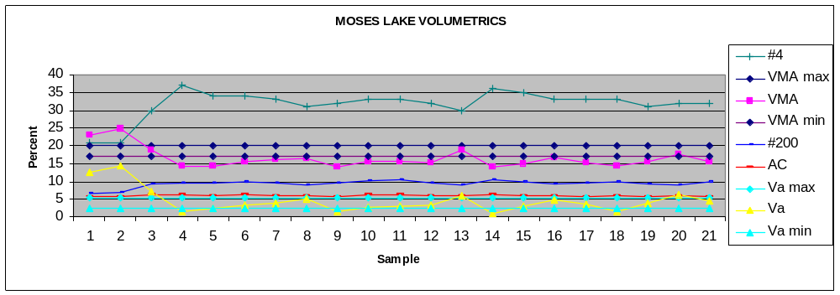

Figure 10. Volumetrics and gragations for Moses Lake project.

Construction Issues
Washington contractors learned that the construction of SMA pavement is very different from conventional HMA pavements. This section will cover specific project experiences in two topic areas: asphalt production and asphalt placement.

Production
The production of SMA mixtures on the four projects experienced the normal learning curve. Plant revisions were not adequate on the first project and became more refined on the last project. This section will discuss the plant revisions that were made for the mineral filler and fiber. The sampling containers were also changed from cardboard boxes to steel containers to eliminate the loss of asphalt binder from the sample.

Mineral Filler
The first project initially experienced gradation problems. There was not a separate silo for the mineral filler. The mineral filler was blended with the No. 4 to dust at the contractor’s concrete blending plant. Clumping occurred on the cold feed conveyor due to wet mineral filler, see left photo in Figure 11. Dust also accumulated along the bin walls which caused dust surges in the mix. This problem was resolved in later projects when a separate silo was provided, see right photo in Figure 11. The mineral filler feed line and liquid asphalt feed line need to be very close together.
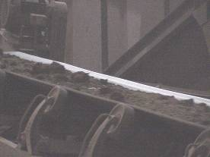 | 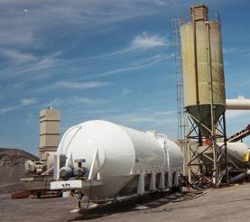
Wet mineral filler clumping on conveyor belt (Lynnwood) | Mineral Filler Silo (Moses Lake)
Figure 11. Mineral filler feeding systems.

Fiber
Mineral (rock wool) and cellulose fibers can be used as stabilizing agents to prevent draindown, see left photo in Figure 12 for fiber example. The contractor on the Lynnwood project introduced cellulose fiber manually which did not uniformly distribute the fiber into the mix, also seen in Figure 12. The last project in Moses Lake had a fiber dispensing system with a control panel, as shown in Figure 13. Fluffing of the cellulose fiber was done to help prevent bridging as seen in Figure 14. Problems still occurred so a change was made to mineral fiber, however then problems arose meeting the volumetric properties. A section of transparent pipe was installed to visually inspect the flow of fiber into the mix, also seen in Figure 14.

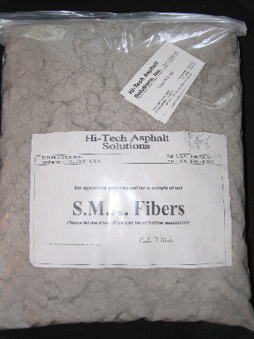 | 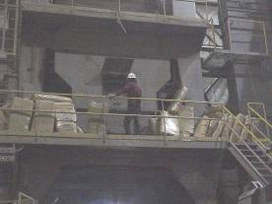
Sample of Cellulose Fibers | Fibers Manually Fed (Lynnwood Project)
Figure 12. Celluslose fibers.

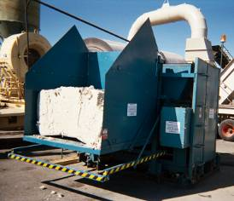 | 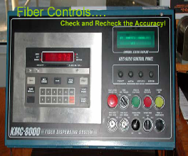
Fiber Dispensing System (Moses Lake) | Dispensing System Controls (Moses Lake)
Figure 13. Cellulose fiber dispensing system.

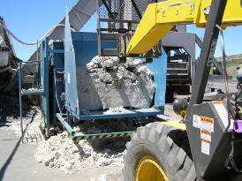 | 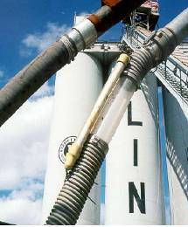
Fluffing Fibers (Moses Lake) | Fiber Inspection Flow Tube (Moses Lake)
Figure 14. Cellulose fiber feed.

Sampling
Cardboard boxes were used for storing samples on the first project. It was discovered the cardboard absorbed some of the liquid asphalt and fines, due to the draindown. The sampling containers were changed from cardboard boxes to steel containers to eliminate the loss of asphalt binder from the sample.

Placement
Washington contractors experienced the expected problems associated with the placement of the harsh sticky mix. Lessons learned will be discussed concerning the hauling, placing, and compaction of this mix.
Short haul delivery is required. Mix should be placed within 2 hours of production to reduce draindown. Drop distance to the truck should be minimized to prevent segregation. Truck loading on the Lynnwood project and the Moses Lake loading is shown in Figure 15. An approved releasing agent is required. Diesel fuel was used a releasing agent on the Lynnwood project which only added to the draindown problem. A container of releasing agent and cold mix sticking to the truck bed, even with a releasing agent, can be seen on the Moses Lake project in Figure 16. Sticking asphalt can cause tare weights to increase. Figure 17 shows asphalt in a truck with draindown problems on the Moses Lake project. Trucks should also be covered with tarps to maintain mix temperature.
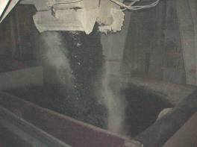 | 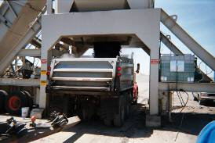
Loading truck (Lynwood) | Loading truck (Moses Lake)
Figure 15. SMA truck loading.

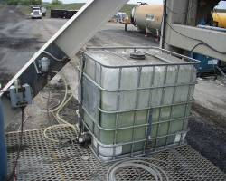 | 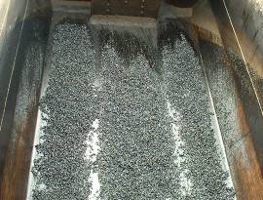
Releasing Agent (Moses Lake) | SMA sticking to truck (Moses Lake)
Figure 16. SMA sticking to truck.

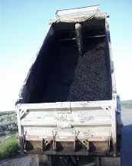 | 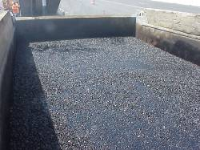
SMA sticking to truck (Moses Lake) | SMA in truck (Moses Lake)
Figure 17. SMA in truck.
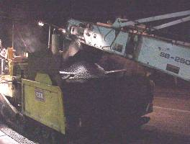 | 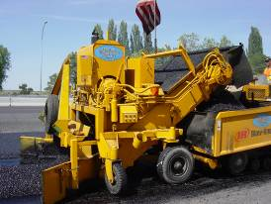
Shuttlebuggy MTV (Moses Lake) | Windrow Pickup Device (Lynnwood)
Figure 18. Placement of SMA.
SMA projects require a Material Transfer Vehicle (MTV) for placement remixing is necessary to prevent segregation and maintain mix temperature (AI 2002). A Shuttlebuggy MTV and a windrow pickup device are shown in Figure 18.
Temperature control is important to ensure adequate compaction. The first project in Lynnwood had a difficult time achieving adequate compaction temperatures due to calibration problems with the temperature probes at the plant. The left photo in Figure 19 shows the temperature differentials for the Lynwood mixture immediately after the breakdown roller. Cool spots resulted in fat spots. Asphalt mix temperatures were controlled on the Moses Lake project as seen in the right photo in Figure 19. Compaction results were within specification on this project.
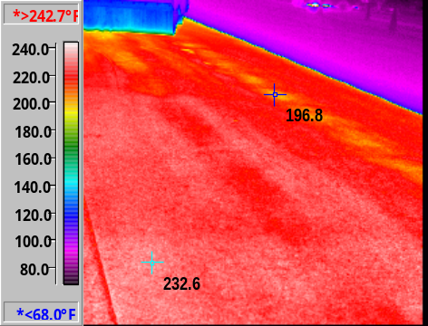 | 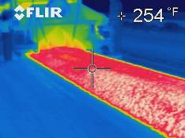
Cold Spots (Lynnwood) | Uniform temperatures  (Moses Lake)
Figure 19. Temperature differentials on mat.
Special attention should be paid to the compaction train for SMA mixtures. The Lynnwood project did not apply a consistent rolling pattern or an aggressive compaction train, which resulted in low densities. The breakdown roller was several hundred feet behind the paver. Vibratory rollers were allowed on this project. The Moses Lake project used five rollers in static mode; two for breakdown, two at the intermediate stage, and one for the finish rolling with a close compaction train, see Figure 20.
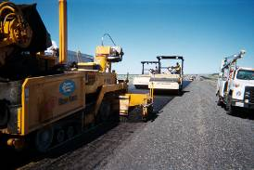 | 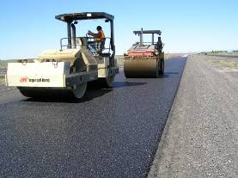
Rollers are kept close behind paver.  (Moses Lake) | Compaction (Moses Lake)
Figure 20. Compaction of mat.
 | 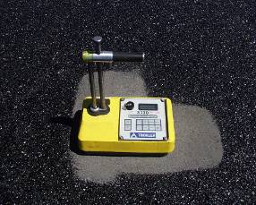
Infrared Camera (Moses Lake) | Nuclear density gauge placed on mineral filler to prevent sticking (Moses Lake)
Figure 21. Infrared camera and nuclear density guage.
The Infrared Thermal Imaging camera was a valuable tool for both the contractor and the inspector on SMA projects during construction as seen in Figure 21. Optimum compaction was achieved between 250°F and 280°F on the Moses Lake project. In place densities were consistent at 94% to 97% of the theoretical maximum using the Nuclear Densometer backscatter mode with a filler material of a No. 10 minus material also seen in Figure 21. The filler material was used so nuclear density gauge would not stick to the mat.

Pavement Performance
Performance of SMA pavements in Washington State has ranged from failing, where the pavement had to be replaced within a year, to very good. Data was acquired from photos, visual inspections and for one project, a rut depth performance report.
The first project was built in 1999 in Lynnwood. The performance of this pavement is mixed. There are several areas where fat spots have occurred. The 44th Avenue West intersection is showing signs of rutting, but this intersection is known to have unstable mix beneath the SMA. The best option for this intersection would have been reconstruction to remove this unstable asphalt mix, however, due to budgetary constraints, this was not a viable option (Pierce 2000). See Figure 22 for Lynnwood photos.

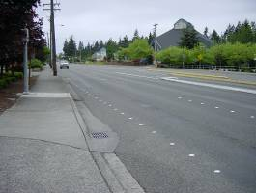 | 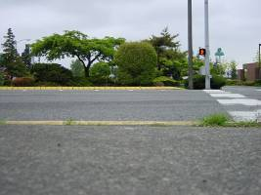
Pavement bleeding (Lynnwood) | Pavement rutting (Lynnwood)
Figure 22. Pavement bleeding and rutting.

The second project, Ritzville to Tokio, was constructed in 2000 on I-90 just west of Ritzville. This pavement failed due to severe flushing and raveling and had to be removed. Cores were removed and analyzed for gradation and Va within the year. Pavement shown in Figure 23 had low Va and experienced flushing. The pavement in Figure 24 had high Va and experienced raveling.

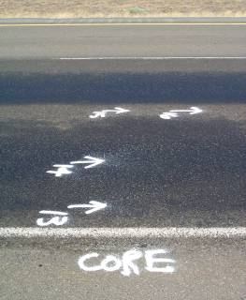 | 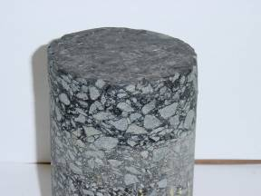
Core Location (Ritzville to Tokio) | Low Air voids Core #14 Va = 0.7
Figure 23. Low air voids (Ritzville to Tokio).

 | 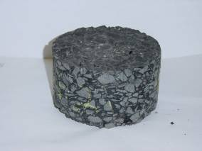
Core Location (Ritzville to Tokio) | High Air Voids Core #21 Va = 10.4
Figure 24. High air voids (Ritzville to Tokio).
Figue 25 below show are photos of extreme fat spots. The findings from the core asphalt residue results indicate that the asphalt did not age.
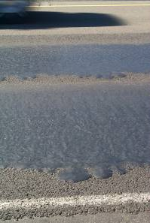 | 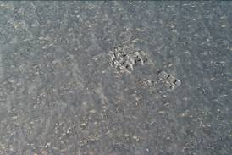
Fat Spot (Ritzville to Tokio) | Footprint in Fat Spot (Ritzville to Tokio)
Figure 25. Fat spots (Ritzville to Tokio).

Figure 26 below shows the skid, air voids and visual (flushing) diagram for the failed pavement. 46 percent of the pavement had air voids less than 2.5 percent which corresponded to the areas that exhibited the flushing.
The third project, SR 21 to Ritzville, on I-90 just west of Ritzville was constructed in 2001, the same summer that the portion east of Ritzville was replaced with conventional dense-graded HMA. In 2003 rut depths were measured in the wheel paths for both sections of pavement for comparison. Figure 27 below is a graph of the rut depth results. Contract 6151 had an SMA portion, from approximately MP 210.5 to MP 213.5. Contract 6136 was the HMA pavement, shown in magenta. Clearly the SMA pavement experienced less rut depth over the same service life.

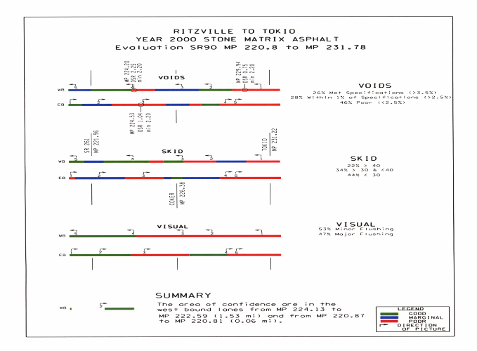
Figure 26. Skid results for failed project (Ritzville to Tokio).

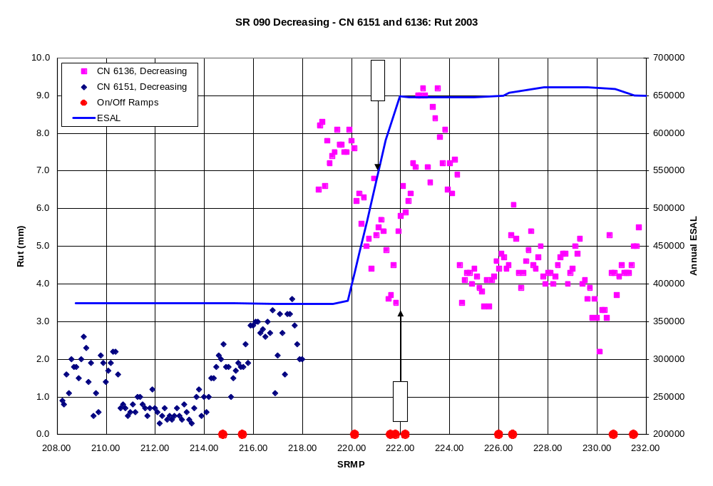
SMA pavements are between MP 210.5 and MP 213.5 (WSDOT)
Figure 27. Rutting of SMA and HMA pavements near Ritzville.
The last project was constructed in 2004 near Moses Lake. This project has performed well with just a few fat spots.

Project Costs
A summary of WSDOT SMA project costs is shown below in Table 16. Note that conventional HMA (PG 64-22) was also placed on the SR 21 to Ritzville and Moses Lake projects. This provides a good comparison of costs between SMA and HMA at the same time.
Table 16. SMA project costs for Washington State.

Project | Tons  SMA  Placed | SMA1/2”  PG  64-22  $/ton | SMA1/2”  PG  64-28  $/ton | SMA1/2”  PG  64-34  $/ton | SMA1/2”  PG  76-28  $/ton | HMA1/2”  PG  64-22  $/ton | Mineral  Filler  Dollar  $/ton | Stabilizer  Dollar  $/ton | Total  SMA  $/ton
Lynwood  (1999) | 5800 | 72.50 |  |  |  |  |  |  | 72.50
Ritz -Tokio  (2000) | 17000 |  |  | 34.00 |  |  | 5.50 | 6.25 | 41.65
SR 21 - Ritz  (2001) | 3195 |  | 28.00¹ |  | 33.42 | 23.50 | 4.25 | 1.80 | 39.47²
Moses Lake  (2004) | 21617 |  |  |  | 41.50 | 23.50 |  |  | 41.50
¹Not used.
²Does not include Change Order for one time plant revisions

The first project was expensive at $72.50 a ton, which was to be expected since it was the first SMA project in the state. The SMA price on the Ritzville to Tokio project, with a PG 64-34 binder was $41.65/ton including mineral filler and stabilizer. The SR 21 to Ritzville project increased the binder from PG 64-28 to PG 76-28. The unit price for the PG 76-28 was $33.42/ton. After mineral filler and stabilizer were included the price was $39.47 a ton. The tonnage was also reduced form 20,000 tons to 3195 tons (Olson 2007). Because of the reduction of tonnage the contractor was reimbursed by invoice the cost of the plant revisions for the mineral filler which totaled $31,782. These revisions included the cost of the weigh hopper, control panel software and the cables to inter-tie the fly ash to the cold aggregate feed. The rational for this payment was, since SMA was experimental the equipment may never be used again. The contractor also experienced another $17,000 (Morgan 2007) for other plant revisions which was not included in the change order. The Moses Lake project placed both SMA 1/2” at $41.50/ton and HMA 1/2” at $23.50/ton. The cost of SMA on this project was 76 percent more than the cost of the HMA.
Asphalt prices have increased dramatically over the last several years. For example average unit bid price for conventional HMA in 2005 was approximately $42.00/ton and in 2007 nearly $60.00/ton. See (WSDOT 2007) for HMA unit bid price comparisons from 1990 to 2007. SMA pavements will still cost considerably more than conventional HMA pavements due to the use of the higher grade oil, required plant revisions, and additional attention needed to place this mix.

Summary and Conclusions
The focus of this paper was to review SMA mix design, construction procedures and performance to date, and specifically investigate SMA pavements constructed in Washington. A literature review was conducted along with case studies of the four Washington SMA projects.

Literature Review
The literature review can be summarized as follows:
Mix Design
- SMA is a tough, stable, rut resistant mixture that relies on stone-to-stone contract for its strength and a rich mortar binder for its durability.
- SMA is a gap graded mix with few medium sized aggregates.
- Aggregates should have 100 percent crushed surfaces and cubical shapes.
- VCA_{MIX} < VCA_{DRY} to ensure stone-to-stone contact.
- There is a relationship between L.A. abrasion and F/E ratio. The lower the L.A. abrasion the higher the F/E ratio can be.
- SMA mixes are sensitive to both the percent passing the 4.75 mm (No. 4) and 0.075 mm (No. 200) screens.
- SMA mixes require mineral filler and stabilization fibers to prevent draindown.
Construction
- SMA mixes are difficult to work with, require plant revisions and require a good Quality Control program by the contractor.
- Impact crushers produce more cubical shaped stones, quarries more crushed surfaces.
- Compaction rollers need to be close behind the paver.
- SMA mixes are extremely sensitive to drops in temperature during compaction.
- Paving lift thickness is less for SMA pavements.
- SMA pavements usually cost 30 percent to 50 percent more than conventional HMA pavements.
Performance
- Rutting has been significantly reduced with the use of SMA pavements.

Washington SMA projects
The following conclusions were made after studying the four SMA projects in Washington State.
- There is an SMA learning curve with every contractor and contracting agency.
- SMA mixes are difficult to design and construct but perform well.
Mix Design
- Contractors need to implement a Quality Control Plan for SMA in order to produce a predictable mix.
- Good quality aggregate sources exist in Washington State.
- SMA mixes are also sensitive to percentage passing the 2.36mm (No. 8) screen
- Cardboard sampling containers absorb oil and fines and affect test results.
Construction
- Several aggregate piles are needed to obtain and control SMA gradations.
- Mineral filler needs its own silo and should be metered near the AC feed. Mineral filler feed can determine the production rate of the plant.
- Limit aggregate source to quarries to achieve 100 percent crushed surfaces.
- Need a controlled fiber distribution system.
- Limit the use vibratory rollers.
- SMA projects are expensive in Washington. The last project was 76 percent more than the conventional SMA project.
- The cost for the mineral filler plant revisions for the SR 21 to Ritzville project was $31, 782 per change order. Contractor said total plant revisions were about $17,000. Total estimated revisions were $48, 782.

Performance
- Washington state projects are performing well even though volumetric specifications were not always met.
- Volumetric field testing is subject to greater operator error than AC and gradation, which was seen on these projects.
- Volumetric pay factors can be difficult to achieve and are correlated to AC, gradation.
In summary the construction of SMA pavements by WSDOT has certainly evolved. Each new project learned from the previous project. The contractor that built two SMA projects certainly learned how to build a successful SMA pavement.
The Lynnwood project placed 5800 tons of SMA in 1999 and experienced some of the usual SMA mix design and construction problems. It was learned plant revisions were necessary for the mineral filler and stabilizer. SMA construction procedures were learned as well. This pavement has performed reasonable well. There are some failing sections; unfortunately these portions were placed over poor existing pavement.
The same contractor built both of the Ritzville projects. The Ritzville to Tokio project placed 17,000 tons in 2000. This section of pavement failed and had to be replaced with conventional HMA the following year. There was a problem in controlling the amount of 0.075mm (No. 200) in the mix. Average daily construction densities did meet specifications. Test data from the cores revealed inconsistent results from the production test data. The cores showed a large variation of Va and AC. The asphalt binder did not appear to age. It appears there was not adequate control over the production of this mix.
The SR 21 to Ritzville project placed 3195 tons of SMA in 2004 and was a success. The contractor learned from the mistakes made on the previous project. An inter-tie was added between the dust feed and the plant. Plant production was in control, construction went well, and the pavement has performed very well to date.
The Moses Lake project placed 21,617 tons in 2004. Asphalt plant revisions were designed well and production overall was good. The aggregate exhibited rounded surfaces which might have been a problem with not meeting the volumetric specifications. The contractor did have access to a quarry but chose to use his own pit. There were pay factors for both Va and VMA and the contractor ended up paying a penalty on both. It was concluded, that the high variation of test results was due to operator error and were not a good indicator of pavement performance. In place densities were consistent at 94 percent to 97 percent. The pavement has performed very well to date.
SMA certainly is a quality, rut resistant pavement. WSDOT has worked through most of the problems associated with the design, production, and placement of SMA. Since the grade of asphalt is bumped up a couple of grades it will always be more expensive. The use pay factors on volumetric properties should be dropped. If more projects are constructed the cost of plant revisions will spread over more projects. When SMA costs become approximately 30 to 50 percent more than HMA, instead of 76 percent more than HMA, SMA will likely become cost effective.

Bibliography

Aschenbrener, T. (2004). “Results of Survey on Stone Matrix Asphalt (SMA),” Colorado Department of Transportation, April 2004.

Asphalt Institute (AI). 2002. “SMA, The Maryland Experience,” Accessed May 23, 2007.
http://www.asphaltinstitute.org/upload/SMA_Maryland.pdf

Brown, E. R., Mallick, R. B. (1994) “Stone Matrix Asphalt-Properties Related to Mixture Design,” NCAT Report No. 94-2, September 1994.

Brown, E. R., Haddock, J. E., Mallick, R. B., and Bukowski, J. (1999). “Performance of Stone Matrix Asphalt (SMA) Mixtures in the United States,” NCAT Report No. 97-1, January 1997.

Brown, E. R., Haddock, J. E., Mallick, R. B., and Lynn, Todd A. (1997). “Development of a Mixture Design Procedure for Stone Matrix Asphalt (SMA),” NCAT Report No. 97-3, March 1997.

Brown, E. R., Cooley, L.A. (1999). “Designing Stone Matrix Asphalt Mixtures for Rut-Resistant Pavements,” NCHRP Report 425, Transportation Research Board, 1999.

Brown, E. R., Hainin, M. R., Cooley, L. A. (2004). “Relationships of HMA In-Place Air Void, Lift Thickness and Permeability,” Project 9-27,”Transportation Research Board , September 2004

Cooley, A. L., James, R. S. (2003). “Micro-Deval Testing of Aggregates in the Southeast,”
Transportation Research Record: Journal of the Transportation Research Board. No. 1837, TRB, National Research Council, 2003.

Cooley, A. L., Brown E. R. (2003). “Potential of Using Stone Matrix Asphalt (SMA) for Thin Overlays,” NCAT Report 03-01, April 2003. Accessed May 23, 2007.
http://www.eng.auburn.edu/center/ncat/reports/rep03-01.pdf

Gatchalian, Dennis. (2006). “Characterization of Aggregate Resistance to Degradation in Stone Matrix Asphalt Mixtures,” Research Report ICAR-204-1F, Aggregates Foundation for Technology, Research, and Education & Texas A & M University, 2006. Accessed May 23, 2007. http://www.icar.utexas.edu/reports/204_Series/ICAR%20204%20Final%20Report.pdf

Georgia Department of Transportation (GDOT). (2002). “Summary of Georgia’s Experience with Stone Matrix Asphalt Mixes.” Accessed May 23, 2007. http://www.dot.state.ga.us/dot/construction/materials-research/b-admin/research/onlinereports%5Cr-SMA2002.pdf

Glacier Northwest-Pioneer Aggregates website. 2003 Accessed May 23, 2007.
https://resources.myeporia.com/company_111/Pioneer%20Agg.%20Brochure.pdf

Hongbin, X., Cooley, A. L., Huner, M. H. (2003). “4.74 mm Nmas Stone Matrix Asphalt (SMA) Mixtures,” NCAT Report 03-05 December 2003. Accessed May 23, 2007.
http://www.eng.auburn.edu/center/ncat/reports/rep03-05.pdf

Johnson, C.N., Palmer S.P., Poelstra, J.L. (2005). “Rock Aggregate Resource Land Inventory Map for Clark County,” Department of Natural Resources, November 2005.

Mahoney, Joe. (2000). “An Introduction to SMA,” November (2000). Included in WSDOT Post Construction Report WA-RD 504.1. Accessed May 23, 2007.
http://www.wsdot.wa.gov/biz/mats/pavement/SMA_SR-524_Final_Report.pdf

McGhee, Kevin K., Clark, Trenton M., Reid, Robert A. (2005). “A Performance Baseline for Stone Matrix Asphalt,” Virginia Department of Transportation and University of Virginia, August 2005.

Michael, L., Burke, G., Schwartz, C.W. (2002). “Performance of Stone Matrix Asphalt Pavements in Maryland,” Maryland State Highway Administration’s Office of Material and Technology.

Moomaw, Tim. (2004). “ Stone Matrix Asphalt Project Summary Report & Presentation,” Washington State Department of Transportation-Central Region, November 2004.

Morgan, T.J. (2007). “SMA Questions”, Inland Asphalt, office email. May 2007.

Myers, Leslie. (2004). “Superpave Performance Testing,” Washington State Department of Transportation, Mobile Asphalt Testing Laboratory, Federal Highway Administration Office of Pavement Technology, May 2004.

National Asphalt Paving Association (NAPA). (1999). “Designing and Constructing SMA Mixes-State-of-the Practice,” QIP-122, Jan 1999.

National Stone, Sand and Gravel Association (NSSGA). (2001) The Aggregate Handbook November 2001.

Olson, Ken (2007). “SMA Questions,” Washington State Department of Transportation, office email. May 2007.

Palmer S.P, Poelstra, J.L., Johnson, C.N. (2005). “Rock Aggregate Resource Land Inventory Map for Yakima County,” Department of Natural Resources, November 2005.

Pierce, L. M. (2000) “Stone Matrix Asphalt, SR-524, 64th Avenue West to I-5 MP 3.30 to MP 4.88, Post Construction Report,” WA-RD 504.1, Washington State Department of Transportation, November 2000. Accessed May 23, 2007.
http://www.wsdot.wa.gov/biz/mats/pavement/SMA_SR-524_Final_Report.pdf

Schmiedlin, R. B., Bischoff, D.L. (2002) “Stone Matrix Asphalt, The Wisconsin Experience,” Report Number: WI/SPR-02-02, Wisconsin Department of Transportation, January 2002. Accessed May 23, 2007. http://www.dot.wisconsin.gov/library/research/docs/finalreports/tau-finalreports/sma.pdf

Washington State Department of Transportation (WSDOT). (2007). “WSDOT Cost Index for HMA” http://www.wsdot.wa.gov/biz/construction/CostIndex/CostIndexPdf/HotMix.PDF
Accessed June 6, 2007.

Washington State Department of Transportation (WSDOT). (2002). “WSDOT Pavement Guide” http://training.ce.washington.edu/WSDOT/Modules/02_pavement_types/02-3_body.htm
Accessed May 23, 2007.

Willoughby, K., Mahoney, J.P. (2007). “An Assessment of WSDOT’s Hot Mix Asphalt Quality Control and Assurance Requirement,” Washington State Transportation Center (TRAC), January 2007. http://www.wsdot.wa.gov/research/reports/fullreports/517.2.pdf. Accessed May 23, 2007.

APPENDIX

WSDOT SMA SPECIFICATIONS

DIVISION 5
SURFACE TREATMENTS AND PAVEMENTS

Asphalt Concrete Pavement

(*****)
Description
Section 5-04.1 is supplemented with the following:

The first sentence of the third paragraph is revised to include Stone Matrix Asphalt (SMA).

Materials
The first paragraph of Section 5-04.2 is supplemented with the following:

Stabilizing additives shall be accepted based on the Manufacturer’s Certification that the material meets the requirements listed below. The type of stabilizing additives shall be limited to cellulose fibers or mineral fibers.

Stabilizing additives shall conform to one of the following requirements:

Cellulose Fibers: Cellulose fibers shall be added at a dosage rate of approximate 0.3% or more by weight of the total mix as approved by the Engineer. Fiber properties shall be as follows:

Cellulose Fiber Quality Requirements
Property | Requirement
Sieve Analysis
Method A- Alpine Sieve¹
Fiber Length | 0.25 in. Maximum
Passing U.S. No. 100 sieve | 70 ± 10 percent
Method B - Mesh Screen² Analysis
Fiber Length | 0.25 in. Maximum
Passing U.S. No. 20 sieve | 85 ± 10 percent
Passing U.S. No. 40 sieve | 65 ± 10 percent
Passing U.S. No. 140 sieve | 30 ± 10 percent
Ash Content³ | 18 ± 5 percent non-volatiles
pH⁴ | 7.5 ± 1.0
Oil Absorption⁵ | 5.0 ± 1.0 (times fiber mass)
Moisture Content⁶ | Less than 5 percent (by mass)
¹ Method A – Alpine Sieve Analysis. This test is performed using an Alpine Air Jet Sieve (Type 200 LS). A representative five gram sample of fiber is sieved for 14 minutes at a controlled vacuum of 11 psi. The portion remaining on the screen is weighed.
² Method B – Mesh Screen Analysis. This test is performed using standard No. 20, No. 40, No. 60, No. 80, No. 100, and No. 140 sieves, nylon brushes, and a shaker. A representative 10 gram sample of fiber is sieved, using a shaker and two nylon brushes on each screen. The amount retained on each sieve is weighed and the percentage passing calculated. Repeatability of this method is suspect and needs to be verified.
³ Ash Content. A representative 2-3 gram sample of fiber is placed in a tared crucible and heated to between 1100 and 1200F for not less than two hours. The crucible and ash are cooled in a desiccator and weighed.
⁴ pH Test. Five grams of fiber are added to 100 ml of distilled water, stirred and let sit for 30 minutes. The pH is determined with a probe calibrated with pH 7.0 buffer.
⁵ Oil Absorption Test. Five grams of fiber are accurately weighed and suspended in an excess of mineral spirits for not less than 5 minutes to ensure total saturation. It is then placed in a screen mesh strainer (approximately 0.5 mm² hole size) and shaken on a wrist shaker for 10 minutes (approximately 1 ¼ in. motion at 240 shakes per minute). The shaken mass is then transferred without touching to a tared container and weighed. Results are reported as the amount (number of times its own weight) the fibers are able to absorb.
⁶ Moisture Content. Ten grams of fiber are weighed and placed in a 250F forced air oven for two hours. The sample is then re-weighed immediately upon removal from the oven.

Mineral Fibers: Mineral fibers shall be made from virgin basalt, diabase, or slag which is to be treated with a cationic sizing agent to enhance disbursement of the fiber as well as increase adhesion of the fiber surface to the bitumen. The fiber shall be added at a dosage rate of approximate 0.4% or more by weight of the total mix as approved by the engineer.

Mineral Fiber Quality Requirements
Property | Requirement

Size Analysis
Fiber Length¹ | 0.25 in. maximum mean test value
Thickness² | 0.0002 in. maximum mean test value

Shot Content³
Passing U.S. No. 60 sieve | 90 ± 5 percent
Passing U.S. No. 230 sieve | 70 ± 10 percent
¹The fiber length is determined according to Bauer McNett fractionation.
²The fiber thickness, or diameter is determined by measuring at least 200 fibers in a phase contrast microscope.
³Shot content is a measure of non-fibrous material. The shot content is determined on vibrating sieves. Two sieves, the U.S. No. 60 and the U.S. No. 230, are typically utilized. For additional information see ASTM C612.

The third paragraph of Section 5-04.2 is deleted and replaced with the following:

The use of recycled asphalt pavement (RAP) shall not be used in SMA.

The fifth paragraph of Section 5-04.2 is deleted and replaced with the following:

The Contractor shall use (Performance Grade) PG76-28 asphalt binder meeting the requirements of AASHTO M 320 in the production of SMA.

(******)
Construction Requirements
Section 5-04.3 is supplemented with the following:

Quality Control (QC) by the Contractor
The Contractor shall exercise quality control over the SMA on this project. At a
Minimum, the Contractor shall perform the following test methods:

Procedure Number | Owner | Test Method
TM 6 | WAQTC | FOP for WAQTC for Moisture Content of Bituminous Mixes by Oven
T 27/11 | WAQTC | FOP for AASHTO for Sieve Analysis of Fine and Coarse Aggregates and Material Finer Than 75 mm (No. 200) in Mineral Aggregates by Washing
T 168 | WAQTC | FOP for AASHTO for Sampling Bituminous Paving Mixtures
T 305 | AASHTO | Determination of Draindown Characteristics in Uncompacted Asphalt Mixtures
T 308 | WSDOT | FOP for AASHTO for Determining the Asphalt Binder Content of Hot-Mix Asphalt by the Ignition Method
T 712 | WSDOT | Standard Method of Reducing Bituminous Paving Mixtures

All samples shall be taken from random locations within a sublot and testing shall be performed by qualified testers with calibrated equipment. The samplers and testers will be evaluated for qualification by WSDOT as defined by Section 9-5.5 of the Construction Manual. The Contractor will schedule time with WSDOT in advance of paving, to qualify the samplers and testers.

The QC program shall be samples independent of from WSDOT acceptance samples. The QC sublot size shall be a maximum of 800 tons for all testing except AASHTO T 305. The QC testing for AASHTO T 305 shall be completed at the frequency of one test each day of paving SMA.. All QC test data shall be provided to the Engineer by the next workday. The Contractor shall post and provide up to date run charts showing all of the QC data.

The cost of the Contractor’s QC program shall be included in the per ton unit bid price for “Stone Matrix Asphalt Class 1/2 In. PG76-28”.

Acceptance (QA) by WSDOT
WSDOT shall do all acceptance testing on this project. All applicable acceptance tests identified elsewhere in these provisions will be used for acceptance on this project. The acceptance test for gradation, asphalt binder content, and volumetric properties (VMA and Va) shall be a maximum of 1600 ton sublots. The acceptance samples shall be independent from the Contractor’s QC sampling and testing program.

Requirements for All Plants
Section 5-04.3(1)A is supplemented with the following:

Stabilizing Additives Supply System.
A separate system for feeding shall be used to proportion the required amount of stabilizing additives into the mixture so that uniform distribution is obtained. The stabilizing additives supply system shall include low level and no-flow indicators, a printout of the status of feed rate in gal/min, and shall have a 60 second plant shut down function for no-flow occurrences. The Contractor shall provide a metering or weighing device that determines the amount of fiber incorporated within any selected time period, which is of sufficient accuracy to proportion fibers to within plus or minus 10% of the amount of fibers required. The stabilizing additives supply line shall include a section of transparent pipe for observing consistency of flow or feed. All stabilizing additive supply systems shall be approved by the Engineer.

Mineral Filler Supply System
A silo shall be provided for dry storage of the mineral filler, and provisions shall be made for proportioning the filler into the mixture uniformly and in the desired quantities. The mineral filler supply system shall be capable of operating at the required production rates, and the silo for mineral filler shall be on calibrated load cells such that the amount of mineral filler incorporated within any selected time period may be determined. The load cells shall be accurate to within plus or minus 0.5 percent. The filler system shall be interlocked with the aggregate feed or weigh system so as to maintain the correct proportions for all rates of production and batch sizes.

Requirements for Batch Plants
Section 5-04.3(1)B is supplemented with the following:

The stabilizing additives shall be added to the aggregate in the weigh hopper and both dry and wet mixing times shall be increased. The stabilizing additives shall be uniformly distributed prior to the addition of asphalt binder into the mixture. The plant shall be so interlocked that asphalt binder can not be added until the stabilizing additives have been introduced into the mix.

If required, mineral filler shall be added directly into the weigh hopper.

Requirements for Rotary Drum Plants
Section 5-04.3(1)D is supplemented with the following:

The stabilizing additives shall be added to the mixture in a manner that prevents the stabilizing additives from becoming entangled in the exhaust system. At no time shall there be any evidence of fiber (stabilizing additives) in the baghouse or returned/wasted baghouse fines.

If required, mineral filler shall be added directly into the drum mixer. The mineral filler line into the drum shall be next to the asphalt cement line.

(******)
Hauling Equipment
Section 5-04.3(2) is replaced with the following:

Trucks used for hauling SMA shall have tight, clean, smooth metal beds and shall have a cover of canvas or other suitable material of sufficient size to protect the mixture from adverse weather. Whenever the weather conditions include, or forecast to include during the workshift, precipitation or an air temperature less than 45°F, the canvas cover shall be securely attached to protect the SMA.

In order to prevent the SMA mixture from adhering to the hauling equipment, truck beds are to be sprayed with environmentally benign release agent. Excess release agent shall be drained prior to filling hauling equipment with SMA. Petroleum derivatives or other coating material that contaminate or alter the characteristics of the SMA shall not be used. For hopper trucks, the conveyer shall be in operation during the process of applying the release agent.

(******)
Asphalt Pavers
Section 5-04.3(3) is supplemented with the following:

Material Transfer Device/Vehicle
Direct transfer of the SMA mixture from the hauling equipment to the paving machine will not be allowed. A material transfer device or vehicle shall be used to deliver the asphalt concrete mixture from the hauling equipment to the paving machine when placing any course of asphalt concrete pavement except prelevel less than 0.08 feet in thickness. A material transfer device or vehicle is optional for paving shoulders when they are paved separately from the traveled way. If a windrow elevator is used, the length of the windrow may be limited in urban areas or through intersections, at the discretion of the Engineer.

The material transfer device or vehicle shall mix the SMA after delivery by the hauling equipment but prior to laydown by the paving machine. Mixing of the asphalt concrete material shall be sufficient to obtain a consistent temperature throughout the mixture.

Prior to use, the Contractor shall submit the manufacturer and model number of the equipment to the Engineer for review and approval. All costs to incorporate the material transfer device or vehicle into the paving train shall be included in the unit contract prices for associated bid items.

Preparation of Existing Surfaces
The third sentence in the second paragraph of Section 5-04.3(5)A is deleted and replaced with the following:

The emulsified asphalt shall not exceed the maximum temperature recommended by the emulsified asphalt manufacturer.

The third paragraph of Section 5-04.3(5)A is deleted and replaced with the following:

A tack coat of emulsified asphalt shall be applied to all paved surfaces on which any coarse of SMA or asphalt concrete is to be placed or abutted. Tack coat shall be uniformly applied to cover the existing pavement with a thin film of residual asphalt, free of streaks and bare spots. A heavy application of tack coat will be applied to all joints. For roadways open to traffic, the application of tack coat shall be limited to surfaces that will be paved during the same working shift. The spreading equipment shall be equipped with a thermometer to indicate the temperature of the tack coat material.

Heating of Asphalt Material
Section 5-04.3(6) is deleted and replaced with the following:

The temperature of the asphalt binder shall not exceed the maximum
recommended by asphalt binder manufacturer. The asphalt binder shall be
heated in a manner that will avoid local variations in heating. The heating method
shall provide a continuous supply of asphalt binder to the mixer at a uniform
average temperature with no individual variations exceeding 25°F.

(******)

Mix Design
Section 5-04.3(7)A is supplemented with the following:

Prior to the production of SMA, the Contractor shall perform a minimum of three aggregate trial blends for the purpose of determining the design aggregate structure in accordance with WSDOT Standard Operating Procedure 732. Once the design aggregate structure has been established, the Contractor shall provide data that demonstrates the design aggregate structure meets the requirements of Sections 9-03.8(2) and 9-03.8(6). All cost associated with this portion of the mix design shall be incidental to the cost per ton of SMA.

The Contractor shall obtain representative samples from mineral aggregate stockpiles, stabilizing additives and mineral filler sources to be used in SMA production, and submit to WSDOT for mix design verification testing. Sample submittals shall include asphalt binder source, stabilizing additives source, three aggregate structure trial blend data, design aggregate structure data, combining ratios of mineral aggregate stockpiles and mineral filler that will be used. This will be the basis for the mix design and job mix formula (JMF). Adjustments to the JMF may be made per Section 9-03.8(6)A. The Contractor shall allow 25 calendar days for verification once the material has been delivered to the State Materials Laboratory in Tumwater.

(******)
Mixing
The fourth paragraph in Section 5-04.3(8) is supplemented with the following:

The time between plant mixing and placement of the SMA shall not exceed two hours. Material held for more than two hours after mixing shall be rejected and disposed of by the Contractor at no expense to the Contracting Agency.

Acceptance Sampling and Testing
Section 5-04.3(8)A Item 1 is supplemented with the following:

SMA will be evaluated for quality of volumetric properties (VMA, Va), gradation and asphalt binder content.

Section 5-04.3(8)A, Item 3.A. (2), is supplemented with the following:

SMA samples for compliance of volumetric properties (VMA, Va), gradation and asphalt binder content will be obtained on a random basis from the hauling vehicle.

Section 5-04.3(8)A, Item 3.C., is deleted and replaced with the following:

Test Results
The Engineer will furnish the Contractor with a copy of the results of all acceptance testing performed in the field at the beginning of next paving shift. The Engineer will also provide the Composite Pay Factor (CPF) of the completed sublots after three sublots have been produced. The CPF will be provided by the midpoint of the next paving shift after sampling.

Sublot sample test results (gradation, asphalt binder content, and volumetrics) may be challenged by the Contractor. To challenge test results, the Contractor must submit a written challenge within five working days after receipt of the specific test results. A split of the original acceptance sample shall be sent for testing to either the Region Materials Lab or State Materials Lab as determined by the Project Engineer. The split of the sample with challenged results will not be tested with the same equipment or by the same tester that ran the original acceptance test. The challenge sample will be tested for a complete gradation, asphalt binder content and volumetric analysis.

The results of the challenge sample will be compared to the original results of the acceptance sample test and evaluated according to the following criteria:

Deviation
VMA ± 1.5 percent
Va ± 0.7 percent
No.4 sieve and larger ± 4 percent
No. 6 sieve to No. 80 sieve ± 2 percent
No. 100 and No. 200 sieve ± 0.4 percent
Asphalt binder % ± 0.3 percent

If the results of the challenge sample testing are within the allowable deviation
established above for each parameter, the acceptance sample test results will be used for acceptance of the SMA. The cost of testing will be deducted from any monies due or may come due the Contractor under the contract at the rate of $250 per challenge sample. If the results of the challenge sample testing are outside of any one parameter established above, the challenge sample will be used for acceptance of the SMA and the cost of testing will be the Contracting Agency’s responsibility.

Section 5-04.3(8)A, Item 3. D., is supplemented with the following:

Test Methods. Acceptance testing of SMA for compliance of volumetric properties (VMA, Va), gradation, and asphalt binder content determinations, will be performed using the following test methods:

Procedure Number | Owner | Test Method
TM 6 | WAQTC | FOP for WAQTC for Moisture Content of Bituminous Mixes by Oven
T 27/11 | WAQTC | FOP for AASHTO for Sieve Analysis of Fine and Coarse Aggregates and Material Finer Than 75 mm (No. 200) in Mineral Aggregates by Washing
T 166 | WSDOT | FOP for AASHTO for Bulk Specific Gravity of Compacted Bituminous Mixtures Using Saturated Surface-Dry Specimens
T 168 | WAQTC | FOP for AASHTO for Sampling Bituminous Paving Mixtures
T 209 | WSDOT | FOP for AASHTO for Method of Test for Maximum Specific Gravity of Bituminous Paving Mixtures – “Rice Density”
T 308 | WSDOT | FOP for AASHTO for Determining the Asphalt Binder Content of Hot-Mix Asphalt by the Ignition Method
T 312 | WSDOT | FOP for AASHTO for Preparing and Determining the Density of Hot-Mix Asphalt (HMA) Specimens by Means of the Superpave Gyratory Compactor
T 712 | WSDOT | Standard Method of Reducing Bituminous Paving Mixtures
SOP 731 | WSDOT | Method of Determining Volumetric Properties of Asphalt Concrete Pavement Class Superpave

Section 5-04.3(8)A, Item 3.E. (5), is deleted and replaced with the following:

A Lot in Progress. The Contractor shall shut down operations and shall not resume SMA or asphalt concrete placement until such time as the Engineer is satisfied that specification material can be produced:

Whenever the Composite Pay Factor (CPF) of a lot in progress drops below 1.00 and the Contractor is taking no corrective action:

Whenever the Item Pay Factor (PFi) for any individual item of a lot in progress drops below 0.95 and the Contractor is taking no corrective action:

Whenever either the Composite Pay Factor (CPF) or Item Pay Factor (PFi) for any individual item of a lot in progress is less than 0.75.

(******)

Compaction

General
The third paragraph of Section 5-04.3(10)A is supplemented with the following:

Pneumatic tired rollers shall not be used in the construction of SMA.

The fourth paragraph of Section 5-04.3(10)A is supplemented with the following:

Only static steel wheel rollers shall be used in the construction of SMA. The Contractor shall exercise care so that the asphalt mastic does not migrate to the surface and that aggregate breakdown does not occur.

Control
The first sentence of the first paragraph of Section 5-04.3(10)B is is supplemented with the following:

SMA used in traffic lanes and having a specified compacted course thickness greater than 0.10 shall be compacted to a specified level of relative density.

The second sentence in the first paragraph of Section 5-04.3(10)B is supplemented with the following:

For SMA the specified level of relative density shall be a Composite Pay Factor of not less than 1.00 when evaluated in accordance with Section 1-06.2(1), using a minimum of 93.0 percent and maximum of 98.0 percent of the reference maximum density as determined by WSDOT FOP for AASHTO T 209.

The third paragraph of Section 5-04.3(10)B is supplemented with the following:

For SMA, prior to the start of production paving a test section shall be constructed for each mix design used for the purpose of determining if the mix is compactable, establish a nuclear density gauge correlation factor, and meets the requirements of Section 9-03.8(2) and 9-03.8(6).

The SMA test section shall be constructed at the beginning of production paving and will be at least 600 tons and a maximum of 800 tons. No further wearing or leveling will be paved the day of and the day following the test section.

The SMA test section shall be constructed using the equipment and rolling patterns that the Contractor expects to use in the paving operation. A test section will be considered to have established compactibility, when the average of three tests is equal to or exceeds 93 percent of the maximum density determined by WSDOT FOP for AASHTO T 209. This will require consideration of the presence of the correlation factor for the nuclear density gauge and may require resolution after the correlation factor is known. When results have demonstrated that the mix is not compactable, or not capable of meeting the requirements in Sections 9-03.8(2) and 9-03.8(6), the Contractor shall make appropriate adjustments to the mix, or placement and compaction operation, based on information obtained from the construction of the test section. After Engineer approved adjustments are made, production paving my proceed, or the Contractor may request that another test section be constructed according to the above procedure.

The SMA used for the test section shall be measured by the ton and paid for at the unit bid price for SMA. All costs associated with constructing the test section or sections will be incidental to the cost of the SMA. A pay factor of 1.00 for compaction, gradation, asphalt content, and volumetrics will be used for the quantity of mix used in construction of the test section or sections.

(******)
Payment
Section 5-04.5 is supplemented with the following:

“Stone Matrix Asphalt Class 1/2 In. PG76-28,” per ton

“Stabilizing Additives,” will be paid in accordance with Section 1-09.6 except that no overhead, profit or other costs shall be allowed. Payment shall be made only for the invoice cost of the stabilizing additive plus shipping costs paid by the Contractor. For the purpose of providing a common proposal for all bidders, the Contracting Agency has entered an amount in the proposal to become a part of the total bid by the Contractor.

(******)
Price Adjustment for Quality of AC Mix
Section 5-04.5(1)A is supplemented with the following:

Factors for SMA

Constituent | Factor “f”
VMA (Voids in mineral aggregate) | 30
Va (Air Voids) | 30
All aggregate passing 1/2" | 2
All aggregate passing 3/8" | 2
All aggregate passing U.S. No. 4 | 15
All aggregate passing U.S. No. 8 | 15
All aggregate passing U.S. No. 200 | 15
Asphalt Content | 30

(******)
Test Requirements
Section 9-03.8(2) is supplemented with the following:

Aggregate for SMA shall consist of 100 percent crushed aggregate and must meet the following test requirements:

Coarse Aggregate

Test Properties | Test Methods | Specification Limits
LA, Abrasion loss | AASHTO T96 | 30% max.
Flat and Elongated Particles,  Retained on 3/8" Sieve | WSDOT FOP for ASTM D4791 | 5:1 @ 5% max.  3:1 @ 20% max.
Particles retained on the U.S. No. 4 sieve shall have at least | WSDOT Test Method 113  one fractured face  two fractured faces | 99% min.  90% min.
Degradation | WSDOT Test Method 103 | 30 min.
Absorption | AASHTO T 85 | 2% max.

Fine Aggregate
The Fine Aggregate shall consist of 100% crushed aggregate and shall conform to the following:

No natural or uncrushed blend sand will be allowed in SMA.

The sand equivalent for the aggregate shall equal or exceed 45.

The fine aggregate angularity for the combined fine aggregate is tested in accordance with WSDOT FOP for AASHTO T304, Method A. The minimum voids shall be 45.0%.

The properties of the mix design for the Stone Matrix Asphalt Class 1/2 In. PG 76-28 shall be such that when it is combined within the limits set forth in Section 9-03.8(6) and mixed in the laboratory with the designated grade of asphalt cement, using the Superpave gyratory compactor in accordance with WSDOT FOP for AASHTO T312, at 100 gyrations, shall produce a mixture with the following test values:

Mix Design Criteria
SMA Class 1/2?
Properties
Voids in Mineral Aggregate (VMA) @ 100 gyrations | 18.0 min.
Air Voids (Va) @ 100 gyrations | 4.0
AC Content (_{NOTE 1}) | 6.0 min.
Voids in Coarse Aggregate of the Asphalt Mixture (VCA_{MIX}) @ 100 gyrations(_{NOTE 2}) | <VCA_{DRC}
Stabilizing Additive (by weight of total mix) | (_{NOTE 3})
Modified Lottman Stripping Test AASHTO T 718 | Pass
Draindown @ Production Temperature., AASHTO T 305 | 0.3 max.
Note 1, When SMA cannot be designed with a minimum asphalt content of 6.0% using available aggregates, the guidelines given in the following table can be used to establish minimum asphalt content requirements based on the combined aggregate bulk specific gravity:

Guide to adjust Minimum Asphalt Content based on Varying Bulk Specific Gravities of Aggregates
Combined Aggregate Bulk Specific Gravity |  | Minimum Asphalt Content, Percent
2.40 | 6.8
2.45 | 6.7
2.50 | 6.6
2.55 | 6.5
2.60 | 6.3
2.65 | 6.2
2.70 | 6.1
2.75 | 6.0
2.80 | 5.9
2.85 | 5.8
2.90 | 5.7
2.95 | 5.6
3.00 | 5.5

Note 2, The VCA_{mix} can be calculated as shown below:

VCA_{mix} = 100 - (Gmb/G_{ca} x P_{ca})
Gmb = bulk specific gravity of mix
G_{ca} = bulk specific gravity of the coarse aggregate
P_{ca} = percent of coarse aggregate in mix by weight of total mix.

Note 3, Refer to Section 5-04.2 for Stabilizing Additive type.

Definition of Coarse Aggregate Fraction
Mix Type Portion of aggregate Retained on
1/2 in. U.S. No. 4 sieve

The Voids of Coarse Aggregate Dry-rodded condition (VCA_{DRC}) shall be determined according to AASHTO T 19 Section 10, Unit Weight and Voids in Aggregate. The VCA_{drc} for the fraction can be calculated by using the following equation:

VCA_{drc} = (G_{ca} Y_{w} - Y_{s} / G_{ca} Y_{w}) 100

VCA_{drc} = Voids in Coarse aggregate in the dry-rodded condition
Y_{s} = unit weight of coarse aggregate in the dry-rodded condition (lb/ft³)
Y_{w} = unit weight of water (62.24lb/ft³)
G_{ca} = bulk specific gravity of the coarse aggregate.

Gradation – Recycled Asphalt Pavement and Mineral Aggregate

Section 9-03.8(3)C is supplemented with the following:

No recycled asphalt pavement (RAP) will be used in the construction of SMA.

(******)

Proportions of Materials
Section 9-03.8(6) is supplemented with the following:

Stone Matrix Asphalt
The SMA shall be within the requirements listed in the following table, and meet the volumetric requirements listed in Section 9-03.8(2). When the SMA is tested in the field using the gyratory compactor, the SMA will have air voids with 2.5% to 5.5% at 100 gyrations. Voids in the mineral aggregate (VMA) shall be greater than 17.0%.

SMA Class 1/2 In. Gradation Control Points (percent passing)
Sieve Size | 1/2 in.
 | Lower | Upper
3/4" |  | 100
1/2" | 90 | 98
3/8" | 50 | 80
U.S. No. 4 | 20 | 35
U.S. No. 8 | 16 | 24
U.S. No. 16
U.S. No. 30
U.S. No. 50
U.S. No. 200 | 8.0 | 11.0

(******)

Basis of Acceptance
Section 9-03.8(6)A, Item 3, subsection a, supplemented with the following:

SMA

Constituent of Mixture | Tolerance Limits
 | The tolerance limit for each mix constituent shall not exceed the limits of the control points, except the tolerance limits for sieves designated as 100% passing will be 99 – 100.
Aggregate passing 3/4", 1/2", and 3/8” sieves | ± 5%
Aggregate passing U.S. No. 4 sieve | ± 5%
Aggregate passing U.S. No. 8 sieve | ± 4%
Aggregate passing U.S. No. 200 sieve | ± 2.0%
Asphalt cement | ± 0.5%

Subsection c1 is supplemented with the following:

1. Aggregates. For SMA the Project Engineer may approve the Contractor’s written request to adjust the JMF. The maximum adjustment from the approved mix design shall be 2 percent for the aggregate on the U.S. No. 8 sieve and above, 1 percent for aggregate passing the U.S. No. 8 sieve, and 0.5 percent for aggregate passing the U.S. No. 200 sieve. These field adjustments to the JMF will only be considered if the changes produce material of equal or better quality. The adjusted JMF plus or minus the allowed tolerances shall be within the range of the control points.

The NMAS is one size larger than the first sieve that retains more than 10 percent aggregate.

