CEE 587 Transportation Logistics  
April 27, 2011

Extra GIS Assignment:

If you complete this assignment by answering all of the first 3 questions correctly, you will share $1000 with the other students that also achieve this.

If you complete the bonus section and present your results to the class during the final exam period, you will compete for the final $500. In the case of a tie, this may be shared across students.

1. Identify the fastest route for the delivery driver to take
2. Identify the cheapest route for the delivery driver to take
3. Identify the lowest emissions route for the delivery driver to take

Bonus) Identify ways to reduce cost, distance, time or emissions. Document what changes you suggest and quantify the impacts of those changes are on cost, distance, time, and emissions. Explain which strategy you recommend to Tantastic Sweater Pros (TSP) and why.

Write up your results and your process in a logical, readable document with appropriate documentation.

To complete this assignment you will need the following files:

1. Roads layer - SeattleAreaStreets
2. Delivery stop location layer – DeliveryStops
3. Depot location layer - Depot

To start the assignment you will need to create a Network Dataset from SeattleAreaStreets (see the tutorial for a guide). When you create the Network Dataset, make sure you create the correct Attributes & Evaluators for the assignment. Some may appear automatically, others you may need to create manually. Start by “Add”ing a new attribute (you will want to have Seconds, Feet, Dollars, and kgCO2 when you are done amongst all of the attributes).

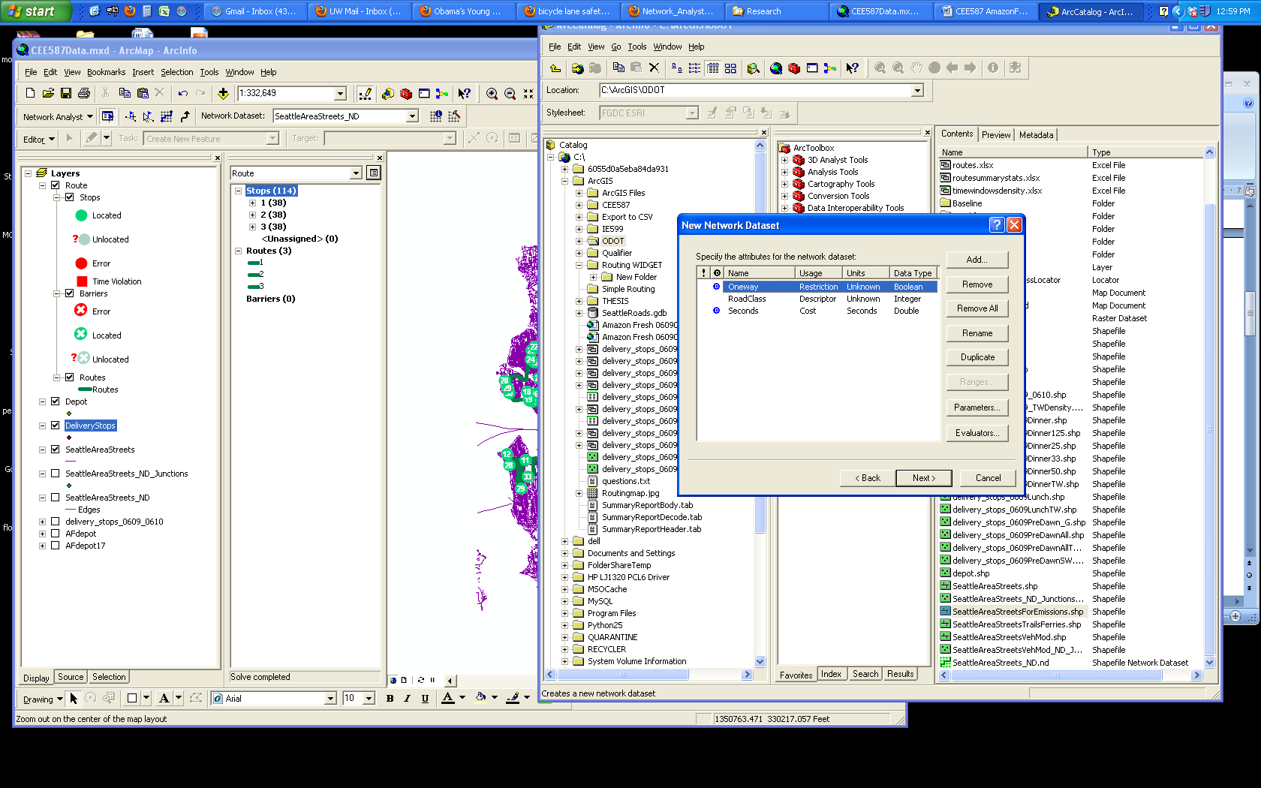

After you try to Add a new Attribute, you’ll need to label it appropriately, and select the appropriate Units (for Seconds and Feet, use Seconds and Feet, respectively. For Dollars and kgCO2, use Unknown for both).

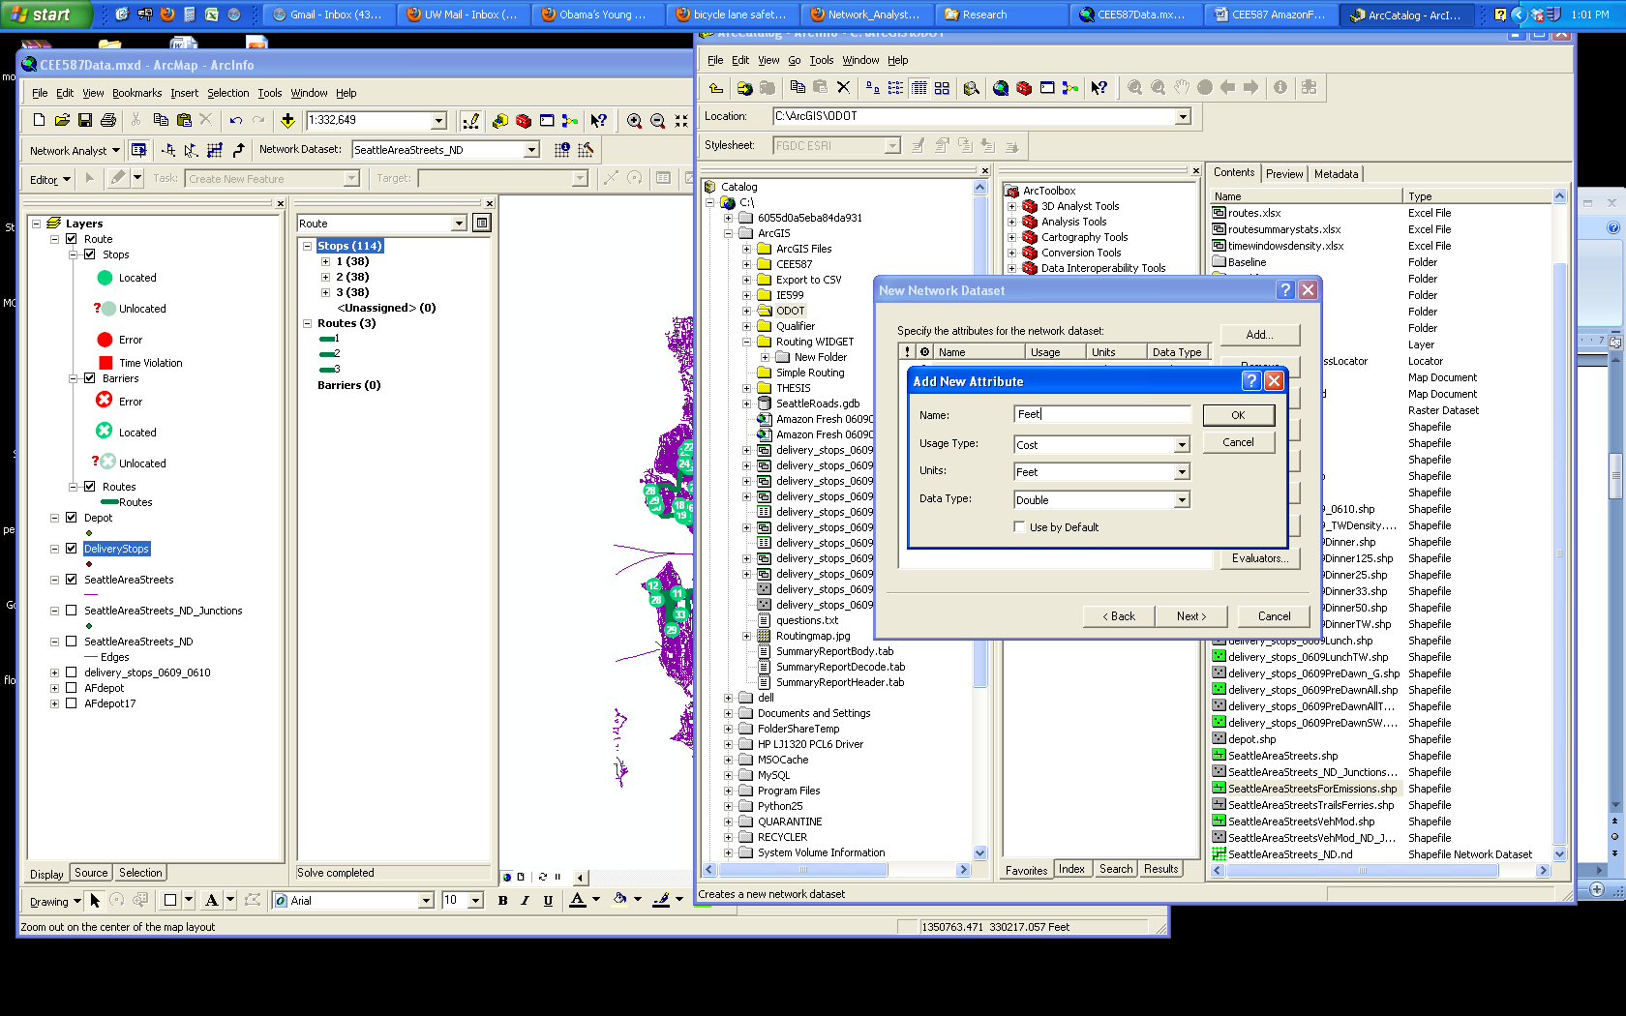

When you add certain evaluators, the program may correctly and automatically assign the Attribute to the correct Evaluator/column in the Attribute Table. If not, select Evaluator and correctly assign the Attribute.

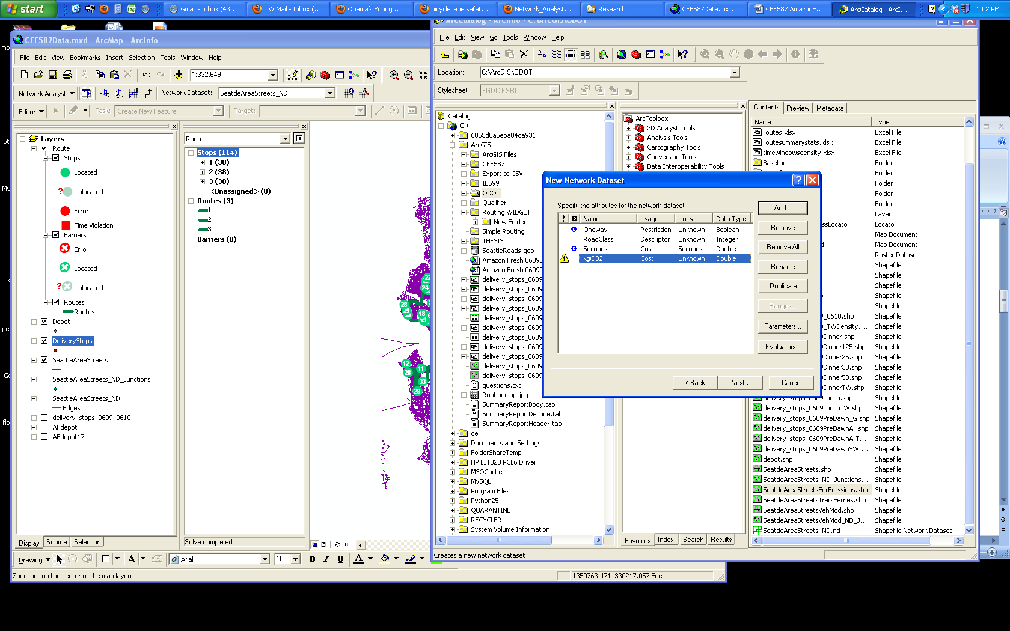

You will need to Label the Type as “Field” and the Value as the Evaluator you would like.

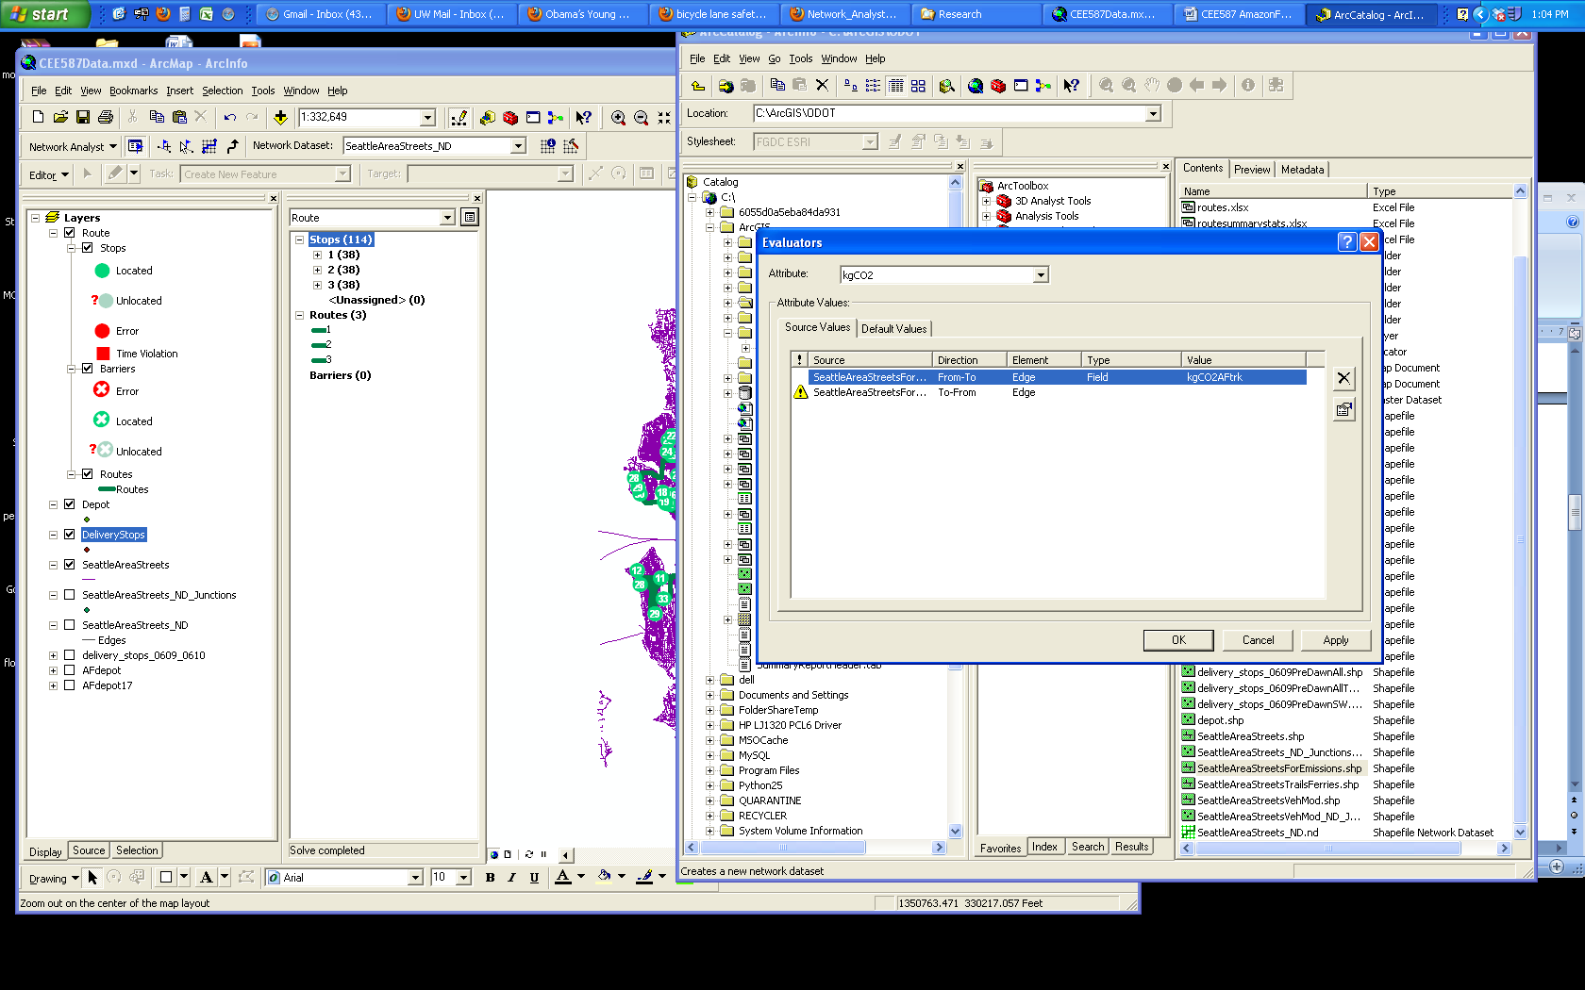

The DeliveryStops layer contains information for 108 customers of Tantastic Sweater Pros. TSP owns 1 truck capable of holding 36 customers’ orders. As such, they provide 3 different delivery windows and have assigned the customers to one of the 3 delivery windows (indicated by the column in the DeliveryStops’ Attribute Table “Route”). These 3 routes correspond to 3 copies of the Depot included in the Depot layer (also labeled as “Route” in the Depot’s Attribute Table).

Because the delivery vehicle needs to start from and return to the Depot for each route, you will need to load all three of the Depots as a Stop as the first stop, load all of the DeliveryStops, and then load all three of the Depots as a Stop as the last stop. Use the “Load Locations” options when you right click on the Stops segment in the Network Analyst window for your New Route. 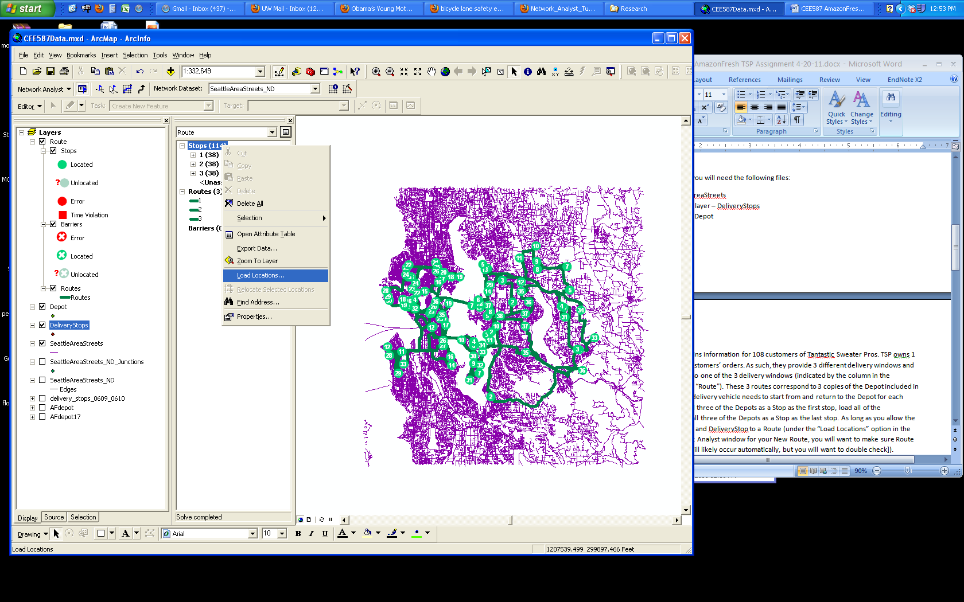

As long as you allow the program to assign each Depot and DeliveryStop to a Route (after selecting the “Load Locations” option, you will want to make sure RouteName is labeled as “Route” [it will likely occur automatically, but you will want to double check since it you won’t get the correct results otherwise]).

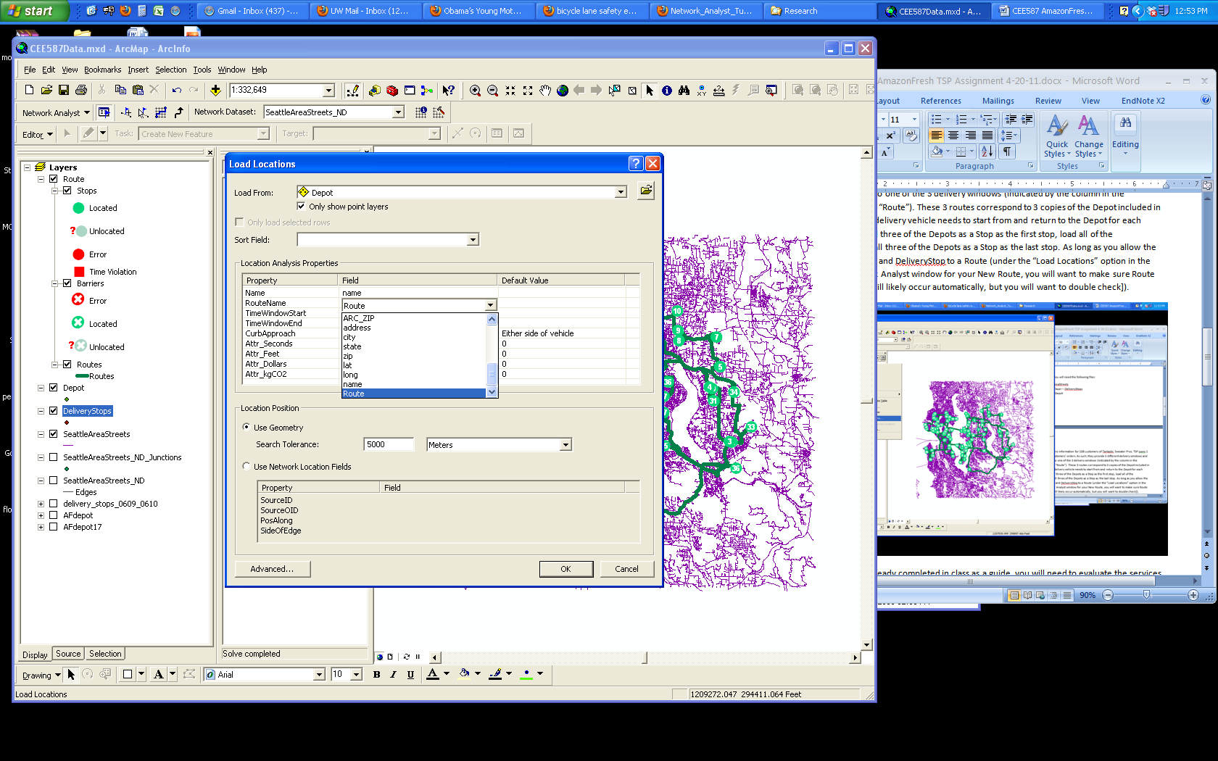

Using the tutorial you have already completed in class as a guide, you will need to evaluate the services of the Tantastic Sweater Pros delivery arm. The delivery vehicles start and end at the depot. As such, make sure you reorder the delivery stops but keep the first and last stop the same.

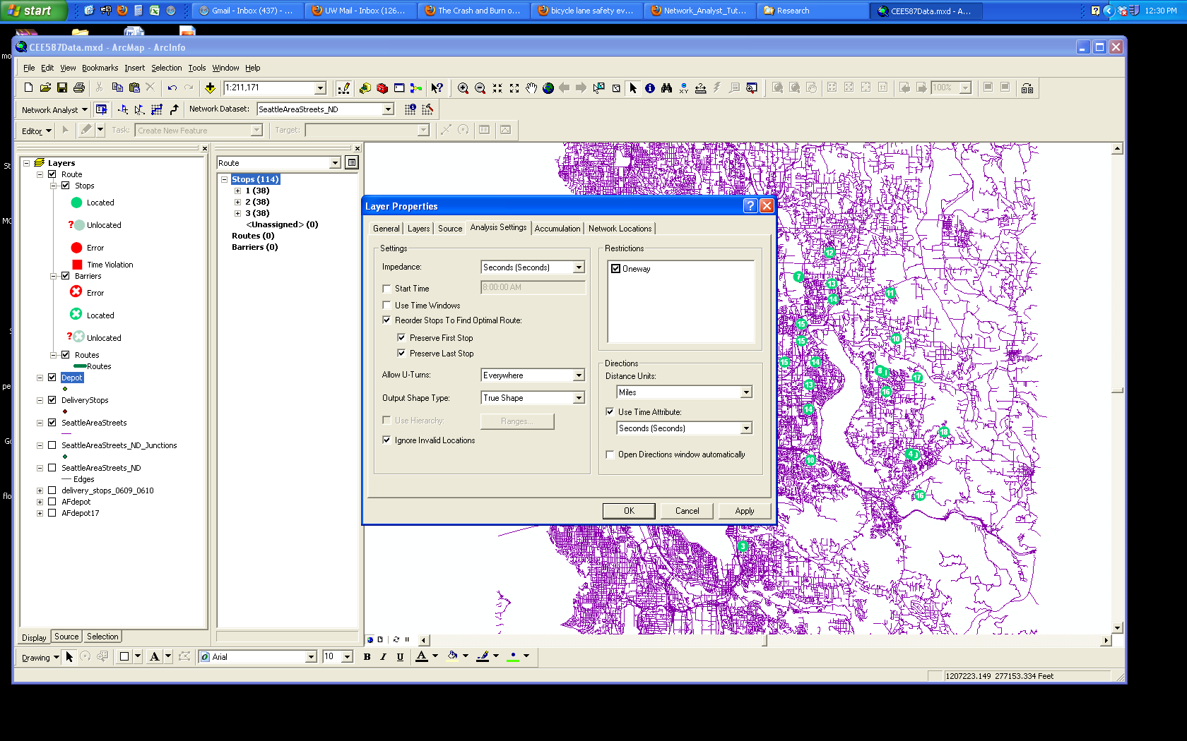

You will need to select the appropriate metrics for the routing to track the necessary variables.

