VRP and TSP Problems

You are helping to design the logistics for a new online pharmacy. The company plans to deliver prescriptions directly to customers from their store at the center of a square region. Based on market research they believe there will be about 400 customers who want service during their 8 hours of operation each day, evenly distributed through the region. The company is considering 2 and 4 hour time windows, and would like to understand the cost implications of each. Assume the driver can average 25 miles/hour and requires at most 10 minutes stopping time to visit each customer. Assume the area is square with sides of 10 miles.

Practice Problem VRP and TSP

Estimate the vehicle miles travelled by a trash truck collecting from 500 homes in the Old Goucher neighborhood (not including the area overlapping with Charles Village). It is approximately 1 mile from Guildford Ave to Howard Street.
Please list any necessary assumptions.
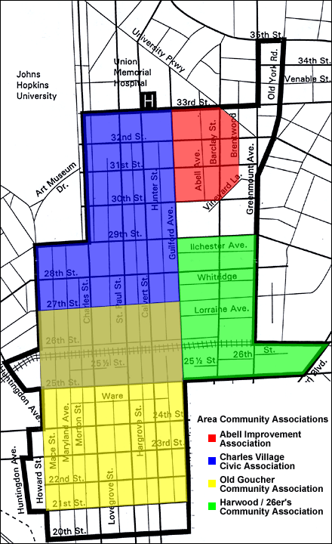

b) Is it reasonable to assume these homes could all be visited in one vehicle tour?

Practice Problem VRP and TSP

You are helping to evaluate a change in the logistics for a garbage collection system shown in the figure below. Currently, each home in the 20 by 20 mile region is currently served once a week and the garbage stored at the collection facility where it is compacted. The truck does one tour of the region each day, Monday through Thursday. On Friday, the truck moves the compacted garbage from the collection center to the depot. There are 400 homes in the region. 100 are served Monday, 100 on Tuesday, 100 on Wednesday and 100 on Thursday. The homes are evenly distributed through the region. The company is considering splitting the one large region into four smaller regions, and serving one of these smaller regions each day. This will still allow each home to be served once a week, and for the truck to operate four days a week. What is your best estimate of the impact on total weekly truck miles traveled?

