Practice Problem VRP and TSP ( 10 points)

You are helping to design the logistics for a new online pharmacy. The company plans to deliver prescriptions directly to customers from their store at the center of a square region. Based on market research they believe there will be about 400 customers who want service during their 8 hours of operation each day, evenly distributed through the region. The company is considering 2 and 4 hour time windows, and would like to understand the cost implications of each. Assume the driver can average 25 miles/hour and requires at most 10 minutes stopping time to visit each customer. The area is 100 square miles. Estimate the number of customers that can be visited with 8 hour, 4 hour, and 2 hour time windows.

- To get full credit for this problem you needed to recognize the relationship between number of stops and tour length.
- Needed to compare the 2 and 4 hour solutions to the 8 hour solution.
- Compare VMT, number of trucks for both cases, in 2 hour time window need 11 trucks, 4 hour we need 10 trucks.

Practice Problem VRP and TSP (5 points)

Estimate the vehicle miles travelled by a trash truck collecting from 500 homes in the Old Goucher neighborhood (not including the area overlapping with Charles Village). It is approximately 1 mile from Guildford Ave to Howard Street.
Please list any necessary assumptions.
L=k*sqrt(AN)=0.92(sqrt(500))=20.6 miles
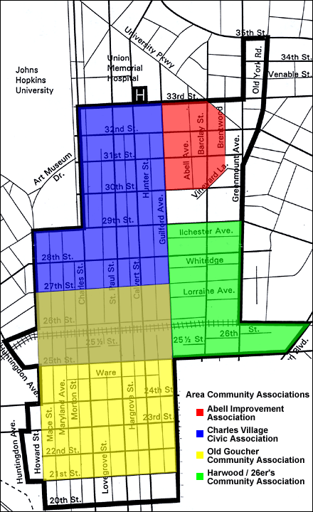

b) Is it reasonable to assume these homes could all be visited in one vehicle tour?
If travel speed is average 20.6 miles an hour it will take 1 hour for the drive time. With 500 customers we can spend up to 50 seconds with each customer and still get the route done in 8 hours.

Practice Problem VRP and TSP (5 points)

You are helping to evaluate a change in the logistics for a garbage collection system shown in the figure below. Currently, each home in the 20 by 20 mile region is currently served once a week and the garbage stored at the collection facility where it is compacted. The truck does one tour of the region each day, Monday through Thursday. On Friday, the truck moves the compacted garbage from the collection center to the depot. There are 400 homes in the region. 100 are served Monday, 100 on Tuesday, 100 on Wednesday and 100 on Thursday. The homes are evenly distributed through the region. The company is considering splitting the one large region into four smaller regions, and serving one of these smaller regions each day. This will still allow each home to be served once a week, and for the truck to operate four days a week. They will still use the collection center to collect the weekly refuse, and deliver to the depot once a week. What is your best estimate of the impact on total weekly truck miles traveled?

The long-haul distance is the same.

Originally the TSP gives 144 miles per day
New version TSP gives 72 miles per day

