AutoCAD Intro Tutorial – Creating a Map
A team was dispatched to survey the parts of the area around Drumheller Fountain. The survey points have been provided to you, converted into an AutoCAD drawing file. Your job is to use the points obtained and create a map of your site to submit. The Google Earth image below is provided as you draw your map.
Equipment/Materials:
- Computer
- Software – AutoCAD 2013
- AutoCAD Drawing with Survey Points to be downloaded from Class Website
  - http://courses.washington.edu/cive316/labs/autocad/ACADTemplate.dwg
Tutorial:
45-60 minutes tutorial on basic AutoCAD functions that will be needed. After that, you will have 2 hours in lab to work on the map. If you don’t complete it during lab, you can finish your work outside of class and submit it before the following lab section.
Procedure:
After the tutorial, copy & paste the .dwg file from the specified path listed above. DO NOT CUT & PASTE THE FILE as other students will need a copy of the file to work on. Rename the file with your name in it and make sure to save a copy on a flash drive or email it to yourself.
Deliverable:
- Submit a completed map of the area that was surveyed. Make sure to fill in all the required fields within the title block. Turn in the printed map at the beginning of your next lab section.
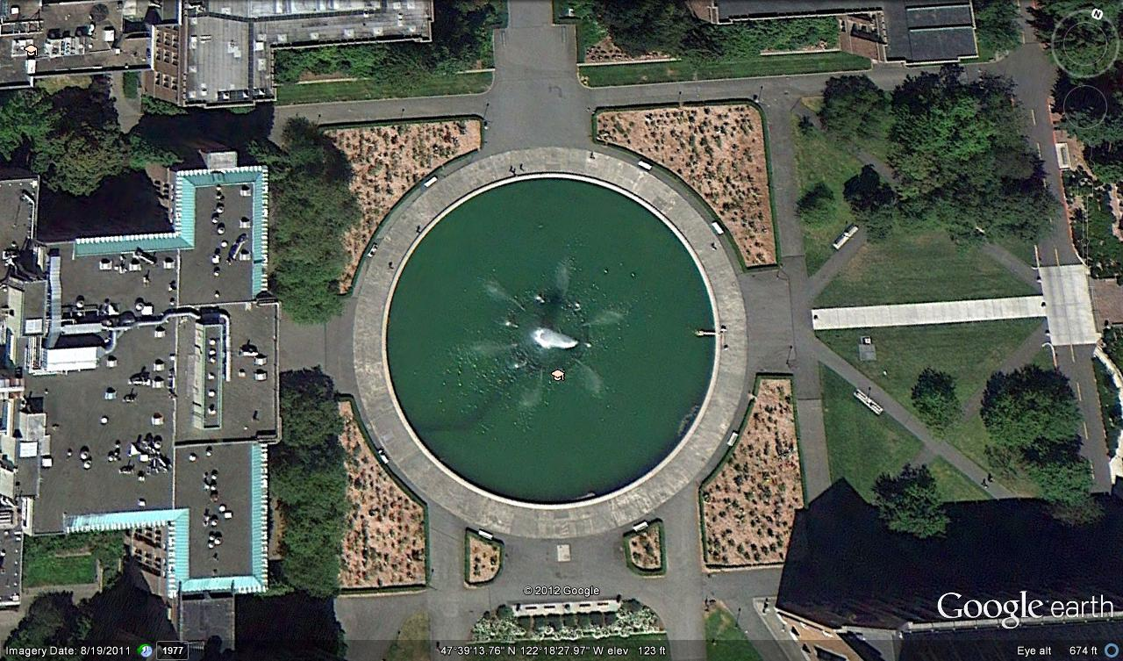
Guidelines for Map:
- The feature codes listed below correspond to the following objects to draw:
  - lp – light pole
  - lstb – trees
  - we – fountain
  - lse – lawn
  - brsh – flower bed
- For the light pole and trees, using the corresponding blocks that are in the template to represent those features. For trees, the fountain and flower beds, hatch all of those polygons with different hatch patterns (You will be printing in black and white so you need to distinguish between the hatches).
- Create a legend for all of the features. Make sure in your legend that you are adding the symbols representing points and hatches representing polygons.
- For the title block, fill in the following parts:
  - Filename
  - Time
  - Date
  - Plotted by, designed by, entered by, checked by, proj. engineer (it will just be your name in all of those boxes)
  - Scale
  - Project Name
  - Class and Lab Section
- In the template is a green line that connects your “Control points.” If you zoom in to the two end points of that line, you will notice that one is labeled “36” and the other is labeled “20.” You do not need to include point “20” in your printed map, but you do need to put a note saying “To 20” for reference.
- In paper space, add a North Arrow, which is a provided as a block in your template.
Ensure that all of these are done before turning in your map.

