Description of Existing Seawall
The existing Alaskan Way seawall is made up of a number of retaining wall types as shown in Figure 1. All wall types were determined to have vulnerabilities to earthquakes, in varying degrees, as described in a separate report “Analysis of the Existing Alaskan Way l, Volume 1 of 7, dated January 2003.” In addition to describing the structural deficiencies of the walls, the preliminary analysis report also provided a complete description of all the wall types and an operational history of the maintenance problems with the walls. A brief summary of the wall types and deficiencies is provided below.

The Alaskan Way seawall extends from Washington Street at its southern terminus to Bay Street at its northern terminus, a distance of 8,016 feet. However, the seawall is interrupted in places resulting in a total length of 7,232 feet. The southern terminus of the wall abuts bulkheads and fills in the vicinity of the Port of Seattle’s Pier 48. The northern terminus of the wall ends at the southern end of Myrtle Edwards Park, where it abuts natural slopes that have been armored with heavy riprap.
The design of the seawall changes over the length depending on the period in which each section was constructed. The southern end is a mixture of pile-supported gravity walls (hereinafter referred to as gravity walls for simplicity) and pile-supported structural sidewalks. These were built in 1916, with some sidewalk sections being replaced in 1964 and the rest in 1987. A portion of the wall in front of the Bell Harbor Conference Center (hereinafter referred to as Pier 66) constructed in 1932 (hereinafter to referred to as the 1932 Seawall) consists of a cellular concrete bulkhead supported on piles. The remaining portion and the majority of the seawall consists of a bulkhead system constructed in 1934. This 1934 system uses a steel sheet pile along the waterside topped by a precast concrete panel. The concrete panel and steel sheet are anchored to a pile-supported timber relieving platform, which also supports the roadway above. This 1934 construction is either one of two types, Type A or B. Both are similar in function, but Type B is larger than Type A and is used in sections of deeper water. There are 4,621 lineal feet of the existing Type A relieving platform and 1,337 lineal feet of the Type B platform
At two locations along the seawall are areas of fill on the seaward side of the seawall; one of these is located at the Colman dock and the other at Pier 66. It is our understanding that the seawall extends past the fill at Colman dock, but not at Pier 66. A description of the seawall in the vicinity of the Pier 66 follows.

Port of Seattle drawings dated 1912 and 1913 show that the area at the present day Pier 66 at pier 66 was filled prior to constructing a large pile-supported building. A double-wall bulkhead using concrete sheet pile tied together with steel rods was constructed in 1914. In 1932, the City of Seattle, as part of the Alaskan Way Seawall project, constructed a bulkhead consisting of timber pile-supported cellular concrete frames at each end of the 1914 bulkheads to transition to the 1934 Type A seawall. Consequently, there is a 784-foot length of Type A seawall missing on the landward side of Pier 66. The outer wall of the 1914 and 1932 bulkheads are shown on current Port of Seattle drawings as the bulkhead line.

The following figures and photos are for the Type A and B seawalls.
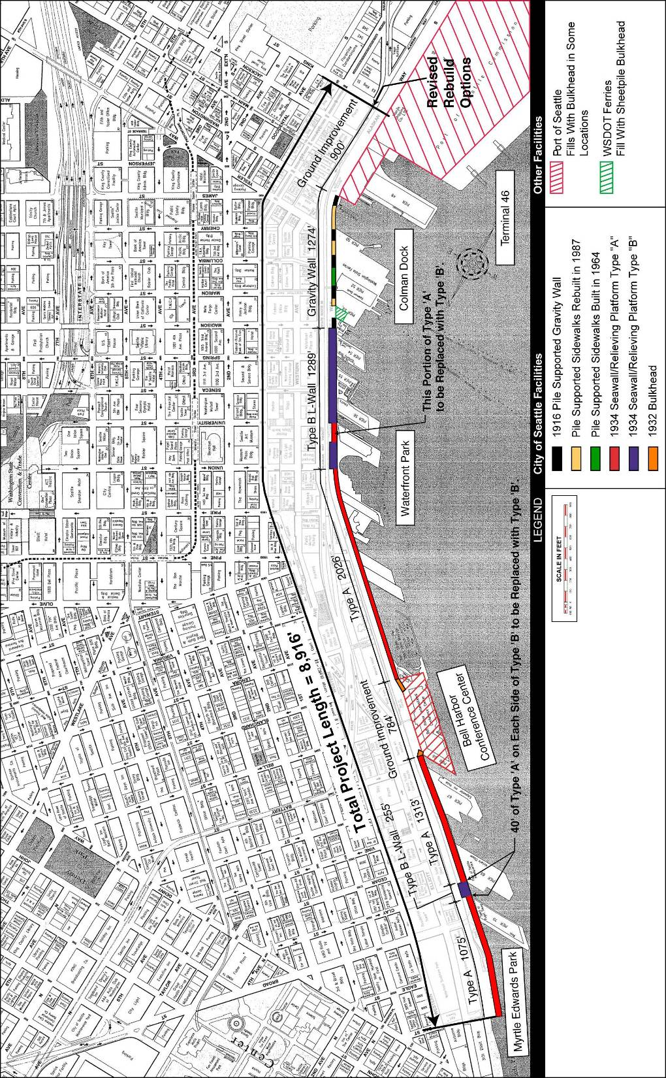

Figure 1. - Plan of Alaskan Way Seawall

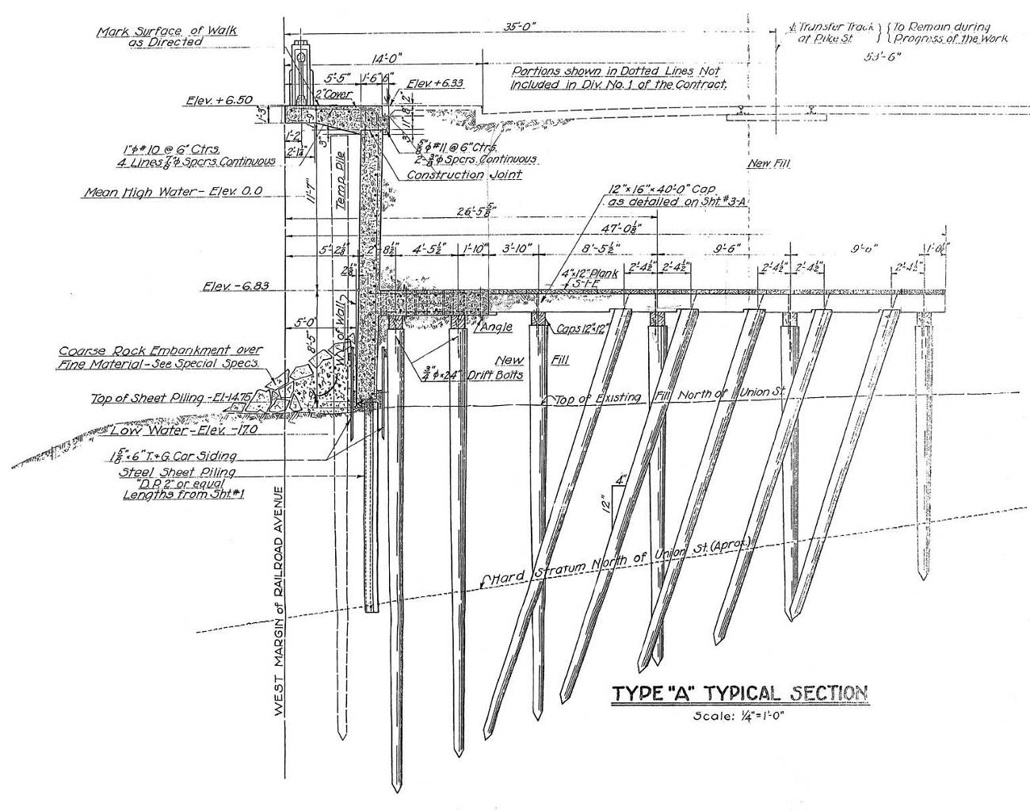
Type A Seawall

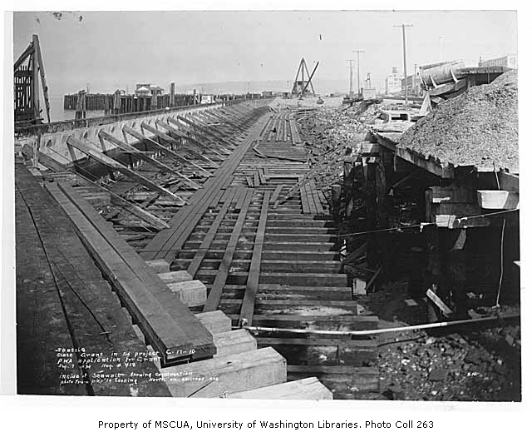

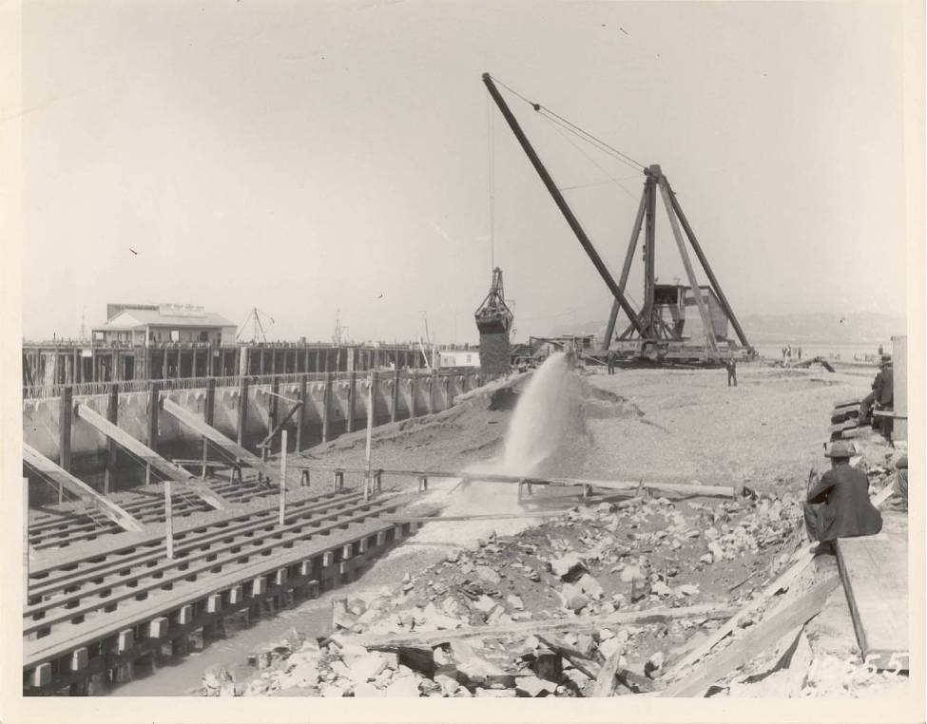
Type A Seawall Being Constructed North of Pier 70

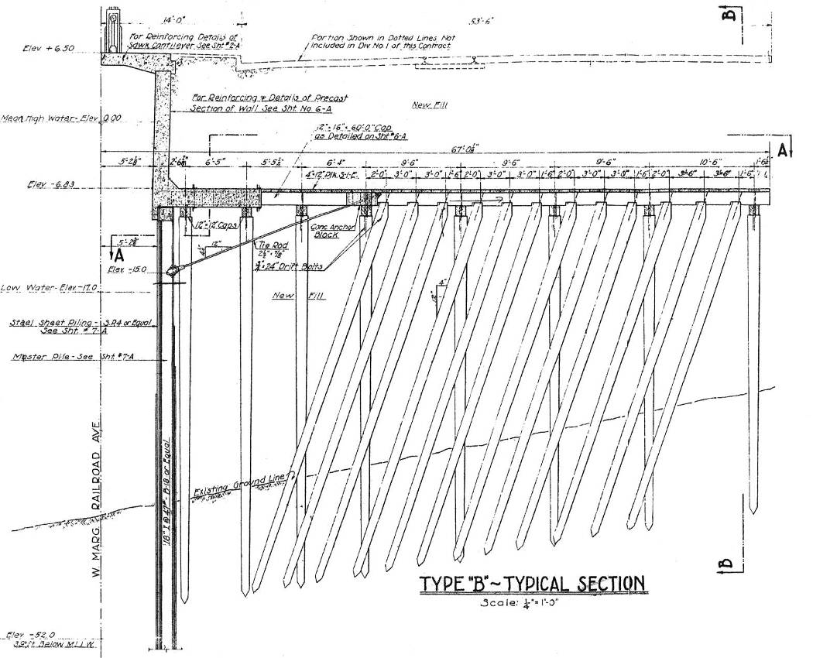

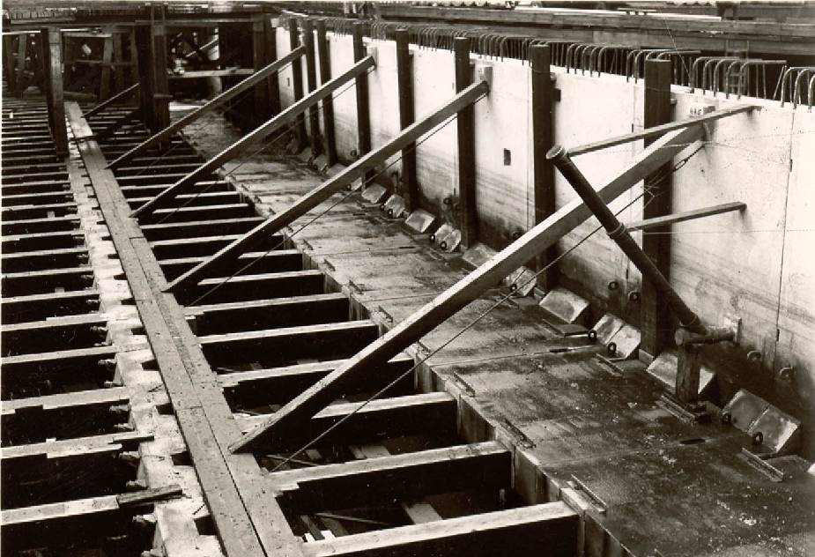

Type B Seawall Being Constructed

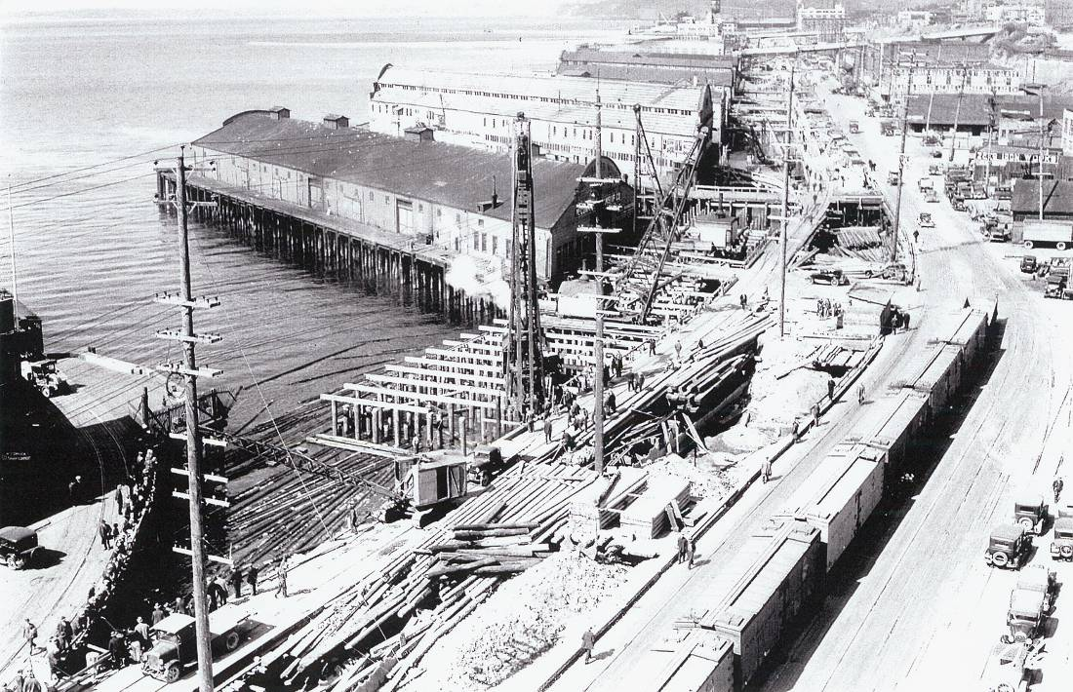

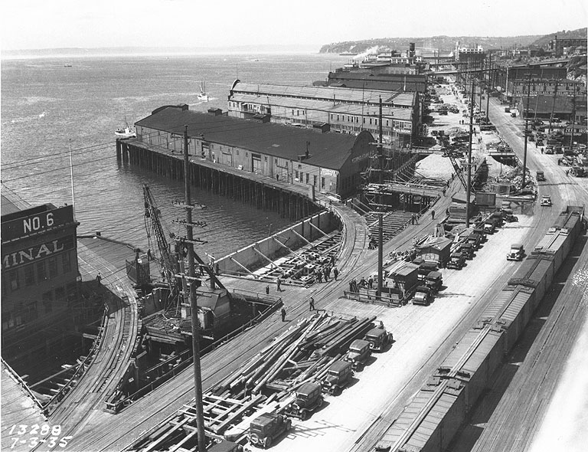
Type B Seawall Under Construction near Union St

