Animals Group (Sarah, Kent, Melissa, Zack)

Question: What terrestrial plants do midges like?

Source: Brandy Reed, King County Conservation District, (425) 277-5581. She works on nearshore restoration projects. Her background is botany/habitat ecology.
Overall Recommendations: Marine Riparian plants are necessary, which she defined as “all native plants associated with the bluffs.” She also recommended Estuarine plants, particularly members of the Scirpus (bulrushes) and Carex (sedges) families and certain saltmarsh type plants.
She said the topography and channel configuration of a site is how she decides what to put in. Where you have a steep drop-off, Marine Riparian plants are the only ones that are appropriate. The emergent plants need flat benches in full sun which are always submerged in order to grow. Because many of them require a relatively low salt concentration, they are typically restricted to stream mouths.
In an ideal world, she recommended planting both types of plant communities. The emergent plants can grow happily in an area of about 10 square feet. NOTE: She did not know whether 10 sq. ft. would be a sufficient size to support a healthy animal population. She focuses on plant community health, not animal population health.

MARINE RIPARIAN PLANTS

Common Name | Latin Name
Big Leaf Maple | Acer macrophyllum
Red Alder | Alnus rubra
Douglas Fir
Common Snowberry | Symphoricarpos albus var. laevigatus
Thimbleberry
Salmonberry | Rubus spectabilis
Oceanspray | Holodiscus discolor
EMERGENT PLANTS
Common Name | Latin Name | Height |  | Location | Blooms | Notes | Wetlands pg. | Pojar pg.
Lyngby Sedge | Carex lyngbyei | 15-100 cm |  | Estuaries, coastal marshes, tidal flats | April-July |  | 278
Water Sedge | Carex aquatilis var. dives (Carex sitchensis) | 30-150 cm, often mats |  | Shallow water, very wet soil, in swampy places or at margins of ponds and lakes | June-August |  | 266
Seacoast Bulrush | Scirpus maritimus | 20-150 cm |  | High brackish or salt marshes inundated 1-2 times a day. | June-Sept. | Often associated with Potentilla anserine and Carex lyngbyei | 300
Three-square bulrush, Olney’s bulrush, American threesquare | Scirpus anericanus | 15-100 cm |  | Marshes with fresh or brackish water, in shallow water or soil saturated to surface | May-August | Adds community diversity is brackish areas | 297
Hardstem Bulrush, Tule | Scirpus acutus (Scirpus lacustris ssp acutus) | 1-3 m |  | Emergent marshes and mostly freshwater marshes. Tolerates salt and alkali. Favors mud substrates and tolerates water up to 1m deep | June-August | Stems are used by brids ofr nesting material and as nest attachment sites. Achene s are a favored food of waterfowl. Often associated with Typha species of Cattails and Nuphar luteum | 296
SALTMARSH PLANTS COMMONLY FOUND TOGETHER
Seashore Saltgrass | Distichlis spicata var. spicata |  |  | Salt marshes | May-Sept. | Erosion control species also high productivity for saline habitat. Most common perennial coastal grass in area | 325
Fleshy Jaumea | Jaumea carnosa | Weak, trailing to 30cm long |  | Salt marshes and tide flats at or just above MHW | July-Sept. | Forms extensive colonies co-dominant with Salicornia viriginica and Distichlis spicata or grows in single species stand | 131
Seaside Plantain, Saltmarsh Plantain | Plantago maritima | 5-30cm long leaves |  | All elevations w/in salt marsh and on rocky areas at edge of salt water | June-August | Seldom the dominant species in the marsh. Traditional native American food plant. Waterfowl like to eat it | 157
Pickleweed, Woody Glasswort, Virigina Glasswort | Salicornia virginica (Salicornia pacifica) | 5-30cm long, forms mats |  | Areas with regular tidal inundation. Likes sandy substrate but also grows in mud or clay | June-Sept. | “voraciously grazed” by waterfowl and other herbivores. Young shoots are edible | 185
Seaside Arrowgrass | Triglochin maritima | 10-80cm long |  | Low salt or brackish tidal marshes, mudflat colonizer. Minor component of high marshes | May-August | Heavily grazed by waterfowl. Traps sediment at salt marsh edges so good for erosion control and extending salt marsh. Seeds were traditional food. Now known to be toxic. | 209

Question: What are good indicator species for various habitats?

Source: Si, Mark Plunkett (Conservation Planner, Seattle Aquarium)

Overall Recommendations: Both Si and Mark recommend creating a diversity of habitat. Mark recommends eelgrass on sandy beach near the seawall, plus a lot of mixed rocky shoreline throughout the sites. Lots of boulders and cobble because these substrates provide a place for deeper water plants to get established and allow large predators a better feeding ground, while attracting a wide variety of animals.

Seattle Aquarium Definitions for substrate sizes:
Gravel = pea to chicken egg
Cobble = chicken egg to basketball
Boulder/Erratic = basketball to move with a bulldozer

INDICATOR SPECIES – ROCKY SHORELINE, BEACH, MUDFLAT
Taken from the Seattle Aquarium pamphlet on the class website. Flip through the pamphlet but NOTE THE FOLLOWING:

Clams & Oysters:
Pacific geoduck – deeper subtial
Giant Pacific Oyster (Japanese Oyster) – WILL NOT grow in our sites. Water is too cold
Pacific Littleneck Clam
Japanese Littleneck Clam-not native but has been here for 100+years
Heart Cockle
Blue Mussel-early colonizer, will grow easily. Will have big colonies in 3-5 years
Rough Piddock- WILL NOT grow here

Rock Dwellers:
Acorn Barnacle
Thatched Barnacle
Little Brown Barnacle
Giant Barnacle-low subtidal only

Mossy Chiton
Hairy Chiton
*chitons need larger substrate, as well as good stands of seaweed, which they eat. Takes a few years to get enough seaweed in a stie for them.

Mask Limpet
Shield Limpet
Plate Limpet
*can be found even on small rocks

Isopods
*need good seaweed stands

Snails:
Moonsnail – will get lots
Periwinkles
Frilled Dog Whelk

Crabs, Shrimp:
Shore Crab
Kelp Crab
Dungeness Crab
Red Rock Crab
Hermit Crab
Shrimp

Sea Slugs:
Sea Lemon
Shaggy Mouse

Spiny Skinned:
Purple Sea Star
Mottled Sea Star
Sunflower Sea Star
*larger sea stars (fist sized) need lots of mussels and barnacled to feed on. Won’t see the sea stars until 5-10 years out
Red Sea Cucumber
Sand Dollar – need stable, wet, FLAT, sand. Like depressions where water pools

Rocky Shore Fishes (NOT the same as Rockfish):
Tidepool Sculpin
Gunnel
Prickleback
Northern Clingfish
Wolf Eel
*the fish like bigger rocks with holes between them to hide in

Sandy Bottom Fishes:
English Sole
Starry Flounder

Jellies:
Water Jelly
Moon Jelly
Fried Egg Jelly
*jellies like in water column and float by

Worms:
Calcereous Tube Worm – will eventually show up

Sea Anemones:
Aggregating Anemone
Moonglow Anemone
Mottled Anemone
*the bigger the better for rock size because more surface to cling to. Early colonizer but takes a few years to grow. Filter feed from water

Seaweed:
Rockweed
Sea Lettuce- free floats so some consider it a nuisance since it will wash up on land and be smelly. BUT important because one of the only green seaweeds in area. Important food source
Sugar kelp
Nori
Turkish Towel
*need some from all “families” – brown, green, red

Sargassum- non native, but been here for 100+ years. DO NOT USE

ROCKY SHORE POPULATION TIMELINE
1-year: Barnacle dots on large rocks – look like grains of white pepper, rocks will look fuzzy due to tiny dots of anemone and mussel polyps, sea weed / algal growth visible
3-5-years: established barnacles, clams, mussels, limpets, chitons colonies, anemones look like anemones, sea stars move in
10-years: fully functional, diversely populated rocky shore

KELP FOREST INDICATOR SPECIES
Forests up here are Bull Kelp, NOT Giant Kelp. Grow from -3ft to -80ft. need big rocks that don’t move.

Fish:
Rockfish
Blue
Black
Canary
Brown
Quillback
China
Lingcod – MARK SAYS THIS ONE WOULD BE A BIG DEAL IF IT WAS THERE
Greenlings – see book on sarah’s desk
Kelp
Others
Perch
Pile
Shiner
Striped Sea
Kelpfish

OTHER INDICATOR ANIMAL SPECIES

Animal | Size | Prey | Predators | Habitat | Behavior | Importance
Melibe Leonina  (Nudibranch) | Up to 90 mm long | Copepods/amphipods (zooplankton). Very prey specific | Kelp Crab (Pugettia producta). Others uncertain | Kelp forests, eelgrass beds | Largely stationary. Blends in with kelp and eelgrass fronds. Filters food out of the water passing by. | Middle of the food chain. Very prey/habitat specific. If there’s enough kelp/eelgrass for good sized population then the habitat is doing well
Herring, Surf Smelt, Sand Lance |  |  |  | Lay eggs in Eelgrass
Ghost Shrimp | 12 cm | Plankton and detritus |  | Dunes and beaches | Tunnels in sediment to hunt for food | Many other small creatures use their tunnels for shelter
Killdeer | 10.5 inches long | Insects and worms |  | Dunes and beaches | Makes nests on ground
Bay pipefish | Up to 33 cm | mysids and other small crustaceans, larval organisms | adult salmon and other larger fish | Eelgrass beds and intertidal region | swim upright in eelgrass beds and camouflage with grass blades; females deposit eggs into a pouch on male where they remain for about 2 weeks before hatching | Rely on eelgrass for habitat and protection from predators
Red octopus | Up to 20 inches | crabs, mollusks, fish (forages at night) |  | juveniles live attached to kelp | eggs laid in intertidal area

ROCKFISH:
- At least 26 different species in the Puget Sound
- In general, rockfish are demersal, (associated with ocean bottom near low-pro rocks and reefs)
- They are long lived, anywhere from 10- 200yrs!
- Highly residential species: non-migratory
PREY: Opportunistic carnivores: eating forage fish, mollusks, worms and crustaceans.
PREDATORS: Juveniles eaten by many fishes, adults preyed upon by lingcod and other larger predators.
Humans also commercially fish rockfish. A lot believe a direct relationship to declining population. Maturation and the ability to spawn takes awhile in many rockfish species, so the loss of larger, highly productive fish can be a direct result of lowered spawning potential.
Secondly, Rockfish are demersal and often in direct contact with sediments. Therefore, they are vulnerable to high contamination and slow recovery. Elliot Bay and other “industrial” rockfish showed much higher levels of mercury and PCB’s. Species as a whole has been in decline steadily since the 1970’s. Several species petitioned for endangered species act, some listed?
HABITAT BREAKDOWN:
Rockfish need 3 different habitat types as they go through the life cycle:
1--- Born as free swimming larvae, live in surface waters where they stay for several months.
2--- Juveniles settle in nearshore vegetated substrates: eelgrass, bull kelp, rock reefs.
3--- Adults require complex, high relief substrate: rocky reefs, slope pilings, and artificial reefs. (which is why they like rip rap)

SOME SPECIFIC SPECIES IN THE SOUND:
Brown Rockfish: S. auriculatus
Quillback: S. maliger
Canary: S. pinniger
Black: S. melanops
China: S. nebulosus
SOURCES and ADDITIONAL RESOURCES:

Seattle Aquarium Guide

Pacific Seashores – Thomas Carefoot

Kelp Forests – Conner and Baxter, Monterey Bay Aquarium

Pacific Coast Inshore Fishes

“Living Species List.” Monterey Bay Aquarium. http://www.mbayaq.org/efc/living_species/default.asp

“Sound Species.” Washington Department of Ecology: Puget Sound Shorelines. http://www.ecy.wa.gov/programs/sea/pugetsound/species/species.html

Schmidt, Michael and Pam Johnson. “Toxics in the Puget Sound Food Web.” People for Puget Sound. 2001. http://www.pugetsound.org/index/pubs

Videos of underwater habitat
http://www.oceanfootage.com/stockfootage/Surf+Perch///?DVfSESSCKIE=70e24f7ee3dc859d786cebdeebda160b1437d43f

Tables of information on Shiner Perch, growth, habit, etc.
http://elib.cs.berkeley.edu/kopec/tr9/html/sp-shiner-perch.html

Fishing Guide for Vancouver, B.C.
http://www.fishingwithrod.com/fish_profile/shiner_perch.html

lake washington and pcb contents of fish, yellow perch in particular
yellow perch from lake washington averaged 191 ppb of pcbs
http://seattletimes.nwsource.com/html/localnews/2002022097_fish01m.html

APPENDIX:
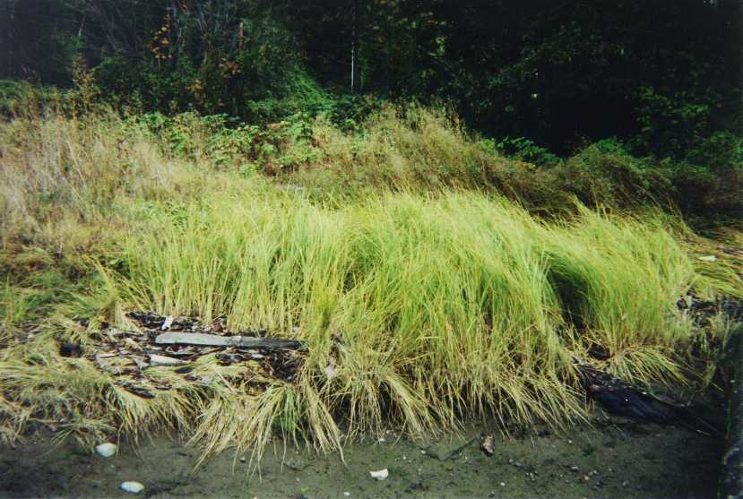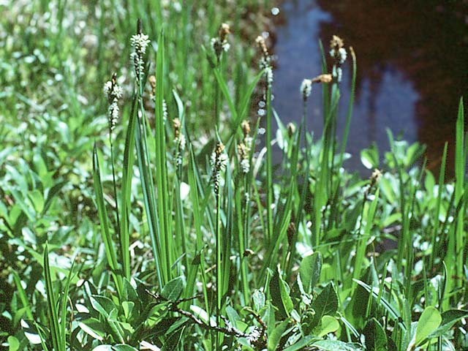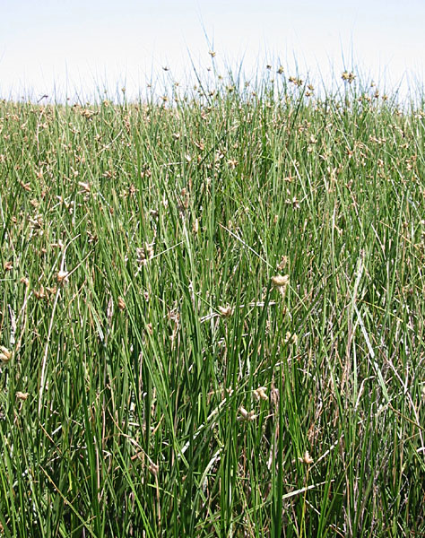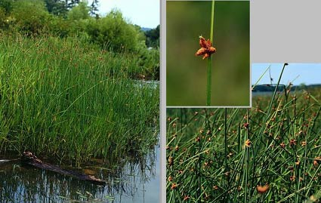
Carex lyngbyei Carex aquatilis Scirpus maritimus Scirpus americanus

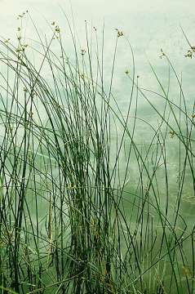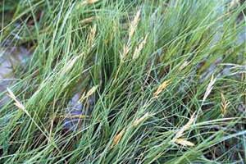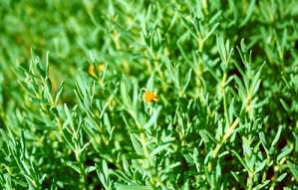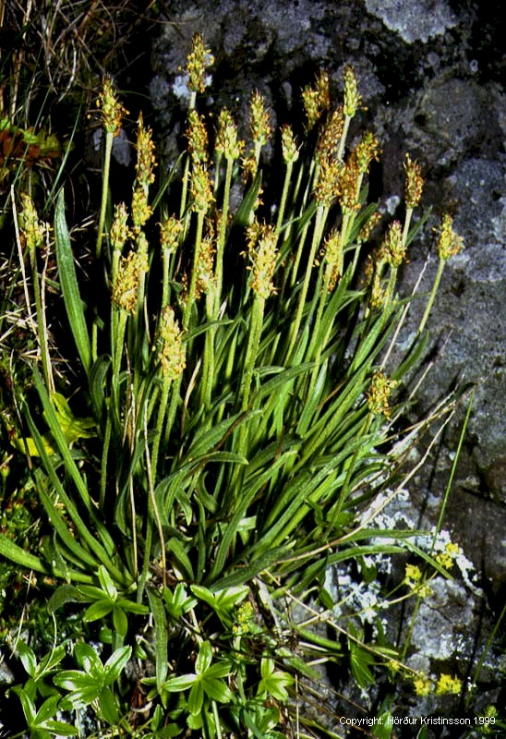
Scirpus acutus Distichlis spicata jaumea carnosa plantago maritime

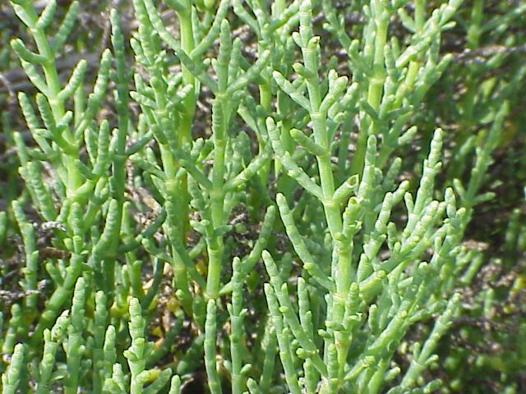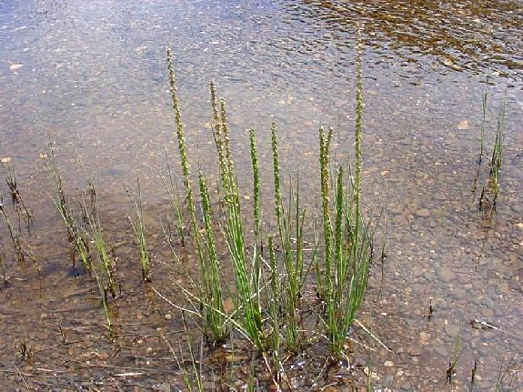
Salicornia virginica Triglochin maritima

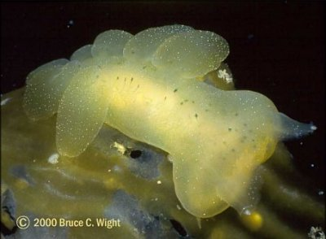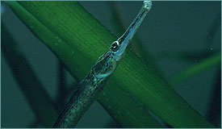

Melibe leonine Bay pipefish (Syngnathus leptorhynchus)

Puget Sound’s Habitat Types
Food webs describe the complex feeding interactions within a community of organisms. Puget Sound in its entirety has such a complex food web that researchers look at it as a combination of several smaller interlocking food webs, segmented by six habitat types: Open Water, Rocky Intertidal and Subtidal, Gravel and Mixed Course Sediment, Sandy and Muddy Intertidal and Subtidal, Eelgrass, and Vegetated Estuarine Wetland 10, 14.

Open Water Habitat
This habitat type is characterized primarily by its abundance of open water dwelling species such as orca, gray whale, salmon, harbor seal, sea lion and the Dalls porpoise. Baitfish, also known as forage fish (herring, surf smelt, sand lance) also occupy these waters en masse. Phytoplankton are abundant in the surface waters and, along with detritus (decayed material and bacteria), provide the base food level for all organisms in this habitat. Most species of fish and marine invertebrates in larval stages are included in the zooplankton of the open water area.

Rocky Intertidal and Subtidal Habitat
Most of the plants and animals in this habitat grip the rocks or take refuge from strong wave and current actions. Benthic microalgae (relatives of floating phytoplankton) and seaweed feed the herbivores of this region. Detritus also plays an important role in this habitat, directly providing food for the detritus eating amphipods, which, in turn, are prey for over half the organisms in the secondary trophic level. Representative species are: benthic animals such as sea stars, anemone, mussel, barnacle, sea urchins; fish such as rockfish, ling cod, sea perch, greenlings, pricklebacks, gunnels, and other various non-migratory, rocky or reef dwelling fish; birds such as gulls, oyster catchers, cormorants, and herons; and mammals also from the open water habitat such as harbor seal and sea lion.

Gravel and Mixed Coarse Sediment Habitat
Habitats characterized by coarse sediment (mixtures of sand, gravel, and cobbles), make up most of the beaches of Puget Sound and in subtidal zones where currents and surf are prevalent. This type of habitat provides little shelter from wave and current actions, so many organisms burrow into the sediments for protection. Some small seaweed and macroalgae are present on the sea floor. Clams (manila, littleneck, horse, butter clams, and geoducks) dominate the herbivore community. This habitat also hosts a variety of crustacean, echinoderms, other mollusks, and both pelagic and bottom fish. Many marine birds such as cormorant, murres, puffin, auklets, and gulls, and shorebirds such as duck, geese, and crow are common foragers. This habitat is also critical spawning grounds for forage fish.

Sandy and Muddy Intertidal and Subtidal Habitat
These habitats are found on gradually sloping sea floors with weak circulation
and are located at the heads of protected bays, the mouths of rivers, and in
several deep water zones. Although not the prettiest to look at, this habitat is extremely productive. Large clams, sand dollars, sculpin, sea cucumber, sea urchin, crab, worms, starfish, hydrocorals and microscopic invertebrates make up a large portion of the benthic life. Oysters can also be found in abundance attached to any hard surface they can find. Popular sportfish such as flounder and sole dominate the fish community, and juvenile salmon and herring also use shallow tide flats.

Eelgrass Habitat
Eelgrass, one of the most important plant species in Puget Sound, dominates the shallow, sandy subtidal habitats. Unlike seaweed, eelgrass is not a type of algae but instead a flowering perennial that roots in the soft substrate at the low tide line. Eelgrass provides food (for the most part indirectly after decay), substrate, and shelter for a great diversity of organisms including: flatworms, snails, small crustaceans, jellyfish, crabs, starfish and sea cucumbers. Juvenile salmon feed extensively on small worms and crustaceans living in and on the mud. Pacific herring rely on the eelgrass for spawning habitat. Shorebirds such as herons, sandpipers and gulls and open water birds like loons, grebes and diving ducks can also be found roaming this area. Finally, the harbor seal may be found in eelgrass beds feeding on fish such as herring, sculpin, and hake. Eelgrass is also rearing habitat for bottomfish.

Vegetated Estuarine Wetland Habitat
Estuarine wetlands include vegetated salt marshes, tidal freshwater marshes and swamps, and tidal sloughs. Tidal sloughs support secondary production activities and are an important habitat for fish, shellfish, marsh and water birds, shorebirds, waterfowl and coastal marine and aquatic mammals. Vegetated salt marshes, characterized by their salt-tolerant grasses, support both primary and secondary productivity and are critical habitats for crabs, shrimp, marine
fish and birds. Salmon also spend a good part of their juvenile stages in the estuarine habitat, feeding on aquatic insects, amphipods and other crustaceans.
From “Toxics in the Food Web,” People for Puget Sound, 2001

