Underwater Habitats
Plants
- Eelgrass beds
  - Functions
    - Primary production
    - Nutrient processing
    - Wave and current energy buffering
    - Organic matter input
    - Habitat for fish and invertebrates
  - Location
    - +4’mllw to -15’mllw
      - +4’ because of dessication stress
      - -15’ because of light penetration
  - Stressors
    - Natural
      - increased turbidity
      - foraging
      - black rot disease
      - rhizome exposure
      - hydrogen sulfide in soils
    - human influenced
      - clam harvesting
      - propeller scour and wash
      - eutrophication
      - physical disturbance from shoreline armoring
      - shading form over water structures
      - dredging and filling
- Kelp Forests
  - Functions
    - Primary production
    - Habitat for fish, especially rock fish, salmon
    - Contributor to pelagic food webs particulate and dissolved carbon
    - Herring spawning substrate
    - Wave and current buffering
    - Substrate for secondary production
    - Extraction of chemicals for commercial use
  - Location
    - -10’mmlw to -60’mmlw in Puget Sound
      - Grows best in strong currents
      - attaches to rocks 1’ in diameter to 4”
  - Stressors
    - Degree of tissue bleaching (oil)
    - Epiphyte loads
    - Changes in distribution and density
    - Physical disturbances from armoring, marina construction and harvesting
    - Shading from over water structures
- Rockweed (Fucus sp.)
  - Location
    - +6.4’mllw to -3.5’mllw
- Red Algae
  - Location
    - 0.0’mllw to -9’mllw
Other vegetation types that are seen in the Puget Sound are brown and green algae along with Ulva (water lettuce) beds. Studies are infrequent so gathering information is difficult.

This image relates types of vegetation to type of substrate.
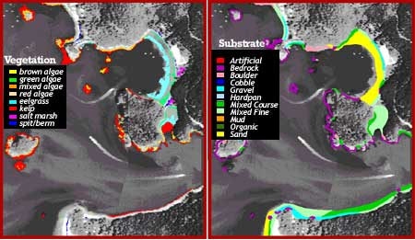
Substrates vary from Sand, Pea gravel, Pebble, Cobble, Course, to boulders.

