Why is the diameter of the cam gear twice the diameter of the crank gear? What does it mean when someone says that the “timing of the engine” is off? Why won’t an engine run if the timing is off?

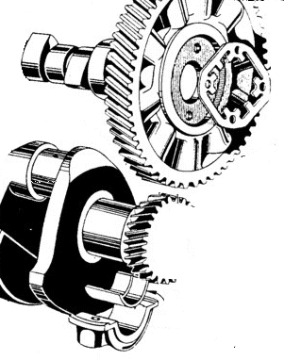
Crank Gear
Crankpin Journal
Cam Gear
Cam Lobe

Why is this engine designed so that the spark plug sparks twice during the 4-strokes (also how do you know it sparks twice)? How could it be changed so that it only sparked once during the 4-strokes? Would this be a better design?

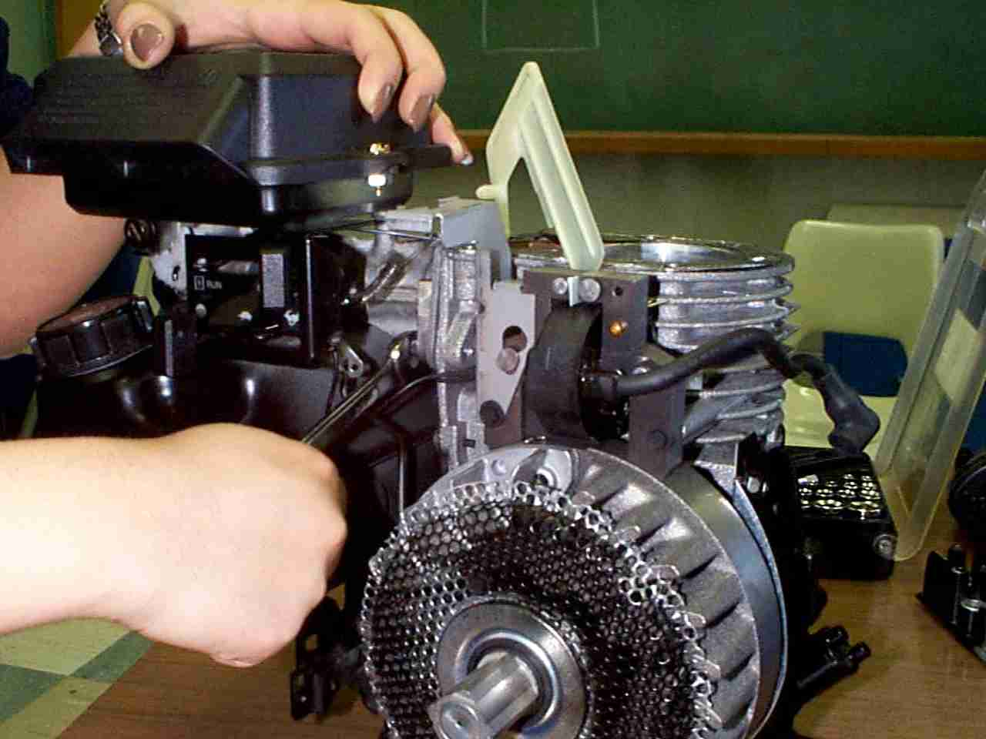
Hold a light strip of paper in your fingers right below your lower lip. Blow over the paper. What happens? How is this same principal used in the design of the carburetor Also explain why the choke and throttle are important?

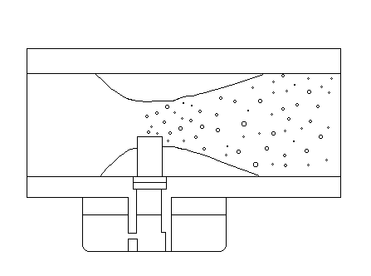
Fuel
Lower Pressure in Combustion Chamber

Higher Pressure Outside Engine

Venturi
Choke
Throttle
What is the purpose of the air vane and how does it work? What are the multiple “jobs” of the flywheel?

Air vane
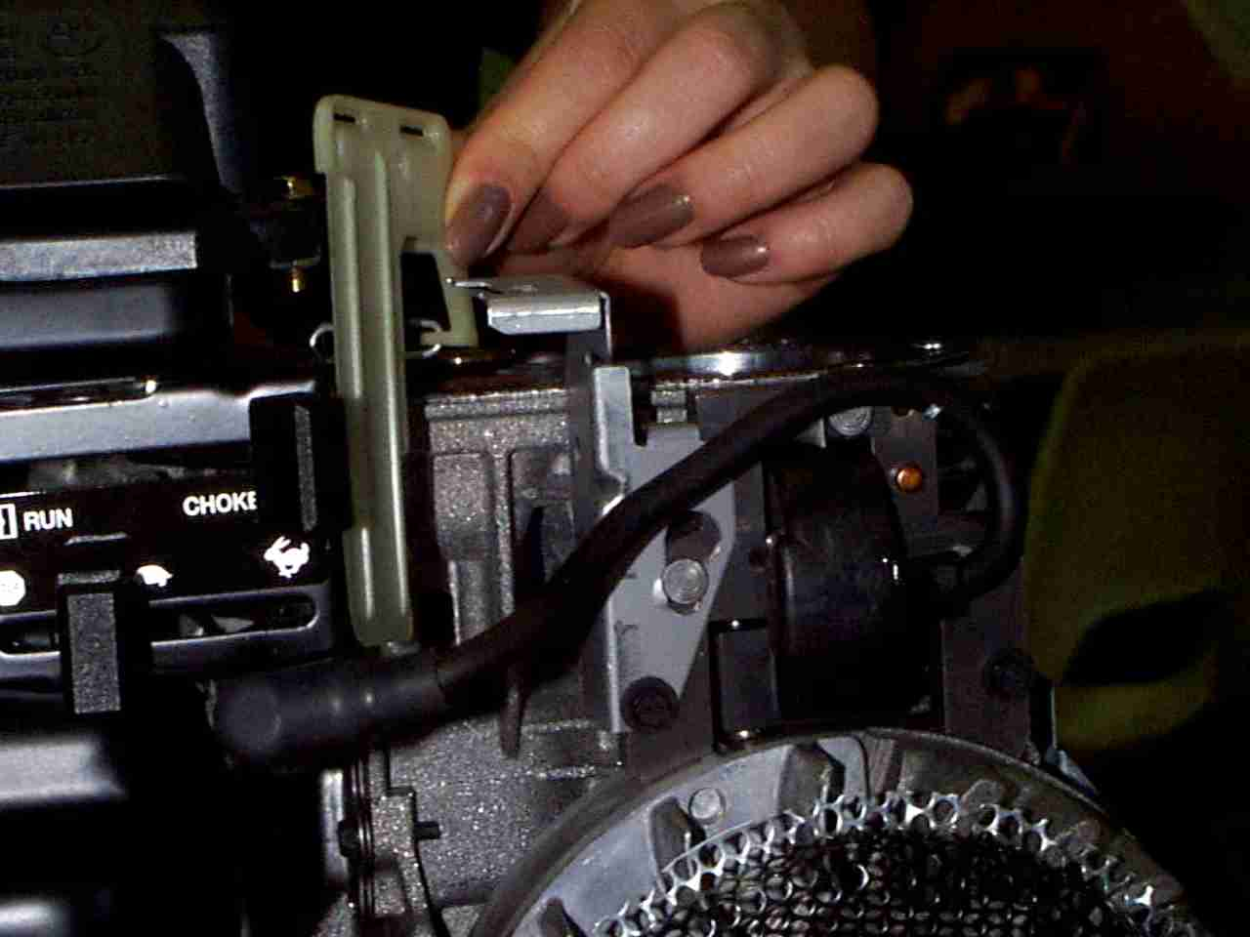

In physics, WORK is defined as FORCE x DISTANCE (through which the force acts). POWER (like horsepower) is defined as the WORK / TIME. Identify what the “forces” are in the engine, what the “distance” is and what the “time” is. Explain why you have to subtract two quantities of work to calculate the net horse power of the engine.
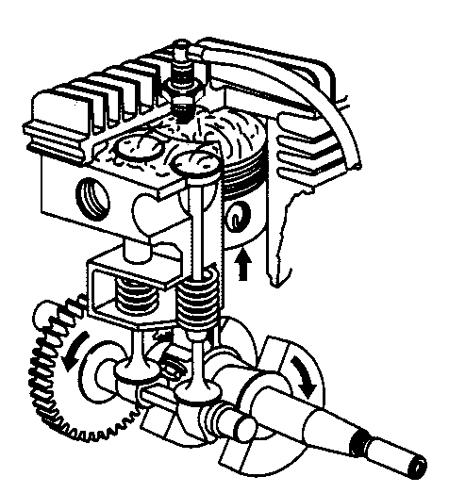
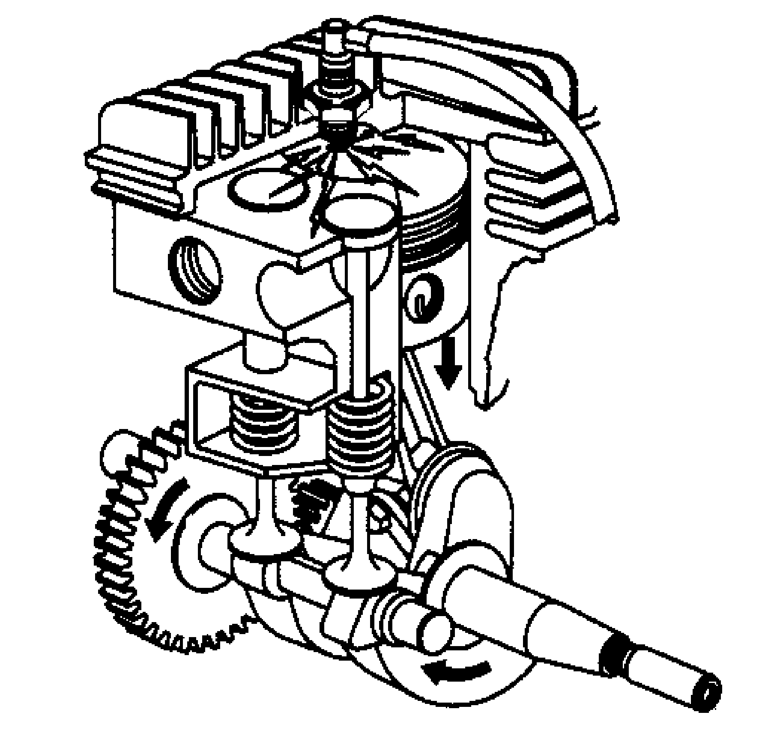
What is the compression release, why is it needed, and how does it work?

Compression release Exhaust Tappet

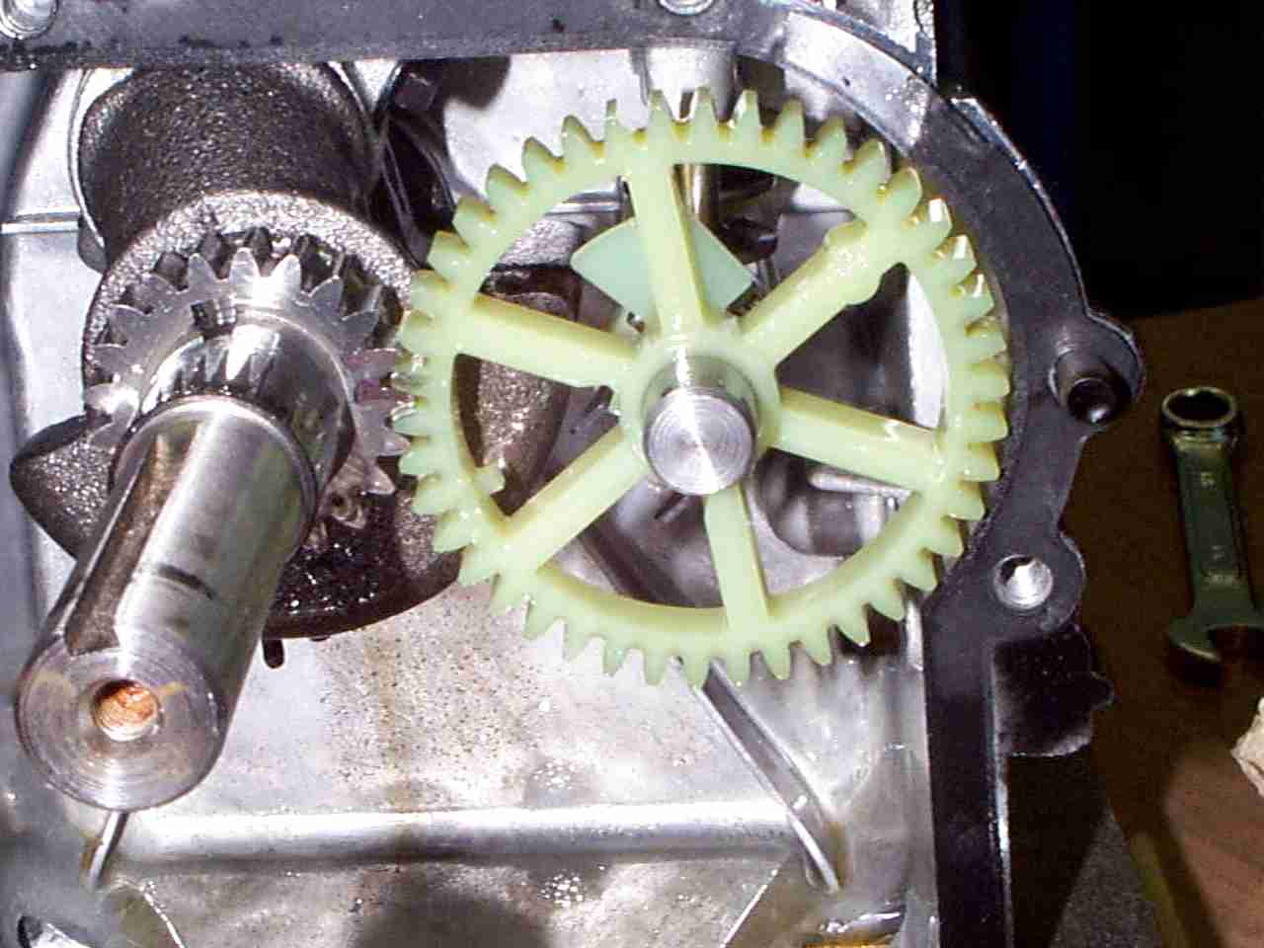
Explain how a 2-stroke engine works compared to a 4-stroke.

Compression
(ports closed)
Air Taken Into
Crankcase
Combustion
(ports closed)
Exhaust
(intake port closed)
Air compressed in crankcase
Scavenging
and Intake
(ports open)
Your instructor gives you several poorly assembled ENGR 100 engines that don’t work. The problems are listed below. What do you think is wrong with each engine?

  - You go to pull the starter cord and it won’t budge.
  - You put your hand next the muffler and you don’t feel any air rush out as you pull the starter cord.
  - You feel air rushing out of the muffler but when you smell your hand, there is no smell of gasoline.
  - As you pull the starter cord, the engine sounds like it is turning over correctly but it just won’t start.

