ENGR 100: Internal Memorandum

To: ENGR 100 Students

From: ENGR 100 Instruction Team

Date: Dec. 3, 2001

Subject: Design Specification (45 pts HW)

Group Assignment

For this assignment, your team will print the three programs (RCX or NQC) written for the robot competition and include text explaining the logic and commands of each program. A corrected version of this assignment needs to be included as a section in the final report.

Deliverables

Begin with an introductory paragraph outlining the purpose of this section of the report. Organize the programs with subheadings (e.g. Robotic Wheelchair, Car and Defender Robot). Before each sample of code, write several sentences explaining what the program does and the logic used. These initial comments will help the reader more easily decipher the code. Then include a figure showing the program*. You may include arrows and text boxes to further explain the program.

*You can't print a copy of your code directly, but you can take a "snap shot" of the screen and insert those images into the report. While in the Mindstorms program, hit "Print Scrn" button. Then exit the program (or minimize it) and open a program like "Paint" (should be under Start/Programs/Accessories). Select Edit/Paste to view the image and use the cut tool to save only portions of the image. Finally you can Edit/Paste the image into a Word document.

Example:

Here is a sample to show the level of detail and formatting recommended for this assignment:

"The following program (Figure 1) allows the robot to count lines and stop after it has crossed four lines. The robot recognizes lines by registering a change in light intensity with its light sensor as it crosses the dark lines. To keep track of the number of lines crossed, a counter variable is incremented every time the light changes. Finally, a beep command is included in the program to act as audio cue for the programmer to determine if the robot is working correctly during execution.”

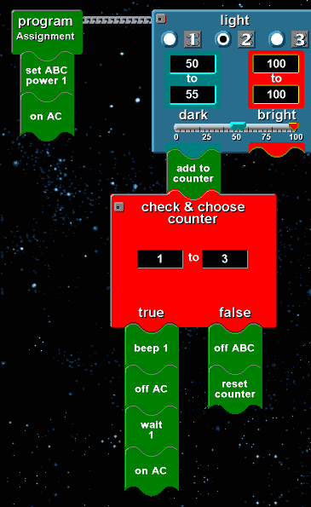
Increments a counter variable by one each time the robot crosses a line.
Turns robot off after crossing 4th line.

Figure 1. Line Counter Program

Grading :

The Design Specifications will be graded on completeness and accuracy:
- Does the program do what it is supposed to?
- Does the program contain any errors that will prevent it from working correctly under any conditions?
- Are the comments (arrows and text) easy to understand? Is more/less detail needed?

Each program is worth 15 pts (total is 45 pts). This assignment needs to be corrected and included in the final report.

