ENGR 100 Assignment 1: Rocket Science

1.0 Rocket Layout

Once you are done building your rocket, enter your rocket design into RockSim. Figure 1 shows an example rocket design (different than the one your group may have built):

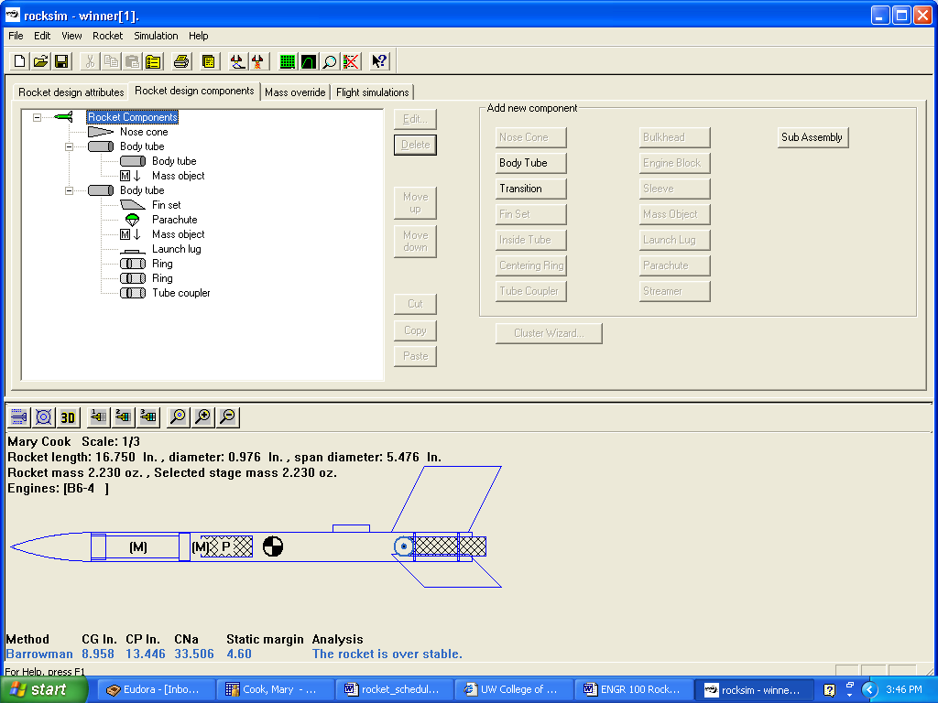
Figure 1. Example of RockSim design

2.0 Engine Thrust

Background

When selecting an engine, there are two things to consider – the average engine thrust and the delay time. Engines are named with these two factors in mind. The first letter in the engine name refers to the thrust force, so an “A” engine has less thrust than a “B” engine. A “C” engine has more than the “B”. The heavier the rocket, the larger the engine you need.

The number refers to the delay time. This is the time measured from when the engine burns out until the instant the ejection charge is fired. The ejection charge causes the parachute to come out, so you need to select an engine that has a delay time approximately equal to the coast time of your rocket. RockSim calculates the optimal delay time for your rocket design.

Questions

- To find the best engine for your rocket, follow the steps below and fill in the table for each simulation you run.

Trial | Engine Loaded | Maximum Altitude | Time to Apogee | Altitude at deployment | Optimal Delay | Result?
1 | Example B6-4 | 483.72 ft | 5.22 s | 479.57 ft | 4.47 s | Okay – 4s delay is less than optimal but close enough
2
3
4

- Select “Launch Preparation” from the top menu.
- Select one of the following engines (if no engine options appear, go back and select your body tube and click the check box marked “Use body tube as engine mount”):

Estes 1/2A3-2T Estes A8-3 Estes B6-2 Estes B6-4 Estes C6-3

- Run a flight simulation. Continue to select engines until you get find the best engine for the delay time and altitude. To learn more about engines, click on the Rocket Resources link on the web page.

3.0 Rocket Stability

Background

A model rocket must be stable in order to fly properly. During flight a rocket encounters many disturbances, such as, wind, possibly crooked fins, an off-center engine, irregularities in model construction, etc. All of these disturbances can cause the rocket to become unstable and fly in a highly irregular manner.

In order to overcome these disturbances a rocket must have a stabilizing, restorative feature. Then, the disturbances will be damped out so that the rocket can go on its intended flight direction. A stable configuration has the Center of Pressure (CP), blue circle, located behind the Center of Gravity (CG), circle with black and white sections as shown in Figure 2.

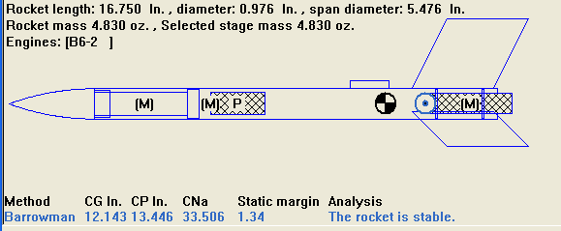
Figure 2. Rocket CG and CP Located
These two points represent balance points of the rocket. The Center of Gravity is the balance point for the mass of the rocket. For example, if you balanced your rocket length-wise on your finger, the point where it balances corresponds to the CG. The CG serves as the pivot point for all pitching (nose up or down) and yawing (nose left or right) and roll action during the flight.
The Center of Pressure is similar to the CG except it is the point where all pressure or drag forces act as the rocket flys upwards. The CP is the "balancing" point for these forces. To see why it is important that the CP be behind the CG, imagine that the total drag force is located at the CP. As a rocket veers off course from vertical (and pivots about the CG), the pressure force would swing the rocket back to vertical similar to the motion of a pendulum.
Questions:
2. What will happen if the CG is behind the CP? Draw a picture w/ your answer.

3. What is your static margin?
The distance between the CP and CG is known as the static margin. The ideal distance between the two points should be approximately 2 times the diameter of your rocket or a static margin of 2. For example, if your rocket has a diameter of 1 in, the CG and CP should be separated by 2 in.

4. What changes do you need to make to your rocket to improve the stability?

- To move the CG, add mass to your rocket

Adding weight to the nose of the rocket will move the CG closer to the nose (use clay). Adding a larger (and thus heavier) rocket motor at the back of the rocket will move the CG towards the fins. A rocket will tend to be more stable when the CG is more towards the front of the rocket.
- To move the c.p., increase or decrease the size of the fins.
Larger fins cause the CP to move towards the rear of the rocket. A curved nose cone or the addition of small fins on the front of the rocket will move the CP forward.
5. Did your rocket pass the swing test?
Perform a swing test to ensure your rocket is stable. Tie a string around the rocket at the CG and swing around your head. If the rocket flights unstable or backwards do steps in #3 to fix rocket.

