Rocket Design Assignment

Part One: Free Body Diagram

Draw and label the force vectors to complete the free body diagram for a rocket in thrust phase and in coast phase.

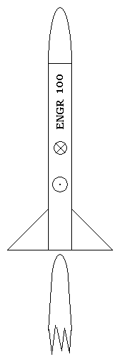 | 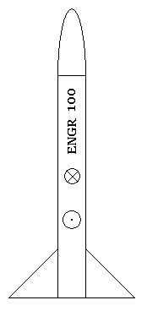
Thrust phase | Coast Phase

Complete Newton’s second law for both cases.

Thrust: $\sum{F=}$

Coast: $\sum{F=}$

Define each term in the two equations. Through which point (Center of Gravity or Center of Pressure) does each force act?

Part Two: Wind Tunnel Data

Wind tunnel test were performed on a model rocket to investigate how the number of fins and fin size influences the coefficient of drag and the location of the center of pressure. The data appears in the table below.

No. Fins | Fin Size | C_{D} | F_{D} (N) | CP Location (cm)* | Static Margin
3 | Tiny | 0.52 | 1.9 | 18.3
3 | Small | 0.6 |  | 11.5
3 | Medium | 0.65 |  | 9.8
3 | Large | 0.7 |  | 7.8
4 | Tiny | 0.62 |  | 12.3
4 | Small | 0.64 |  | 9.8
4 | Medium | 0.76 |  | 7.4
4 | Large | 0.82 |  | 5.5
* The CP location is measured from the bottom of the rocket.

Complete the table by calculating the static margin and the drag force when the rocket is traveling at V = 100 m/s. The equation for drag force is F_{D} = 0.5ρC_{D}AV² where A is the cross-sectional area of the rocket tube (you may assume that the fins are very thin and do not contribute to the total cross-sectional area of the rocket).

Static Margin = (CG – CP)/D

where CG and CP are the distance from the bottom of the rocket.

Parameters:
Density of air ρ = 1.2 kg/m³
Diameter of rocket D = 2.8 cm
Center of Gravity is located 16 cm from the bottom of the rocket (the weight of the fins is small so that the CG doesn’t change much with size and number of fins).

Part Three – Design Problem:

A rocket is required that will carry a pressure sensor. Due to the sensitivity of the instrument, the total drag force acting on the rocket must be less than 2.5 N. Based on the information in the table above, and what you know about rocket stability, make a recommendation to the design team as to the appropriate number of fins and size of fins to use for this rocket. Write one paragraph that explains your recommendation and describes the reasons for your decision.

