ENGR 100: Individual Robot Programming Assignment
Directions: Please answer the following questions on this handout. This assignment uses code written for the following robot:
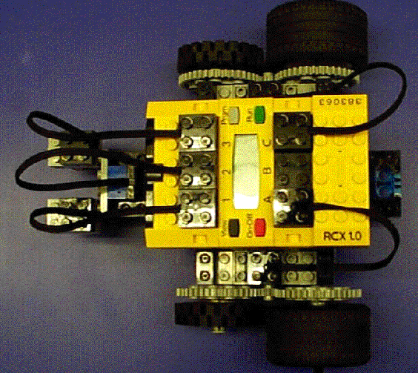
- Left motor = Port A
- Right motor = Port C
- Touch sensors = Ports 1 & 3 (sensors pointing ahead)
- Light sensor Port 2 (sensor pointing towards ground)
Note the orientation of the connection wires. By connecting the wires differently to the output ports, the motors will turn in a different direction. The following diagram shows the settings required to move the robot forward (both arrows pointing up):

Gearing
- Which way does the motor (small gear in center) need to turn to have wheel 2 move forward?
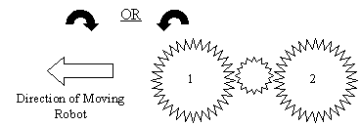
- Do Gears 1 and 2 rotate in the same direction? YES NO

- Would the robot move faster if the diameter of the Gears 1 and 2 were larger? Why or why not?

- Would increasing the diameter of Gears 1 and 2 allow the robot to be able to climb easier over obstacles? Why or why not?

- Would the following gear set-up increase or decrease torque (small gear on left is the motor and the wheel is attached to the large gear on the right)?

Programming
Program 1:
- Write several sentences that explain EXACTLY what the robot does when executing this program. Be sure to include details about relative speed and which direction the robot turns.
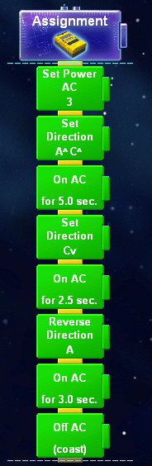
- How else could you program the robot to turn? Is there a way to make the robot turn slower or faster?

Program 2:
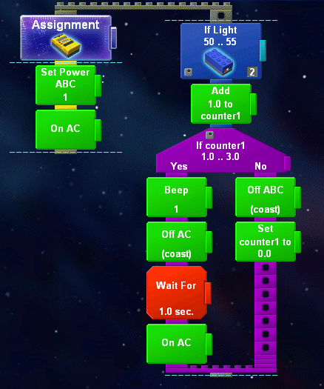

The robot runs on the following track. Note that the light sensor points towards the floor and registers a value between 50-55 when it is directly over a dark line.
Think very carefully before answering the following questions!
- How many times does the robot beep?
- At which line (measured from the left) does the robot stop?

