Scoring equation:

Final score will be awarded based on the following equation. It is intended to make the contest as realistic and as fair as possible. Apologies are made if it reminds you of the federal tax code.
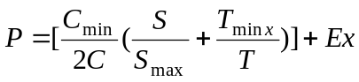 (don’t include the cost in the calculation)
P = Final scores (%)

C = your machine cost (Use the price list given to you in the first day of the project for the erector set components. For retail pricing on materials used in catapult device and others-- any of the following are acceptable: A receipt or A "tear-out" of an ad from a newspaper or magazine, clearly indicating the item price. )
C_{min} = lowest cost machine in your section
T= Total time used in the obstacle course
(excluding playoff)
T_{min} = Shortest time used in the obstacle course by any team in the competition
S = Your score from the course (see Figure below to calculate the score)
S_{max}= Highest score among your section
Master controller
1 ft
1ft
10 pt
25pt

25 pt

25 pt
10 pt
10 pt

- 25 points are awarded to team that can program the robot to stop at the crosswalk
when the “message # 1” signal was received from the master controller and
it proceed after receiving the “message # 2”.

- 25 points are awarded to team that program the robot to stop and back away from the crosswalk when “message # 3: was received from the master controller.

- 25 points are awarded to team that either fight off the unfriendly robot or stop the robotic wheelchair from moving forward.

- 10 points each are awarded to team that either go over a 3” ramp, ¼” steps or sand pit

* For retail pricing -- any of the following are acceptable:
- A receipt
- A "tear-out" of an ad from a newspaper or magazine, clearly indicating the item price.

Ex = extra credit for ingenious design

RANKING:
1. The competitor with the best score win the competition and to be awarded the top prize of $100 in cash!!!!!!!!!!!.
2. The WINNER's score will also get the maximum 20%.
3. The scores of all other teams will be calculated on the basis of the winner's score.

Price List

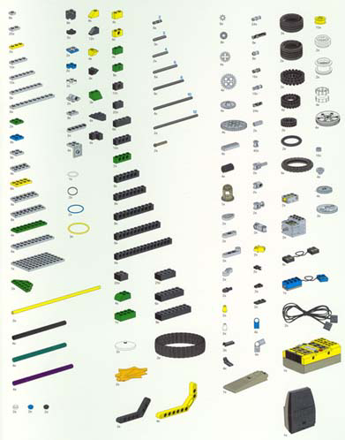
Wheels and belts- 50 cents each
Tires – 60 cents each
Others (beams, plates, axles, shafts, connector pegs, cones, steering wheels, rubber band, wires)– 15 cents each
Gears- 40 cents each
Motors - $3.00 each
Touch sensors- $1.50 each
Light sensor – $3.00 each

- For retail pricing on materials used other than in the kits-- any of the following are acceptable:
- A receipt
- A "tear-out" of an ad from a newspaper or magazine, clearly indicating the item price. )

 | 1w | 2w | 3w | 4w | 5w | 6w | 7w
Trail 1 | 2c,3c  4d,5d * | 3c,4c  5d,6d | 4c,5c  6d,7d | 5c,6c  7d,1d | 6c,7c  1d,2d | 7c,1c  2d,3d | 1c,2c  3d,4d
Trial 2 | 4c,5c  6d,7d | 5c,6c  7d,1d | 6c,7c  1d,2d | 7c,1c  2d,3d | 1c,2c  3d,4d | 2c,3c  4d,5d | 3c,4c  5d,6d
Competition Schedule:

Each team is given two chances to cross the obstacle course as a wheelchair, and four times as a car and four times as a defender. You can score either as a wheelchair, car or defender. Please refer to the scoring equation for details.

The following table shows the schedule of the competition:

w = wheelchair
c = car
d = defender

* For example, when group #1 is a wheelchair in the first trial, the robotics of group #2 and #3 are cars and the robotics of group #4 and #5 are defenders

SCORE CARD

Team # :

Wheelchair | Ramp 10 pts | Turn 25 pts | Robots 25 pts | Steps 10 pts | Sand 10 pts | Crosswalk  25 pts | Total pts | Time  (s) | Comments
Round 1

Round 2*

Car (25 pts)

Defender (25 pts)

Total Cost: Extra Credit:

Final Score =

Team # :

Wheelchair | Ramp 10 pts | Turn 25 pts | Robots 25 pts | Steps 10 pts | Sand 10 pts | Crosswalk  25 pts | Total pts | Time  (s) | Comments
Round 1

Round 2*

Car (25 pts)

Defender (25 pts)

Total Cost: Extra Credit:

Final Score =

