ENGR100
Rube Goldberg Machine Contest

Background
Rube Goldberg spent 55 years drawing cartoons of machines and contraptions. His cartoons depicted simple household items, connected in funny but logical ways to perform a simple task. For instance, his cartoon invention of an automatic garage door opener used a bathtub, a flower, a bumblebee and an athlete. He had an extraordinary style and worked over 30 hours on each invention cartoon. The result was always another magnificent work of fine lines and great attention to detail.
Rube Goldberg believed that most people preferred doing things the hard way instead of using a more simple and direct path to accomplish a goal. In the words of the inventor, the machines were a "symbol of man's capacity for exerting maximum effort to achieve minimal results." His drawings became so well known that Webster's Dictionary defined the term rube goldberg as "accomplishing by extremely complex, roundabout means what seemingly could be done simply."
Inspired by cartoonist Rube Goldberg, students will compete to design a machine that uses the most complex process to complete a simple task - put a stamp on an envelope, screw in a light bulb, make a cup of coffee - in 8 or more steps.

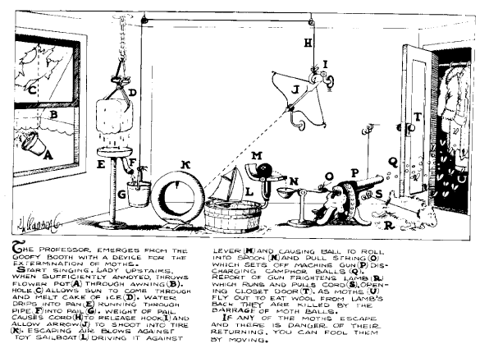
A Simple Moth Killing Machine

Problem Definition
To construct in the true Rube Goldberg style a complicated contraption which will in effect accomplish a very simple task. For example A simple Moth killing machine as shown in Figure above.
Educational Goals
- To show simple design is the key in good engineering design
- To show a single system composed of several interacting parts that contribute to the basic function, and where the removal of any one of the parts causes the system to cease functioning.
- To demonstrate that design processes involve a multitude of skills and knowledge from many subject areas
- To allow students to experience the perilous designer/builder intreface
References
Book: Rube Goldberg by Maynard Frank Wolfe
Eamples of machine design:
http://www.y3k.com/rube.html
http://www.larenstein.nl/goldberg/tweede%20wedstrijd.html
http://www.rube-goldberg.com/html/gallery.htm
http://www.uns.purdue.edu/UNS/rube/rube.index.html (best one, the original rube Goldberg competition in Purdue)

Procedure
1. Chose a purpose for your machine. Use websites books or your own imagination to create a purpose for your machine.
2. Design and illustrate your design of a Rube Goldberg Machine on a full size poster
Title should be short and bold.
Steps should be clearly labeled with numbers or letters
3. Write the steps on a separate sheet of paper and tape it to the back of the poster.
4. Describes machines that are required in the design. Different kinds of pulleys, levers, etc.
5. Using more than one form of energy will enhance the creative nature of the cartoon.
6. A presentation will be made to the class:
Explain all steps.
Identify all simple machines.
Identify all forms of energy.
7. Final Report describing the design process and details of the design.
8. The grade will be based upon clarity, creativity, completeness of the final report (20%), oral presentation (10%), poster (30%) and the result from the competition (40%).

TIPS
1. Plan your machine on paper first. Use your imagination!
2. Start with one to two steps first - don't get carried away! Begin with the last step - what you're required to do, and work backwards.
3. From the garage, junk drawer, or your desk, gather the essentials: string, balls of different sizes, tape, empty cardboard tubes, more cut up cardboard from pizza boxes, any junk. Sit down and roll the ball around. Play with the stuff! See what it can knock over or make happen.
4. For some fun, use a mousetrap. Don't use rat traps - you can break the bones in your hand!
5. Don't use fire - too dangerous.
6. Brainstorm - don't worry if an idea seems crazy - just write it down for now. The idea is to look at things in a new way. Can the ball knock down something else, or land on something, or pull something? Use your brain!
7. As someone once said "Gravity is your friend". Use it!
8. More things to gather: wire, empty thread spools or pulleys, old toys, small wheels.
9. If there is time later, make your machine sturdy from wood, nails, etc.
10. Your machine may only "run" for 5 seconds, but plan on testing each step over and over, before you continue.
11. Remember what your science teacher taught you about simple machines: levers, inclined planes, wheels...
12. Thought for the day: It's better to have a few steps that work well, then 8 steps that don't work at all!

Competition Guideline

The objective is to build a true Rube Goldberg style a complicated contraption which will in effect accomplish a very simple task.

Team

The team will consists of three or four members. Each member is responsible for a part of the design and construction. Great emphasis will be place on teamwork. Evaluation of contribution from each team member will play a big part in the team’s final grade.

Ground Rules
- SAFETY IS THE TOP PRIORITY! The entry shall not include any device that might endanger the entrants, spectators, or judges. Entries deemed unsafe by the judges will be disqualified
- The Device shall not make use of ANY animal.
- The Device must include three (3) of the following elements: a wheel and axle; a lever; a pulley; an inclined plane; a process which converts potential energy to kinetic energy; a gear system; a funnel or trough or tube with marbles.
- The Device must include fully descriptive labels for each of the elements in Rule 3, which are incorporated in the design.
- The Device, including any non-connected subassemblies, must fit in an area 1.5 meters by 1.5 meters on the floor, or fit on the top of a card table (which you provide). In no instance is the Device (or the Device and table) to exceed two meters in height.
- The Device will not incorporate the use of any flammable or corrosive substances, liquids in excess of 2 liters, falling weights in excess of five kilograms, or electrical components powered by ANYTHING OTHER than a 9-volt battery.
- Any destructive action against another machine is grounds for disqualification.
- Each entry will be allowed three trials, so Devices should be designed to allow for quick resetting.
- Any entry judged to be the work of individuals other than those entered in the contest (or their peers in the case of group entries) will be disqualified.
- The decision of the judges in the competition will be final.
- Students must set up and start their contraption within 20 minutes.
- Students are penalized 5 pts. each time they help their projects.
- The student's grade will be determined by the best of three trials.
- A CHANGE is counted every time the action moves from one type of thing to another. For example, a marble rolling down a ramp and striking a domino would be recorded as one change. A domino striking another domino is not a change, but still may be useful.
- Similar changes like the marble striking a domino may only be repeated once in a project.
- There are no limitations on the type of materials to be used. There is no maximum number of steps.
- The contraption MUST do something useful like break a balloon, turn on/off a light etc.
- Any loose or flying objects must remain within the set boundaries of the machine. This includes, but is not limited to, drops of water, slivers of balloon, and other “small” objects. Steam and other gasses are exempt from this ru
- The MOUSETRAP game is a good example of a Rube Goldberg contraption.

Judging Criteria
Demonstration will be graded base on the best of the three trials:
- Judging will be based on a 100 point scale broken down into the following categories:
  - General Impressions (35 points)
    - Theme (0 to 10 points)
    - Rube Goldberg Spirit (0 to 10 points)
    - Explanation / Description (0 to 5 points)
    - Team Chemistry (0 to 5 points)
    - Submitted Machine Description (0 or 5 points)
  - Timing Issues (0 points)
    - Description Length (-5 to 0 points)
    - First Run Length (-10 to 0 points)
    - Second Run Length (-10 to 0 points)
  - Run Related (65 points)
    - Completed Task – Run One (0, 10, or 20 points)
    - Completed Task – Run Two (0, 10, or 20 points)
    - Flow of machine easily followed (0 to 10 points)
    - Rube Goldberg Style Steps (0 to 15 points)
    - Human Interventions (-5 points each)
    - Objects Leaving Machine (-5 points each)
  - Number of changes in contraption (extra credit points)
10 pt. = 7 changes or more; 5pt. = 5 changes; 0 pt. = less than 3 changes.
A short set-up time will be given and three trials will be allowed if needed.

Assignment
RUBE GOLDBERG MACHINE
A Team Building Project
Students will work in teams of 3 to 4 to design, construct, and test a series of simple machines which act in a chain reaction to accomplish a simple task of the student's choice.
REQUIRED: Minimum of eight steps (A student will start the sequence of events but that does not count as a step.) Machines to include lever, inclined plane, wedge, and pulley
WILL IMPROVE GRADE: Using electrical and/or chemical energy. Including a wheel and axle, screw, and/or a second class lever.
Purchased simple machines may not be used except for wedges and pulleys. Hand made pulleys are preferred.
MAXIMUM SIZE: Length – 1.5 meters; Width – 1.5 meters. Base may be longer if width is reduced to achieve the same surface area.
MAKE A POSTER with the machine's purpose as a title and include an illustrated set of the steps.
GRADES:
Final Report describing the design process and details of the design (20%)
Presentation of Rube Goldberg Machine to class including oral presentation (10%), poster (30%), and demonstration (40%).
Demonstration will be graded base on the best result from the three trials. For more details, please refer to the Judging Criteria section.
DUE DATE: Fourth week Friday (demo at class)

Judging Criteria
Demonstration will be graded base on the best result from the three trials:
- Judging will be based on a 100 point scale broken down into the following categories:
  - General Impressions (35 points)
    - Theme (0 to 10 points)
    - Rube Goldberg Spirit (0 to 10 points)
    - Explanation / Description (0 to 5 points)
    - Team Chemistry (0 to 5 points)
    - Submitted Machine Description (0 or 5 points)
  - Timing Issues (0 points)
    - Description Length (-5 to 0 points)
    - First Run Length (-10 to 0 points)
    - Second Run Length (-10 to 0 points)
  - Run Related (65 points)
    - Completed Task – Run One (0, 10, or 20 points)
    - Completed Task – Run Two (0, 10, or 20 points)
    - Flow of machine easily followed (0 to 10 points)
    - Rube Goldberg Style Steps (0 to 15 points)
    - Human Interventions (-5 points each)
    - Objects Leaving Machine (-5 points each)
  - Number of changes in contraption (extra credit points)
10 pt. = 7 changes or more; 5pt. = 5 changes; 0 pt. = less than 3 changes.
A short set-up time will be given and three trials will be allowed if needed.

Poster Assignment (30%)
Objective:
Design and illustrate your design of a Rube Goldberg Machine on a full size poster.
1.Title should be short and bold.
2.Steps should be clearly labeled with numbers or letters
3. Write the steps on a separate sheet of paper and tape it to the back of the poster.
4. Describes machines that are required in the design. Different kinds of pulleys, levers, etc.
5. Make a drawing of a Rube Goldberg device of your own creation which includes labeling the types of energy and different energy conversions involves in the process.
*
energies - these should be clearly labeled and numbered in blue next to where the energy occurs in the drawing.
* | different energy changes - arrows should be drawn connecting each energy in the drawing to the next in red to show how one type of energy is changing into another.

Notes: Not all energies will be connected with arrows since not all energies will be directly changing from one form to another. Some energies will not change into another, but cause an energy from another source to be started. Remember the example of the broken energy chain.
Oral presentation (10%)
Oral presentation will be made to the class:
Explain all steps.
Identify all simple machines.
Identify all forms of energy and energy conversions.
Final Report (20%)
Final Report describing the design process and details of the design. Please follow the final project report format.

Rube Goldberg Contest Hints #1
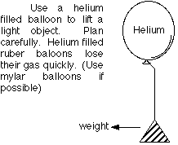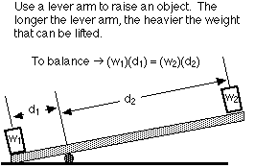
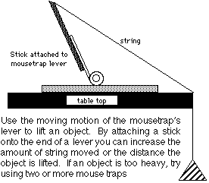
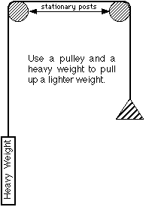

RUBE GOLDBERG HINTS #2
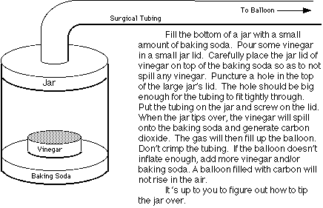
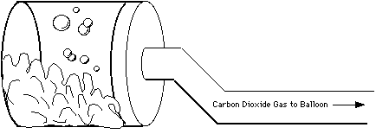

RUBE GOLDBERG HINTS #3
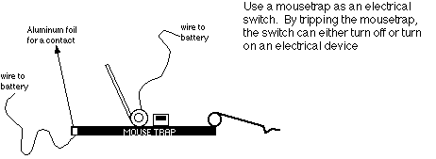
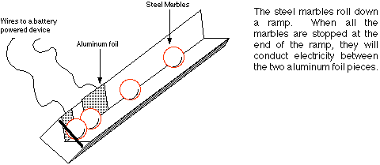
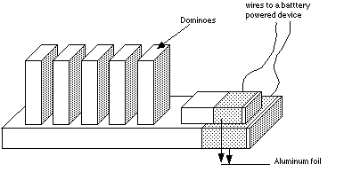

Examples of Rube Goldberg’s idea for simple task

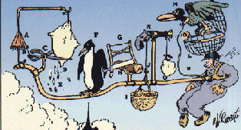
Rube Goldberg TM & © of Rube Goldberg, Inc.
Rube Goldberg's idea for a simple parachute.
As aviator jumps from plane, force of wind opens umbrella (A) which pulls cord (B) and closes shears (C), cutting off corner of feather pillow (D). As white feathers (E) fly from pillow, penguin (F) mistakes them for snow flakes and flaps his wings for joy which draws buck-saw (G) back and forth cutting log of wood (H). As piece of wood falls into basket (I), its weight causes rope (J) to pull trigger of gun (K) which explodes and shoots lock from cage (L), realizing giant Umpha Bird (M) which flies and keeps aviator afloat with rope (N). Aviator breaks paper bag of corn (O), causing corn to fall to ground when bird swoops down to eat corn. Flier unhooks apparatus and walks home. The biggest problem is where to get the Umpha Bird. Write your Congressman.

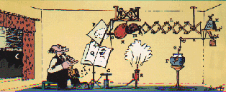
Rube Goldberg TM & © of Rube Goldberg, Inc.
At Last! The great brain of Rube Goldberg gives the world a simple automatic sheet music turner!
Press left foot (A) on pedal (B) which pulls down handle (C) on tire pump (D) pressure of air blows whistle (E). Goldfish (F) believes this is dinner signal and starts feeding on worm (G). The pull string (H) releases brace (I), dropping shelf (J), leaving weight (K) without support. Naturally, hat rack (L) is suddenly extended and boxing glove (M) hits punching bag (N) which, in turn, is punctured by spike (O). Escaping air blows against sail (P) which is attached to page of music (Q), which turns gently and makes way for the next outburst of sweet or sour melody.

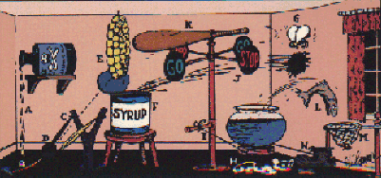
Rube Goldberg TM & © of Rube Goldberg, Inc.
Rube Goldberg's idea for his latest simple fly swatter.
Carbolic acid (A) drips on a string (B) causing it to break and release elastic of bean shooter (C) which projects ball (D) into bunch of garlic (E) causing it to fall into syrup can (F) and splash syrup violently against side wall. Fly (G) buzzes with glee and goes for syrup, his favorite dish. Butler-dog (H) mistakes hum of fly's wings for door buzzer and runs to meet visitor, pulling rope (I) which turns stop-go signal (J) and causes baseball bat (K) to sock fly who falls to floor unconscious. As fly drops to floor, pet trout (L) jumps for him, misses, and lands in net (M). Weight of fish forces shoe (N) down on fallen fly and puts him out of the running for all time. If fish catches the fly, the shoe can be used for cracking nuts.
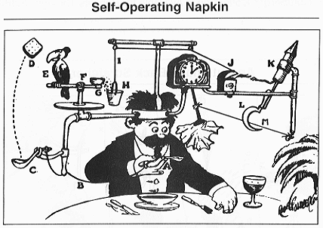
The Self-Operating Napkin: As you raise spoon of soup (A) to your mouth it pulls string (B), thereby jerking ladle (C) which throws cracker (D) past parrot (E). Parrot jumps after cracker and perch (F) tilts, upsetting seeds (G) into pail (H). Extra weight in pail pulls cord (I), which opens and lights automatic cigar lighter (J), setting off sky-rocket (K) which causes sickle (L) to cut string (M) and allow pendulum with attached napkin to swing back and forth thereby wiping off your chin.
Rube Goldberg TM & © of Rube Goldberg, Inc.

Below is one of our favorite cartoons created by Rube Goldberg. Try to figure out what it does!
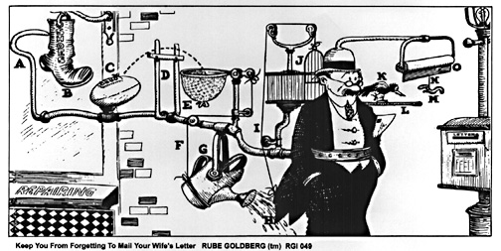
Device to Keep You from Forgetting to Mail Your Wife's Letter
It starts as you are walking down the street, with your contraption around your waist. As you near the mailbox, the boot from the shoemaker's shop gets caught on your hook. It ends when a sign is pulled down in front of you, with the reminder, "You sap. Mail that letter." Don't leave home without one.

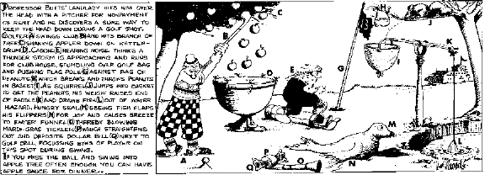
Was Goldberg a genius? Or was he just stretching things a little bit?

Maybe his barbs were pointed at today's world! Look at this 1916 cartoon, drawn years before talking movies, let alone camcorders:
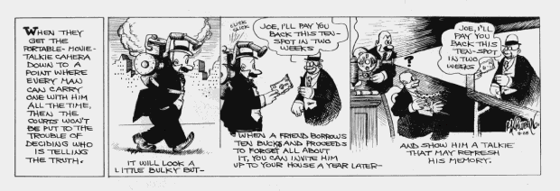

Rube Goldberg Biography

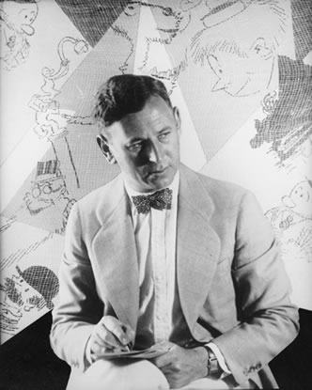
Rube Goldberg (1883-1970) was a Pulitzer Prize winning cartoonist, sculptor, and author.
Reuben Lucius Goldberg (Rube Goldberg) was born in San Francisco. His father, a practical man, insisted he go to college to become an engineer. After graduating from University of California at Berkeley, Rube went to work as an engineer with the City of San Francisco Water and Sewers Department.
He continued drawing, and after six months convinced his father that he had to work as an artist. He soon got a job as an office boy in the sports department of a San Francisco newspaper. He kept submitting drawings and cartoons to his editor, until he was published. An outstanding success, he moved from San Francisco to New York drawing daily cartoons for the Evening Mail. A founding member of the National Cartoonist Society, a political cartoonist and a Pulitzer Prize winner, Rube was a beloved national figure as well as an often-quoted radio and television personality during his sixty-year professional career.
Through his 'INVENTIONS', Rube Goldberg showed difficult ways to achieve easy results. His cartoons were, (as he said), symbols of man's capacity for exerting maximum effort to accomplish minimal results. Rube believed that there were two ways to do things: the simple way and the hard way, and that a surprisingly number of people preferred doing things the hard way.
Rube Goldberg's work will endure because he gave priority to simple human needs and treasured basic human values. He was sometimes skeptical about technology, which contributed to making his own mechanical inventions primitive and full of human, plant and animal parts. While most machines work to make difficult tasks simple, his inventions made simple tasks amazingly complex. Dozens of arms, wheels, gears, handles, cups, and rods were put in motion by balls, canary cages, pails, boots, bathtubs, paddles, and even live animals for simple tasks like squeezing an orange for juice or closing a window in case it should start to rain before one gets home.
Rube's drawings depict absurdly-connected machines functioning in extremely complex and roundabout ways to produce a simple end result; because of this RUBE GOLDBERG has become associated with any convoluted system of achieving a basic task.
Rube's inventions are a unique commentary on life's complexities. They provide a humorous diversion into the absurd that lampoons the wonders of technology. Rube's hilarious send-ups of man's ingenuity strike a deep and lasting chord with today's audience through caught in a high-tech revolution are still seeking simplicity.
Hardly a day goes by without The New York Times, National Public Radio, The Wall Street Journal or some other major media invoking the name Rube Goldberg to describe a wildly complex program, system or set of rules such as our "Rube Goldberg-like tax system". The annual National Rube Goldberg Machine Contest at Purdue University as well as the increasing number of state-wide high school contests, which are covered widely by the national media, brings Rube's comic inventions to life for millions of fans.
The work of Rube Goldberg continues to connect with both an adult audience well versed in the promise and pitfalls of modern technology (can anyone over 40 program their VCR?) as well as younger fans intrigued by the creativity and possibility of invention.

(taken from http://www.rubegoldberg.com/html/bio.htm)

Energy Types

Exercise 1: Find The 10 Basic Types of Energy
Group any types, sources, or associated words that seem to refer to the same type of energy. You can do this using colored pencils, or by making lists of each set of words that seem to be a given type of energy. Try to get all of the words into 10 categories, one for each basic type of energy.
For example, gasoline and charcoal are both examples of chemical energy.

nuclear
chemical
gasoline
electricity
batteries
fusion
oil
mechanical
pistons in a car engine
kinetic
potential
natural gas
steam
ball held above the ground
food
light
microwaves
hydro
fission
spring
thermal
sound
x-rays
heat
uranium
magnetic
wind
planetary poles
hot water
gun powder
wound up spring toy
static cling
ball in motion
heavy water
hydro
solar
ultraviolet rays
turning drill bit
lightning
wood
stretched bungee cord
star light
heat lamp
streetched rubber band
charcoal
heavy water
compass

Energy Types

In assignment 1, you tried to place the types, sources, and words associated with energy into 10 basic categories or types of energy. Since energy comes in so many forms and, as we will see, is also constantly changing from one form into another, selecting a perfect set of 10 basic types is not easy. Below are one possible set of 10 basic types of energy and the words from the list of assignment 1 that go with each type. You may have come up with your own perfectly reasonable set of 10 basic types that are somewhat different than the 10 listed below.
The 10 Types of Energy
Kinetic energy is energy of motion - the energy is contained in the movement of the object or movement inside of the object. Potential energy is stored energy, energy that can be kept for use at a later time.

Type of Energy
Examples or Sources | KE= Kinetic  PE= Potential
Kinetic Energy | kinetic  sound  wind  turning drill bit | KE
Gravitational Energy | ball held above the ground  hydro | PE
Spring | spring  stretched rubber band  wound up spring toy  stretched bungee cord | PE
Electrical | electricity  static cling  lightning | KE
Magnetic | magnetic  planetary poles  compass | PE
Mechanical | mechanical  pistons in a car engine | KE
Heat | heat  thermal  hot water  steam | KE
Nuclear | nuclear  fission  fusion  heavy water  uranium | PE
Light | light  microwaves  x-rays  solar  ultraviolet rays | KE
Chemical | chemical  gasoline  batteries  oil  natural gas  food  gunpowder  wood  charcoal | PE

Energy Changes
As we have said, energy is constantly changing from one type into another. This is happening all around us and throughout the universe.

Examples of Changes
Many of the most obvious examples of energy changing from one type into another occurs in our homes. A number of examples are illustrated below. In each example energy starts as one type (energy in) and changes into another type (energy out). In some cases the energy might actually change into more than one type before the final energy out. In those situations, ignore the energy changes in the middle. Try to identify when this is happening and check your guesses with the information given after the examples.

 | Example Description | Energy In | Energy Out
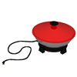 | Electric Wok | Electrical | Heat
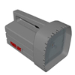 | Flashlight | Chemical  (in the batteries) | Light
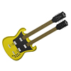 | Guitar String  ( being plucked) | Mechanical | KE  (sound)
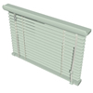 | Blinds  (being opened) | Mechanical | Gravitational
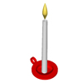 | Burning Candle | Chemical  (wax) | Light
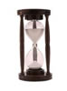 | Sand Clock | Gravitational | Kinetic
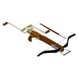 | Arrow Shot From Crossbow | Spring | Kinetic
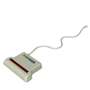 | Hand Scanner | Light | Electrical
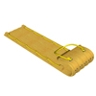 | A Toboggan  Going Downhill | Gravitational | Kinetic
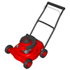 | Gasoline Powered Lawnmower | Chemical | Mechanical
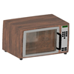 | Microwave Oven | Light | Heat
Notes: The one example where there was an obvious energy change in the "middle" was the flashlight. Chemical energy from the chemicals inside the batteries first changed into electrical energy before finally being changed into light energy.

Energy Changes
You have seen a number of examples of energy changes. Let's see if you can identify some energy changes on your own.

Fill In Exercise
There are 10 examples of energy changes below. Type in or print and fill in what you think the energy in and energy out will be for each example. Then check your answers against the answers given below.

 |  | Example Description | Energy In | Energy Out
1 | 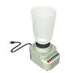 | Blender |  | .
2 | 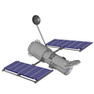 | Solar Panel Powered Communications Satellite | . | .
3 | 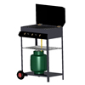 | Gas Powered Grill | . | .
4 | 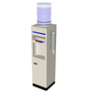 | Water Dispenser | . | .
5 | 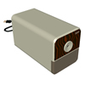 | Electric Pencil Sharpener | . | .
6 | 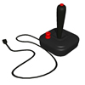 | Game Controller | . | .
7 | 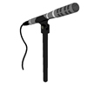 | Microphone | . | .
8 | 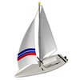 | Sail Boat | . | .
9 | 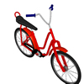 | Bike | . | .
10 | 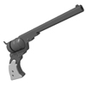 | Pistol | . | .
Top of Form

Bottom of Form

Energy Changes
Not only can energy change from one type into another, energy can even change into several other types at the same time. Sometimes it may seem that energy is being changed from one form into another, but the first energy is only causing another source of energy to be turned on. This can cause some confusion when energy changes types over and over again in what we might call energy "chains."

Energy Chains
Below there are several examples. The first few illustrate how energy might change into two types of energy. The second illustrates an energy chain or a continuous changing of energy. And the third illustrates an energy chain that is broken, the energy does not continue to change but causes another energy to be turned on. Make sure you understand these examples before continuing.

Energy Changing into Several Types
 | Example Description | Energy In | Energies Out
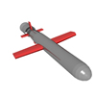 | Cruise Missile Gaining Altitude | Chemical | Gravitational  +  Kinetic
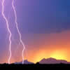 | Lightning | Electrical | Heat  +  Light  +  Sound
Energy Chains
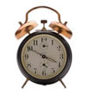 | Wind Up Alarm Clock Ringing
  Spring |  | Mechanical |  | Kinetic  (Sound)
Note: Sometimes it is hard to tell whether the energy is changing into two forms simultaneously or sequentially. In this case the spring is making the parts of the bell move which then hit to make the sound.
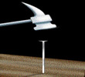 | A Hammer Hitting a Nail
  Kinetic |  | Kinetic |  | Heat
Note: In this example the moving hammer drives the nail into the wood giving it initially kinetic energy. But after the nail is driven into the wood, the nail stops. Where did the kinetic energy go? The kinetic energy goes into heat. Many energy changes are accompanied by part of the original energy turning into heat, and when the energy seems to disappear, it often has gone into heat energy. This "loss" of energy into heat will be important later when we see how the "lives" of energy are used up.
Broken Energy Chain
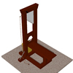 | A Person Pulls a Cord of a Guillotine  (to chop a cabbage)
Chemical |  | Mechanical |  | Mechanical |  | Gravitational |  | Kinetic

Note: The person's chemical energy (from food) allowed the movement of a hand, or mechanical energy, to move the cord, mechanical energy. This is the end of the chain. The cord pull allowed the energy already stored in the guillotine blade, or gravitational energy, to turn into kinetic energy. The gravitational energy was already stored and did not come from the mechanical energy of the moving cord.

Energy Generation

To generate energy, we must have some source to generate energy from. While energy is everywhere, only certain sources can be efficiently used.

Energy Sources
Following is a table of the most common sources of energy that are available to us today. These sources have been categorized into the 10 types of energy.
Chemical | Wood  Coal  Oil  Natural Gas  Hydrogen (Fuel Cells) | Occasionally Used  Extensively Used  Extensively Used  Extensively Used  Being Developed | Power Plant  Power Plant  Home Heating | PE
Gravitational | Hydro | Extensively Used | Power Plant | PE
Nuclear | Uranium (Fission)  Heavy Water (Fusion) | Extensively Used  Being Developed | Power Plant | PE
Kinetic | Wind | Alternative | Power Plant | KE
Light | Solar | Alternative | Power Plant | KE
Heat | Geothermal | Alternative |  | KE
As you can see, useful sources have not been found for all 10 types of energy. Some sources are used a lot in our modern world, while others are still being developed.
Fuel cells and fusion are being researched for future use, while wind, solar, and geothermal have been around for years but have not been cheap enough to be used extensively. These available but not yet competitive sources (like solar) are often called alternative energy sources.
Note that the potential energy sources can be stored for future use. Oil from your home storage tank can sit for years until it is needed. The kinetic energy sources must be used as they are available since they cannot be stored. Once the sunshine or solar energy hits the ground, it no longer can be collected by a solar panel.
Also, some of these sources tend to be used to produce energy (or power - more on this later) in large power plants that produce electrical energy. While electrical energy is kinetic and cannot be stored, it can be easily distributed long distances to where it is needed, to industrial plants or to your home.
Example of a Rube Goldberg Machine
1) A golf ball is placed into the mouth of a tube in the corner of the machine at a height of one foot.
2) The ball rolls down the tube and hits a seesaw.
3) The Ball is then stopped by a wall.
4) When hit, the seesaw completes a circuit, which activates a motor.
5) This motor pulls up on an attached string, thereby opening the cover to a pack of playing cards which is attached to the other end of the string.
6) The case is suspended at a steep angle, so as the cover is lifted, the cards fall out.
7) The cards fall into a container that is on the raised end of a seesaw.
8) When the cards fall into the container, the opposite end of the seesaw is forced up, thereby completing a circuit which turns on a motor.
9) This motor pulls up a cardboard tube as well as the wall that has held the ball in place until now, allowing the ball to continue.
10) The ball rolls down this tube and then enters a small container attached to a hinge.
11) The momentum from the ball entering the container forces the container to fall.
12) As the container falls, it causes a row of dominoes to fall.
13) The container then delivers the ball into the carriage of an elevator.
14) Meanwhile, as the last domino falls, it completes a circuit, thereby turning on a motor.
15) This motor reels up the elevator.
16) As the elevator approaches the top of the machine, it makes contact with a horizontal bar.
17) Due to the arrangement of the elevator and the horizontal bar, the elevator is forced to tilt.
18) As the elevator tilts, the ball rolls out.
19) The ball then falls into an "L" shaped series of tubes.
20) The momentum from the ball falling into these tubes turns off a "master switch," thereby cutting the power to the three motors used to this point in the machine. This was done to conserve the battery's energy.
21) When the ball approaches the end of the tubes, it falls down. The momentum from this fall lowers the platform it falls into. This ball is now "dead" and is not used again in the machine
22) As the platform is lowered, a switched is turned on.
23) This switch activates a robot. The robot begins ‘walking’ along a fourteen inch cardboard platform.
24) As the robot is forced to fall when it reaches the end of the road.
25) When the robot falls off, a string attached to the robot turns on the switch which is attached to the other end of the string.
26) This switch activates an electric car. There is a ball at rest on the top of the car.
27) The car travels 2 feet and then hits a wall. The wires attached to the car are now pulled between the car and a switch located in the beginning of the car's "track." The wires turn off a "master switch," thereby cutting the power to the robot and the car. This was done to conserve the batteries’ energy.
28) The momentum gained from hitting the wall causes the ball to fall out of the car.
29) The ball falls into a track seventeen inches long.
30) When the track ends and the ball falls down.
31) One inch into its fall, the ball hits a small stick which is attached to a hinge, thereby pushing the stick down.
32) Two and a half inches later, the ball is stopped from falling by another stick which is resting on the entrance to the ball's next track.
33) As the first stick is pushed away, a tube attached to the stick is let loose, and falls vertically down the machine along two attached guide wires.
34) When the tube hits the bottom of the machine, it completes a circuit, thereby turning on a motor.
35) This motor pulls away the stick which restricted the balls movement.
36) The ball continues down a series of tubes which eventually come to an end, thereby causing the ball to fall.
37) As the ball begins to fall it activates a mouse trap
38) The ball falls eleven inches and then enters a container. This ball is now ‘dead’.
39) The momentum from this drop causes the container which is on the raised end of a seesaw to be lowered.
40) As the container is lowered, a string attached to the other side of the seesaw is pulled which turns on a switch attached to the other end of the string.
41) This switch activates a blue-light which reveals a message that was previously hidden. The message is written in Clorox, which "glows" when blue-light is shined on it.
42) Meanwhile, attached to the arm of the mouse trap is a string. The other end of the string is attached to a nail that is supporting a 1kg weight on top of a pole.
43) As the nail is pulled away by the mousetrap being activated, the weight drops down the pole.
44) The weight lands on the raised end of a seesaw. On the other end is a golf ball.
45) As the weight strikes the seesaw, the ball is flung into the air.
46) The ball lands in a series of tubes.
47) These tubes eventually lead the ball to the conclusion of the machine, at a height of one foot.


