Forest Upper Canopy Assessment

Objectives:
1) To gain experience measuring tree attributes, e.g., DBH, Tot. Height, Crown Ht;
2) Relocate a Permanent Sample Point (PSP), often used in monitoring programs;
3) Establish a Temporary Sample Point (TSP) and measure trees there;
4) To gain familiarity with variability / reliability of overstory measurement data and the magnitude of possible measurement errors.

FIELD WORK
Equipment:
Hand compass, 100-ft cloth tape, DBH-tape, clinometer, calculator, write-in-the-rain notebook & handout materials
Procedure:
Each measurement team will relocate one Permanent Sample Point (PSP) and establish one Temporary Sample Point (TSP) and measure the trees at those points. The PSP acts as the center of two plots, one large, one small. Large plots are circular (37.2-ft horizontal radius) and 0.1-acre in size; its paired small plot is 0.025-acre and circular (18.6 ft horizontal radius). Large trees are 5.0” DBH at the PSP have been tagged with numbered aluminum tags. Small trees (DBH < 5.0”) have not been tagged (see FIG. 1). After measuring the large- and the small-tree PSP plots, teams will then establish their TSP (large & small plot pair) a distance of 1.5 chains from the PSP center and away from the access trail.
Once in the forest, at the PSP location do the following:
- Record average slope and aspect of the plot. Observe the area, making general notes of what tree species are present and any interesting stand features and other canopy features, such as condition of tree crowns, forest health issues, etc. Record any other features of the area or the landscape that seem interesting and / or relevant to the objectives of the exercise or a potential Forest Stewardship / Management Plan.
- Measure and record species, status (live or dead), and DBH for every large tree or snag (DBH 5.0”) standing in the 0.1-acre plot. Note any damage to live trees - for example, indicate presence of forks, crooks, scars, conks, etc., and approximate height of the damage (ocular, i.e. “eyeball” estimate OK).
- Select two (2) live trees for total height and crown height measurement using the random azimuth method: while spinning the compass dial, ‘randomly’ stop it, choose the tree nearest to that azimuth (or ‘clockwise’ from it, if no tree is intersected exactly on that azimuth). For each selected tree, measure and record percent inclination to the top and base of the tree, percent inclination to live crown base, and any “add-on,” and finally observer distance to the tree, and slope angle of measurement tape. Ocularly estimate height for all snags.
- Measure the total height of a dominant, undamaged Douglas-fir tree for the purpose of estimating site index later. If no such “site” tree exists on the plot, travel up to 1-ch off the plot to obtain it. For small trees (height > 10’ and DBH < 5”) within the small plot, measure and record species, status, and DBH. Measure the height of a single tree, chosen at random (using the ‘random azimuth’ method) from trees enumerated.
Use the ‘random azimuth’ method for direction to your TSP, move there, establish center. Then:
- Repeat steps (1) and (2) above.
- Select a single tree for height measurement using the ‘random azimuth’ method, described above in step (3). Estimate ocularly the height of all snags.
- Repeat step (4) above.

OFFICE WORK
This will be a team report. Using just your own team’s data, work up your live-tree data according to the handout entitled “Fixed-Area Plot Summary, and Beyond – Upper Canopy Module.” Use your results to produce a report including the following information:

1. Calculate mean DBH and Height:DBH ratio, R, for each plot.

2. Calculate basal area for each tree on each plot.

3. Estimate basal area per acre and trees per acre that each plot represents.

4. Estimate stand mean DBH, stand mean height, mean basal area per acre and mean trees per acre.

5. Estimate 70% Confidence Intervals for number of trees per acre and basal area per acre.

6. Calculate average species composition on a basal area basis.

7. From the average breast-height age given in class and total tree height of your site tree, estimate the site index for your forest stand.

8. Use an appropriate sample size formula to calculate how many sample plots would be needed to estimate the mean basal area per acre to within +/- 5% of true population mean per acre with 90% confidence. To do this, first compute a Coefficient of Variation (CV) for per acre basal area for the stand you were in using the derived per acre basal areas you computed.

9. [EXTRA CREDIT] Use the stand map (Fig. 3) to calculate the area of the stand your team measured using the “dot grid” method.

Submit a single report for your group to the CollectIt dropbox, i.e., one (1) report per team, Word™ doc format preferred. Also, submit your group data in spreadsheet format (Excel™ format preferred) along with your report. Your report should consist of two parts: 1) Executive Summary page, and 2) Appendix. Your Executive Summary should include a general description of your stand area, a description of weather conditions the day of fieldwork, AND responses to all OFFICE WORK items, preferably in prosaic form – it should NOT contain detailed information from each plot you measured – i.e., NO RAW DATA. Your appendix should include either your original field notes or a photocopy thereof and one example calculation (including actually computed numbers, not just formulas) for each of the derived quantities in items 1 – 8.

FIGURE 1.

Large Tree measurement plot
- 0.1 acre plot ➔ 37.2 foot radius
- white PVC pipe at plot center; plot number written on it w/ indelible ink
- all trees within the plot have aluminum tags
- first tree on plot marked with pink flagging

Small Tree measurement plot
- 0.025 acre plot ➔ 18.6 foot radius
- same plot center as large plot
- trees are not tagged
- perimeter is not marked

FIGURE 2.
Measuring Tree Height
O
T
D
B
Tree Height = TD + DB.
TD/OD = tan(TOD), therefore, TD = OD x tan(TOD)
DB/OD = – tan(DOB), therefore, DB = – OD x tan(DOB),
TD + DB = OD x tan(TOD) + [– OD x tan(DOB)], or,
Tree Height = OD x [tan(TOD) – tan(DOB)].
Horizontal distance OD is measured with a tape.
Angles TOD, DOB are measured in percent w/clino, e.g.,
T% = 100 x tan(TOD), therefore, tan(TOD) = T% / 100, so
Tree Height = OD x [T% / 100 – B% / 100], or
Tree Height = OD x (T% – B%) / 100
On sloping ground
O
D
D’
OD/OD’ = cos(DOD’) ⇒ OD = [ OD’ x cos(DOD’) ]
Measure angle DOD’ with clinometer in deg. (S), then:
Tree Height = [ OD’ x cos(S) ] x (T% – B%) / 100
FIGURE 3.
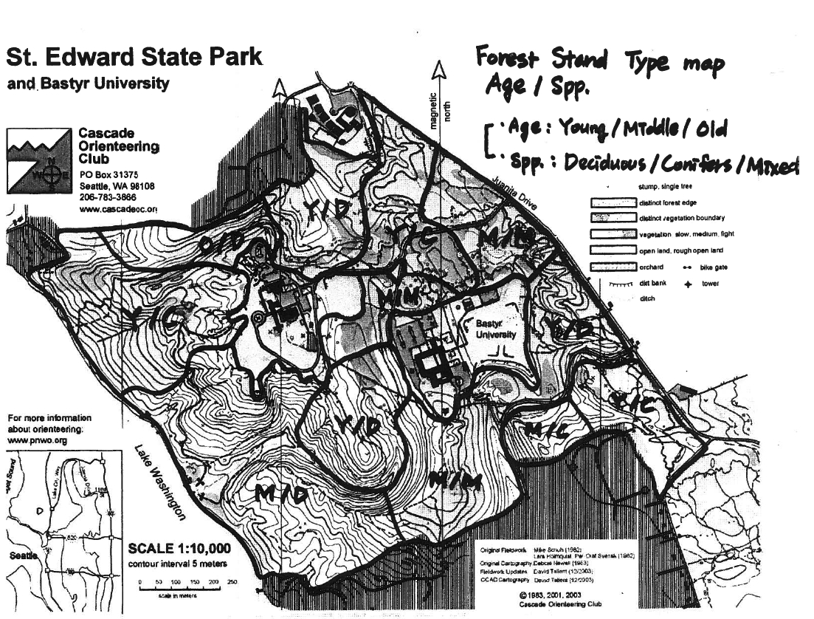
Plot and Tree Enumeration Card Page of

Date Team Forest

Compartment Stand Plot

Slope Aspect Elevation

Tree | Spp | DBH | Ht. | Dist | S (º) | B. (%) | T. (%) | C. (%) | Add-on | Comment(s)
Comments & Notes

Field Sampling of Forest Upper Canopy

- Slope: ➔ steepness of the ground, measure with clinometer
- Aspect: ➔ orientation of the ground, measure with compass
- Plot Number ➔ hand written on the short PVC pipe at plot center using indelible ink
- Plot and Tree Enumeration Card:
- 0.1 acre plot
- all large trees in the plot should have tags
- write tag # under the ” Tree” column
- generally, start measuring trees by going N and then clockwise (all tags will face you as you walk around the plot).
- For dead snags
  - Ocularly estimate height
  - In Comment column indicate “firm” or “soft” (some branches intact or disintegrating)
- For measuring tree heights
  - Do NOT go downhill to observe tree!
    - Make observations at SAME elevation as tree or uphill from it
  - Start at base of tree, look around for ‘gap’ in canopy, walk toward gap & look back at tree
    - Find a spot where you can see both top and base (or a known height off ground to use as base, if base is obscured)
  - Record clinometer reading (percent) to top of tree in column T
  - Record clinometer reading (percent) to base of tree in column B
  - Record clinometer reading (percent) to base of live crown in column C
  - Record height of lowest sighted point if tree base was obscured under “add-on”
  - Record taped distance from tree to observer in column ”Dist”
  - Record clinometer reading (use degrees) for slope of ground in column S
- 0.025 acre plot
- lay out or extend the tape 18.6 feet from plot center
- Same basic tree measurement data is collected, except fewer tree heights are measured
- write these on the same plot card as the large plot, starting after the last numbered tree.

