Chapter 8
GIS Data Analysis for Planning Decision Support

Table 8.1 Comparing Procedural and Communicative Rationality
Procedural rationality | Communicative rationality
- All goals considered | - All interests represented
- All aspects of current and future situations assessed  - All alternatives considered  - All impacts from alternatives tested  - All alternatives evaluated on all criteria | - Interests informed and able to converse about situation  - Interests equally empowered  - Good reasons, good argument  - Allow all claims and assumptions to be questioned
- Best alternative selected | - Consensus reached

Note. After Hopkins (2001). Copyright Island Press. Adapted by permission.
Table 8.2. Comparing Workflow Phases Presented by Meyer and Miller (2001), the National Cooperation Highway Research Program (NCHRP; Cambridge Systematics 1996), and Steinitz et al. (2003)
Meyer and Miller decision oriented framework associated with planning process | NCHRP urban transportation planning process, adapted by Meyer and Miller (2001) | Steinitz landscape planning (modeling) framework
problem identification / problem definition | “Vision” expressed in terms of a triangle with nodes labeled  - prosperity  - quality of life  - environmental quality  each is related to the other | Representation modeling
Problem identification / problem definition | Goals and objectives | Representation modeling
Evaluation and feedback | Performance measures | Representation modeling
Debate and choice | Data | Representation modeling
Debate and choice | Analytical methods | Process modeling  Change modeling  Impact modeling
Debate and choice | Alternative improvement strategies | Decision modeling
Debate and choice | Other sources for project ideas | Representation modeling
Debate and choice | Evaluation criteria | Evaluation modeling
Implementation | Fiscal and resource prioritization | Decision modeling
Implementation | Implementation of strategies
Evaluation and feedback | System operations | Evaluation modeling

Table 8.3. Planning Steps and Key Questions in a Small-System Context
Planning Step | Key questions to guide planners
Step 1. Specify Mission and Goals | - What is the water system’s mission?  - What values guide the water system?  - What are the system’s immediate and long-term goals?  - Are values and goals established in an open and participatory process that includes employees, customers, and other stakeholders?
Step 2. Assess structure and roles | - How is the water system structured in terms of the hierarchy from governance, to management, to operations?  - What service functions does the water system presently provide?  - What operational tasks does the water system perform?  - What is the role of the water system for each service function?
Step 3. Identify challenges and opportunities | - What are the principal change factors or drivers affecting the water system?  - What challenges are presented?  - What opportunities are presented?
Step 4. Evaluate system capacity | - Does the water system have adequate technical, financial, and managerial capacity?  - What are the systems strengths (performance enhancing factors) and weakness (performance-limiting factors)?  - Can the system manage change and effectively respond to external challenges and opportunities?
Step 5. Identify strategic options | - What strategic options are available to the system for achieving its goals?  - What benefits and costs are associated with each option?  - How are the system’s technological and structural options interrelated?
Step 6. Choose a strategy | - Which strategic option (or combination of options) can best provide the system’s service roles and functions?  - How do options compare in terms of cost-effectiveness?  - Which alternative is optimal in terms of the selection criteria?
Step 7. Implement | - What implementation issues are presented by the strategy and how are they being addressed?  - What will be the character of the improvement programming process to provide incremental financial build out of the plan?
Step 8. Monitor | - How will the strategy be monitored over time to ensure success?  - Is the plan producing desired outputs and achieving desired outcomes?

Note. Adapted from Beecher and Shanaghan (2002). Copyright by McGraw-Hill. Adapted by permission.
Table 8.4. Comparison of Water Planning Information Needs for Texas and Wyoming
Texas | Wyoming
Information about water demand | Information about water demand
Information about water supply | Information about water supply
Information about strategies for meeting future needs | Information about water transferability
Information about ecologically sensitive areas | Information about water resources infrastructure
Information about water laws and regulations | Information about water laws and regulations
 | Information about cultural and social factors associated with water resources

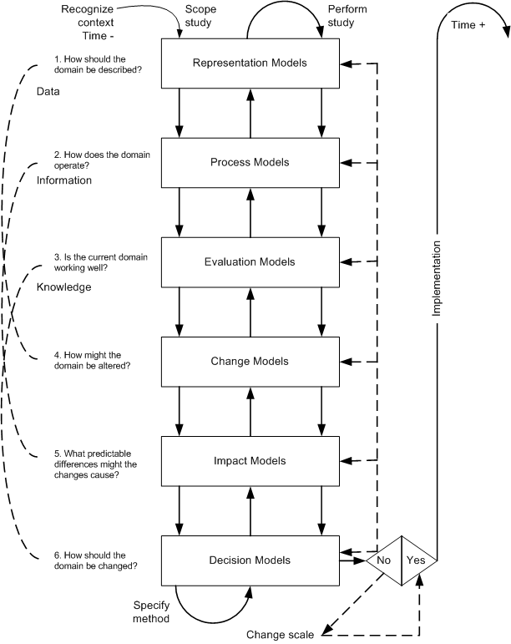
Figure 8.1 Workflow for analysis at the scale of regional planning. From Steinitz et al. 2005. Adapted by permission.
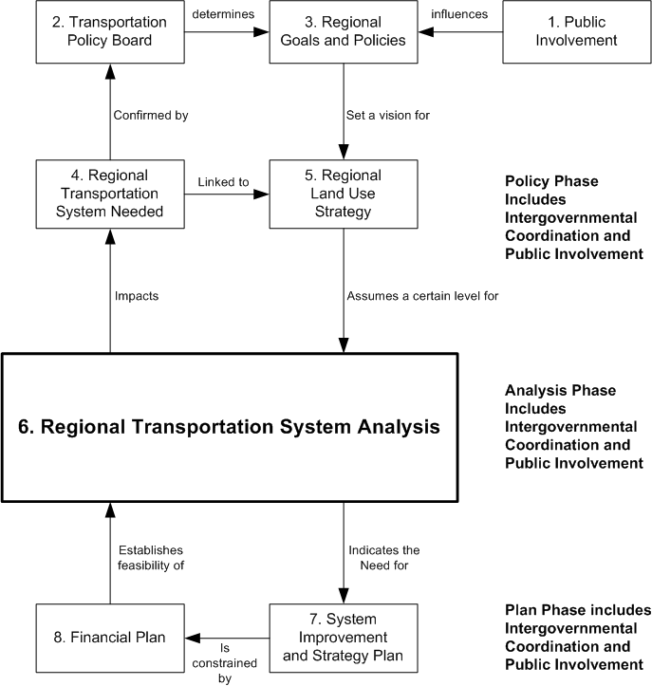

Figure 8.2 Transportation plan-making process of the Puget Sound Regional Council circa 1995. From Nyerges (1995). Reprinted by permission.

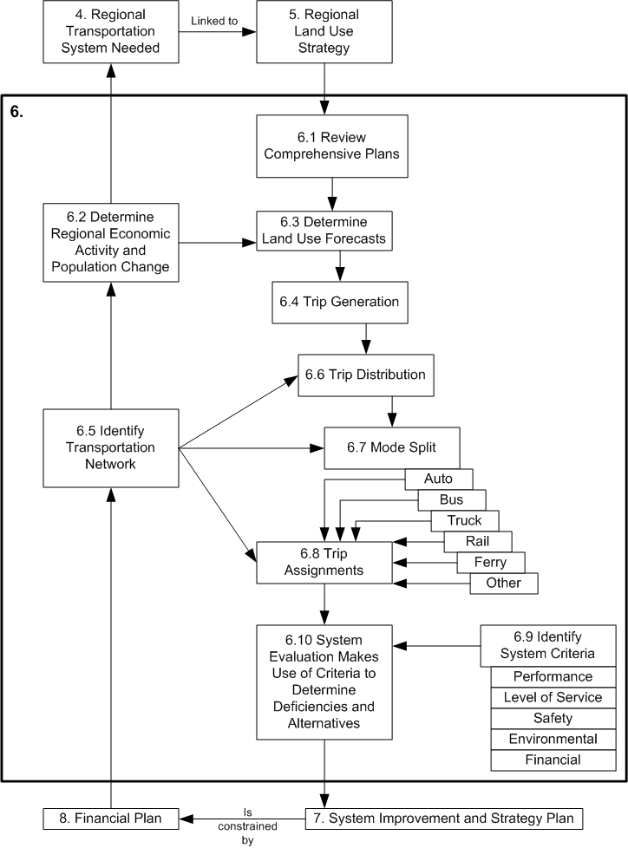

Figure 8.3 Steps in transportation (travel demand forecasting) analysis process.
From Nyerges (1995). Reprinted by permission.
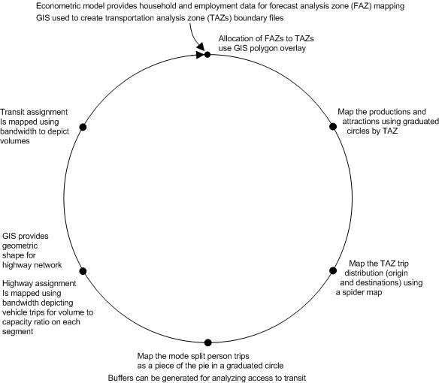
Figure 8.4. GIS Support for travel demand forecasting. From Nyerges (1995). Copyright 1995 by Guilford Publications. Reprinted by permission.

