Chapter 10
GIS Data Analysis for Improvement Programming Decision Support

Table 10.1. Phases in a Decision Process for TIP Improvement Site Selection

Initial screening of projects
Phase 1: Establish basic criteria for preliminary project screening based on mandates
Phase 2: Identify a comprehensive list of projects, collected from various sources as suggestions for capital improvement
Phase 3: Screen projects according to the basic criteria established in Phase 1

Refined evaluation
Phase 4: Refine criteria to evaluate the projects passing initial screening process
Phase 5: Describe aspects of the projects in more detail, using the criteria and weights from Phase 4, as well as any other concerns that need to be made known

Selection of projects
Phase 6: Consider unusual circumstances in the evaluation of the projects
Phase 7: Compare the project alternatives against each other to determine those most worthy of consideration
Phase 8: Negotiate for the most important projects

Table 10.2. Decision-Aiding Techniques for a Group-based GIS for Transportation
Level 1 : Basic information handling support
(a) Information management: storage, retrieval and organization of transportation data and information (e.g. distributed database management system support)

(b) Representation aids: manipulation (analysis) and expression (visualization) techniques for a specific part of a transportation problem (e.g. shared displays of charts, tables, maps, diagrams, matrix and/or other representational formats)

(c) Group collaboration support: techniques for idea generation, collection, and compilation; includes anonymous input of ideas, pooling and display of textual ideas, and search facilities to identify possible common ideas, (e.g. data and voice transmission, electronic voting, electronic white boards, computer conferencing, and large-screen displays)

Level 2 : Decision analysis support
(d) Process models: computational models that predict the behavior of real-world processes, (e.g. simulation models of traffic congestion, or air pollution contribution based on traffic volume)

(e) Choice models: integration of individual criteria across aspects or alternative choices, (e.g. multi-criteria decision models using multi-attribute and multi-alternatives for systematically weighted rankings or preferences)

(f) Structured group process techniques: methods for facilitating and structuring TIP decision-making, (e.g., automated Delphi, nominal group techniques, electronic brainstorming, and technology of participation)

Level 3 : Support for group process consistency
(g) Judgment refinement/amplification techniques: quantification of heuristic judgment processes (e.g. Bayesian analysis, social judgment analysis for tracking each members judgments for feedback to the individual or group, and sensitivity/trade-off analysis for comparing transportation project alternatives)

(h) Analytical reasoning methods: perform problem specific reasoning based on a representation of the transportation decision problem, (e.g. using mathematical programming or expert systems guided by automatic mediation, parliamentary procedure, or Robert's Rules of Order, identifying patterns in reasoning process).

Note. Based on Nyerges, Montejano, Oshiro, and Dadswell (1998; adapted from material in DeSanctis and Gallupe 1987). Copyright 1998 by Elsevier. Reprinted by permission.

Table 10.3. Selection Criteria for Determining Project Priority Support from WSHFC
(a) Projects should be located in areas of special need as demonstrated by location, population, income levels, availability of affordable housing and public housing waiting lists; Washington State Housing Finance Commission Approved by the Commission on January 25, 2001 Low-Income Housing Tax Credit Program Qualified Allocation Plan 2.

(b) Projects should set aside units for special needs populations, such as large households, the elderly, the homeless and/or the disabled.

(c) Projects should preserve federally assisted projects as low-income housing units.

(d) Projects should rehabilitate buildings for residential use.

(e) Projects should include the use of existing housing as part of a community revitalization plan.

(f) Projects should be smaller than larger.

(g) Projects have received written authorization to proceed as a United States Department of Agriculture - Rural Housing Service multifamily new construction project approved by the Commission.

(h) Projects are historic properties.

(i) Projects should be located in targeted areas.

(j) Projects should leverage public resources.

(k) Projects should maximize the use of credits.

(l) Projects should demonstrate a readiness to proceed.

(m) Projects should serve tenant populations of individuals with children.

(n) Projects are intended for eventual tenant ownership.

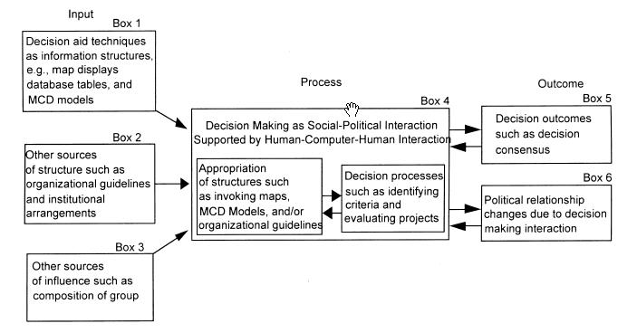

Figure 10.1. A task model for summarizing the influence of group-based GIS technology in support of TIP project selection. From Nyerges, Montejano, Oshiro, and Dadswell 1998). Copyright 1998 by Elsevier. Reprinted by permission.
S
n
o
h
o
m
i
s
h
K
i
n
g
P
i
e
r
c
e
Kitsap

Figure 10.2. Puget Sound Regional Council four-county region in Washington State.
From Jankowski and Nyerges (2001a). Copyright 2001 by Taylor & Francis. Adapted by permission.
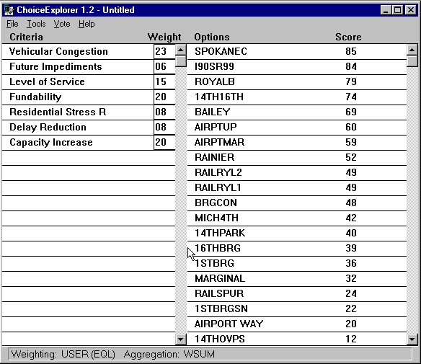
Figure 10.3 Decision table of project ranking tied to histogram of sensitivity in Plate 10.3. From Jankowski and Nyerges (2001a). Copyright 2001 by Taylor & Francis Ltd. Reprinted by permission.
Plate 10.1. FAST freight mobility (railway-grade separation) sites in a decision experiment.
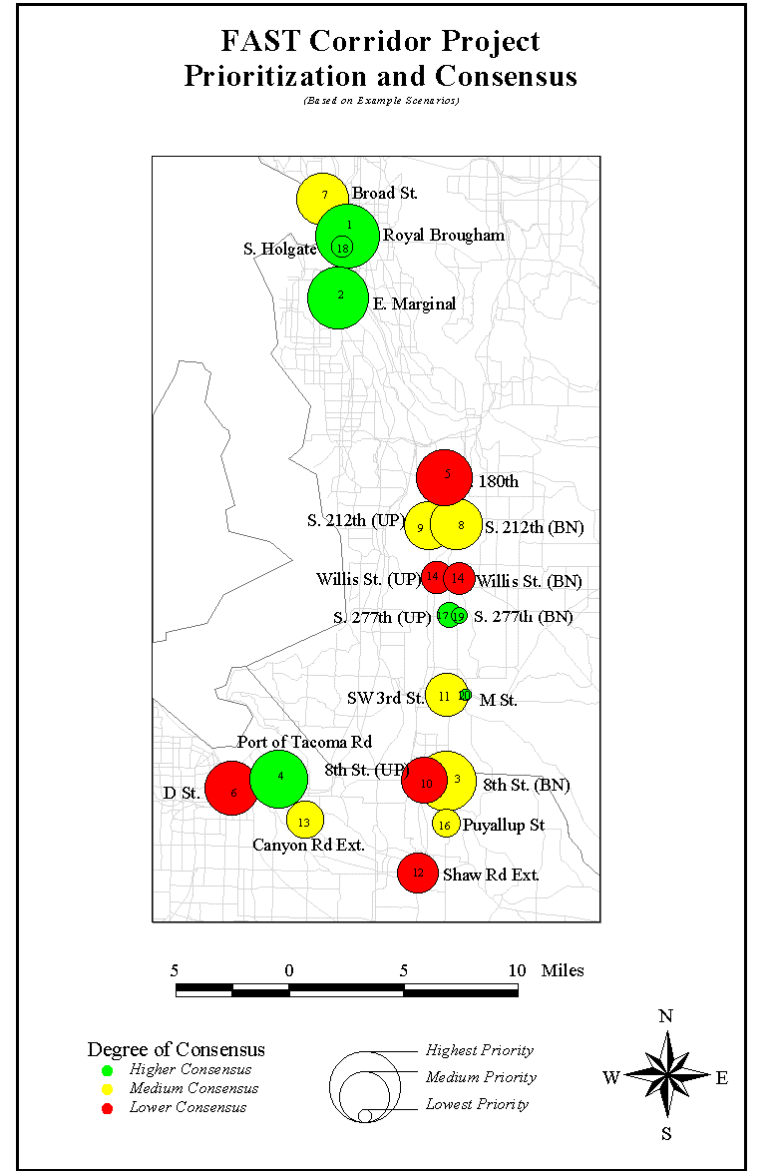
Plate 10.2 Consensus map of FAST program. From Jankowski and Nyerges (2001a). Copyright 2001 by Taylor & Francis Ltd. Reprinted by permission.
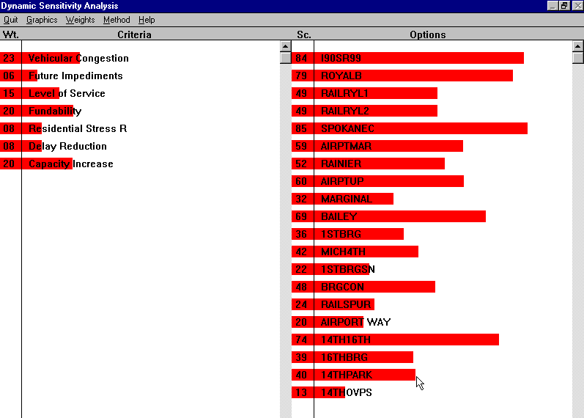
Plate 10.3 Sensitivity evaluation of project ranking tied to a decision table in Figure 10.3.
From Jankowski and Nyerges (2001a). Copyright 2001 by Taylor & Francis Ltd. Reprinted by permission.

