Geography 465 – Using cursors to manipulate geometries

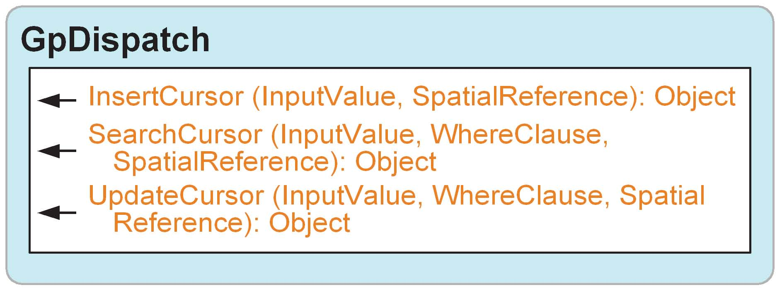

A cursor is a data access object that can either be used to iterate over the set of rows in a table or insert new rows into a table. Cursors have three forms, referred to as a search, insert, or update cursor. Each type of cursor is created by a corresponding geoprocessor method (SearchCursor, InsertCursor, or UpdateCursor) on a table, table view, feature class, or feature layer. A search cursor can be used to retrieve rows. An update cursor can be used to positionally update and delete rows, while an insert cursor is used to insert rows into a table or feature class.

All three cursor methods create an enumeration of row objects. The methods supported by the row object depend on the type of cursor created. The Next method on a search or update cursor returns the next row in the enumeration. To retrieve all rows in a table containing N rows, the script must make N calls to Next. In Python, a call to Next after the last row in the result set has been retrieved returns None, which is a special data type that acts as a placeholder.

Cursors can only be navigated in a forward direction; they do not support backing up and retrieving rows that have already been retrieved or making multiple passes over data. If a script needs to make multiple passes over the data, the application needs to reexecute the method that returned the cursor. If both executions of a method are made within the same edit session (or database transaction with the appropriate level of isolation), the application is guaranteed not to see any changes made to the data by other concurrently executing applications. This example shows a simple cursor operation. It prints out the value of the each field for the first row in a table.

# Create search cursor
rows = GP.SearchCursor(“D:/st_johns/roads.shp”)
row = rows.Next()
fields = GP.ListFields(“D:/st_johns/roads.shp”)
field = fields.Next()
while field:
if field.type != “Geometry”:
print field.name + “: Value = “ + str(row.GetValue(field.name))
field = fields.Next()

Note that no data is fetched from the table until the Next method is called.
When you are using a cursor and changing the underlying data at the same time, you may be concerned about the cursor operation and positioning. The situation, summarized by the table below, is actually quite simple.
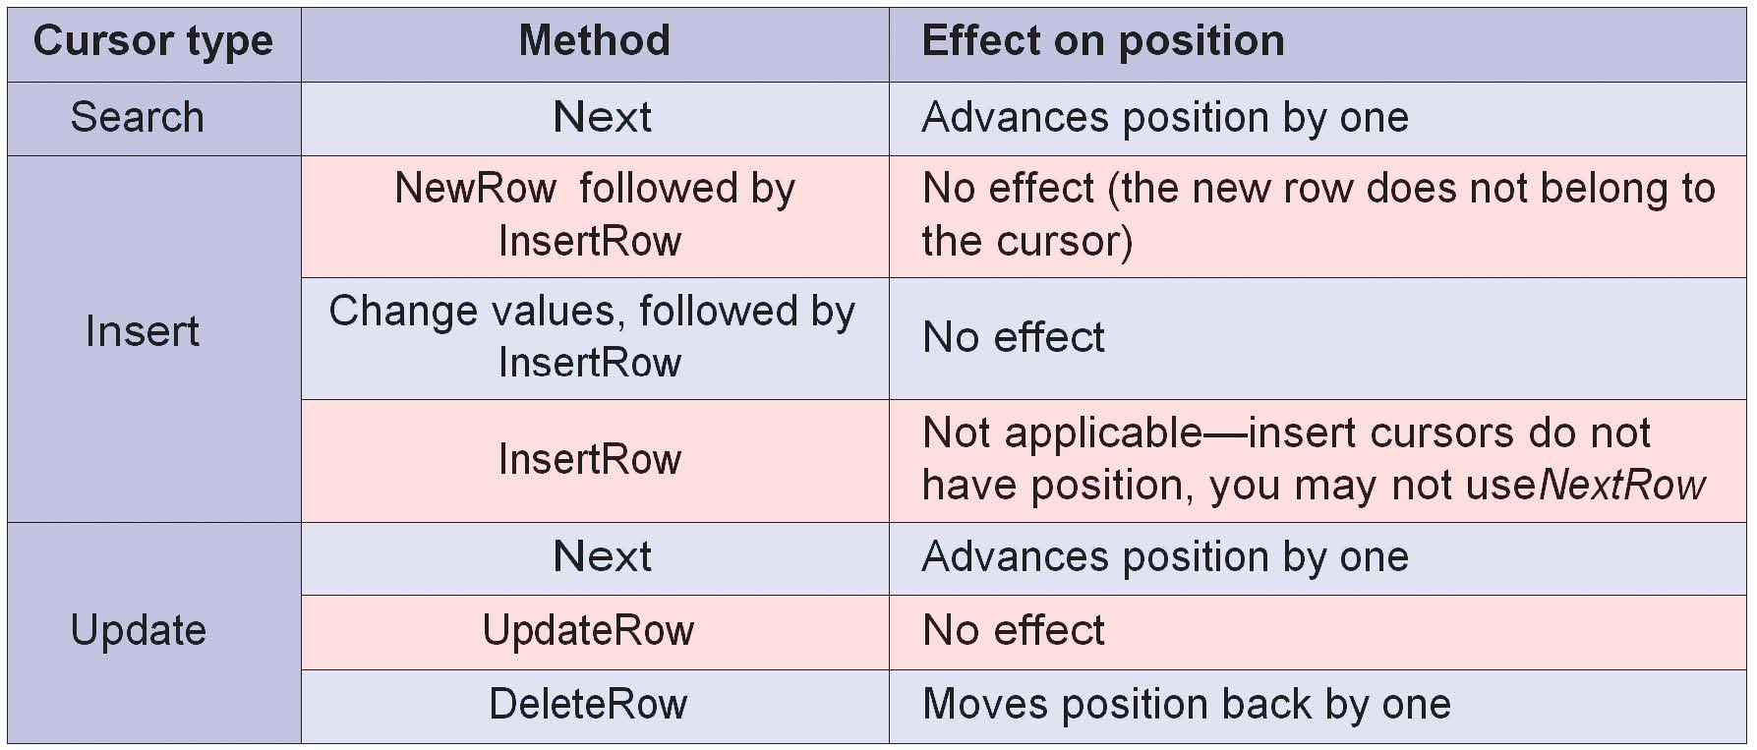

All row objects retrieved from a table logically contain the same ordered set of fields. In particular, the order of fields in a row of a table is the same as the order of fields returned from the ListFields method. The row will only contain the visible fields of the table used to create the cursor, with each field name being a property of the object.
Fields are accessed using the row object. Values are returned using either the field name as a property of the row object or by its position in the table.

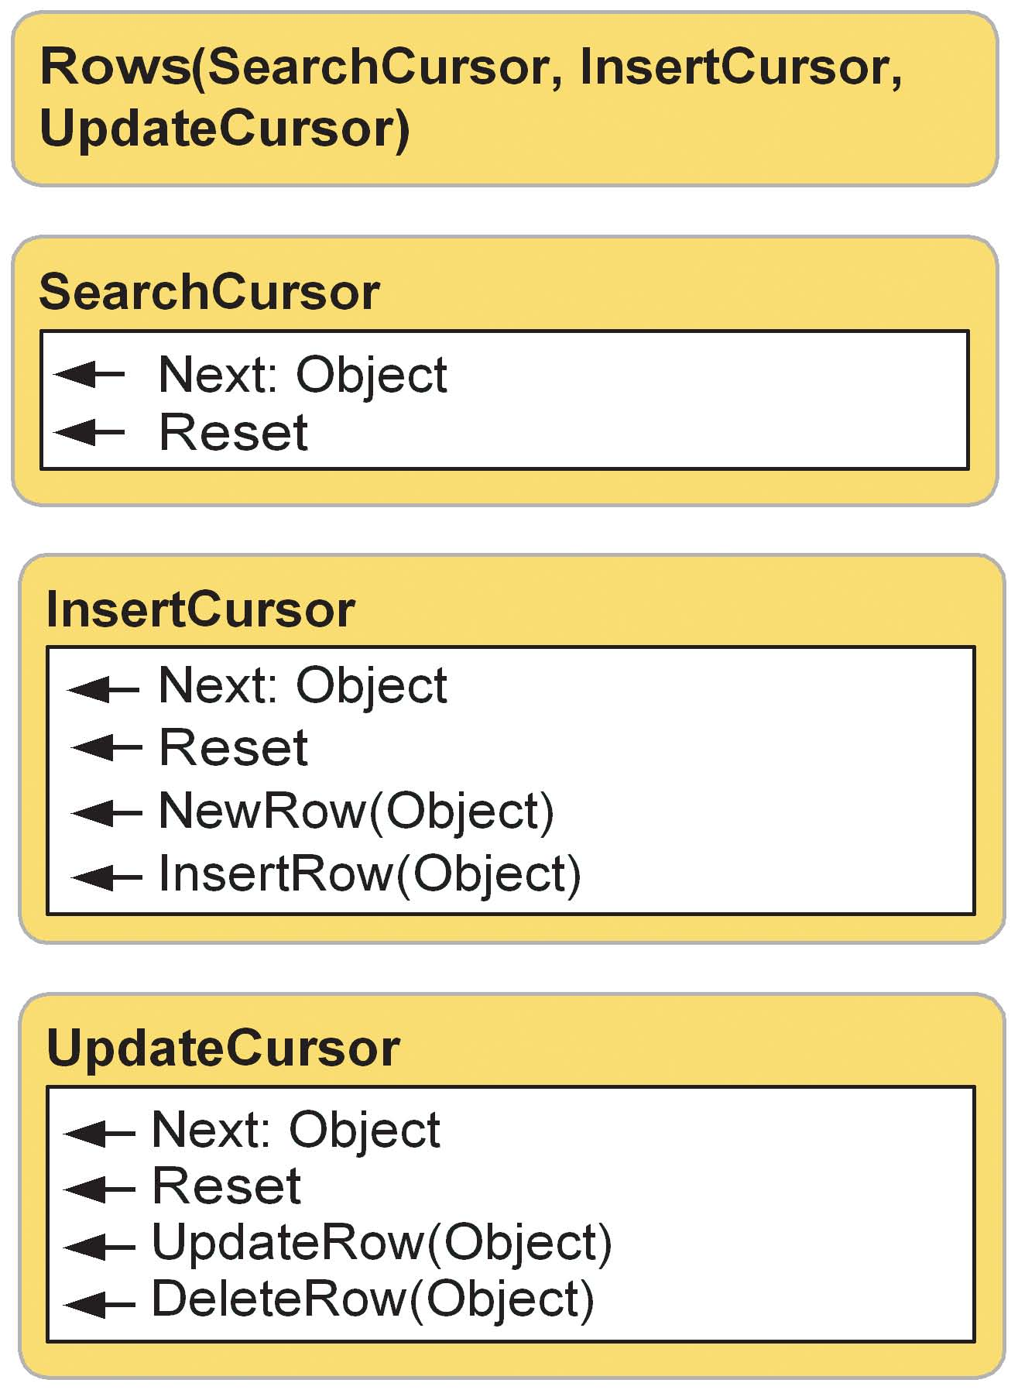

Row enumeration object
The methods of the enumeration object created by the various cursor methods vary depending on the type of cursor created. The following chart shows what methods are supported for each cursor type.
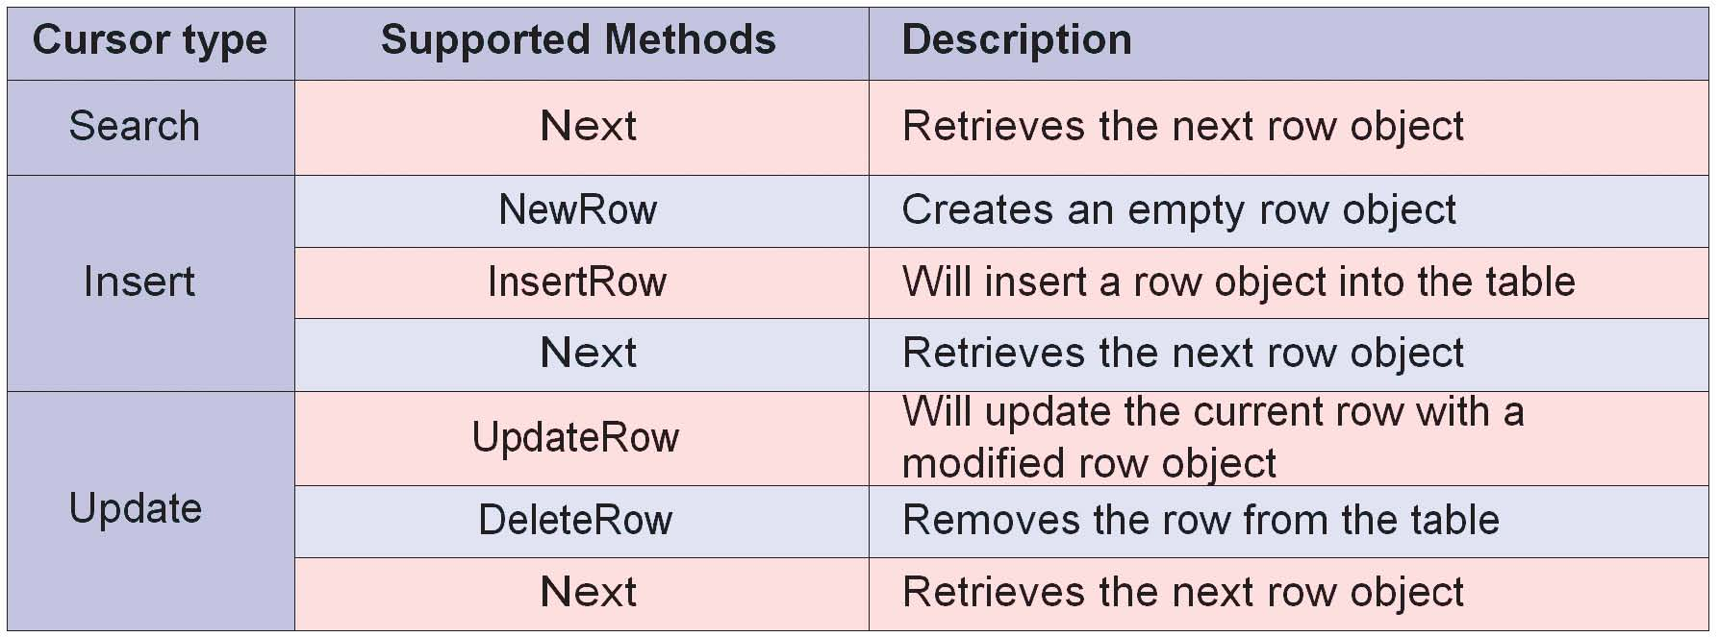

UpdateRow
The UpdateRow method can be used to update the row at the current position of an update cursor. Making a call to Next on a cursor returns a row and positions the cursor on that row. After fetching a row object using Next, the script can modify the row as needed and call UpdateRow, passing in the modified row.

# Create update cursor for feature class
rows = GP.UpdateCursor("D:/St_Johns/data.mdb/roads")
row = rows.Next()
# Update the field used in buffer so the distance is based on the road
# type. Road type is either 1, 2, 3 or 4. Distance is in meters.
while row:
row.buffer_distance = row.road_type * 100
rows.UpdateRow(row)
row = rows.Next()

DeleteRow
The DeleteRow method can be used to delete the row at the current position of an update cursor (that is, to delete the row returned by the last call to Next on this cursor). After fetching the row object using Next, the script should call DeleteRow on the cursor to delete the row.

# Create update cursor for feature class
rows = GP.UpdateCursor("D:/St_Johns/data.mdb/roads")
row = rows.Next()
while row: # Delete all rows that have a roads type of 4
if row.road_type == 4:
rows.DeleteRow(row)
row = rows.Next()

Cursors honor layer/table view definition queries and selections.The row enumeration object will only contain the rows that would be used by any geoprocessing tool during an operation.
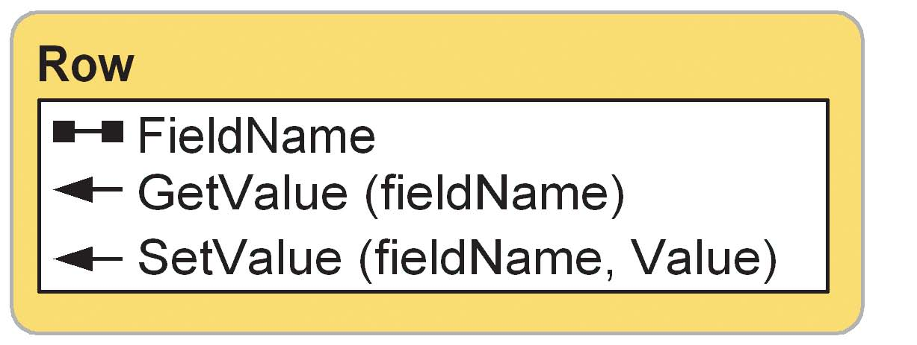

InsertRow
Insert cursors are used to bulk insert rows. The InsertRow method takes a row object as an argument. The script obtains a new row object using the NewRow method on the enumeration object into which rows are to be inserted. Each call to InsertRow on the cursor creates a new row in the table whose initial values are set to the values in the input row.

# Create insert cursor for table
rows = GP.InsertCursor("D:/St_Johns/data.mdb/roads_lut")
x = 1
# Create 25 new rows. Set the initial row id and distance values
while x <= 25:
row = rows.NewRow()
row.rowid = x
row.distance = 100
rows.InsertRow(row)
x = x + 1

Not all scripting languages support the evaluation of a variable as an object property or method. In these cases the GetValue and SetValue methods are particularly useful. Python supports the use of a variable as a property or method name using the Eval function.

GetValue and SetValue
The row object may access and update field values using field names or a field’s index position. This approach works well when the field names or order is known, but this may not always be the case. Variables may be used to create generic scripts with no knowledge of what fields exist within a table. The row has two methods that allow the use of variables as field names. The GetValue method simply returns a field’s value, with the field name being the only input parameter. The SetValue method has two parameters—the field to be updated and the value to be used. The sample below creates a lookup table for all polygon feature classes in a workspace. The lookup table contains an ID that corresponds to the ObjectID for each feature in the feature class and a distance value that could be used for the Buffer tool.

# List the polygon feature classes
fcs = GP.ListFeatureclasses("*","polygon")
# Loop through the results. Get the ObjectID field
fc = fcs.Next
while fc:
OIDFields = GP.ListFields(fc,"*","OID")
# Create a search cursor on the feature class and an insert cursor
# on a new look-up-table
featcur = GP.SearchCursor(fc)
# Create look-up-table and add fields
tab = fc + "_lut"
GP.CreateTable(tab)
GP.AddField(tab,"id","long")
GP.AddField(tab,"dist","long")
# Open insert cursor on new look-up-table
tabcur = GP.InsertCursor(tab)
f_row = featcur.Next()
# Get the OID field from the feature class
OIDField = OIDFields.Next()

# Loop through the rows in the feature class
while f_row:
# Create a new row for the look-up-table and set its id to be the
# same as the feature OID and set the distance to 100.
t_row = tabcur.NewRow()
t_row.id = f_row.GetValue(OIDField.name)
t_row.dist = 100
# Insert the row into the look-up-table and get the next row
# from the feature class
tabcur.InsertRow(row)
f_row = featcur.Next()
fc = fcs.Next

Queries
Structured Query Language (SQL) is a powerful language you use to define one or more criteria that can consist of attributes, operators, and calculations. For example, imagine you have a table of customer data and want to find those who spent more than $50,000 with you last year and whose business type is “Restaurant”. You would select the customers with this expression: “Sales > 50000 AND Business_type = ‘Restaurant’”.

Specifying a query
When a query is specified for an update or search cursor, only the records satisfying that query are returned. A SQL query represents a subset of the single table queries that may be made against a table in a SQL database using the SQL SELECT statement. The syntax used to specify the where clause is the same as that of the underlying database holding the data. Refer to the ArcGIS Desktop Help system for more information on defining SQL where clauses. The example below filters the rows of a search cursor to only roads of a certain type:

# Import COM Dispatch and create geoprocessor
from win32com.client import Dispatch
GP = Dispatch("esriGeoprocessing.GpDispatch.1")
# Create search cursor
rows = GP.SearchCursor("D:/St_Johns/data.mdb/roads",
"[type] = ‘residential’")
row = rows.Next()
while row:
# Print the name of the residential road
print row.Name
row = rows.Next()

Geometries

All simple feature classes require a geometry type field. It contains the actual geometry of a feature and is typically called Shape.The ListFields or Describe methods may be used to retrieve the geometry field from a feature class.The name of the field can be determined from the field object.

The geometry object
Using a geometry object, the geoprocessor supports cursor access of feature geometry. The object, created by the row object when the shape field is specified, exposes a number of properties that describe a feature. The example below shows how to create a geometry object for each line feature in a feature class and sum their length:

# Create search cursor
rows = GP.SearchCursor("D:/St_Johns/data.mdb/roads")
row = rows.Next()
# Calculate the total length of all roads
length = 0
while row:
# Create the geometry object
feat = row.shape
length = length + feat.Length
row = rows.Next()
print length

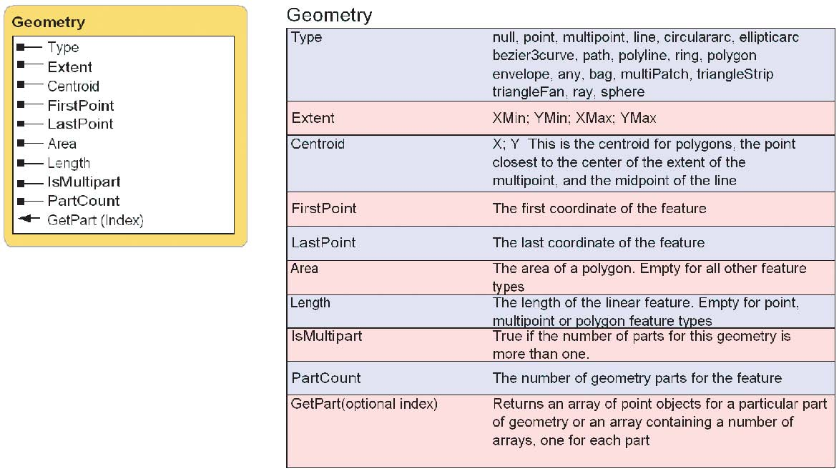
Reading geometries - Each feature in a feature class contains a set of points defining the vertices of a polygon or line or a single coordinate defining a point feature. These points may be accessed using the geometry object, which returns them in an array of point objects. The array object may contain any number of geoprocessing objects, such as points, geometries, or spatial references.
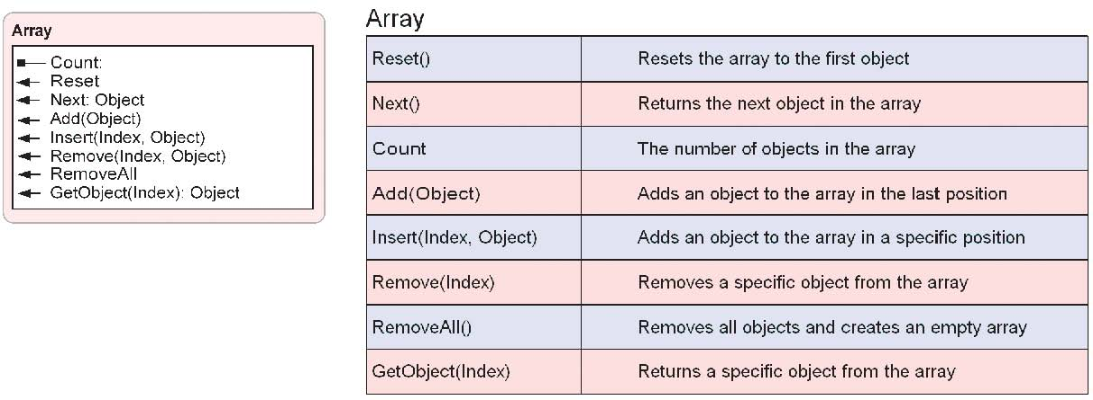
Features in a geodatabase or shapefile may have multiple parts. The geometry object’s PartCount property returns the number of parts for a feature. The GetPart method will return an array of point objects for a particular part of the geometry if an index is specified. If an index is not specified, an array containing an array of point objects for each geometry part will be returned. The example below will print the coordinates for all features to the output window:

# Create search cursor
rows = GP.SearchCursor("D:/St_Johns/data.mdb/roads")
row = rows.Next()
# Print the coordinates of each road line feature
while row:
# Create the geometry object
feat = row.shape
a = 0
while a < feat.PartCount:
# Get each part of the geometry
roadArray = feat.GetPart(a)
roadArray.Reset
# Get the first point object for the feature
pnt = roadArray.Next()
while pnt: print str(pnt.id) + ";" + str(pnt.x) + ";" + str(pnt.y) pnt = roadArray.Next()
a = a + 1
row = rows.Next()

Point features return a single point object instead of an array of point objects. All other feature types—polygon, polyline, and multipoint—return an array of point objects or an array containing multiple arrays of point objects if the feature has multiple parts.
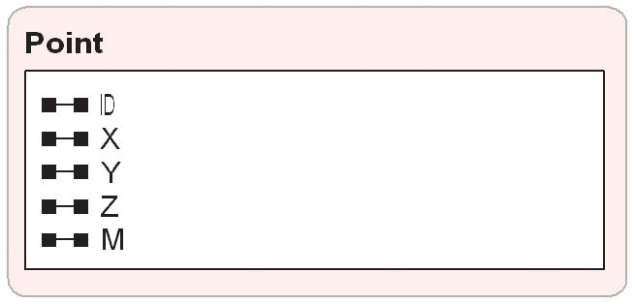

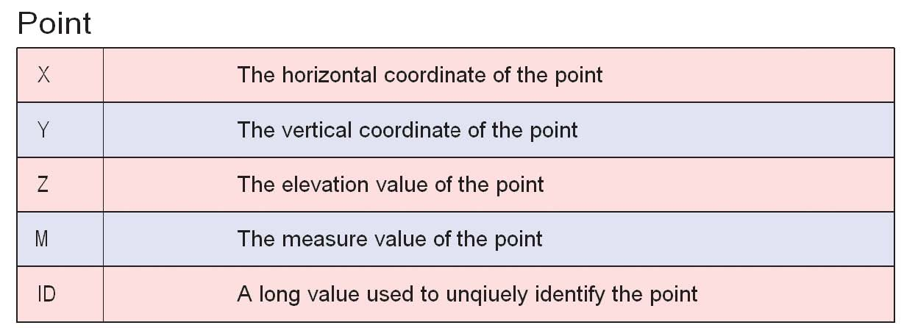
A multipart feature is composed of more than one physical part but only references one set of attributes in the database. For example, in a layer of states, the State of Hawaii could be considered a multipart feature. Although composed of many islands, it would be recorded in the database as one feature.

A ring is a closed path that defines a two-dimensional area. A valid ring consists of a valid path such that the from and to points of the ring have the same X and Y coordinates.A clockwise ring is an exterior ring, and a counterclockwise ring defines an interior ring.

A polygon will consist of a number of rings if it contains holes. The array of point objects returned for a polygon will contain the points for the exterior ring and all inner rings. The exterior ring is always returned first, followed by inner rings, with null point objects as the separator. Whenever a script is reading coordinates for polygons in a geodatabase or shapefile, it should contain logic for handling inner rings if this information is required by the script; otherwise, only the exterior ring will be read. The following script prints out the coordinates for polygons in a feature class. It shows how to handle multipart polygons and polygons with multiple rings.

from win32com.client import constants, Dispatch
from types import *
import pythoncom, sys

GP = Dispatch("esriGeoprocessing.GpDispatch.1")
fc = sys.argv[1]
dsc = GP.describe(fc)
print "Describing:", fc
print "Extent:"
print dsc.Extent
# Create search cursor
rows = GP.SearchCursor(fc)
row = rows.Next()
# Print the coordinates of each landuse polygon feature
while row:
# Create the geometry object
feat = row.shape
a = 0
print " "
print "Feature: " + str(row.fid) + " number of parts: " +
str(feat.PartCount)
while a < feat.PartCount:
# Get each part of the geometry
print "Part: " + str(a + 1)
LUArray = feat.GetPart(a)
LUArray.Reset()
b = 1
# Get the first point object for the polygon
pnt = LUArray.Next()
while pnt:
print str(pnt.id) + "," + str(pnt.x) + "," + str(pnt.y)
pnt = LUArray.Next()
# The point may be a null separator, so check to
# see if another point exists.
if not pnt:
pnt = LUArray.Next() # If the point does exist, continue printing # the coordinates of the inner ring.
if pnt: print "Inner ring: " + str(b)
b = b + 1
print " "
a = a + 1
row = rows.Next()

Strings may be easily concatenated in Python using the addition operator. The Str function can be used to return the string value of any object so the value can be concatenated with other strings.

Writing geometries
Using insert and update cursors, scripts may create new features in a feature class or update existing ones. A script can define a feature by creating a point object, populating its properties and placing it in an array. That array may then be used to set a feature’s geometry. A single geometry part is defined by an array of points, so a multipart feature can be created from multiple arrays of points.

Read the upcoming section about locking to understand how cursors affect other applications.

The following example shows how to read a text file containing a series of linear coordinates and then use them to create a new feature class.

# Create a new line feature class using a text file of coordinates.
# The coordinate file is in the format of ID;X;Y.
import win32com.client, sys, fileinput, os, string
# Create the geoprocessor object
GP = win32com.client.Dispatch("esriGeoprocessing.GPDispatch.1")
# Get the name of the input file
infile = sys.argv[1]
# Get the name of the output feature class
fcname = sys.argv[2]
# Get the name of the template feature class.
template = sys.argv[3]
try:
# Create the feature class GP.CreateFeatureclass(os.path.dirname(fcname),os.path.basename(fcname),
"Polyline", template) # Open an insert cursor for the new feature class. cur = GP.InsertCursor(fcname) # Create the array and point objects needed to create a feature lineArray = GP.CreateObject("Array") pnt = GP.CreateObject("Point") ID = -1 # Initialize a variable for keeping track of a feature's ID. # Assume all IDs are positive. for line in fileinput.input(infile): # Open the input file
# Create a list of input values and set the point properties.
values = string.split(line,";")
pnt.id = values[0]
print pnt.id
pnt.x = values[1]
print pnt.x
pnt.y = values[2]
print pnt.y
if ID == -1:
ID = pnt.id
# Add the point to the feature's array of points.
# If the ID has changed create a new feature
if ID != pnt.id:
# Create a new row, or feature, in the feature class.
feat = cur.NewRow()
# Set the geometry of the new feature to the array of points
feat.shape = lineArray
# Insert the feature
cur.InsertRow(feat)
lineArray.RemoveAll()
lineArray.add(pnt)
ID = pnt.id
except:
print GP.GetMessages(2)

Below is an example of a file that may be processed by this script.
The file has a blank line at the end to ensure all inputs are used:
1;-61845879.0968;45047635.4861
1;-3976119.96791;46073695.0451
1;1154177.8272;-25134838.3511
1;-62051091.0086;-26160897.9101
2;17365918.8598;44431999.7507
2;39939229.1582;45252847.3979
2;41170500.6291;27194199.1591
2;17981554.5952;27809834.8945
3;17365918.8598;44431999.7507
3;15519011.6535;11598093.8619
3;52046731.9547;13034577.2446
3;52867579.6019;-16105514.2317
3;17160706.948;-16515938.0553

That file is similar to the one in Exercise 4.

The spatial reference for a feature class describes its coordinate system (for example, geographic, UTM, and State Plane), its spatial domain, and its precision.The spatial domain is best described as the allowable coordinate range for x,y coordinates, m- (measure) values, and z-values.The precision describes the number of system units per one unit of measure.

An array of points is not necessary when writing point features. A single point object is used to set the geometry of a point feature.
The geoprocessor validates all geometries before they are written to a feature class. Issues such as incorrect ring orientation and self-intersecting polygons, among others, are corrected when the geometry is simplified before its insertion. The geoprocessor will not write invalid geometry.
Setting a cursor’s spatial reference
By default, the spatial reference of the geometry returned from a search cursor or set by an update or insert cursor is the same as the feature class referenced by the cursor. A different spatial reference for the input or output features may be specified when the cursor is created. In the case of a search cursor, specifying a spatial reference that is different from the spatial reference of the input feature class will result in geometries that are projected to the cursor’s spatial reference. The example below has a point feature class with a coordinate system of Universal Transverse Mercator (UTM) zone 21 North, defined in its spatial reference. The script will produce a text file with the coordinates of the points in decimal degrees.

import win32com.client, sys
# Create the geoprocessor object
GP = win32com.client.Dispatch("esriGeoprocessing.GPDispatch.1")
# Describe a feature class with a geographic coordinate system
desc = GP.Describe("D:/St_Johns/data.mdb/latlongbnd")
# Create search cursor. Use the spatial reference object from the # described feature class so geometries are returned in decimal degrees. rows = GP.SearchCursor("D:/St_Johns/data.mdb/buildings", "",
desc.SpatialReference)
row = rows.Next()
# Open the file for output. This also creates the file if it does not exist.
out = open(sys.argv[1],"w")
# Print the coordinates of each building point feature
while row:
# Create the geometry object
feat = row.shape
# Get the geometry's point object.
pnt = feat.GetPart()
# Write the XY coordinate to the output file
out.write(str(pnt.x) + ";" + str(pnt.y) + "\n")
row = rows.Next()
# Close the output file
out.close()

Setting the spatial reference of an insert or update cursor is required when the coordinate system of the input geometries is different from the referenced feature class. Defining an insert or update cursor’s spatial reference allows the cursor to project the coordinates on the fly before they are actually written to the feature class. A script that writes geographic Global Positioning System (GPS) coordinates to a feature class with a State Plane Coordinate System is an ideal example of when to set a cursor’s spatial reference.

When working in a Python editor, such as PythonWin, you may need to clean up object references to remove dataset locks set by cursors. Use the gc (garbage collection) module in the Interactive window to control when unused objects are removed and/or explicitly delete references within your script.

Other scripting languages have different functions or statements for undoing referencing to objects. For example, VBScript uses the Set statement to release an object by setting it to Nothing. For more information regarding object handling, refer to the reference of the language you are using.

Locking
An edit session in ArcMap will apply a shared lock to data during the edit session. An exclusive lock is applied when edits are saved. A dataset is not editable if an exclusive lock already exists.

Insert and update cursors honor table locks set by ArcGIS. Locks prevent multiple processes from changing the same table at the same time. There are two types of locks—shared and exclusive. A shared lock is applied anytime a table or dataset is accessed. Multiple shared locks can exist for a table, but no exclusive locks are permitted if a shared lock exists. Displaying a feature class in ArcMap or previewing a table in ArcCatalog are examples of when a shared lock would be applied. Exclusive locks are applied when changes are made to a table or feature class. Editing and saving a feature class in ArcMap, changing a table’s schema in ArcCatalog or using an insert cursor on a shapefile in PythonWin are examples of when an exclusive lock is applied by ArcGIS.
Update and insert cursors cannot be created for a table or feature class if an exclusive lock exists for that dataset. The UpdateCursor or InsertCursor methods will return an error stating that the methods failed because an exclusive lock exists for the dataset. If these methods successfully create a cursor, they will apply an exclusive lock on the dataset, so two scripts may not create an update or insert cursor on the same dataset.
Locks persist until the application or script releases a dataset, either by closing or releasing the cursor object explicitly. In a script, the cursor object should be deleted so the exclusive lock it placed on the dataset is released. Otherwise, all other applications or scripts could be unnecessarily prevented from accessing a dataset. The sample below shows how to open an update cursor and release it. An error handler is used to check if the UpdateCursor method fails because of another exclusive lock on the table.

# Create update cursor for feature class
try:
rows = GP.UpdateCursor("D:/St_Johns/data.mdb/roads")
row = rows.Next()
# Update the field used in buffer so the distance is based on the road
# type. Road type is either 1, 2, 3 or 4. Distance is in meters.
while row:
row.buffer_distance = row.road_type * 100
rows.UpdateRow(row)
row = rows.Next()
# Delete the row and cursor
del row, rows
except:
if not GP.GetMessages() == "":
GP.AddMessage(GP.GetMessages(2))
if row:
del row
if rows:
del rows

