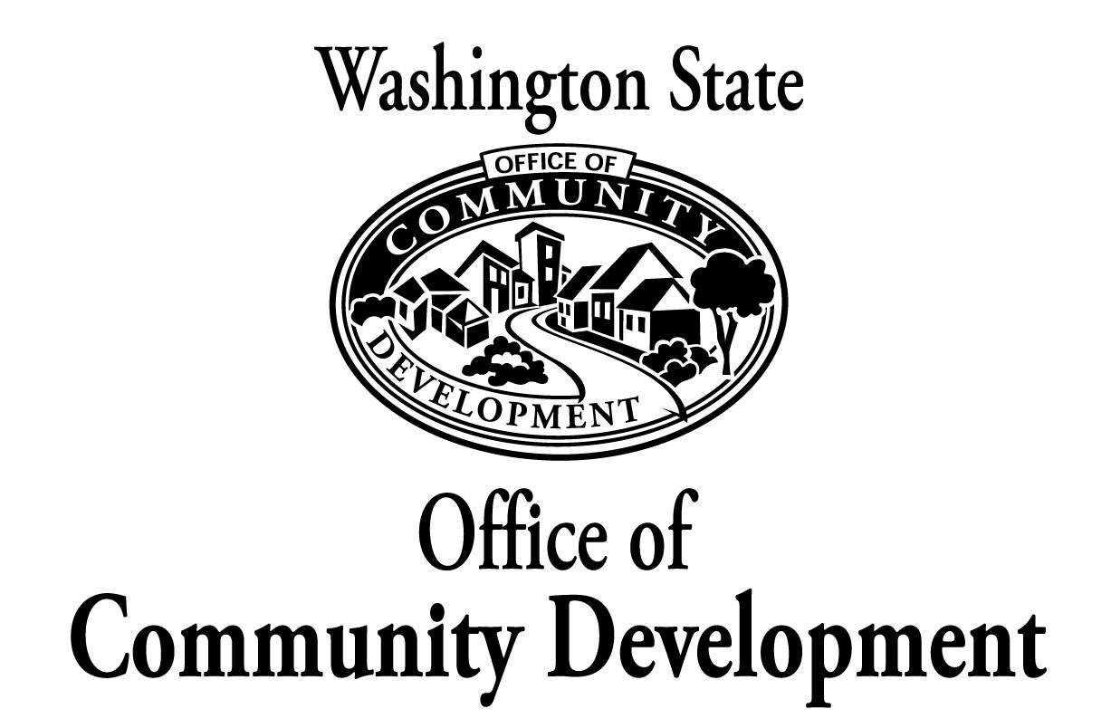

GMA & transportation

Providing Financial and Technical Resources to Build Livable and Sustainable Communities
 | GMA links transportation and land use
Description | The Growth Management Act (GMA) calls on local communities to rethink the traditional approach to transportation planning. Transportation plans need to be consistent with the community’s comprehensive plan, under the GMA. In addition, regions are to agree on a framework for transportation facilities and strategies.
Background | Communities decide what their vision is for the future and what part transportation plays in that vision, as part of GMA planning. At the regional level, cities and counties agree on broad transportation facility needs and priorities. At the local level, communities look at how people and goods will be moved from place to place, what destinations people will choose, and what types of transportation will be offered.  Communities also determine level of service standards (LOS) for automobiles, transit, and non-motorized modes such as bicycles and pedestrians. LOS standards for traffic congestion are often expressed through a letter system from “A” (the best) for the least amount of congestion to “F” (the worst) for the most amount of congestion.  When a community identifies the LOS it expects, it determines how to meet this standard based on assumptions contained in the land use chapter of the comprehensive plan. Communities face tough decisions on how to fund increasing shortfalls for streets, roads, and other transportation needs. New housing and commercial and industrial projects need to be developed in a manner that assures that the roads and other infrastructure supporting the project are in place or scheduled for completion when the project is complete. This is called concurrency.  Growth management also encourages regional coordination of transportation planning with special districts such as ports, recognizing the benefits and cost savings that such cooperation can bring about.
What’s being done | Growth management provides a clear link between transportation and land use planning. But the true benefits of this linkage occur at the local level on a project-by-project basis when comprehensive plans are carried out.  For example, when Douglas County completed its comprehensive plan, county officials organized a monthly project coordination meeting. Called the Committee on Planning Organization, Utilities, and Technology, the group includes representatives of special districts providing fire protection, sewer, water, irrigation, transit, school, recreation, and industrial development services. In addition, private sector companies providing cable, natural gas, and telephone services participate.  The monthly meetings in Douglas County are creating benefits under growth management. Project coordination is:  - Contributing to significant savings of taxpayer dollars for utility installation in urban growth areas (UGAs) by cutting road construction and repair costs.  - Helping improve project timing and scheduling to reduce disruption of other services being provided in the UGA.  - Assisting Douglas County to carry out its comprehensive plans since each project is built consistent with transportation and land use chapters.  - Helping each community meet the concurrency requirements of growth management.  - Helping provide developers with timely information that will reduce project delays and costs in UGAs, since the capital facilities questions necessary to develop lands can be quickly reviewed and answered.  Twenty-nine counties have completed county-wide planning policies addressing transportation facilities and services. County-wide planning policies are joint city-county policies that help to ensure city and county comprehensive plans are consistent.  In addition, most counties and cities have adopted comprehensive plans with transportation chapters that are consistent with their land use and other chapters. Regional transportation planning organizations review local comprehensive plans for their consistency with regional transportation plans.
What’s next | Most local governments planning under the GMA have adopted their first comprehensive plans under the act. They are monitoring the transportation chapters of the plans to see if their goals and strategies for roads, transit, bicycle paths, and other types of transportation will meet the needs of growing populations.  The Washington State Department of Transportation and Washington State Office of Community Development )CD) will continue to provide assistance to local communities as they develop and carry out these plans. This technical assistance is ongoing as each community continues to build on its successes and as new challenges arise.
For more information | Contact David Andersen, OCD senior planner, at (360) 725-3000, or check the Web Site at www.ocd.wa.gov/growth.

