OILS FOUND IN WASTEWATER

What Are They?

How to Separate and Eliminate Them
From Wastewater

A Layman’s Guide to Emulsion Breaking

by

George R. Alther
President and Founder
Biomin, Incorporated

Manufacturer of Organophilic Clays
That Remove Oil From Water,
And Facilitate Recycling Of Wastewater

Biomin, Incorporated
P.O. Box 20028

Ferndale, MI 48220

Phone: (248)-544-2552 — Fax: (248)-544-3733
e-mail: biomin@aol.com
website: http://www.biomininc.com

TABLE OF CONTENTS

Page

Prologue iv
Acknowledgements v
1. Introduction vi

PART I: What are Oils, Lubricants, Fats and Greases? 1
1. What is Oil 1
2. Definitions 2
3. Definitions of Oils 3
4. Types and Uses of Oils 8
5. Fats 10
6. Lubricants 11
7. Lubricating Oils 14
8. Lubricating Greases 15
9. Sources of Oils 15
10. Coal Oil and Coal Tar 16
11. Aqueous Cleaners 17

Part II: What are Emulsions? 18
12. Introduction 18
13. HLB Values 24
14. Asphalt Emulsions 25
15. Description of Some Terms 27
16. Detergents 30
17. Soaps 31
18. Surfactants 33
Part III: Demulsification: Or How To Break An Emulsion 40
19. Introduction 40
20. Testing Procedures 43
21. Physical Separation Methods 44
22. Chemical Methods 45
23. Step-By-Step Approach to Emulsion Breaking 46
24. Bentonite-Based Powders 48
25. Types of Polymers to Use 49
26. Post Polishing of Wastewater of Small Amounts of Oil
With Organoclay and Activated Carbon 49
27. Activated Carbon And Its Ability To Remove Surfactants 50

Appendix 1: Figures 52

Appendix 2: Lubricant Guide 56

Appendix 3: Design of a Wastewater Treatment System 60
References 61

PROLOGUE

During the years that I have been involved in ground water and wastewater treatment, I realized that when it comes to certain technical terms and definitions, the engineering community operates in a "Tower of Babel" environment. Frequently, we are not sure what we mean or understand by terms and items such as detergents, surfactants, absorption Vs. adsorption, COD, etc.
I have therefore attempted to define diligently the most pertinent terms as accurately as possible, coming from the viewpoint that if someone like myself, a trained geologist, can understand it, then an engineer will certainly be able to understand it. It is my intention to help the engineer to become more familiar with terms that chemists and chemical engineers throw around at random.
Furthermore, it is my hope that this guide will help the wastewater engineer to better understand what the chemicals are that cause him problems in his wastewater, what their source is, and how to deal with them so that they can be removed from the water, without the need to have a Ph.D. in Chemical Engineering. I am referring, of course, to oil, fats and grease.
This guide is not meant to be an original document in the sense of a Ph.D. dissertation or a technical article. Many discussions and descriptions are straight out of the source books and articles, without first paraphrasing. Proper acknowledgments are listed in the back.
It is my hope, that after the operations manager studies this guide, he will be in a good position to deal with fats, oil and greases in his wastewater (or ground water) in the most economical manner. Once he understands how to break an emulsion, why it exists in the first place, and what its source is, he is home free to achieve zero discharge and he can recycle his water, a need that is becoming more and more of a necessity.

George R. Alther,
Biomin, Inc., 1997.

ACKNOWLEDGMENTS

The Author would like to thank the following people:

Tom McClanahan, 3E Co., Ken Burroughs, and Tom Cleaver for critically reviewing the manuscript.

Michael Braden, Nalco Chemical Co., for the many helpful technical explanations and hints that he provided.

Gary Davis, Great Lakes Environmental, for the technical help that he has provided over the years.

Ken Lissant for technical help and encouragement.

Last but not least to Marcia Alther, my wife, for editing the manuscript, and for putting up with the insanity of this undertaking.

INTRODUCTION

Wastewater engineers and ground water remediation specialists are constantly confronted with the presence of fats, oils and greases (FOGs) in the water, which must be removed either to conform to discharge permit limits, or because it coats other media or elements such as in an evaporator.
Removing FOG can be simple if it is not emulsified, i.e. it floats as a sheen on water. After all, oil and water do not mix, right? Yes and no. It can be mechanically emulsified, in which case letting the wastewater sit in a tank for a while will cause most of it to rise to the surface. But some of it may stay in the water, if the oil globules are small enough. What do we do now? If the oil contains an "emulsifier" that was added to cause it to dissolve in water, it is chemically dissolved/emulsified, and requires addition of chemicals to remove it from water.
FOGs can potentially be an expensive nuisance if they are not removed, because they coat pipe(s), filtration media such as granular activated carbon, sand filters, ion exchange resins, air stripper media, and the membranes of ultra-filtration and RO (reverse osmosis) units. The coating from FOGs create the need for frequent change-outs and/or cleaning.
However, the newest membranes have a cross flow mechanism mad consequently the oil does not blind the pores, i.e. cause fouling! Yet, one must still deal with the concentrate that now accumulates during the operation, which may involve costly water hauling ($0.15-1.-/gal). This concentrate also coats the heating elements of evaporators, resulting in frequent cleanup and disposal of this oil.
One may find themselves in the following scenario: You find yourself in compliance with the discharge permit for oil (say 50 ppm). The oil content of your water is only 30 ppm. You have nothing to worry about, right? Wrong! You are in violation of your permit with your COD (chemical oxygen demand), the limit is 50 ppm, but you are discharging 65 ppm. Oil is part of the COD, which encompasses any organic compound that can be oxidized. Therefore, if you remove half of the oil you are in compliance. The COD could be a result of the presence of ethyl alcohol or some other volatile compound that is difficult to remove. The COD is defined as the amount of oxygen, expressed in ppm, consumed under specific conditions in the oxidation of organic and inorganic matter contained in a wastewater or ground water.
The BOD, biochemical oxygen demand, also includes oil. It estimates the degree of contamination of water supplies, particularly those contaminated by sewage and industrial waste. It is expressed as the quantity of dissolved oxygen (in mg/l) required during stabilization of the decomposable organic matter by aerobic biochemical action, usually measured before and after a five day incubation period.

Several states have lowered the discharge limit for oil into surface waters to 10 ppm, and the prospects for even lower limits are likely. Any facility that wants to recycle its water, and shoots for zero discharge, will have to deal with its oil in the wastewater. So, it is desirable to learn how to deal with it. To do this successfully requires some basic knowledge about oil, Its sources, chemical composition, and the technologies required to remove it from water. It is the purpose of this guide to supply this information.
The first question the engineer should always ask when confronted with the presence of oil is: “What kind of oil is it?” If he does not attempt to answer this question, he may be lucky and choose the proper removal method, or he will get stumped fight from the beginning.

Part I: WHAT ARE OILS, FATS, LUBRICANTS AND GREASES?

- WHAT IS OIL?

Oil and grease are commonly found in many process waters and groundwater. Oil that is found in contaminated water can be classified into five areas:
- Free oil, which is oil that rises rapidly to the surface under calm conditions.
- Mechanically emulsified oil. These are find droplets ranging in size from microns to a few millimeters. These droplets are electrostatically stabilized without influence of surfactants.
- Chemically stabilized emulsions: surface active agents provide enhanced stability due to interaction at the oil/water interface.
- Chemically emulsified or dissolved oil: this includes finely divided oil droplets (5 micron diameter), benzene and phenols.
- Oil-wet solids. The oil adheres to sediments, metal shavings or other particulate matter in the wastewater.
All petroleum products include a water-soluble fraction, the lighter the oil, the larger the soluble fraction. Gasoline releases MTBE (methyl tertiary butyl ether), organic lead, BTEXs, etc. Even heavy Bunker C has a small soluble fraction.

Below is a classification of oils by type and function:

A.) Mineral Oils
- Aliphatic or wax base
- Aromatic or asphalt base
- Mixed base

B.) Petroleum Derived
- Lubricants: engine oil, machine oil, cutting oil
- Medicinal: Refined paraffin oil

C.) Vegetable (chiefly from seeds or nuts)
- Drying (linseed, tung, oitica)
- Semidrying (soybean, cottonseed)
- Non-drying (castor, coconut)
- Inedible soap stocks (palm, coconut)

D.) Animal Oils
These usually occur as fats (tallow, lard, stearic acid). The liquid types include fish oil, liver oil, oleic acid, sperm oil, etc. They usually have a high fatty acid content.

E.) Essential Oils
Complex, volatile liquids derived from flowers, stems, leaves and often the entire plant. They contain terpenes (pinene, dipentene, etc.) and are used chiefly for perfumery and flavorings. Usually, resinous products are admixed with them. Turpentine is a highly residuous essential oil.

Petroleum, which is the same as crude oil, is a highly complex mixture of paraffinic, cycloparaffinic (napthenic), and aromatic hydrocarbons, containing low percentages of sulfur and trace amounts of nitrogen and oxygen compounds. The most important fractions are obtained by cracking or distillation, and include the following: Various hydrocarbon gases (butane, ethane, propane), naphtha of several grades, gasoline, kerosene, fuel oils, gas oils, lubricating oil, paraffin wax, and asphalt.

From the hydrocarbon gases ethylene, butylene, and propylene are obtained. These are the source of alcohols, ethylene glycols, and monomers for a wide range of plastics, elastomers and pharmaceuticals.

Benzene, toluene, xylene, and phenol are derived from the light end (in terms of molecular weight, low boiling point) of petroleum. 5% of the petroleum consumed in the U.S. is used as feed stock for the chemical industry.

2. DEFINITIONS

ALIPHATIC: A group of organic compounds characterized by straight or branched-chain arrangements of the constituent carbon atoms. Aliphatic hydrocarbons comprise three subgroups:
- Paraffins (alkanes), all of which are saturated (all carbon electrons satisfied with hydrogen or other ions) and comparatively unreactive. The branched chains are suitable for gasoline.
- Olefins (alkenes or alkyl dienes), which are unsaturated and therefore quite reactive.
- Acetylenes (alkynes), which contain a triple bond and are very reactive. In complex structures, the chains may be branched or cross linked.

AROMATIC (arene): A major group of unsaturated cyclic hydrocarbons containing one or more rings, typified by benzene, which has a 6 carbon ring containing three double bonds. The term aromatic derives from the somewhat pleasant odor of these compounds. Naphtenes belong into this category.

Types of oil found in wastewater can include fats, lubricants, cutting fluids, and heavy hydrocarbons such as tar, grease, crude oil, diesel oils. Other oils are classified as light hydrocarbons such as kerosene, jet fuel and gasoline, which can also be found in wastewater.

Major components of oils found in contaminated groundwater are: Benzene, Toluene, Xylenes, Naphthalene, Benzo-a-anthracene, Benzo-a-pyrene, PCB, TCE; 1,1,1-Trichloroethene, Trichloroethene, Tetrachloroethene, MTBE, PNAHs and Phenols.

Petroleum products tend to float on top of water as a sheen, but a small fraction is water soluble (see paragraph above). Some compounds may be adsorbed to solids, or sink. Low molecular weight alkanes such as pentane and hexane are slightly water soluble. Alkenes are slightly more water soluble then alkanes, and aromatics are even more water soluble (the BTEXs). Even when crude oil comes into contact with water, a small portion dissolves. Thus all petroleum products have a water soluble fraction, the light end having a higher fraction than the heavy end. The heavier the hydrocarbon, the higher its boiling point, the less soluble it is in water.

3. DEFINITION OF OILS

CRUDE OILS are liquid hydrocarbons which have a lower specific gravity than water. They are found in porous rock formations underground and are pumped out of the ground and refined, at which point they are called petroleum. CRUDE OIL is also called MINERAL OIL. Before shipping the crude oil to a refinery, it is heated and treated with chemicals to remove gases, solids and water.

MINERAL OIL is a bituminous hydrocarbon. It is a viscous liquid that is insoluble in water but soluble in alcohol or ether. It is flammable.

ANIMAL OILS are carbon-hydrogen-oxygen compounds, called fatty oils or fixed oils. They differ from fats only in that they are liquid and fats are solids. These are oils such as tallow oils derived from beef, lard oils from hogs, whale oil and cod liver oil. They are extracted by boiling the tissue of these animals in hot water, resulting in the fat floating to the surface of the boiling kettle. They are further classified as drying and non-drying oils.

VEGETABLE OILS are derived from the kernels of soy beans, cotton seed, olives, palms, JoJoba, Aloe Vera leaves and others. Tall oil is derived from Pine trees.

Also included are Essential and volatile oils derived from specific plants which are used for fragrances and cosmetics. Vegetable oils are used primarily for cooking purposes.

PETROLEUM is used for motion power, lubrication, fuel, dyes, drugs, cooling and so on. Petroleum is made up of gaseous, liquid and solid components, the solids being wax. Its consistency (i.e. viscosity), varies from very thin and light to heavy such that it can barely be poured.

The petroleum is subdivided into three generic classes:
1. Paraffin type: which contains twice as many hydrogen atoms as carbon plus two. The paraffins contain waxes.
2. The naphtenic type: which contains twice as many hydrogen atoms as carbon, and bears few or no waxes.
3. Mixtures of naphtenes and paraffins: These oils are divided into five base stocks based on their viscosity, which serve as the basic components of all lubricants.

Each petroleum product is a mixture of individual chemical compounds that changes from type of crude to type of crude.

Paraffins are odorless, colorless, tasteless mineral waxes which are beneficial in the manufacture of lubricants for low temperature applications. They are a mixture of hydrocarbons from the methane series. Paraffin, also called alkane, is a class of aliphatic hydrocarbons with a straight or branched chain. Its physical form ranges from methane gas to a waxy solid (with increasing molecular weight). If the hydrogen atoms in a paraffin wax or oil are replaced with chlorine atoms, lubricants, plasticizers and additives for detergents are produced. The waxes derived from paraffins have a soapy, greasy texture and turn into liquids upon heating. They include esters of fatty acids and monohydric alcohols. These waxes are mixtures of saturated hydrocarbons of higher molecular weight and are also employed in rust preventives, anti-oxidants for rubber, electrical insulators, printing inks, paper coatings, textile finishes, leather dressings, waxed food containers and so on. These applications require waxes of various melting points, hardness, gloss, tensile strength, durability and water resistance. The waxes are used in candle making, tapers, paper matches, water proofing, and sealing of jam, jelly and marmalade jars.

Naphtenes are a colorless volatile flammable liquid mixture of hydrocarbons used in making varnishes, waxes, soap, as cleaning fluid in the dry cleaning industry, as a solvent for fats, greases and resins. Naphtha is lighter and has a lower boiling point than kerosene. Crude naphtha is obtained from coal tar, oil shale and wood.

Solvent naphtha is a high boiling point fraction distilled from coal tar and is used to dissolve rubber.

Naphthalene is a crystalline white polynuclear aromatic hydrocarbon compound that gives mothballs their familiar odor. It consists of two benzene rings with one common side. Napthalene is used in antiseptics and insecticides. They are sub-grouped as naphtha, which is derived from natural gas, distilled, may or may not be refined, and is a source of fuels such as gasoline; naphthalene (a solid used as an intermediate), and others.

A further petroleum type is asphalt which is a black, cementitious material that is solid or semi-solid at room temperature. When heated to 220 degrees Fahrenheit, it can be poured. It is present in most crude oils and can be separated during refining. It is not to be confused with tar that is derived from coal.

Petroleum Fuels can be classified in the following manner:

Product | Carbon  Chain  Range | B.P.  Degr. C. | Use
Gases black, | C1-C4 | -164 to +30 | Fuel, Carbon
Petroleum Ether | C6-C7 | 30-90° C | Solvent, Dry Cleaning, Refrigerant
Straight Run Gasoline | C6-C12 | 40-200° C | Motor Fuel
Kerosene | C12-C16 | 200-315° C | Lighting and Oil Stove Fuels Diesel Engines
Diesel | C12-C24 | 200-315° C | Motor Fuel
Fuel Oil | C15-C18 | Up to  375° C | Furnace Oils, Diesel Engines
Lubricating Oils | C16-C20 | 350° C + | Lubrication
Greases, Vaseline  Paraffin Wax  Match | C20+  C26+ | Semisolid  Melts at  51-55° C | Lubrication Candles,  Sticks, Household Cleaning
Pitch and Tar Paving, | C26+ | Residue | Roofing, Rubber
Petroleum Coke | C26+ | Residue | Fuel, Carbon Electrodes

The Refining Process

After crude oil is cleaned at the drill site, it is shipped to a refinery for fractional distillation. This process is based upon the fact that different compounds can be separated from the crude at their different boiling points. In other words, the oil is heated to successively higher boiling points which allows for the separation and collection of different compounds, i.e. fractions, of the oil. This process is called thermal cracking and fractionation.

Refining is a separation process where undesirable components are removed from the various types of mixtures to give a concentration of purified products. Such separation can be affected:

- Mechanically by pressing, centrifuging, filtering

- By electrolysis

- By distillation, solvent extraction

- By chemical reaction.

In the case of petroleum this includes fractional distillation of crude oil to naphtha, low octane gasoline, kerosene, fuel oil, and asphaltic residues. High octane gasoline is produced by thermal and catalytic cracking.

The major processing units fundamental to producing fuel from crude are:

- Crude distillation
- Catalytic reforming
- Catalytic cracking
- Catalytic hydro-cracking (cracking of a distillate or gas oil in the presence of a catalyst and hydrogen to form high octane gasoline blending stock)
- Alkylation
- Thermal cracking
- Hydro-treating (removal of sulfur and nitrogen by replacing it with hydrogen)
- Gas concentration.

The word “fractions” is the refiner’s term for portions of hydrocarbon compounds with a certain boiling range, separated from other portions by distillation.

In the catalytic cracking process crude oil is cracked in the presence of a fine powdered catalyst, thus producing many diverse hydrocarbons that can be recombined by alkylation, isomerization and catalytic reforming to produce:

- Anti-knock engine fuels and alcohols
- Detergents (surfactants)
- Synthetic robber
- Glycerin
- Fertilizer
- Sulfur
- Solvents
- Feedstock for the manufacture of drags
- Lubricants
- Nylon
- Plastics
- Paints
- Polyester
- Food additives
- Explosives
- Dyes
- Insulating materials.

4. TYPES AND USES OF OILS

These fractions are subdivided into lower, medium and high temperature, and high viscosity fractions. They are:

Gasoline: A mixture of the lighter liquid hydrocarbons from oil, produced by direct distillation of crude, condensation of natural gas, or thermal decomposition of petroleum. Additives include detergents to clean out the carburetor, but they do not result in emulsification/dispersion in water, organic lead, oxygenates, ethylene dibromide and dichloride, organic manganese.

Gasoline is also generated by using heat, pressure and a catalyst to break heavier molecules into lighter molecules that make up gasoline. To increase the yield of gasoline per barrel of crude oil, two additional processes, alkylation and catalytic cracking are employed.

In alkylation small molecules generated by thermal cracking are recombined in the presence of catalysts, producing branched molecules in the boiling range of gasoline. These compounds have superior properties such as higher anti-knock ratings, and are used as fuel for high-powered engines such as commercial airplane engines.

Benzene, Toluene; Xylene: Distilled from the light end of crude oil, these hydrocarbons will emulsify in water at concentrations higher then 2000 ppm.

Aviation Fuel: These fuels contain up to 4.6 ml tetraethyl or tetramethyl lead per gallon. Ethylene dibromide is added to scavenge the lead. Phenolic compounds and some amines are also included.

Jet Fuel JP 1, 2, 3, 4, 5: These are kerosene fuels or blends of kerosene and gasoline. Only JP-5 is in use today. Jet fuels used by commercial airliners are called Jet A, A-l, and Jet-B, which are also of the kerosene type. The additives are similar to the ones found in gasoline, except emulsifiers are not found in this fuel category because they promote formation of water in fuel emulsions. They do include dyes, detergents and performance enhancers.

Kerosene: Distilled and fractionated from the lighter portion of crude oil. See description of jet fuel.

Diesel Fuel No. 1-6, 1-D, 2-D: The No.1 diesel fuels are used for city buses and similar operations; fuels for diesel engines in trucks, tractors and similar equipment. The other fuels are used for railroad diesel engines. Heavy distillate and residual fuels are used for large stationary and marine diesel engines (including old submarines).

Diesel fuels are from the medium weight portion of crude oil. Additives include: polymeric and other type detergents that increase fuel filter life and keep fuel injection nozzles clean. These detergents should not promote dispersion in water. Diesel is also called “No. 2” fuel oil. There is also winter diesel that contains antifreeze additives.

Burner Fuel Oil, Home Heating Oil, Grade No.2 Fuel Oil; Residual Fuels No. 2, 4, 5, and 6: These are all heavier oils, used in heating of homes and industrial furnaces. They are mostly distillation products. Many are blends of several oils to meet certain criteria. They do not contain surfactants or emulsifiers.

Bunker C Oil: is also called “No 6.” Heavy fuels of high viscosity, used for heavy industrial and marine applications and in electrical power plants.

Table 1 (below) shows the different types of oils and lubricants derived from petroleum.

TABLE 1

Lubricating Oils |  | Waxes
Motor Oils |  | Coal Tars
Metalworking Oils |  | White Oils
Electrical Oils |  | Coolants
Transformer Oil (with and without PCB) |  | Cutting Fluids Hydraulic Oils
Petroleum Greases |  | Rolling Oils
Industrial Oils |  | Gear Oils and Greases
Petroleum Solvents

5. FATS

Fats are groups of naturally occurring compounds, consisting primarily of glyceryl esters of fatty acids with one carboxyl group (COOH). They are soft, greasy solids at room temperature, tasteless, colorless and odorless.

Such fats occur in animal and vegetable tissue as a mixture of several pure fats plus free fatty acids.

The most common fats are palmitin, the ester of palmitic acid; olein, the ester of oleic acid, and stearin, the ester of stearic acid. Esters are compounds formed by the reaction of acids and alcohols with the elimination of water; a process called esterification. Mixtures of esters are the principal constituents of beef (tallow) fats, hog fat (lard), fish oil (cod liver oil), or flax seed (linseed) oil. The base structure of esters is CH3COOH+C2H5OH-H+. These esters occur in various natural oils and fats and determine their physical characteristics.

Fats are saturated or unsaturated, depending on whether the chemical bonds between the carbon atoms of the fat molecule are holding all the hydrogens they are capable of holding, (i.e. they are saturated) or if they have capacity for additional hydrogens, (i.e. they are unsaturated). Saturated fats are solid at room temperature, unsaturated ones are liquid.

Animal fats are obtained by boiling fat containing tissue in water, then allowing it to cool. When the fat rises to the surface, it is skimmed off. More complex forms of animal fats are lipids and sterols. Sterols contain 20 or more carbon atoms and are fused into a ring structure. Phosphatic lipids are derivatives of fatty acids, glycerol, phosphatic acids and nitrogen containing bases.

Vegetable fats are obtained by pressure extraction of oil from seeds and fruit. Unsaturated oils such as cottonseed oil and peanut oil are partially hydrogenated to increase their melting point. They are then used as shortening and cooking fats.

Fatty acids include sainted (hydrogenated), straight chain acids with a single carboxyl (COOH) group which are produced by the hydrolyses of fats. They also include saturated and straight chain acids with branched chain and cyclic structures, such as simple acids like formic acids and acetic acids. They have a sour taste, sharp smell and irritate the skin. More complex fatty acids are butyric, capronic and capric ones which have a pungent odor. Stearic, oleic, palmitic and naphtenic acids are greasy materials with little odor.

Fatty acids are used in the production of biodegradable detergents, thickeners for paints and lubricants, rubber manufacture (stearic acid), ore flotation, disinfectants, varnishes, dryers, heat stabilizers for vinyl esters, coatings for wood and metals, air cleaner housings and upholstery.

Tall oil is a by product of pine wood found in paper pulp manufacture.

6. LUBRICANTS

There are two fundamental classes of lubricating agents: Natural and synthetics.

Lubricants are substances applied to bearings, grinding or contact surfaces of machinery to reduce friction and wear between moving parts. This function is accomplished in the following manner:

Formation of adsorbed films on the two opposed surfaces, which is more easily sheared than the solid substrate. (Also see Appendix 2).

Natural lubricants are liquid or semi-liquid such as mineral or vegetable oils, semi-solid lubricants are greases. Solid lubricants are graphite powder. Synthetic lubricants include silicones that can operate at high temperatures. They consist of polyglycols (hydraulic and break fluids), phosphate esters (fire resistant), di-basic esters (aircraft, turbine engines), chlorofluorocarbons (aerospace), silicone oils and greases (electrical motors, anti-friction beatings), silicate esters (heat transfer agents), neopentyl polyol (turbine engines).

The pre-requisite for a good lubricant is: Density (body), resistance to corrosive acids, fluidity, minimal frictional or tensional resistance, high burning and flash points, and resistance to oxidation and gumming. These lubricants flee mechanical functioning by preventing abrasion of metal parts due to heat expansion.

Conventional oil based lubricants are made of base oils or base stock (five different ones to choose from based on their viscosity), which is blended with a package of additives. The additives amount to one-third to one-quarter of the entire blend. The process sequence is such that a blending facility receives the base oil from an oil company like EXXON, the additive package from a manufacturer such as Lubrizol, and blends the two.

The base oil stock is either naphtenic or paraffinic oil or a blend of the two, depending on their eventual application. Naphtenic oils which contain little or no wax are suitable in cold temperatures because there is no wax that can precipitate and cause problems, such as abrasion in gears.

Thin film lubricants are used for heavy loads to prevent loss of power. Thick film (fluid) lubricants are used in machinery where oscillating conditions are moderate. Lubricants are injected by rotating rings, valves, immersion devices, splash devices, pumps, and centralized reservoirs. Greases are applied by pumping and pressing.

Some lubricants are used as coolants, preventing metal expansion and deformation due to heat. Such coolants are made from a special base stock and mixed with additives that help them withstand pressure and heat. The coolants’ job is also to prevent fusion of one metal to another such as in metal cutting and/or motion. Coolants are usually made from naphtenic oil stock. They may be mixed with water by adding an emulsifier to make them water soluble, whereby the water helps cooling. They are basically oil/water emulsions.

Most of the lubricants are made from paraffinic base stock.

The additive packages consist of the following compounds:
- Butene polymer for low viscosity;
- Metallic stearate soap for detergent properties;
- Calcium stearate for oxidation stability;
- Silicone compounds for reduced foaming tendency;
- Phosphorous compounds for high temperature resistance;
- Water may be added to reduce the viscosity, in which case an emulsifier is included to make an invert (water in oil) emulsion.

A demulsifier may be added to a lube oil if mixing with water is not desired. Metal working fluids, also called cutting fluids, help in controlling heat and reducing the friction between the chip and the tool. These fluids also increase the rate of debris removal, cool the metals, lubricate, and provide rust protection.

There are several types of metal working fluids: Straight mineral oil, which is used for light machining as well as a base fluid for various blends. It contains NO additives, except perhaps a mist suppressant. Non-corrosive type mineral oils also have no anti-wear additives.

Corrosive or action mineral oils contain additives such as sulfur, sulfurized fat, chlorine, etc.

Soluble cutting fluids are oils blended with surfactants and diluted with water. Emulsifiers help blend the base oil with the water. They may contain VOCs (volatile organic compounds). These cutting fluids are often used in stamping plants.

Additional information on lubricants is presented in Appendix 2.

SOLUBLE oils are water soluble emulsions that are a combination of oil additives, emulsifiers and water. The base fluid is a low VI naphtenic or a high VI paraffinic oil. The soluble oils are mixed with water at 5-10% (5 to 10 gal of concentrate per 100 gallons of water). They are usually applied through a re-circulating fluid system that needs oil skimmers and filtration to remove tramp oil that leaks into the systems from hydraulics or gear boxes. The emulsifier may be a sodium sulfonate fatty acid salt (soaps) or alkanol amides.

SEMI-SYNTHETIC fluids or chemical emulsions have a lower mineral oil content than soluble oils. The mixture is transparent because of a high content of more than two emulsifiers (called micro-emulsion), implying the presence of very small oil droplets (0.1 micron).

SYNTHETIC cutting fluids consist of chlorinated esters and non-ionic surfactants, and have to be prepared in a manner that they are insensitive to phenols. They are sulfurized and chlorinated by reacting the oil with hydrochloric acid and sulfonic acid. As the heat from cutting hits the cutting fluid, ferric sulfate or chloride is generated at the point where the cutting metal hits the metal being cut, which show up in the wastewater. They are mixed with water and are transparent.

7. LUBRICATING OILS

TYPES OF LUBRICATING OIL EMULSIFIER / DETERGENT

Yes or No?
Automotive Lubricants Yes
Maintenance Lubes (Way Oil) Yes
Metal Working Fluids (straight mineral oils) No
Extreme Pressure Lubes Yes
Cutting Fluids Yes
Coolants Yes
Motor Oils Yes
Air Line Oils Yes
General Purpose Lubes Yes
Compressor Oil Yes
Clutch and Break Yes
Rolling Mill Oil Yes
Gear Oil No
Hydraulic Oil No
Air Tool Oil No
Bearing Oil No

Those lube oils that contain no detergents are pure if they leak out, as long as they are in an isolated system, i.e. they become mechanically emulsified in the wastewater, which requires no pre-treatment to break the emulsion. If they mix with other lubes they get contaminated with the detergent and begin to disperse in wastewater.

Sources of these lubes in wastewater are usually from leaks at the point of use, or from cleaning operations.

8. LUBRICATING GREASES

Lubricating Grease is a mixture of a mineral oil or oils with one or more soaps. The soaps in use are usually of the metallic type, including sodium, calcium, barium, etc. The base oil stock is often paraffinic oil where the wax has not been removed, thickened with residuum or petrolatum. Some graphite may be added. Many greases include organophilic clays as thickeners. The texture may be smooth, buttery, ropy, fibrous, spongy or rubbery. Greases may be thin liquids to solid blocks. If they enter the wastewater, the soap will cause emulsification.

9. SOURCES OF OILS

Basic Metals Industry

Oily wastes are generated in steel mills. They include both emulsified and non-emulsified oil. Other sources are oils from hot rolling mills which are primarily lubricating and hydraulic pressure fluids. Wastes from cold strip operations contain rolling mill oils that were used to lubricate the steel sheet and reduce rust. Oily water is sprayed onto the metal during rolling as coolants.

Wastewaters from steel mills thus include a variety of oils, but also solids, including metal fines.

Automotive and Machining Industries

Metal parts manufacturing and metal working plants generate wastewater containing lubricating and cutting oils, coolants, lapping and deburring compounds, grinding and other specialty fluids. These wastewaters contain floor soaps and a wide variety of oils and surfactants.

Textiles

Wastewater from wool and cotton manufacturing plants contain oils and greases from scouring, de-sizing and finishing operations. Finishing oils are used to reduce friction. Such oils include lube oils, cotton seed oil and other oils contained in wool.

Meat and Food Processing

This group includes rendering plants, creameries, breweries, bakeries, canneries, a.o. They generate emulsions containing natural fats derived from animal processing, and oils from container and packing manufacture. The wastewater will contain both types of oils.

Certain processes in the leather industry also produce oily wastewater.

10. COAL OIL AND COAL TAR

Coal oil is the crude oil obtained by the destructive distillation of bituminous coal. Coal tar can be hydrogenated under pressure, resulting in a petroleum-like fuel suitable for residual use. Coal tar fractions obtained by distillation, and some of the chemicals found in each, are:

- Light oil (up to 200 degrees C) which includes benzene, toluene, xylenes, cumenes, coumarone, and indene.

- Middle oil (200-250 degrees C) which includes similar compounds.

- Heavy oil (250-300 degrees C) including naphthalene, fluorene, methyl naphtalenes, phenol, cresols, pyridene, picolines.

- Anthracene oil (300-350 degrees C) including phenantrene, anthracene, carbazole, quinolenes.

- Pitch which are derived by destructive distillation of bituminous coal, such as in coke ovens. Coal tar fractions may be used as raw materials for plastics, solvents, dyes, drugs, waterproofing, paints, pipe coatings, roads, roofing, sealants, insulation, pesticides, etc.

11. AQUEOUS CLEANERS

While cleaners are not oils, they nevertheless are an important wastewater constituent in many operations that include oils and greases removed from surfaces. Aqueous cleaners are detergent solutions capable of removing oil and grease from solid surfaces. Typically these cleaners consist of surfactants which emulsify the oil and grease, i.e. lifting it off the surface by breaking the surface tension, and which wet the surface and penetrate pores. Alkaline builders included are caustic soda, which neutralizes hard water that interferes with the activity of the soaps. Other builders chelate inorganic soils, and others cause saponification of natural oils. Saponification means alkalyne hydrolysis of glycerol trialkonates, which produces glycerol and a mixture of salts of long chain carboxylic acids, resulting in soap. Other constituents are corrosion inhibitors and anti-redeposition and rinsing agents. Wastewater containing cleaning fluids will require strong pre-treatment if the oil and grease is to be removed and the cleaner re-used.

Part II: WHAT ARE EMULSIONS?

12. INTRODUCTION

The area of liquids dissolved in liquids is the domain of emulsions. Whenever two immiscible liquids such as oil and water contact each other, there is a tendency for one liquid to disperse in the other, without completely dissolving in the other. In other words, one liquid is dispersed in another liquid in the form of drops. To get an emulsion, one of the liquids must be broken into drops and dispersed in the other liquid, meaning that an emulsions is a "construct." These drops tend to coalesce and rise to the surface if they have a lower density than the external phase (usually water).

One sphere of a liquid has a smaller surface area than two smaller spheres of the same combined volume. When these two smaller drops come into contact they tend to coalesce to reduce interfacial tension between the two liquids. Dispersions of one liquid in another are called emulsions if they remain stable for a period of time. This period could be two seconds or several months.

There are two super groups of emulsions, oil in water (o/w) and water in oil (w/o). The term water includes most highly polar hydrophilic liquids. Hydrophobic non-polar liquids are considered "oils." The o/w phase with which the wastewater engineer is concerned is divided into three subgroups: a) emulsions with less than 30% oil (internal phase), b) 30-74% oil, and c) 74%+ oil.

Emulsions consist of three phases: The internal phase, external phase and interphase. The internal phase, also called discontinuous phase, consists of finely divided droplets, in our case, oil droplets. The external or continuous phase is the matrix, i.e. the water that contains the oil droplets in suspension. The interphase consists of an emulsifier, also called stabilizer because it keeps the emulsion stable. This binds the internal and external phase together and prevents the oil droplets from approaching each other and coalescing. A phase is any physically distinct, homogeneous region of a system possessing distinct boundaries.

The region does not have to be continuous. There are chemical and mechanical emulsions, whereby the chemical emulsions are stabilized by the addition of an emulsifier. However, mechanical emulsions are not stable, unless the oil is present in the groundwater in a confined aquifer where the surface pressure may force it to stay in suspension.

Therefore an emulsion is: A heterogeneous system that consists of at least one immiscible liquid intimately dispersed in another liquid in the form of droplets, whose diameter generally exceeds 0.1 micron. Such systems possess a minimal stability which may be accentuated by such additives as surface active agents and/or finely divided solids.

Emulsifiers: Are usually surfactants or soaps, present by themselves or as part of the make up of a detergent that may be included in a particular oil that is emulsified, or that was introduced due to cleaning operations such as truck and car washes. Surfactants increase stability of the emulsion due to interfacial action by causing heterogeneity on the surface. The emulsifying agent lowers the interfacial tension and may impart a charge onto the surface by adsorbing to the interface between the oil and water.

Adsorption: Refers to a situation where one substance is attracted to the surface of another substance, where it is held in place. This is an exothermic process in which the adsorbate condenses from the bulk phase onto the adsorbed phase. An increase in temperature increases solubility resulting in a reduction in adsorption amounts.

Absorption: In contrast, means that that one substance penetrates into the inner structure of another such as when activated carbon removes contaminants by absorbing them into its pore structure. Emulsifiers can be present as singular molecules in small amounts, or form polymolecular aggregates which are called "micelles." The number of molecules per micelle can increase and concentrate at the interface. They may then become more water soluble or oil soluble and become soluble in one or the other phase. Stability can also be increased by mechanical action with stirrers, colloid mills or homogenizers. Such equipment is called a mechanical emulsifier.

The function of the emulsifier is to migrate to the interface of the internal and external phase. It consists of a molecule with a hydrophilic portion and a hydrophobic (oleophilic) portion (also called lyophilize or lipophilic). At the interface it forms a protective sheath (barrier) around the droplets of the dispersed phase (oil droplets). It does this in a manner that the lipophilic (oleophilic) end of the molecule migrates or partitions into the oil droplets (for a definition see Part III on demulsification) and the hydrophilic end stays in the water.

The emulsifier thus acts as a coupling agent (see Figure in Appendix 1.) Thus if the surfactant can be oriented in such a manner that ‘the hydrophilic polar hydrocarbon chain is presented toward the water phase, and the non-polar hydrocarbon chain toward the oil droplets, i.e., like orients toward like, then the correctly chosen surfactant/emulsifier interposes itself between the two phases. The overall interfacial tension approaches zero. (For definitions of interphase and interfacial tension, see the end of this chapter.)

The stability that results from the addition of the emulsifier depends on its physical nature. When well dispersed it forms an interfacial film around the oil droplets, preventing oil droplets from approaching each other and coalescing. It accomplishes this by changing the interfacial tension of the internal and external phase.

The development of the emulsion then depends on the interface, (i.e., if it wets the water more readily than oil), water is the continuous phase. Emulsions form when the interfacial tensions between oil and water are reduced. When the interfacial tension value is reduced to zero, an emulsion forms spontaneously. This means that the surface area of the internal phase, (i.e. the oil droplets) has increased to its maximum. This means that very fine droplets have formed giving the emulsion a milky appearance and the oil particles are probably less than 1 micron in size. This effect can be achieved mechanically by the use of colloid mills, centrifugal pumps and Waring type blenders.

At equilibrium the particle size of the internal phase (oil phase) of an emulsion is dependent on the amount of emulsifier available to maintain that equilibrium. Therefore, the concentration of an emulsifier must be balanced by the droplet size to prevent coalescence of the oil particles. The smaller the droplets, the larger the amount of emulsifier required to cover the larger surface area. In other words, the concentration of emulsifier determines the amount of stabilizer absorbed at the interface. The most important factor in emulsion stability is the radius of the oil droplets, which relates to the volume of the dispersed phase and the interfacial area available.

Example:

A container is partially filled with a liquid, such as water. A second, immiscible liquid is added, such as a Bunker C oil. The oil will, upon impact, coalesce and form a second layer or phase, because its specific gravity is lower than that of water. This means it will float on the surface of the water. If we turn on a water faucet at full blast, the physical impact of the water on the oil will cause some droplets to emulsify (disperse) in the water. Once we turn off the water these droplets will quickly re-coalesce and float to the surface, (i.e. de-emulsify). However, if we pour in a surfactant/emulsifier, it will start dispersing the oil into the water (i.e. emulsify it) although some physical agitation such as shaking may be needed. Each of these droplets is spherical, and the system can be imagined as a collection of small spheres dispersed in the continuous phase (water). Unless the droplets are small enough to be kept in suspension by thermal forces, they will eventually settle out or rise to the surface and form a layer of droplets. This process is called creaming. If this emulsion is allowed to stand quietly, the following will happen: (1) the oil droplets collide and coalesce, unless enough emulsifier was added to cover the entire interfacial area; (2) the larger particles rise to the surface; (3) the risen droplets coalesce back into a single layer. Adding an ionized substance (i.e. an emulsifier) that is attracted to the oil/water interface will impart a positive or negative charge to each droplet. The coalescence rate will be slowed down, because electrically repulsive forces are building up between the droplets.

Surfactants have a polar / non-polar structure. This means that molecules are constructed of two distinct sections, one possesses polar characteristics, the other non-polar ones. The polar portion is reasonably water soluble. Acetic acid, the smallest carboxylic acid having any hydrocarbon character, is very soluble in water.

The non-polar (hydrocarbon) portion of the molecule is insoluble in water. This is why the polar portion is called the hydrophilic (water loving) group, and thc non-polar portion is called thc hydrophobic (water hating) or lipophilic (oil loving) group. Molecules of this type are called amphipathic.

The term polar means that the polar end is more soluble in polar solvents such as water, while the non-polar portion is more soluble in non-polar solvents such as benzene (like dissolves like).

When the emulsifier is added to the oil in water emulsion, it has a tendency toward orientation. This means that the hydrophilic end or carboxylic head is dissolved into the water (the polar groups are oriented toward the water phase). While each non-polar hydrocarbon tail droops over onto the surface or sticks out of the water, (i.e. the carbon chains are oriented toward the oil). When the molecules become crowded around an oil droplet, and space becomes limited, the film of surfactant around the droplet compresses and the surfactant molecules are now packed in an oriented position (Figure in Appendix 1). If enough emulsifier is added to coat the entire surface area of the droplets, a stable emulsion will have formed that can last for years (such as those found in cosmetics, shampoos, etc.). The emulsifier thus forms a skin around each droplet, preventing it from colliding with other droplets. When oil is emulsified in a wastewater, usually at a few parts per million to 5 %, it does not require a large amount of detergent to emulsify the oil into a stable emulsion.

The creaming of an emulsion is governed by Stoke's law which says: u=2 Gr2(dl-d2)/9v, where u= the rate of sedimentation of a spherical particle of radius r and density dl in a liquid of density d2 and viscosity v; G= acceleration of gravity

If dl is less than d2 the particle will rise but if d2 is larger than dl it will fall. In other words, large droplets rise (or fall) faster than small ones, and drops move faster in a liquid of lower viscosity. The settling velocity varies as the square of the particle diameter. Since the oil density is usually smaller than that of water, upward sedimentation (creaming) will occur.

It was stated earlier that the internal phase of an emulsion is dispersed in droplets of a diameter greater than 0.1 micron. Few emulsion droplets are smaller than 0.25 micron in diameter but the larger ones are about 100 times greater.

Effect of Particle Size on Emulsion Appearance

Particle Size |  | Appearance
Macro Globules |  | Two phases may be distinguished
Greater than 1 micron |  | Milky white emulsion
1 to approx. O. 1 micron |  | Blue-white emulsion
O. 1 - 0.05 micron |  | Gray, semitransparent
0.05 micron or smaller |  | Transparent (3 or more phases), micro-emulsion

Emulsions can consist of micelles, which are colloidal electrolyte aggregates.

A second process that takes place in low internal phase ratio emulsions such as wastewater is flocculation or aggregation, which means particles sliding together without coalescing, to form clumps or chains of clumps of larger effective size. The settling rate then increases even though the particles do not behave like spheres, as Stokes law demands.

To re-state, chemical emulsification mechanisms are:

- The reduction of the interfacial tension, i.e., lower the surface tension, between the internal and external phase.

- The formation of a rigid interfacial film.

- The modification of electrical charges between oil particles to cause repellance.

Therefore, the solubility of the emulsifier itself is very important. This can be enhanced by adding a co-solvent or co-emulsifier, if necessary. It will act as a coupler to assure stability at all temperatures. Propylene glycol is often added for this purpose. A blend of several surfactants can add significantly to form a tightly packed film around the oil droplets. The presence of finely divided solids such as clays can also act as emulsifiers. The oil droplets will then coat these solids, resulting in an emulsion or settling.

Soaps are excellent emulsifiers (described later in report). Depending on the pH of the water, soaps assume a number of forms. A dilute laurate soap exists as the laurate cation at a pH above 10.5. At a pH of 8.8, one half of the acid soap is in the form of the laurate ion and the other half exists as a free fatty acid. At a pH of 6.8, there are two free lauric acid molecules for each laurate ion.

The second type of emulsifiers are detergents (this includes soaps). They consist of caustic, surfactants and other items. Detergents can be present in the additive package of motor oils, or enter the wastewater of car and truck washes.

The third type are surfactants, which may have been added to the oil as part of the additive package to create a water in oil emulsion to manufacture lubricants.

Surfactants are cationic, anionic, amphoteric (they have both charges on the molecule), or non-ionic. There are literally hundreds of types on the market, with various functions and applications. This makes it extremely difficult to determine which type caused the oil in the wastewater to be emulsified. Knowing the type of surfactant used could greatly enhance emulsion breaking. The source of oils found in wastewater are usually motor oils, hydraulic oils, coolants, cutting fluids, hydraulic oils, greases and lubricants. These oils tend to be stabilized with anionic surfactants (emulsifiers). Most industrial detergents and cleaning formulations contain sulfonates, sulfates or soaps which are anionic and stabilize the internal phase ratio of oil in water emulsions.
13. HLV VALUES

One way that emulsion formulators choose an emulsifier is based on the HLB balance. HLB stands for hydrophile vs. lipophile balance, which determines the relative simultaneous attraction of an emulsifier for oil and water. This balance is determined by the chemical composition and extent of ionization of the surfactant (or several surfactants). The HLB balance of propylene glycol mono stearate (pure), (CH3CHOHCH2OOC(CH2)16CH3) is strongly hydrophilic, but sodium stearate (CH3CH2)16COONa) is strongly lipophilic or hydrophobic. The HLB has been divided into a numerical system to facilitate choosing of emulsifiers for different applications. This is shown in Table 2:

TABLE 2
HLB No. |  | Application
4- 6 |  | Emulsifiers for water in oil systems
7- 9 |  | Wetting Agents
8-18 |  | Emulsifiers for oil in water systems
13-15 |  | Detergents
15-18 |  | Solubilizers

Table 3 shows the activity of emulsified oil based on the HLB number of the surfactants:

TABLE 3
HLB Range |  | Action in Water
1- 4 |  | Not dispersible
3- 6 |  | Poor dispersibility
6- 8 |  | Milky dispersion after vigorous agitation
10-13 |  | Stable milky dispersion
13+ |  | Clear transparency (micro-emulsion)

Examples of the HLB number for some chemicals are: Glycerol mono stearate 3.8; Lecithin 4.2; polyoxyethylene 400 mono-oleate (non-ionic) 11.4; Sodium lauryl sulfate 40. Thus the HLB number can be estimated based on the solubility of the surfactant in water. It is therefore clear that the HLB number of the emulsifier/surfactant is related to its solubility in water, even though two emulsifiers of similar HLB may exhibit different solubility characteristics. For an oil contaminant to be solubilized in water, the presence of a surfactant with a high HLB number is required.

The temperature of the water can be a factor in the emulsifiers efficiency. Non-ionic surfactants in aqueous solutions are often less soluble hot then cold. As the temperature increases, turbidity increases to a maximum point called the cloud point. By determining the cloud point, the HLB number can be estimated.

A stable emulsion shows no indication of coalescence (phase separation, aggregation of oil droplets) or creaming during its normal expected shelf life, or when frozen or thawed repeatedly, or when exposed to elevated temperatures (40-50° C). For best results when preparing an emulsion, the additives (emulsifiers) must be added slowly to the internal phase, and added to the external (continuous) phase under high shear to assure the smallest possible particle size.

Emulsifiers add the following properties to the system: dispersion, suspension and wetting of particles, aeration, suppression of foaming, lubrication, crystallization modification and compelling of the end product. Foams consist of globules of gas dispersed in a liquid. Suspensions are dispersions of finely divided, insoluble materials in a liquid medium. Demulsification and antifoaming is caused by an emulsifier of the opposite type of the one in use, i.e. one that will throw the HLB number out of balance. Depending on the emulsion, a strongly hydrophilic surfactant such as polysorbate 80, or a strongly lipophilic surfactant such as mono-glyceryl or di-glyceryl oleate will break an emulsion. De-emulsification, which is the main topic of this guide, will be thoroughly discussed in the next chapter.

14. ASPHALT EMULSIONS

To reiterate, there are three major classes of emulsifiers: (1) Surfactants, (2) Naturally occurring materials (including surfactants), (3) Finely divided solids. Asphalt emulsions, which can be a problem in storm water runoff of roads and parking lots particularly during the hot season, are oil in water emulsions.

The emulsifiers are chosen based on their HLB number and the desired end result. Many emulsifiers used in asphalt contra linear alkyl groups as the hydrophobic components. They are characterized by their ability to pack together and form a tight monomolecular film around the internal phase. These films totally or partially surround the emulsion droplets and provide the electrically charged double layer (Figure in Appendix 1). This adds stability to the system (i.e., prevents coalescence of the oil droplets). Naphtenic acid salts, which may occur naturally in asphalt as the acids, are only partially solubilized in asphalt emulsion droplets after the salt is formed.

Other emulsifiers used in asphalt are lignin and rosin derivatives which resist dilution with water and remain stable. Without these types of emulsifiers, dilution of an asphalt emulsion with water can break up the emulsifier films and transfer the emulsifier to the bulk water phase.

Most known types of anionic surfactants are included in asphalt emulsions, including petroleum derived materials such as: Naphtanates, sulfonates, cresylates, and wax acid soaps which are usually sodium salts. The naphtanates are the most important ones and can be produced when the molten asphalt contacts a caustic solution.

Anionic Emulsifiers

Included are alkali-metal soaps. They are incompatible with divalent metals, cationic surfactants, and stable only at a high pH. Divalent metal soaps may contain potassium oleate formed from potassium hydroxide and oleic acid, or calcium hydroxide and oleic acid, and are used for water in oil emulsions. Amine soaps such as triethanol amine oleates or stearates are used in cosmetic creams. Sodium salts of sulfated fatty alcohols are also used in creams because they are stable over a wide pH range. Sulfonic acid salts tend to be oil-soluble soaps. Water soluble detergent sulfonates are also useful emulsifiers. Sodium bis-(dodecylphenyl)ether disulfonate is useful in making emulsions whose breaking rate can be controlled by adding coagulants such as calcium chloride or cement. Mono-alkyl and dialkyl benzene sulfonates of average molecular weight (400-500) improve emulsion stability. For example: Some emulsions are made with oil soluble sodium petroleum sulfonates in the asphalt phase, and water soluble alkyl benzene sulfate in the aqueous phase.

Tall oil soaps, when sulfonated (tall oil is pine tree oil), improves adhesion of deposited asphalt to aggregate. Polymerized rosin and vinsol resin (pine chip extracted resin) emulsions are characterized by small particle size. Lignin sulfonates are obtained from the paper pulping industry as the sodium, ammonium and calcium salts. Lignin and humic acid derivatives have also been used to disperse asphalt.

When wastewater or stormwater runoff or groundwater contains emulsified asphalt droplets, knowledge of the presence of these surfactants can be helpful when determining the course of action to split the emulsion.

Certain additives are added to asphalt. To increase the viscosity of anionic emulsions that may include chlorinated paraffin oils, amines, or oil soluble sulfonates, sugar, starch, gelatin, glue or glycogen is added. To reduce the viscosity, phenols, creosotes, wood and lignite tar polyethylene glycol esters or fatty acids, calcium chloride or lignosulfonates are added. All these compounds end up in stormwater runoff, ground water or other wastewater.

Cationic Emulsifiers

These include: Polyethoxylated derivatives of Na-fatty alkyl polimethylene diamine salts, N-alkyl polymethyl diamine salts (C12-C22 alkyl groups plus 2 to 4 methyl groups), secondary alkyl polymethylene diamine (alkyl groups with 13-22 carbon atoms), reaction products of fatty acids (tall oil acids) with polyamines such as diethylenetriamine, imidazolines, etc. Others are: Alkyl quaternary ammonium salts (particularly halides) which actually reduce runoff from pavements during seal coating operations. They include tallow trimethyl ammonium chloride, alkyl piridinium halides and alkyl imidazolimum halides.

Non-ionic Emulsifiers

Some co-polymers of polyethylene oxide, polypropylene oxide and polyethoxylated alcohols.

15. DESCRIPTION OF SOME TERMS

- Surface Tension

The emulsification of 10 cubic centimeters of oil to form droplets of radius 0.1 micron creates a total interfacial area of 300 square meters.

The physical definition of surface tension is the work necessary, in ergs, to generate one square centimeter of surface. One erg equals one dynes centimeter, defined as a force acting along a 1 cm length of surface. Van der Waal’s forces (short range attractive forces) exist between molecules and are responsible for the existence of substances in liquid form. These forces are strong enough to keep most molecules from escaping into the vapor phase. These forces balance out in the bulk of the liquid. In the surface region the molecules are not completely surrounded by other liquid molecules, and are therefore subjected to an unbalanced attraction, having a net effect of an attractive force directed inward normal to the surface. The smaller the surface, the lower this net force. A condition of minimum surface leads to a low energy. Now the surface of the liquid has a "tendency" to contract. To increase the surface of a film requires that more molecules are brought into a higher energy condition in the surface.

The surface tension of most liquids decreases with rising temperatures resulting in absorption of heat when the surface is expanded. This is because the increased kinetic energy imparted on the surface molecules by the rise in temperature tends to overcome the net attractive forces of liquids. Therefore the presence of a solute has an effect on the surface tension of the solution. Lowering of the surface tension increases with concentration and is also based on the molecular weight of the solids. Addition of electrolytes such as sodium chloride drastically reduces the interfacial tension (i.e., it increases the ionic strength).

- Interfacial Tension

Interfacial tension is the tendency toward minimization of surface area, which is why droplets in emulsions are spherical.

Boundary tension exists between two liquids, and between a liquid and a solid. Such boundary tension is referred to as an interfacial tension.

- Liquid-Liquid Interfaces

When two immiscible liquids are placed in contact, an interface results. The value of interfacial tension lies between the individual surface tensions of the two liquids. Adhesion and cohesion forces become important in terms of their interaction between surface and interfacial tensions. These concepts are mathematically described as "work," and can be described as a cylinder that is pulled apart (an oil droplet) resulting in two new surfaces each with individual surface tensions.

When a small amount of water insoluble material is allowed to spread on a water surface, spreading occurs if work of adhesion between the two liquids is greater than the work of cohesion of the water insoluble liquid. This is measured by the "spreading coefficient" which is the difference between the work of adhesion and cohesion.

- Nature of the Interfacial Film

There are three main types of emulsions:

- OIL HYDROSOLS: These are unstabilized emulsions, mostly oil in water, and contain less than one percent internal phase.

- EMULSIONS STABILIZED BY ELECTROLYTES: Electrolytes in low concentrations can stabilize emulsions, i.e. w/o emulsions.

- EMULSIONS STABILIZED BY EMULSIFYING AGENTS: These include emulsions where a surfactant or a finely divided solid have been added.

The oil droplets in an oil in water emulsion will likely have a negative charge, described by the Helmholtz theory of the electrical double layer.

This theory says that if the negative charges line up or are closely bound to the interlayer, charges of opposite will line up parallel to them, forming an electrical double layer (see Appendix 1). This is the reason why oil droplets repel each other, and why during demulsification a neutralizer must be added, acid or base, to overcome these charges and allow coalescence.

There is an electrokinetic gradient across the double layer called the Zeta potential. This is the potential across the interface of all solids and liquids. This gradient is largely responsible for colloidal stability. Discharge of the Zeta potential accompanied by precipitation of the colloid occurs by addition of polyvalent ions of a sign opposite to that of the colloidal particles.

Zeta potential is calculated by electrophoretic mobilities, i.e., the rates at which colloidal particles travel between charged electrodes placed in the solution. When we neutralize a surfactant we are pushing the Zeta potential towards zero.

For solids to act as emulsifiers they must be more easily wetted by water than by oil.

The most stabile emulsions achieved with solids is when the contact angle with the solid at the interface is close to 90 degrees. A concentration of solids at the interfacial film represents an interfacial film of considerable strength and stability. The Zeta potential of the solids may add to the stability of the emulsion.

16. DETERGENTS

DETERGE: deterged, deterging. Derived from the French word "detergere," to wipe off, wipe away, to cleanse.

DETERGENCY: quality, power.

DETERGENT: a "cleansing substance." Materials that aid in the removal of dirt and other foreign matter from surfaces are detergents.

A detergent, in the strictest sense, is any substance that, when dissolved, lowers the surface tension of the solvent (usually water), and which also breaks up dirt clumps and holds them in suspension. Reducing the surface tension facilitates cleaning by increasing the penetration power of the solvent. Breaking up of clumps prevents resettling of soil on the cleaned surfaces and enables better rinsing. Detergency involves the use of surfactants to remove soil through chemical processes. These processes include the use of solvents or agents such as acids, enzymes, bleaches, that degrade the soil. Mechanical processes involve physical means such as abrasion.

Detergents consist of two types of chemicals: Soaps and surface active agents also called surfactants.

Until 1940 soap was the only important available detergent. Shortages of raw materials during the war resulted in development of surfactants. A common feature of soaps and surfactants is that they are formed from relatively large molecules (molecular weight over 200.) The name surfactant implies that these compounds "act" on a surface, they are surface active.

Detergents are formulated by treating an aromatic, i.e., benzene-type compound with sulfuric acid, followed by neutralization with an alkali (sodium or potassium) which converts the compound into a salt. These products are able to withstand hard water and cold water, something soaps are incapable of withstanding (bathtub ring, curds). These detergents (surfactants) are alkyl benzene sulfonates, ABS, which are neither soluble in water nor biodegradable, resulting in groundwater pollution that is still a problem today.

In the 1960s, the ABS were replaced with LAS, linear alkylate sulfonates, which are biodegradable. These compounds used to contain phosphates which cause eutrophication of lakes. They have now been replaced with zeolites and other compounds.

17. SOAPS

Soaps are surfactants, they are sodium or potassium salts of a blend of long-chain fatty acids. They are also detergents. Thus the word detergent includes soaps and surfactants, and the word "surfactant" includes soaps, but not all surfactants are necessarily considered detergents, although they may act as such. Such exceptions would include wetting agents, whose function is wetting surfaces, rather than cleaning them.

Soaps cleanse by lowering the surface tension of water, which is 64 dynes/m2, to 40 dynes/m2, resulting in emulsification of oil and grease. The dirt adsorbs directly into the foam. Soap is produced by saponification which is the reaction of fat with alkalies resulting in sodium and potassium salts of fatty acids and glycerin. Saponification is carried out by stirring alkalies into heated fats or oils and adding sodium chloride to form curds. In other words, soaps are the salts of long chain fatty acids, derived from naturally occurring fats and oils, in which the acids are found as the triglycerides. The most commonly employed fatty acids are mixtures of tallow, coconut oil, palm oil, etc.

The hydrogen on the fatty acid is replaced by the alkali or other metals. These soap curds are then further processed to form liquid soaps or solid bars. Properties of soaps vary according to alkalis, fats and fillers employed. In industry, soaps are also used as paint dryers, lubricating greases, cleansers, etc.

Typical commercial soaps are made by reacting fatty acid esters with sodium hydroxide (caustic), with glycerol as by-product. They are, in solution, very alkaline, causing a pH of 10. If such a high pH cannot be tolerated in the system, amine soaps are used which result in a pH of about 8. The primary amine used is tri-ethanol amine. Multivalent soaps favor the formation of water in oil emulsions, which was discussed in the chapter on lubricants. They do not promote emulsion stability so are of little concern to the wastewater engineer.

The alkali and amine soaps are widely used as stabilizers for o/w emulsions. They are sensitive to hard water, which can lead to breaking of the emulsion. They are not used in applications where hard water is used, such as in insecticidal emulsions, which are often diluted just prior to use. Other soaps are prepared with carboxylic acids derived from rosin where the principal component is abietic acid. If the abietic acid is hydrogenated, dehydrogenated, or polymerized, the resulting derivatives of abietic acid perform much better then fatty acid soaps, but are also much more expensive. The lower the hydrogenation of the acid, the thinner the soap. Such soaps include water, trictosan, sodium C14-C16, olefin sulfonate, ammonium lauryl sulfonate, cocoamide DEA, glycerin, polyquaternium 7, NaC1, tetrasodium EDTA, and other compounds such as fillers and colors. Many different carboxyl-containing substances may be included, such as rosin, tall oil, vegetable and animal oils and fats (stearic, palmitic, and oleic acids). Olive oil is used for Castile soap. The specific gravity of soaps is slightly more than 1.0; entrainment of air causes it to float. Water solutions of sodium soaps are universally used as mild emulsifying detergents for washing textiles, skin, paint, etc.

Transparent soaps are made from decolorized fats, liquid green soaps are made with potassium hydroxide. Other sources of carboxylic acid are tall oil which is refined for improved performance.

Except in very dilute solutions, soaps exist as micelles. Soap micelles are usually spherical clusters of carboxylate ions that are dispersed throughout the aqueous phase.

The carboxylate ions are packed together with their negatively charged (polar) carboxylate groups at the surface, and with their non-polar (oil loving) hydrocarbon chains in the interior. A carboxyl group has the formula COOH; carboxylic acid is R-COOH. Micelle formation accounts for the fact that soaps dissolve in water. Because the surfaces of the micelles are negatively charged, the micelles repel each other.

18. SURFACTANTS

Surfactants are essential components in industrial laundry detergents. They aid in the process of removing, emulsifying and suspending soils. Wastewater from laundries, in particular, contains significant amounts of emulsified FOG, fats, oil and grease.

Discharge limitations for these compounds are becoming increasingly tighter, thus an understanding of surfactants by the wastewater engineer is important.

The term surfactant or surface active agent is literally descriptive because surfactants concentrate at the surface between immiscible phases.

Surfactants are classified as "natural" and "synthetic." The more appropriate term is oleochemical (derived from animal and vegetable fats) and petrochemical. There is no such thing as a surfactant plucked from the pound, but natural sounds good from a marketing point of view. Naphtenic acids, which are found in oil wells during secondary recovery, may be an exception.

This category of chemicals includes any compound that reduces surface tension when dissolved in water or water solutions, or which reduces interfacial tension between two liquids, or a liquid and a solid.

There are three categories of surfactants: detergents, wetting agents, and emulsifiers. All use the same basic chemical mechanism and differ chiefly in the nature of surfaces involved.

A further category is natural surfactants such as alginates, celluloses, gums, sterols and lipids. Bacteria in contaminated groundwater degrade organic compounds into surfactants, which then act as natural emulsifiers on oil and grease.

Other functional names given to surfactants are: Wetting agents, emulsifiers, demulsifiers, dispersents, foam boosters, soaps, corrosion inhibitors, defoamers, detergents, sanitizers, tensides, solubilizers, anti-static agents, plasticicers. As long as the compound has a hydrophilic (water loving) and a lipophilic (oil loving) end, it classifies as a surfactant. This bi-modal structure allows the compounds to concentrate at the interfaces of the two liquids, where it affects the surface tension of the materials it comes in contact with.

The non-polar lipophilic portion of the surfactant are usually linear or branched hydrocarbons that react weakly with water molecules, but strongly with oil.

The polar, usually aliphatic or aromatic end, i.e., the ionic portion of the surfactant (sodium, nitrogen) interacts strongly with water and weakly with oil due to components like carboxyl groups, oxygen, sulfate, sulfonate, nitrogen, phosphates.

It is the balance between the hydrophilic and lipophilic end of the surfactant, expressed by the HLB number discussed earlier, that characterize the surfactant.

Wetting is defined as the displacement of air from a solid or liquid by an aqueous solution. It refers to the ability of a surfactant solution to spread over a given surface. Surfactants accomplish this by lowering the energy barrier between the solvent and the substrate. The ability to wet is a result of the molecular structure of the surfactant, its concentration, its environment, and the composition of the substrate to be wetted. Needless to say, such a wetting agent can end up causing emulsification of oils present in the wastewater due to leaks from pumps, hoses, etc.

There are four types of surfactants: Anionic, cationic, non-ionic, and amphoteric (which involve both non-ionic and anionic ends).

- Anionic Surfactants

These are surfactants with a negative charge when dissociated in water. They are normally sold as sodium, potassium or ammonium salts, such as linear alkylbenzyl sulfonate, alcohol sulfate, alcohol ether sulfate, soap, secondary alkane sulfonate, alpha olephin sulfonate, methyl ester sulfonate.

A. Carboxylic Acids

1. Carboxyl joined directly to hydrophobic group.
2. Carboxyl joined through an intermediate linkage.

B. Sulfuric Esters (Sulfates)

1. Sulfate ion joined directly to hydrophobic group.
2. Sulfate group joined through intermediate linkage.

C. Alkene Sulfonic Acids

1. Sulfonic group directly linked to hydrophobic group.
2. Sulfonic group joined through intermediate linkage.

D. Alkyl Aromatic Sulfonic Acid

1. Hydrophobic group joined directly to sulfonated aromatic nucleus
2. Hydrophobic group joined to sulfonated aromatic nucleus through intermediate linkage.

E. Miscellaneous Anionic Hydrophilic Groups

l. Phosphates and phosphoric acids.
2. Persulfates, thiosulfates, etc.
3. Sulfonamides.
4. Sulfande Acids.

II. Cationic Surfactants

Surfactants that have a positive charge when dissociated in water. They normally consist of alkylammoninm salts with chloride or sulfate as the counterion, such as dodecyltrimethylammonium chloride, ditallowdimethylammonium methosulfate, etc.

A classification of these surfactants includes:

A. Amine Salts (Primary, Secondary, Tertiary)

1. Ammo groups joined directly to hydrophobic group.
2. Amino group joined through intermediate link.

B. Quaternary Ammonium Compounds

1. Nitrogen joined directly to hydrophilic group.
2. Nitrogen joined through an intermediate group.

C. Other Nitrogenous Bases

1. Non-quaternary bases (e.g., guanidine, thiuronium salts, etc.)
2. Quaternary bases

D. Non-nitrogenous Bases

1. Phosphonium compounds
2. Sulfonium compounds

III. Non-ionic Surfactants

These are surfactants that do not ionize in solution, such as alcohol ethoxylates, alkylphenol ethoxylates, ethylene oxide/propylene oxide block copolymers, alkyl polyglicosides:

A. Ester Linkage to Solubilizing Group
B. Ester Linkage
C. Amide Linkage
D. Miscellaneous Linkages
E. Multiple Linkages

IV. Ampholytic Surfactants

A. Amino and Carboxy

1. Non-quaternary
2. Quaternary

B. Amino and Sulfuric Ester

1. Non-quaternary
2. Quaternary

C. Amino and Alkane Sulfonic Acid

D. Amino and Aromatic Sulfonic Acid

E. Misc. Combinations of Basic and Acidic Groups

V. Water Insoluble Emulsifying Agents

A. Ionic Hydrophilic Group
B. Non-ionic Hydrophilic Group

VI. Amphoteric Surfactants

These are surfactants that can carry both charges, positive and negative, when dissociated in water. They are also called zwitterionic surfactants. They include dodecylbetaine.

These classes are further subdivided, but for our purposes this suffices.

A summary of the corresponding hydrophobic groups is given below:

1. Straight chain alkyl groups of 8 to 18 carbon atoms derived from natural fatty acids.

2. The lower alkyl groups from 3 to 8 carbon atoms, frequently attached to aromatic nuclei such as benzene or naphthalene, the combination forming the hydrophobic group.

3. Propane, isobutene, and some of the isomers of pentene and hexene are polymerized to a low degree, resulting in branched chain, mono-olefins of 8 to 20 carbon atoms. They can be condensed with benzene to form alkyl aromatic hydrophobes.

4. Petroleum hydrocarbons with 8 to 20 or more carbon atoms, such as kerosene, light oil, paraffin wax fractions, which are further modified to form hydrophobes.

5. Naphtenic acids from certain types of petroleum are surface active in themselves. They may be used as a source of hydrophobes.

6. The higher alcohols and hydrocarbons obtained from the Fischer-Tropsch reaction and related syntheses.

7. Rosin acids are used in the same way as natural fatty acids.

8. Terpenes and terpene alcohols are used as alkalating agents for aromatic nuclei.

Only a limited number of total possible surfactants are used as emulsifiers, due to cost, efficiency and availability considerations.

Types of surfactants in use were outlined under asphalt emulsions.

To reiterate, the cationic surfactants are the soaps, they are fatty carboxylic salts. The fatty acid group is the oil soluble group and the carboxylate sodium salt is the water soluble group or water dispersible component. When reacted with hard water containing calcium, ferric, barium, magnesium and aluminum ions, they form insoluble soaps. They are also insoluble in low pH’s. Such soaps are found in laundry detergents, hand soaps and lubricants.

Anionic surfactants all have one thing in common, they are fatty alcohol sulfate esters. The fatty alcohol is the oil soluble component and the carboxylate sodium salt is the water soluble or dispersible component. When some are reacted with calcium, ferric, barium and aluminum ions, they form insoluble salts. The most widely-used surfactant in the world are the LAS type, linear alkyl benzene sulfonate. Linear alkyl benzene is the feed stock. Optimal detergent performance in soft water is found with high molecular weight LAS. Shorter carbon chain lengths perform better in hard water. Hard water also increases foam performance, which is why sometimes epsom salt is added to a formula. They are also used in laundry detergents, lubricants and hard surface cleaning agents. They are not as effected by hard water as are soaps.

The non-ionic detergents are produced by ethoxylation of fatty alcohols, glycerol, sorbitol and mannitol. The oil loving group is created by the alkyl or lakylaryl component. The water soluble hydrophilic part is the ethoxylation chain. Hydrogen dioxide attaches to the vacant space in the electron shell of the oxygen. This bond helps to make the ethoxylation chain soluble.

The longer the chain, the more hydrogen dioxide molecules are attached. The shorter the chain, the less soluble the molecule.

Short chain ethoxylated molecules act more like oil, hence they can be removed from water with organoclays. Mixtures of anionic and cationic surfactants also result in non-ionic surfactants. They cause an oil in water emulsion by hydrogen bonding.

Amphoteric materials have both cations and anions in their structure; they are sensitive to pH changes. They can be removed at pHs of 5.87-7.8.

To repeat, surfactants are essential components of laundry detergents, metalworking fluids, metal cleaners, textile processing formulations, and other industrial products that remove oils, fats and greases. But once the emulsified oil, fat and grease end up in water, it is often a problem to clean up that water due to the solubility of the oil emulsified by these surfactants. The oil or soil in the wastewater can cause filter blinding, over-dispersed particles, persistent emulsion, water sensitivity, etc.

A new family of non-ionic surfactants, the "TRITON SP SERIES," has been developed by Union Carbide. Their chemistry combines a unique hydrophobe and an ethoxylate chain hydrophile. When the pH of the wastewater is lowered, the bond between the surfactants hydrophobe and lipophile is PERMANENTLY broken, (i.e., the loss of surfactency is irreversible.) For maximum efficiency, a pH of 3-5 is required to break it apart.

The chapter on demulsification will show that this can be done with all surfactants, but all others can re-emulsify as the pH rises back toward neutral. This will not happen with the Triton types. These surfactants are useful in metalworking fluids, industrial laundry detergents, textile processing, pulp and paper manufacturing, metal cleaning formulations, transportation cleaners, and industrial cleaning and processing operations.

Thus the plant engineer who is sensitive to the subsequent wastewater cleanup and problems related to it, may consider using detergents/cleaners that include Triton non-ionic surfactants.

Obviously, the engineer should consult with the manufacturer of these surfactants before making any changes to a system that is already in place and works.

Part III: DEMULSIFICATION, OR HOW TO BREAK AN EMULSION

19. INTRODUCTION

Demulsification, or breaking of an emulsion, or resolving an emulsion, means separating the two original mixtures into two parts. This is done by neutralizing the stability factors of the emulsion, i.e., surfactants, by introducing a charge opposite to that of the droplets. All chemical and mechanical methods of emulsion breaking are related to Stoke’s law, an equation which describes how fast an oil droplet will rise through water (see Part II, “What Is An Emulsion?”) Demulsification is enhanced by a decrease in the water phase viscosity (or increase in oil viscosity), an increased diameter of oil droplets, and a much lower density of the oil vs. the water.

The main purpose of demulsification is to destroy the interface, and to drive the surfactant to either the oil side or the water side, allowing coalescence of the oil particles and sedimentation to the surface (creaming).

Coalescence means that two droplets of the same compound merge into one, (i.e., charges on the oil droplet have been neutralized.)

Coagulation means two solids join up to make a larger clump. It means neutralization of the individual particles.

Flocculation means settling out of the flocs, or clumps, of solids. The stabilization factors must be neutralized or eliminated to allow coalescence of the droplets. These factors include Zeta potential, stearic stabilization, surfactant stabilization, ion solubility, interfacial shear viscosity, interfacial tension and interfacial elasticity.

Demulsification is divided into several processes:

1. Gravity separation of free, non-emulsified oil.
2. Chemical treatment and separation of emulsified oil.
3. Electrolytic methods (will not be discussed here).

Before we design a program to break the emulsion, we need to obtain answers to a number of questions, such as:

- What type of emulsion are we dealing with?
- What kind of oil is in the emulsified state?
- What is its source?
- What is the percent oil in water (or ppm)?
- What is the pH of the water?
- What is the oil particle size distribution, i.e., can we see the droplets with our eyes?
- Are there any solids present?
- Are these solids oil wetted or water wetted?
- Do we know if surfactants are present in either phase?
- If so, what kind, i.e., cationic, anionic, or non-ionic?
- Are they oil soluble or water soluble?
- What mechanical treatment has the wastewater experienced prior to collection? Violent mixing, sharp bends in the effluent pipes?

Dirty oily process water may contain, in addition to oil, metal shavings, silt, surfactants, cleaners, soaps, solvents, metal particles and other residue, which will accumulate in the rag layer unless it settles out by gravity. Depending on the industry, the type of oils found in these emulsions may be fats, lubricants, cutting fluids, heavy hydrocarbons such as tar, grease, crude oils, diesel oils, and also light hydrocarbons including gasoline, kerosene and jet fuel. Their concentration can range from a few ppm to 5-10% in the wastewater. An emulsified droplet stability is maintained by anionic and non-ionic surfactants and solids present on the interfacial film.

The surfactants are responsible for the film's high Zeta potential, high interfacial shear viscosity, high interfacial elasticity, and low interfacial tension. The emulsifier's purpose is to neutralize the Zeta potential by imparting a positive charge to the droplet (opposite of the charge in place). The dielectric characteristics of the water and oil cause the emulsified oil droplets to carry a negative charge. Therefore, as a norm, a cationic demulsifier is used. Coalescence occurs when the Zeta potential approaches zero, at which point coalescence is in progress.

As a class, oils are non-ionized and non-conductive. Inorganics are not soluble in most oils. Therefore we want to move the emulsion breaker out of the oil droplets into the water phase. In wastewater oils are defined as substances that can be extracted from water by hexane, carbon tetrachloride, chloroform, fluorocarbon, and freon 113.

Solvent extraction was mentioned earlier. These tests are found in ASTM D 2910 and in R.M. Skellerup, Ed., American Petroleum Institute and American Society of Lubr. Eng., 1971, pp.23-25, W.J. Barnes, "Oily WasteWater Control."

We can counteract the emulsion in the following manner:

1. Decompose it;
2. React with it chemically;
3. Increase the solubility of the surfactant in either bulk phase;
4. Disrupt the oriented structure of the interfacial phase.

This is done in the following manner:

- Decompose it by oxidation with air (dissolved air flotation), ozonation or other methods. This is expensive.

- 2. Chemical reactions modify the surfactants charge so that it no longer acts as an emulsifier. For an ionic surfactant neutralization is often the simplest method, using an acid, base, or an ionizer. If a calcium or magnesium salt such as CaCl or MgSO4 is added to an emulsion stabilized by a sodium soap, the soap will convert into a calcium or magnesium soap which is less soluble in water because the interfacial film has changed. The emulsion may break.

- Alcohol or other polar solvents such as acetone can be used to increase the solubility in the water phase and pull the emulsifier out of the oil phase. If the aqueous phase is a brine, dilution with water may be all that is needed to achieve this separation.

- Commercial demulsifiers are used to disrupt the oriented structure of the surfactant phase. These materials are not very soluble in either phase thus they concentrate at the interface. There they insert themselves between the surfactant molecules, increase the intermolecular distance, and weaken the binding forces constructed by the emulsifier. This results in separation.

Chemical emulsion breakers provide the opposite charge to the emulsion. This will allow neutralizing the accumulated electrical charges on the interface of the emulsified droplets. It is said that the dielectric characteristics of water and oil cause emulsified oil droplets to carry negative charges. Thus cationic demulsifiers are used primarily to destabilize o/w emulsions.

20. TESTING PROCEDURES

The first step is to establish if it is an emulsion, (i.e., are there two separate phases present.) If the water is cloudy or opaque, with visible amounts of a second liquid at the top or bottom of the sample container, or sticking to its side, it probably is an emulsion. It could also be a slurry of finely divided (colloidal) solids. Mix the sample thoroughly, place it into a test tube, place the test tube into a hot bath. Does separation occur? Do solids settle? Is there a change in color?

Many emulsions are light brown or cream colored. As they begin to break, they first darken, then separate. If the liquid is a clean cut one phase liquid, but becomes cloudy on heating, you may have either a micro-emulsion or the presence of a non-ionic detergent. If simple heating (to about 162° F) results in separation, and this approach is economically feasible, skim the oil off the surface. Then run the water through an absorber vessel filled with organoclay to remove the remaining traces of oil, possibly followed by activated carbon. Then re-use the water.

Another test to determine the amount of oil in the water and its emulsified nature is the Babcock Test (ASTM D1497). A sample of the emulsion is placed into a long, thin, graduated flask. Sulfuric acid is added to destroy the effect of the emulsifier, then the bottle is spun in a centrifuge until the oil separates. The amount of oil present can be read off the bottle.

Oil particle size distribution is also of use and can be done by eye. If the drop size is above 200 micron, it is visible to the eye. Particle sizes of 100-10 micron cause a milky white appearance. 10 - 1 micron sizes cause a bluish white color. 1- 0.5 micron causes a smoky gray color and smaller ones do result in a transparent liquid. Light scattering devices, refractive index measurements, and others are used to measure droplet size.

Particle charge measurements have been reported to aid in determining the treatment method. Ionic emulsifiers contribute a charge to the interface which can be determined by electrodes. If the external phase is non-conductive, such as in a water in oil emulsion (they can consist of 80% water), the drops acquire a static charge. Charges can be induced on the particles by an electric or magnetic field.

21. PHYSICAL SEPARATION METHODS

- Coalescing Equipment

Oily waste is typically a combination of free, non-emulsified oil, stable emulsified oil, and insoluble solids including grit, metal fines, carbon, paint, pigments, and corrosion products. API and CPI separators, which are circular or parallel, remove free oil droplets by gravity if they are larger than 0.015 cm in diameter. This is done by settling which requires a tank and time. Proper sizing and piping design are essential. This method works for mechanically emulsified oils only.

There are a myriad of slant plate coalescers, centrifuges, skimmers, etc.

Oil droplets and light solids can be removed from water by introducing small bubbles of a gas, including air, into the water. The bubbles will attach themselves to the oil droplets and solids and float them up to the surface where they can be skimmed off. The air bubbles act as oil scavengers. The two systems in use are dissolved air flotation and induced air flotation.

Dissolved air flotation (DAF) uses pressurized water, supersaturated with air, releasing bubbles of 30-120 micron size that float the flocs to the surface.

Induced air flotation (OAF) which utilizes mechanical agitation to aspirate and entrain air into the water, resulting in bubbles up to 1000 microns in size that bring the oil/solid flocs to the surface as froth.

- Heating

The mixture must be heated to at least 160° C and allowed to settle for 8 hours. This method may break poorly emulsified oils.

- Evaporation

This works well for small volumes of water. Using gas, cost is about 7 cents per gallon, with electricity it is 12 CTS per gallon. Pre / post-polishing with organoclay is advisable to lower these costs.

22. CHEMICAL METHODS

Remove as much of the solids as possible prior to emulsion breaking to lower costs, (i.e. reduce chemicals requirement).

1. Ferric chloride and aluminum chloride are still a popular measure to break emulsions, because they lower the pH and aid in the coalescence of oil droplets. Their disadvantage is that they build up sludge and are difficult to remove. This requires a pH adjustment to 5. Salts such as aluminum sulfate add ionic strength and add a high charge, which help later removal of surfactants by activated carbon, although the pH must be raised back to 8 to do that successfully. Organic emulsion breakers produce much smaller amounts of sludge than inorganic coagulants. A listing is on the following page.

Table 1. Types of Emulsion Breakers

Main Type | Description | Charge | Use
Inorganic | Polyvalent metal salts such as Alum, A1C13, FeC13, Fe2(SO4)3 | Cationic | O/W
 | Mineral Acids such as HC1, H2SO4 HNO3 | Cationic | O/W
 | Adsorbents (adding solids) including clay, lime | None | O/W
Organic | Polyamines, polyacrylates and their substituted copolymers | Cationic | O/W
 | Alkyl substituted benzene sulfonic acids  and their salts | Anionic | W/O
 | Alkyl phenolic resins, substituted polyalcohols | Non-Ionic | W/O

23. STEP-BY-STEP APPROACH TO EMULSION BREAKING

Over 99% of oil in water in industry contains anionic and non-ionic surfactants. So when we neutralize the Zeta potential of these oil droplets (i.e., the surfactant), we can do the following:

Add 1 - 4 lb. per 100 gallon wastewater of a metal salt such as aluminum, iron or calcium chloride or sulfate to adjust the pH. If the pH is high, above 10, we may need sulfuric acid to do so. If it is 5 - 9 no adjustment is needed. At low pH the surfactant precipitates. Care must be taken that it not re-dissolves at a higher pH. We may need to add sulfuric acid to lower the pH to between 3 and 4. This requires 0.5 lb/100 gallon. We then allow the solution to react for 5 minutes. Then we slowly add sodium hydroxide (50% concentration) to bring the pH back to 7.5. The amount depends on the amount of acid and aluminum salt that was added. Then we let this mixture stand from 30-90 minutes to allow the floc to rise or fall. We may still wish to add cationic polymer to form a tighter floc and improve settling. We can also use Tannin or polyaluminum chloride, which require no pH adjustment, and produce much less sludge than do the other metal salts. This method costs 2 to 4 cents per gallon. Capitalization of a 10 gpm facility is around $50,000.

We look for separation which will tell us whether the charges are neutralized. Then we bench test with a cationic polymer (or several different types of high and low charge cationic polymers) to cause coalescence of the oil droplets, i.e., the forming of aggregates. We do this until we define the lower and upper addition range. In these aggregates the droplets have not completely lost their identity even though, from the point of view of creaming, they behave as a single drop. The aggregation can be reversible at this stage. At this stage we are attempting to overcome the repulsive forces of the double layer. Then as a third step we add a small amount of anionic polymer to cause flocculation of solids and oil droplets, which results in creaming.

This step is irreversible, total coalescence results and the oil is now one single drop, totally demulsified. The surfactants and solids accumulate in the rag layer. Polymer cost is also 0.1 - 1 cent per gallon. Elimination and disposal of sludge, and its complexities, need also be considered when deciding which method to use.

For Example:
- I have a 1 gallon sample of wastewater with 1% (10,000 ppm) emulsified oil.
- The pH is 9.1.

- Add 10 ppm to 200 ppm of polyaluminum chloride (or tannin) to neutralize charges. Observe separation. If it docs not occur, gradually add more. A high surfactant presence, such as 8 - 10%, requires a high tannin (or polyaluminum chloride) level, 100 ppm plus.

- Add cationic polymer, at 1 to 1000 ppm addition. Observe coagulation and further separation, clarity of water. Shake sample jar during this process, or stir at low speed. Enough time should be allowed between step l and 2 to insure complete reaction, from several seconds to 5 minutes.

- Add 5 - 10 ppm anionic polymer. Should have 2 layers, clear water. If the anionic does not work, try a cationic or non-ionic. The flocculant, which can also be cationic, should be of high molecular weight, greater than 1 million. Residence time between 2 and 3 should be at least 30 seconds.

You will not remove all oil in this manner, polymers are cost effective to about 30 ppm. To re-use the water, pass it through a column of organically modified clay and activated carbon. The organoclay removes the remaining oil, the carbon removes the surfactant. Since the charges are neutralized, the oil should not re-emulsify.

Case Histories

- A drum cleaning facility reported a wastewater with a brown color, 3-7% heavily emulsified oil, containing surfactants, acids, bases, polymers, dispersants, water-soluble materials, solids, etc. The pH was adjusted to 7. First a neutralizer with a low cationic charge was added to the wastewater, which could be a metal salt or an organic low charge polymer. Then they added a high charge cationic polymer to initiate coalescence.

Once separation occurred, a high charge anionic polymer was added to sweep the oil contaminants from the wastewater. They were swept either to the top or to the bottom, depending on the amount of solids present.

- Another facility with 360 ppm fats, oil and greases found sufficient reduction in FOG to meet discharge standards. This is done by first dropping the pH of the normally alkaline wastewater to 4 with sulfuric acid, where latex coagulated, cleaning compound emulsions were broken, and oils de-emulsified. Next, 200 mg/l alum was added with the acid simultaneously to ensure completion of the reaction. Then the water was mixed for 10 minutes. At that point sodium hydroxide was slowly added to raise the pH to 7.5. This rise in pH activated the alum (aluminum sulfate) to cause a clear separation.

The coalescence rate can be increased by the addition of heat, which results in interfacial film rapture, if this is economically feasible.

If an acid has been used to destroy the non-ionic surfactant, such as the Triton, then discharge permit rules will require that the pH be raised back to neutral. This is an additional cost factor that must be considered.

In the final analysis, however, it is clear that there is no one single formula or equation that tells us in every instance what to do. Lab work is required, and consulting with the vendor of the chemicals may be the easiest way. These types of inorganic and organic polymers are available from firms such as Biomin, Inc.

24. BENTONITE-BASED POWDERS

Another method that needs to be mentioned is that of Bentonite-based powders. Aside from the Bentonite, aluminum salts, polymers and other special additives are pre-mixed into the Bentonite. This method requires a pH adjustment if the pH is outside of 7 - 9.5. Those systems are used in small shops that do not have access to sophisticated lab equipment, and/or a wastewater engineer to dose the organic polymers properly and efficiently. It is also used by those who wish to have a filter cake that passes the TCLP test rather than a concentrated sludge that needs to be hauled away. Overshooting the proper amount is not fatal.

This method does not require complicated lab tests. Often it can be done in one step. The equipment is batch or continuous mode. This method produces sewerable water due to its excellent removal of organics and metals. Treatment costs are 2 – 5 cents per gallon. Capital costs for equipment up to 30 gpm is less than $50,000; for 4000 gallons per day it is less then $15,000. To get recyclable water, the wastewater is post-polished with granular organoclay.

25. TYPES OF POLYMERS TO USE

This is related to cost and volume of sludge generated. For example: A low charge polymer may require 1 ml/100 gallon, a medium charge 1/2 ml, a high charge 1/4 ml. Obviously the high charge produces the least amount of sludge but its use may be offset by its high costs.

26. POST-POLISHING OF WASTEWATER WITH SMALL AMOUNTS OF OIL WITH ORGANICALLY MODIFIED CLAY AND ACTIVATED CARBON

A Bentonite or other clay material is modified with a quaternary amine. The Bentonite, whose main clay constituent is montmorillonite, has an ion exchange capacity of 70 - 90 meq/100 gram. The quaternary amine has a hydrophilic nitrogen end which is positively charged. This nitrogen ion exchanges unto the clay replacing sodium, potassium, calcium, etc. When this now organically modified clay is placed into water, the amine chain stands perpendicular to the clay surface (montmorillonites have the shape of a rectangular platelet). Thus we have the lipophilic, oleophilic, hydrophobic, oil-loving end of the quat (quaternary amine) with the halide attached to it (chlorine, bromine, etc.) sticking into the water in an undissolved state. As an oil droplet passes by this end of the quat chain, it enters, dissolves, partitions into the oil droplet, assuming that the oil is only mechanically emulsified, or poorly emulsified by a surfactant. We have now formed a solid/liquid emulsion, whereby the hydrophilic end, instead of being dissolved into water, is "dissolved" into the clay. The quat is wetted by the oil or vice versa. It is obvious that an organically modified or organophilic clay can be used to remove small amounts of oil from water, the amounts that oil/water separators allow to pass through because the droplets are too small to coalesce (in the absence of solids) or they are poorly emulsified.

The term “partitioning” is used to denote an uptake in which the sorbed organic chemical permeates into the network of an organic medium, by forces common to solutions such as Van der Waal's forces. When the organic phase is a solid, partition is distinguished from adsorption by the homogeneous distribution of the sorbed material through the entire volume of the solid phase. The organoclay is the sorbent phase. Anytime there are two phases and we stick something in between that dissolves into both phases, it is said it ‘partitions.’

This describes the activity of the emulsifier. How much partitions into each side, i.e., oil and water, is called the ‘partition coefficient, Kd,’ which is "the amount of organic absorbed on the organoclay/the amount organic left in solution x volume of solution/mass of organoclay." For example, benzene and water do not mix. If you add anhydrous acetic acid, it partitions into both sides. The amount depends on the concentration and temperature. The process is pH and temperature-sensitive. The solubility of oil increases with increased temperature, lowering the removal capacity of the organoclay. The percent removal capacity of the organoclay varies with the size of the oil droplets, the smaller they are, the more quat you need on the clay surface. Once again we deal with an inexact science.

The organoclay is used either as a powder in batch treatment systems to remove oil and other organics or it is used as a granule for flow through systems at a particle size of 8 x 30 mesh (smaller sizes cause pressure drop problems.) The organoclay is blended with anthracite to prevent early plugging of interstitial pores in the adsorber vessel. Because of this partitioning capacity the organoclay removes mechanically emulsified oil at 7 times the rate of activated carbon.

Activated carbon also has a place, either as a post-polisher to remove traces of oil (1 ppm or less) to achieve ultra-pure water or to remove the surfactants in the wastewater while the organoclay removes the oil.

As a rule, the less soluble, the more hydrophobic, the more chlorinated an organic compound, the more effectively organoclay will remove it from water.

27. ACTIVATED CARBON AND ITS ABILITY TO REMOVE SURFACTANTS

Activated carbon has been used to remove alkyl benzyl sulfonate (ABS), linear ABS, and other surfactants from water since the 1960s.

There are several rules of thumb that govern this process:

- The higher the molecular weight, the higher the sorption.
- The lower the solubility, the higher the sorption.
- A moderately high pH (7.5 - 9) causes higher sorption.
- High salt concentrations decrease the solubility of organic compounds, resulting in higher sorption.
- The highest solubility of anionics is at a neutral pH.
- Solubility = Molecular Weight/Density.
- The higher the polarizability (related to refractive index) the higher the sorption.
- The presence of aromatic tings and halides encourages high sorption.

For something to adsorb on activated carbon it has to diffuse into the pores. Non-ionic surfactants adsorb well onto carbon, especially in alkaline environments. When they are emulsified they are difficult to remove because while they can be broken apart at low pH, the fractions join back together as the pH is raised (except for the Triton series, explained earlier); however, they are heat sensitive.

This analysis shows that, for example in car wash and truck wash situations, an organoclay/activated carbon system can be very effective if the pH can be controlled. It also shows that the conditions of the waste/wash-water must be known and understood for successful, economical treatment. If one desires to reuse the surfactant/soap, as in military truck washes, the activated carbon is simply left out of the treatment train That also precludes use of an RO unit. For total cleanup and re-use of wash/rinse water, the treatment train is: Oil/water separator with possible pH adjuster system, organoclay, activated carbon, RO unit to remove salts. Activated carbon may be necessary to bring the wastewater into compliance with COD discharge limits if removing the oil only does not suffice.

It is hoped that this brief synopsis of oily emulsions and their demulsification procedures can serve as a guide to wastewater engineers that must deal with these tricky situations. In the end, field experience, and lots of it, is the most efficient guide.

APPENDIX 1

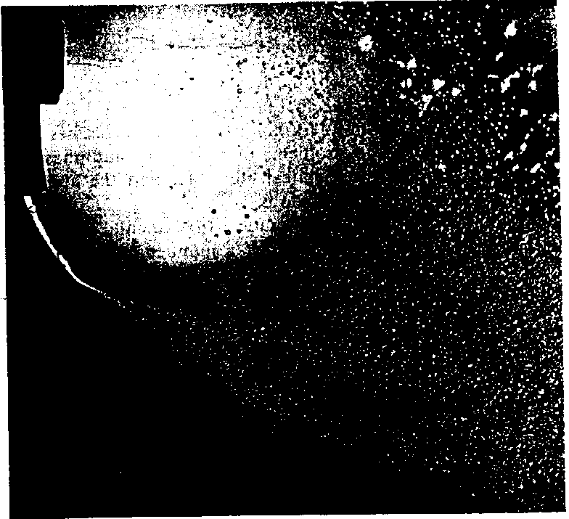

FIGURE 7-4: Breakup in a liquid jet at velocities above the critical.24
Courtesy: Prof. E. G. Richardson and Journal of Colloid Science.

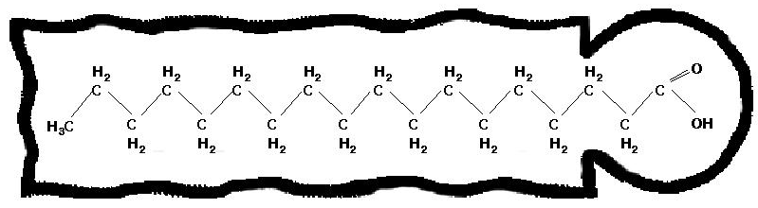

FIGURE 2-10: The structure of stearic acid considered as an amphiphilic compound. Thc section in the rectangle is the non-polar, hydrophobic, hydrocarbon tail; thc section in the circle is the polar, hydrophilic, carboxylic head.
APPENDIX 1 (cont’d)
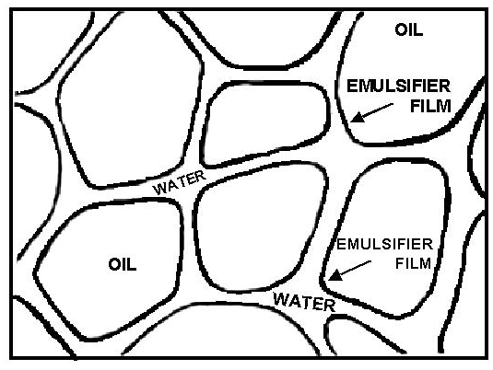
FIGURE 19: The structure of a true emulsion.

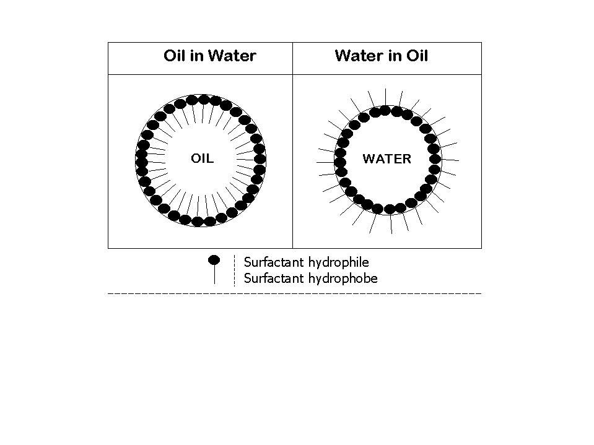
 | Droplet Size of  Dispersed Phase¹ |  | Appearance
 | < 1 μm |  | Opaque, white
 | 0.1 - 1 μm |  | Opaque, blue-white
 | 0.05 – 0.1 μm |  | Gray, semitransparent
 | 0.01 – 0.05 1 μm |  | Transparent
¹Macroemulsions (0.2-50 μm); ¹Microemulsions (0.01-0.2 μm).

Figure 3.6: Oil-in-water and water-in-oil emulsion types and typical appearances.
APPENDIX 1 (cont’d)
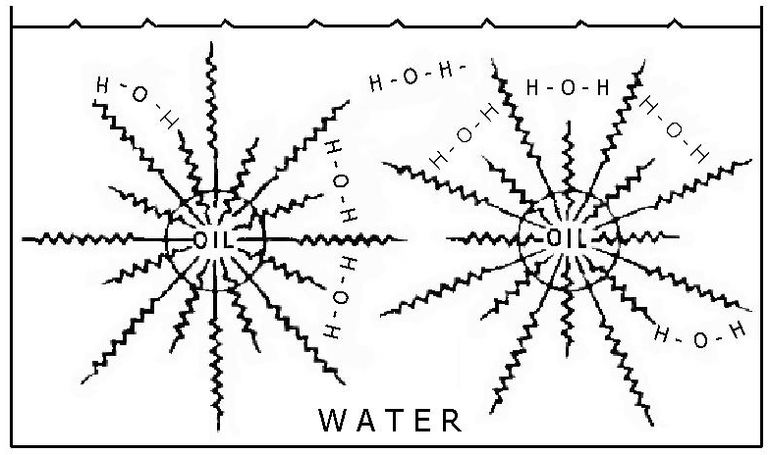
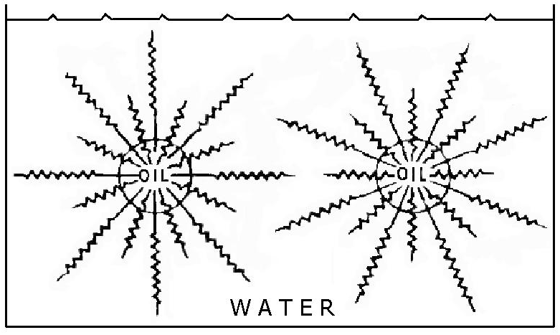
FIGURE 3: Hydrogen bonding between non-ionic emulsifiers confers further rigidity and stability to interfacial films. (Though Ref. 25)

FIGURE 2: Non-ionic polyoxyethylene type of emulsifier forming a zigzag protective interfacial film in an oil-in-water emulsion. (Through Ref. 17)
APPENDIX 1 (cont’d)

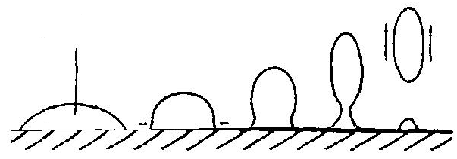
Liquid (oil) soil
Roll-up

FIGURE 3.5: “Roll-up” mechanism for removal of liquid oil soils.

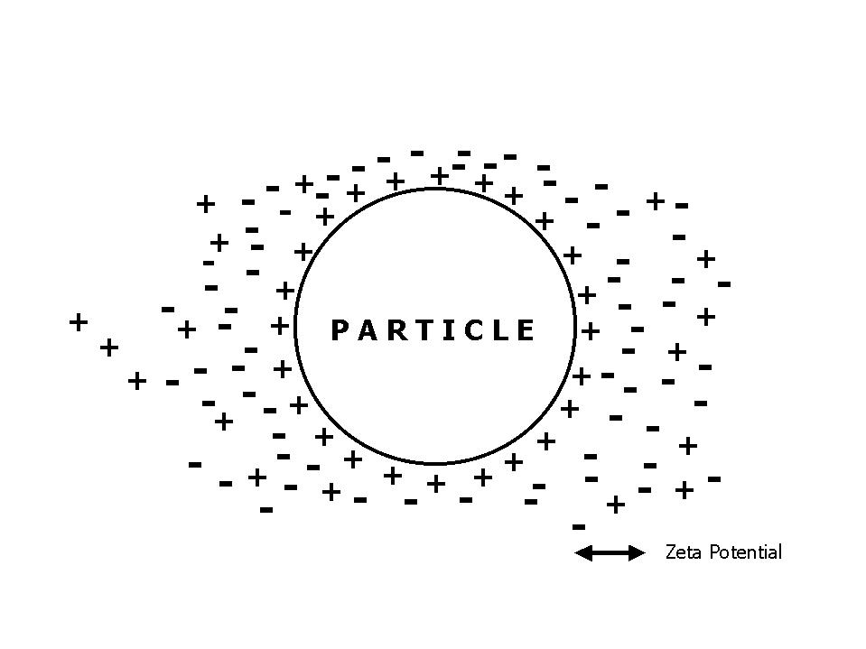

FIGURE ____: Electric Double Layer

APPENDIX 2

LUBRICATION HANDBOOK
THEORY OF LUBRICATION

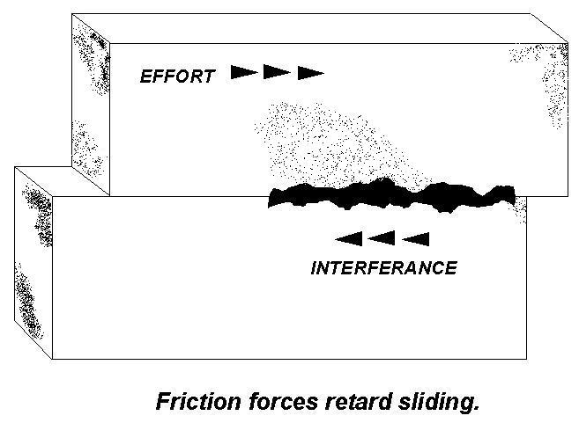 | When one rough metal block is pushed across a second rough metal block, microscopic peaks on the block surface interfere with the sliding action and cause a form of solid friction. Sliding two smooth surfaces against each other causes welding—a second form of solid friction.  Friction can be reduced by employing smooth surfaces that keep interference friction low, and by choosing dissimilar metals that will reduce metal-to-metal welding.  Surfaces designed to allow relative movement between components while providing support, or
guiding movements, are subject to friction and wear. Wear can be essentially eliminated and friction can be controlled to the point where it presents little problem through proper design and lubrication.
Hydrodynamic lubrication shows a continuous film of fluid lubricant separating the surfaces; the relative surface movement has created an oil wedge that supports the upper component.  The lubricant used should have the proper viscosity, or resistance to flow, so it has sufficient "body" or "thickness" to resist being squeezed-out while being thin enough to prevent excessive fluid friction.  Looking at a simple journal-bearing, we see that journal rotation causes the formation of a lubricant |  |  | 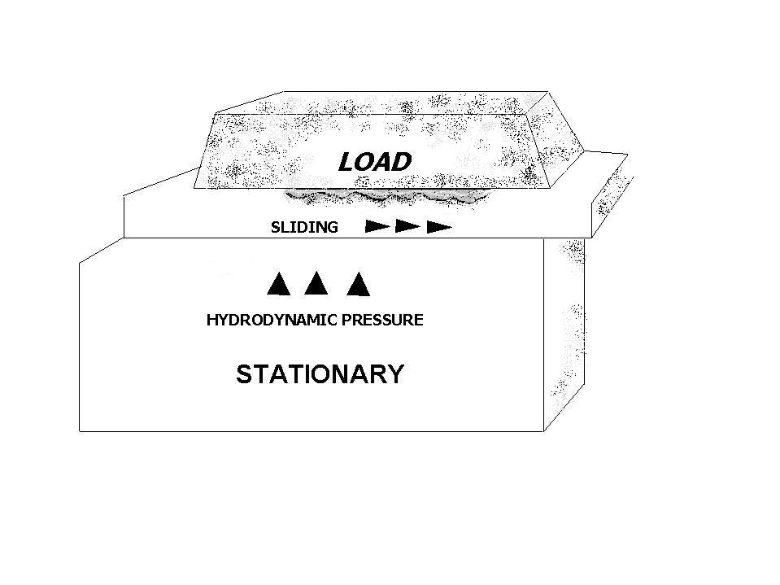
wedge just like the flat surfaces shown earlier. The pressure generated by this wedge reaches a maximum at the point where the lubricant film is thinnest; pressure is lowest at the bearing edges and at the bearing inlets and outlets.
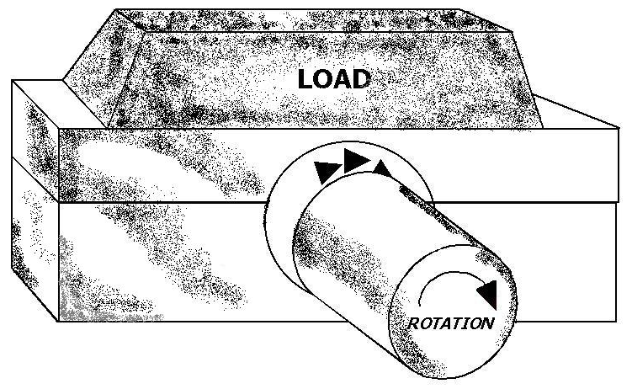 |  | All full-time lubricants involve the lubricant wedge and pressure build-up.  Some surfaces are so highly loaded that the lubricant film is interrupted, requiring "extreme pressure" (EP) lubrication. Mixed film lubrication, involving monomolecular films and frequent metal-to-metal contact, generally provides low-friction sliding and controlled wear of the metal. As this film is constantly removed by the continuing contact, the surfaces are eaten away, but at a
Lubricant wedges support  bearing pressures. |  | tolerable rate, avoiding catastrophic wear that would occur with a non-EP lube.

APPENDIX 2 (cont'd.)

LUBRICANT TYPES

There are four basic types of metalworking lubricants used in metal forming and metal cutting operations. They include: Straight Oils, Soluble Oils, Semi-synthetics and Synthetics.

STRAIGHT OILS
Straight oils have been around the longest. They include mineral oils, napthenic and paraffinic oils and vegetable oils such as lard and castor oil. To the base oils, additives are often blended to improve EP, anti-weld, etc. They typically offer excellent lubricating properties with only minimal heat-transfer or "cooling."

SOLUBLE OILS
Soluble oils were developed to offer the lubricating properties of oils with the cooling properties of water. Soluble oils perform well on ferrous and non-ferrous metal. One drawback of soluble oils is their tendency for biodegradation.

SEMI-SYNTHETICS
Semi-synthetics are basically water solutions with small amounts of oil micro-emulsified for improved lubricity while offering the cooling properties and cleanliness of synthetics.

SYNTHETICS
Synthetics are non-petroleum-based materials which offer varying degrees of lubricity with excellent cooling and cleanliness. Synthetics are preferred because they are bio-degradeable, less likely to become rancid and generally do not cause dermatitis. They also make filtering and recycling an easier possibility.

LUBRICANT COMPOSITION

Most high quality lubricants contain additives. Some of the more common additives, the reason for their use, their function and the way they enhance performance include:

TYPE | REASON FOR USE | HOW THEY WORK | ADVERSE EFFECTS | LIMITS OF ACTIVITY | TYPICAL COMPOUNDS
Emulsifiers | Hold lubricant and water together in soluble oils and semi-synthetics. | Polar-type compounds line up at the lube/water interface providing the solubility bridges between the fluid and water. | Reduces oxidation resistance. Fights activity of anti-wear, EP, oiliness, anti-rust and anti-foam agents. May cause seal swell. | Different emulsifier packages must be used for each base lube. | Metal sulfonates, glycols, ethoxylated phenols, alcohols or acids, napthenic acids
Extreme Pressure (EP) and/or Lubricity Agents | Modify friction, reduce wear, prevent galling and seizing, | Form bonds that provide supplemental "wear surfaces." The key is "control," not elimination. | Promote oil oxidation, foaming, and emulsion tendencies. Thermal stability is weakened. | Heat (metal-to-metal contact) is needed Notable properties are obtained with one EP additive | Oiliness = fatty acids, amides, esters & soaps. Antiwear = phosphates, lead, sulfur, chlorine, poly-alkaline glycols.
pH/Alkalinity Buffers | Maintain sufficient alkalinity to retard biodegradation and corrosion. | Larger amounts of alkaline materials having a low pK_{b} value require large amounts of acid contaminants or decomposition to neutralize them. | Too high pH can cause skin irritation and metal attack. Too low pH results in bio-activity and rust. | Affected by some water sources, concentration fluctuation and contaminants. | Amines, caustics, carbonates.
Corrosion Inhibitors | Prevent oxidation of machine surfaces, tools and work pieces. | Polar-type compounds react with, or are absorbed by, metal surfaces. | Reduce oxidation resistance in lube, tendency to emulsify, may leave sticky residues. | Most require direct contact for effectiveness. They deplete and must be replaced. | Organics, soaps, carboxylates, sulfonates, phosphate, organic acids and esters, molybdates and borates.
Anti-foamants | Ensure rapid collapse of large air bubbles. Prevent excessive lubricant oxidation. | Attracted to lube/air interfaces; lowers surface tension of air bubbles causing quick break. | Silicone types promote air entrapment. Others increase emulsion tendency. | Some lube additives or contaminants render anti-foams ineffective. | Silicone polymers, methyl acrylic polymers, stearates
Demulsifiers | Encourage rejection of tramp oils. | React with polar emulsifiers at oil/water interface, breaking solubility bridge between oil and water causing separation. | Demulsification must be controlled to avoid breaking the solubility bridge between the lube and the water. | Some weakly emulsified lube may also be separated out. Avoid over-treatment. | Cationics, polymers
Preservatives | Prohibit or retard microbial growth. | Provides an environment toxic to microbes. | Over-concentration can cause irritation to humans. | They're consumed or decomposed. Must be replenished regularly. Most work at pH 8.8-9.2. Resistant strain can develop if under-treated. | Triazines, omadine, phenol, oxizolidines, imidazolines.

MACHINING (CHIP MAKING) OPERATIONS

Broaching | A machining process where a cutting tool having multiple transverse cutting edges is pushed or pulled through a hole or over a surface to remove metal by axial cutting.
Cold Heading | A high speed method of gathering metal in certain sections along lengths of bar, rod or wire by causing the metal to flow between the dies without preheating the metal. This process is used to make fasteners, i.e., bolts, screws, nails, etc. The initial operation forms the head which is the essential part of the fastener.
Drilling | An efficient and economical method of cutting a hole in solid metal. A drill for cutting metal is a rotary end-cutting tool with one or more flutes to promote chip removal and the admission of cutting fluid.
Extruding | A forming technique where steady compressive forces on unheated steel cause its controlled flow into a die.
Grinding | The removal of small chips of metal from the workpiece by the mechanical action of irregularly shaped grains imbedded into a grinding wheel.
Honing | An abrasive machining process designed to improve bore geometry and surface finish.
Punching | The shearing of holes in sheet metal with a punch and die.
Roll Forming | The process of forming strip metal into channels, moldings, architectural sections and similar parts through the use of dies or forming roles.
Stamping | The process used to cut lines of letters, figures and decorations on smooth metal surfaces. The impact of a punch with comparatively sharp projecting outlines impresses the characters into the surface of the metal. Stamping is also used when referring to various press-forming operations, i.e., coining, embossing, blanking and pressing.
Tapping | The machining process for making internal threads. A tap is a cylindrical or conical thread-cutting tool having threads of a desired form on the periphery. Combining rotary with axial motion, the tap cuts or forms the internal thread.
Threading | Cutting external threads on cylindrical or tapered surfaces.
Turning | Generating external surfaces of revolution by thc action of a cutting tool on a rotating workpiece, usually in a lathe.

APPENDIX 3

WASTEWATER TREATMENT PLANT
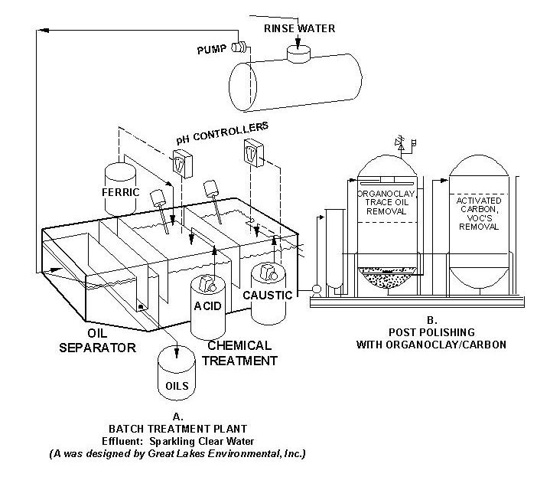

REFERENCES

Becher, Paul, 1965. Emulsions: Theory and Practice. Reinhold Publishing Co., NY. 439 pg.
Braden, M., 1991. Demulsification of Oily Waste Waters. WPCF. #AC-91-061-005, Alexandria, VA 22314-1994.
Braden, M., 1996. Techniques for Breaking Oil and Grease Emulsions. Water Environmental Federation Emulsion Workshop, Dallas, TX
Oct. 6, 1996.
Chemical Encyclopedias.
Cox, M. F. Vista Chemical Co., P.O. Box 200135, Austin, TX. Handbook on Surfactants.
Kemmer, F.N., and J. McCallion, Ed., 1979. The Nalco Water Handbook. McGraw Hill Co., NY.
Lissant, K. J., Ed., 1974. Emulsions and Emulsion Technology: Vol. I, II, III. Marcel Dekker, Inc., NY.
Lismt, K. J., 1983. Demulsification. Marcel Dekker, NY. 162 pp. Encyclopedia Brittanica, Funk and Wagne[
Lubricating Grease Guide, 4th Ed., 1996. National Lubricating and Grease
Institute, Wyandotte Street, Kansas City, MO 64112.

