Research Credit Management Instructions

Your participation in studies for the research pool requirement is managed online. Read the information below carefully to learn how to register, sign up for studies and check your credits online. If you have any questions please email: mgmtpool@u.washington.edu.

Even if you do not plan to take the experiments (i.e., would rather write the papers based on academic research) you should also register for purposes of course credit assignment.

Start by going to: http://uwbs.sona-systems.com

Getting Started: Registration and Login.

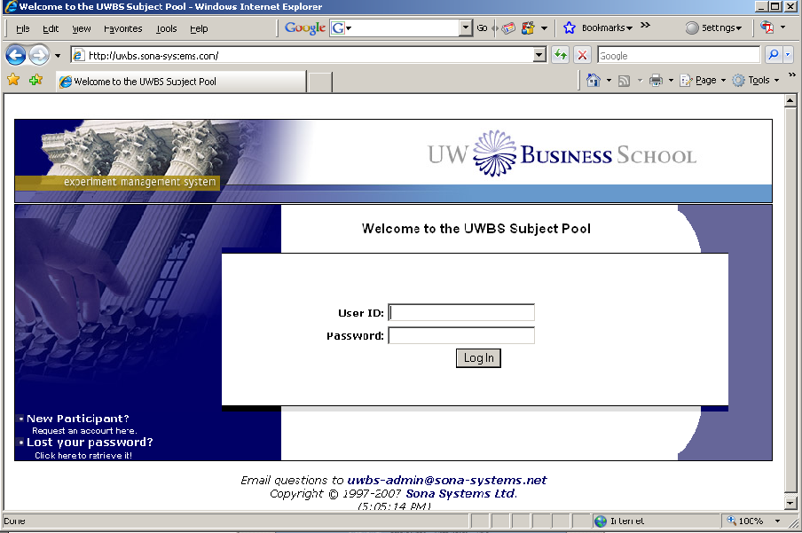
Click on “New Participant” to request an account. From this screen you can also retrieve your password once you are registered (click on “Lost your password?”.

Account Request Screen
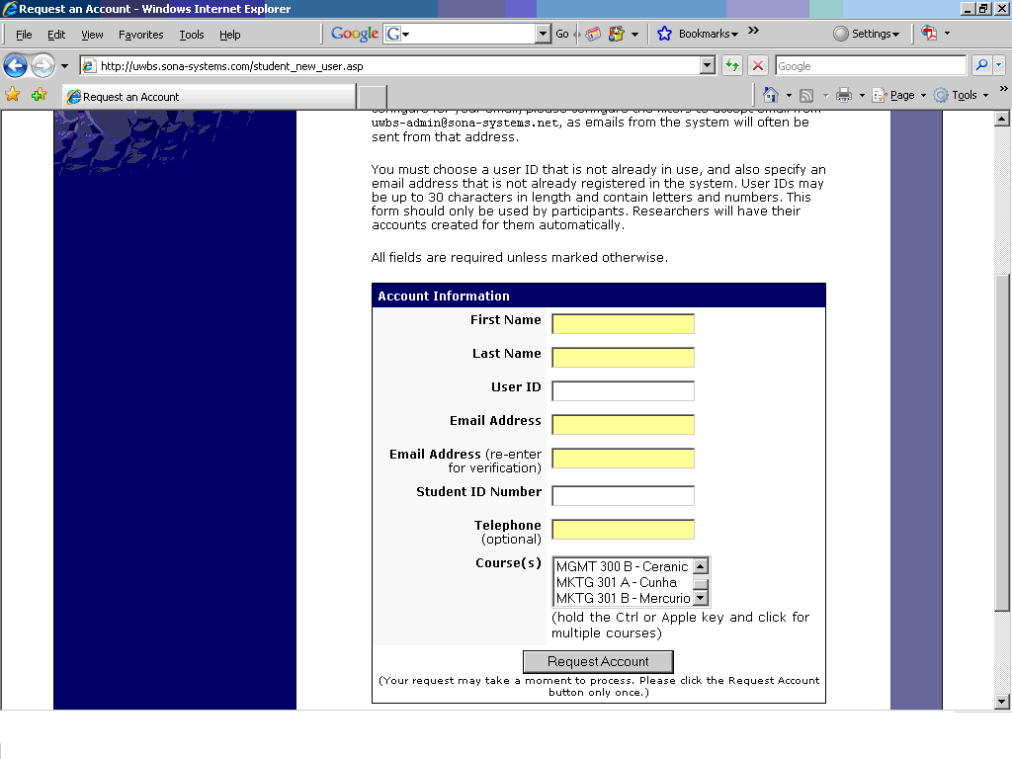
Read the instructions on this screen carefully and fill out the information fields and select your course (or courses) It is very important that you select the courses correctly. Once you click on “request account”, you will receive a validation email with your temporary password from: UWBS Subject Pool. Check your junk mail folder if you don’t see the email in your inbox. Set up your inbox to accept emails from this account since the system will send you automatic reminders of your appointments. Follow the instructions in the email and login to your account (you should change your password once you’re logged in).
The first time you login, the system will collect some basic information such as age, race, etc. This information is often used to provide statistics concerning the characteristics of the pool to the Human Subjects Division.

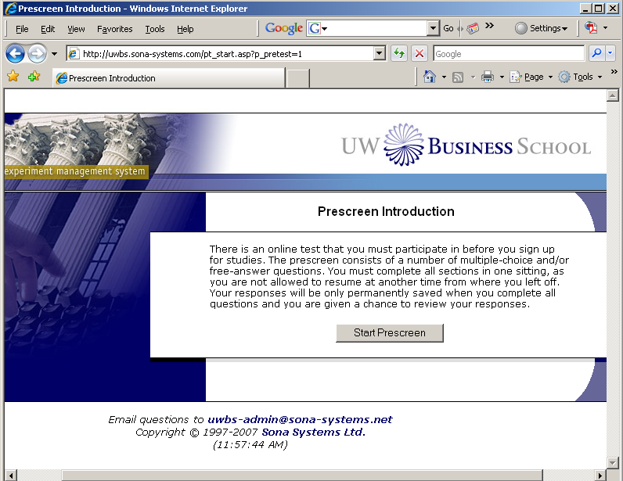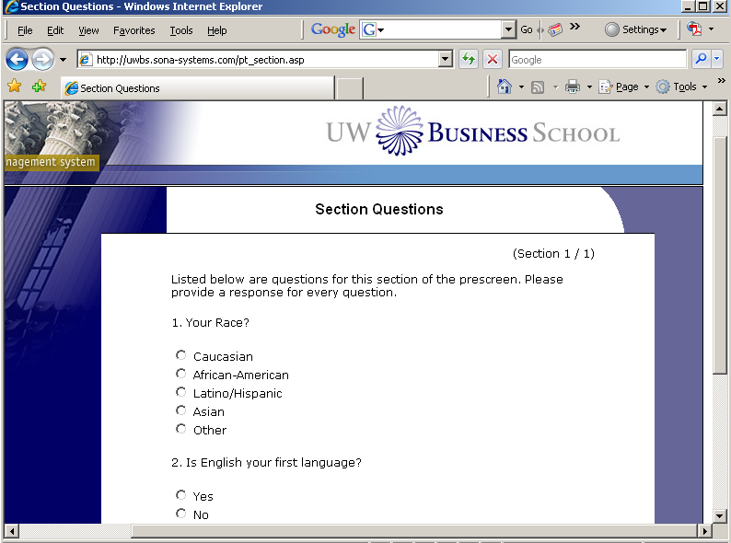

Main Menu Screen
After confirming your answers to the prescreening questions, you will be taken to the main menu screen. On this screen you can sign up for a study, view/cancel appointments, check your assigned credits and make changes to your profile. Just click on the link referring to what you want to do.

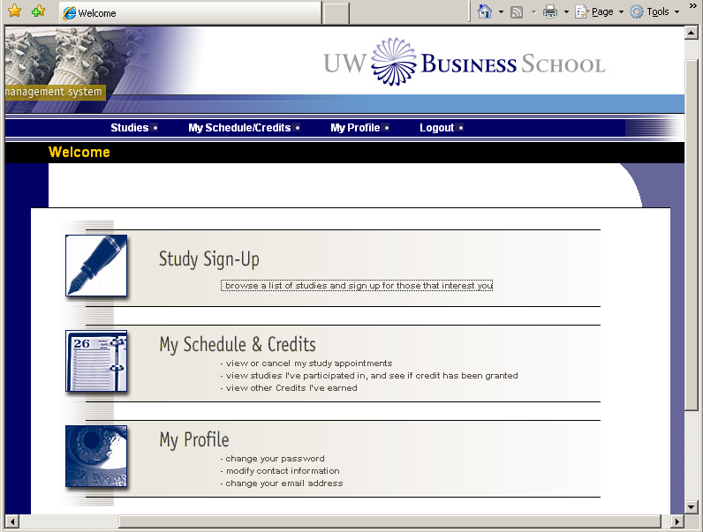
Click on “browse a list…” or on “studies” to see the list of studies available.

To sign up for a study in the lab:

On this screen you will see the list of studies available. Click on the link of the study you wish to take.

On this screen you will see additional information about the study. Click on “View Time Slots for This Study” to see the dates and number of slots available.

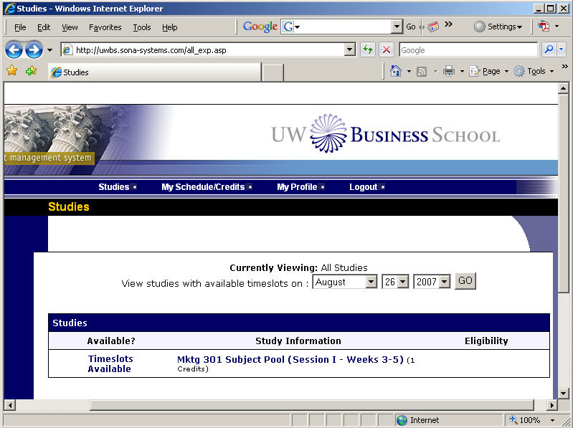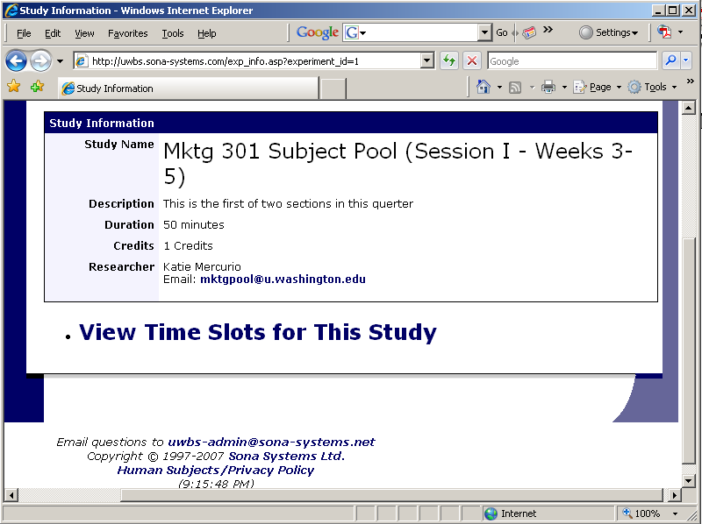

Click on the “Sign Up button” for the day and time you want to take the study.
You will then see information confirming your sign up.

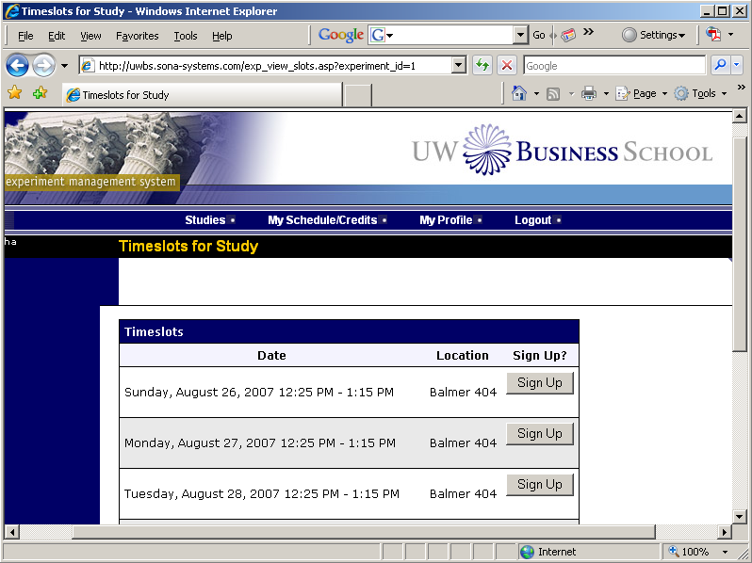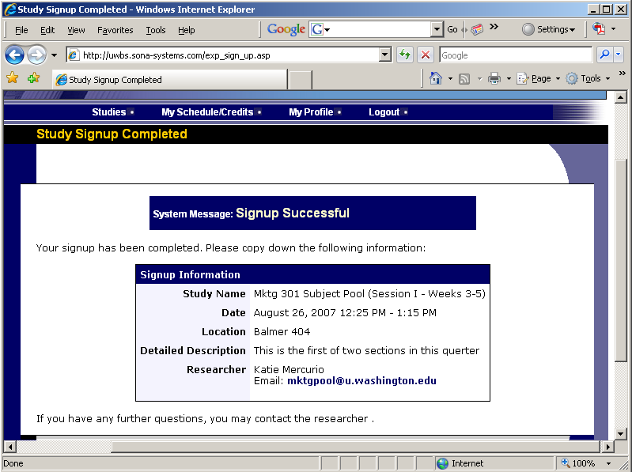

To sign up for an online/Internet Study:
1. Once you’ve selected the study you want to participate in, this screen will open up with instructions. First click the link that says VIEW STUDY WEBSITE. This will open up a new window with a survey for you to complete.
2. After you’ve completed the survey, you’ll see a screen that provides a unique confirmation code. COPY DOWN THIS NUMBER!

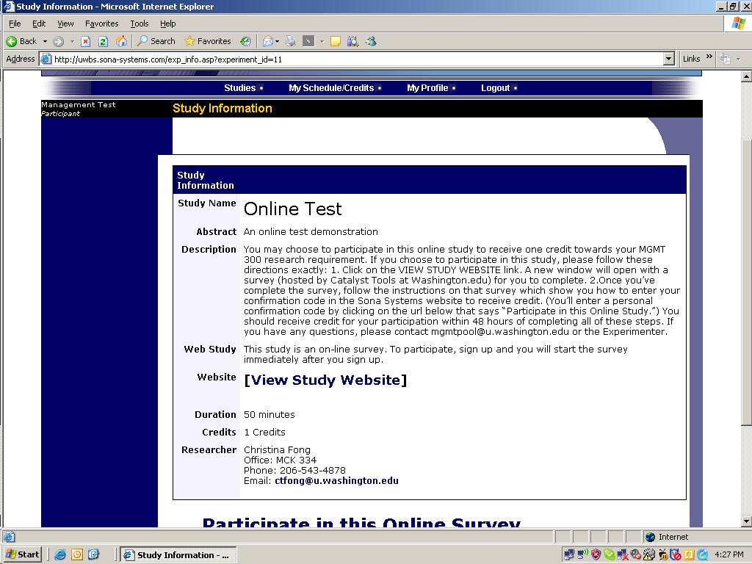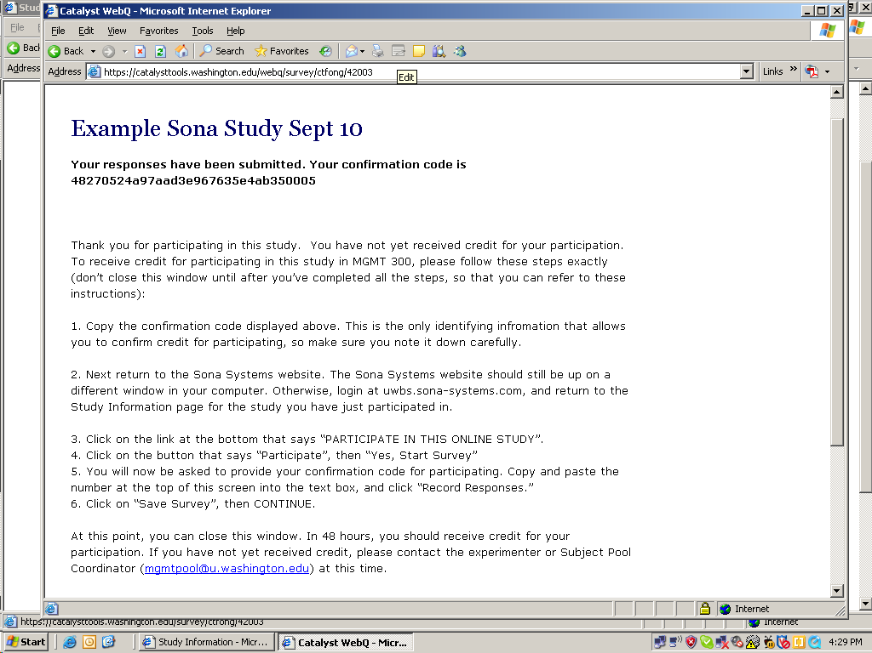
Click here first to do the survey
Copy this number to get credit.
3. Next return to the Sona window and click on the link below that says PARTICIPATE IN THIS ONLINE SURVEY.
4. Once you’ve clicked through a few windows, you’ll be asked for your confirmation code. Paste the code from the Survey Website into this textbox and hit “record.”

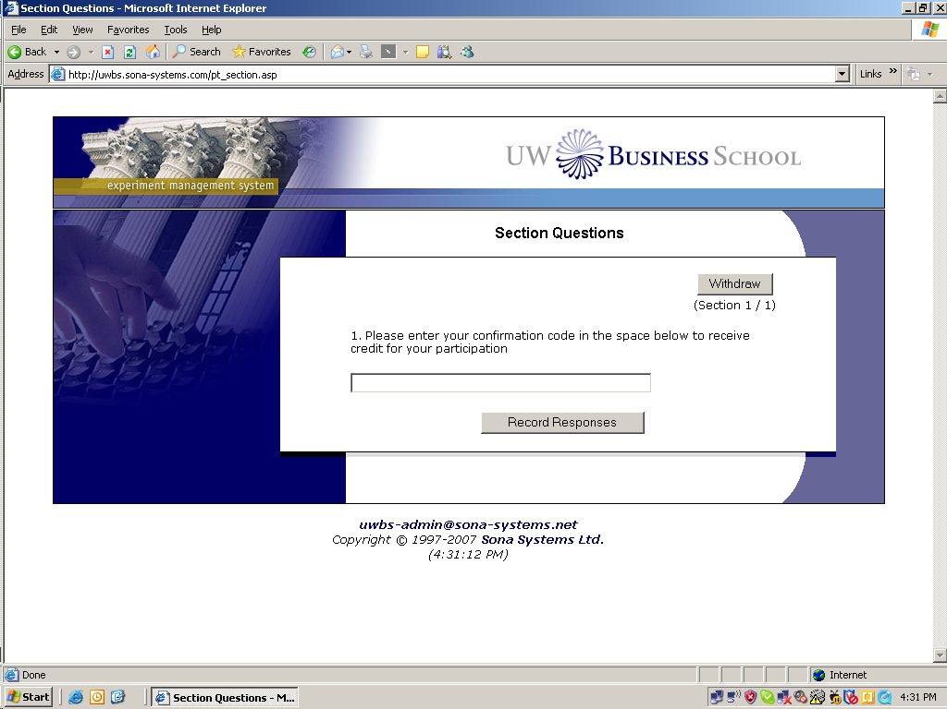
Click here after the survey to get credit.
Enter your confirmation code

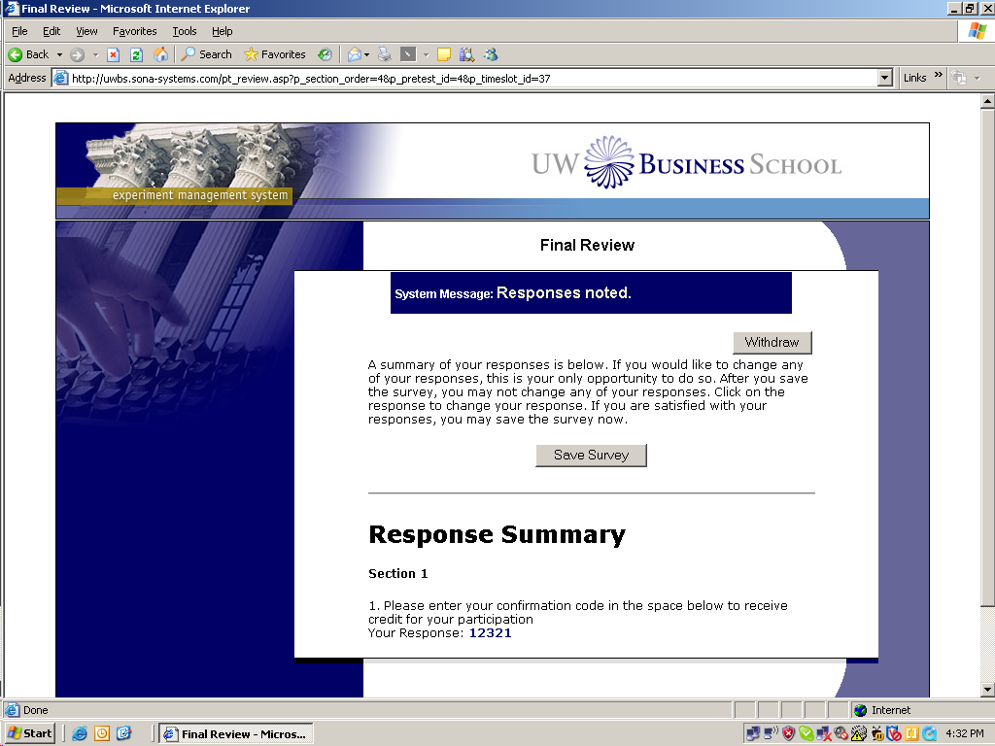
5. Finally, you’ll see a message that says” Information saved and credit granted for completion.” At this point you can close the Survey window, and you should receive credit within 48 hours for your participation.
Schedule and Credits:

Click on “My Schedule & Credits” to view or cancel your participation in studies and to check the credits you have earned (IMPORTANT: credits are posted 48 hours after your participation. Don’t email the experimenter before then.)

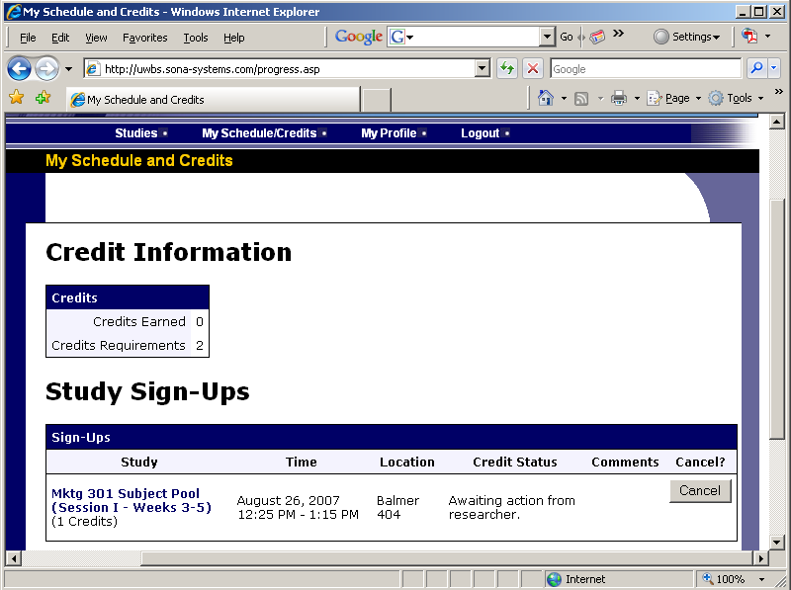
On this screen you can see the number of credits required and earned, as well as information about your current appointments. If you wish to cancel your participation in a study you can use the “Cancel” button. You can use the cancel button if you decide to participate in this study on a different day. You can not sign up for a different day until you cancel an appointment.
Click on “My Profile” to make changes to your personal information and classes that you are enrolled in.

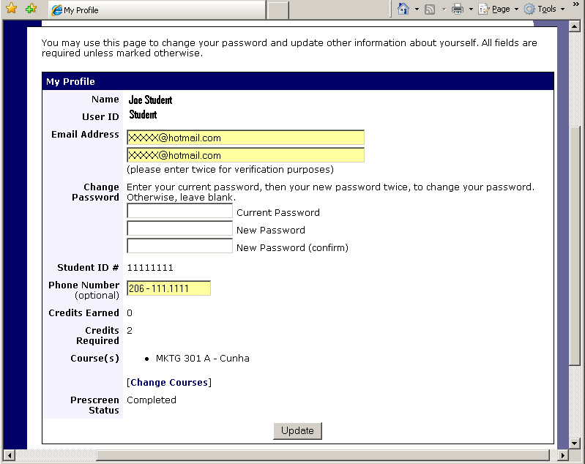
On this screen you can change your information, password and make changes to the courses you are enrolled in by clicking on “Change Courses” (only make changes if you made a mistake when you registered)

Once you made the changes, click on “Update”

For further information contact: mgmtpool@u.washington.edu

