- Use these pictures in your report to discuss the grain shape change as a result of cold-working and annealing
- You can make the pictures smaller if you want, but make sure any important features are still visible
- Pictures of the brass microstructure were taken in two different orientations (LONGITUDINAL and TRANSVERSE) with respect to the direction of Cold-Working
LONGITUDINAL
TRANSVERSE
Direction of Cold-Working (CW)

- For LONGITUDINAL pictures
  - the direction of CW is up and down
  - the length of the bar is up and down
  - the thickness of the bar is right to left
- For TRANSVERSE pictures
  - the direction of CW is into and out of the page
  - the width of the bar is up and down
  - the thickness of the bar is right to left

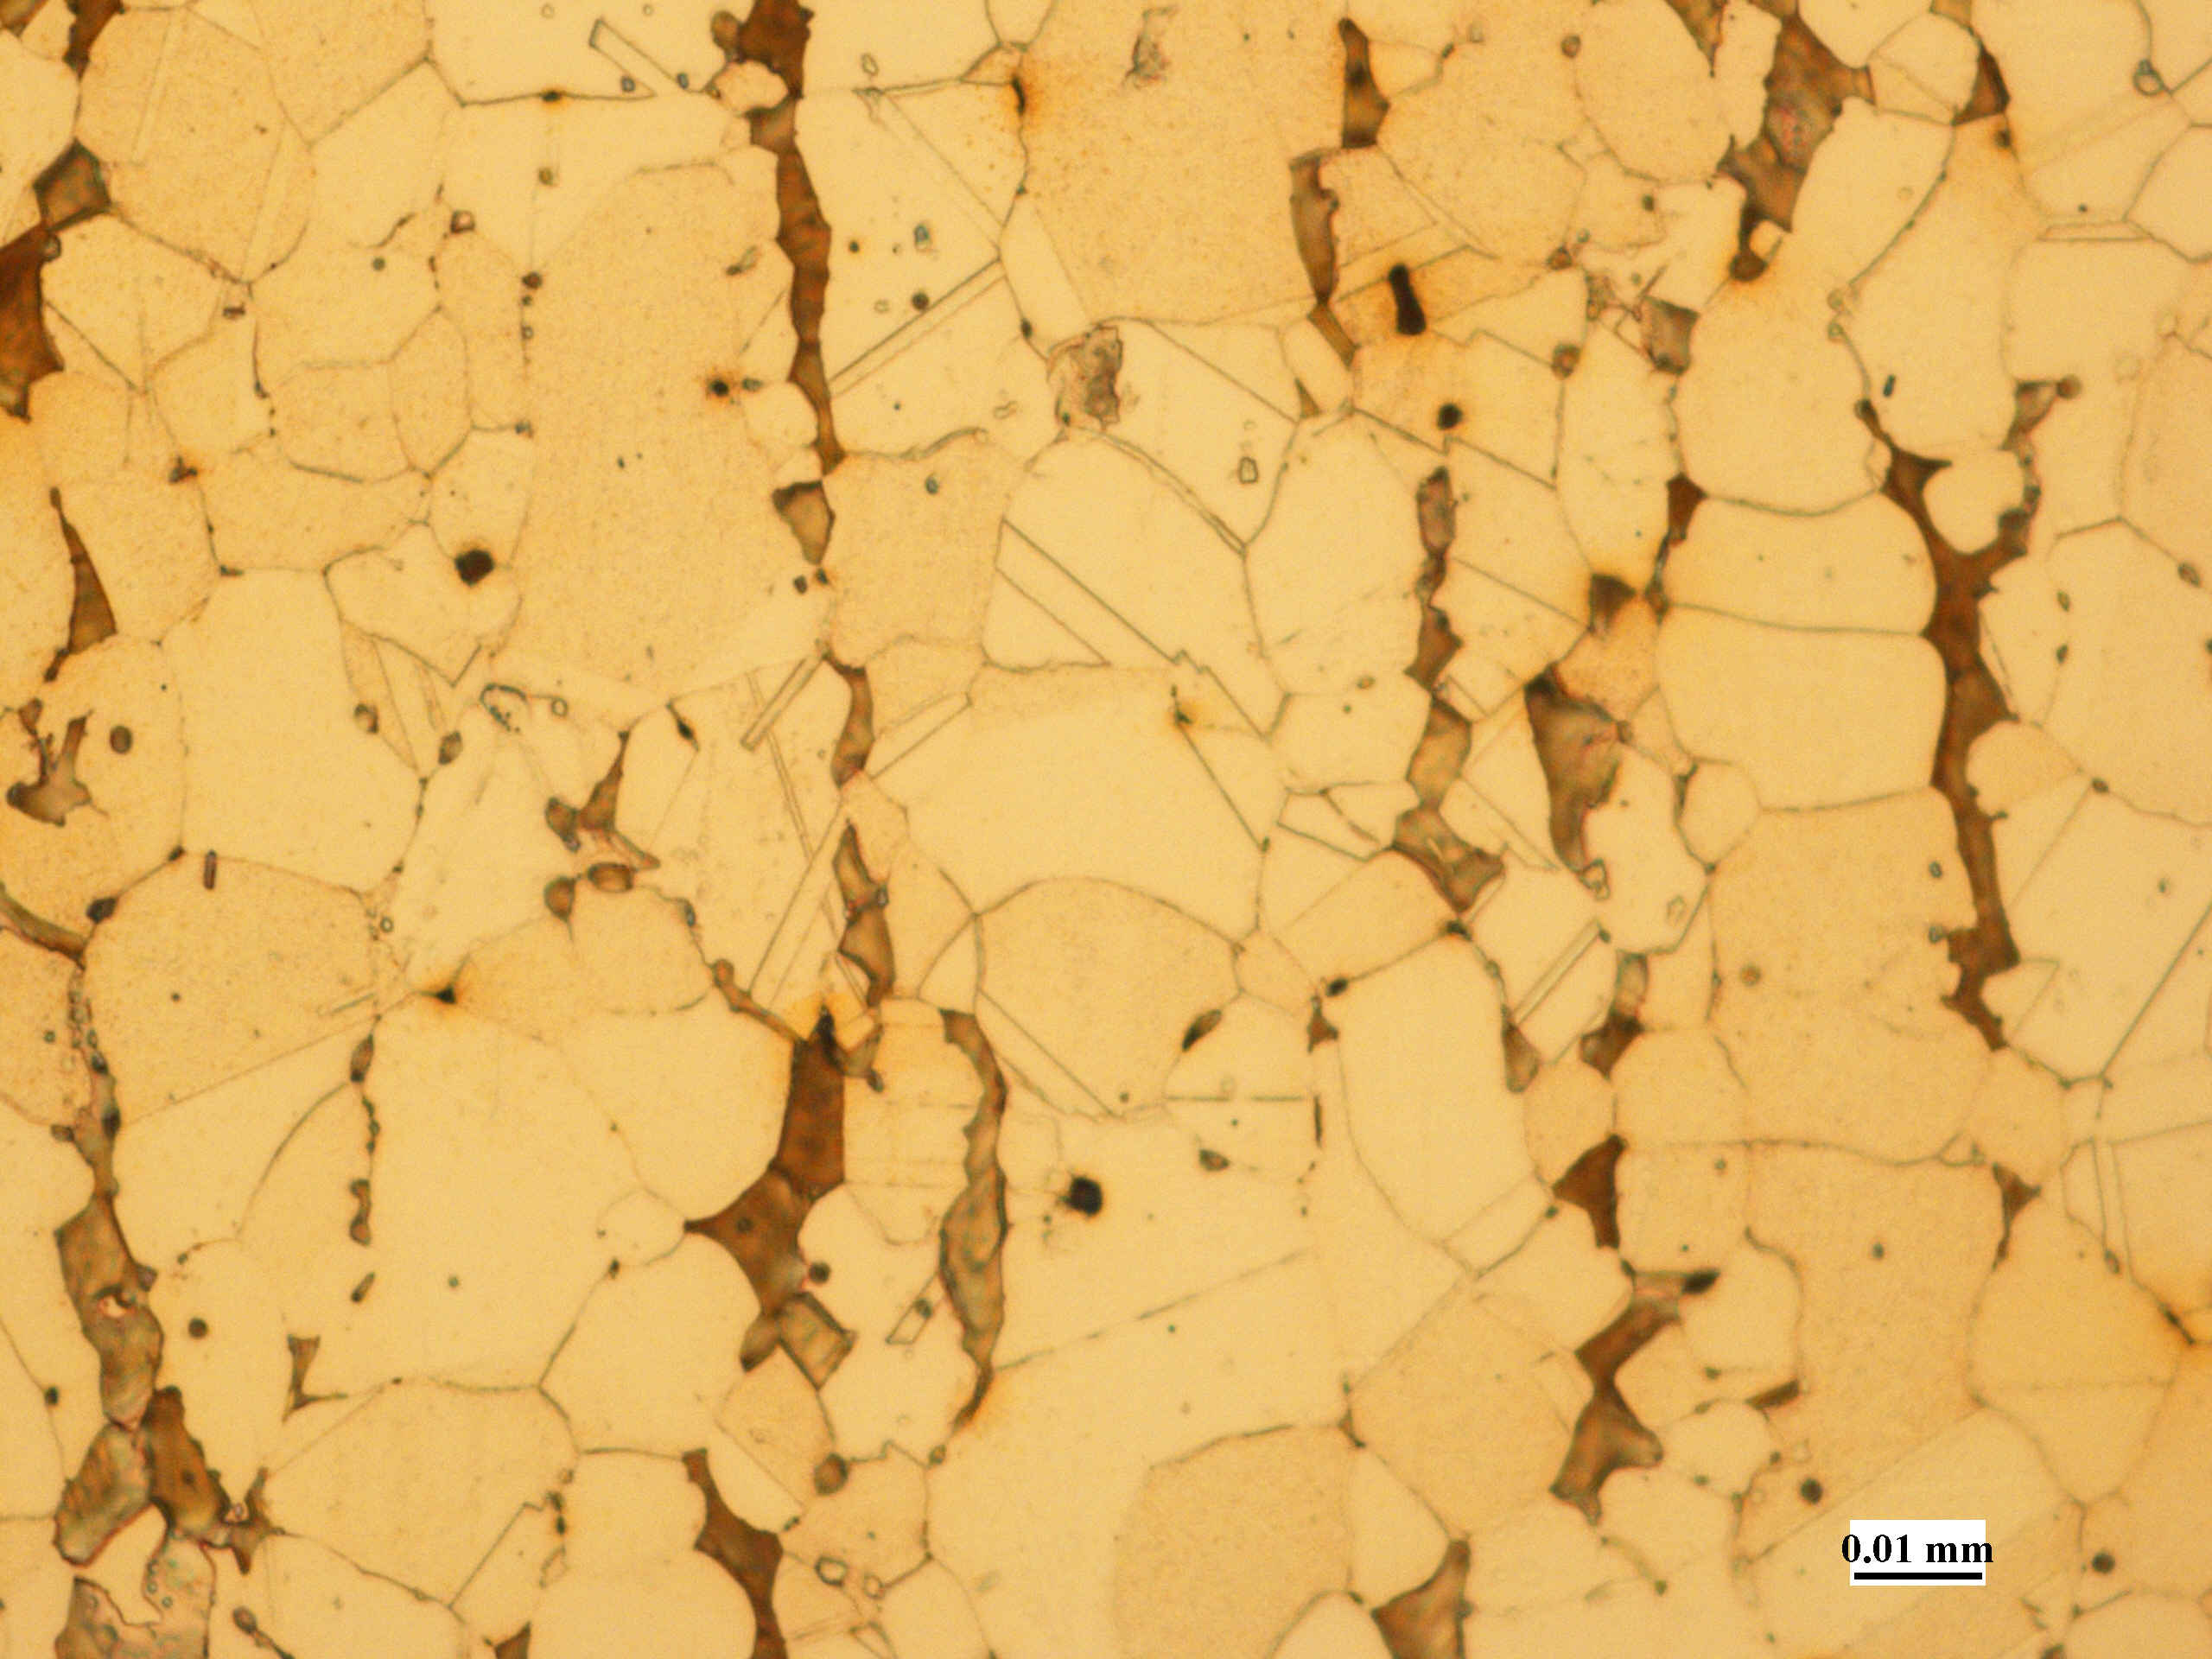
As-Received – Longitudinal
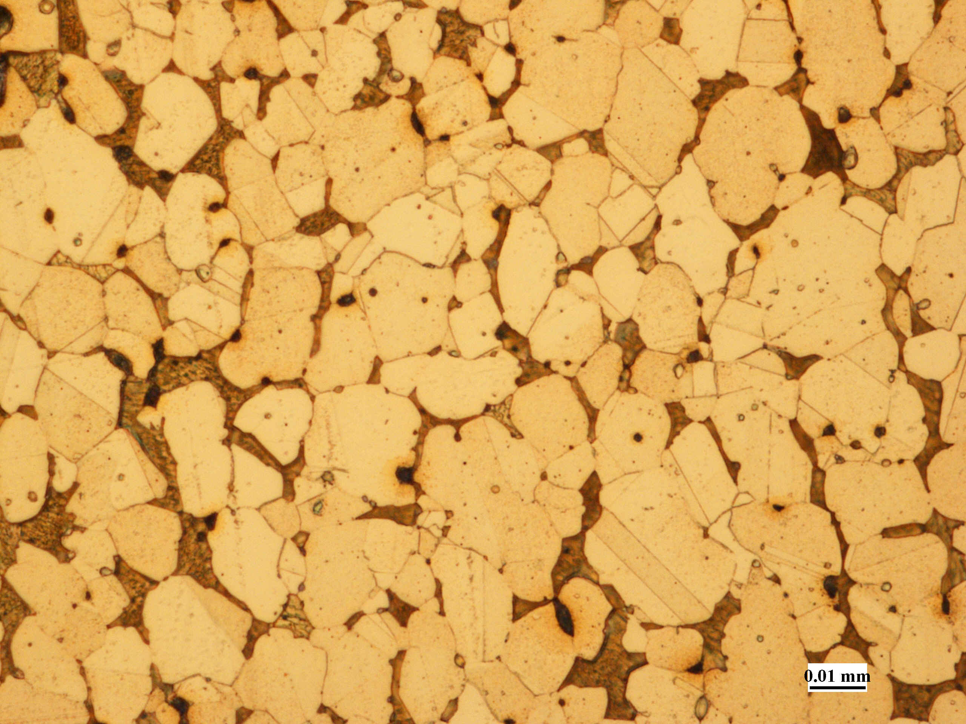
As-Received – Transverse
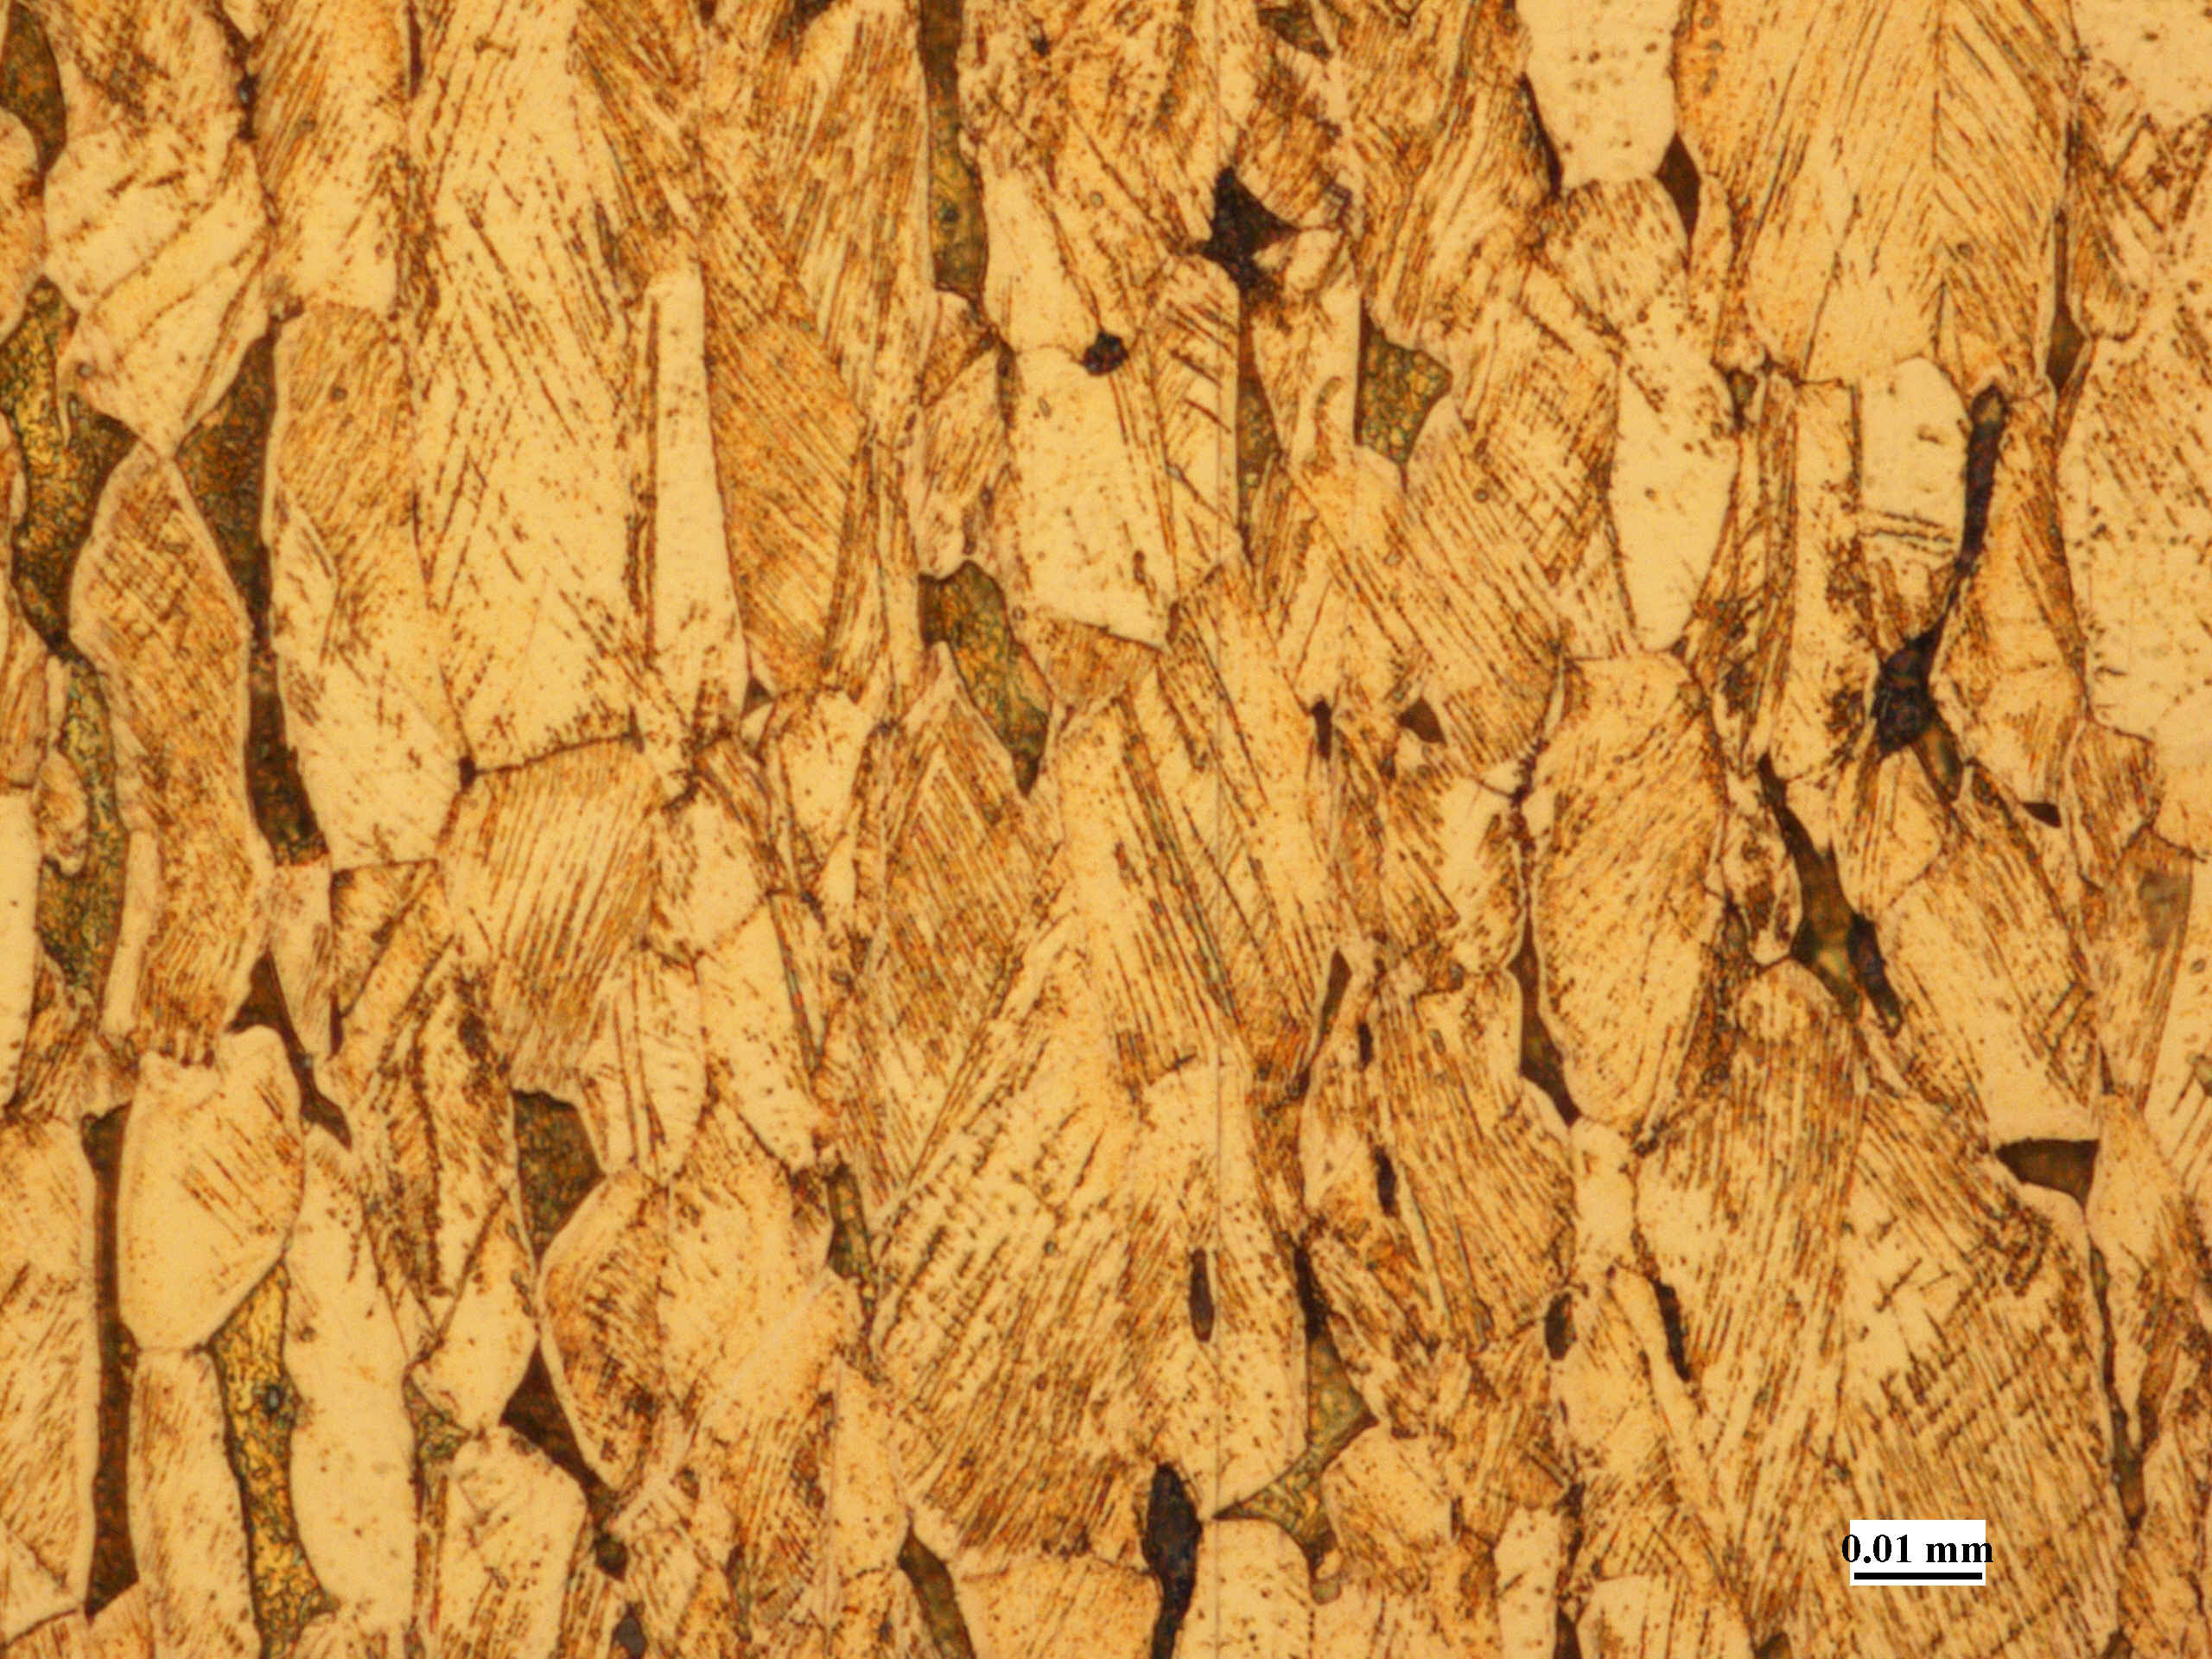
20%CW – longitudinal
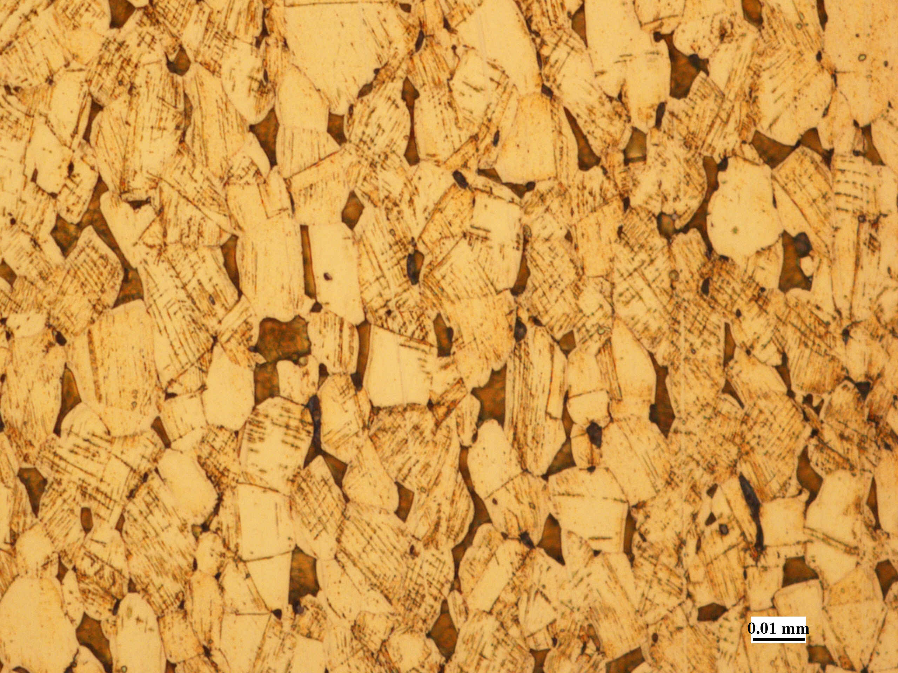
20%CW – transverse
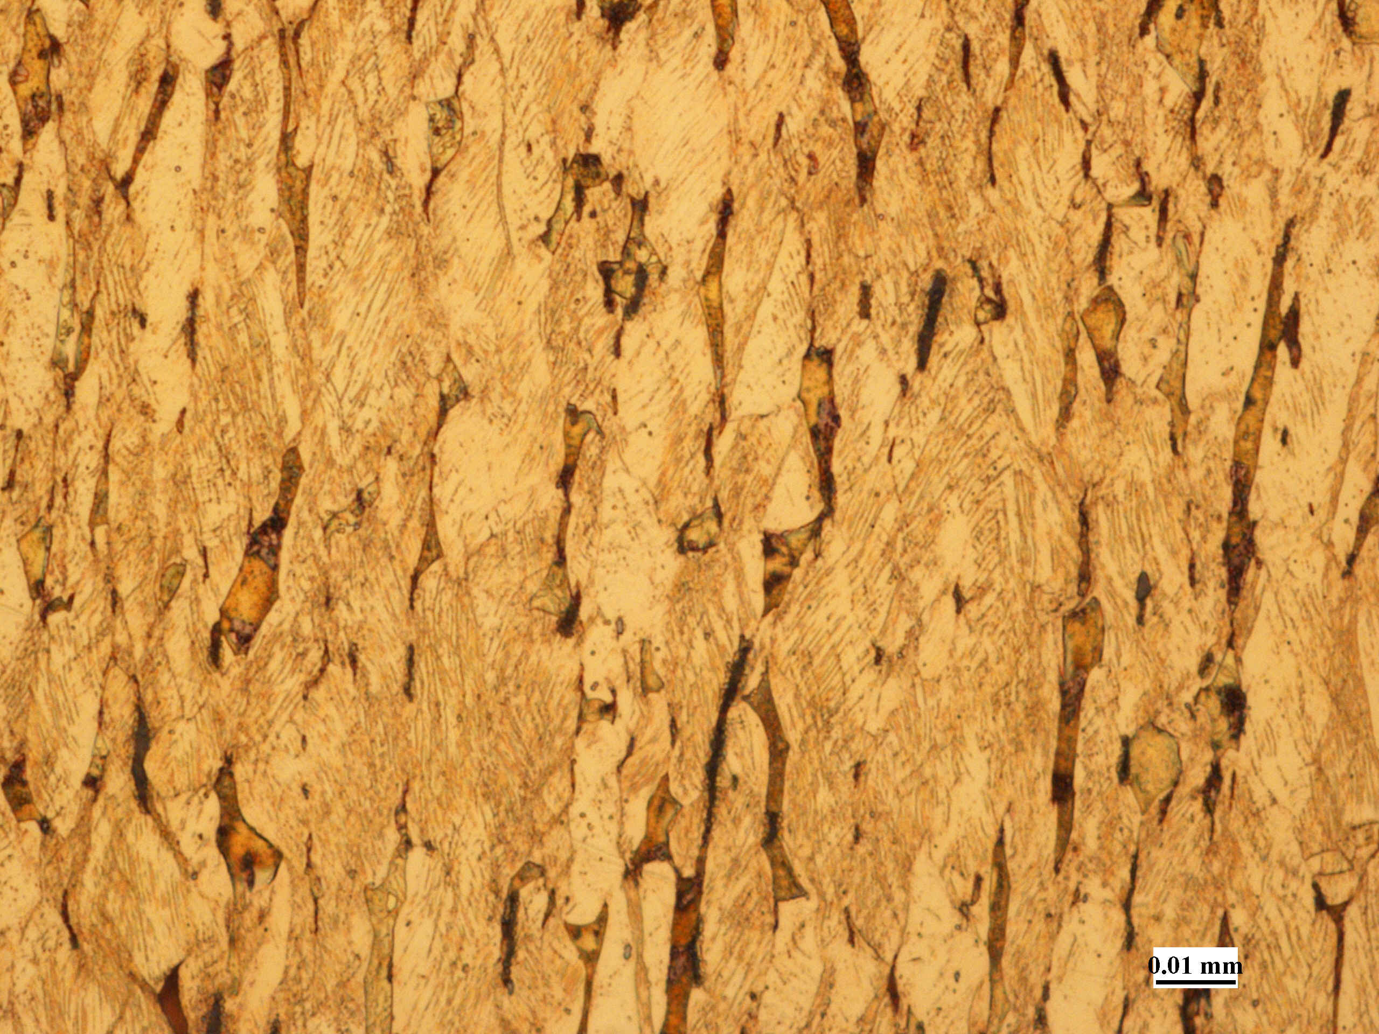
40%CW – longitudinal
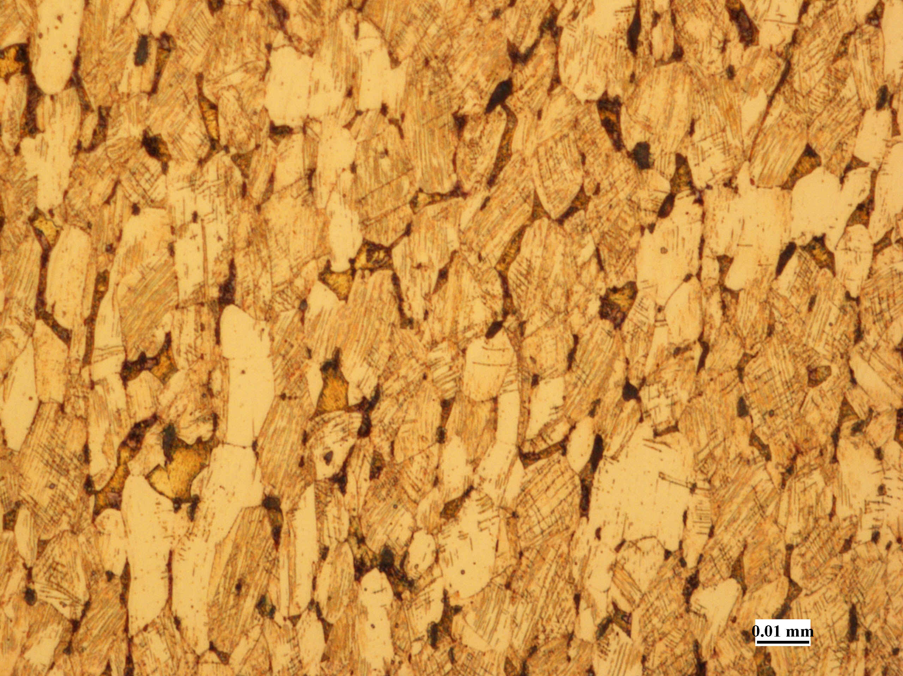
40%CW – transverse
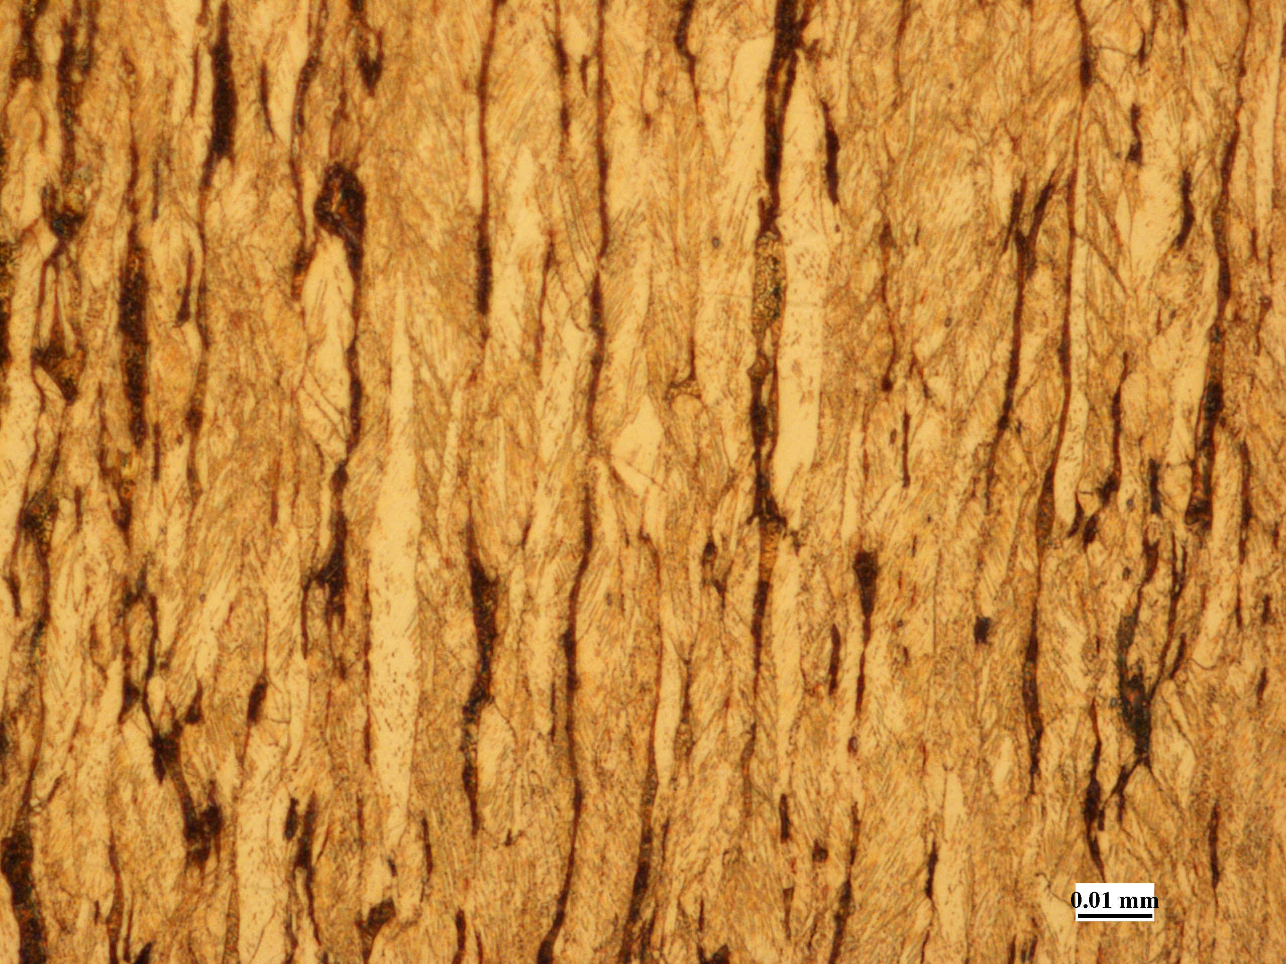
60%CW – longitudinal
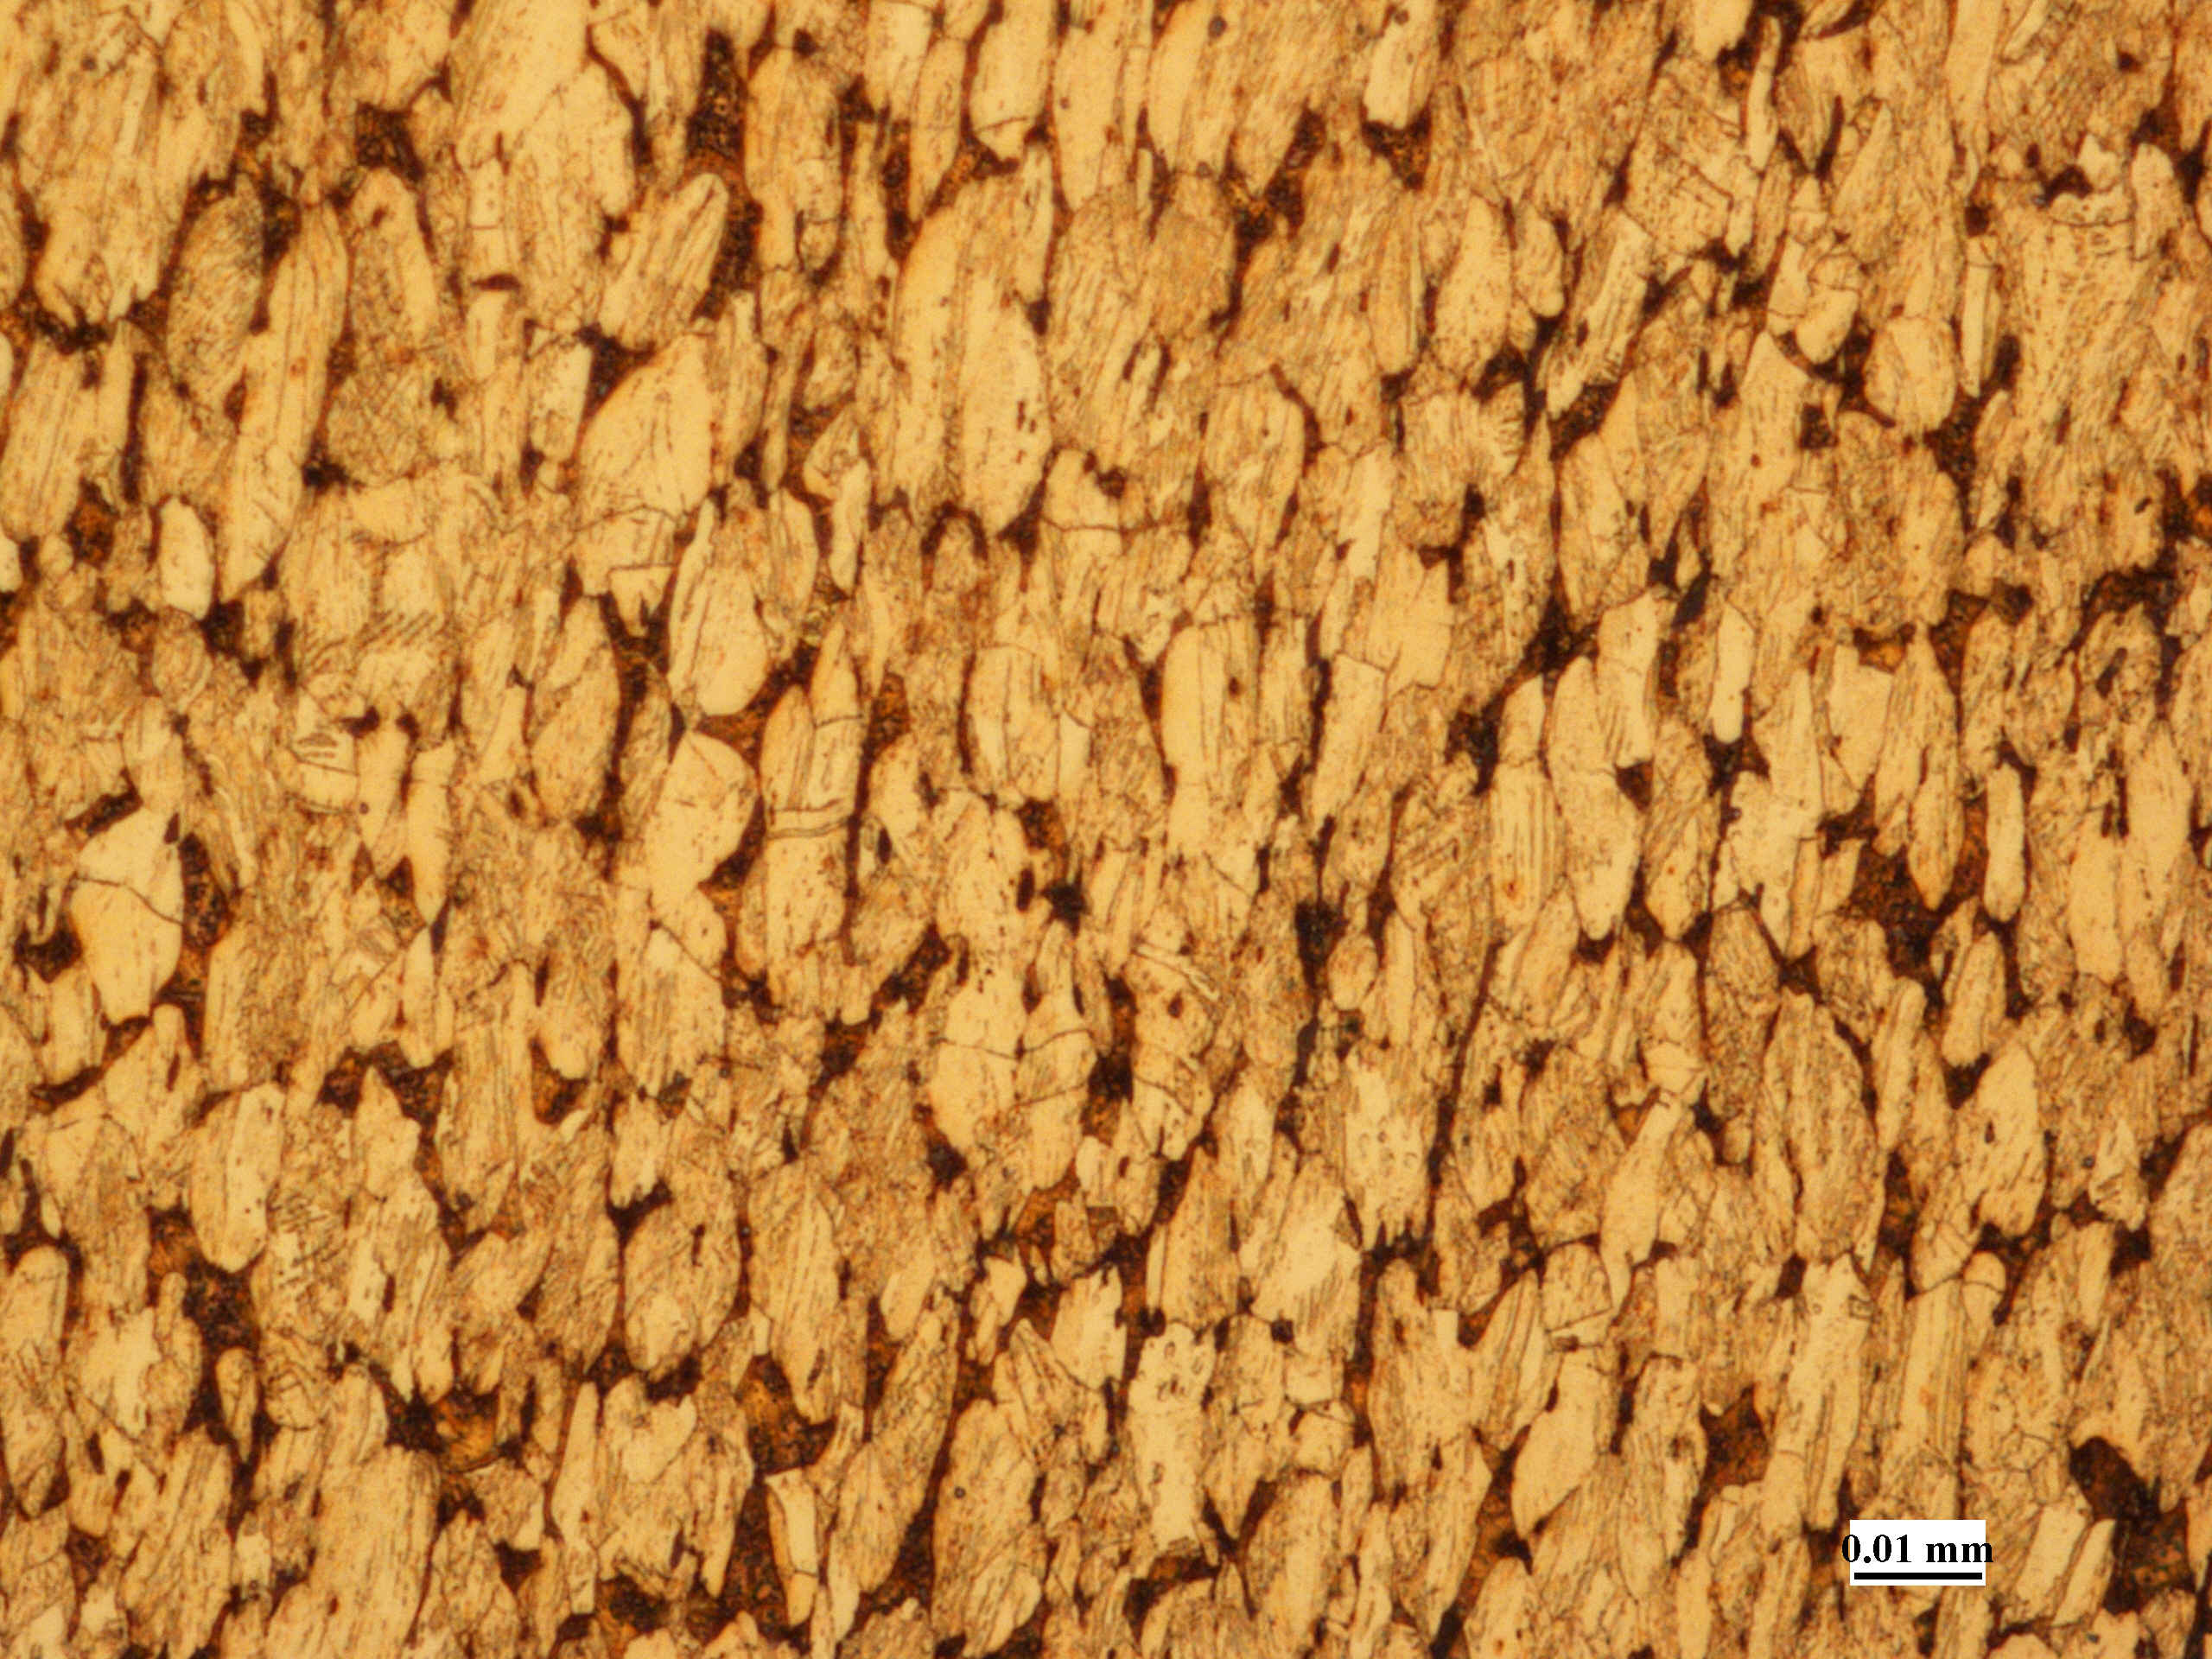
60%CW – transverse
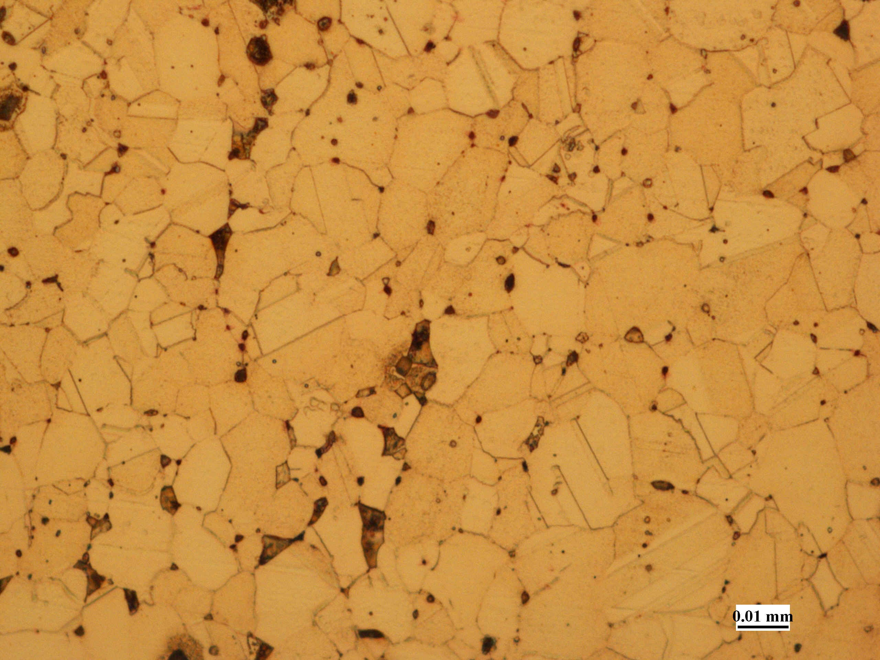
As-Received + Annealed – longitudinal
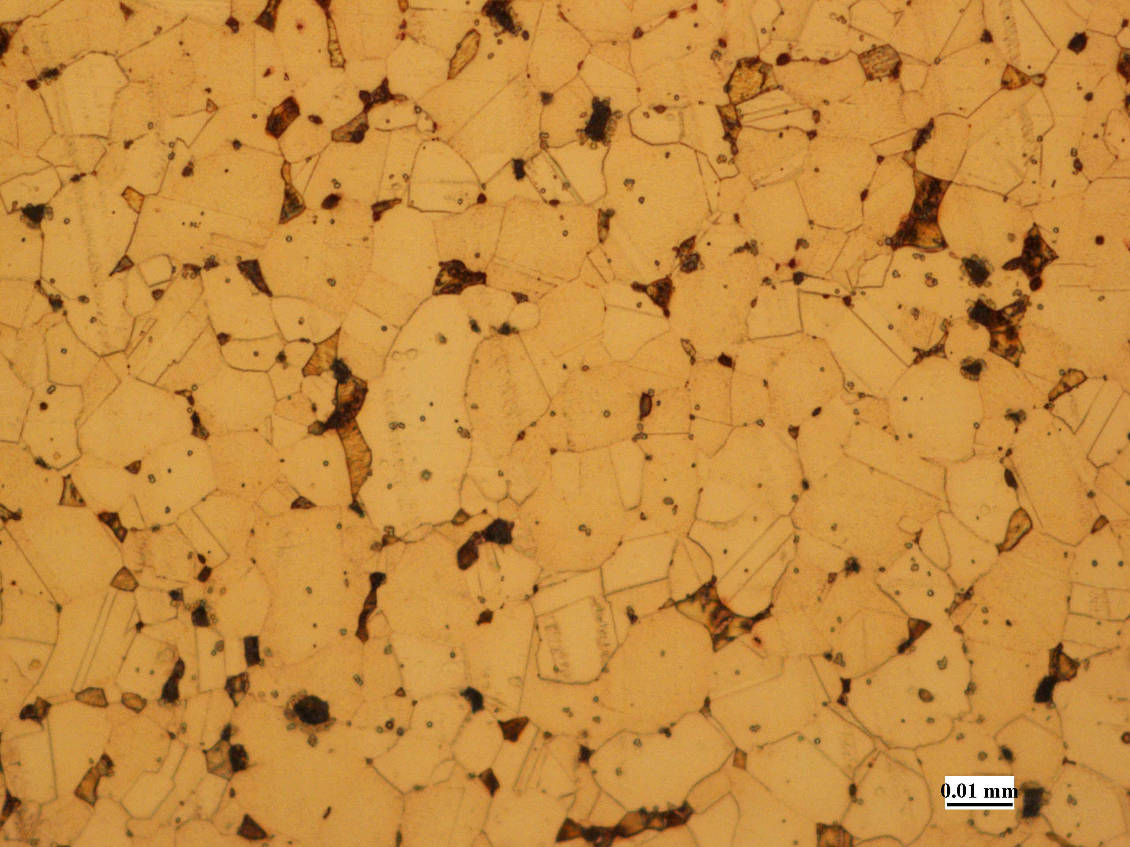
As-Received + Annealed – transverse
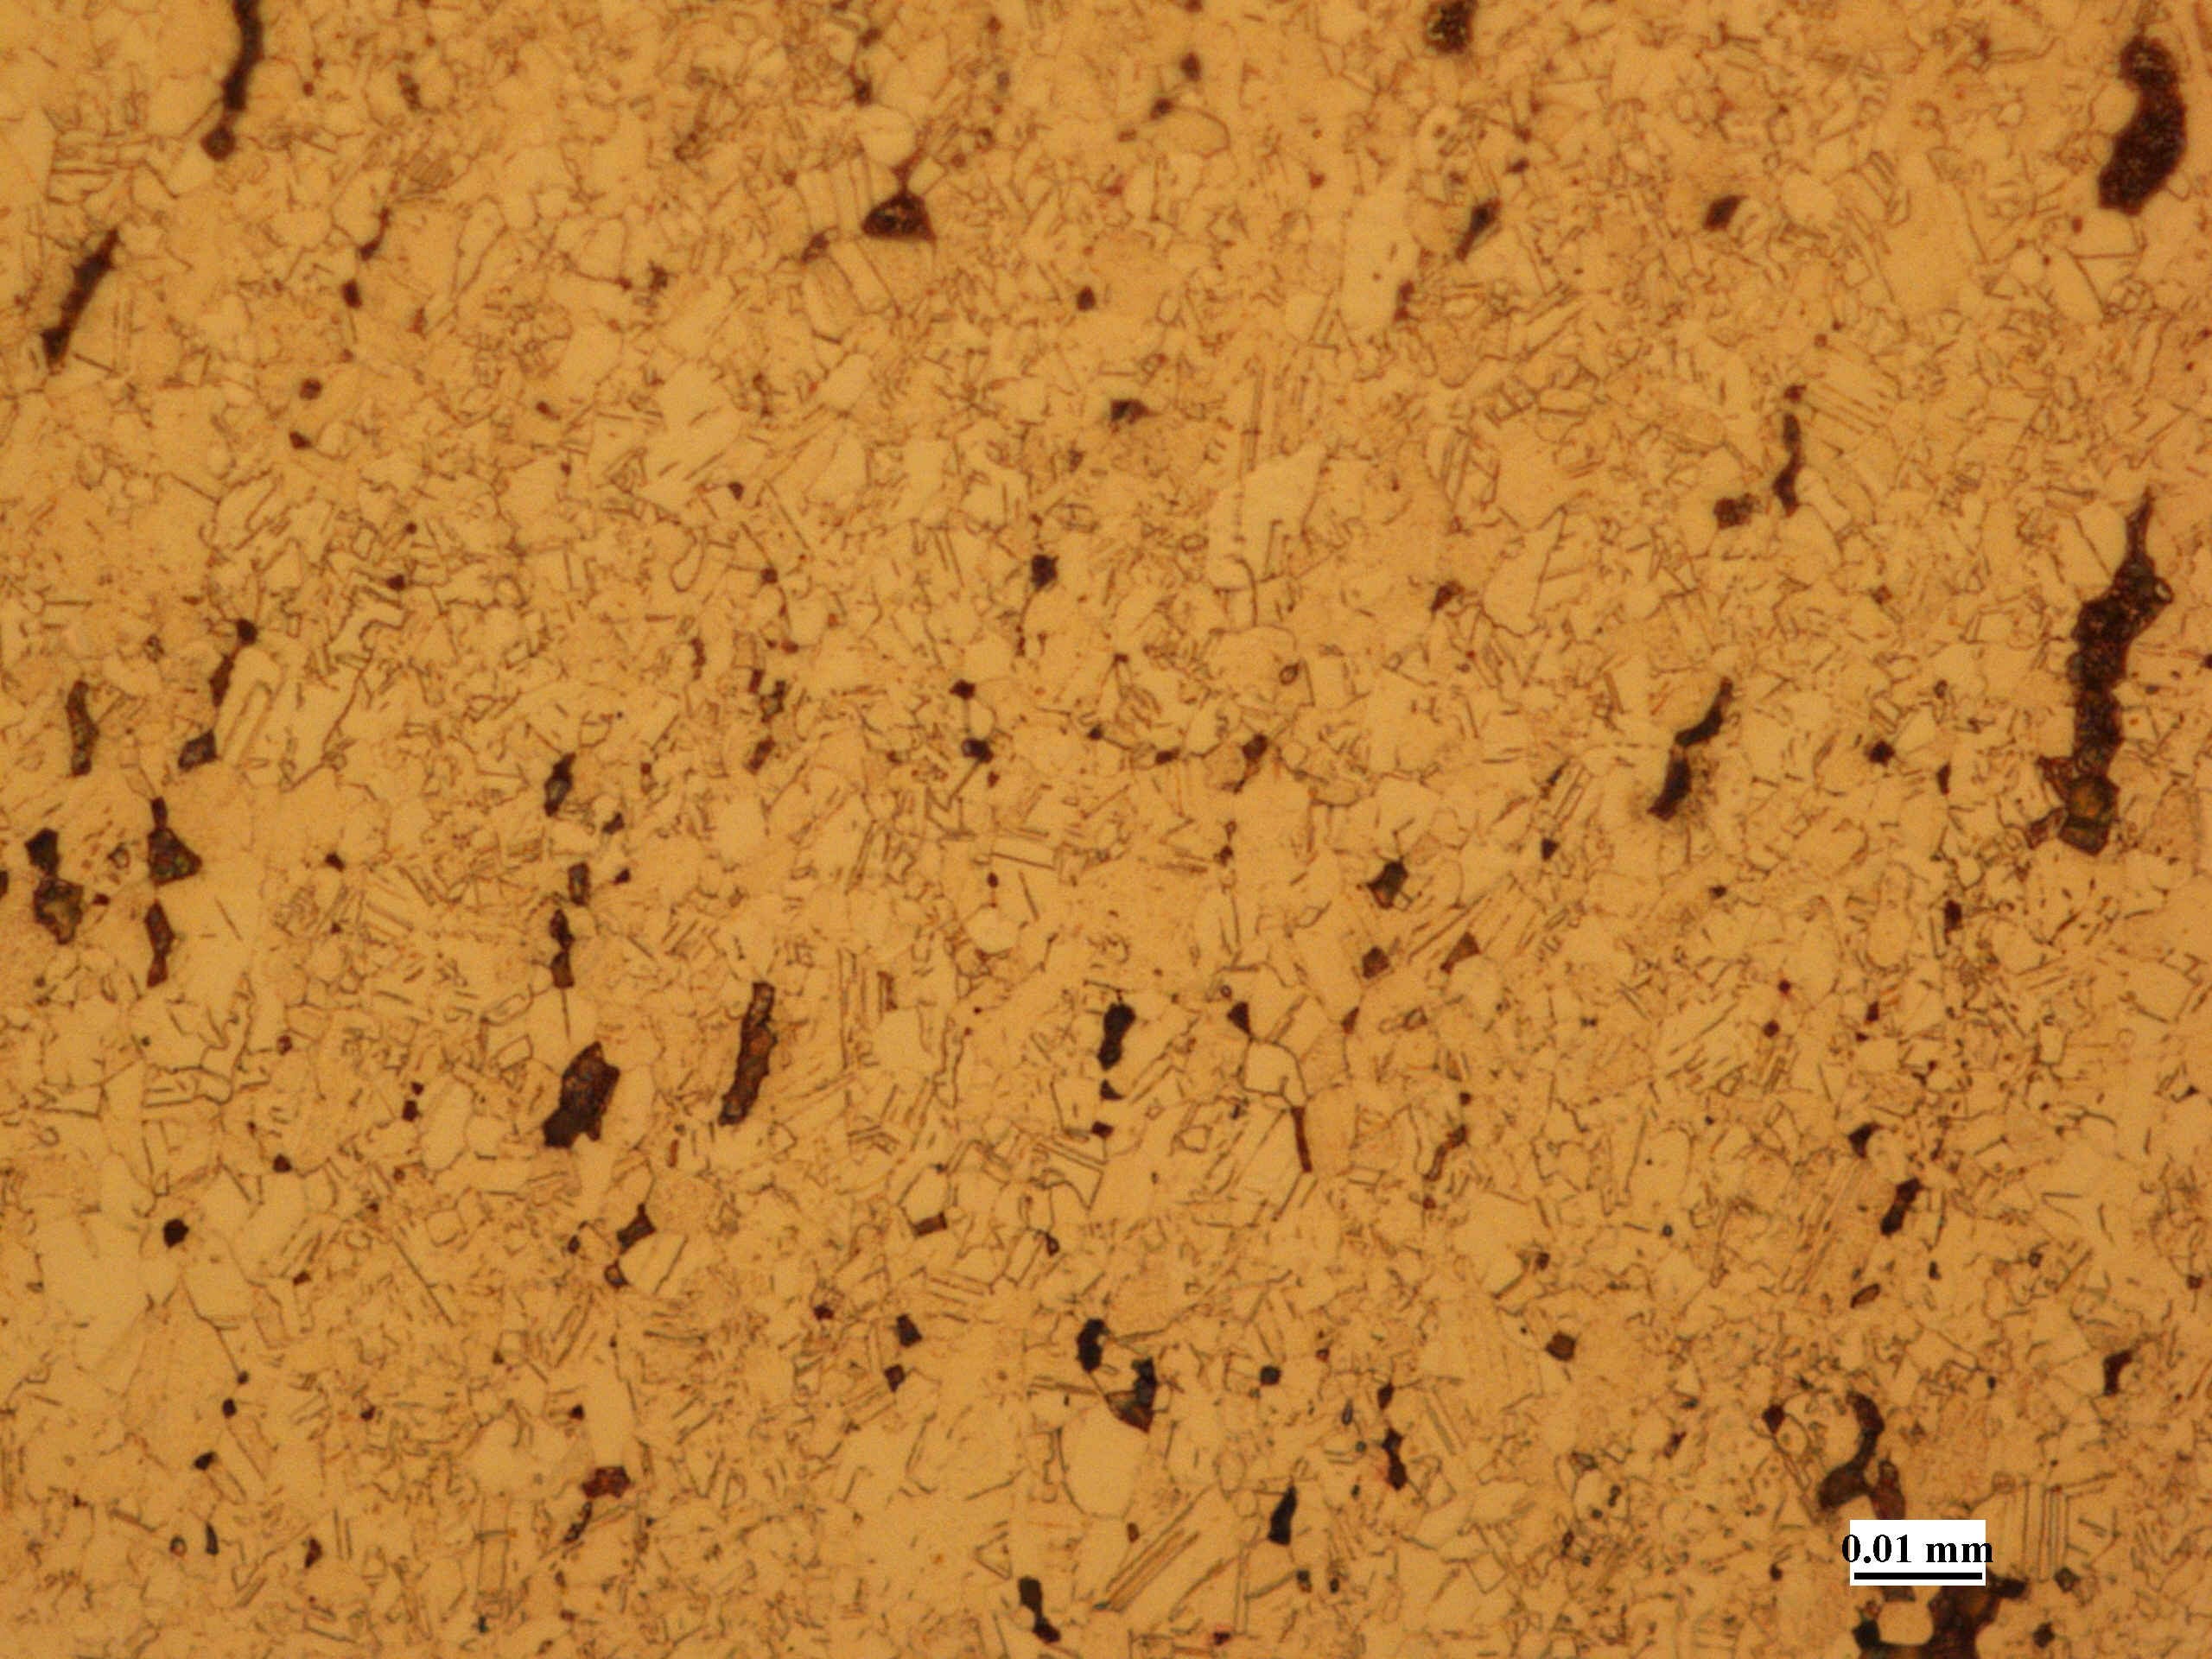
60%CW + Annealed – longitudinal
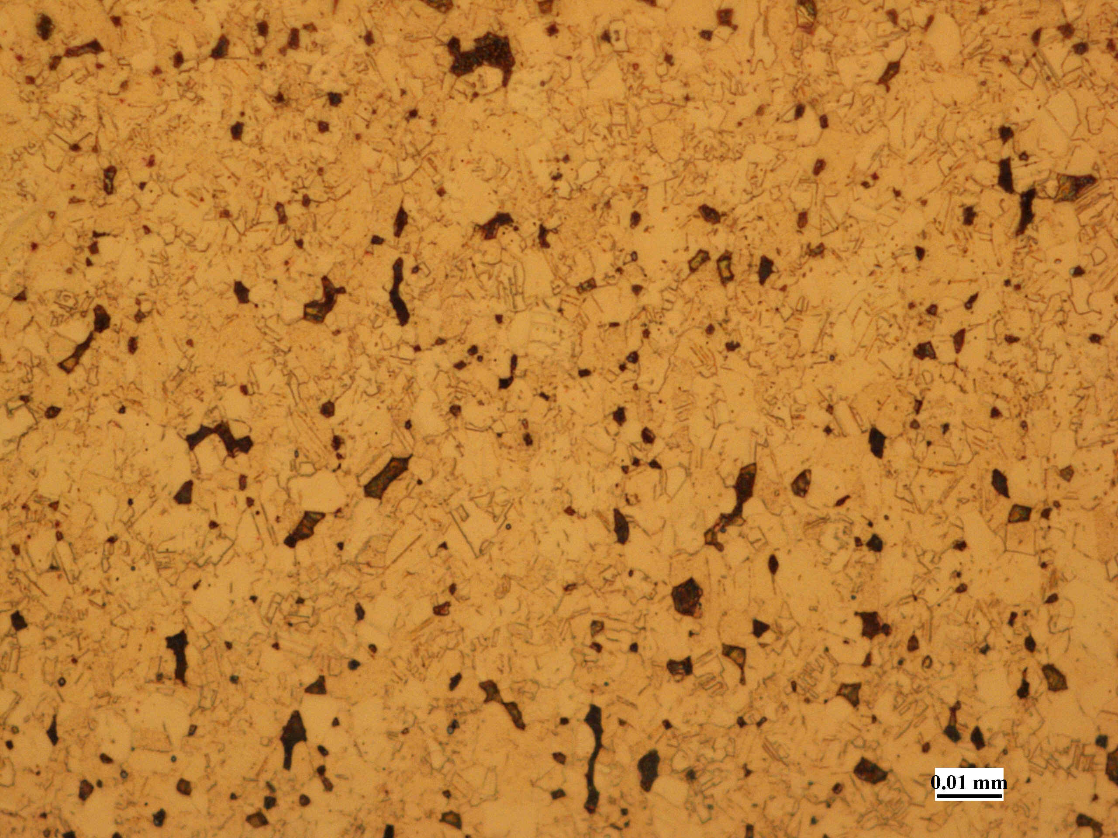
60%CW + Annealed - transverse

