Name:

Student ID:

ENGR/MSE 170 A Final exam 6/6/2006
(Total:100pts)
This is a two-hour, closed book exam

Instruction
- Write your name and student ID number on upper right-hand corner of this page
- Write legibly

Problem 1. Basic concepts (40 points): Answer the following questions:

- What are the atomic and molecular bondings for C₂H₆?

- Briefly state why sharp corners should be avoided in designing structures that are subjected to stresses.

3) Briefly describe martensite in terms of its crystal structure and microstructure.

4) Explain why ceramic materials are harder but more brittle than metals.

5) Discuss the difference in strengthening mechanism for large-particle and dispersion-strengthened particle-reinforced composites.

6) What is the mechanism of plastic deformation of metals? List three approaches that can be used to impede dislocation motion in metals.

7) Briefly explain how molecular weight and degree of crystallinity of a material influence the yield strength of a polymer.

8) Draw stress-strain relation curves for three types of commonly used polymers.

- (a) Cite the two modes of fracture and the difference between them.
(b) Note which type of fracture is preferred, and give two reasons.

10). Determine Miller indices for planes A and B shown in the following unit cell and sketch a plane of (3 11) within the unit cell.

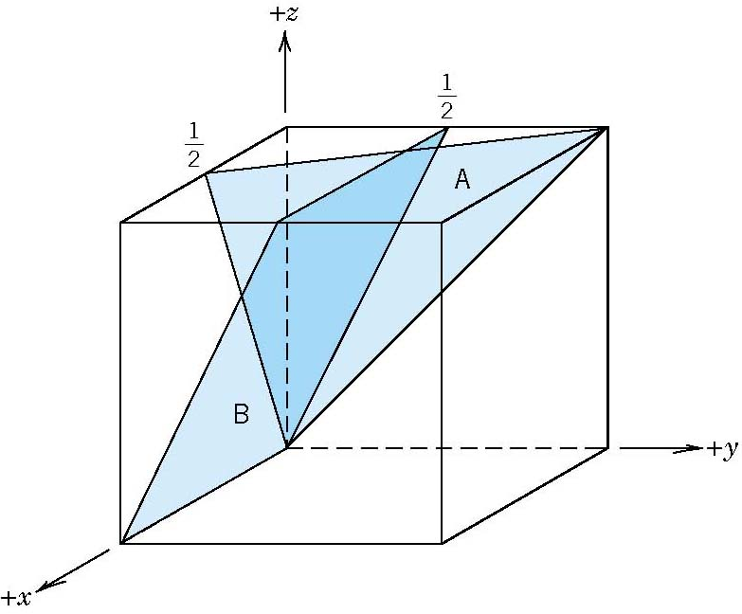

$\sqrt{m}$Problem 2. (6 points) A specimen of 4340 steel alloy with a fracture toughness of 54.8 MPa experiences a tensile stress of 1030 MPa. Will this specimen undergo fracture, given that the largest surface crack is 0.5 mm long? Justify your answer.

Problem 3. (14 points) Answer the following questions about electrical properties:

a. Discuss the mechanisms of electrical conductivity for metals, semiconductors, and ionic crystals.
b. Make the distinction between electronic and ionic conduction.
c. If Zn element is introduced substitutionally in GaAs semiconductors, will the Zn act as a donor or an acceptor?

Problem 4. (10 points) Answer following questions about polymer materials
- Cite the differences in mechanical behavior for thermoplastic and thermosetting polymers, and describe the differences in their molecular structures
- Cite the main difference in crystalline state between polymers and metallic materials
- Briefly explain how molecular weight, degree of crystallinity, deformation of drawing influence the yield strength of a semicrystalline polymer.

Problem 5. (15 points) Answer the following questions based on the iron-iron carbide phase diagram shown below.

- Indicate crystal structures of α- ferrite, austinite, and δ-ferrite.
- What is the solubility of Fe in Fe₃C cementite at 700 °C?
- Sketch the microstructure when carbon concentration is 0.76% and temperature is at 600 °C.
- Make schematic sketches of the microstructures that would be observed for a very slow cooling from 1000 °C to 400 °C with the carbon concentration of 0.4%. Label all the phases.
- For an overall composition of 0.4% C, what is the mass fraction of the proeutectoid cementite at 725 °C .

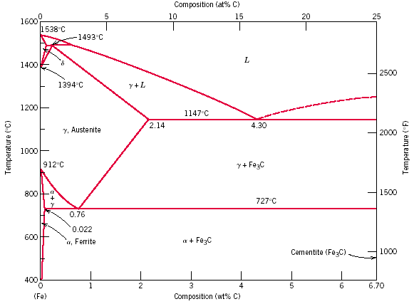

Problem 6. (15 Points) Using isothermal transformation diagram provided at the end of the problem for an iron-carbon alloy of eutectoid composition, answer the following questions. In the figure: A, austenite; B, bainite; M, martensite; P, pearlite.

- When the material is cooled rapidly from 727 °C to 575 °C and held for 500 seconds, then cooled rapidly to 300 °C and held for 1000 seconds, and followed by quenching to room temperature, what is the resultant microstructure?

b. When the material is cooled rapidly from 727 °C to 350 °C and held for 10 seconds, and then quenched to room temperature, what is the resultant microstructure?

- Design a heat treatment process to produce a composite with a microstructure of 50% pearlite and 50% bainites.

- State three major characteristics of the austenite-to-martensite transition?

e. Discuss briefly the difference in microstructure and mechanical property between pearlites, spheroidites, martensites, and tempered martensites.

