Name:

Student ID:

ENGR/MSE 170 B Final exam 6/8/2006
(Total: 100pts)
This is a two-hour, closed book exam

Instruction
- Write your name and student ID number on upper right-hand corner of this page
- Write legibly

Problem 1. Basic concepts (40 points): Answer the following questions:

- What are the atomic and molecular bondings for CH₄?

2) Sketch electron band structures for metals, semiconductors, and insulators.

- Briefly explain why ceramic materials are stronger in compression than in tension.

4) Boron is added to high-purity silicon. The semiconductor thus produced is
- an intrinsic or extrinsic semiconductor?
- an N type or P type semiconductor?

5) Cite three characteristics/properties that will be altered when a metal is plastically deformed.

6) What is the mechanism of plastic deformation of metals? List three approaches that can be used to impede dislocation motion in metals.

7) Briefly explain how molecular weight and degree of crystallinity of a material govern the yield strength of a polymer.

8) Draw stress-strain relation curves for three types of commonly used polymers.

9) List two major factors that influence the electrical resistivities of metals.

10) Determine the Miller indices for planes A and B shown in the following unit cell
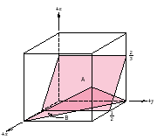

Problem 2. (10 points) From the stress-strain plot for a plain carbon steel shown in the figure below:

(a) Label the yield strength, resilience, toughness, ductility in the following figure.
(b) If a tensile stress of 80 × 10³ psi is applied on a carbon steel specimen, what would be the elastic and plastic strains?
- A steel bar 100 mm long with a square cross section of 20 mm × 20 mm is pulled in tension with a load of 100 KN, and experiences an elongation of 0.10 mm. Calculate the elastic modulus of the steel for the given conditions if the deformation is entirely elastic.
- Calculate the elastic modules from the figure and compare the result with that obtained from (c).
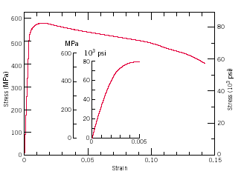

Problem 3. (10 points) Discuss the mechanisms of electrical conductivity for metals, semiconductors, and ionic crystals; and the mechanisms of plastic deformation for metals, ceramics, and semicrystalline polymers.

Problem 4. (10 points) Answer the following questions about composite materials

(1) Generally, the elastic modulus of a material can be improved by adding a dispersed phase that is stiffer than the matrix phase. What arrangement of the dispersed phase will increase the modulus of elasticity most effectively in a given direction?
- aligned short fibers.
- aligned long fibers.
- particles.

(2) The mechanical properties of aluminum may be improved by incorporating fibers of aluminum oxide. Given that the moduli of aluminum and aluminum oxide are 69 GPa and 393 GPa, respectively, estimate the required minimum volume fraction of aligned continuous aluminum oxide fibers so that the elastic modulus of the resultant composite equals 200 GPa in the direction parallel to the fibers.

(3) If the aluminum oxide of the same volume in the composite is in form of particulates rather than fibers, would you expect the tensile strength of this particulate-reinforced composite to be greater or less than that of the fiber-reinforced composite?

Problem 5. (15 points) Answer the following questions based on the iron-iron carbide phase diagram shown below.

a. What is the composition of a plain carbon steel having the eutectoid composition?
- Specify eutectic and eutectoid points and write the phase transformation reactions at the eutectic and eutectoid points
- Make schematic sketches of the microstructures that would be observed for a very slow cooling of the composite from 1000 °C to 400 °C with the carbon concentration of 0.4%. Label all the phases.
- For an overall composition of 0.4% C, what is the mass fraction of the pearlite at 725 °C.
- For an overall composition of 0.4% C, what is the mass fraction of the proeutectoid α-ferrite at 725 °C.

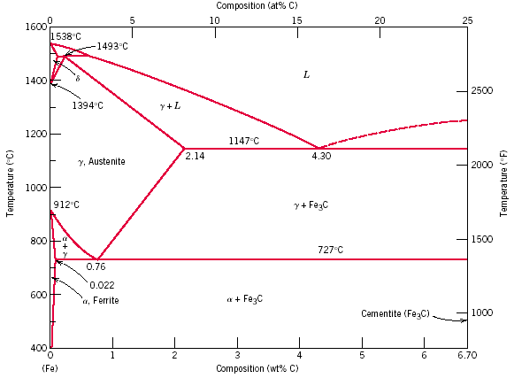

Problem 6. (15 Points) Using isothermal transformation diagram provided at the end of Problem 6 for an iron-carbon alloy of eutectoid composition, answer the following questions. In the figure: A, austenite; B, bainite; M, martensite; P, pearlite.

a. When the material is cooled rapidly from 727 °C to 350 °C, held for 10 seconds, and then quenched to room temperature, what is the resultant microstructure?

b. When the material is cooled rapidly from 727 °C to 650 °C, held for 20 seconds, then cooled to 400 °C, held for 1000 seconds, and quenched to room temperature, what is the resultant microstructure?

- Design a heat treatment process to produce a composite with a microstructure of 50% bainites and 50% martensites.

- Briefly describe the microstructural difference between spheroidite and tempered martensite?

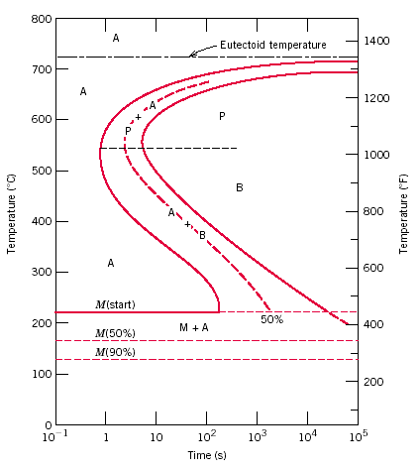
e. Briefly describe the simplest heat treatment process that can be used to convert a 0.76% C steel from martensite to spheroidite.

$σ_{\text{cl}}=σ_{m}V_{m}+σ_{f}V_{f}$

$$σ_{\text{ct}}=\frac{σ_{m}σ_{f}}{σ_{f}V_{m}+σ_{m}V_{f}}$$

