**MSE 170 A Midterm 11/2/2009 100pts. Total**

**Exam is closed book, closed notes, no collaborations with neighbors.**

(Two sheets of letter-size paper is allowed)

***Instructions:***

1. *Write your name and student ID on the top of the page.*
2. *Read the questions carefully.*
3. *Read the questions carefully, again.*
4. *Make sure you are answering the right questions.*
5. *Write legibly.*
6. *Show work as needed to justify answers.*
7. *After you are done, hand in your work and as once a wise man said: “ Do a little dance, …….”*

**GOOD LUCK!**

**Point Distribution (total=100)**

*Problem 1 50*

*Problem 2 25*

*Problem 3 25*

**Problem 1.** Basic concepts (50 points): Answer the following questions:

1. What kind of atomic and intermolecular bonds exist in Kevlar? Comment on their relative strengths.
   1. 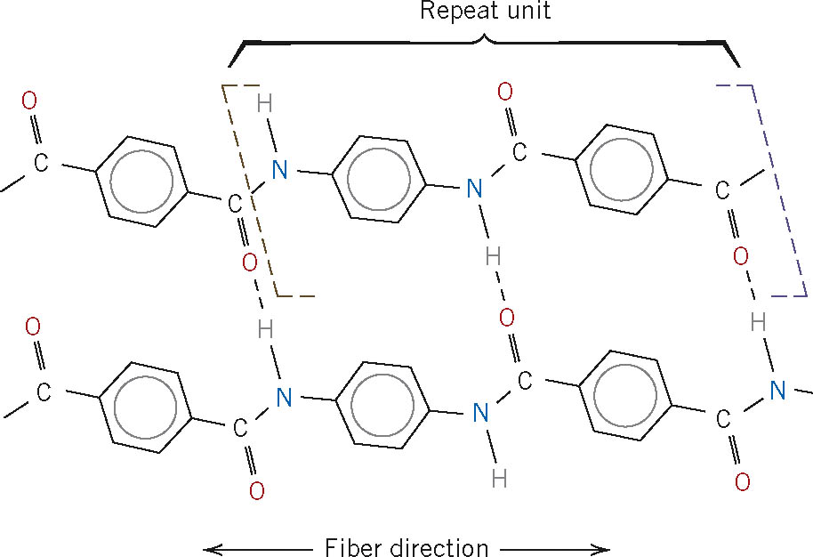
2. What differentiates a crystalline structure from an amorphous one?
3. Draw a unit cell for a BCC structure.
4. Determine the Miller indices for the planes A and B shown in the following unit cell.

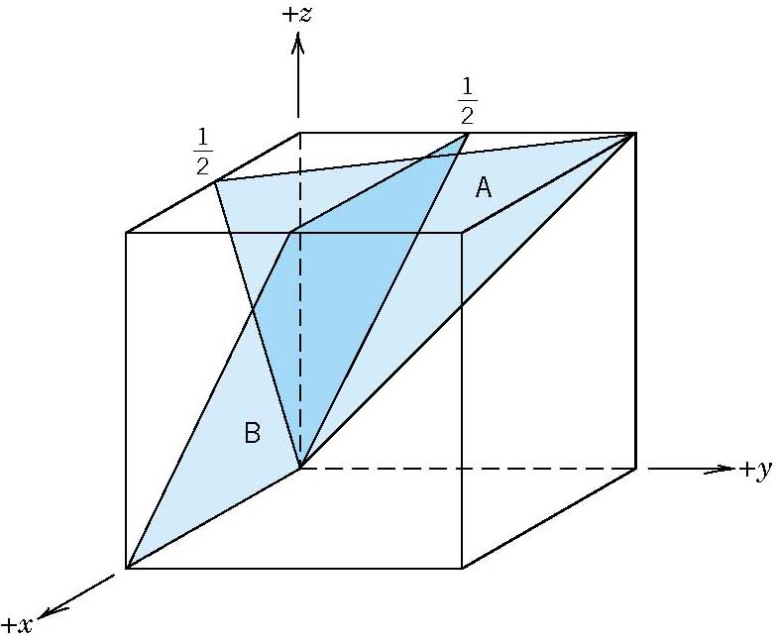

1. What defect plays a major role in influencing the plastic deformation of metals? Explain.
2. Referring to the periodic table on page 11, determine what is the predominant type of bonding for SiC (Silicon Carbide), LiCl (Lithium Chloride), and solid Mo. Why?
3. All other parameters being equal, how would you expect the ductility of a metal to depend on the number of dislocations? Consider the cases of some dislocations, and a large number of dislocations. Explain your answer with a few words.
4. Complete the following sentence:
   1. Virtually all strengthening strategies rely on this simple principle:
5. Indicate the type the dislocation below, and label the dislocation line and slip plane. Indicate the type of stress above and below the slip plane.
   1. 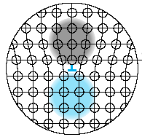
6. List three allotropes of carbon.

**Problem 2.** (25 points) From the stress-strain plot for a plain carbon steel shown in the figure below:

1. Label in the following figure the yield strength, resilience, toughness, and ductility ( 10 points)

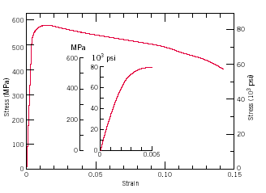

1. A steel bar 100 mm long with a square cross section of 20 mm × 20 mm is pulled in tension with a load of 100 kN, and experiences an elongation of 0.10 mm. Calculate the elastic modulus of the steel for the given conditions if the deformation is entirely elastic. (10 points)
2. Calculate the elastic modulus from the figure and compare the result with that obtained from (b). (5 points)

**Problem 3 (25 points) Diffusion**

1. Given Fick’s first law of diffusion  define all the quantities present in the equation and state which assumption was made to derive it (10).
2. Explain how Fick’s second law can be derived from Fick’s first law by making a few simple physical arguments (no need to derive). Think about the meaning of C and J and how they relate to each other in time. (10)
3. Qualitatively describe the dependence of D on temperature and explain how this dependence relates to Qd (diffusion activation energy) (3). Would you expect case hardening of a gear to proceed faster at 500 C or 700 c? (2)

# Periodic Table

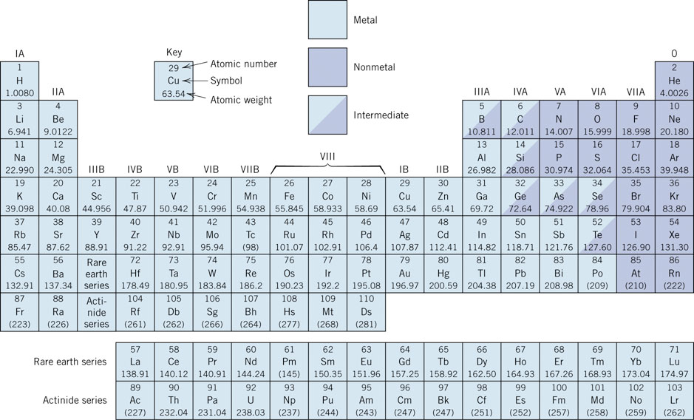

**Electronegativity**

