ENGR/MSE 170 B Midterm 4/30/2007 100pts. Total
Exam is closed book, closed notes, closed neighbors
(one sheet of letter-size paper is allowed )
Instruction:
- Write your name and student ID on top of page.
- Write legibly.
- Show work as needed to justify answers

Problem 1 (15 points): Bonding and interatomic forces

a. Referring to the periodic Table on page 8, determine what are predominant bondings for GaAs and BaS.

b. Briefly describe the main differences between ionic, covalent, metallic bonding

c. Explain why the covalently bonded materials are generally less dense than the ionically and metallically bonded ones.

Problem 2 (15 points) Crystal structures

a. Determine the Miller indices for the planes A and B of the unit cell shown in Figure 2.
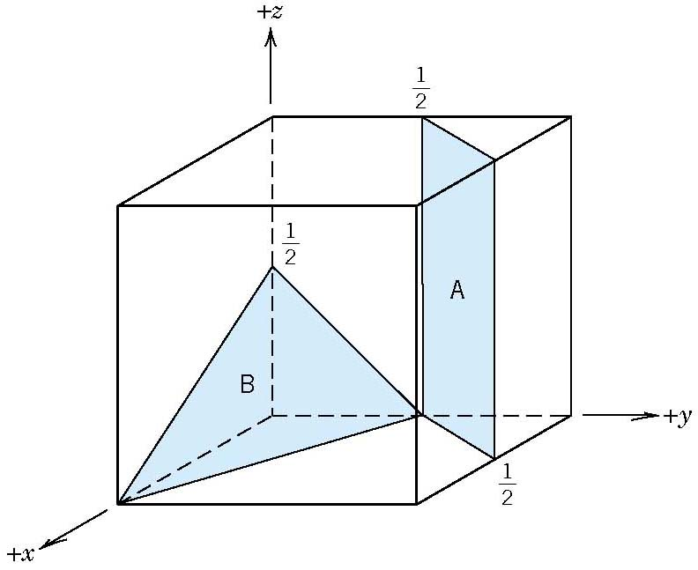
Figure 1

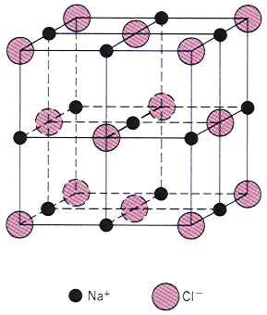
b. In Figure 2, the big shaded circles and small black circles represent anions and cations, respectively. Indicate the type of crystal structure and the type of the unit cell, and also determine the coordination numbers for both cation and anion.
Figure 2

c. Draw atomic packing along (100) and (111) planes of the unit cell shown in Figure 2.

Problem 3 (15 points): Defects

- List at least 3 types of defects that can exist in solids.

- Explain why yield stress of materials is usually much smaller than theoretical stress.

c. A mixed dislocation line is shown in Figure 3. Specify what part of the dislocation line is pure edge and what part is pure screw dislocation.
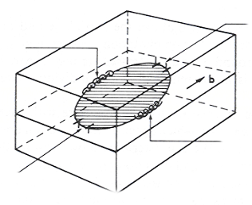
Figure 3

Problem 4 (15 points) Diffusion

a. Assuming steady-state conditions, calculate the flux (including the correct units) of carbon gas diffusing through a 5 mm thick stainless steel. The concentration of carbon on the low and high pressure sides are 0.5 kg/m³ and 3 kg/m³, respectively. Assuming this occurs at 500⁰C and a diffusion coefficient of 3x10⁻¹¹m²/s.

b. Would the flux be higher or lower at 600⁰C? Why?

c. Determine what diffusion mechanism dominates the process?

Problem 5 (20 points). Mechanical properties & plastic deformation

From the stress-strain plot for an alloy steel shown in the Figure 4:
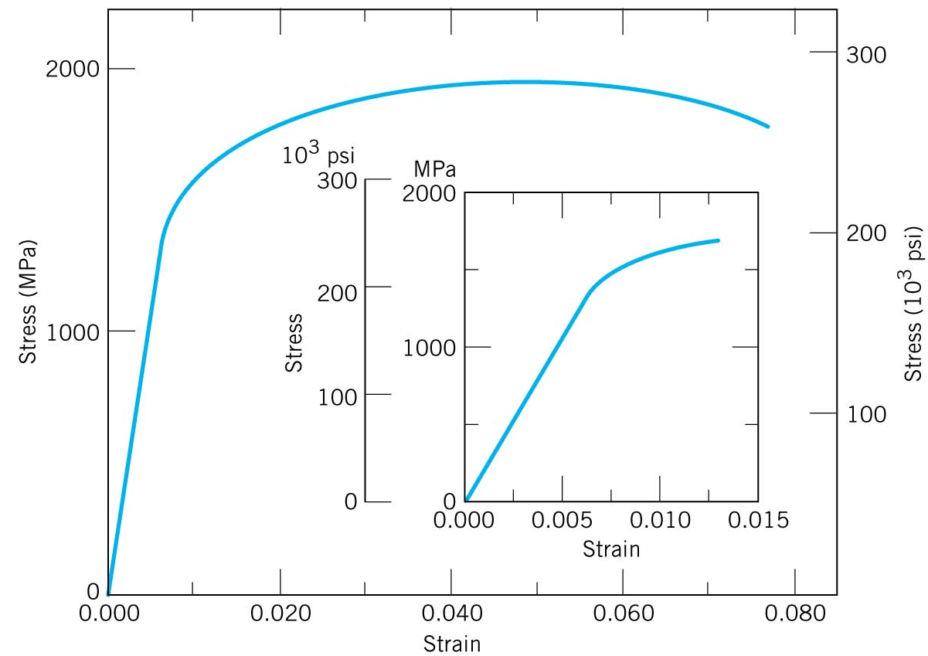
a. Determine the elastic and plastic strains when a tensile load 1000 MPa is applied on a cylindrical specimen.
Figure 4. Tensile stress-strain behavior for an alloy steel

b. Label yield and tensile strengths, resilience, toughness, ductility on the Figure 4.

c. If the original length of the cylindrical specimen mentioned is 120 mm, what will be the length of the steel bar after a tensile force of 1700MPa has been removed?

Problem 6. (10 points) Plastic deformation

- List three mechanisms that can strengthen metals.

b. A cylindrical bar has diameter D₀=15.2 mm before cold work and Dd=12.2mm after cold working as shown in Figure 5. The tensile strength and ductility of materials versus cold work are shown in Figure 6. What are the yield and tensile strengths and ductility of the cylindrical bar after cold working?
Figure 5

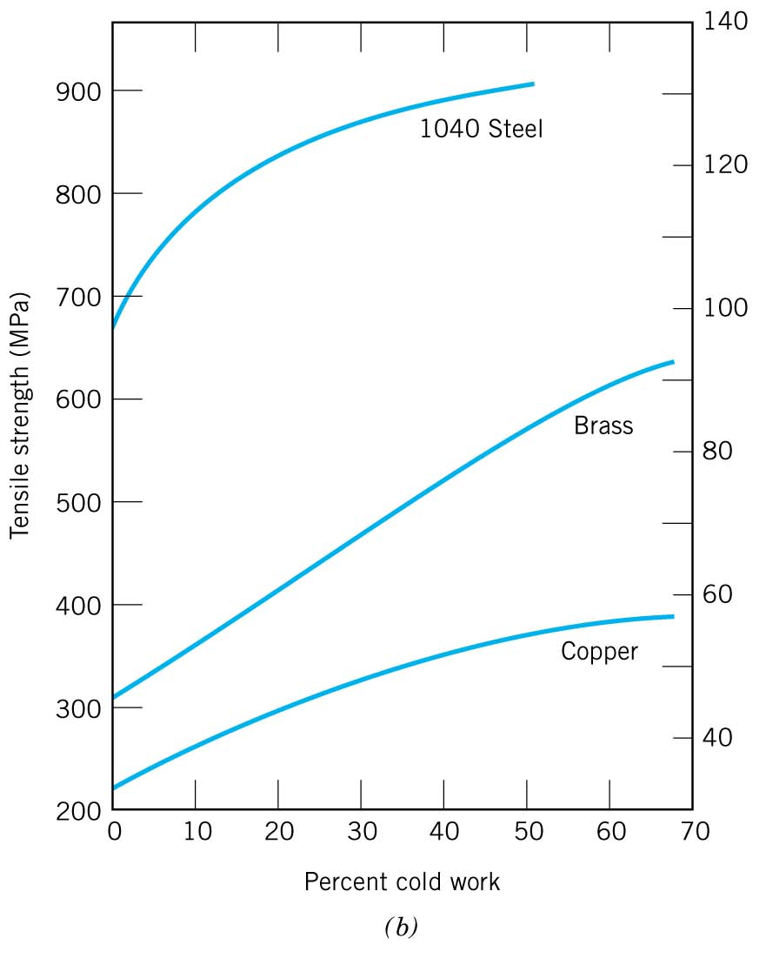
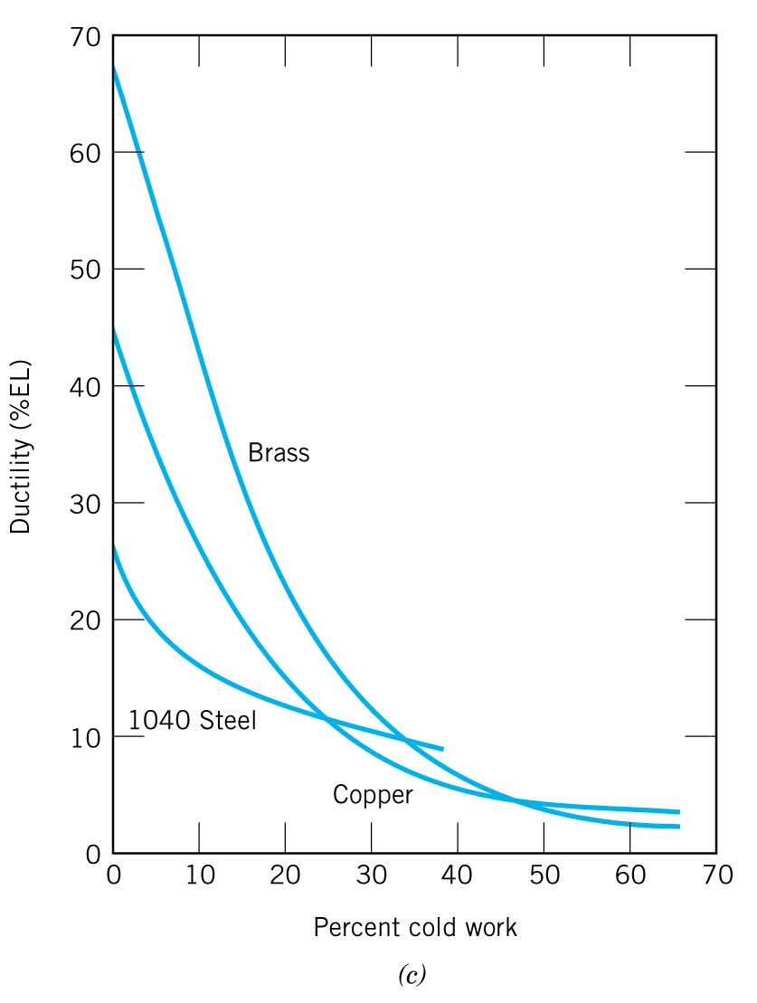
Figure 6

Problems 7 (10 points) Failure

- What are three failure modes of materials?

b. What are the two fracture modes of materials?

Bonus (5 points)

- Compare the magnitude of the elastic modulus for ceramics, metals, and polymers and explain why?

b. The interaction force (F) between atoms in a crystal equals to the derivative of the interactive energy (E) with respect to r, the distance between the two atoms. Draw the F-r and E-r curves for the above three types of materials.

