**MSE 170 B Midterm 11/2/2009 100pts. Total**

**Exam is closed book, closed notes, no collaborations with neighbors.**

(Two sheets of letter-size paper is allowed)

***Instructions:***

1. *Write your name and student ID on the top of the page.*
2. *Read the questions carefully.*
3. *Read the questions carefully, again.*
4. *Make sure you are answering the right questions.*
5. *Write legibly.*
6. *Show work as needed to justify answers.*
7. *After you are done, hand in your work and as once a wise man said: “ Do a little dance, …….”*

**GOOD LUCK!**

**Point Distribution (total=100)**

*Problem 1 50*

*Problem 2 25*

*Problem 3 25*

**Problem 1.** Basic concepts (50 points): Answer the following questions:

1. What kind of atomic and intermolecular bonds exist in skyzophyllan (mushroom based fiber)? Comment on their relative strengths.
   1. 
2. What is the defining characteristic of a crystalline structure?
3. Draw a unit cell for a FCC structure.
4. Determine the Miller indices for the planes A and B shown in the following unit cell.

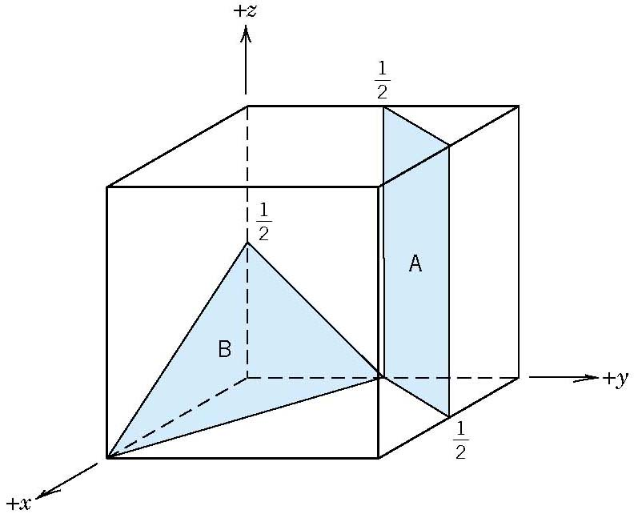

Figure 1

1. What happens to dislocations during plastic deformation of metals?
2. Referring to the periodic Table on page 12, determine what is the predominant type of bonding for Ge (Germanium), KI (Potassium Iodide), and solid V. Why?
3. All other parameters being equal, how would you expect the ductility of a metal to relate to the grain size? Explain
4. What do reducing grain size, and increasing the number of dislocations have in common as strengthening mechanisms? Explain.
5. Indicate the type the dislocation below, and label the dislocation line and slip plane. Indicate the type of stress above and below the slip plane.
   1. 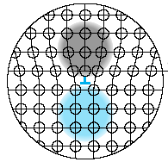
6. Draw the unit cell for NaCl.

**Problem 2.** (25 points) From the stress-strain plot for a brass specimen

1. Label in the following figure the yield strength, resilience, toughness, and ductility (10 points)

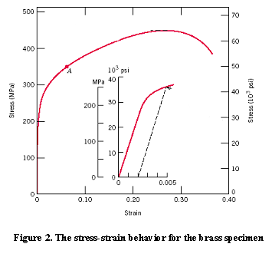

1. Determine the elastic and plastic strains when a tensile load 250 MPa is applied on a cylindrical specimen. If the specimen is 120 mm long, how long can it be elongated before it witnesses plastic deformation?

(10 points)

1. Calculate the elastic modulus from the figure (5 points)

**Problem 3 (25 points) Crystal Structures**

* 1. Draw a BCC unit cell and determine the number of atoms per unit cell (10 points).
  2. Derive the relationship between a (lattice parameter) and r (atomic radius) (7 points)
  3. Define atomic packing factor and calculate the APF for the BCC structure. (8points)

# Periodic Table

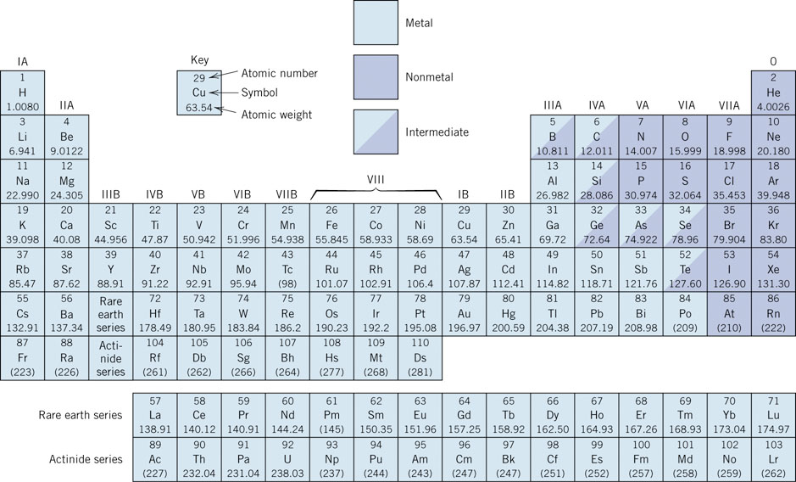

**Electronegativity**

