MSE 170 A Final 12/9/2008 100pts. Total
Exam is closed book, closed notes, no collaborations with neighbors.
(Two sheets of letter-size paper is allowed)
Instructions:
- Write your name and student ID on the top of the page.
- Read the questions carefully.
- Read the questions carefully, again.
- Make sure you are answering the right questions.
- Write legibly.
- Show work as needed to justify answers.
- After you are done, hand in your work.

GOOD LUCK!

Point Distribution (total=100)

Problem 1 45
Problem 2 10
Problem 3 15
Problem 4 10
Problem 5 10
Problem 6 10

Problem 1. Basic concepts (45 points): Answer the following questions:

- What kind of atomic and intermolecular bonds exist in Kevlar? Comment on their relative strengths.
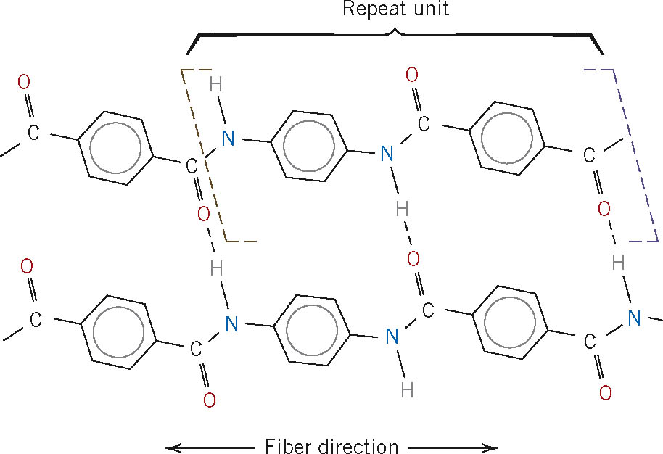

- What differentiates a crystalline structure from an amorphous one?

- Draw a unit cell for a BCC structure.

- Determine the Miller indices for the planes A and B shown in the following unit cell.
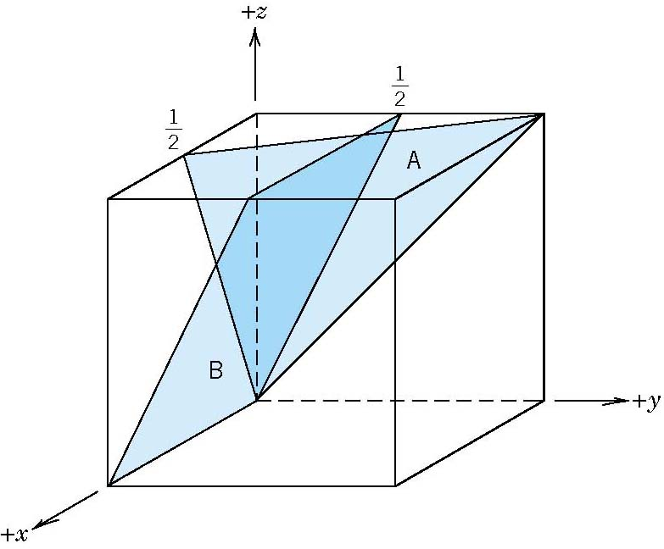

- What defect plays a major role in influencing the plastic deformation of metals? Explain.

- All other parameters being equal, would you expect case hardening of a steel gear to occur faster at 500C or at 700C? Why?

- Define toughness and resilience.

- All other parameters being equal, how would you expect the ductility of a metal to depend on the number of dislocations? Consider the cases of some dislocations, and a large number of dislocations. Explain your answer with a few words.

- Complete the following sentence:
Virtually all-strengthening strategies rely on this simple principle:

- List three allotropes of carbon.

- Fill in the dots in the following sentence:

A eutectic solution is a solution of two substances in a specific ratio that has a ………….……. lower than either of the substances if measured individually.

- Define a eutectic and a eutectoid transition.

- What kind of balance is required for both defects and impurities in ceramics?

- Briefly explain how molecular weight and degree of crystallinity influence the yield strength of a polymer.

- Sketch the band diagrams for a conductor, a semiconductor, and an insulator.

Problem 2. (10 points) From the stress-strain plot for a plain carbon steel shown in the figure below:

- Label in the following figure the yield strength, resilience, toughness, and ductility.
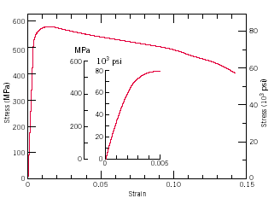

- A steel bar 100 mm long with a square cross section of 20 mm × 20 mm is pulled in tension with a load of 100 kN, and experiences an elongation of 0.10 mm. Calculate the elastic modulus of the steel for the given conditions if the deformation is entirely elastic.

- Calculate the elastic modulus from the figure and compare the result with that obtained from (b).

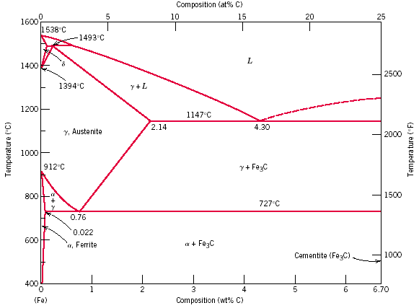
Problem 3. (15 points) Answer the following questions based on the iron-iron carbide phase diagram shown below.

- What is the amount of carbon in a plain carbon steel having the eutectoid composition?

- Indicate on the diagram eutectic and eutectoid points and write the phase transformation reactions at the eutectic and eutectoid points .

- Make schematic sketches of the microstructures that would be observed for a very slow cooling of the composite from 1000 °C to 400 °C with the carbon concentration of 0.4%. Draw at least three microstructures total for the different temperatures and transition points clearly indicating all the phases. Would you expect the final microstructure to be different if the sample was rapidly quenched to room temperature? Explain.

- For an overall composition of 0.4% C, what is the approximate mass fraction of the pearlite at 725 °C?

- For an overall composition of 0.4% C, what is the approximate mass fraction of the proeutectoid α-ferrite at 725 °C?

Problem 4. (10 points) Answer following questions about composite materials

a) Generally, the elastic modulus of a material can be improved by adding a dispersed phase that is stiffer than the matrix phase. What arrangement of the dispersed phase will increase the modulus of elasticity most effectively in a given direction? Why?
- aligned 1 D short fibers.
- aligned 1 D long fibers.
- particles.

b) The mechanical properties of aluminum may be improved by incorporating fibers of aluminum oxide. Given that the moduli of aluminum and aluminum oxide are 69 GPa and 393 GPa, respectively, estimate the required minimum volume fraction of aligned continuous aluminum oxide fibers so that the elastic modulus of the resultant composite equals 200GPa in the direction parallel to the fibers. Show work.

Problem 5. (10points) Answer following questions about polymer materials
- Explain the general differences in behavior and structure for thermoplastic and thermosetting polymers.

- Explain the main difference between the crystalline state in polymers and in metallic materials

Problem 6. (10 points) Electrical properties

a. Qualitatively explain the temperature dependence of the electrical conductivity in a metal and in a semiconductor. What are the underlying mechanisms?

b. When referring to electrical properties, what is a hole?

c. If you added to same amount of Phosphorous to a slab of iron and a slab of silicon, what would you expect to occur the conductivity of the two materials? Consider the conductivity of the iron before and after the addition of Phosphorus, and consider the conductivity of the silicon before and after the addition of Phosphorous. Explain the underlying mechanisms.

Periodic Table

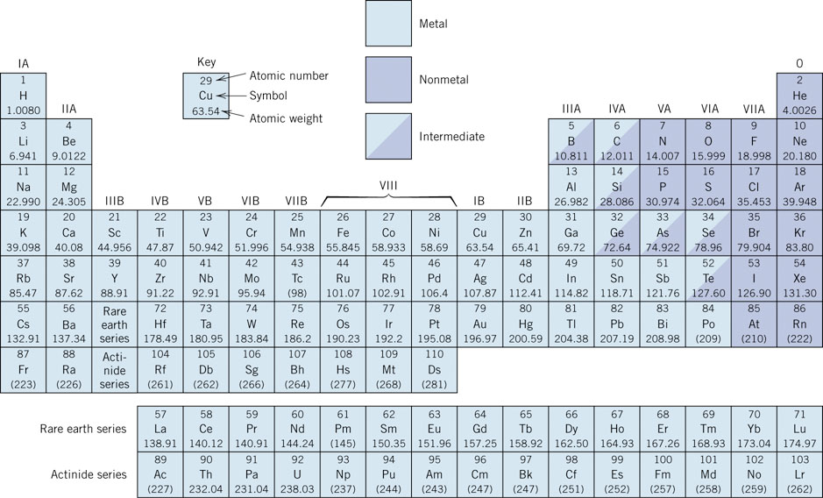
Electronegativity

