**Washington State Food Procurement Regulations**

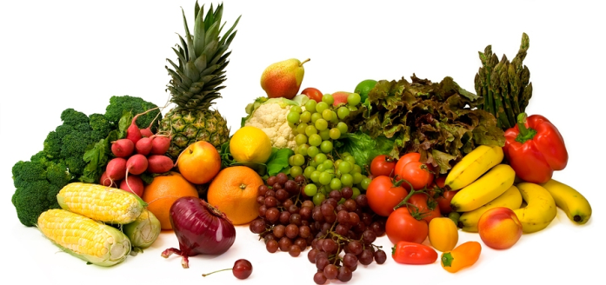

A Policy Brief for the Washington

State Coalition for Childhood Obesity

**The Problem**

In 2009, the State of Washington provided more than 22 million meals to vulnerable populations residing in state operated institutions (hospitals, schools, veteran's administrations, and prisons) as well as food for state sponsored meetings.

**Many of the foods purchased by the state doNOT contribute to diets that meet the Dietary Guidelines for Americans.**

**Food procurement policies and guidelines are a promising way to:**

* Support producers and distributors of healthier foods in Washington State
* Improve the nutritional quality of foods served to thousands of Washington residents each day
* Decrease the impact of diseases related to poor diet

**Diet & Health Details**

* Many costly chronic diseases are related poor diet; such as obesity, cardiovascular disease (CVD) and diabetes
* 25.5% of Washington's population is obese, costing approximately $1.8 billion in 2008
* Washington residents spent over $3.5 billion in the treatment of CVD and diabetes in 2009

**Food Policy Successes**

* Massachusetts (2009): Governor Patrick signed an executive order requiring food bought by state agencies to meet the Dietary Guidelines for Americans.
* New York City (2008): Mayor Bloomberg signed an executive order requiring nutrition standards for food purchased and meals and snacks served by state agencies.
* United Kingdom (2003): Government recommends, through the Public Sector Food Procurement Initiative (PSFPI), that food bought by the government be sustainable and promote fruit and vegetable consumption. Evaluation showed increased availability of nutritious foods.
* Norway: Economic and nutrition policies throughout the last century, influencing the price and availability of food, have shifted the population’s diet away from high fat, energy-dense foods.

**Recommendations**

* Require food bought by state agencies to meet nutrition guidelines set by the state.

