An Overview of Two Land Use Planning Tools:
Location Efficient Mortgages and Inclusionary Zoning
Toby Birdsell, James Dewar, Katie Sommers, Michelle Zeidman

TOOL 1: Location Efficient Mortgages
What are location efficient mortgages designed to solve?
Location efficient mortgages (LEM) are designed to encourage home ownership and to reduce transportation, land use, and environmental issues that many urban areas are currently faced with. By creating monetary incentives to potential homeowners, the following societal benefits occur:
- Decrease auto use, improve transit use
- Improve air quality pollution
- Reduce residential demand on urban fringe
- Support higher density
- Supper local consumer services and cultural amenities
- Enhance housing affordability
- Increase home ownership

What is a location efficient mortgage?
LEMs are a tool developed by the Institute for Location Efficiency to increase the buying power for people who choose to live in neighborhoods that are considered efficient. Efficient locations are defined as places in which people can live, work, and play without a heavy reliance on personal transportation. The LEM pilot program is a relatively new tool to encourage home ownership in 4 urban areas of the United States.

LEMs are special mortgages that increase the amount a person is eligible to receive by adjusting their mortgage to income ratio from 28% up to 39%. When mortgages increase above 28% of a family’s income, the likelihood of default increases because their disposable income decreases. However, for a resident that lives in a location efficient neighborhood and uses the cost reducing benefits that exist there, one’s disposable income should be high enough to adequately offset the higher mortgage payments. The end result is paying for a larger mortgage from income that would have been spent on transportation related expenses.

Location Efficient Value (LEV)
The black box within the LEM that is used to score the efficiency of a location is called the location efficient value (LEV). The efficiency value is based solely on the location of the home and considers the availability of public transportation, density, and pedestrian access. Using data from multiple sources including the Census and the Department of Transportation, researchers determine an average cost of transportation for both non efficient and efficient locations. The difference between these two costs is the increased amount that a person receives in a LEM.

Details within the LEM
To qualify for an LEM, a person must be able to afford a 3% down payment on a house, condominium, or town home. LEMs range from a 15 to 30 year term, with the fixed rate dependent on the market. Before purchasing the new residence, the buyer must attend mandatory counseling concerning the value of a LEM and the benefits of living in an efficient location. However, there is no requirement that prohibits borrowers from owning multiple vehicles, or having to adjust their lifestyle once they move into an efficient location.

How do you put it into place?
Location Efficient Mortgages (LEM) are currently available in selected metropolitan areas only: the cities of Chicago and Seattle, Los Angeles/Orange County and the 9-county San Francisco Bay area. These four regions were the original test markets for LEM. A few years into this pilot project, Fannie Mae decided that the LEM application process was too extensive and they began promoting a simplified version of LEM called Smart Commute Mortgages. Smart Commute Mortgages (SCM) are available in the cities of Pittsburgh, Louisville and Salt Lake City, the Minneapolis/St. Paul region and the Philadelphia metropolitan area.

While planners have no direct influence over institutional lending practices, they can work with Fannie Mae to bring LEM and SCM to their jurisdiction. All LEM and SCM regions have entered into a partnership with Fannie Mae and local financial lenders to provide these mortgage programs in their areas. In these regions, individual homebuyers contact mortgage lenders directly to apply for a LEM or SCM. Below is a diagram of organizations involved in these programs:

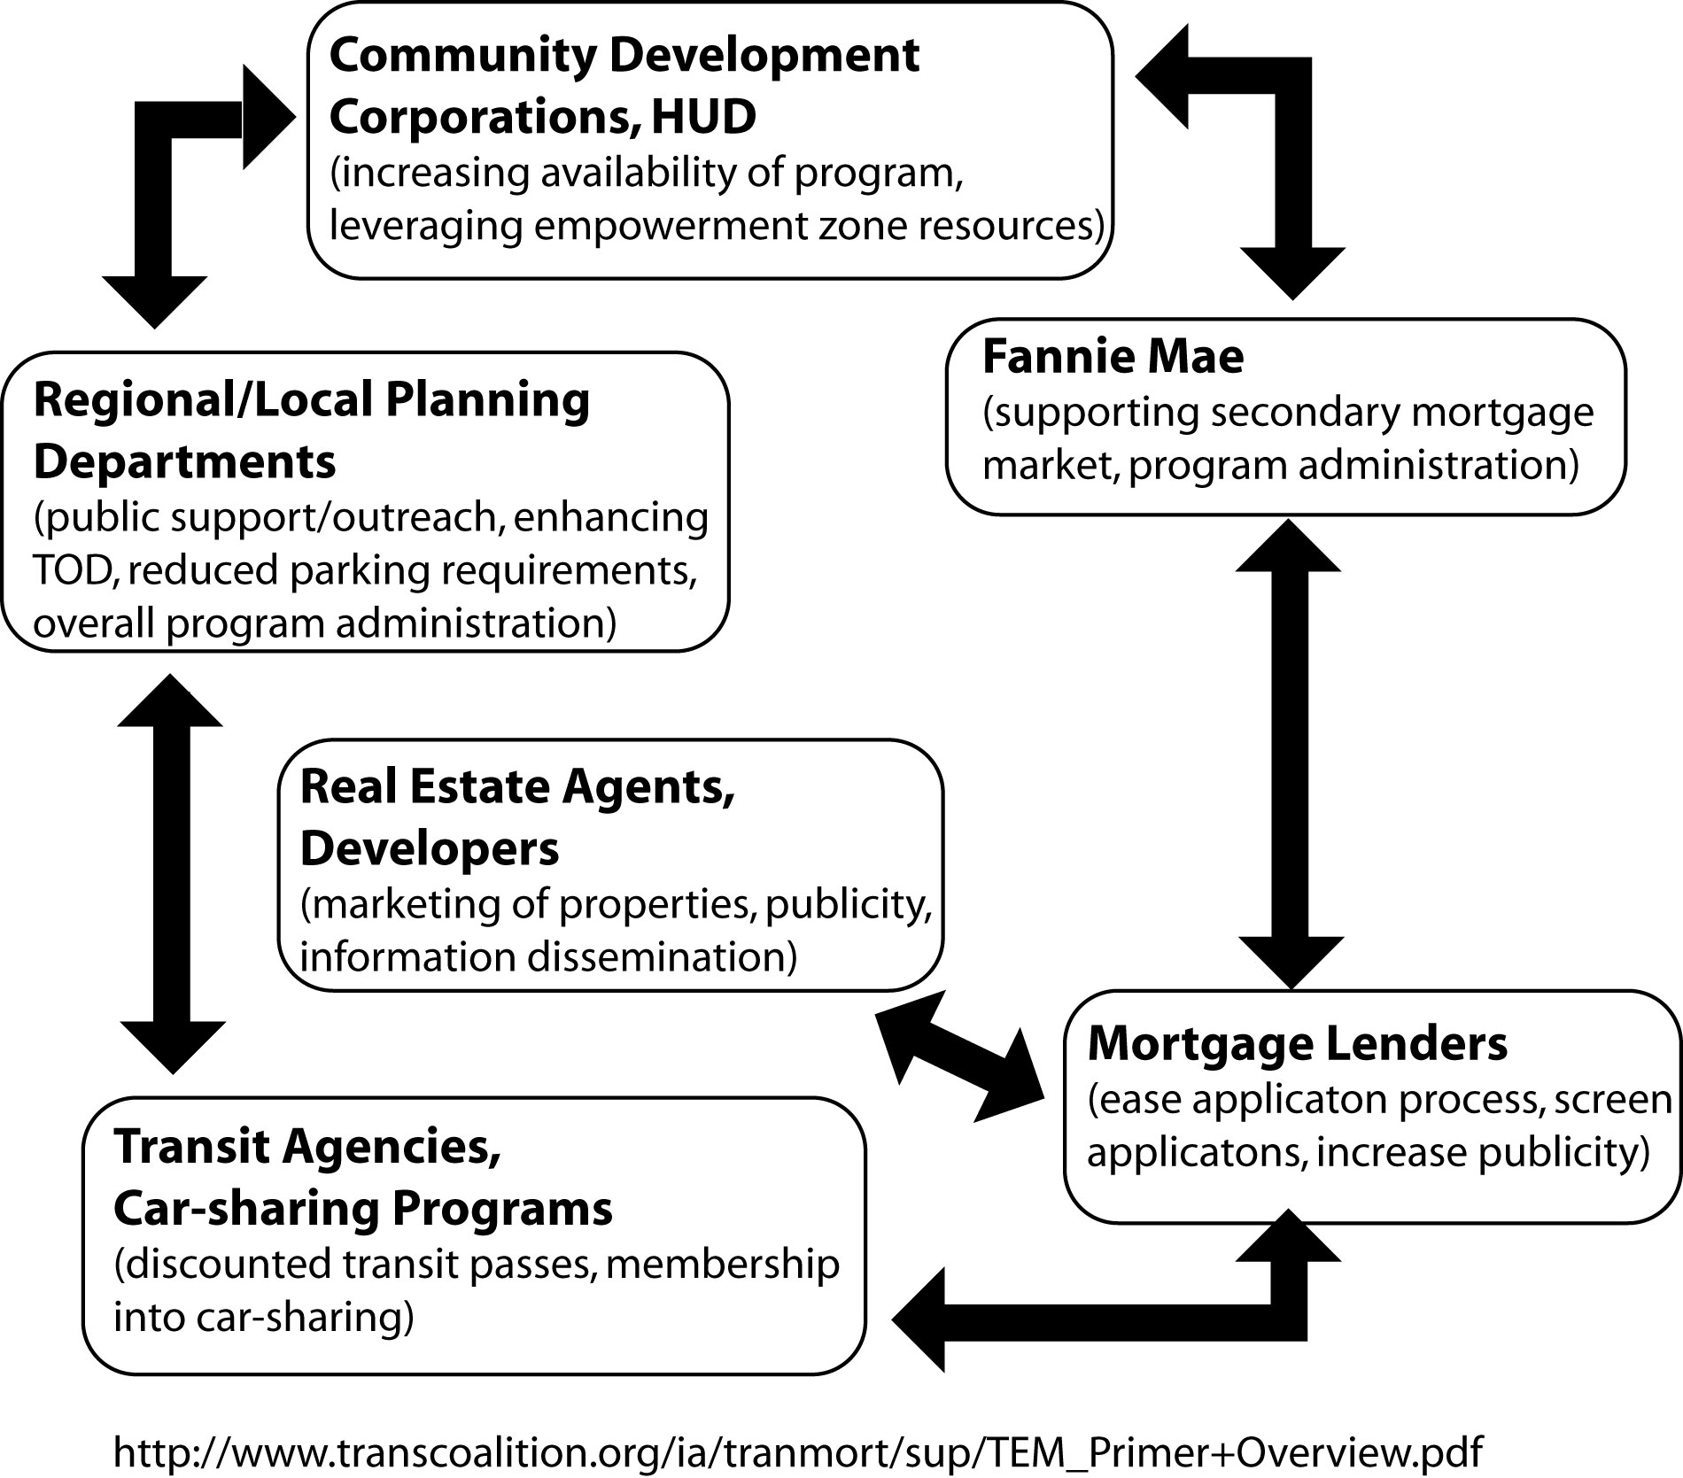
Under what circumstances does LEM work or not work?
This is an incentive-based tool targeted to private lenders and individual home buyers. It works best when the program is well publicized and the location efficient value (LEV) calculation is integrated into the lenders’ computerized application process.

This tool can be an effective way of increasing the “affordability” of housing in the central city, by increasing the number of places people can afford to live. However, the usefulness of these programs is limited by loan amounts which typically max out below median housing prices. In Seattle, San Francisco and Chicago maximum loan values are $417,000, $315,000 and $275,000 respectively.

Problems with LEM
The LEM does an excellent job of addressing land use, transportation, and environmental problems while simultaneously creating incentives for the individual to become a homeowner. The problem with the LEM is that it will only be effective for a specific and very small segment of residents who are either living an efficient lifestyle, or who are willing and able to adjust to a non auto dependent lifestyle.

Another concern is that transportation needs are highly elastic while home ownership is highly inelastic. Merging these two concepts so that they are reliant on each other could create additional hardships if a resident transfers to a job that requires a longer commute. Furthermore, unexpected changes or sudden hardships in a homeowner’s life can increase the need for the disposable income that is being allocated to the mortgage.

Finally, the default risk for borrowers is significantly higher which may reduce the LEMs presence in the secondary markets if lenders are not adequately compensated for that risk. LEMs were introduced into the housing market when there was irrational exuberance for larger, more expensive homes. Now as foreclosures approach an all time high, lenders are more wary of borrowers who are at default risk and who cannot afford larger initial down payments.

Example of Location Efficient Mortgages: City of Seattle
The city of Seattle is promoting greater use of LEMs in the neighborhoods that will have light rail stations. Their intention is to allow for the development of housing that is affordable to people with a wide range of incomes, especially in the North Beacon Hill and Pioneer Square neighborhoods where more affordable housing has historically been available. Whether LEM is an effective tool for preserving affordable housing in these neighborhoods is yet to be seen.
TOOL 2: Inclusionary Zoning
What is Inclusionary Zoning?
Inclusionary zoning is used to create affordable housing within a locality. Here, a locality refers to counties and municipalities. The definition of affordable housing is generally based on the Area Median Income (AMI) for a region; also, the required income threshold for an inclusionary zoning ordinance varies. As such, inclusionary zoning entails socio-economic objectives—essentially, it is used to further the economic and racial integration of different peoples.

When applied by a locality, inclusionary zoning can be either mandatory or voluntary. In addition, some inclusionary zoning ordinances offer incentives and subsidies. Examples of incentives and subsidies include loosening zoning restrictions, an expedited permit process, reimbursements, fee waivers or reductions, and priority for available government subsidies.

There are three ways inclusionary zoning can be implemented—either integrated into a development, built off-site, or as an in-lieu fee. The first option is the most desirable for achieving socio-economic integration. For the third option, a developer places money in a general fund which is used later to subsidize private or public affordable housing developments. In addition, inclusionary zoning can be implemented as a local ordinance, as part of a general plan policy, and as part of a permit approval process.

Constitutional Challenges
There are three major constitutional challenges that could be levied against inclusionary zoning. These challenges are the substantive due process clause of the Fourteenth Amendment, the takings clause found in the Fifth Amendment, and the equal protection clause in the Fourteenth Amendment.

According to the due process argument, inclusionary zoning represents a constitutional violation because it attempts to implement socio-economic objectives, it is discriminatory (since it usually applies to larger developments) and because it prevents a developer or property owner from receiving a fair return on their investment. Concerning the first argument, most zoning laws implement socio-economic objectives; what matters is whether an inclusionary ordinance advances a legitimate state interest. Moreover, the US Supreme Court has created a 2-step test to gauge whether a land use tool is discriminatory—does the development create a need for affordable housing (the nexus test) and is the exaction roughly proportional to the need created (the ‘rough-proportionality test)? The third component of this argument also applies to the equal protection clause—it can usually be avoided if the ordinance can be waived, or if it provides cost off-sets.
The second constitutional argument pertains to cases where the inclusionary zoning ordinance requires a mandatory set-aside. Nevertheless, local governments are not required to ensure the ‘highest and best use’ of a property for a developer; rather, they are required to ensure a ‘reasonable use’. Moreover, incentives and subsidies can be used to off-set the costs of a mandatory set-aside.

Examples: Inclusionary Zoning
Voluntary: Morgan Hill, CA
The incentive-based program of Morgan Hill, California is one of few voluntary inclusionary zoning programs that have been effective. As part of its growth management policy, the City strictly limits the number of residential building permits issued each year. The City uses a point system to determine which proposed developments are awarded permits. In order to earn enough points for a permit, a development must incorporate one of several affordable housing options. In 26 years of the inclusionary zoning program, Morgan Hill added over 300 affordable housing units.

Mandatory: Boston, MA
Boston first passed its inclusionary zoning policy in 2000 to combat skyrocketing housing prices and the spread of gentrification. This program requires nearly all residential projects of 10 or more units to set aside 10% of them as affordable. Developers can transfer the affordable units off-site, but must then set aside 15% of the units as affordable. The program also allows developers to pay an in-lieu fee calculated as 15% of the market value units times the cost of an affordable housing unit. The City uses the in-lieu fees collected to help fund other affordable housing projects. By January, 2002, the policy had precipitated the construction of over 200 new affordable housing units in Boston.

Mandatory: San Diego, CA
San Diego’s first inclusionary zoning requirement was enacted in 1992 and pertained only to a specific area of the City referred to as the North City Future Urbanizing Area (FUA). This area was developing rapidly but contained no rental or affordable housing. The policy states that 20% of all new residential developments in the FUA must be affordable. No in-lieu fee option is offered. Over 1,200 affordable units were built in the FUA by 2002. An additional 1,200 affordable units are expected by the time the FUA is fully built out.

In July, 2003, San Diego passed an inclusionary zoning ordinance that encompassed the rest of the City. The FUA is still governed by the first policy. The new ordinance requires 10% of new residential developments over 10 units to be affordable. Unlike in the FUA, in the rest of San Diego, an in-lieu fee option is offered. The booming housing market in San Diego makes it likely that developers will pay the fee instead of providing affordable housing units. For this reason, the inclusionary zoning ordinance may not result in many integrated affordable housing units.

Krizek, Kevin. LEM: Theory, Application, and Prospects for Smart Growth.
Institute for Location Efficiency. Location Efficient Mortgage. Retrieved February 22, 2007, from http://www.locationefficiency.com/
Transportation and Land Use Coalition. Transportation Efficient Mortgages. Retrieved February 22, 2007, from http://www.transcoalition.org/ia/tranmort/07.html
City of Seattle. Envisioning Beacon Hill. (n.d.) Retrieved February 22, 2007, from http://www.seattle.gov/transportation/SAP/BeaconHill.pdf
For instance, a locality may require a formula, in which a certain percentage of affordable units be priced for people who make 50% and 30% or below of AMI. California Coalition for Rural Housing (CCRH) and the Non-Profit Housing Association of Northern California (NPHANC), Inclusionary Housing in California: 30 years of Innovation,” National Housing Conference Affordable Housing Policy Review 3.1 (2004): 16.
Nico Calavita, Introduction, National Housing Conference Affordable Housing Policy Review 3.1 (2004): 1; Daniel R. Mandelker, “The Constitutionality of Inclusionary Zoning: An Overview,” eds. Dwight Merriam, David J. Brower, and Philip D. Tegeler, Inclusionary Zoning Moves Downtown (Washington, D.C., Chicago, IL: APA Planners Press, 1985), 33.
Nadia I. El Mallakh, “Does the Costa-Hawkins Act Prohibit Local Inclusionary Zoning Programs,” California Law Review 89.6 (2001): 1857.
The expedited permit process can be important in localities that restrict growth by limiting the number of available building permits. Reimbursements are usually geared towards developers that set aside dwelling units below a certain income threshold. For density bonuses, see Mandelker, 35; El Mallakh, 1860. For expedited permit process, see Calavita, 6. Denver, CO includes an example of reimbursements; see, Nick Brunick, Lauren Goldberg, Susannah Levine, Large Cities and Inclusionary Zoning (Chicago, IL: Business and Professional People for the Public Interest, 2003), 7. For fee waivers or reductions, see CCRH and NPHANC, 23. Finally, Sacramento, CA grants developers who meet the inclusionary requirements priority for government funding, Brunick, Goldberg, Levine, 9; 16.
Calavita, 18-22.
Deborah Collins and Michael Rawson, “Avoiding Constitutional Challenges to Inclusionary Zoning,” National Housing Conference Affordable Housing Policy Review 3.1 (2004): 32; Mandelker, 31-37.
Collins and Rawson, 35-36; Mandalker, 33-36; “Constitutional Law. Fifth Amendment Takings Clause. California Court of Appeal Finds Nollan’s and Dollan’s Heightened Scrutiny Inapplicable to Inclusionary Zoning Ordinance. Home Builders Association of Northern California vs. City of Napa. 108 Cal Rptr. 2d 60 (Cal. Ct. App. 2001),” Harvard Law Review 115.7 (2002): 2060.
National Housing Conference, Inclusionary Zoning: The California Experience, Library of Congress, 2004.
Website accessed on February 24, 2007: http://www.policylink.org/EDTK/IZ/How.html.
Nick Brunick, Lauren Goldberg and Susannah Levine, Large Cities and Inclusionary Zoning, Business and Professional People for the Public Interest, November, 2003.
Ibid.
Ibid.

