**ESS 431 PRINCIPLES OF GLACIOLOGY**

**ESS 505 THE CRYOSPHERE**

**Lecture 13 – Recent Changes in the Cryosphere**

*Due Wednesday, November 7 2018, at start of class*

|  |
| --- |
| Reading from IPCC AR5 (2013) |

1. Suppose you are a scientist who has been tasked with measuring the rate of change of the amount of ice in the Greenland Ice Sheet. What tools would you use to go about making this measurement?
   1. Method 1:

Tools:

* 1. Method 2:

Tools:

* 1. Method 3:

Tools:

1. What is causing the high rates of Antarctic mass loss shown in Figure 4.14 d-e-f ?
2. Where in Greenland are the greatest rates of surface elevation change? Based on this information alone, draw a map of what you might expect the ice sheet to look like in the year 3000. Do the same for Antarctica.

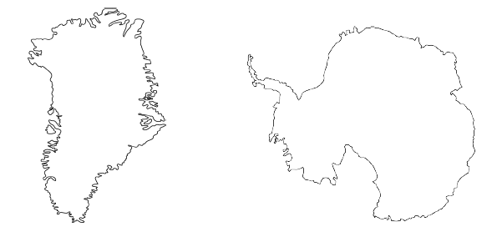

1. Draw two processes that could harm the integrity of this ice shelf. According to the IPCC report, which ice shelves or geographic locations are vulnerable to each process?

