EARTH AND SPACE SCIENCE  431 PRINCIPLES OF GLACIOLOGY  505 THE CRYOSPHERE | Autumn 2018  4 Credits, SLN 14855  4 Credits, SLN 14871

Homework 1 – Due Friday, October 12th

- The Skater (8 points). Ice skates can move rapidly across ice because there is little friction between the skate blade and the ice. It has been suggested that the lack of friction under an ice skate is due to pressure-melting. The Clausius-Clapeyron Relation describes the relationship between the melting temperature and the applied pressure, and it can be used to evaluate that suggestion.

Useful Information:  Clausius-Clapeyron Relation:  $\frac{dP}{dT}=\frac{L}{T∆v}$  [Watch your units] | P = Pressure (Pa)  T = Temperature (K)  L = Latent heat of fusion (J/kg)  $∆v$ = change in specific volume at phase transition (m³/kg)

Consider a 70-kg person skating on ice of temperature -5°C (23°F). The skate blade is 300 mm long and 1 mm wide.

(a) (2 points) What is the contact area of the skate with the ice, when one foot is lifted off the ground?

(b) (2 points) What is the pressure exerted on the ice in this case?

(c) (2 points) By how many degrees is the melting temperature reduced?

(d) (2 points) Argue for or against pressure-melting as the explanation for the low friction.

- Density of Ice (6 points). Calculate the density of ice (hexagonal ice I, ice Ih) from first principles by considering the net number of water molecules in the unit cell (the repeating unit that can fill space), which is illustrated below, and the definition of density.

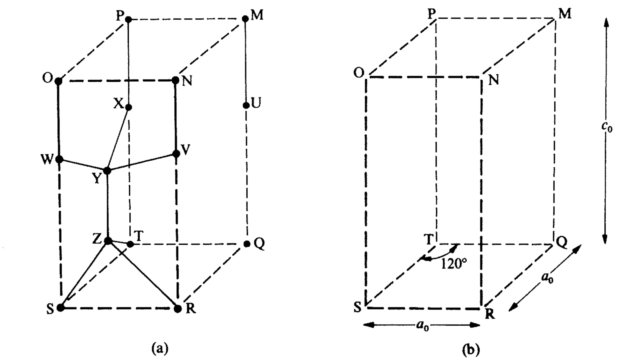

- (2 points) Given dimensions $a_{0}=4.52$ Å and $c_{0}=7.36$ Å and the separation angles in the unit cell as shown in the figure, what is the volume of the unit cell? [Please keep in mind that the base of the unit cell is not a square!!]

- (2 points) How many complete water molecules (be careful not to over count as some water molecules are “shared” by adjacent unit cells) are contained within the unit cell? What is the mass of the unit cell?

- (2 points) Considering your calculations above, what is the density of ice?

- Melting Antarctica (5 points). How many 1-megaton nuclear bombs would it take to melt the Antarctic ice sheet? [One ton of TNT releases 10⁹ calories or $4.2 ×{10}^{9}$ J]. Only one significant figure is desired here.

Useful Information:

Volume of Antarctic ice sheet: $25.4 × {10}^{6}$ km³
Average temperature of Antarctic ice: $-20℃$
Density of ice: 917 kg/m³
Latent heat of fusion for ice: $334$ J/g
Specific heat capacity of ice: $2.1\frac{J}{g K}$

- (1 points) Using the information above, what is the mass of the Antarctic ice sheet (in grams)?

- (2 points) How much energy per gram is required to melt ice from this average temperature? [Consider the energy need to raise the ice to the melting point (sensible heat) and the energy needed to melt the ice (latent heat).]

- (2 points) How many 1-megaton bombs are needed to melt all the ice? [At this point, this problem can be solved using solely dimensional analysis.]

- Flux imbalance for ice-sheet melting (5 points). It took ~10,000 years for the Laurentide ice sheet (~70 m global sea-level equivalent) to melt as the Earth exited the last ice age. Calculate the latent heat associated with the conversion of this volume of ice into liquid water.

- (3 points) Using the information from the previous problem and assuming the Earth’s surface is 70% covered by ocean and that the density of water is 1000 kg/m³, what is the global imbalance of radiation required in the Earth radiation budget to melt the Laurentide ice sheet over 10,000 years?

- (2 points) How does this value compare to the solar constant and its uncertainty, as typically used in global climate models? [Please list the reputable source you use.] Given this comparison, do you think latent heat is a constraint on the change in size of an ice sheet on multimillennial timescales?

