EARTH AND SPACE SCIENCES Autumn 2018
431 PRINCIPLES OF GLACIOLOGY 4 Credits, SLN 14855
505 THE CRYOSPHERE 4 Credits, SLN 14871

Homework 3 – Due Friday, October 26th
Instructions:
This assignment consists of three written statements:
- Observations and description of the glaciers on Mt. Baker from Satellite Data [~150-200 words]
- Field observations about the Easton glacier system. (What features could you see in person that you couldn’t see in the satellite data? What features could you only see in the satellite data but not in person?) [~150-200 words]
- Based on your experience writing (1) and (2), what are the pros and cons of satellite remote sensing versus in situ data collection? [~100 words]
This is designed to get you thinking about taking measurements in the cryosphere during the satellite era. Data collection from space provides amazing perspective on certain aspects of the system, but it can’t measure everything we might be interested in.
Attached you will find two images of the south side of Mt. Baker. The first is a hillshade image of a “Digital Elevation Model” (DEM), produced using aerial laser scans of the region. The second is a visible light image taken by the Landsat satellite. In groups of 2, record observations about these two data sets, focusing on features you might look for during our hike on Saturday. These should include:
- Observations of texture – can it help you figure out what is glacier and what isn’t?
- Observations of color – Is color better than texture at finding glacier boundaries? What might it tell us about the regions downstream of the current glaciers? Where is there vegetation, what type is it, and why isn’t it everywhere?
- Unique features in the ice or rock – what stands out of the images? Is there evidence of unique and interesting glacial processes [even if you aren’t sure what exactly you are seeing]?
- Further features and specific phenomenon are listed on page 3. Compare how at least two of these features manifest in remotely-sensed vs. field observations.

Finally, write down some expectations for what the terrain will be like on the hike. Be specific. (are we walking on soil? gravel? boulders? Densely vegetated or open? Large rivers? Small streams?)

[If you can’t attend the field trip, written statements (2) and (3) will be replaced by a separate writing assignment, which is detailed on page 3 of this assignment.]
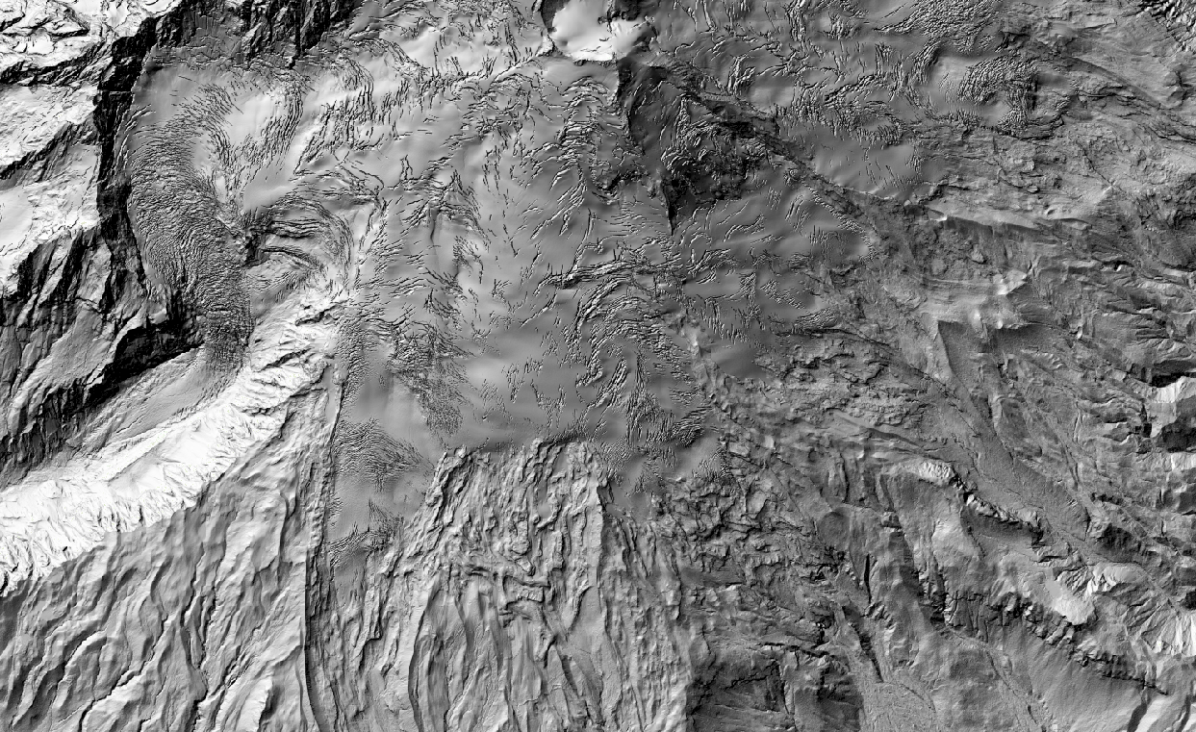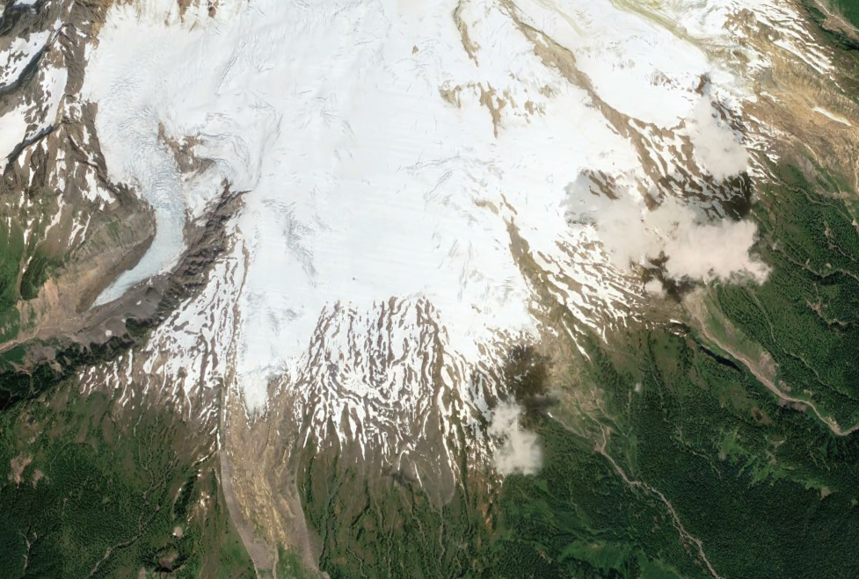
1km
1km

Phenomena/Features on the Mt. Baker Field Trip (examples of features to compare between remotely-sensed and field observations)
- The structure of glacier ice. Features might include crystal sizes and orientations, crevasse patterns, and foliation.
- Metamorphism of snowflakes held in a constant temperature environment.
- Glacier advances and retreats on Mt. Baker since the Little Ice Age.
- Effects of glaciers on landscapes (deposits, erosion patterns).
- Effects of glaciers on ecosystems (recolonization).
- The relationship between glacier mass balance (snow accumulation and melting) and flow.
- The formation of needle ice.
- Avalanche tracks - why they form, and their implications for human activities.

If you could not make the field trip:
Write a ~500 word (2 page) report on one of the topics listed above.

The field trip provided first-hand experience with the phenomena listed here - your goal is to describe expected field observations, or the source process that leads to the expected field observations, based on other scholarly material. Be sure to list any references (and you should use references from peer-reviewed literature) you used to investigate these topics.

